Git cherry-pick

What is a git cherry pick?

git cherry-pick is a powerful command that enables arbitrary Git commits to be picked by reference and appended to the current working HEAD.

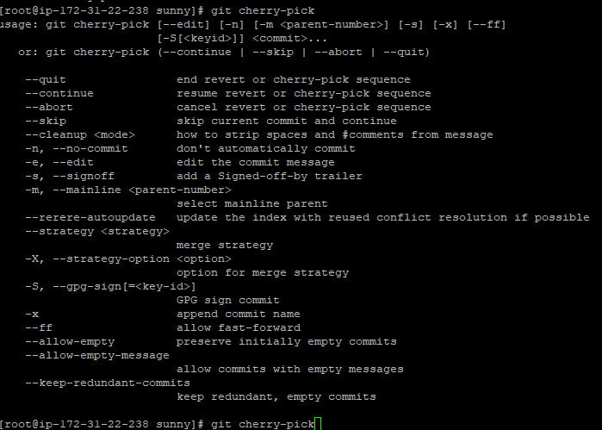

Git branch

What is the git branch?

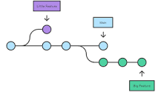

In Git, branches are a part of your everyday development process. Git branches are effectively a pointer to a snapshot of your changes.



Git log –-oneline

What does git log -- Oneline do?

The oneline is an option of the git log command. The main purpose of this command is to print a single commit in a single line as output when the git log command is executed using this option.



Git rebase

What is a rebase in git?

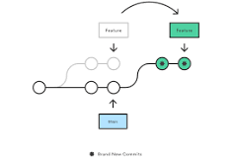

What is git rebase? Rebasing is the process of moving or combining a sequence of commits to a new base commit.



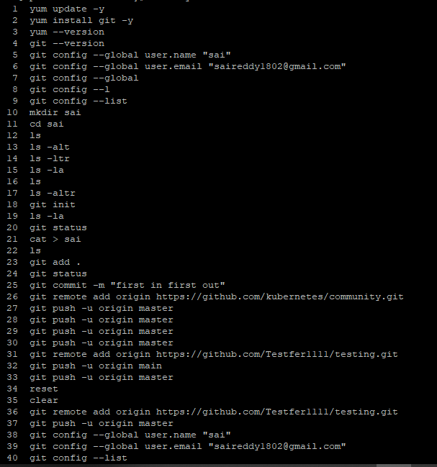

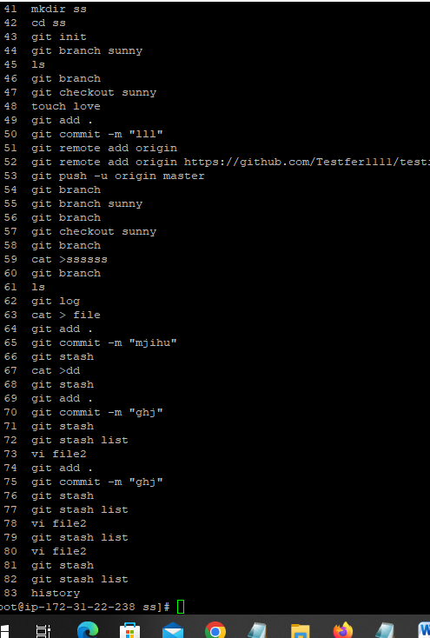

Git staging

What is a git staging?

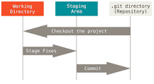

Git has three main states that your files can reside in: modified, staged, and committed: Modified means that you have changed the file but have not committed it to your database yet. Staged means that you have marked a modified file in its current version to go into your next commit snapshot.

