All information comes from

[Learn ASP.NET Core MVC (.NET 6) (freecodecamp.org)](https://www.freecodecamp.org/news/learn-asp-net-core-mvc-net-6/)

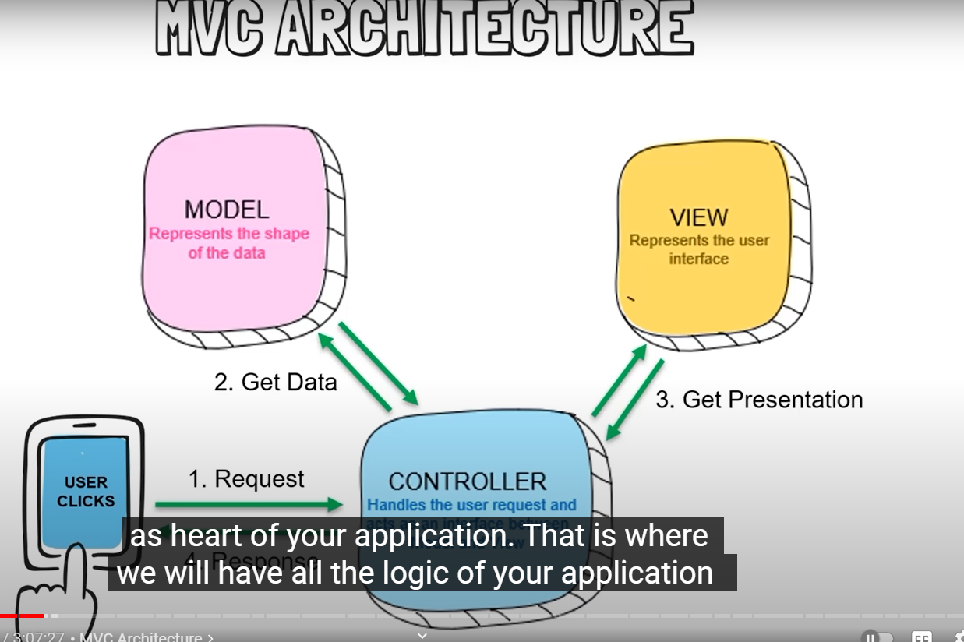

Controller option

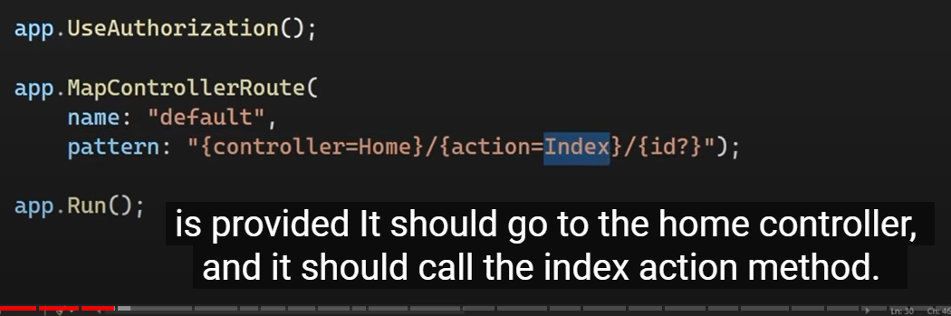

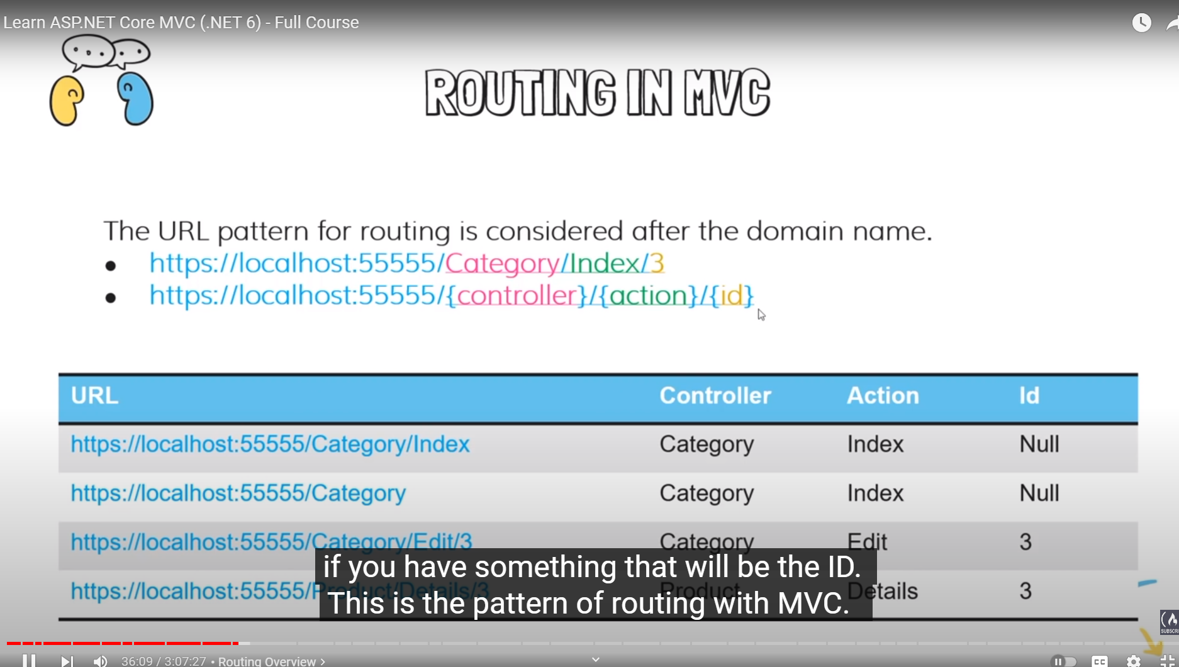

Shared folder is a place that has Views that can be accessed by other views.

Tag helps are like angular directives but enables server side code html code for razor

Below shows the difference between tag and html helpers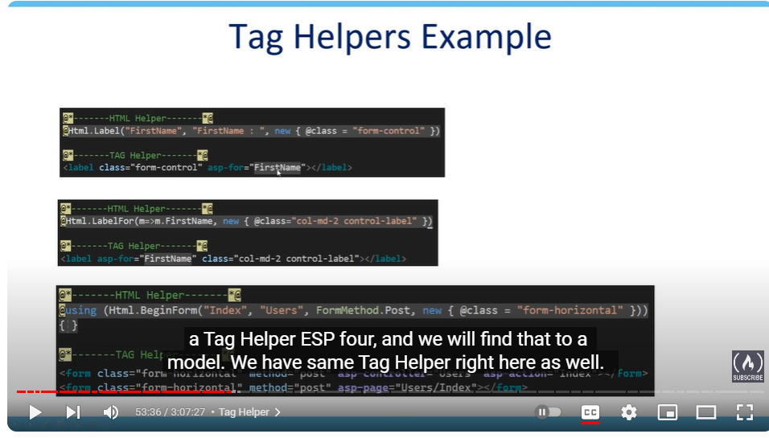

Action results

Are the same in mvc and razor page applications

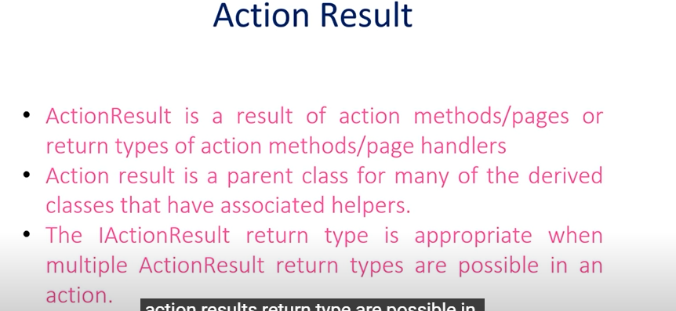

Action result in razor pages

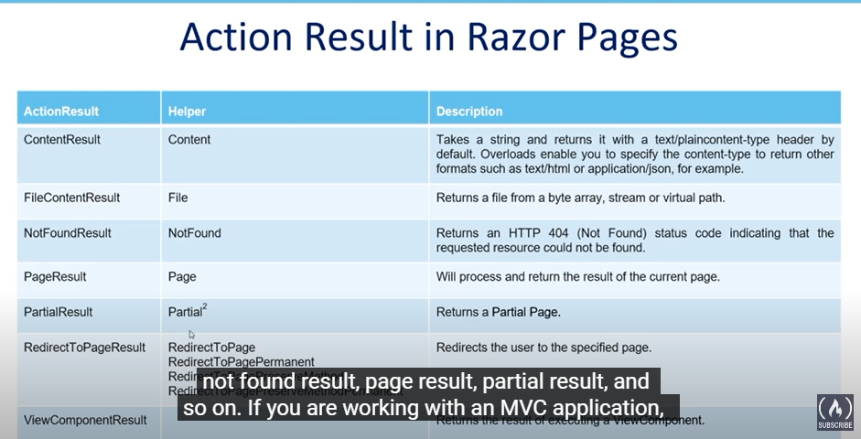

Action result in mvc

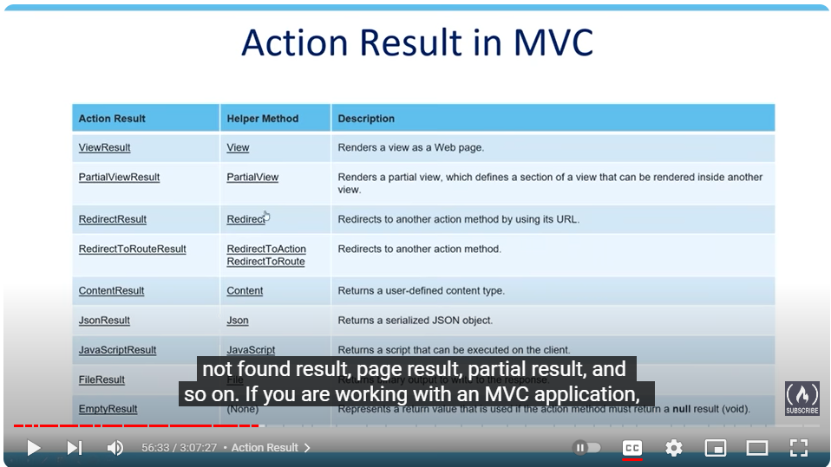

Example of how to use actionresult and iactionresult

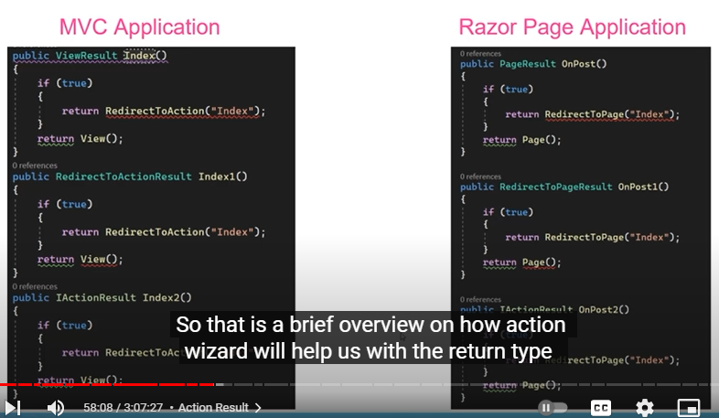

Name spaces in C#

[Namespaces - C# language specification | Microsoft Learn](https://learn.microsoft.com/en-us/dotnet/csharp/language-reference/language-specification/namespaces)

Appsetting.json is the best place to leave connection strings to sql data bases. You can choose multiple different appsettings.

Versions of modules in nuget manager have to be the same for things to work right.

When naming a controller it must have controller at the end of its name.

Like CategoryController.cs

IF you make a change in a controller you have to restart the project to actually view the updated change.

You can instead of creating the controller from scratch you can use create controller the name will be.

MVCController with views, using Entity Framework this creates everything for you for the controllers but you have to spend time editing the look of the data.