Data Pre-Processing:

# What is it?

* Data Pre-Processing is all about resolving the issues present in the data, which might be potentially handling null values, Incorrect values

# Stages of Data Pre-processing:

* Data Acquisition
* Data Cleaning
* Data Sampling

# What is Data Acquisition:

* Reading Data from following:
  + CSV
  + Excel
  + JSON
  + XML
  + Image
  + Web Scraping

# Web Scraping:

* Packages Used:
  + Requests
  + BeautifulSoup

# Way of Using requests

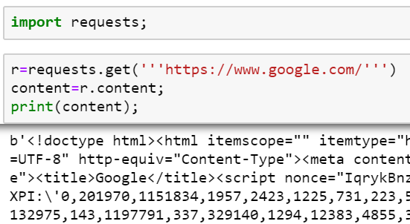

# Way of Using BeautifulSoup:

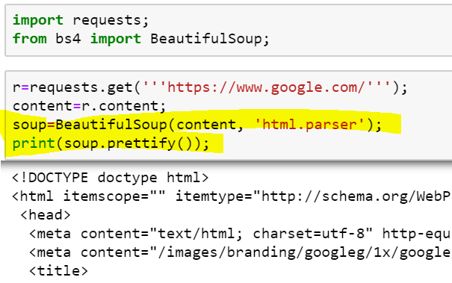

# Data Acquisition from BeatifulSoup:

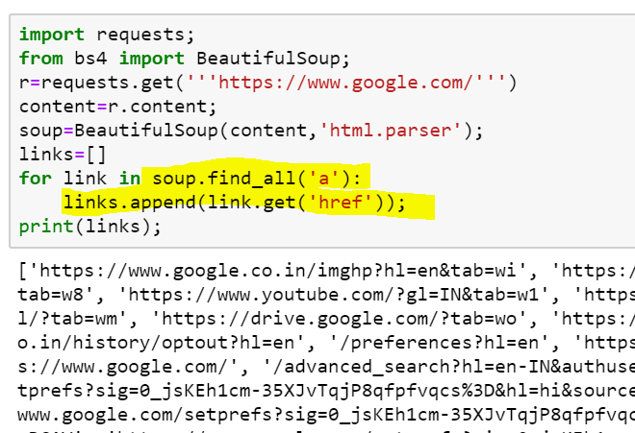

# Data Cleaning [Techniques Used]:

* Removing Null Values
* Handling the Missing Values
* Handling the Categorial Values
* Scaling the Data
* Normalization

# Removing Null Values

## Step 1 [Check if any Columns has null values]

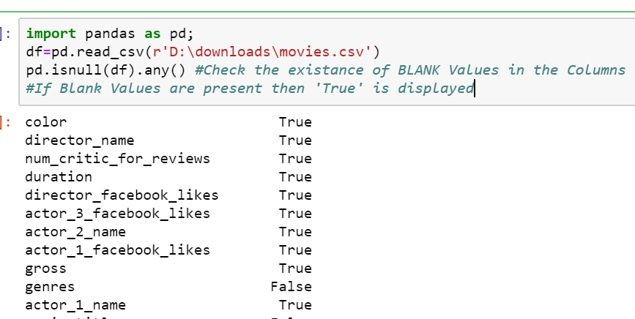

## Step 2: [Remove Null Values]:

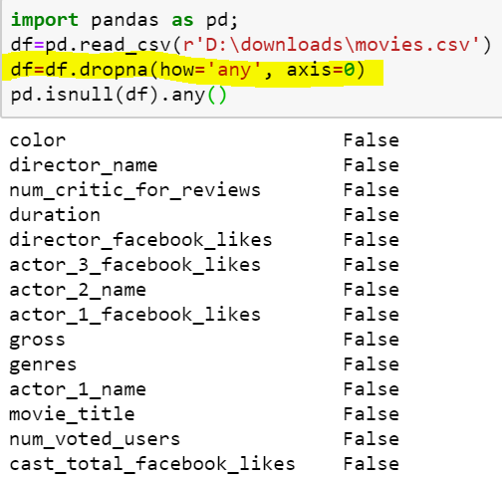

# Handling the Missing Values

