# Importing numpy module:



# Initializing a numpy Array: [ np.array([data1, data2])]

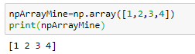

# 2D Numpy Array : [np.array([[data1, data2, ….], [data3, data4,….]])]

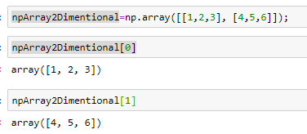

# aRange Function:

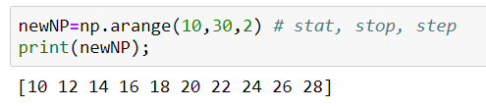

# Creating an Empty Numpy dataset and Its Updation:

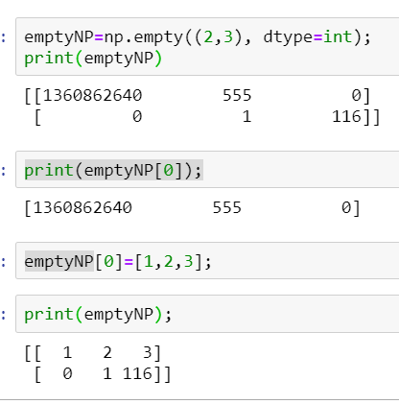

# Creation of Numpy which has Zeros

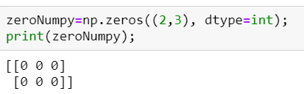

# Linear Spaced Numpy Array

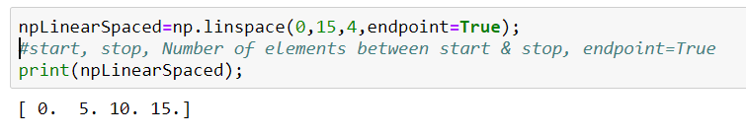

# ReShape Numpy:

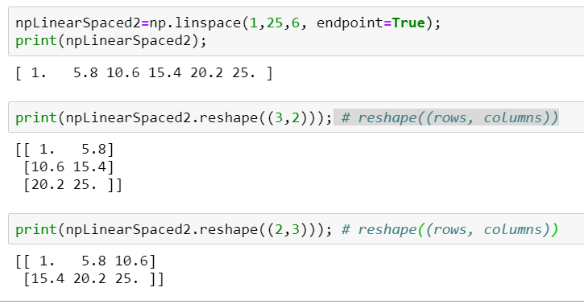

# Reading Numpy Arrays:

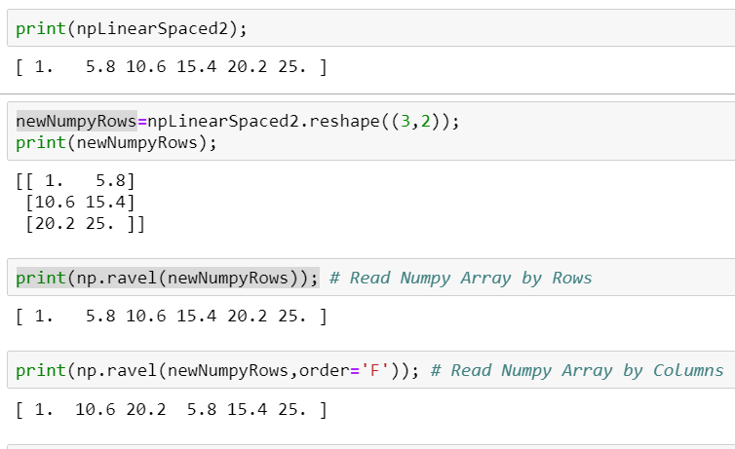

# Indexing & Slicing:

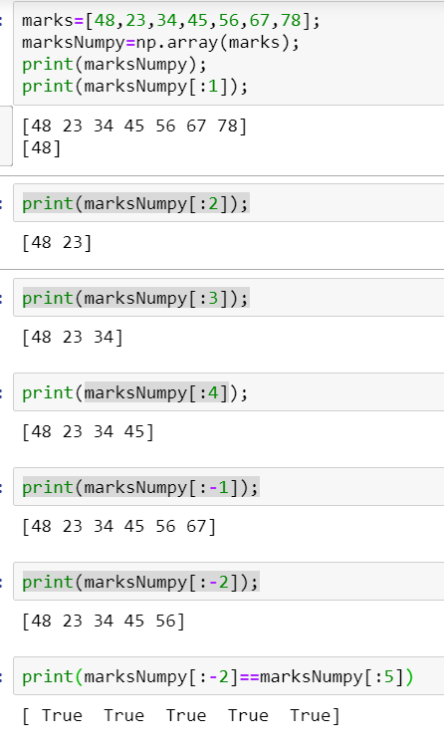

# Indexing and Slicing [Multi-Dimensional]

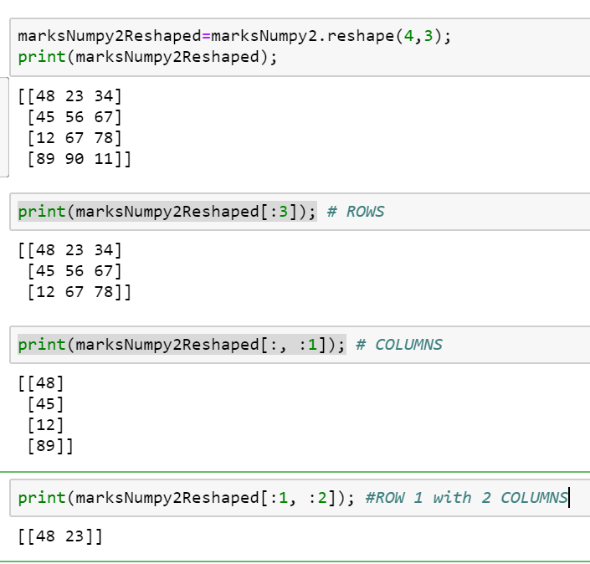

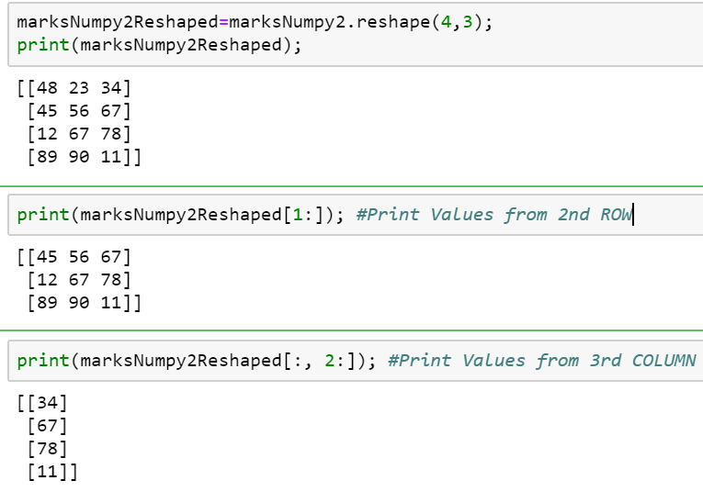

# Numpy Attributes: [shape, ndim]

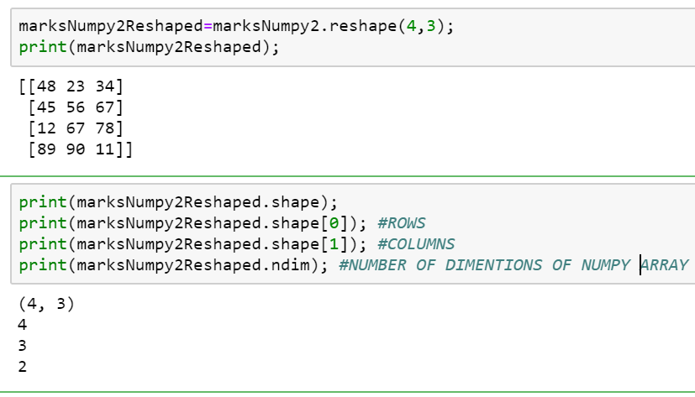

# Calculation of Mean, min, max:

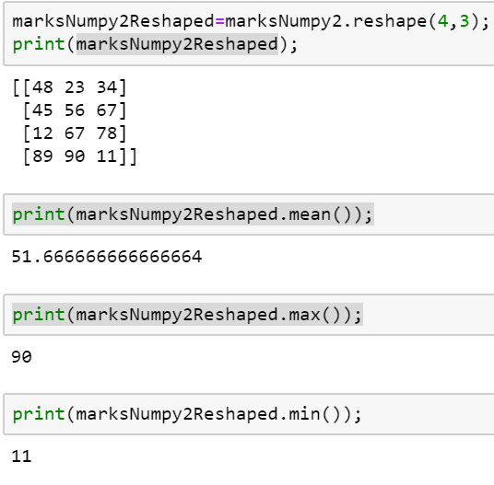

# Axis

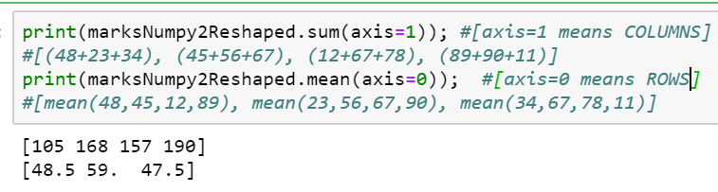

# Appending Data to Rows Of Numpy Array:

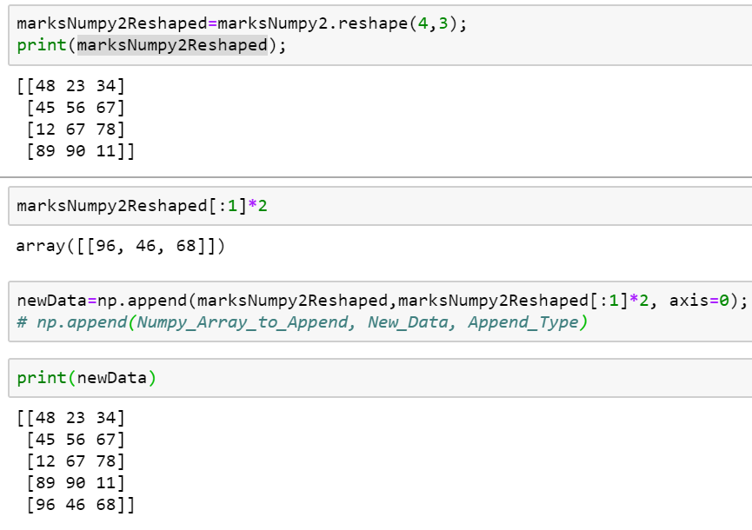

# Appending Data to Columns Of Numpy Array:

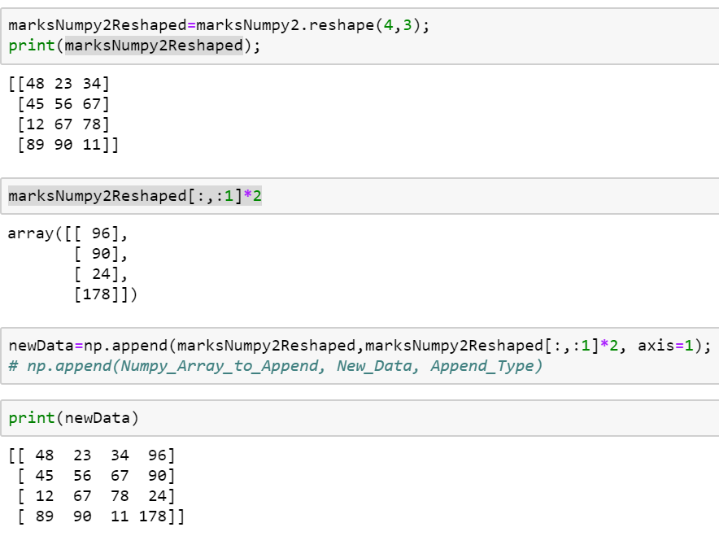

# Read and Write Data to TXT:

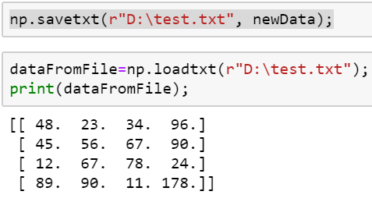

# Read and Write Data to CSV:

