# Way of Creating a DataFrame Using Pandas:

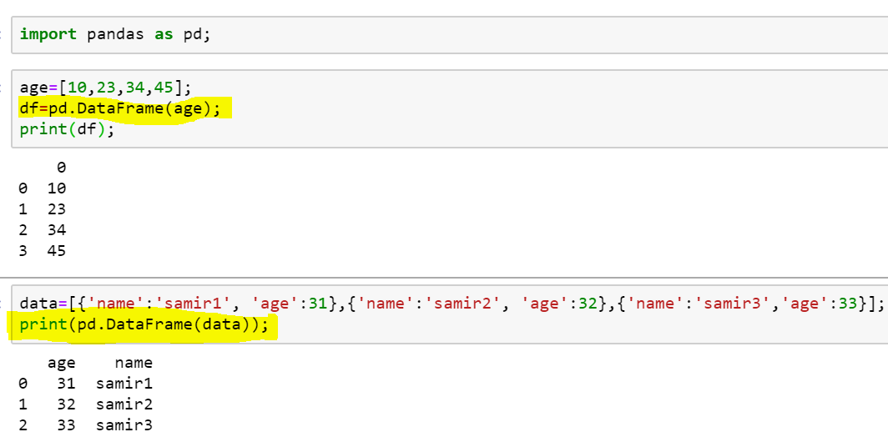

# When a Key is present in one Node and is not present in another node

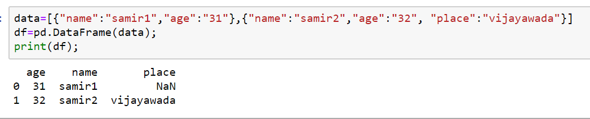

# With Row Indexes:

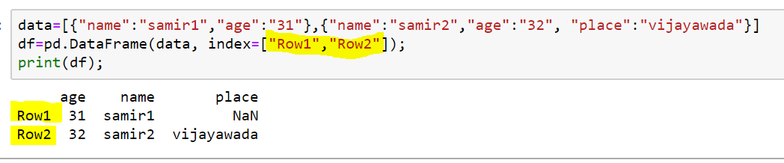

# With Row Indexes for a data, whose form is with out Key Value Pair:

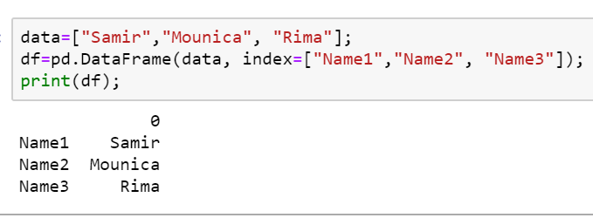

# Pd.Series:

* When a dataframe is created, using “Series”, we will not be seeing Column Name

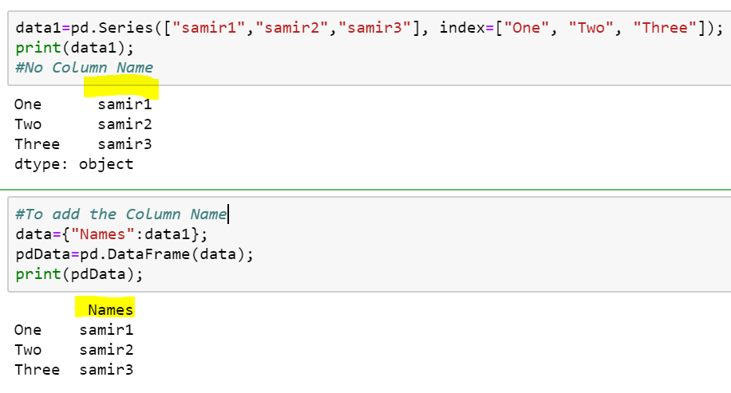

# Addition of Columns in Pandas DataFrame:

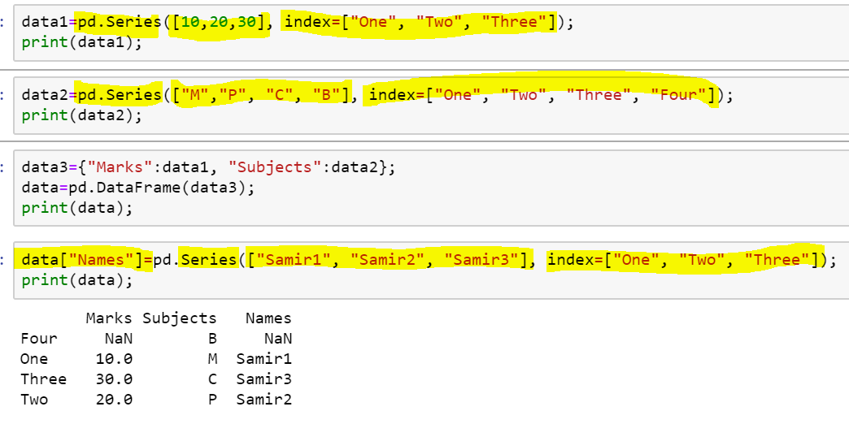

# Deletion of Column in Pandas DataFrame:

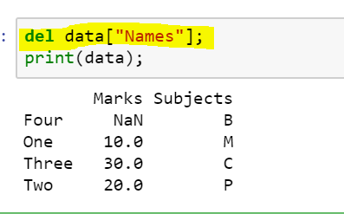

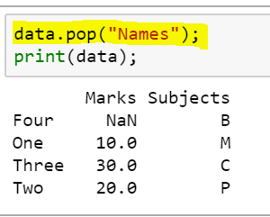

# Selecting an Item from Pandas DataFrame:

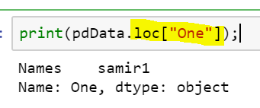

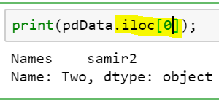

# Appending Data to Pandas DataFrame:

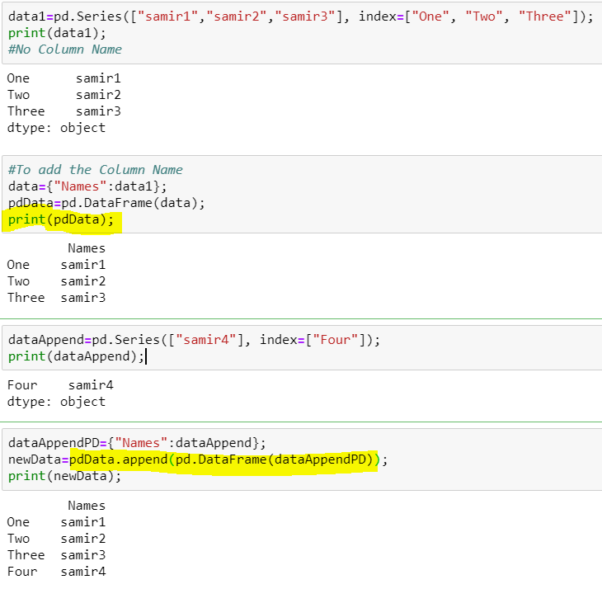

# Deleting a Particular Row:

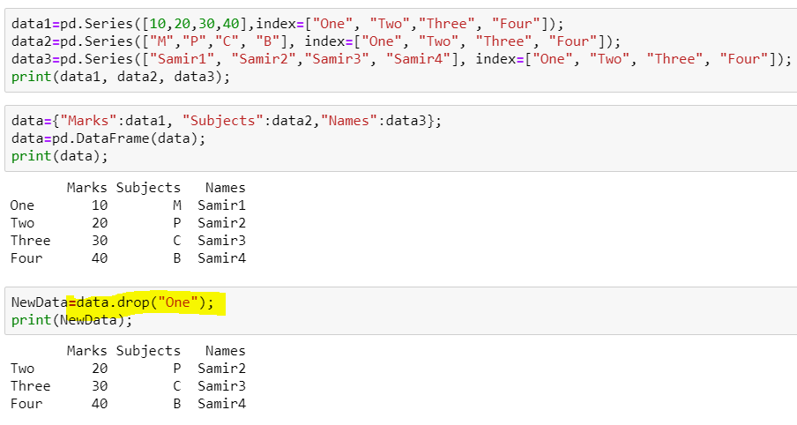

# Loading DataSet From CSV:

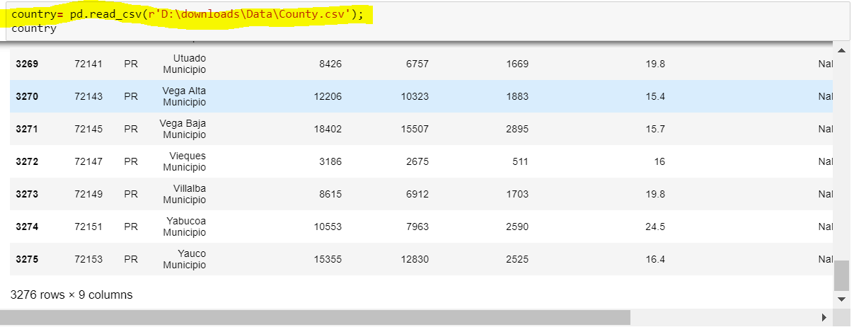

# Removing a Column from DataSet:

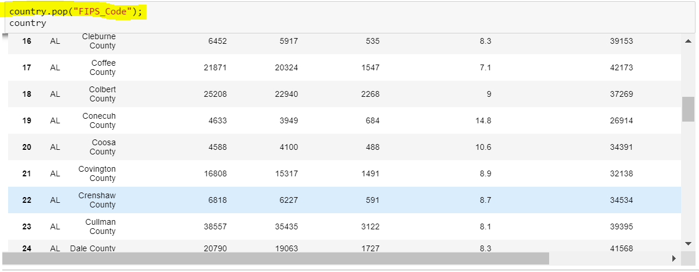

# Display Specific Columns

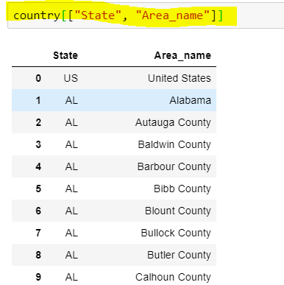

# Writing Content to CSV:

