For getting the type of the variable:

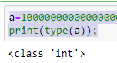

Tuple: ()🡪Braces Used

* 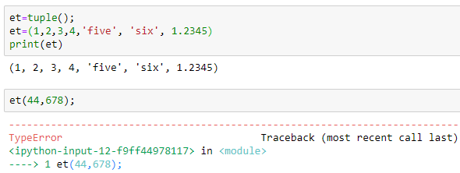
* 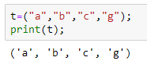

List: []🡪Braces Used

* 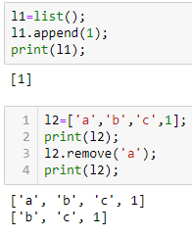

DICTIONARIES: {}🡪Braces Used

* 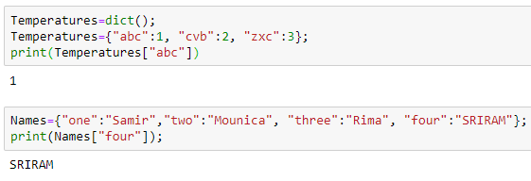

Sets: {}🡪Braces Used

* 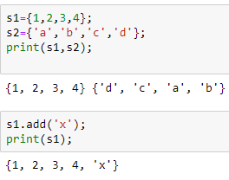

Member Ship Operator:

* 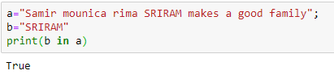

Identity Operator:

* 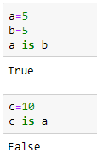

If Condition:

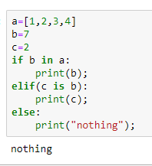

For Loop:

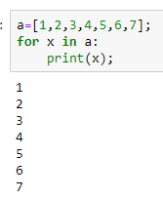

While Loop:

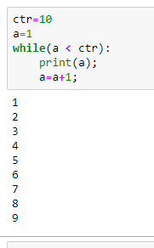

File Write:

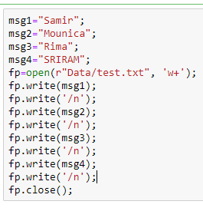

File Read:

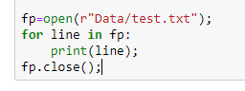

File Attributes:

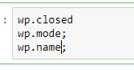

Rename & Remove:

