‘’Derive the expression for a Ray-Cylinder intersection’’

First thing first, in order to find the expression for a ray-cylinder intersection we need to find an implicit parametrization for the cylinder with the following parameters :

* center **c**
* radius **r**
* axis **a**
* height *h*

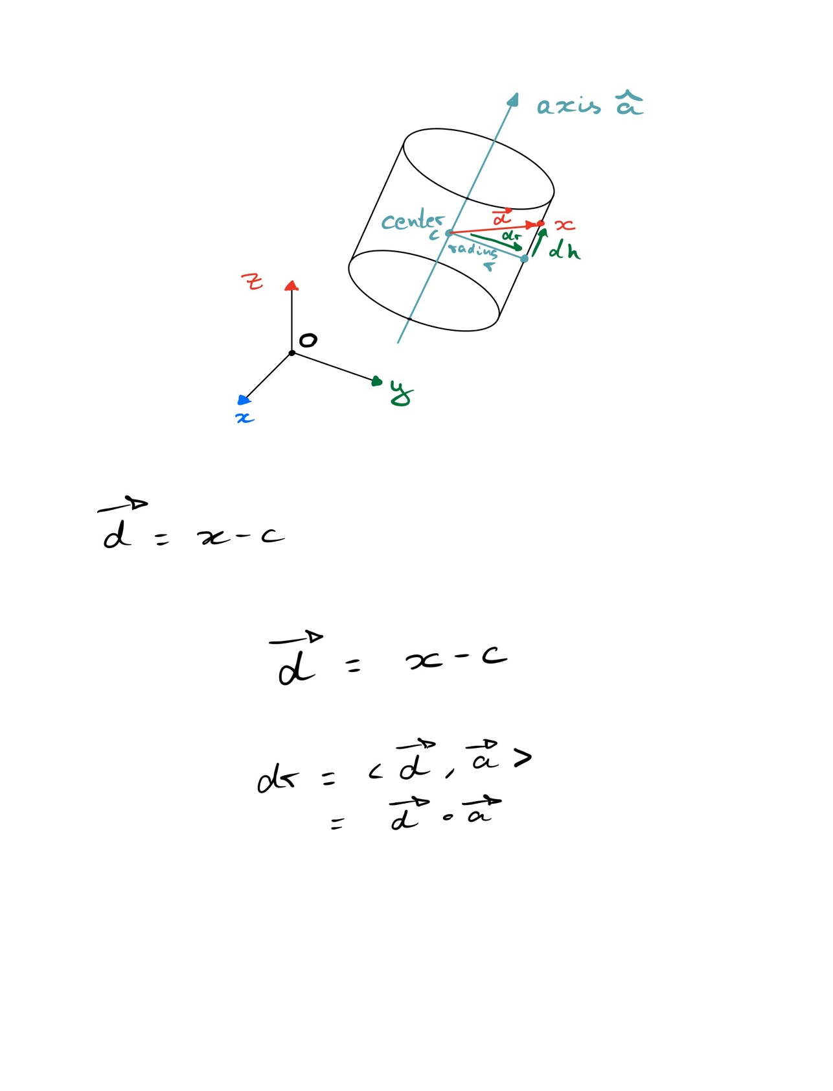

For an infinite cylinder, the points on the cylinder surface are points such that the radial distance **dr** from point to axis **a** is of length radius R.

Using the distance vector **d** from a point x to the center c of the cylinder

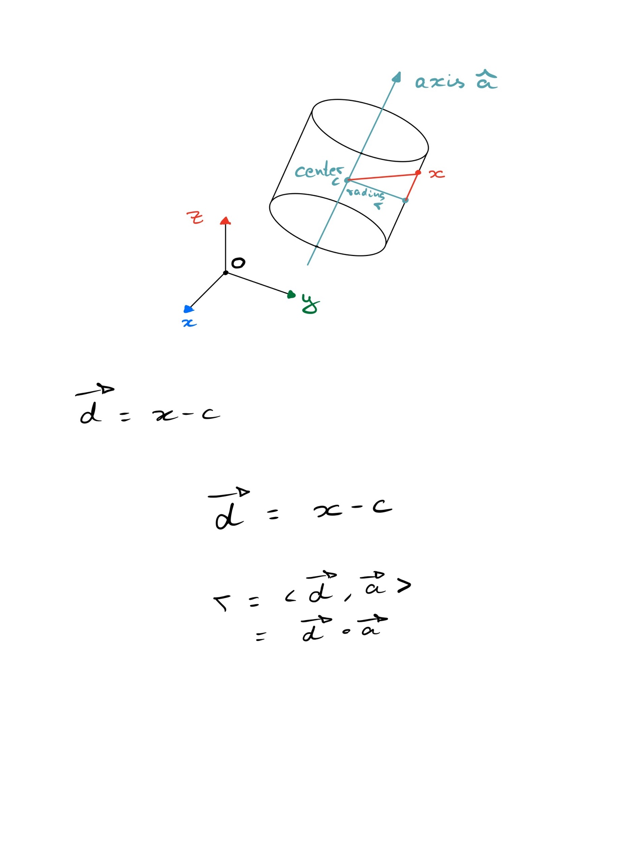

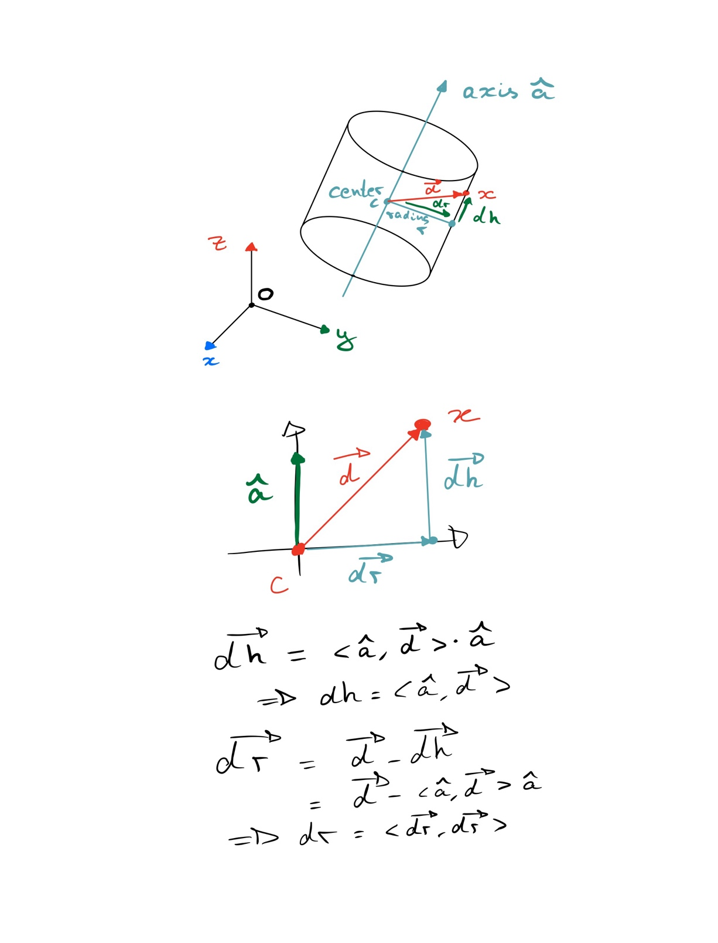

We can compute the radial distance **dr** and the height distance **dh** as follow :

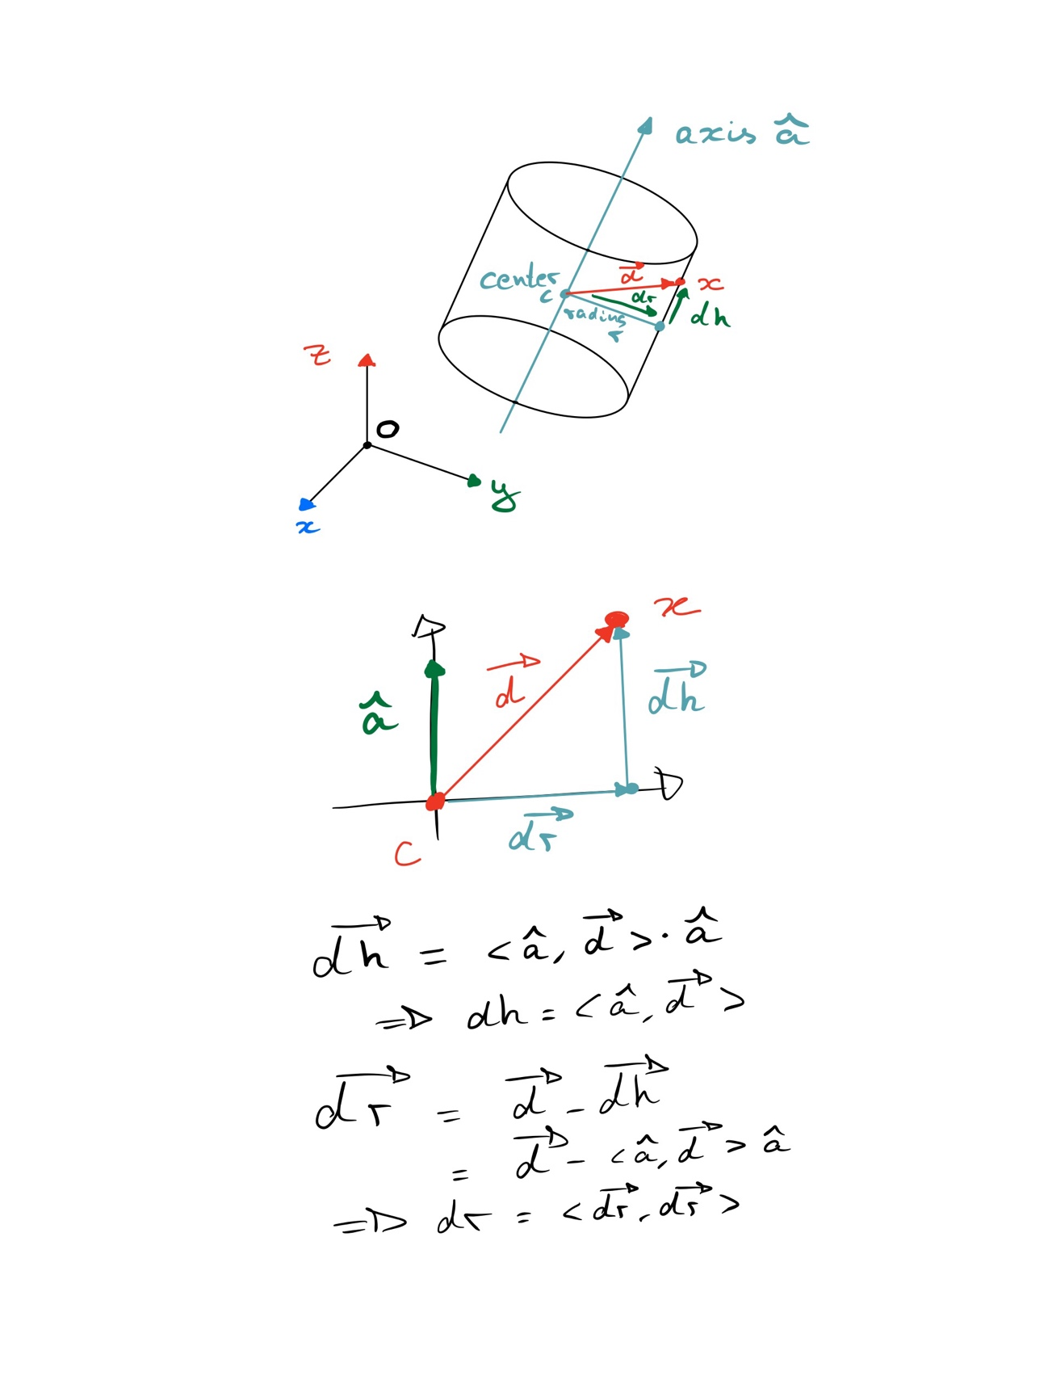

A point x is on the infinite cylinder if it’s radial distance with the axis is such that :

For a finite cylinder, we still need to verify that the height distance from center is less than h/2 :

This leads to the following system of equation to determine if a point x is on the cylinder of height h :

Now let’s consider the ray-cylinder intersection problem. The ray equation is as follow :

To search for ray-cylinder intersection we first try to find a t such that the point on the ray will be solution of the equation 1 :

If there are points satisfying this equation, we pass to the second test, otherwhise there cannot be a cylinder-ray intersection.

The second test consists of looking if one of the potential points find in the previous step, has an height distance to center smaller than h/2. If yes, we found the one, otherwhise there cannot be an intersection.