Part A

Question 1
[Partner 1 and Partner 2 do jointly – 3.0 marks]
Clearly identify who is partner 1 and who is partner 2, underlining the first letter of your family name and the last digit of your student number.
From the data given, prepare an air consumption rate load profile graph for a typical 30minute period. The only consumption figure that need be considered as a peak is that caused by the forge’s operation. Sample calculations, showing how the figures used to generate the graph were obtained, must be provided.

Solution
Forge:
Mass flow rate = (density)*(Velocity)*(Cross-sectional area) (1)
From the ideal gas formula,
P=ρRT
Here, P = 590 + 101.325 = 691.325 kPa T = T_{amb} = 25⁰C = 298K
R = 0.287 kJ/(kg.K)
- ρ= P =8.08 kg / m³
RT
Area in-stroke = π (d²−d²)= π (0.35²−0.08²)=0.0911 m²
4 1 2 4

Area out-stroke = π (d2 )= π ( 0.352 )=0.096 m2
4 ¹ 4
6∗0.665
Velocity (in/out stroke) = 60 = 0.066
Putting all values in equation (1), we get, Mass flow rate (in-stroke) = 0.049 kg/s Mass flow rate (out-stroke) = 0.05158 kg/s Total air consumption by cylinder,
m’ = 0.049 + 0.05158 = 0.101 kg/s = 6.06 kg/min
Load factor = 20%
For other tools used in the factory, we will use the same equations that we will use the ideal gas law with flow rates,

P_{f} V´ =m´
RTamb

Here,
T amb=298 K
Pf =101.325 kPa
R = 0.287 kJ/(kg. K)
V´ =volume flowrate
m´ =mass flow rate Also, X = 9 and Y = 4 Fettling shop
- Grinders
Volume flow rate = 0.0265 m³/s Mass flow rate = 0.031 kg/s
For 8 grinders = 0.248kg/s = 14.88 kg/min
In our load profile graph, we will assume that only 1 grinder works at a time and not all of them simultaneously.
Load factor = 50%
- Chippers
Volume flow rate = 0.01 m³/s Mass flow rate = 0.0118 kg/s
For 5 chippers = 0.059kg/s = 3.54 kg/min Load factor = 50%
- Hoists
Volume flow rate = 0.02 m³/s Mass flow rate = 0.0237 kg/s
For 2 hoists = 0.047kg/s = 2.82 kg/min Load factor = 10%

Machine Shop
Volume flow rate = 0.03m³/s Mass flow rate = 0.0355 kg/s Load factor = 25%
Overall Leakage
Volume flow rate = 0.03m³/s Mass flow rate = 0.0355 kg/s
Assembly Shop
- Small screw drivers
Volume flow rate = 0.00375 m³/s Mass flow rate = 0.0044427 kg/s
For 20 small screwdrivers = 0.0888kg/s = 5.328 kg/min Load factor = 20%
- Nut Setters
Volume flow rate = 0.028 m³/s Mass flow rate = 0.033 kg/s
For 3 nut setters = 0.099kg/s = 5.94 kg/min Load factor = 25%
- Steel drills
Volume flow rate = 0.016 m³/s Mass flow rate = 0.0189 kg/s
For 3 steel drills = 0.0567kg/s = 3.402 kg/min Load factor = 25%
Paint Shop
- Polishers
Volume flow rate = 0.007 m³/s Mass flow rate = 0.00829 kg/s
For 4 polishers = 0.033kg/s = 1.98 kg/min Load factor = 25%
- Spray Painting Guns
Volume flow rate = 0.003 m³/s Mass flow rate = 0.00355 kg/s
For 4 spray painting guns = 0.0142kg/s = 0.852 kg/min Load factor = 50%
- Spray Paint Masks
Volume flow rate = 0.004 m³/s Mass flow rate = 0.00474 kg/s
For 3 steel drills = 0.0189kg/s = 1.134 kg/min Load factor = 50%

Electroplating Shop
Air Consumption rate(kg/min)
Volume flow rate = 0.00075m³/s Mass flow rate = 0.000737 kg/s Load factor = 100% (Assuming)
Packaging Shop
- Wood borer
Volume flow rate = 0.016 m³/s
Mass flow rate = 0.0189 kg/s = 1.134 kg/min Load factor = 25%
- Large screw-driver
Volume flow rate = 0.01 m³/s
Mass flow rate = 0.0118 kg/s = 0.708 kg/min Load factor = 10%
- Hoist
Volume flow rate = 0.02 m³/s
Mass flow rate = 0.024 kg/s = 1.44 kg/min Load factor = 10%

Load Factor Profile for all tools
Load factor profile
forge overall leakage 8 grinders 5 chippers
- hoists Machine shop 20 small screwdrivers 3 nut setters
- steel drills 4 polishers 4 spray paint guns 4 spray paint masks Electroplating shop 1 wood borer 1 large screw driver 1 hoist
7
6
5
4
3
2
1
0
1 2 3 4 5 6 7 8 9 10 11 12 13 14 15 16 17 18 19 20 21 22 23 24 25 26 27 28 29 30
Time elapsed (min)

Load factor profile with forge peaks only
load profile for forge
7
6
5
4
3
2
1
0
1 2 3 4 5 6 7 8 9 10 11 12 13 14 15 16 17 18 19 20 21
Time elapsed (min)

forge
Air consumption rate (kg/min)

Question 2
[Partner 1 and Partner 2 do jointly – 3.0 marks]

  - Determine the minimum capacity compressor that can cope assuming a storage receiver will be used. Clearly explain your reasoning including appropriate references to your graph in Question 1. Express your answer in terms of required free air delivery capability.

Solution
In the factory, there is a range of air consumption rates depending on the number of appliances used. Let the minimum capacity be the value of the least air consumption rate in the factory while considering the forge peak. Similarly, let maximum capacity be the highest air consumption occurring at a certain in the factory.
For minimum capacity compressor, the factory will operate at the least air consumption rate possible. This is when the load factors of different tools are considered and only one type of tool is operated at a single time. For example, in the paint shop, there are 12 tools that need compressed air. However, there are only 3 distinct tools. If we assume that at a time of minimu
capacity, a worker only works with a single tool of a certain type and that all types of tools are used, then this will be the least air consumption rate occurring at a time.
With the help of excel, we have calculated the minimum capacity as shown below,

Hence, minimum capacity of compressor is:
m’ _{minimum} = 7.0458 kg/m³.
In the same way, we calculated the highest flow rate and the maximum required capacity of capacity.
m’ _{maximum} = 18.798 kg/m³
If the air receiver is considered, the compressor should operate at the mean air flow of the two limits.

7.0458+18.798
m’ = 2
= 12.92 kg/m³

Required FAD,
FAD=12.92∗0.287∗298
101.325
= 10.9 m³/min

  - 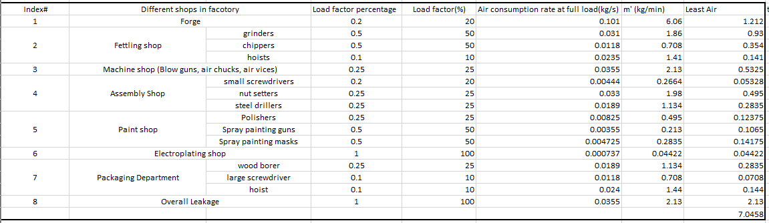From the sample table of compressors provided at the e-reserve address given in Chapter 2 Appendix 2A, select a compressor that will satisfy (a) allowing for 4% possible future decay in free air delivery capability as the compressor wears. The normal working pressure required from the compressor is 690 kPa.g. The factory manager states that no future extra tools, or increase in load factor need be considered. Discuss the reasons for your choice including any advantages and disadvantages and any warning you think you should give the factory manager

about the capacity of the machine you have chosen in compliance with his/her aforesaid statements.

Solution
For our required air flow demand and free air delivery requirement, we have chosen DR2 two stage compressor with an FAD of 11.1 m³/min and an air flow of 13.15 kg/min when new and 12.64 kg/min after its free air delivery is decreased by 4% due to wear.
We have chosen the compressor because it has small power input and air volume requirement compared to other compressors. Other than this, it works perfectly at our desired pressure (690 kPa or 100 psi). It also has an air coolant installed in it which further removes additional costs of installation.
One disadvantage is that at times when compressor capacity exceeds demand, the factory manager should make sure that the compressor operating time is reduced so that increased air pressure in the receiver does not cause a back flow inside the compressor.
  - Calculate the volumetric efficiency of the compressor you have chosen and comment on what other efficiency figure it would be useful to have from the maker in order to compare his product to others.

Solution

- Volumetric efficiency =
11.1
14.6 = 76%

Other efficiency figures include small weight, less volume and eligible normal working pressure (690 kPa).

Question 3
[Partner 1 and Partner 2 do (a) jointly – 1.0 mark] [Partner 1 and Partner 2 do (b) jointly – 3.0 marks]

- Determine what volume receiver is necessary to cope with the peak caused by the forge. Carry out this volume determination for the compressor you have chosen in 2(b). As a preliminary to this, recall the statement above that the pressure in the receiver should not fall below 620 kPa, and carefully consider what the compressor might be doing when the forge peak commences. Clearly explain the reasoning you have used in this volume determination, including appropriate references to the graph you prepared in Question 1. This determination of the necessary receiver volume is to be done for:
  - When the compressor is new

Solution
Volume of receiver is given by:

Here,
V = Volume of Reciever

V = t*C*Pa/ (P₁ – P₂)

t = time taken for pressure to decrease from upper limit to lower limit. Pa = Atmospheric pressure
P₁ = Upper limit of receiver discharge pressure P₂ = Lower limit of receiver discharge pressure C = free air needed

Considering, maximum required capacity of compressor (m’ _{maximum} = 18.798 kg/m³), we have:

18.798∗0.287∗298
C = 101.325
= 15.87 m³/min

Pa = 101.325kPa P₁ = 790 kPa
P₂ = 620 kPa
Note that only during the forging process, the air flow consumption is large enough to decrease the pressure from the upper limit to lower limit. The other tools either operate at the lower limit or operate at free air. Hence, t should only be calculated for forging process.
From the given data, the forging process repeats 6 times in minute. Thus,
t = 1/6 = 0.16667 min = 10 seconds

0.1667∗15.87∗101.325
- Volume of receiver = 790−620

= 1.577 m³.

  - When its delivery capability has decayed by 4%

If the delivery capacitor decreases by 4% and the air consumption rate remains constant, then volume of air receiver should increase by 4%. Hence, volume of receiver = 1.64 m³
.

- Consider now the receiver’s ability to prevent the compressor’s stop/start system from cycling too often. We are assuming for the purposes of this question that simple on/off motor control is being used – (another possibility is to “unload” the compressor by holding the suction valve open so the compressor ceases to compress the air and hence ceases to pump it through to the receiver). Large currents flow during motor start up and hence too frequent starting can lead to motor burn out so it is particularly important if the method of motor on/off control is being used, to ensure that start-ups are not too frequent.
  - For a fixed size of receiver, comment on what would happen to the length of time between compressor starts and stops as the compressor’s volumetric efficiency decays due to wear

Solution

With the decrease in volumetric efficiency, the air flow supplied by compressor(m’) will reduce. Thus, for the same volume of compressor, on-time will increase, and off-time will decrease.

  - Using the larger of the values of volume determined in (a) as the fixed size of receiver, determine if the receiver has sufficient capacity to ensure that the number of compressor starts in an hour is no more than 10 when the compressor is new. As part of this aspect of receiver volume determination: calculate the compressor’s on time span and off time span. Initially you will find it helpful to consider an appropriate type of mean air demand with the forge peaks smoothed out, and then consider behaviour with the forge peaks present. Draw a graph of receiver pressure versus time for 30 minutes for the compressor in the as new state, starting with the pressure at 690 kPa.g. and the compressor just restarted.

Solution
During the off time of compressor, the air receiver pressure drops from higher limit to lower limit. This was calculated in the previous question and is equal to,
T_{off-time} = 10 seconds.

For on-time, we will use,

m
Ton-time = m'

m’ = air flow discharge from compressor = 13.15 kg/min

m = mass of air delivered by compressor as it raises the temperature of air from 620 to 790 kPa before it turns off again.
For m, we will use,
m = mass at upper limit – mass at lower limit.
Using ideal gas law, P = ρ∗R∗T and m = ρV , we calculated the masses at these limits. m = 14.665 – 11.45 = 3.2124 kg.
3.214

- Ton-time =
13.15 = 0.244min = 14.64 seconds

Total time = 10 + 14 = 24 seconds
No. of times compressor starts in a minute = 3 (14.64 + 10 + 14.64 + 10 + 14.64 = 62 seconds) Graph for receiver pressure vs time for 30 minutes or 1800 seconds
Reciever Pressure vs TIme
900
800
700
600
500
400
300
200
100
0
0
200 400 600 800 1000 1200 1400 1600 1800 2000
Time (seconds)
Reciever Pressure in KPa..g

Question 4
[Partner 1 and 2 do jointly - 2 marks]

- From the sample table of after-coolers provided at the e-reserve address given in the Chapter 2 Appendix 2B, select an after-cooler to match the chosen compressor, and confirm that it is suitable and safe to use under the conditions you believe it has to.
For this after cooler, if water enters it at 15°C, at what

temperature will the air leave it?

Solution

From Appendix 2B, we select Type HD 11 after-cooler with an FAD of 11 m ³, if water enters at 15⁰C, it will leave at 15 + 10 = 25⁰C.
- Assuming the large electric motor driving the compressor is 93% efficient determine approximately what percentage of the electroplating hot water demand can be met by heat scavenging.

Solution
We know that 80% of the electrical energy can be converted into heat if the motor is ideal (100% efficient). Thus, approximate percentage of electroplating hot water demand met by heat scavenging = 80% of 93% = 74.4%.

Question 5
[Partner 1 and Partner 2 do (a) jointly – 1.0 mark]
[Partner 1 to do (b) (i) – 2 marks, Partner 2 to do (b) (ii) – 2 marks]

Before doing detailed calculations for this question, confirm with the lecturer or tutor that your choice of compressor and receiver size are acceptable.
From the sample table of safety valves provided at the e-reserve address given in Chapter 3 Appendix 3A select a safety valve suitable for protecting the receiver from the excessive pressures that could occur if the compressor’s pressure controls failed to deactivate the compressor appropriately. Fully identify the valve and its pressure setting, and give reasons for your selection.
Relevant Clauses from AS1210 2010 include: Cl 3.2.1.1; Cl 8.2.1; 8.4.3; 8.4.5; 8.6.1;
and 8.7.1.

Solution
In question 3, we had set the upper limit of air receiver at 790 kPa. Now, the air receiver pressure should not operate at a value greater than 10% of this upper limit for avoiding destructive back pressure. For safety purposes and to keep the pressure close to the upper limit, we will use,
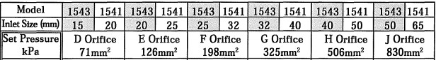

With an E orifice 126mm².
- In the event of a fire occurring near the receiver the heat input to the vessel would cause the pressure of the air in the vessel to rise. If the compressor has also failed to turn off, the

discharge capacity of the valve chosen in (a) may be inadequate to deal with this situation.

(b)(i) For the situation of a ‘mild’ fire, where the design strength of the vessel has not deteriorated, determine: the required rate of discharge (in kg/sec) of a pressure activated relief valve to deal with this situation; the pressure at which this flow may occur; the pressure setting at which this valve is to open, and from the sample table of possible safety valves provided at the e-reserve address given in Chapter 3 Appendix 3A, select a suitable safety valve to deal with the aforementioned flow.
[Relevant clauses for (b) (i) from AS1210-2010 include 8.2.2; 8.7.3; 8.6.2.1; 8.6.2.2 and 8.6.2.4(c) and eqn 8.6.2.3(2).]

Assume the thickness of the corroded vessel is 6 to 8 mm for the purposes of this question. This assumption may require revision when more detailed vessel design is carried out in part B. Assume the minimum operating temperature T_{o} is 15oC (288K). The vessel will be made of low carbon manganese steel boiler quality plate manufactured in accordance with AS 1548 PT 460 NR (L0) [See Table B1(B) in AS1210 2010]

Solution

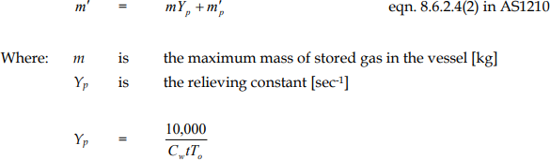

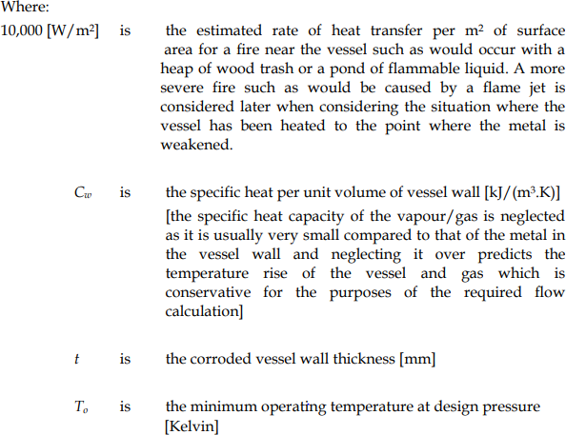

Here,
m = mass of air at 790 kPa
ρ= P = 790 =9.24 kg/ m³
R∗T 0.287∗298

- m = 9.24*1.58 = 14.6kg.
t = 8mm = 0.008m T₀ = 273 + 15 = 288K
m’_{p} =mass flow rate of compressor = 13.15 kg/min = 0.219 kg/s For low carbon manganese steel, C_{w} = 565 J/(kg.K)
10000
Yp = 519∗0.008∗288 = 7.68
  - m’ = (7.68*14.6)/60 + 0.219 = 2.192 kg/s

Using the formula,
We c]

We know from our

Putting this value in ideal gas law for T = 593 K (300⁰C), m’ = 2.192 and R = 0.287 we get, P = 134.075 kPa.
Now, comparing it with our upper pressure limit, this value is quite small. So our choice of safety valve of 800kPa holds true for this case.

We know from our analysis of compressor that for DR2, FAD = 11.1m³/min Using Ideal gas law,
Pressure at m’ = 2.192 kg/s = 1014.11 kPa.

As our air reciever can not operate above 790kPa, our safety valve should open at 790-850 kPa .

We will now review our choice of safety valve to accout for the mild fire. From Appendix 3A, we have choosen,

With orifice G with large cross-sectional area for high air flow rates.

For normal operation, we will stick to our previous selection made in part (a) : 800 kPa with E orifice.

(b)(ii) In the situation where the fire has caused the temperature of the vessel to be raised sufficiently to cause the design strength of the metal to be weakened, a pressure activated relief device may not provide adequate protection. Clause 8.6.2.4(b), addresses this issue, giving a method for determining the discharge capacity of temperature activated relief devices. Determine the required rate of discharge (in kg/sec) for such a device for your air receiver using this method. Also determine the value of the free air flow capacity that you would look for in a catalogue of such devices, were one provided, where such data was given, as is usually the case, for flows at 15oC upstream temperature.
Assume, for the purposes of this question, that the thickness of the corroded vessel is 6 to 8 mm and that there may be some flanges whose thickness is in the range 12 to 42 mm. These assumptions may require revision when more detailed

vessel design is carried out in part B. Assume the minimum operating temperature To is 15oC (288K). Assume the design temperature T is 100oC (373K). The vessel will be made to Class 2A of low carbon manganese steel boiler quality plate manufactured in accordance with AS 1548 PT 460 NR (L0) grade. [See Table B1(B) in AS1210 2010 ]

Solution

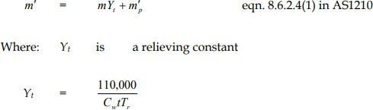

Here m’_{p} = 0.219 kg/s m = 14.6 kg
At design temperature, T = 100⁰C, tensile strength = 277 MPa from AS1548 PT 460 NR (L0) (Z/1.21) * 277 = 228.92 MPa (Z = 1)
At 228.82 MPa Tr = relieving temperature = 250⁰C = 523 K t = 8mm
C_{w} = 0.519 kJ/(kg.K)
110000

  - Y_{t} =

Now,
0.519∗8∗523 = 50.656

m’ = (50.656 x 14.6)/60 + 0.219 = 12.54 kJ/kg
For free air flow capacity,
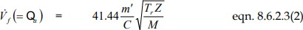

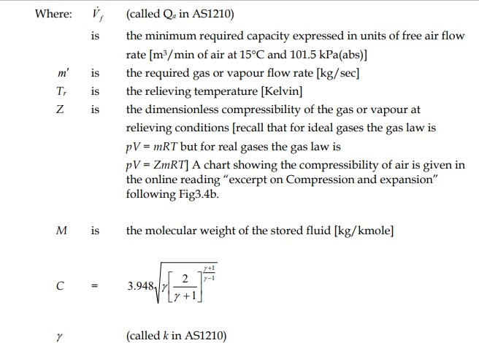

Calculating these values we get, C = 2.7
Z = 1
T_{r} = 523K
m’ = 12.54 kg/s
  - Free air flow capacity = V_{f} = 817.9 m³/min

Question 6
Partner 1 do (a) – 1.0 mark, Partner 2 do (b)
- 1.0 mark.
X and Y are defined below the next diagram.

If X + Y = odd number then Partner 1 and Partner 2 do (c) together – 4 marks and skip (d).
If X+Y= even number then Partner 1 and Partner 2 do (d) together – 4 marks and skip (c)

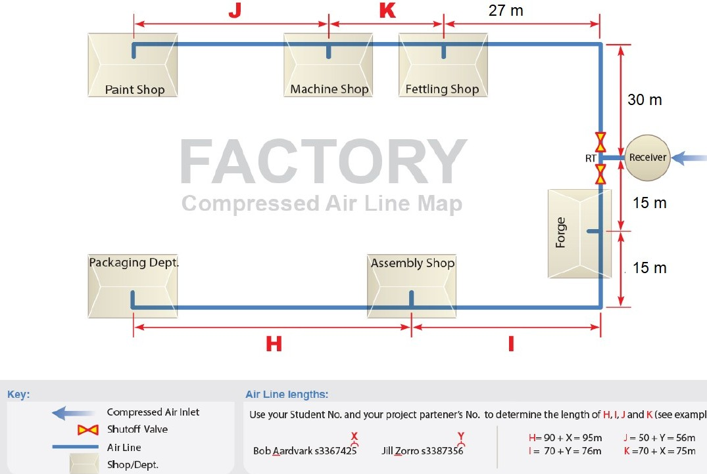The route of the main compressed air line is shown on the next page.
“
.
/
.
“
.
.“
“
.,
.
.
,
“
.
/
“
.
‘ TSJ
  - Transfer the sketch given on the next page to your report and show on it appropriate drain positions. On a larger scale sketch show the arrangement of piping and fittings you propose using at a typical drain.

Solution

Here X=9 Y = 4,
H = 90 + X = 99m I = 70 + Y = 74m J = 50 + Y = 54m K = 70 + X = 79m

On the map,

. represents a superior drain tee.
/ represents a better drain tee.
“ represents a threaded steel joint.
‘ represents a welded steel joint.
Note that electroplating shop does not require compressed air. Instead, it works on hot water with 2.7 m³/hr entering at 15⁰C and operating at 60⁰C. Using drains, we can condense the water in the pipes before it enters the tools and direct it to the electroplating shop(not shown). In this way, we can minimize the wastage of water. However, this means that at the end of drainage we need a water pump to increase the flow rate of water before It enter the electroplating shop.

Position and Arrangement of Drains

Drains are best suited for pipe joints and bends where flow direction changes and water separates from compressed air. We will use Superior Drain tee at bends. In the Factory map above, these bends occur before the entry of each shop and at the division of the pipes from the main branch.

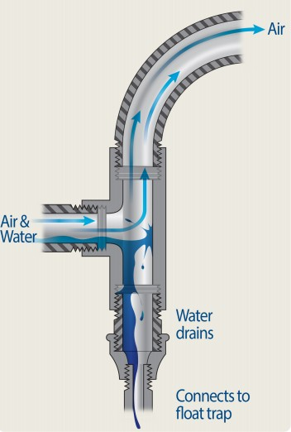
We will use threaded steel joints at the entry of each shop and the point of division of the two side branches. For the water condensate that was not precipitated at bends, we will use a better drain tee shown below.
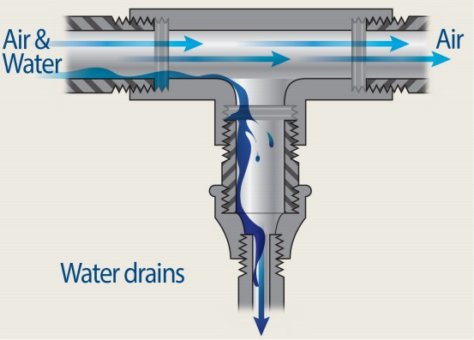
Figure 1 better Drain Tee

Noting the design pressure determined in Question 5, and
b)

b)

b)

b)

Figure 2Superior Drain Tee

referring to the data on some sample steel pipe sizes and associated pressure ratings provided at the e-reserve address given in the Chapter 4 Appendix 4

establish a suitable “class” of pipe, and state the range of sizes for which threaded fittings may be used, above which welded fittings must be used.

Solution
At design temperature, T = 100⁰C, tensile strength = 277 MPa from AS1548 PT 460 NR (L0) and at times of fire, the design pressure was taken as 1014,6kPa for receiver.
For normal operations, design pressure ranges from 620 to 790 kpa,g with a compressor working at 690 kpa,g. The pressure should not fall below 620 kPa.
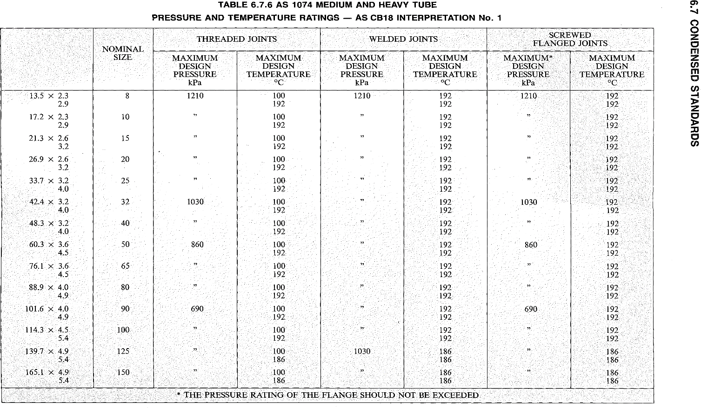

• For a forge inlet and receiver outlet, we will use welded joints as the maximum design pressure can vary from 690 kpa,a (normal operation) to 1200 kpa,a (times of fire).
• For fettling shop and machine shop, the pipe lengths range up to 146 cm. For assembly shop, the maximum pipe length is 104cm. As design pressure in this case is 620 kpa and threaded joints offer 690 kpa, we will use threaded joints for a pipe length of 114.1 m for assembly shop and threaded joints with a pipe length of 165.1 m for fettling shop and machine shop.
• For packaging department and paint shop at the end of factory, we will use welded joints. Lengths of pipe for these shops exceed the list allocated in the table. However, for reference, we will use pipe length of 210 m.

The objective in questions (c) and (d) below is to determine appropriate internal diameters of the various sections of the main pipe. Leakage in each workshop is estimated at 5.0 litres/s free air, i.e. 30 litres/s overall.
Two commonly accepted guides for compressed air piping in factories are:
- The velocity in the main pipe should not exceed 6m/sec to avoid entrainment of water;
- The frictional pressure drop between the compressor plant and the furthermost point of use should not exceed
about 30kPa, (or alternatively expressed as ∼ 5% of the
applied pressure.) For this assignment you are to size the
pipe so that when the pressure at the branches of the receiver outlet T piece “RT” is 620 kPa (gauge), the frictional pressure drops between “RT” and the branches to packaging and paint shops are no more than 20kPa. (The remaining 10kPa of allowable pressure drop is allocated to occur within the branch lines in the various workshops). Making the pipes bigger than need be increases capital cost; making them too small means that to give the required pressure downstream at the tools, a higher upstream pressure will be necessary to compensate for the frictional losses, and this will in turn mean increase in compressor running cost. The advice at (2) represents a compromise between these two issues.

Within workshops the pipes usually terminate at chest height with an isolating valve, combined filter/water/separator/ pressure regulator/pressure gauge unit and then a hose connection fitting. If the driven machine requires lubricant to be added to the air, a drip feed lubricator is also fitted.

As X+Y = 9 + 4 = 13, we will do part (c).

- Determine the minimum acceptable nominal bore pipe sizes for the three sections of main pipe between the relevant outlet of the tee “RT” and the branch to the packaging department. The three sections are indicated schematically on the next page. Sample calculations must be given.

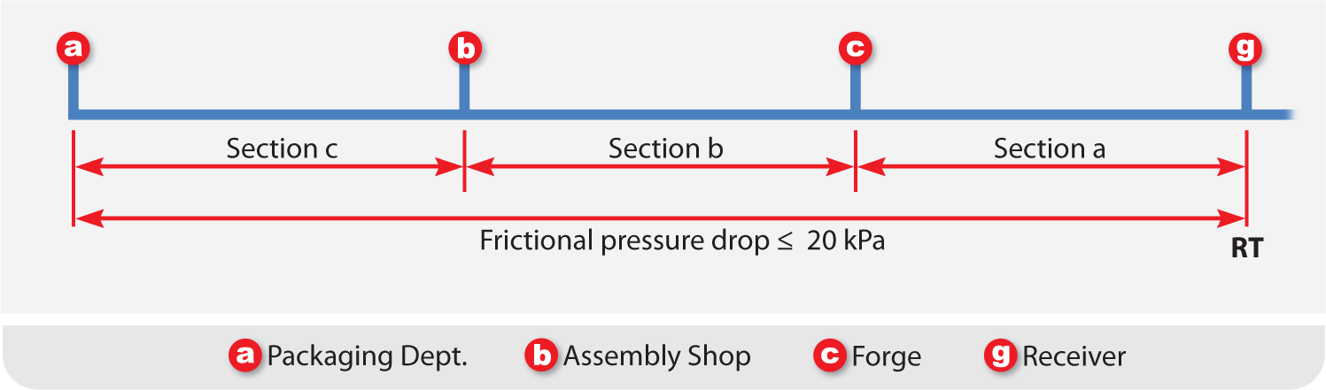
Figure 2. Main Pipe Run from Receiver Tee (RT) to Packaging Dept. © RMIT University.

Solution
Length of pipe from receiver to forge: 15 m
Length of pipe from receiver to assembly shop: 89 m
Length of pipe from receiver to packaging department: 203 m. Leakage in each workshop = 5 liters/s of free air = 0.005 m/s Maximum frictional pressure drop = 20 kPa.
Maximum velocity of main pipe = 5 m/s
One thing to be noted is that we are not concerned with what happens inside the workshops. Therefore, the frictional losses due to joints, isolating valves, combined filter/water/separator/pressure regulator/ pressure gauge unit and then a hose are not of our concern.
Considering the design temperature T = 100⁰C as our operating temperature and 721.325kpa,g or 7.21325 bara as design pressure, we have
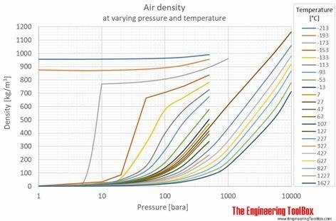

From the graph for temperature greater than 0⁰C and pressure less than 1MPa, density is independent of pressure. From air property tables given at the end of Fundamentals of Fluid Mechanics, 6th Edition (2009, Wiley) by Bruce R. Munson, Donald F. Young, Theodore H. Okiishi, Wade W. Huebsch, we have
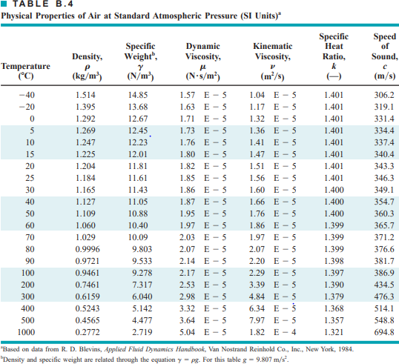

For dynamic viscosity,
ρ=0.9461kg / m³

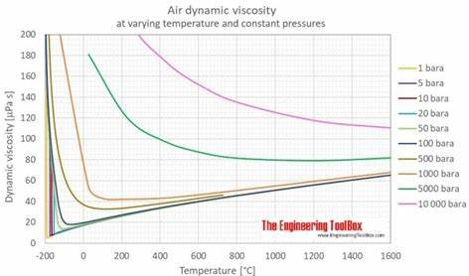
For temperature T = 100⁰C and P = 7.21325 bara, dynamic viscosity is equal to,
Now at P = 620+101.325 = 721.325 kPa = 0.721325 MPa (abs.), dynamic viscosity of dry air at 373K is calculated by interpolating between 300K and 400K and is equal to,
η=21.7 μPa. s=¿ 2.17 x 10⁻⁵ N.s/m².

ρVD
- Reynold’s number = μ

= 261.59 x 10³ D…….(1)

We will calculate bore diameter from the formula,

Here, l = 203m. Putting the values of all variables, we get
D = 0.17285 f (2)
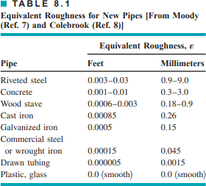
For surface roughness, we select cast iron for better real-world approximation.
- ε =0. 26 mm=0. 00026 m .

Now from Moody chart,

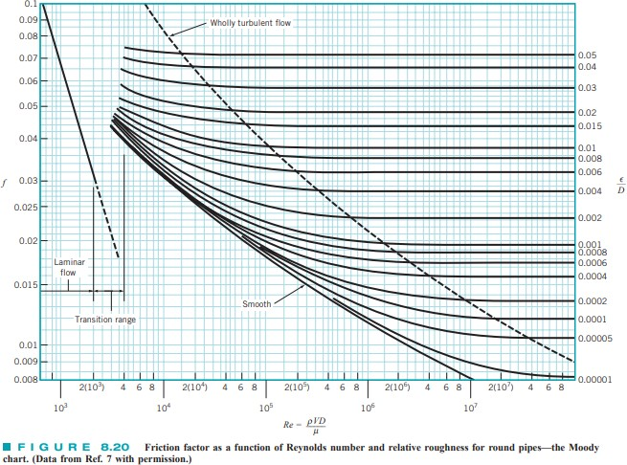
After multiple iterations using equation (1), (2) and Moody Chart, we get:
D = 0.0106m = 1.06cm
Minimum bore diameter = 0.0106m

