Student Number:203603082

Student Name: Osama Mohammad Najeeb Abualfeilat

Creating a data frame
month=c(1,2,3,4,5,6,7,8,9,10,11,12,1,2,3,4,5,6,7,8,9,10,11,12,1,2,3,4,5,6,7,8,9,10,11,12,1,2,3,4,5,6,7,8,9,10,11,12,1,2,3,4,5,6,7,8,9,10,11,12,1,2,3,4,5,6,7,8,9,10,11,12,1,2,3,4,5,6,7,8,9,10,11,12,1,2,3,4,5,6,7,8,9,10,11,12,1,2,3,4,5,6,7,8,9,10,11,12,1,2,3,4,5,6,7,8,9,10,11,12,1,2,3,4,5,6,7,8,9,10,11,12,1,2,3,4,5,6,7,8,9,10,11,12,1,2,3,4,5,6,7,8,9,10,11,12)
yr=c(2008,2008,2008,2008,2008,2008,2008,2008,2008,2008,2008,2008,2009,2009,2009,2009,2009,2009,2009,2009,2009,2009,2009,2009,2010,2010,2010,2010,2010,2010,2010,2010,2010,2010,2010,2010,2011,2011,2011,2011,2011,2011,2011,2011,2011,2011,2011,2011,2012,2012,2012,2012,2012,2012,2012,2012,2012,2012,2012,2012,2013,2013,2013,2013,2013,2013,2013,2013,2013,2013,2013,2013,2014,2014,2014,2014,2014,2014,2014,2014,2014,2014,2014,2014,2015,2015,2015,2015,2015,2015,2015,2015,2015,2015,2015,2015,2016,2016,2016,2016,2016,2016,2016,2016,2016,2016,2016,2016,2017,2017,2017,2017,2017,2017,2017,2017,2017,2017,2017,2017,2018,2018,2018,2018,2018,2018,2018,2018,2018,2018,2018,2018,2019,2019,2019,2019,2019,2019,2019,2019,2019,2019,2019,2019,2020,2020,2020,2020,2020,2020,2020,2020,2020,2020,2020,2020)
var1=c(26.50,
33.40,
32.00,
47.00,
28.99,
38.95,
67.00,
31.99,
38.40,
43.90,
26.98,
30.30,
36.97,
32.89,
44.90,
49.48,
44.67,
36.01,
51.23,
18.26,
21.54,
23.89,
24.39,
29.34,
50.71,
18.96,
14.24,
23.89,
24.84,
29.50,
27.25,
21.48,
33.34,
34.19,
17.64,
24.05,
25.23,
27.51,
74.73,
24.46,
26.32,
23.58,
21.98,
31.31,
24.57,
17.07,
26.56,
22.04,
22.89,
17.32,
27.20,
36.93,
26.41,
41.14,
17.05,
31.94,
17.89,
20.35,
25.55,
31.60,
31.00,
14.70,
16.80,
20.00,
34.47,
47.80,
19.46,
26.62,
31.90,
36.51,
42.81,
51.31,
59.01,
65.11,
39.61,
44.08,
48.33,
47.66,
18.99,
24.05,
22.36,
30.00,
30.45,
36.81,
27.53,
21.24,
21.54,
24.04,
27.61,
32.56,
27.51,
36.75,
54.90,
74.70,
87.60,
43.90,
46.00,
46.60,
90.50,
40.30,
18.50,
25.39,
31.25,
31.40,
34.30,
27.80,
22.89,
23.15,
29.15,
23.27,
41.23,
36.60,
30.35,
17.64,
21.08,
23.85,
48.00,
26.61,
24.72,
30.31,
26.67,
28.76,
30.64,
46.43,
76.02,
79.97,
38.12,
31.10,
15.69,
17.54,
19.29,
23.84,
20.01,
27.70,
25.10,
18.11,
22.52,
30.55,
21.88,
16.53,
27.37,
21.89,
27.29,
56.73,
19.90,
21.70,
26.20,
24.99,
22.50,
20.90,
28.40,
29.40,
32.50,
33.80,
50.50,
41.00
)
var2=c(140.00,
225.00,
225.00,
210.00,
150.00,
200.00,
310.00,
170.00,
193.00,
193.00,
175.00,
240.00,
205.00,
205.00,
275.00,
275.00,
275.00,
200.00,
255.00,
115.00,
170.00,
175.00,
180.00,
200.00,
345.00,
120.00,
55.00,
180.00,
163.00,
168.00,
200.00,
132.00,
253.00,
253.00,
132.00,
163.00,
168.00,
202.00,
450.00,
230.00,
175.00,
175.00,
120.00,
230.00,
150.00,
110.00,
190.00,
170.00,
155.00,
107.00,
200.00,
210.00,
150.00,
240.00,
119.00,
220.00,
106.00,
135.00,
146.00,
205.00,
210.00,
92.00,
140.00,
148.00,
227.00,
240.00,
120.00,
190.00,
195.00,
210.00,
225.00,
300.00,
290.00,
230.00,
220.00,
275.00,
215.00,
300.00,
113.00,
154.00,
145.00,
210.00,
161.00,
200.00,
173.00,
125.00,
125.00,
153.00,
200.00,
210.00,
170.00,
185.00,
221.00,
275.00,
302.00,
190.00,
185.00,
215.00,
302.00,
215.00,
126.00,
155.00,
222.00,
170.00,
170.00,
170.00,
170.00,
150.00,
215.00,
150.00,
250.00,
190.00,
185.00,
132.00,
132.00,
150.00,
253.00,
150.00,
175.00,
200.00,
195.00,
205.00,
185.00,
217.00,
300.00,
300.00,
170.00,
185.00,
100.00,
100.00,
124.00,
137.00,
137.00,
165.00,
165.00,
120.00,
133.00,
210.00,
140.00,
142.00,
194.00,
127.00,
150.00,
230.00,
115.00,
115.00,
150.00,
115.00,
115.00,
115.00,
160.00,
160.00,
168.00,
168.00,
236.00,
201.00
)
var3=c(13.20,
17.20,
17.20,
18.00,
16.40,
18.50,
23.70,
16.60,
16.60,
18.50,
17.50,
17.50,
18.50,
17.50,
18.50,
18.50,
19.00,
18.00,
30.00,
14.30,
15.00,
16.60,
17.00,
16.80,
19.10,
13.20,
10.30,
17.00,
15.90,
16.00,
17.00,
16.00,
17.00,
17.00,
12.50,
15.90,
16.00,
17.00,
19.00,
26.00,
32.00,
32.00,
22.00,
25.00,
20.00,
12.70,
15.70,
15.00,
16.00,
13.20,
19.00,
21.00,
26.00,
26.00,
20.00,
25.10,
11.90,
17.10,
15.30,
21.10,
20.00,
11.90,
14.50,
17.20,
18.50,
18.40,
19.00,
20.00,
20.50,
18.50,
19.80,
19.80,
22.50,
25.40,
17.20,
20.00,
19.00,
30.00,
13.20,
15.90,
16.30,
19.00,
19.80,
24.30,
19.50,
15.00,
16.00,
16.00,
19.00,
21.00,
20.00,
16.40,
21.10,
23.20,
21.10,
15.90,
14.00,
16.40,
23.20,
19.00,
13.20,
15.90,
18.50,
20.00,
21.00,
19.40,
19.40,
15.20,
18.00,
15.00,
18.50,
17.50,
25.00,
12.50,
16.00,
20.00,
12.00,
15.00,
15.20,
16.80,
18.00,
17.50,
25.00,
17.00,
17.00,
17.00,
18.50,
16.90,
12.10,
12.10,
12.10,
13.10,
13.10,
16.90,
15.90,
13.20,
18.50,
18.50,
14.50,
15.10,
20.90,
15.30,
18.50,
25.40,
14.50,
14.50,
16.40,
13.70,
14.60,
14.50,
15.80,
15.80,
17.90,
17.90,
18.50,
21.10
)
Data=data.frame(month,yr,var1,var2,var3)
Data
## month yr var1 var2 var3
## 1 1 2008 26.50 140 13.2
## 2 2 2008 33.40 225 17.2
## 3 3 2008 32.00 225 17.2
## 4 4 2008 47.00 210 18.0
## 5 5 2008 28.99 150 16.4
## 6 6 2008 38.95 200 18.5
## 7 7 2008 67.00 310 23.7
## 8 8 2008 31.99 170 16.6
## 9 9 2008 38.40 193 16.6
## 10 10 2008 43.90 193 18.5
## 11 11 2008 26.98 175 17.5
## 12 12 2008 30.30 240 17.5
## 13 1 2009 36.97 205 18.5
## 14 2 2009 32.89 205 17.5
## 15 3 2009 44.90 275 18.5
## 16 4 2009 49.48 275 18.5
## 17 5 2009 44.67 275 19.0
## 18 6 2009 36.01 200 18.0
## 19 7 2009 51.23 255 30.0
## 20 8 2009 18.26 115 14.3
## 21 9 2009 21.54 170 15.0
## 22 10 2009 23.89 175 16.6
## 23 11 2009 24.39 180 17.0
## 24 12 2009 29.34 200 16.8
## 25 1 2010 50.71 345 19.1
## 26 2 2010 18.96 120 13.2
## 27 3 2010 14.24 55 10.3
## 28 4 2010 23.89 180 17.0
## 29 5 2010 24.84 163 15.9
## 30 6 2010 29.50 168 16.0
## 31 7 2010 27.25 200 17.0
## 32 8 2010 21.48 132 16.0
## 33 9 2010 33.34 253 17.0
## 34 10 2010 34.19 253 17.0
## 35 11 2010 17.64 132 12.5
## 36 12 2010 24.05 163 15.9
## 37 1 2011 25.23 168 16.0
## 38 2 2011 27.51 202 17.0
## 39 3 2011 74.73 450 19.0
## 40 4 2011 24.46 230 26.0
## 41 5 2011 26.32 175 32.0
## 42 6 2011 23.58 175 32.0
## 43 7 2011 21.98 120 22.0
## 44 8 2011 31.31 230 25.0
## 45 9 2011 24.57 150 20.0
## 46 10 2011 17.07 110 12.7
## 47 11 2011 26.56 190 15.7
## 48 12 2011 22.04 170 15.0
## 49 1 2012 22.89 155 16.0
## 50 2 2012 17.32 107 13.2
## 51 3 2012 27.20 200 19.0
## 52 4 2012 36.93 210 21.0
## 53 5 2012 26.41 150 26.0
## 54 6 2012 41.14 240 26.0
## 55 7 2012 17.05 119 20.0
## 56 8 2012 31.94 220 25.1
## 57 9 2012 17.89 106 11.9
## 58 10 2012 20.35 135 17.1
## 59 11 2012 25.55 146 15.3
## 60 12 2012 31.60 205 21.1
## 61 1 2013 31.00 210 20.0
## 62 2 2013 14.70 92 11.9
## 63 3 2013 16.80 140 14.5
## 64 4 2013 20.00 148 17.2
## 65 5 2013 34.47 227 18.5
## 66 6 2013 47.80 240 18.4
## 67 7 2013 19.46 120 19.0
## 68 8 2013 26.62 190 20.0
## 69 9 2013 31.90 195 20.5
## 70 10 2013 36.51 210 18.5
## 71 11 2013 42.81 225 19.8
## 72 12 2013 51.31 300 19.8
## 73 1 2014 59.01 290 22.5
## 74 2 2014 65.11 230 25.4
## 75 3 2014 39.61 220 17.2
## 76 4 2014 44.08 275 20.0
## 77 5 2014 48.33 215 19.0
## 78 6 2014 47.66 300 30.0
## 79 7 2014 18.99 113 13.2
## 80 8 2014 24.05 154 15.9
## 81 9 2014 22.36 145 16.3
## 82 10 2014 30.00 210 19.0
## 83 11 2014 30.45 161 19.8
## 84 12 2014 36.81 200 24.3
## 85 1 2015 27.53 173 19.5
## 86 2 2015 21.24 125 15.0
## 87 3 2015 21.54 125 16.0
## 88 4 2015 24.04 153 16.0
## 89 5 2015 27.61 200 19.0
## 90 6 2015 32.56 210 21.0
## 91 7 2015 27.51 170 20.0
## 92 8 2015 36.75 185 16.4
## 93 9 2015 54.90 221 21.1
## 94 10 2015 74.70 275 23.2
## 95 11 2015 87.60 302 21.1
## 96 12 2015 43.90 190 15.9
## 97 1 2016 46.00 185 14.0
## 98 2 2016 46.60 215 16.4
## 99 3 2016 90.50 302 23.2
## 100 4 2016 40.30 215 19.0
## 101 5 2016 18.50 126 13.2
## 102 6 2016 25.39 155 15.9
## 103 7 2016 31.25 222 18.5
## 104 8 2016 31.40 170 20.0
## 105 9 2016 34.30 170 21.0
## 106 10 2016 27.80 170 19.4
## 107 11 2016 22.89 170 19.4
## 108 12 2016 23.15 150 15.2
## 109 1 2017 29.15 215 18.0
## 110 2 2017 23.27 150 15.0
## 111 3 2017 41.23 250 18.5
## 112 4 2017 36.60 190 17.5
## 113 5 2017 30.35 185 25.0
## 114 6 2017 17.64 132 12.5
## 115 7 2017 21.08 132 16.0
## 116 8 2017 23.85 150 20.0
## 117 9 2017 48.00 253 12.0
## 118 10 2017 26.61 150 15.0
## 119 11 2017 24.72 175 15.2
## 120 12 2017 30.31 200 16.8
## 121 1 2018 26.67 195 18.0
## 122 2 2018 28.76 205 17.5
## 123 3 2018 30.64 185 25.0
## 124 4 2018 46.43 217 17.0
## 125 5 2018 76.02 300 17.0
## 126 6 2018 79.97 300 17.0
## 127 7 2018 38.12 170 18.5
## 128 8 2018 31.10 185 16.9
## 129 9 2018 15.69 100 12.1
## 130 10 2018 17.54 100 12.1
## 131 11 2018 19.29 124 12.1
## 132 12 2018 23.84 137 13.1
## 133 1 2019 20.01 137 13.1
## 134 2 2019 27.70 165 16.9
## 135 3 2019 25.10 165 15.9
## 136 4 2019 18.11 120 13.2
## 137 5 2019 22.52 133 18.5
## 138 6 2019 30.55 210 18.5
## 139 7 2019 21.88 140 14.5
## 140 8 2019 16.53 142 15.1
## 141 9 2019 27.37 194 20.9
## 142 10 2019 21.89 127 15.3
## 143 11 2019 27.29 150 18.5
## 144 12 2019 56.73 230 25.4
## 145 1 2020 19.90 115 14.5
## 146 2 2020 21.70 115 14.5
## 147 3 2020 26.20 150 16.4
## 148 4 2020 24.99 115 13.7
## 149 5 2020 22.50 115 14.6
## 150 6 2020 20.90 115 14.5
## 151 7 2020 28.40 160 15.8
## 152 8 2020 29.40 160 15.8
## 153 9 2020 32.50 168 17.9
## 154 10 2020 33.80 168 17.9
## 155 11 2020 50.50 236 18.5
## 156 12 2020 41.00 201 21.1

question 1
a
t.test(Data$var2,Data$var3,paired =TRUE)
##
## Paired t-test
##
## data: Data$var2 and Data$var3
## t = 38.248, df = 155, p-value < 2.2e-16
## alternative hypothesis: true difference in means is not equal to 0
## 95 percent confidence interval:
## 159.3202 176.6733
## sample estimates:
## mean of the differences
## 167.9968
b
wilcox.test(Data$var2,Data$var3,conf.int =TRUE, conf.level = 0.95)
##
## Wilcoxon rank sum test with continuity correction
##
## data: Data$var2 and Data$var3
## W = 24336, p-value < 2.2e-16
## alternative hypothesis: true location shift is not equal to 0
## 95 percent confidence interval:
## 153 173
## sample estimates:
## difference in location
## 160

F-test
var.test(Data$var2,Data$var3,conf.level =0.95)
##
## F test to compare two variances
##
## data: Data$var2 and Data$var3
## F = 212.68, num df = 155, denom df = 155, p-value < 2.2e-16
## alternative hypothesis: true ratio of variances is not equal to 1
## 95 percent confidence interval:
## 155.0571 291.7297
## sample estimates:
## ratio of variances
## 212.6846

Fligner test
fligner.test(Data$var2~Data$var3)
##
## Fligner-Killeen test of homogeneity of variances
##
## data: Data$var2 by Data$var3
## Fligner-Killeen:med chi-squared = 63.284, df = 54, p-value = 0.1814

Bartlett Test
#bartlett.test(Data$var2,Data$var3)
- Analysis of Variance
library(tidyverse)
## -- Attaching packages --------------------------------------- tidyverse 1.3.1 --
## v ggplot2 3.3.5 v purrr 0.3.4
## v tibble 3.1.6 v dplyr 1.0.9
## v tidyr 1.2.0 v stringr 1.4.0
## v readr 2.1.2 v forcats 0.5.1
## -- Conflicts ------------------------------------------ tidyverse_conflicts() --
## x dplyr::filter() masks stats::filter()
## x dplyr::lag() masks stats::lag()
library(ggplot2)
Data%>%ggplot(aes(var1))+geom_boxplot(fill="slateblue")+ggtitle("Boxplot for variable 1")+theme_bw()
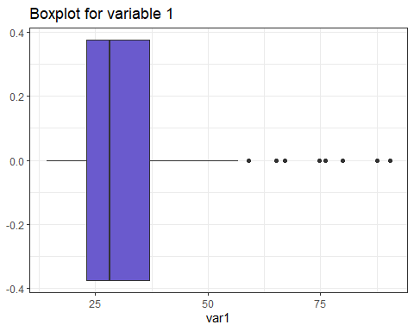
Data%>%ggplot(aes(var2))+geom_boxplot(fill="slateblue")+ggtitle("Boxplot for variable 2")+theme_bw()
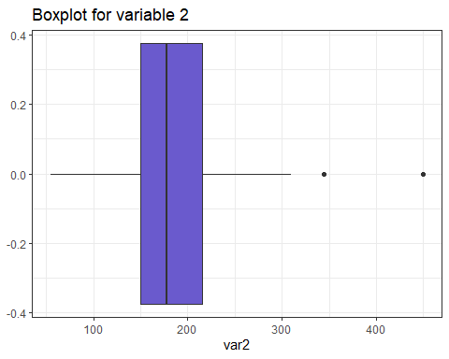
Data%>%ggplot(aes(var3))+geom_boxplot(fill="slateblue")+ggtitle("Boxplot for variable 3")+theme_bw()
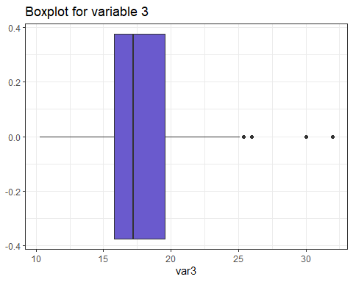 3. Simple linear regression
lm(var3~var1)
##
## Call:
## lm(formula = var3 ~ var1)
##
## Coefficients:
## (Intercept) var1
## 14.226 0.115
summary(lm(var3~var1))
##
## Call:
## lm(formula = var3 ~ var1)
##
## Residuals:
## Min 1Q Median 3Q Max
## -7.7477 -1.8222 -0.7415 1.3637 15.0616
##
## Coefficients:
## Estimate Std. Error t value Pr(>|t|)
## (Intercept) 14.22570 0.70221 20.258 < 2e-16 ***
## var1 0.11504 0.01984 5.798 3.68e-08 ***
## ---
## Signif. codes: 0 '***' 0.001 '**' 0.01 '*' 0.05 '.' 0.1 ' ' 1
##
## Residual standard error: 3.534 on 154 degrees of freedom
## Multiple R-squared: 0.1792, Adjusted R-squared: 0.1738
## F-statistic: 33.62 on 1 and 154 DF, p-value: 3.684e-08
The regression coefficients for our linear model that’s $β_{0},\text{and},β_{1}$ are 14.22570 and 0.11504 respectively the coefficient shows the variation of the dependent variable whether increasing for positive or decreasing for negative value. The t-value represents the models coefficient divided by the standard error. The model had a multiple R-squared of 0.1792 which was the fraction of the variation in the dependent variable that’s Var3 that can be predicted by the predictor variables, from the p-value the independent variables are all statistically significant as the p-value is less than 0.05 the assumed alpha
4. Multiple regression
Data%>%lm(formula=var3~var1+var2)
##
## Call:
## lm(formula = var3 ~ var1 + var2, data = .)
##
## Coefficients:
## (Intercept) var1 var2
## 11.604481 0.003831 0.033468
summary(Data%>%lm(formula=var3~var1+var2))
##
## Call:
## lm(formula = var3 ~ var1 + var2, data = .)
##
## Residuals:
## Min 1Q Median 3Q Max
## -8.2558 -1.9342 -0.8958 1.1682 14.4483
##
## Coefficients:
## Estimate Std. Error t value Pr(>|t|)
## (Intercept) 11.604481 0.963994 12.04 < 2e-16 ***
## var1 0.003831 0.034907 0.11 0.912744
## var2 0.033468 0.008807 3.80 0.000208 ***
## ---
## Signif. codes: 0 '***' 0.001 '**' 0.01 '*' 0.05 '.' 0.1 ' ' 1
##
## Residual standard error: 3.389 on 153 degrees of freedom
## Multiple R-squared: 0.25, Adjusted R-squared: 0.2402
## F-statistic: 25.5 on 2 and 153 DF, p-value: 2.778e-10
The regression coefficients for our multiple linear model that’s $β_{0},…,β_{3}$ are 11.604481,0.003831 and 0.033468 respectively the coefficient shows the variation of the dependent variable whether increasing for positive or decreasing for negative value. The t-value represents the models coefficient divided by the standard error. The model had a multiple R-squared of 0.25 which was the fraction of the variation in the dependent variable that’s Var3 that can be predicted by the predictor variables, from the p-value the independent variables are all statistically significant as the p-value is less than 0.05 the assumed alpha apart from variable 1
5. ANOVA Analysis
type=c("Type1","Type2","Type3")
ANOVA=aov(formula =var3~var1+var2,data =Data)
summary(ANOVA)
## Df Sum Sq Mean Sq F value Pr(>F)
## var1 1 419.8 419.8 36.55 1.09e-08 ***
## var2 1 165.9 165.9 14.44 0.000208 ***
## Residuals 153 1757.3 11.5
## ---
## Signif. codes: 0 '***' 0.001 '**' 0.01 '*' 0.05 '.' 0.1 ' ' 1
- Time Series Analysis
library(zoo)
##
## Attaching package: 'zoo'
## The following objects are masked from 'package:base':
##
## as.Date, as.Date.numeric
Data$Time=as.yearmon(paste(Data$yr,Data$month),"%Y %m")
Data
## month yr var1 var2 var3 Time
## 1 1 2008 26.50 140 13.2 Jan 2008
## 2 2 2008 33.40 225 17.2 Feb 2008
## 3 3 2008 32.00 225 17.2 Mar 2008
## 4 4 2008 47.00 210 18.0 Apr 2008
## 5 5 2008 28.99 150 16.4 May 2008
## 6 6 2008 38.95 200 18.5 Jun 2008
## 7 7 2008 67.00 310 23.7 Jul 2008
## 8 8 2008 31.99 170 16.6 Aug 2008
## 9 9 2008 38.40 193 16.6 Sep 2008
## 10 10 2008 43.90 193 18.5 Oct 2008
## 11 11 2008 26.98 175 17.5 Nov 2008
## 12 12 2008 30.30 240 17.5 Dec 2008
## 13 1 2009 36.97 205 18.5 Jan 2009
## 14 2 2009 32.89 205 17.5 Feb 2009
## 15 3 2009 44.90 275 18.5 Mar 2009
## 16 4 2009 49.48 275 18.5 Apr 2009
## 17 5 2009 44.67 275 19.0 May 2009
## 18 6 2009 36.01 200 18.0 Jun 2009
## 19 7 2009 51.23 255 30.0 Jul 2009
## 20 8 2009 18.26 115 14.3 Aug 2009
## 21 9 2009 21.54 170 15.0 Sep 2009
## 22 10 2009 23.89 175 16.6 Oct 2009
## 23 11 2009 24.39 180 17.0 Nov 2009
## 24 12 2009 29.34 200 16.8 Dec 2009
## 25 1 2010 50.71 345 19.1 Jan 2010
## 26 2 2010 18.96 120 13.2 Feb 2010
## 27 3 2010 14.24 55 10.3 Mar 2010
## 28 4 2010 23.89 180 17.0 Apr 2010
## 29 5 2010 24.84 163 15.9 May 2010
## 30 6 2010 29.50 168 16.0 Jun 2010
## 31 7 2010 27.25 200 17.0 Jul 2010
## 32 8 2010 21.48 132 16.0 Aug 2010
## 33 9 2010 33.34 253 17.0 Sep 2010
## 34 10 2010 34.19 253 17.0 Oct 2010
## 35 11 2010 17.64 132 12.5 Nov 2010
## 36 12 2010 24.05 163 15.9 Dec 2010
## 37 1 2011 25.23 168 16.0 Jan 2011
## 38 2 2011 27.51 202 17.0 Feb 2011
## 39 3 2011 74.73 450 19.0 Mar 2011
## 40 4 2011 24.46 230 26.0 Apr 2011
## 41 5 2011 26.32 175 32.0 May 2011
## 42 6 2011 23.58 175 32.0 Jun 2011
## 43 7 2011 21.98 120 22.0 Jul 2011
## 44 8 2011 31.31 230 25.0 Aug 2011
## 45 9 2011 24.57 150 20.0 Sep 2011
## 46 10 2011 17.07 110 12.7 Oct 2011
## 47 11 2011 26.56 190 15.7 Nov 2011
## 48 12 2011 22.04 170 15.0 Dec 2011
## 49 1 2012 22.89 155 16.0 Jan 2012
## 50 2 2012 17.32 107 13.2 Feb 2012
## 51 3 2012 27.20 200 19.0 Mar 2012
## 52 4 2012 36.93 210 21.0 Apr 2012
## 53 5 2012 26.41 150 26.0 May 2012
## 54 6 2012 41.14 240 26.0 Jun 2012
## 55 7 2012 17.05 119 20.0 Jul 2012
## 56 8 2012 31.94 220 25.1 Aug 2012
## 57 9 2012 17.89 106 11.9 Sep 2012
## 58 10 2012 20.35 135 17.1 Oct 2012
## 59 11 2012 25.55 146 15.3 Nov 2012
## 60 12 2012 31.60 205 21.1 Dec 2012
## 61 1 2013 31.00 210 20.0 Jan 2013
## 62 2 2013 14.70 92 11.9 Feb 2013
## 63 3 2013 16.80 140 14.5 Mar 2013
## 64 4 2013 20.00 148 17.2 Apr 2013
## 65 5 2013 34.47 227 18.5 May 2013
## 66 6 2013 47.80 240 18.4 Jun 2013
## 67 7 2013 19.46 120 19.0 Jul 2013
## 68 8 2013 26.62 190 20.0 Aug 2013
## 69 9 2013 31.90 195 20.5 Sep 2013
## 70 10 2013 36.51 210 18.5 Oct 2013
## 71 11 2013 42.81 225 19.8 Nov 2013
## 72 12 2013 51.31 300 19.8 Dec 2013
## 73 1 2014 59.01 290 22.5 Jan 2014
## 74 2 2014 65.11 230 25.4 Feb 2014
## 75 3 2014 39.61 220 17.2 Mar 2014
## 76 4 2014 44.08 275 20.0 Apr 2014
## 77 5 2014 48.33 215 19.0 May 2014
## 78 6 2014 47.66 300 30.0 Jun 2014
## 79 7 2014 18.99 113 13.2 Jul 2014
## 80 8 2014 24.05 154 15.9 Aug 2014
## 81 9 2014 22.36 145 16.3 Sep 2014
## 82 10 2014 30.00 210 19.0 Oct 2014
## 83 11 2014 30.45 161 19.8 Nov 2014
## 84 12 2014 36.81 200 24.3 Dec 2014
## 85 1 2015 27.53 173 19.5 Jan 2015
## 86 2 2015 21.24 125 15.0 Feb 2015
## 87 3 2015 21.54 125 16.0 Mar 2015
## 88 4 2015 24.04 153 16.0 Apr 2015
## 89 5 2015 27.61 200 19.0 May 2015
## 90 6 2015 32.56 210 21.0 Jun 2015
## 91 7 2015 27.51 170 20.0 Jul 2015
## 92 8 2015 36.75 185 16.4 Aug 2015
## 93 9 2015 54.90 221 21.1 Sep 2015
## 94 10 2015 74.70 275 23.2 Oct 2015
## 95 11 2015 87.60 302 21.1 Nov 2015
## 96 12 2015 43.90 190 15.9 Dec 2015
## 97 1 2016 46.00 185 14.0 Jan 2016
## 98 2 2016 46.60 215 16.4 Feb 2016
## 99 3 2016 90.50 302 23.2 Mar 2016
## 100 4 2016 40.30 215 19.0 Apr 2016
## 101 5 2016 18.50 126 13.2 May 2016
## 102 6 2016 25.39 155 15.9 Jun 2016
## 103 7 2016 31.25 222 18.5 Jul 2016
## 104 8 2016 31.40 170 20.0 Aug 2016
## 105 9 2016 34.30 170 21.0 Sep 2016
## 106 10 2016 27.80 170 19.4 Oct 2016
## 107 11 2016 22.89 170 19.4 Nov 2016
## 108 12 2016 23.15 150 15.2 Dec 2016
## 109 1 2017 29.15 215 18.0 Jan 2017
## 110 2 2017 23.27 150 15.0 Feb 2017
## 111 3 2017 41.23 250 18.5 Mar 2017
## 112 4 2017 36.60 190 17.5 Apr 2017
## 113 5 2017 30.35 185 25.0 May 2017
## 114 6 2017 17.64 132 12.5 Jun 2017
## 115 7 2017 21.08 132 16.0 Jul 2017
## 116 8 2017 23.85 150 20.0 Aug 2017
## 117 9 2017 48.00 253 12.0 Sep 2017
## 118 10 2017 26.61 150 15.0 Oct 2017
## 119 11 2017 24.72 175 15.2 Nov 2017
## 120 12 2017 30.31 200 16.8 Dec 2017
## 121 1 2018 26.67 195 18.0 Jan 2018
## 122 2 2018 28.76 205 17.5 Feb 2018
## 123 3 2018 30.64 185 25.0 Mar 2018
## 124 4 2018 46.43 217 17.0 Apr 2018
## 125 5 2018 76.02 300 17.0 May 2018
## 126 6 2018 79.97 300 17.0 Jun 2018
## 127 7 2018 38.12 170 18.5 Jul 2018
## 128 8 2018 31.10 185 16.9 Aug 2018
## 129 9 2018 15.69 100 12.1 Sep 2018
## 130 10 2018 17.54 100 12.1 Oct 2018
## 131 11 2018 19.29 124 12.1 Nov 2018
## 132 12 2018 23.84 137 13.1 Dec 2018
## 133 1 2019 20.01 137 13.1 Jan 2019
## 134 2 2019 27.70 165 16.9 Feb 2019
## 135 3 2019 25.10 165 15.9 Mar 2019
## 136 4 2019 18.11 120 13.2 Apr 2019
## 137 5 2019 22.52 133 18.5 May 2019
## 138 6 2019 30.55 210 18.5 Jun 2019
## 139 7 2019 21.88 140 14.5 Jul 2019
## 140 8 2019 16.53 142 15.1 Aug 2019
## 141 9 2019 27.37 194 20.9 Sep 2019
## 142 10 2019 21.89 127 15.3 Oct 2019
## 143 11 2019 27.29 150 18.5 Nov 2019
## 144 12 2019 56.73 230 25.4 Dec 2019
## 145 1 2020 19.90 115 14.5 Jan 2020
## 146 2 2020 21.70 115 14.5 Feb 2020
## 147 3 2020 26.20 150 16.4 Mar 2020
## 148 4 2020 24.99 115 13.7 Apr 2020
## 149 5 2020 22.50 115 14.6 May 2020
## 150 6 2020 20.90 115 14.5 Jun 2020
## 151 7 2020 28.40 160 15.8 Jul 2020
## 152 8 2020 29.40 160 15.8 Aug 2020
## 153 9 2020 32.50 168 17.9 Sep 2020
## 154 10 2020 33.80 168 17.9 Oct 2020
## 155 11 2020 50.50 236 18.5 Nov 2020
## 156 12 2020 41.00 201 21.1 Dec 2020

Time series plots
ggplot(Data,aes(Time,var1))+geom_line()+theme_bw()+labs(title = "Time series for var 1")
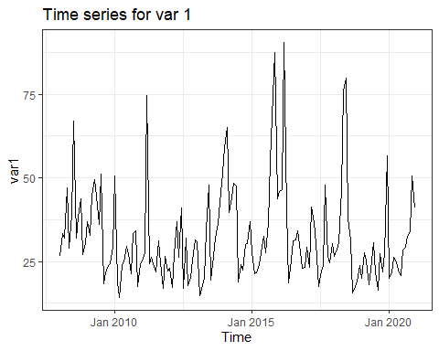
ggplot(Data,aes(Time,var2))+geom_line()+theme_bw()+labs(title = "Time series for var 2")
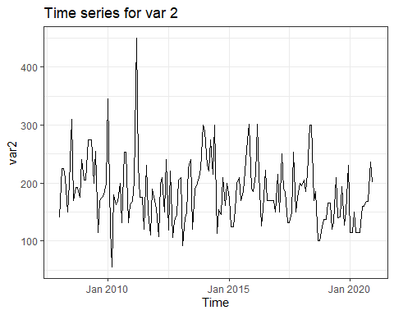
ggplot(Data,aes(Time,var3))+geom_line()+theme_bw()+labs(title = "Time series for var 3")
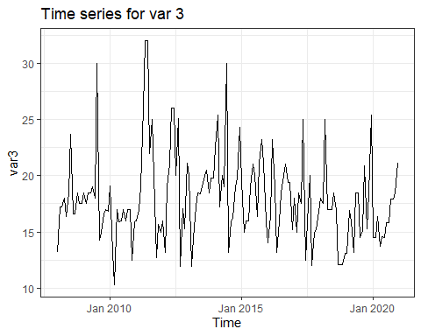
```r
library(tseries)
## Registered S3 method overwritten by 'quantmod':
## method from
## as.zoo.data.frame zoo
ts_model_var1=ts(Data$var1,start=min(Data$Time),frequency = 12)
acf(ts_model_var1)
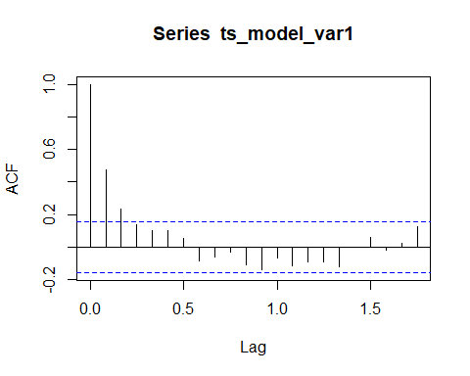
pacf(ts_model_var1)
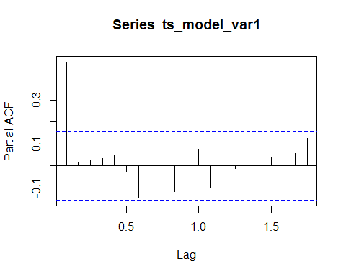
ts_model_var2=ts(Data$var2,start=min(Data$Time),frequency = 12)
acf(ts_model_var2)
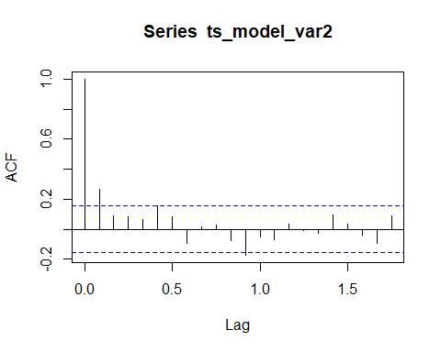
pacf(ts_model_var2)
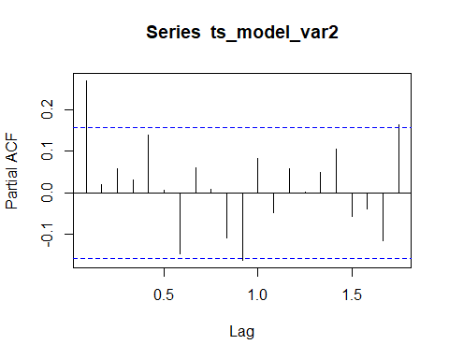
ts_model_var3=ts(Data$var3,start=min(Data$Time),frequency = 12)
acf(ts_model_var3)
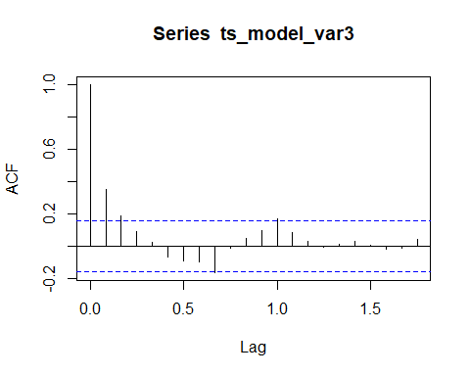
pacf(ts_model_var3)
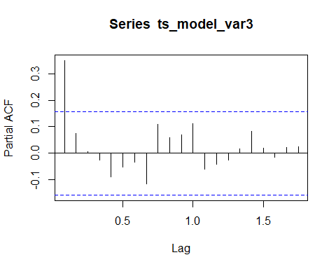
# moving average
ma5=function(var1){
y=numeric(length(var1)-3)
for(i in 3:length(var1)-1){
y[i]=(var1[i-1]+var1[i]+var1[i+1])/5
}
y
}
five=ma5(Data$var1)
length(five)
## [1] 155
plot(five,main = "FIve year moving average",col="red")
