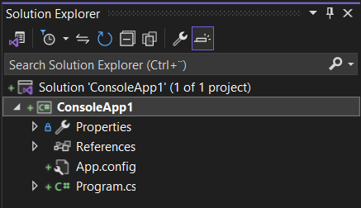

# Solution ‘ConsoleApp1/NameOfTheProject’

Top level solution file

Solution contains references to one or more projects

# ConsoleApp1/ NameOfTheProject

C# project file

References one or more files and source code and other items

# Properties

Contains Assemblyinfo.cs is a special file – add attributes suxh as author name,the date of the program, and so on.

# References

Compiled code converted into an assembly

# App.config

Application configuration file for specify settingsthat can use at runtime to modify its behavior

Such as version of .net

# Program.cs

This is the C# source file

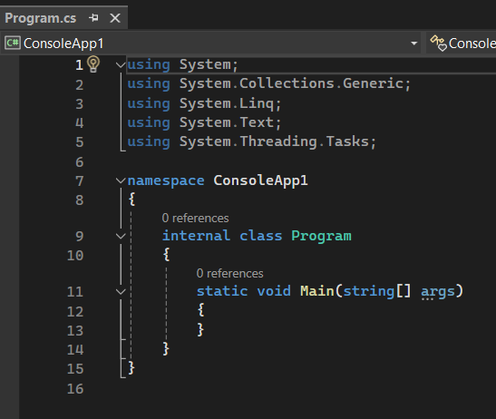

Program.cs file defines a class called Program that contains a method called Main.

All methhods must be defined inside a class.

**C# is case sensitive

Microsoft IntelliSense

Typing Con it will fill Console press Tab or Enter

Console is a built-in class that contains the methhods for displaying messages and getting input from users.

Expand the project and click show all files.

Bin and obj > bin > programname.exe = is responsible for debug

* Also responsible for without debugging

Properties windows is context sensitive- means displays the currently selection only.

* Grid is a container for items in WPF form

# Statements

A statement is a command that performs an action.

Combining statements to create method.

Statements in c# follows well-defined set of rules and this rules collectively known as syntax.

What statement is called semantics.

C# is a free format language

* Trick to programming well is learn the syntax and semantics

Identifiers

* 77 identifers or keyword in ‘C# I cannot reuse
* Such as int, do, abstract, double, try, true, false, typeof, enum, is, break, bool, if, else, checked, cath, delegate, explicit, extern, internal, interface, public, void,static, throw, params, finally, out, lock, implicit, volatile, override

Varible

* Varible is a storage location that holds value
* A box holds temporary information in computer memoröy
* Variable statements follow this

Declaring data type, variable type – variable name - = (assaignment operator) than the value;( semicolon in he end

Primitive data types

* * long wait;

Wait = 42L,

Float away;

Away = 0,42F,

decimal coin;

coin = 0,42M;

unassainged variables is an error in c#

Arrithmatic opperators

Plus, minus, asterisk*, forward slash/

Console.Writeline(“43” + “1”); = 431

Mixing different type of variables is a poor practise

* 5 / 0 is an error
* 5.0/0.0 is an infininity
* 0.0/0.0 is not a number NaN
* Infinity * 0 Is 0
* Nan * 0 is Nan
* In C# reminder can be float or decimal which is funny

প্রাধান্য precedence

অনিশ্চিত Ambiguous

* Parenthesis = ( )
* Braces or curly braces = { }
* Square brackets = [ ]

Operators are left-associative that means when precedence is same they will start from left.

Assignment operator( = ) takes two operand. Value assaigned to or for the left operand.

++ a = prefix operator, a++ = postfix operator,

++ and – is unary operator

One operation is an expression.

* Count++ returned the value of Count before the increment
* ++Count returned the value of Count after the increment

# Writing Methods and Applying Scope