PillTally
Counting pills from one phone photo
Applied AI · Industry project report
Peeranat Patarakittisopol · 10 October 2026

Executive summary
Pharmacy staff count 30, 60 or 90 tablets per prescription by hand, five at a time on a tray. PillTally replaces that with one phone photo: the app returns the count with a numbered dot on every pill, flags uncertain pills in orange for the pharmacist to check, and can mark pills of the wrong form (tablet, caplet or mini tablet) in red. It assists the pharmacist's check; it does not replace it.
The system is two deep-learning models used one after the other: a one-class YOLO11s counter ("pill") and a small YOLO11n-cls form classifier that sees each pill cropped at full resolution. Both are trained with supervised transfer learning. The counter in the app, thai_mix_s1024, was fine-tuned on 151 of my own hand-counted photos together with public photos of 110 other drugs, so it also counts medicines I never photographed.
Result (app counter thai_mix_s1024) | Value
Held-out test set (45 photos, 6 piles of 10–46 pills) | 89% of photos counted exactly (95% CI 78–98%), average miss 0.13 pills
Validation (60 photos, incl. a crowded 90-pill tray) | 93% exact, average miss 0.10 pills
Real mixed tray (82 pills: tablets, caplets, mini tablets) | total exact on 95% of photos; all three form counts exact on 90%
Other medicines (187 photos of drugs never photographed) | 58% exact, average miss 0.7 pills (previous counter: 23%)
Form classifier, per pill | 99.9% on validation, 100% on 1,110 held-out test pills
Speed vs hand counting | 0.009 s vs 0.46 s per pill (processing time, 10–100 pills)
Classical image processing on the same test set | 4% exact, average miss 9.1 pills

Three lessons shaped the result: near-perfect scores hid shortcuts three times (background, lighting, box size); a model trained only on my three medicines did not generalize to other drugs until public multi-drug data was added; and for part of the project the tuning scored photos differently from the deployed app, which hid a failure on heaped caplets. All three were found by targeted tests and fixed. The main limits are piles above 100 pills (untested), unfamiliar medicines (58% exact so far) and a small test set, which was used twice; both runs are reported.

1. Problem and users
Who it is for. Pharmacists and pharmacy technicians at a dispensing counter. Long-term prescriptions are typically 30, 60 or 90 tablets, counted by hand on a tray, five at a time.
What goes wrong today. Counting is slow and repetitive, and a miscount either short-changes the patient or loses stock. The alternative is a dedicated counting machine, which is expensive and takes counter space.
Why it is not trivial. Counting ten separated pills is easy for any method. It becomes hard when pills touch or heap, when they are identical with edges that blend, when the background is speckled or shiny, and when photos come from different distances and lighting. Simple image processing merges touching pills into one blob; the model must find each pill separately.
Why boxes, not just a number. A regression or density model outputs only a count. A detector draws every pill, so the pharmacist can verify the result at a glance and see exactly where the model is unsure. Verifiability is the safety argument of the product.

2. The system
A phone browser sends the full-resolution photo to a web page (Next.js), which forwards it to a Python model server (FastAPI). The server runs:
- Counter (thai_mix_s1024.pt, YOLO11s, one class "pill", 1024 px input, conf 0.55, NMS IoU 0.6): a box on every pill; the count is the number of boxes. Boxes scoring within 0.2 of the cut-off are flagged orange.
- Form classifier (pill_type.pt, YOLO11n-cls): each box is cut from the full-resolution photo, everything outside an ellipse inside the box is grayed out, and the 224 px crop is classified as tablet, caplet or mini tablet. Below 80% confidence the form is reported as unsure.
- Classical counter for comparison (no machine learning): color threshold in LAB space, distance transform and watershed.
The page shows a numbered dot per pill in reading order (green confident, orange check, red other form), the count, the form mix, an optional hand count to compare against, pinch-to-zoom, and an on-device history of past counts. Detector time is about 0.2 s per photo on a laptop CPU.
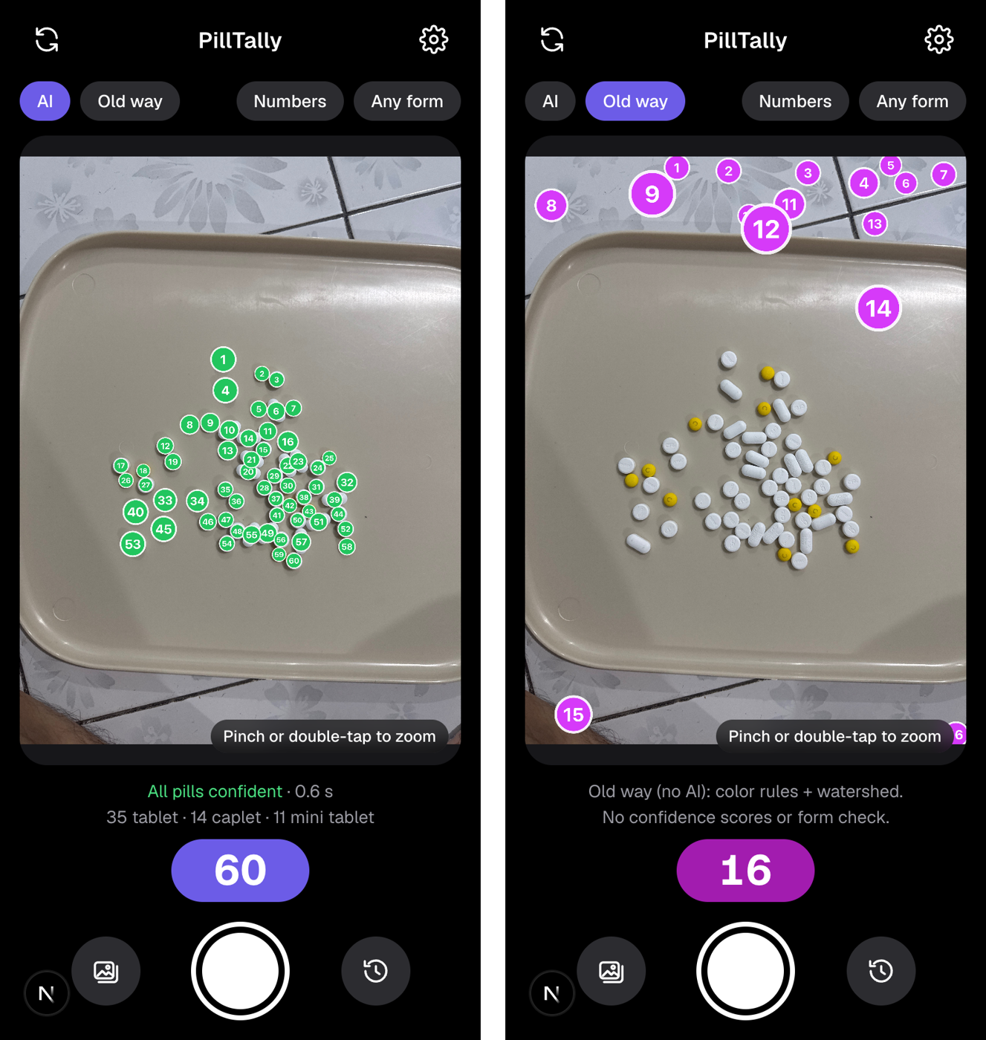
Figure 1. The app on a 60-pill mixed tray. Left: the AI counter finds all 60 pills and the form mix. Right: the classical method on the same photo counts 16, mostly tray edges and floor pattern.
Why two models. Counting learns from every pill as one class, which also lets it learn from public datasets whose drug labels differ from mine. The classifier sees each pill sharply, and its labels come for free from the session (each tray holds one form), so no per-box form labels were needed. A new form only means retraining the small classifier. The cost is that errors chain: a pill the counter misses cannot be classified.

3. Data
Source | Content | Use
My photos (iPhone, hand-counted) | 256 photos in 26 sessions: tablets 80, caplets 36, mini tablets 43, four crowded mixed trays of 90–97 pills (97 photos); plus mixed tray s20 (82 pills, 20 photos) | train / validation / test, split by session; s20 evaluation only
Pill Counting v4 (Roboflow Universe, CC BY 4.0) | 1,236 photos of pharmacy counting trays, 71,269 labeled pills | general pill model; added to the final counter's training
Pill-Counter v2 (Roboflow Universe, public domain) | 1,255 photos of 110 drugs, 1–18 pills each | re-split by prescription: 70% train, 15% validation, 15% held-out "other medicines" test
pill count v1 (Roboflow Universe, CC BY 4.0) | 112 video frames of trays with 10–175 pills, 640×480 | big-pile stress test only

Labels. Photos were pre-labeled by the current model and corrected in Roboflow (one class, "pill"). Every label file was checked against the hand count: all 276 of my labeled photos (15,636 pills) have exactly as many boxes as pills. Pill forms are not labeled per box; they come from the session name.
Split by session. Each pile was photographed 5–30 times, so photos of the same pile never sit in two splits (same-session leakage). Train: 15 sessions, 151 photos; validation: 5 sessions, 60 photos (one per form, floor-tile tablets and one crowded tray); test: 6 sessions, 45 photos, including blue tablets on brown cloth in warm light, a condition never seen in training. The public Pill-Counter v2 set was re-split by prescription and photo session for the same reason.

4. Models and training

4.1 Counter
Transfer learning in steps: yolo11s.pt pretrained on COCO (Level 3) → fine-tuned on Pill Counting v4 (Level 4, Colab T4, 60 epochs) → fine-tuned on my photos (Level 5). The final counter adds the public multi-drug photos to the last step; my photos are listed six times so they make up about a third of every epoch.
- Two stages: stage 1 freezes layers 0–9 (the backbone up to SPPF, 47% of the weights) with SGD at learning rate 0.005 for 30 epochs; stage 2 unfreezes everything at 0.001, up to 60 epochs with early stopping (patience 25). Less data → freeze more first.
- Input 1024 px: pills are about 54 px wide, roughly 7 cells of the finest detection grid (about 4 cells at the default 640 px).
- Augmentation: rotation ±180° and both flips (pills look the same at any angle), scale ±30%, translation, brightness ±40%, saturation ±50%, mosaic.
- max_det = 500, so large piles are not capped at 300 boxes.
- Thresholds (confidence cut-off and NMS overlap limit) are tuned on validation only, scoring each photo the way the app does; the setting with the lowest mean miss wins.
Variants trained on Colab A100 GPUs and compared on validation: YOLO11s and YOLO11m, 1024 vs 1280 px, with and without the public v4 step, and with and without the public multi-drug photos.

4.2 Form classifier
YOLO11n-cls pretrained on ImageNet, fine-tuned on masked crops of my pills: each training pill is cut three times, its box plus two copies resized 0.85–1.2× and shifted up to ±10%, so the classifier does not depend on exactly how the counter draws the box (9,201 training crops). Little color augmentation (saturation ±20%, hue 0), because color helps tell forms apart.

5. Evaluation method
- Metric: exact count rate per photo (a pharmacy needs the exact number), plus mean absolute error (average miss) and bias.
- Baselines: L1 predict the mean training count; L2 classical image processing tuned on train; L3 pretrained YOLO without pill training; L4 the public-data pill model.
- Choice on validation only; confidence intervals by resampling whole sessions, since photos of one pile are not independent.
- End-to-end check: the real mixed tray s20 scores counter and classifier together (each form count exact). Generalization check: 187 held-out photos of other medicines. Practical check: stopwatch timing against hand counting.
- Test set guarded in code (--final, every run logged). It was run twice: run 1 on the earlier models, run 2 on the final model after the training data changed and the scoring fix (section 7). Both are reported.

6. Results

6.1 Test set and baselines (run 2, final model)
Level | Photos exact [95% CI] | Average miss (pills)
L1 predict the mean count | 0% | 37.3
L2 classical image processing | 4% [0–8] | 9.1
L3 pretrained YOLO, no pill training | 0% | 23.2
L4 public pill model (v4) | 82% [57–95] | 0.69
L5 thai_v2 (my photos) | 93% [91–97] | 0.07
L5 thai_v3_m1024 (YOLO11m, my photos) | 82% [71–93] | 0.20
L5 app: thai_mix_s1024 | 89% [78–98] | 0.13
Table 1. Held-out test set: 45 photos, 6 piles of 10–46 pills. The app counter's 5 misses are each 1–2 pills (2 on unseen brown cloth, 3 on caplets).
Every learned counter is far ahead of the baselines. On this small test set the previous counter thai_v2 is slightly ahead (93% vs 89%) with overlapping intervals; the app counter was chosen on validation and on the other-medicines check, where it is clearly better (below), not on the test set.

6.2 The counters compared
Check | thai_v2 | thai_v3_m1024 | thai_mix_s1024 (app)
Training data | my photos (after v4) | my photos only, YOLO11m | my photos + 110-drug public photos
Validation, exact / miss | 68% / 0.37 | 87% / 0.15 | 93% / 0.10
Crowded 90-pill tray (s26) | 63% | 87% | 93%
Mixed tray s20: total / all 3 forms | 60% / 55% | 75% / 75% | 95% / 90%
Other medicines (187 photos): exact / miss | 25% / 1.9 | 17% / 3.6 | 58% / 0.7
Own piles of 10–100 pills | all within ±1 | all within ±1 | 5 of 6 exact, 1 off by 1
Test set (run 2) | 93% | 82% | 89%
Detector time per photo (laptop CPU) | 0.19 s | 0.38 s | 0.20 s
Table 2. All numbers scored one photo at a time, as the app runs, with each model's thresholds tuned on validation (thai_v2 uses its original app setting).

6.3 Forms and the real mixed tray
The form classifier is right on 99.9% of 784 validation pills cut from the counter's own boxes and on all 1,110 held-out test pills, including blue tablets never seen in training. In a stress test that pastes one pill of another form into a tray (600 cases on held-out photos), it caught the wrong pill every time, with 0–2% of correct pills wrongly flagged. On the real mixed tray s20 (20 tablets, 40 caplets, 22 mini tablets, 20 photos), all three form counts are exact on 90% of photos with the final counter, up from 0% with the first classifier.

6.4 Speed and cost
Pile | By hand (five at a time) | PillTally (processing) | App count
10 pills | 3.6 s | 0.4 s | 10
50 pills | 22.0 s | 0.5 s | 50
100 pills | 48.8 s | 0.6 s | 100
Per pill | 0.46 s | 0.009 s
Table 3. Time test on the same piles (single timings; measured with an earlier counter of the same speed class). Processing excludes taking the photo, which adds a few seconds.
Hand time per pill grows with the pile (0.36 → 0.49 s), while the app's time per photo barely changes. Even with 10 seconds added for the photo, 100 pills take about a fifth of the hand time, which meets the proposal's target of at least 50% less time. Counting machines cost about $2,500–7,500 per counter (RxCount Rx-4, Kirby Lester KL1, GSE Eyecon list prices), or ฿49,000–126,000 for counters sold in Thailand. PillTally runs on phones the staff already carry, with a server on an existing PC or a small cloud server (about $15 a month for opening hours in AWS's Thailand region).

7. What went wrong, and how it was found

7.1 Shortcuts behind near-perfect scores
Shortcut | How it was found | Fix
Background and neighbors: a blue pill among white ones was called white 89% of the time, while test accuracy was 100% | Pasting a pill onto the other class's background | Mask everything outside the pill
Lighting: caplets and minis were only photographed on one floor; tablets on that floor became "caplet" (0 of 20 mixed-tray photos right) | The real mixed tray (the pasted test kept each pill's own light) | New photos: tablets on the same floor (18 of 20 right)
Box size: tablets dropped to 84% with the counter's boxes instead of hand-checked ones | Validation using the counter's own boxes | Train on resized and shifted boxes (99.7%)

7.2 A counter that only knew my medicines
A larger YOLO11m counter trained only on my photos won validation, mostly through the crowded tray, but counted other medicines exactly on only 11–17% of photos. Adding public pill data helped (a YOLO11m through the v4 trays: 37%), and training with public photos of 110 drugs gave 58%. Data variety mattered more than model size: the small model with mixed data beat every medium model.

7.3 Evaluated one way, deployed another
The tuning script passed all validation photos to the detector as one list. Eight photos of the crowded tray were 5712×4284 instead of 4032×3024, and with mixed sizes the library padded every photo to a 1024×1024 square, while the app processes one photo at a time (1024×768). The thresholds picked in that mode (NMS IoU 0.4) removed boxes on heaped caplets: on the mixed tray, 44 of the counter's 49 missed caplets had been detected and then filtered out. Scoring photos one at a time, as the app does, picked IoU 0.6, and the mixed tray went from 30% to 95% exact. The test set was not affected (all test photos have one size). The scripts now score one photo per call.

8. Limitations
- Pile size: tested up to 100 pills (exact on 5 of 6 own photos of 10–100 pills). Pharmacies mostly count 30, 60 or 90, but the proposal's 150–300 is untested; on low-resolution video frames of 100–175 pills every counter under-counts.
- Unfamiliar medicines: 58% exact on held-out photos of other drugs; these photos are unseen but come from the same public source as part of the training data.
- Identical-looking drugs: a photo cannot tell two white round tablets of different drugs apart, and the classifier resizes each crop, so it cannot use real size. PillTally is a counter, not a drug identifier; the drug is identified from the stock bottle.
- Small test set used twice: 6 piles give wide intervals (78–98%). A few test photos were also looked at during development (no setting was chosen from them).
- Coverage: one phone; crowded trays on one beige tray; the form classifier knows three forms; the model server runs on a laptop; it is an assistant, not a certified device.

9. Next steps
- More data from use: the app saves every photo; mistakes and corrected counts become new training sessions. Crowded trays on more surfaces and from more phones.
- More medicines: a "teach a new medicine" flow (a few single-drug trays label themselves), and an embedding catalog so a new drug is an entry, not a retrain; an "unknown" answer for the classifier.
- Size and identity: a reference card for real pill size; a barcode scan of the stock bottle for identical-looking drugs, which also turns every count into a labeled example.
- Larger piles (150–300) and a medium model on the mixed data; tiled inference for packed piles.
- Deployment: release the counter, classifier and thresholds together as one versioned set; run on the phone (ONNX / Core ML); a pilot at one dispensing counter measuring time and miscounts against hand counting.

References and credits
- Pill Counting v4, Roboflow Universe (jeonghyeon-kim/pill-counting-im4ph), CC BY 4.0.
- Pill-Counter v2, Roboflow Universe (dubfai/pill-counter-guifm), public domain.
- pill count v1, Roboflow Universe (ncsang1/pill-count-mfuny), CC BY 4.0.
- Ultralytics YOLO11 (detection and classification models); COCO and ImageNet pretrained weights.
- Counting-machine prices: RxCount (rxcount.com, 2019 list prices), eBay and DOTmed listings, Panya Chemipan (Thailand). Cloud price: AWS c7g.large, ap-southeast-7, on demand.

Appendix: reproducing the results
Step | Code
Run the app | ./dev.sh (model server + web page; open the printed address on a phone)
Split by session | src/split.py
Train counters (Colab) | notebooks/train_v4_colab.ipynb, train_counter_v2/v3/v4m/mix_colab.ipynb; data zip from src/make_mixed_zip.py
Form classifier | src/crops.py, src/train_classifier.py, src/test_odd_pill.py
Tune and compare counters (validation) | src/compare_counters.py --rule both <models>
Baselines and test set | src/classical.py, src/evaluate.py report --split test --final
Mixed tray | src/eval_mixed.py --counter <model>.pt --thresholds <name> --trays s20
Other medicines (Colab) | notebooks/eval_other_pills_colab.ipynb
Detailed results | PROGRESS.md, docs/eval_mix_report.md, results/

