|  |
| --- |
| **How To Create A Google Ads Campaign For Online Shopping** |

# Step 1: Search “Google Ads” and Select the Google Ads

|  |  |
| --- | --- |
|  |  |

# Step 2: Create a Google Accounts

|  |  |  |
| --- | --- | --- |
|  |  |  |
|  |  |  |

|  |  |
| --- | --- |
|  |  |

# Step 3: Create New Campaign

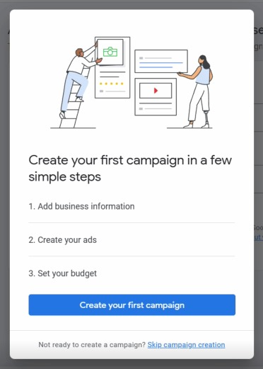

# Step 4: Create New Payment Profile

|  |  |
| --- | --- |
|  |  |

|  |  |
| --- | --- |
|  |  |

# Step 5: Choose Business Type

|  |  |  |
| --- | --- | --- |
|  |  |  |

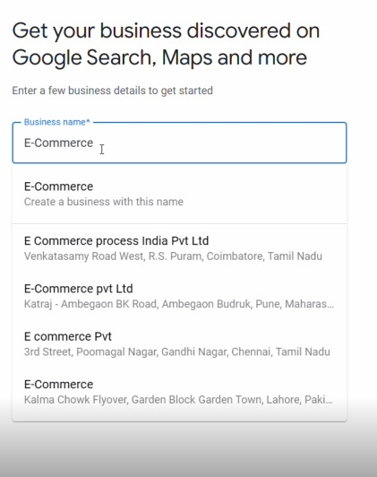

# Step 6: Website Name

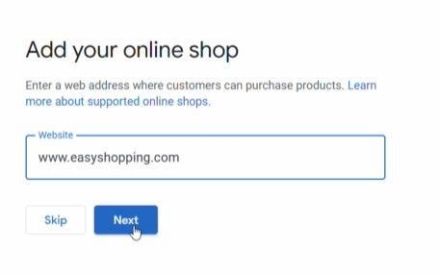

# Step 7: Campaign Information For Faster setup and Description

|  |  |
| --- | --- |
|  |  |
|  |  |

|  |  |
| --- | --- |
|  |  |
|  |  |
|  |  |

|  |  |
| --- | --- |
|  |  |
|  |  |

# Step 8: Ads Descriptions and Ads Keywords

|  |  |
| --- | --- |
|  |  |

|  |  |
| --- | --- |
|  |  |
|  |  |

# Step 9: Main Adverting Goal

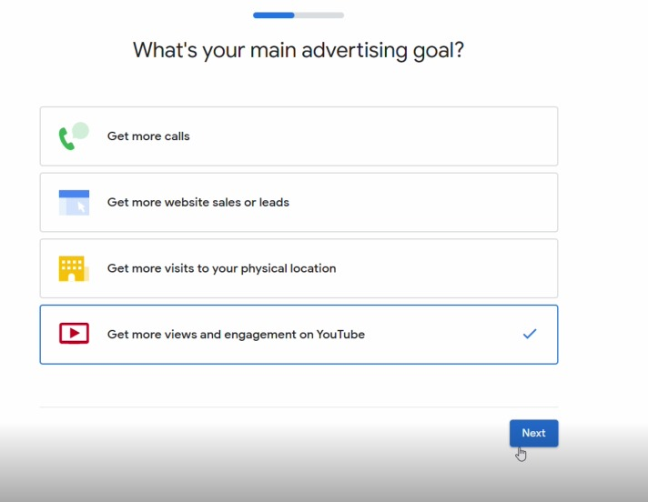

# Step 10: Create and upload the Ads in Google Campaign

|  |  |
| --- | --- |
|  |  |
|  |  |
|  |  |

# Step 11: Campaign Objectives and General Subtypes

|  |  |
| --- | --- |
|  |  |
|  |  |

# Step 12: Ads Budgets

|  |  |
| --- | --- |
|  |  |

|  |  |
| --- | --- |
|  |  |
|  |  |

# Step 13: Audience and Demographics

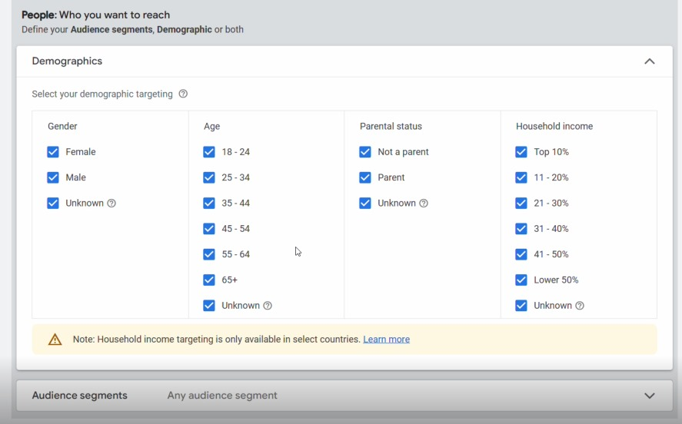

# Step 14: Topics and Keywords

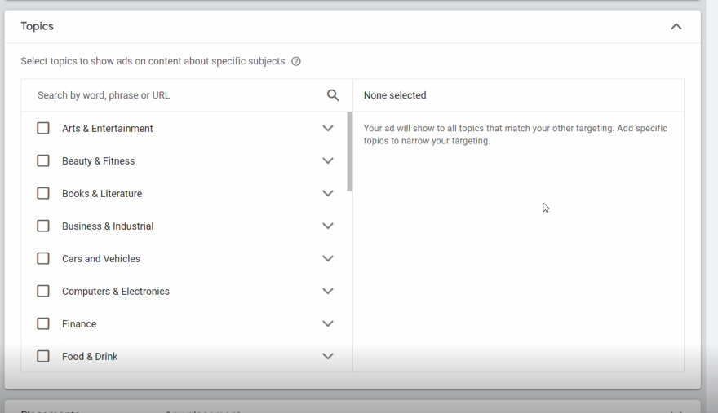

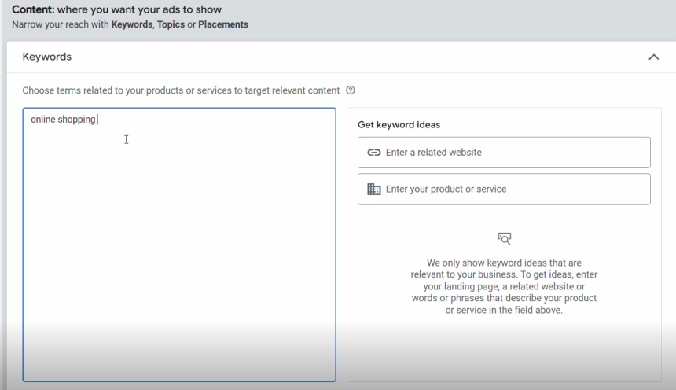

# Step 15: Create Campaign

# 

# Step 16: Campaign Review

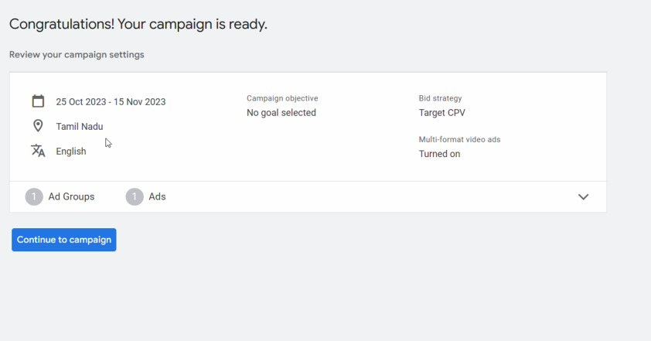

# Step 17: Publish Campaign

