Follow visual steps if necessary: -

1. Create new project

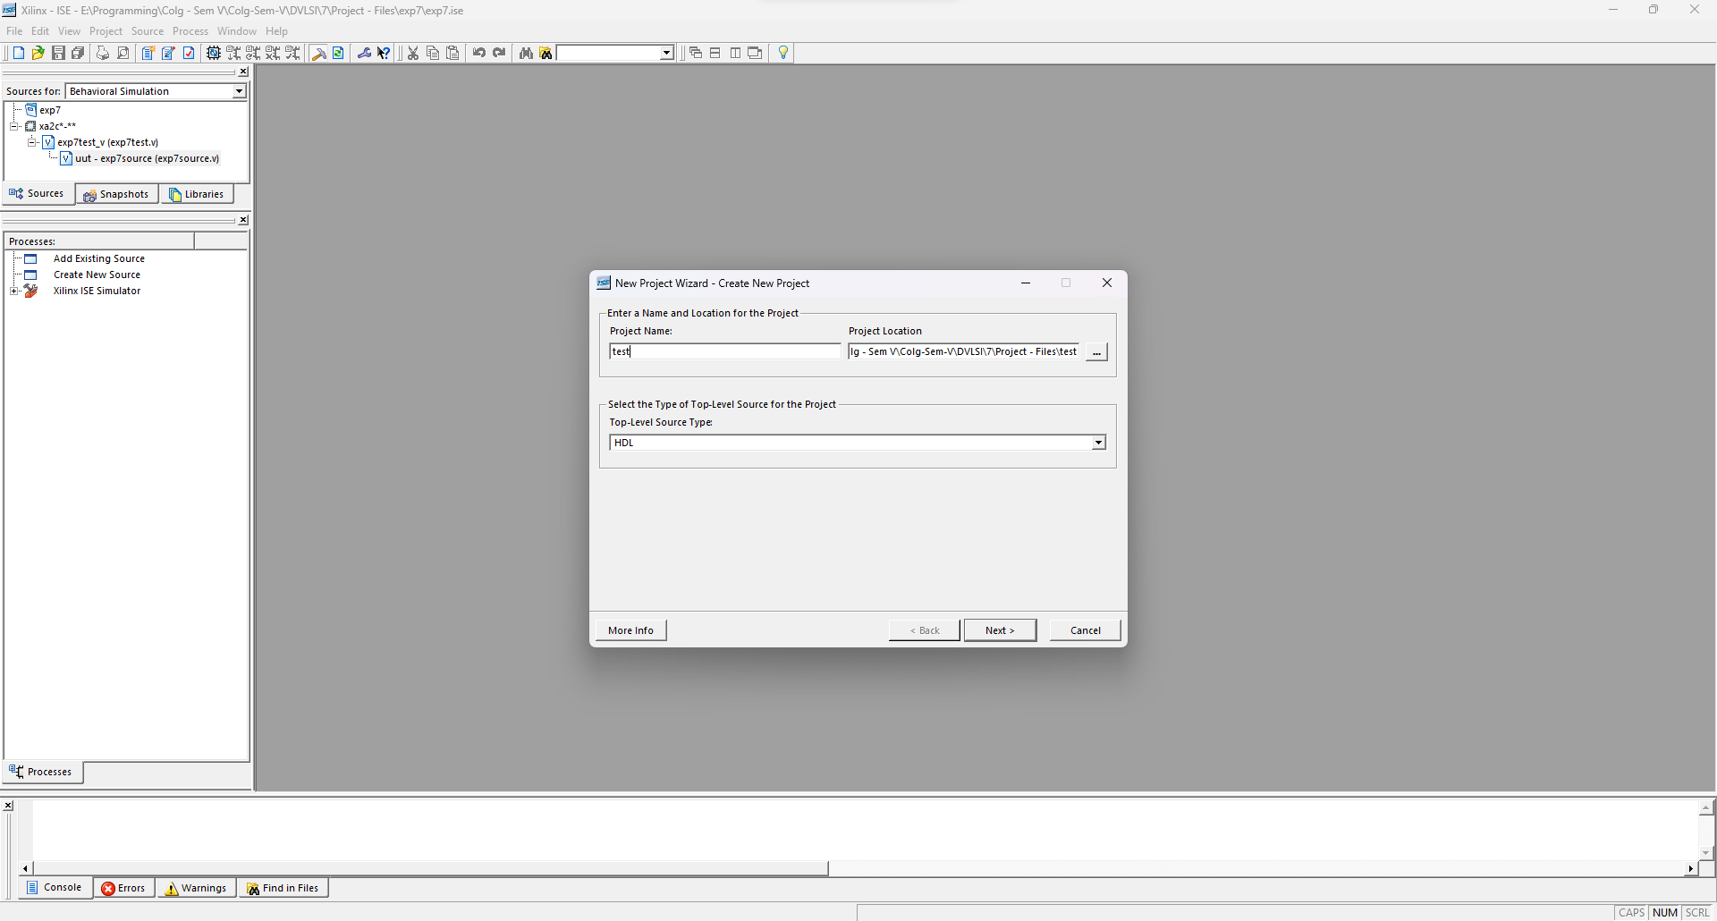

2. Click next then new source

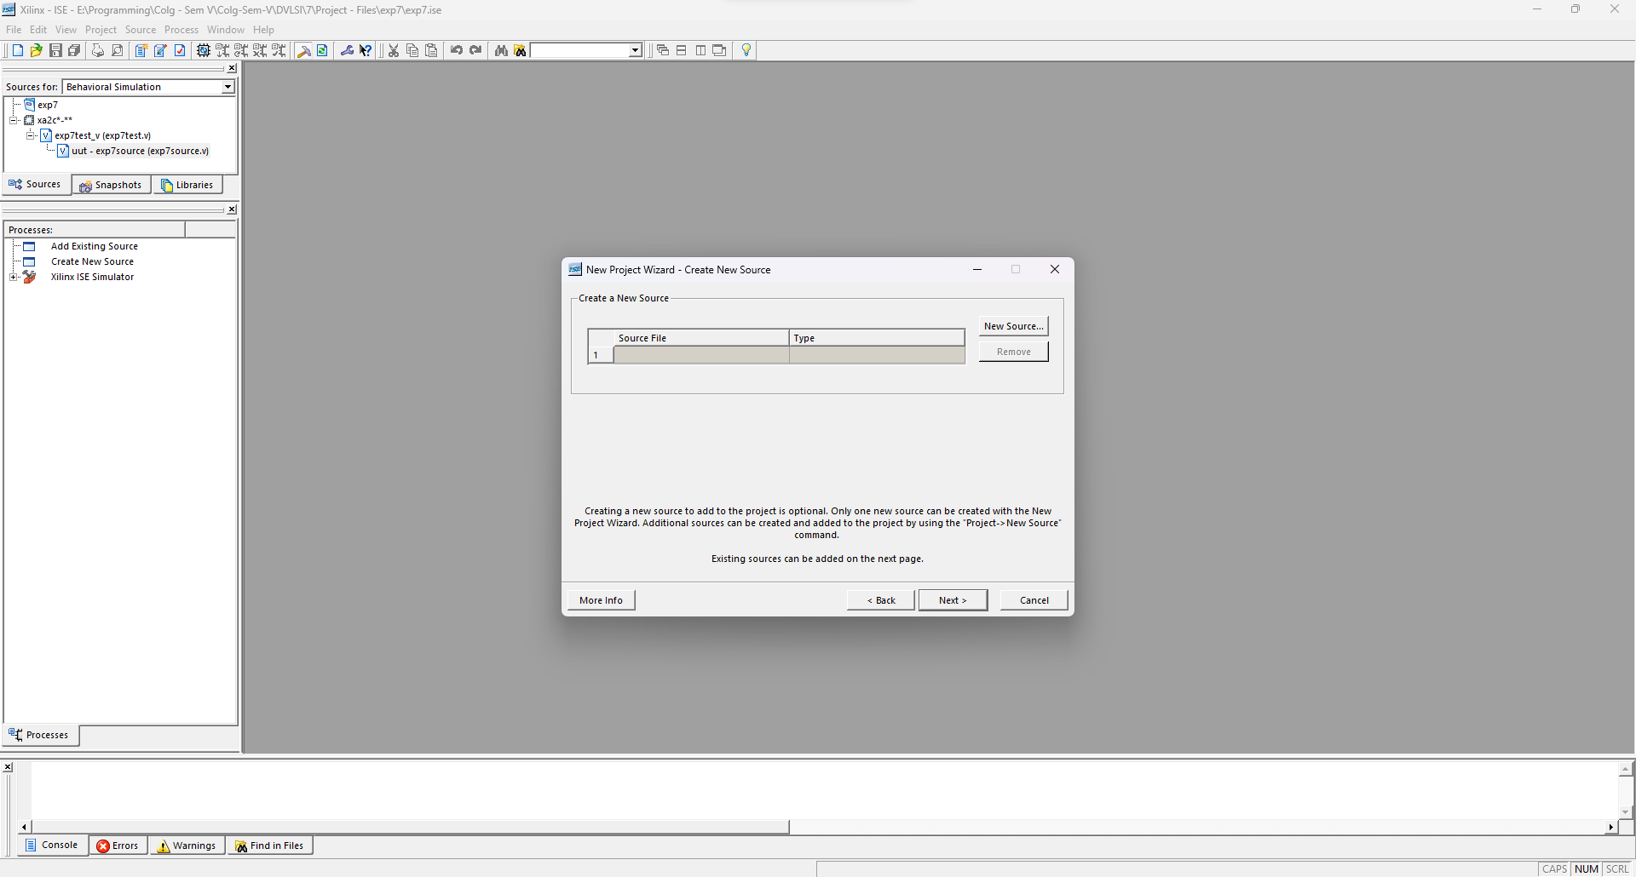

3. Select verilog module (dont include same name as project and any special characters)

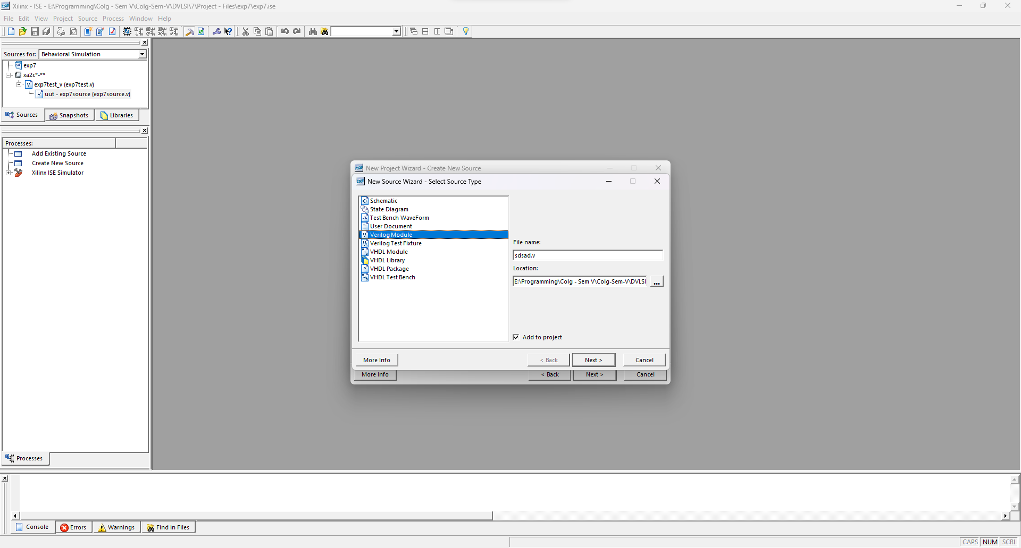

4. In first tab, put a, b, cin. For second tab, put s, cout and select output on direction tab.

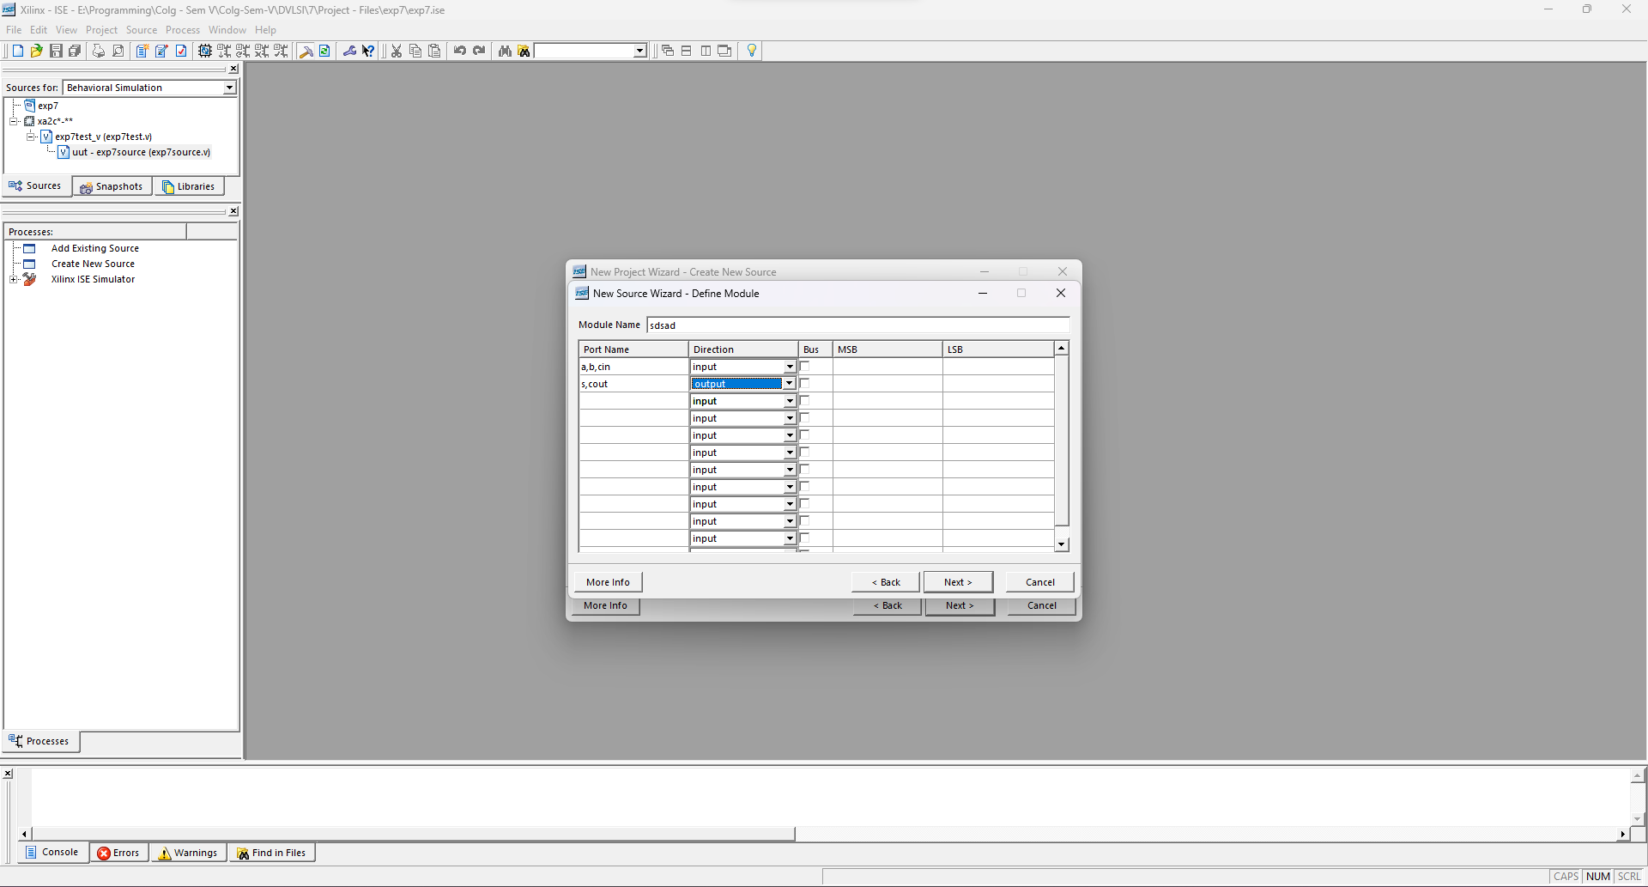

5. Next, Finish on both windows

6. In source file opened automatically copy paste the following (don't replace everything!)

module verilo(a,b,cin, s,cout);

input a,b,cin;

output s,cout;

assign s = a \* b \* cin;

assign cout = (a&b)|(b&cin)|(a&cin);

endmodule

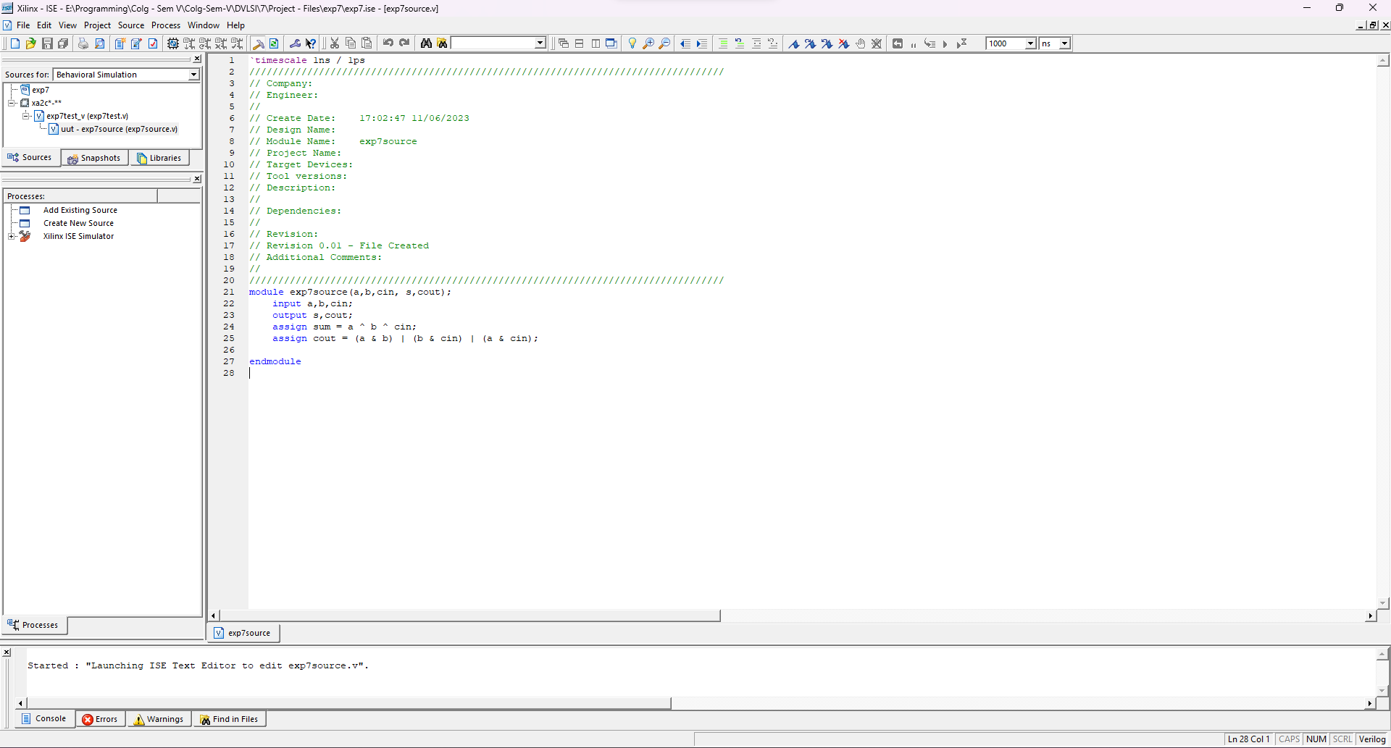

7. Next save the file and expand implement design on left most window. Double click Synthesize - XST (make sure no errrors)

8. Expand Synthesize column then click view RTL Schematic and make sure it matches with the image

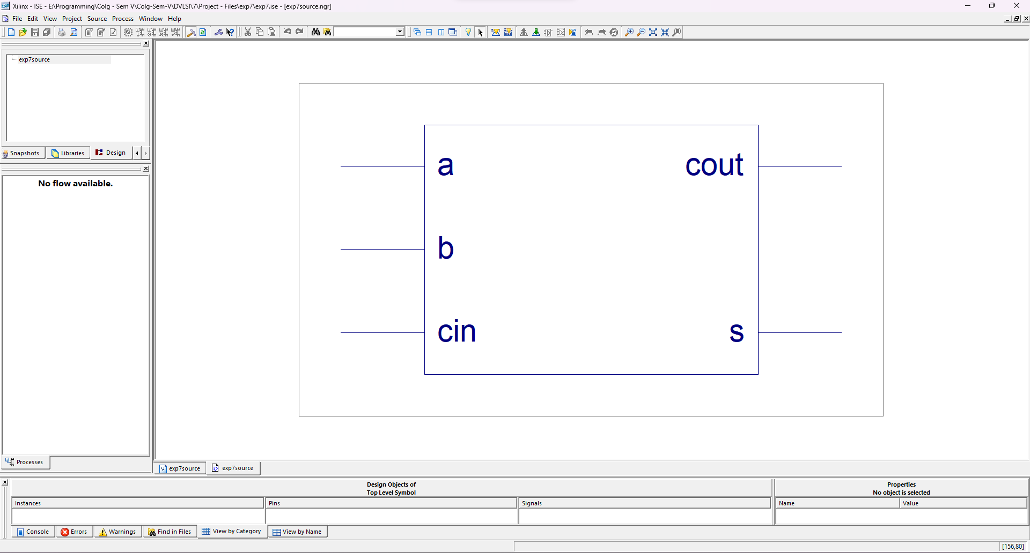

9. Create new source, select verilog test fixture and name something different.

10. Copy paste the following part of code

initial begin

// Initialize Inputs

a = 0;b = 0;cin = 0; #100;

a = 1;b = 0;cin = 1; #100;

a = 0;b = 1;cin = 0; #100;

a = 1;b = 0;cin = 1; #100;

a = 1;b = 1;cin = 0; #100;

// Wait 100 ns for global reset to finish

#100;

// Add stimulus here

end

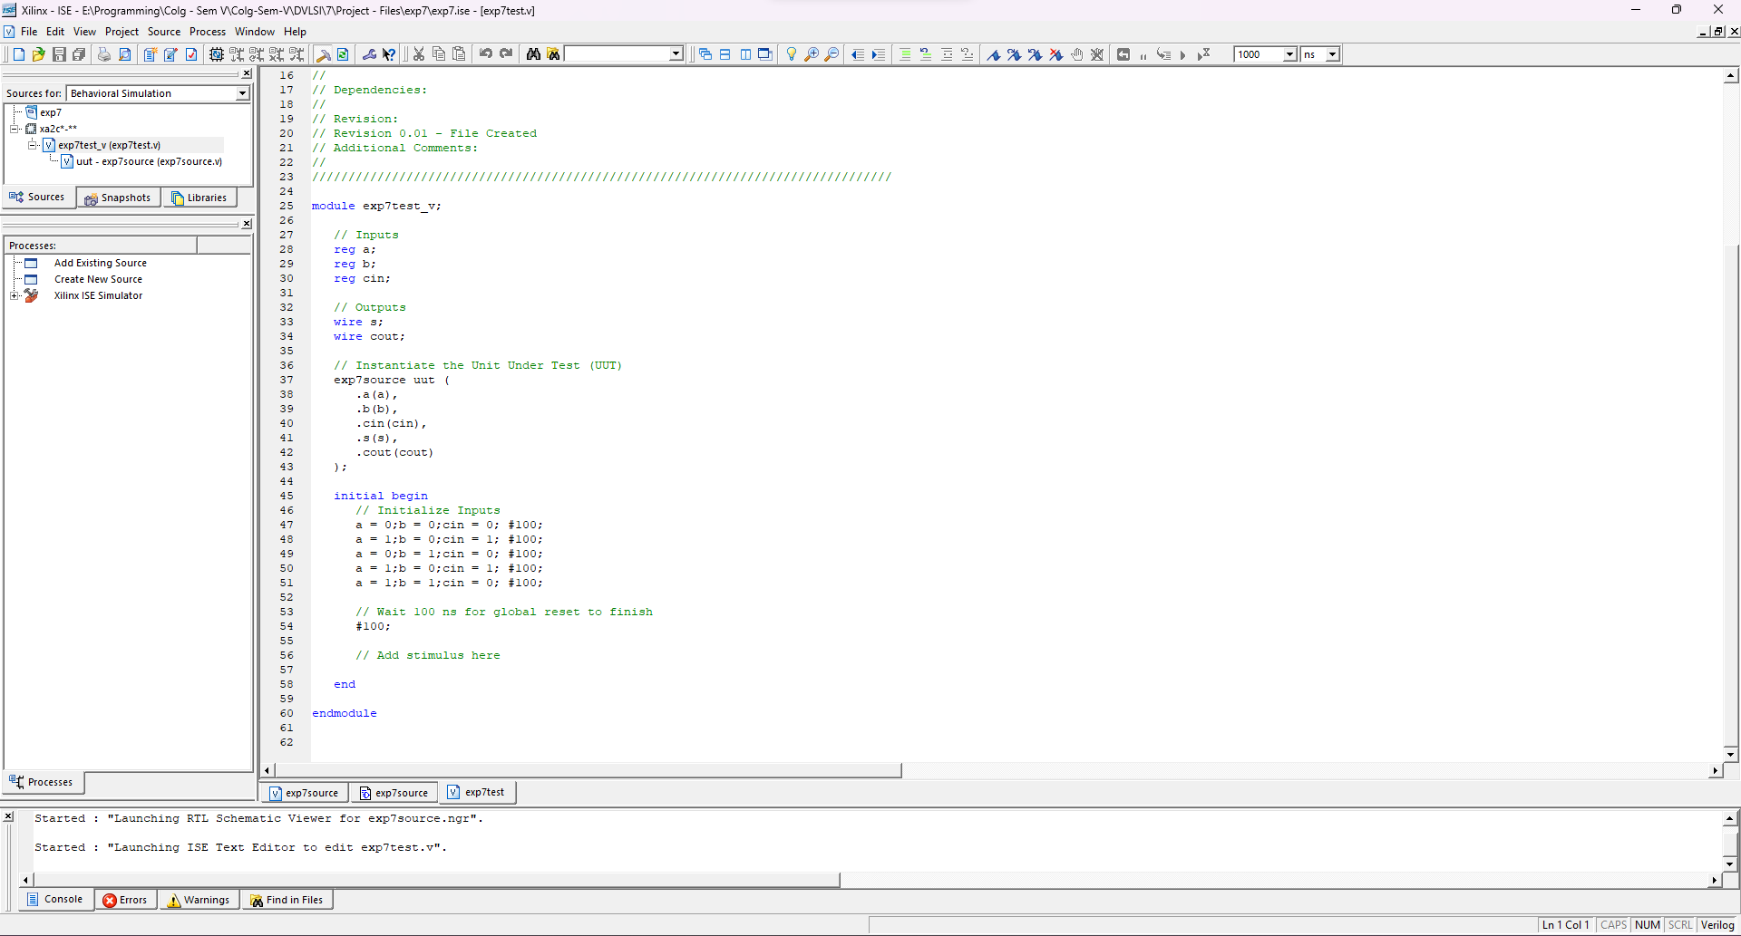

11. Next on top left in sources for: select behavioral simulation. Below expand Simulator tab, check syntax, simulate behavioural model

