**Experiment - 1: Effect of cellular system design parameters on system capacity**

1. **Aim:** To understand the concept of cellular system design and frequency reuse on system capacity
2. **Requirements:** Matlab/Scilab/Phyton

### Pre-Experiment Exercise

* 1. **Brief Theory**

The cellular concept was a major breakthrough in solving the problem of spectral congestion and user capacity. It offered very high capacity in a limited spectrum allocation without any major technological changes. The cellular concept is a system-level idea which calls for replacing a single, high power transmitter (large cell) with many low power transmitters (small cells), each providing coverage to only a small portion of the service area. Each base station is allocated a portion of the total number of channels available to the entire system, and nearby base stations are assigned different groups of channels so that all the available channels are assigned to a relatively small number of neighboring base stations. Neighboring base stations are assigned different groups of channels so that the interference between base stations (and the mobile users under their control) is minimized. By systematically spacing base stations and their channel groups throughout a market, the available channels are distributed throughout the geographic region and may be reused as many times as necessary so long as the interference between cochannel stations is kept below acceptable levels.

Frequency Reuse Concept –

Cellular radio systems rely on an intelligent allocation and reuse of channels throughout a coverage region. Each cellular base station is allocated a group of radio channels to be used within a small geographic area called a cell. Base stations in adjacent cells are assigned channel groups which contain completely different channels than neighboring cells. The base station antennas are designed to achieve the desired coverage within the particular cell. By limiting the coverage area to within the boundaries of a cell, the same group of channels may be used to cover different cells that are separated from one another by distances large enough to keep interference levels within tolerable limits. The design process of selecting and allocating channel groups for all of the cellular base stations within a system is called frequency reuse or frequency planning.

The figure illustrates the concept of cellular frequency reuse, where cells labeled with the

same letter use the same group of channels. The hexagonal cell shape shown in the figure is conceptual and is a simplistic model of the radio coverage for each base station, but it has been universally adopted since the hexagon permits easy and manageable analysis of a cellular system While it might seem natural to choose a circle to represent the coverage area of a base station, adjacent circles cannot be overlaid upon a map without leaving gaps or creating overlapping regions Thus, when considering geometric shapes which cover an entire region without overlap and with equal area, there are three sensible choices—a square, an equilateral triangle, and a hexagon. A cell must be designed to serve the weakest mobiles within the footprint, and these are typically located at the edge of the cell. For a given distance between the center of a polygon and its farthest perimeter

points, the hexagon has the largest area of the three. Thus, by using the hexagon geometry, the fewest number of cells can cover a geographic region, and the hexagon closely approximates a circular radiation pattern which would occur for an omnidirectional base station antenna and free space propagation.

To understand the frequency reuse concept, consider a cellular system which has a total of S duplex channels available for use. If each cell is allocated a group of k channels (k < S), and if the S channels are divided among N cells into unique and disjoint channel groups which each have the same number of channels, the total number of available radio channels can be expressed as

S = kN

The N cells which collectively use the complete set of available frequencies is called a cluster. If a cluster is replicated M times within the system, the total number of duplex channels, C, can be used as a measure of capacity and is given by

C = MkN = MS

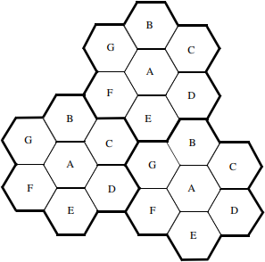

Illustration of the cellular frequency reuse concept. Cells with the same letter use the same set of frequencies. A cell cluster is outlined in bold and replicated over the coverage area. In this example, the cluster size, N, is equal to seven, and the frequency reuse factor is 1/7 since each cell contains one-seventh of the total number of available channels.

### Laboratory exercise

### Part1:

### What is the need for replacing high power transmitter by low power transmitters in cellular communications

### Consider a single high power that can support 40 voice channels over an area of 140 square Km with the available spectrum. If the area is equally divided in to seven smaller cells, each supported by low power transmitters so that each cell supports 30% of the channels, then determine

### A) Coverage area of each cell

### B) Total number of voice channels available in cellular system

### 3) What did you observe after solving the numerical? Comment on the results obtained from the above numerical

### Part 2 : Simulation

1. Write a program to find the cellular system capacity

Consider that a geographical service area of a cellular system is 4200 sq km. A total of 1001 channels are available for handling traffic. Suppose the area of a cell is 12 sq km. How many times would the cluster size of 7 have to be replicated in order to cover the entire service area? Calculate the number of channels per cell and the system capacity. If the cluster size is decreased from 7 to 4, then does it result in an increase in system capacity? Comment on the results obtained

1. Post-experiment Exercise
   1. Conclusion
   2. Questions
2. How do we decide the size of the cell? List out different types of cells and specify their range of coverage and their application

2. What do you understand by cluster? What did you understand by the two different pictures shown below? What happens if the cluster size varies explain with an example.

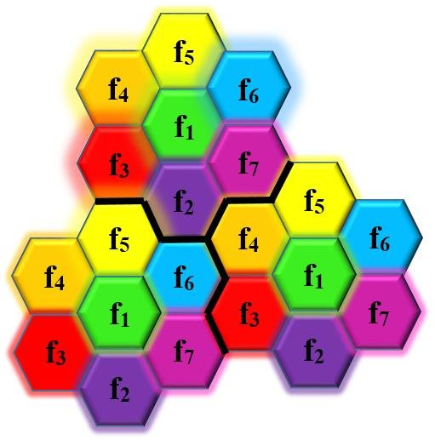 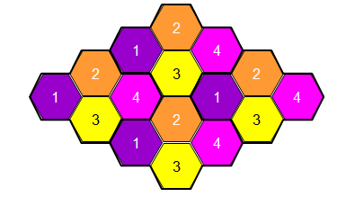

1. What do you understand by co-channel cells and frequency reuse factor?