Experiment - 2: Impedance Matching Network Design

1. **Aim:** To design impedance matching network by the means of stubs using Smith chart and V-Smith tool

# Requirements

* + Smith Chart (Z)
  + V-Smith software v4.1

# 2. Pre-experiment Exercise Brief Theory

One of the most important aspects of high-frequency circuit design and microwave engineering is the problem of impedance matching. Impedance matching is the design of a circuit to be inserted between a source and a load (both used in the general sense) so as to provide maximum power transfer between them.

# Impedance Matching and Transformation

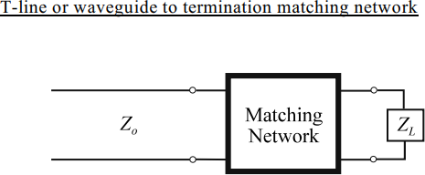Matching the source and load to the transmission line or waveguide in a general microwave network is necessary to deliver maximum power from the source to the load. In many cases, it is not possible to choose all impedances such that overall matched conditions result. These situations require that matching networks be used to eliminate reflections

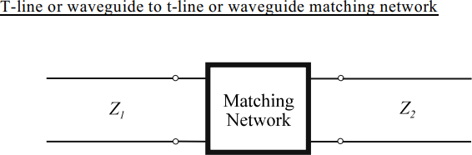

Depending on the application, matching may be required over a band of frequencies such that the bandwidth of the matching network is an important design parameter. If the load impedance varies over a given range, a matching network which can be adjusted or tuned as necessary. In general, matching networks are constructed with reactive components only so

that no loss is added to the overall network.

# Single Stub Tuners

Given that we can obtain any value of reactance or susceptance with the proper length of short-circuited or open-circuited transmission line, we may use these transmission line stubs as matching networks.

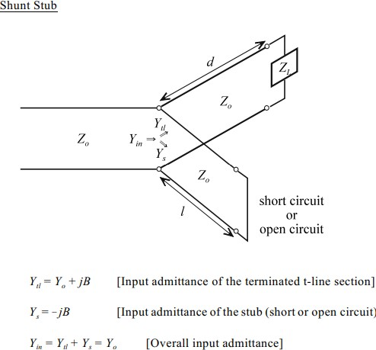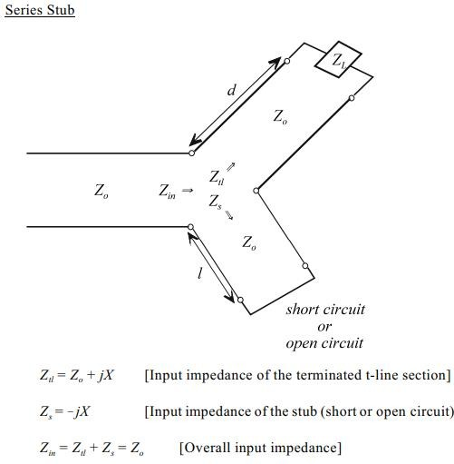

# Laboratory Exercise

**Single Shunt Stub Tuner Design Procedure**

* 1. Locate normalized load impedance and draw VSWR circle (normalized load admittance point is 180 from the normalized o impedance point).
  2. From the normalized load admittance point, rotate CW (toward generator) on the VSWR circle until it intersects the r = 1 circle. This rotation distance is the length d of the terminated section of t-tline. The nomalized admittance at this point is 1 + jb.
  3. Beginning at the stub end (rightmost Smith chart point is the admittance of a short- circuit, leftmost Smith chart point is the admittance of an open-circuit), rotate CW (toward generator) until the point at 0 - jb is reached. This rotation distance is the stub length l.

# Single Series Stub Tuner Design Procedure

1. Locate normalized load impedance and draw VSWR circle.
2. From the normalized load impedance point, rotate CW (toward generator) on the

VSWR circle until it intersects the r = 1 circle. This rotation distance is the length d of the terminated section of t-tline. The nomalized impedance at this point is 1 + jx.

1. Beginning at the stub end (leftmost Smith chart point is the impedance of a short- circuit, rightmost Smith chart point is the impedance of an open-circuit), rotate CW (toward generator) until the point at 0 ! jx is reached. This rotation distance is the stub length l.

# Procedure:

* + 1. Transform the given impedances and design the matching network using lumped elements using the V-Smith tool.
    2. For a given load and characteristics impedance design a matching network with stubs (Short circuit/Open circuit) using the Z-chart. Provide both the solutions.
    3. Verify the networks obtained in step 3 using the V-Smith tool.

# Observations:

|  |  |  |  |  |
| --- | --- | --- | --- | --- |
| **Sr. No** | **Specifications** | **Approach** | **Design elements/parameters using V-Smith**  **(Practical)** | **Design elements/parameters using Smith Chart**  **(Theoretical)** |
| **1** | **VSWR** | **--** |  |  |
| **2** | **Reflection Coefficient** | **--** |  |  |
| **3** | **Impedance Matching Network** | | | |
|  |  |  | **Solution 1** | **Solution 1** |
|  | ZL =  Zo = | Connection: Termination: | d1: | d1: |
| l1: | l1: |
| **Solution 2** | **Solution 2** |
| d2: | d2: |
| l2: | l2: |
| **4** | Connection: Termination: | **Solution 1** | **Solution 1** |
| d1: | d1: |
| l1: | l1: |
| **Solution 2** | **Solution 2** |
| d2: | d2: |
| l2: | l2: |

* 1. **Results:**

# Impedance matching network circuit (Theoretical)

|  |  |
| --- | --- |
| **Connection:** | **Termination:** |
| **Solution 1** | **Solution 2** |
|  |  |
| **Connection:** | **Termination:** |
| **Solution 1** | **Solution 2** |
|  |  |

1. **Post Experiment Exercise:**

# Conclusion/Comments

* 1. **Questions:**
     1. What is meant by impedance matching and state its importance in microwave engineering?
     2. A single stub tuner is to be matched to a lossless line of 400 Ω to a load of 800 – j300 Ω. The frequency is 3GHz. (Use Smith Chart)

1. Find the distance in meters from the load to the tuning stub.
2. Determine the length in meters of the short circuited stub.