Experiment -8: Gunn diode

1. **Aim :** To study V-I characteristics of Gunn diode.

# Requirements

* + Gunn Power Supply.
  + Gunn Oscillator
  + Pin Modulator
  + Isolator with termination
  + Detector Mount
  + Oscilloscope(CRO) or VSWR meter with probe

# Pre-experiment Exercise Brief Theory

A Gun diode, also known as a transferred electron device (TED) is a form of diode used in high –frequency electronics. It is somewhat unusual in that it consists only

Of N-doped semiconductor material, whereas most diodes consist of both P and N-doped regions. In the Gunn diode, three regions exist: two of them are heavily N-doped on each terminal, with a thin layer of lightly doped material in between. When a voltage is applied to the device, the electrical gradient will be largest across the thin middle layer.

Eventually; this layer starts to conduct, reducing the gradient across it, preventing further conduction. In practice, this means a Gunn diode has a region of negative differential resistance.

# Laboratory Exercise

* 1. **Procedure:**

1. Set the components and Equipments as shown in Fig.1 2.Keep the control knob of Gunn Power Supply as below

Meter switch -off

Gunn Bias Knob -Fully anti clockwise

PIN bias knob -Fully anti clockwise

PIN Mode frequency -Any position

1. Set the micrometer of Gunn Oscillator for required frequency of operation.
2. ’ON’ the Gunn Power Supply
3. Turn the meter switch of Gunn Power Supply to voltage position.
4. Measure the Gunn diode current corresponding to the various voltage controlled by Gunn bias voltage below 10 Volts.
5. Plot the voltage and current readings on the graph as shown in fig.2.

Gunn Oscillat

Pin Modulat

Gunn Power

Oscillosco pe

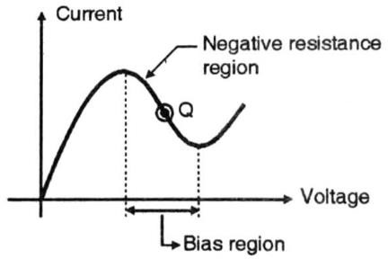**Fig.1. SET UP FOR STUDY OF GUNN OSCILLATOR**

Detecto r

Variable Attenuato

Isolator

# Fig.2. V-I Characteristics of Gunn Diode

* 1. **Observations :**

|  |  |  |
| --- | --- | --- |
| **Sr.No.** | **Gunn Voltage(V)** | **Gunn Current(mA)** |
| **1** |  |  |
| **2** |  |  |
| **3** |  |  |
| **4** |  |  |
| **5** |  |  |
| **6** |  |  |
| **7** |  |  |
| **8** |  |  |
| **9** |  |  |
| **10** |  |  |

# Post Experiment Exercise :

* 1. **Results :**

# Plot Gunn v/s current in a graph paper.

* 1. **Conclusion/Comments**

# Post Experiment Exercise Questions:

* + 1. Describe different modes of oscillation of Gunn diode.
    2. Differentiate between Transit time devices and Transferred electron devices.
    3. Explain the working of a negative resistance parametric amplifier.
    4. Explain any two avalanche transit time devices