**1.**

def palindrome(str):

strcheck = str[::-1]

if strcheck == str:

print("Its a palindrome")

else:

print("Its not a palindrome")

string = input("Enter your string: ")

palindrome(string)

**OUTPUT:**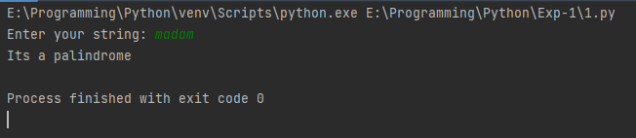

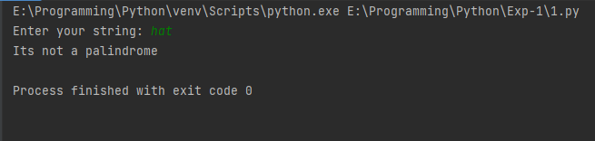

**2.**

num = int(input("Enter number: "))

print("Prime numbers:", end=' ')

for n in range(2, num):

for i in range(2, n):

if n % i == 0:

break

else:

print(n, end=' ')

**OUTPUT:**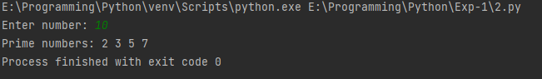

**3.**

def vowels(str1, vowel, char):

newstr = ""

for i in range(len(str1)):

if str1[i] in vowel:

newstr = newstr + char

else:

newstr = newstr + str1[i]

print("New string: ", newstr)

str1 = input("Enter string: ")

char = "*"

vowel = ['A', 'a', 'E', 'e', 'I', 'i', 'O', 'o', 'U', 'u']

vowels(str1, vowel, char)

**OUTPUT:**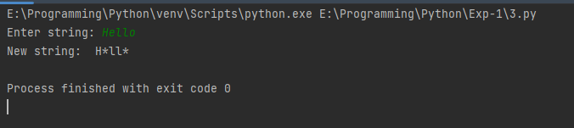

**4.**

def pattern(n):

for i in range(0, n):

for j in range(0, i + 1):

print("*", end=" ")

print("\r")

for i in range(n, 0, -1):

for j in range(0, i - 1):

print("*", end=" ")

print("\r")

number = int(input("Enter number: "))

pattern(number)

**OUTPUT:**