**Experiment 3**

**Functions and Lambda Functions**

1. Write the Pros and Cons of a Lambda Function in Python.
2. Write a Python program to find the second lowest total marks of any student(s) from the given names and marks of each student using lists and lambda. Input the number of students, the names and grades of each student.

Note: If there are multiple students with the same grade then print each name alphabetically.

1. Write a Python program to find numbers divisible by nineteen or thirteen from a list of numbers using Lambda.

**2.**

def second_lowest_marks(n, students):

student_list = [(name, marks) for name, marks in students]

student_list.sort(key=lambda x: x[1])

second_lowest = sorted(list(set([marks for name, marks in student_list])))[1]

second_lowest_students = sorted([name for name, marks in student_list if marks == second_lowest])

return second_lowest_students

n = int(input("Enter the number of students: "))

students = []

for i in range(n):

name = input("Enter the name of student: ")

marks = int(input("Enter the marks of student: "))

students.append((name, marks))

second_lowest_students = second_lowest_marks(n, students)

print("The students with the second lowest marks:")

for student in second_lowest_students:

print(student)

**OUTPUT:**

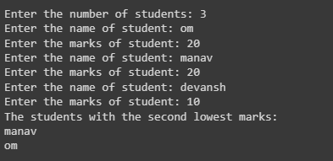

**3.**

numbers = [48,99,28,26,36,97,24,81,42,82]

result = list(filter(lambda x: x % 19 == 0 or x % 13 == 0, numbers))

print("The numbers divisible by 19 or 13:")

print(result)

**OUTPUT:**

