**Experiment 4**

1. Write a Python program that takes a text file as input and returns the number of words of a given text file.
2. Write a Python program to extract characters from various text files and puts them into a list.
3. Write a Python program to generate 26 text files named A.txt, B.txt, and so on up to Z.txt.
4. Write a Python program to create a file where all letters of English alphabet are listed by specified number of letters on each line.

**1.**

with open("input-1.txt") as f:

lines = f.read()

words = lines.split()

wordcount = len(words)

wordcount = str(wordcount)

f.close()

with open("output-1.txt", 'w') as f:

f.write(wordcount)

f.close()

**INPUT FILE:**

The computer wouldn't start. She banged on the side and tried again. Nothing. She lifted it up and dropped it to the table. Still nothing. She banged her closed fist against the top. It was at this moment she saw the irony of trying to fix the machine with violence.

**OUTPUT FILE:**

50

**2.**

lst = list()

paragraph = open('input-2_1.txt', 'r')

for line in paragraph:

line.rstrip()

word = line.split()

for j in word:

lst.append(j)

print(lst)

paragraph = open('input-2_2.txt', 'r')

lst = list()

for line in paragraph:

line.rstrip()

word = line.split()

for j in word:

lst.append(j)

print('\n', lst)

**INPUT-1 FILE:**

The picket fence had stood for years without any issue. That's all it was. A simple, white, picket fence. Why it had all of a sudden become a lightning rod within the community was still unbelievable to most. Yet a community that had once lived in harmony was now divided in bitter hatred and it had everything to do with the white picket fence.

**INPUT-2 FILE:**

Finding the red rose in the mailbox was a pleasant surprise for Sarah. She didn't have a boyfriend or know of anyone who was interested in her as anything more than a friend. There wasn't even a note attached to it. Although it was a complete mystery, it still made her heart jump and race a little more than usual. She wished that she could simply accept the gesture and be content knowing someone had given it to her, but that wasn't the way Sarah did things. Now it was time to do a little detective work and try to figure who had actually left the red rose.

**OUTPUT:**

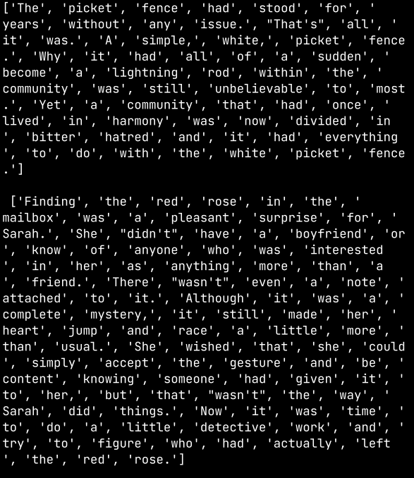

**3.**

import os

import string

path = 'E:/Programming/Python/Exp-4/3'

os.chdir(path)

for letter in string.ascii_uppercase:

with open(letter + ".txt", "w") as f:

f.writelines(letter)

**FILES CREATED:**

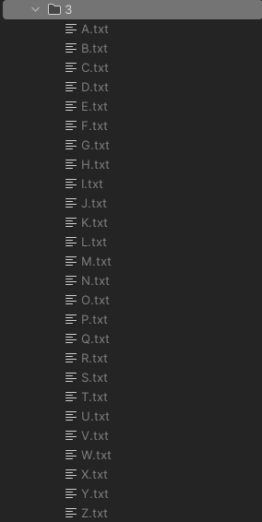

**4.**

def count_alphabets(filename):

with open(filename, 'r') as file:

contents = file.read().lower()

alphabet = 'abcdefghijklmnopqrstuvwxyz'

lettercount = {words: 0 for words in alphabet}

for char in contents:

if char in alphabet:

lettercount[char] += 1

return lettercount

alphabet_counts = count_alphabets('input-4.txt')

for letter, count in alphabet_counts.items():

print(f"{letter}: {count}")

**INPUT FILE:**

The bridge spanning a 100-foot gully stood in front of him as the last obstacle blocking him from reaching his destination. While people may have called it a "bridge", the reality was it was nothing more than splintered wooden planks held together by rotting ropes. It was questionable whether it would hold the weight of a child, let alone the weight of a grown man. The problem was there was no other way across the gully, and this played into his calculations of whether or not it was worth the risk of trying to cross it.

**OUTPUT:**

