**1)**

import numpy as np

arr = np.array([1, 2, 3, 10, 2, 3, 6])

# a

print('Max = ', np.max(arr))

print('Min = ', np.min(arr))

# b

print('Sorted = ', np.sort(arr))

# c

print('Mean = ', np.mean(arr))

# d

'''adding rows'''

array = np.array([[1, 2, 3], [4, 5, 6]])

new_row = np.array([7, 8, 9])

resultant_arr = np.append(array, [new_row], axis=0)

print(resultant_arr)

'''adding columns'''

new_column = np.array([10, 11, 12]).reshape((3, 1))

resultant_arr = np.append(resultant_arr, new_column, axis=1)

print(resultant_arr)

# e

print('Reversed = ', np.flip(arr))

# f

matrix_1 = np.array([[1, 2], [4, 5]])

print(matrix_1)

matrix_2 = np.array([[1, 2], [4, 5]])

print('Multiplication = ', np.multiply(matrix_1, matrix_2))

**OUTPUT:**

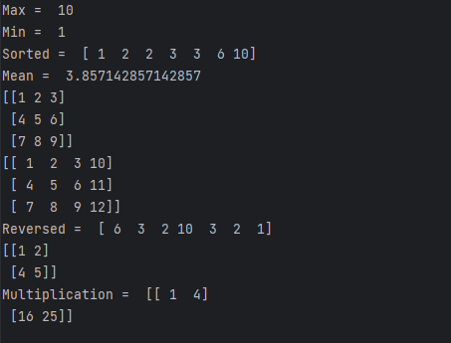

**2)**

import pandas as pd

# a

s1 = pd.Series([1, 2, 3, 4])

s2 = pd.Series([5, 6, 7, 8])

print('Addition: ', s1 + s2)

print('Subtraction: ', s1 - s2)

print('Multiplication: ', s1 * s2)

print('Division: ', s1 / s2)

# b

df = pd.DataFrame({'A': [1, 2, 3], 'B': [4, 5, 6], 'C': [7, 8, 9]})

first_column_series = df['A']

print("First column as a Series (using indexing):")

print(first_column_series)

# c

df = pd.DataFrame({'A': [1, 2, 3, 4],

'B': [5, 6, 7, 8],

'C': [9, 10, 11, 12],

'D': [13, 14, 15, 16]})

selected_columns = df[['A', 'C']]

print("Selected columns:")

print(selected_columns)

selected_rows = df[1:3]

print("\nSelected rows:")

print(selected_rows)

selected_columns_and_rows = df.loc[1:2, ['B', 'D']]

print("\nSelected columns and rows:")

print(selected_columns_and_rows)

# d

df = pd.DataFrame({'StudentID': [101, 102, 103, 104, 105],

'Attempts': [3, 4, 2, 5, 1]})

sum_attempts = df.groupby('StudentID')['Attempts'].sum()

print("Sum of examination attempts by students:")

print(sum_attempts)

# e

df = pd.DataFrame({'A': [1, 2, 3],

'B': [4, 5, 6]})

print("Original DataFrame:")

print(df)

dict_list = [{'A': 4, 'B': 7},

{'A': 5, 'B': 8}]

df_to_append = pd.DataFrame(dict_list)

df = pd.concat([df, df_to_append], ignore_index=True)

print("\nDataFrame after appending list of dictionaries:")

print(df)

new_series = pd.Series({'A': 6, 'B': 9})

df = pd.concat([df, new_series], axis=1)

print("\nDataFrame after appending Series:")

print(df)

# f

df1 = pd.DataFrame({'id': [1, 2, 3],

'A': ['a1', 'a2', 'a3'],

'B': ['b1', 'b2', 'b3']})

df2 = pd.DataFrame({'id': [4, 5, 6],

'A': ['a4', 'a5', 'a6'],

'B': ['b4', 'b5', 'b6']})

df3 = pd.DataFrame({'id': [2, 3, 6],

'C': ['c2', 'c3', 'c6'],

'D': ['d2', 'd3', 'd6']})

print("DataFrame 1:")

print(df1)

print("\nDataFrame 2:")

print(df2)

print("\nDataFrame 3:")

print(df3)

joined_df = pd.concat([df1, df2], ignore_index=True)

print("\nJoined DataFrame (df1 and df2):")

print(joined_df)

merged_df = pd.merge(joined_df, df3, on='id')

print("\nMerged DataFrame (joined_df and df3):")

print(merged_df)

**OUTPUT:**

