|  |
| --- |
| 20th ADADA2022 Conference Proceeding Format for Technical Papers |
| | 1st Author Name  Affiliation  Address  e-mail address | 2nd Author Name  Affiliation  Address  e-mail address | 3rd Author Name  Affiliation  Address  e-mail address | 4th Author Name  Affiliation  Address  e-mail Address | | --- | --- | --- | --- | |
| **Abstract**  Technical Papers are a conventional academic papers. The authors are requested to give their oral presentations at the conference. Any topics about digital art/design fields ranging from technical research to cultural matters can be accepted. Artistic projects are encouraged to submit as Art Papers. In any case, your presentation should mention both aesthetic aspects and technical aspects of your project. Also, a process of the project should be explained logically, and your contribution to digital art/design field must be clarified. Regardless of your topic, you must describe your project in a scholarly manner. If your research could be an interactive system, we strongly recommend you to submit your system to not only papers but also demos. Art Papers are more artistically-oriented papers than Technical Papers. You can present any type of artwork, as long as digital technologies are used in it. If you produced a cutting-edge digital art such as a computer animation and an interactive art, Art Papers would be a great showcase at an oral presentation. You can share your ideas between hundreds of artists and researchers, and it may evoke a synergistic effect in the Asian digital art community. You should describe an artistic motivation, a background of your artwork, and how digital technologies are involved in your work, and so on. If your research could be an interactive system, we strongly recommend you to submit your system to not only papers but also demos. Poster submission provides a venue for authors to present work in progress reports. The Poster presentation also provides you with further discussion from experts. We believe this opportunity will be a great help to advance your work. Demo submission offers a space for displaying artworks, technical demos and any other demonstrations which include interactive arts and systems. If you have interactive systems for demonstration, we strongly recommend you to submit your systems to not only papers but also demos. All submission must be made online through our online submission system. That is, we do not accept submissions via e-mail or postal mail. Please submit a PDF proceeding written in only English. The committee will select papers of exceptional quality for an award from all categories. Furthermore, authors of the selected technical papers and art papers from the conference will be invited to prepare an extended version of their paper to be considered for publishing in ADADA International Journals (ADADA Journal). |
| **Keywords:** keyword1, keyword2, keyword3 (up to 3phrases, serif font, 10pt) |
|  |

**1 Headline (serif font, bold, 12pt)**

Mauris porta accumsan turpis bibendum suscipit. Proin nec nibh ligula. Aliquam a purus eu est gravida posuere id a libero. Suspendisse eget vulputate lacus. Etiam pretium, diam ut imperdiet tempor, velit diam gravida tortor, ac eleifend sem mauris vitae lorem. Phasellus sed nibh diam, eget adipiscing augue. Phasellus adipiscing laoreet massa, ornare dignissim eros interdum id. Praesent placerat suscipit velit, ut varius bibendum sollicitudin. Suspendisse quis tortor nibh, vitae blandit libero suscipit sapien porttitor ut. Nulla facilisi. Integer vestibulum porta neque ut tincidunt. Nam quis tellus turpis. Maecenas bibendum vulputate mi, quam id ipsum vitae venenatis arcu hendrerit a. Etiam rhoncus rhoncus dui eu pretium. eros, in aliquam nulla. Donec elementum mi sapien. Pellentesque ullamcorper dignissim dignissim. Donec elementum mi sapien. Pellentesque ullamcorper dignissim dignissim. Sed mattis pulvinar lacus, id tincidunt ligula tincidunt quis. Nullam eu pulvinar elit. In hac habitasse platea dictumst. Suspendisse nec urna at odio ullamcorper mattis quis quis

**2 Headline**

Praesent fringilla velit nec nunc posuere commodo. Aliquam ac lorem in tortor molestie mattis. Proin malesuada est sit amet diam auctor ornare. Donec et nisl non turpis dictum aliquet. Aliquam sed ante ut nibh tempor posuere. Nunc id libero at enim tincidunt varius. Vivamus ultrices urna et ipsum laoreet at aliquet mi sollicitudin. Morbi varius bibendum sollicitudin. Suspendisse quis tortor nibh, vitae blandit libero. Nullam eu pulvinar elit. In hac habitasse platea dictumst. Suspendisse nec urna at odio ullamcorper mattis quis quis nunc. Donec lacinia lobortis eros, pulvinar malesuada metus facilisis et. In nec lectus eu purus feugiat semper. Nam eu libero mauris, eu

Figure 1: Sample of a wide figure. Be sure to place at the top of the page or bottom of the page.

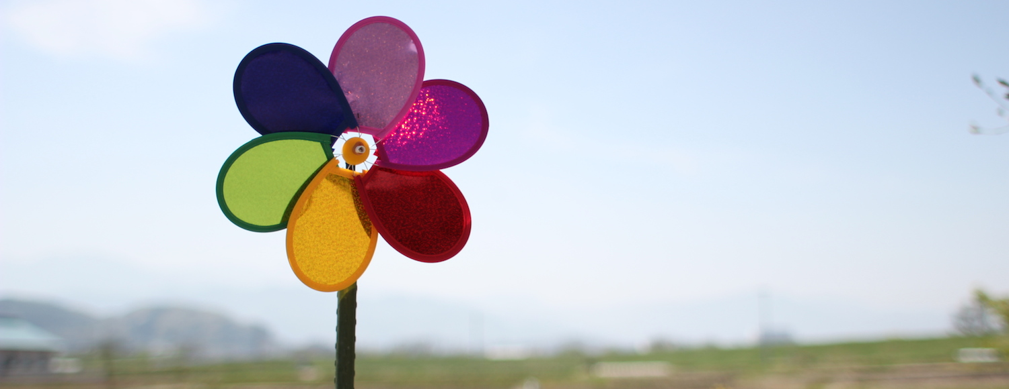

tincidunt diam. In elit urna, bibendum sit amet mollis et, sollicitudin id metus. Integer tristique dictum pellentesque. Donec quam quam, elementum non tristique nec, vestibulum at felis. Duis eget sem nec lectus semper sollicitudin. Integer varius erat sed est placerat vel venenatis velit feugiat. Curabitur aliquam facilisis sollicitudin. Aliquam a purus eu est gravida posuere id a libero. Suspendisse eget vulputate lacus. Etiam pretium, diam ut imperdiet tempor, velit diam gravida tortor, ac eleifend sem mauris vitae lorem. Vivamus scelerisque, nunc sed congue tincidunt, metus libero ultricies mauris, ut aliquam erat diam sed libero. secongue. Lorem ipsum dolor sit amet, consectetur adipiscing elit. Pellentesque sagittis auctor libero, euismod convallis sapien ultricies scelerisque. Sed vel felis a tortor accumsan elementum. Pellentesque eros ipsum, gravida quis tempus quis, elementum vel elit. Proin luctus aliquet magna, eget posuere augue egestas sed. Nullam dictum molestie ipsum, faucibus fringilla risus viverra quis. Fusce diam felis, sagittis et sodales imperdiet, consequat at ipsum. In non scelerisque justo. In tempus commodo mattis. Ut id neque vitae tellus semper commodo a ut eros. Mauris non libero eu mauris interdum fringilla. Vestibulum egestas auctor dui id tristique. Class aptent taciti sociosqu ad litora torquent per conubia nostra, per inceptos himenaeos. Curabitur sed ante arcu, imperdiet posuere ipsum. Curabitur vel tellus lorem. Quisque vitae ipsum ipsum, id mollis lacus. Cras faucibus aliquam luctus. Vestibulum id nulla eget tortor aliquet faucibus non non velit. Curabitur eu volutpat magna.

Table 1: serif font, 9pt, numbered

| Objects | **Caption Position** |
| --- | --- |
| Tables | Above |
| Figures | Below |

Aenean hendrerit tincidunt faucibus. Praesent vitae quam nec magna vulputate pretium at id urna. Phasellus eget nibh nisl, nec scelerisque nibh. Phasellus pulvinar rutrum metus et

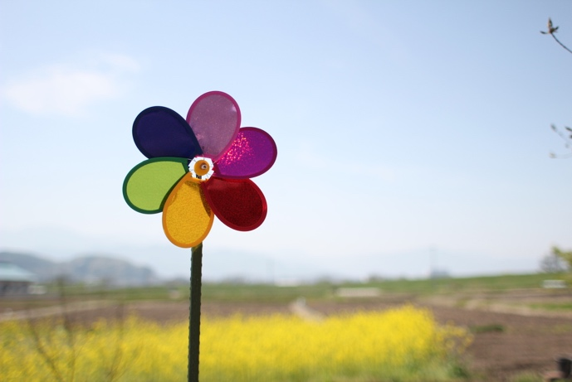

Figure 2: serif font, 9pt, numbered

Phasellus nibh nisl, fermentum quis molestie vitae, cursus ut eros. Phasellus vel euismod quam. Vestibulum luctus tincidunt volutpat.

**References**

All references should be listed according to the order of the citation. Put the citation number in square brackets [ ]. Please include the following information in each reference.

- author(family-name-first style)

- *title(italic)*

- name of the publication

- publisher

- issue

- page(s)

- year

e.g. (journal)

[1] Sutherland, I. E., *Ten Unsolved Problems in Computer Graphics*, Datamation, Vol. 12, No. 5, pp. 22-27, 1966.

e.g. (book)

[2] Rowling, J. K., *Harry Potter and the Deathly Hallows*, Arthur A. Levine Books, 2007