LESSON 3.3 — ADDING INTEGERS

1. Learning Targets

Competency: Grade 7, Quarter 3, Number and Algebra, Competency 9: add integers using concrete counters, pictorial models, and numerals.
By the end of this lesson, you can:
• model integer sums with positive and negative counters;
• show integer addition as moves on a number line;
• add integers using the sign rules;
• use number properties to add several integers quickly.
Essential Questions: (1) Why does a zero pair equal zero? (2) How does a number line show the sign of a sum? (3) When is a sum of integers negative?
🎥 INTERACTIVE MULTIMEDIA: Adding Numbers with Different Signs
Channel: Khan Academy
Direct Link: Watch the video
Concepts to observe:
- Moving right for positive addends and left for negative addends.
- Why the sum takes the sign of the addend with the larger absolute value.
Questions:
1. In the video, which direction does a negative addend move you?
2. Why can a sum of a positive and a negative number be positive, negative, or zero?
3. How could you check a sum using a number line?

Background. Many quantities have a direction: a ₱50 deposit and a ₱80 withdrawal, a 3 °C rise and a 5 °C drop. Integers record both the size and the direction of a change. Adding integers finds the net change.

2. Subtopic 1: Counters and Zero Pairs

A blue counter stands for +1 and a red counter stands for −1. A blue and a red counter together make a zero pair.
📐 KEY CONCEPT: Zero Pair
One positive counter and one negative counter add to zero.
$$(+1) + (−1) = 0$$
Adding or removing zero pairs never changes a sum.

To add with counters, put both addends together, circle the zero pairs, and count what is left.
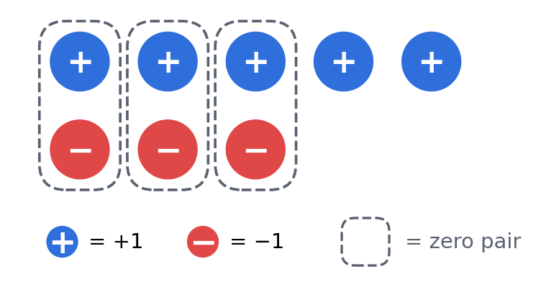
Figure 3.3.1 +5 + (−3). Three zero pairs cancel; two positives remain, so the sum is +2.
When both addends have the same sign, there are no zero pairs. Just count all the counters.
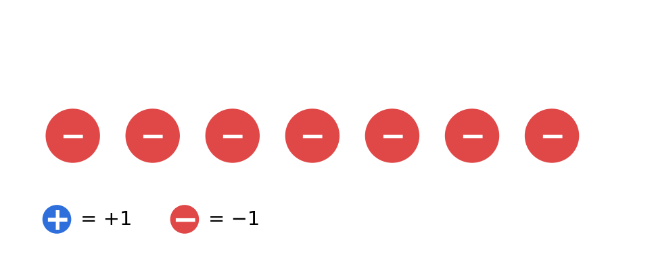
Figure 3.3.2 −3 + (−4). No zero pairs; seven negatives remain, so the sum is −7.
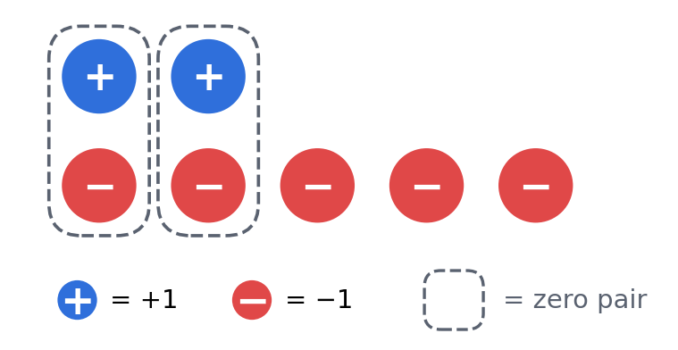
Figure 3.3.3 2 + (−5). Two zero pairs cancel; three negatives remain, so the sum is −3.
Counters | Expression | Sum
5 blue, 3 red | $5 + (−3)$ | +2
0 blue, 7 red | $(−3) + (−4)$ | −7
2 blue, 5 red | $2 + (−5)$ | −3
6 blue, 6 red | $6 + (−6)$ | 0

Quick Check 3.3A
1. Model 4 + (−6) with counters. | 2. How many counters remain in 8 + (−8)? | 3. Model −2 + (−3). Are there zero pairs?

3. Subtopic 2: Adding on a Number Line

Start at the first addend. Move right for a positive addend and left for a negative addend. The point where you stop is the sum.
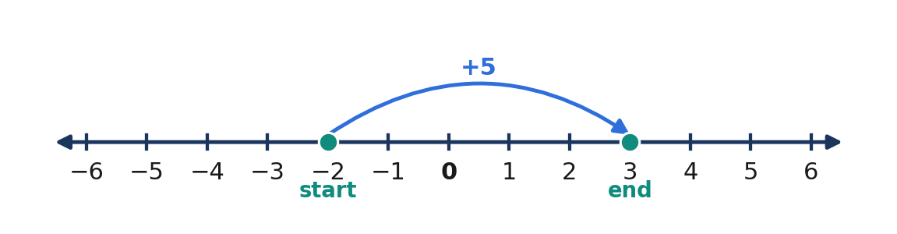
Figure 3.3.4 −2 + 5 = 3. Start at −2 and move 5 units right.
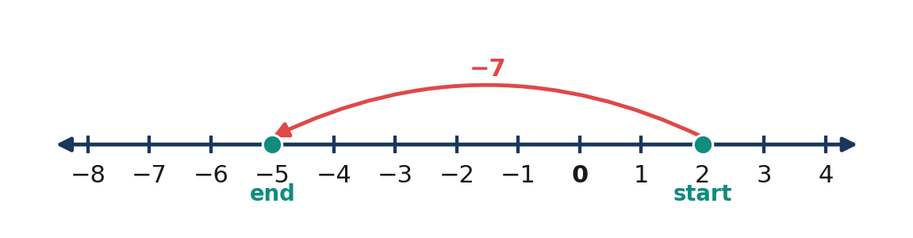
Figure 3.3.5 2 + (−7) = −5. Start at 2 and move 7 units left.
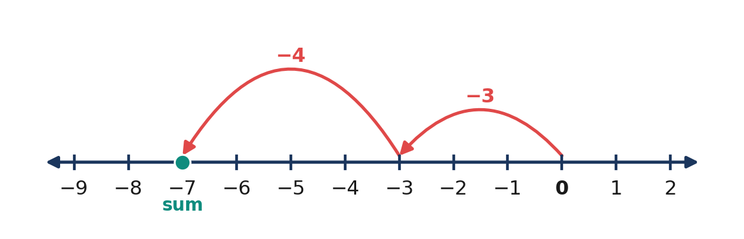
Figure 3.3.6 (−3) + (−4) = −7. Two moves to the left.
Expression | Start | Move | Stop (sum)
$−3 + 7$ | −3 | 7 right | 4
$2 + (−5)$ | 2 | 5 left | −3
$−4 + (−2)$ | −4 | 2 left | −6
$6 + 0$ | 6 | no move | 6

Quick Check 3.3B
1. Describe the moves for −5 + 9. | 2. Find −3 + (−4) on a number line. | 3. Where do you stop for 6 + (−6)?

4. Rules and Worked Examples

📐 KEY CONCEPT: Rules for Adding Integers
Same signs: add the absolute values and keep the common sign.
$$(−a) + (−b) = −(a + b)$$
Different signs: subtract the smaller absolute value from the larger, then keep the sign of the number with the larger absolute value.
$$a + (−b) = a − b, if a ≥ b$$
$$a + (−b) = −(b − a), if b > a$$
Here a and b are whole numbers.

💡 Worked Example 1 — Two Temperature Drops
Problem: The temperature drops 4 °C, then drops another 7 °C. Find the total change.
Given: changes of −4 °C and −7 °C Find: the total change Rule: same signs
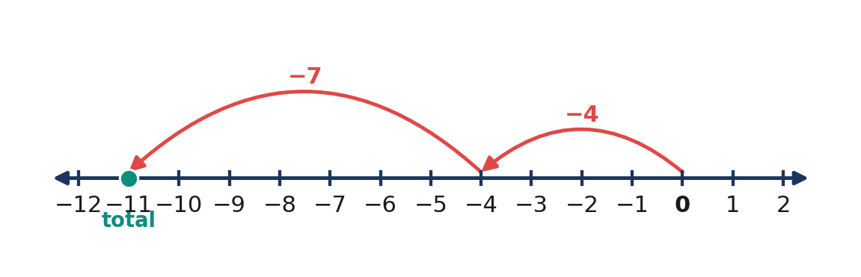
Figure 3.3.7 Two drops: 4 units left, then 7 more units left.
$(−4) + (−7)$ | $= −(4 + 7)$ | same signs: add the absolute values, keep −
 | $= −11$ | simplify

Answer: The total change is −11 °C, a drop of 11 °C.

💡 Worked Example 2 — Saving and Spending
Problem: A learner saves ₱150, then spends ₱230. Find the net change in the learner's money.
Given: +150 and −230 Find: the net change in pesos Rule: different signs
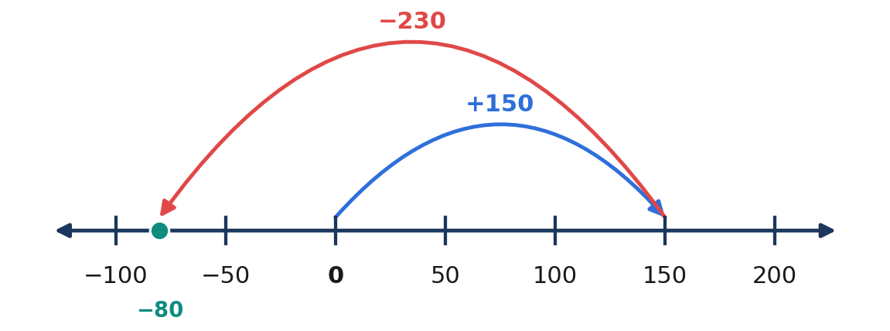
Figure 3.3.8 Move 150 right, then 230 left. The stop is −80.
$150 + (−230)$ | $= −(230 − 150)$ | different signs: subtract, keep the sign of the larger
 | $= −80$ | simplify

Answer: The net change is −₱80, a decrease of ₱80. This is a change, not a balance: the starting amount is not given.

💡 Worked Example 3 — An Elevator Ride
Problem: An elevator starts at basement level −3 and goes up 8 floors. On which floor does it stop?
Given: start −3, change +8 Find: the final floor Rule: different signs
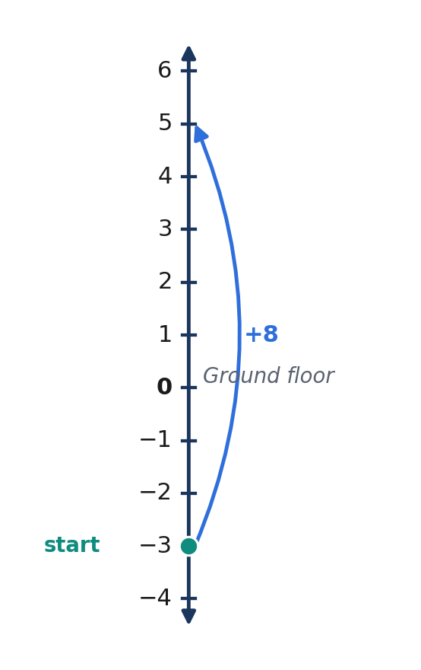
Figure 3.3.9 Start at −3 and move 8 floors up.
$−3 + 8$ | $= 8 − 3$ | different signs: subtract the absolute values
 | $= 5$ | 8 has the larger absolute value, so the sum is positive

Answer: The elevator stops at floor 5.

💡 Worked Example 4 — Adding Several Integers Quickly
Problem: Find $(−17) + 25 + 17 + (−5)$.
Given: four addends Find: the sum Rule: commutative and associative properties, then the inverse property
$(−17) + 25 + 17 + (−5)$ | $= [(−17) + 17] + [25 + (−5)]$ | regroup opposites and easy pairs
 | $= 0 + 20$ | inverse property; different signs
 | $= 20$ | identity property

Answer: The sum is 20.

5. Mathematical Reasoning and Common Misconceptions

⚠️ WATCH OUT — Common Errors
• Wrong: −5 + (−3) = −2. Right: −8. Both addends move left, so add the absolute values.
• Wrong: 3 + (−8) = 5. Right: −5. The number with the larger absolute value, −8, is negative.
• Wrong: 7 + (−7) = 14. Right: 0. Opposites form seven zero pairs.

Reasoning Challenge. Without adding, explain why $−14 + 9$ must be negative. Then check whether $9 + (−14)$ gives the same result, and name the property.

6. Subtopic 3: Properties and Applications

📐 KEY CONCEPT: Properties of Integer Addition
$$a + b = b + a (Commutative)$$
$$(a + b) + c = a + (b + c) (Associative)$$
$$a + 0 = a (Identity)$$
$$a + (−a) = 0 (Inverse)$$

The order of addends does not change the sum. Both paths below stop at 3.
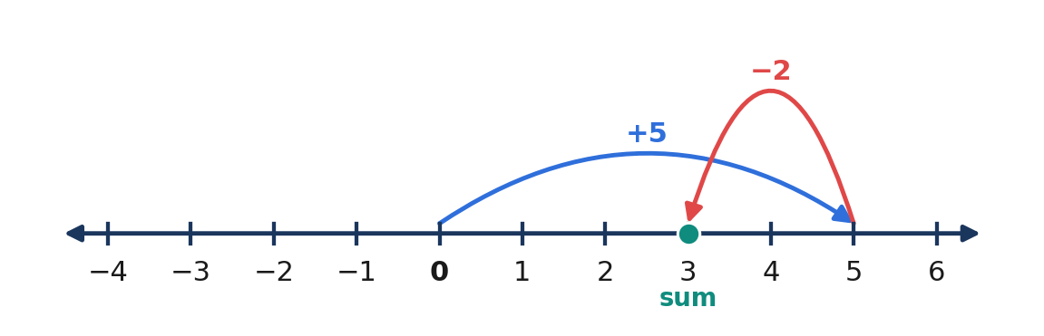
Figure 3.3.10 5 + (−2) = 3.
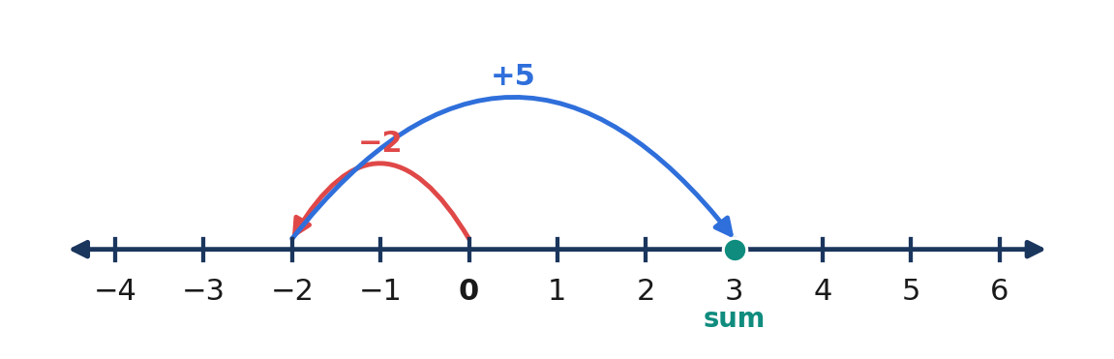
Figure 3.3.11 (−2) + 5 = 3. Same sum: the commutative property.
A vertical number line suits depth and height. Sea level is 0; below sea level is negative.
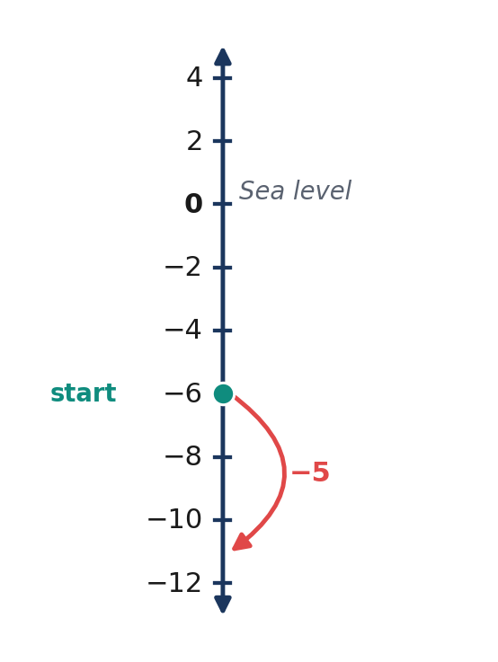
Figure 3.3.12 A diver at −6 m descends 5 m more and reaches −11 m.
Step | What to do | Example: $−6 + 10$
1 | Compare the signs | different signs
2 | Compare the absolute values | 10 > 6
3 | Subtract the absolute values | 10 − 6 = 4
4 | Keep the sign of the larger | positive
5 | State the sum | 4

Quick Check 3.3C
1. Evaluate −19 + 12. | 2. Group to add 15 + (−9) + 4. | 3. A diver at −6 m descends 5 m. Where is the diver?

7. Practice

Basic
1. (+8) + (+13) | 2. (−9) + (−6) | 3. (+17) + (−24)
4. (−35) + (+35) | 5. (−12) + 5 | 6. 14 + (−6)
7. (−20) + (−30) | 8. 0 + (−18) | 9. (−7) + 19
10. 25 + (−40) | 11. (−11) + (−11) | 12. (−3) + 3 + (−4)

Intermediate
13. Find the missing number: (−6) + ☐ = 4 | 14. Find the missing number: ☐ + (−9) = −15
15. (−12) + 7 + (−5) | 16. (−25) + 13 + 25 + (−3)
17. Draw counters for 4 + (−6), then give the sum. | 18. Show (−5) + (−2) on a number line.

Challenge and Word Problems
19. A submarine is 120 m below sea level. It rises 45 m, then dives 30 m. Where is it now?
20. Ana has ₱250. She spends ₱180, receives ₱75, then spends ₱60. Find her final amount and her net change.
21. The sum of two integers is −3. One of them is 8. What is the other?
22. Without calculating, decide whether (−47) + 38 is positive or negative. Explain, then find the sum.

8. Contextual Application: A Three-Day Fund Record

A class fund changes by +₱180 on Monday, −₱245 on Tuesday, and +₱90 on Wednesday. (1) Write the three signed changes. (2) Draw one number-line path for the net change. (3) Find the net change by grouping. (4) Explain why the final balance cannot be found without the starting balance.
Scoring (15 points): signed changes, 3; number-line model, 3; correct net change with work, 4; change versus balance explained, 3; conclusion in pesos, 2.

9. Exit Ticket and Lesson Summary

3-2-1 Exit Ticket: 3 facts about adding integers; 2 mistakes to avoid; 1 way to check a sum.
LESSON SUMMARY
• A zero pair, $(+1) + (−1)$, equals 0.
• On a number line, positive addends move right and negative addends move left.
• Same signs: add the absolute values and keep the sign.
• Different signs: subtract the absolute values and keep the sign of the larger absolute value.
• Commutative, associative, identity, and inverse properties make long sums easier.

10. Formative Assessment

Items 1–10: Choose the best answer.
Item | Question and choices
1 | What is (−7) + (−5)? [ ] A. −2 [ ] B. 12 [ ] C. −12 [ ] D. 2
2 | What is 4 + (−9)? [ ] A. −5 [ ] B. 5 [ ] C. −13 [ ] D. 13
3 | Which sum equals zero? [ ] A. −6 + (−6) [ ] B. 6 + 6 [ ] C. −6 + 3 [ ] D. −6 + 6
4 | Start at −3 and move 8 units right. Where do you stop? [ ] A. −11 [ ] B. 5 [ ] C. −5 [ ] D. 11
5 | Which property shows 2 + (−7) = (−7) + 2? [ ] A. Associative [ ] B. Commutative [ ] C. Identity [ ] D. Inverse
6 | Seven blue and ten red counters show which sum? [ ] A. 17 [ ] B. 3 [ ] C. −17 [ ] D. −3
7 | What is −15 + 0? [ ] A. −15 [ ] B. 0 [ ] C. 15 [ ] D. 1
8 | What is −20 + 7 + 20? [ ] A. −7 [ ] B. −33 [ ] C. 7 [ ] D. 47
9 | The temperature is −2 °C and rises 6 °C. What is the new temperature? [ ] A. 4 °C [ ] B. −8 °C [ ] C. 8 °C [ ] D. −4 °C
10 | What is 18 + (−25)? [ ] A. 7 [ ] B. 43 [ ] C. −43 [ ] D. −7

Items 11–15: Show your work.
11. Use counters to explain why 6 + (−9) = −3.
12. Show −4 + 7 on a number line and state the sum.
13. Find (−18) + 26 + 18 + (−6) by grouping. Name the properties you used.
14. A diver at −12 m rises 5 m, then descends 9 m. Find the final position.
15. Is the sum of a positive and a negative integer always negative? Give three examples.

ANSWER KEY — LESSON 3.3

Item | 1 | 2 | 3 | 4 | 5 | 6 | 7 | 8 | 9 | 10
Answer | C | A | D | B | B | D | A | C | A | D

Item | Model answer
11 | Six zero pairs cancel; three red counters remain, so the sum is −3.
12 | Start at −4 and move 7 right; stop at 3.
13 | [(−18) + 18] + [26 + (−6)] = 0 + 20 = 20; commutative, associative, inverse, identity.
14 | −12 + 5 + (−9) = −16; the diver is 16 m below the surface.
15 | No. 5 + (−2) = 3; 2 + (−5) = −3; 5 + (−5) = 0.

Practice | Answers
Quick Check 3.3A | 4 blue and 6 red: four zero pairs, −2 remains; 0 counters remain; −5, no zero pairs.
Quick Check 3.3B | Start at −5, move 9 right, stop at 4; −7; 0.
Quick Check 3.3C | −7; [15 + (−9)] + 4 = 10; −11 m.
Basic 1–12 | 21; −15; −7; 0; −7; 8; −50; −18; 12; −15; −22; −4.
Intermediate 13–18 | 10; −6; −10; 10; −2; −7.
Challenge 19–22 | −120 + 45 + (−30) = −105, so 105 m below sea level; ₱85 left, net change −₱165; −11; negative because 47 > 38, sum −9.
Contextual application | 180 + (−245) + 90 = 25: a net gain of ₱25.

