MATHEMATICS 7 • QUARTER 3

STATISTICS AND THE SET OF INTEGERS

Data Collection and Statistical Graphs • Integers and Number-Line Reasoning • Operations with Integers
FRONT COVER AI IMAGE PROMPT
Tier 1 — Primary Headline: “MATHEMATICS 7”
Tier 2 — Secondary Title: “QUARTER 3: STATISTICS AND THE SET OF INTEGERS”
Tier 3 — Scope Line: “Data Collection & Statistical Graphs • Integers • Integer Operations”
AI Generation Prompt (DALL-E 3 / Midjourney v6):
A prestigious educational textbook cover in a warm hand-painted Studio Ghibli-inspired watercolor aesthetic. At the top, a sleek deep navy banner with three clear typography tiers: bold white headline “MATHEMATICS 7”, warm gold secondary title “QUARTER 3: STATISTICS AND THE SET OF INTEGERS”, and light silver scope line “Data Collection & Statistical Graphs • Integers • Integer Operations”. In the lower two-thirds, two Filipino Grade 7 learners in neat modern school uniforms without badges collaborate in an open-air school courtyard, examining a large clean poster that combines a simple bar graph, a pie chart with clearly separated sectors, and a horizontal integer number line from negative to positive values. Nearby are a notebook, a small stack of graph-paper sheets, and colored counting counters arranged in positive-negative pairs. Tropical trees and distant Philippine hills appear softly in the background under gentle morning light. Warm watercolor background art, expressive but academically focused, clean textbook composition, crisp geometry, no distorted equations, no extra text, no logos, no watermark, no branding --ar 8.5:11 --v 6.0
Replacement Note: Replace this box with the generated cover artwork in the final Word layout.

Mathematics 7 • Quarter 3

PREFACE AND PEDAGOGICAL FRAMEWORK

Mathematics becomes meaningful when learners can use it to describe information, compare quantities, recognize structure, and justify decisions. Quarter 3 develops these habits through two connected strands: statistics and integers. The first strand begins with the collection, organization, representation, and interpretation of data. Learners examine how sampling choices affect the quality of information, construct frequency distribution tables, and select suitable representations such as bar graphs, line graphs, pie graphs, and stem-and-leaf plots. The second strand extends number sense beyond zero into the set of positive and negative integers, then develops comparison, ordering, absolute value, and the four fundamental operations. Together, these topics strengthen the ability to move among concrete models, diagrams, symbolic notation, and real-world situations.
The quarter follows a 70/30 instructional balance. Approximately seventy percent of the learning experience is devoted to explicit conceptual development, visual models, mathematical reasoning, worked examples, and guided interpretation. The remaining thirty percent is devoted to practice, contextual problem solving, reflection, and assessment. In Mathematics, this balance is not expressed through long essay-like exposition. Instead, each lesson is structured as a sequence of short explanations followed immediately by formulas, code-drawn figures, worked examples, and graded exercises. Important rules appear in clearly marked concept boxes; common errors are addressed through “Watch Out” contrasts; and major procedures are demonstrated through complete step-by-step solutions.
Every lesson is designed to connect conceptual understanding with procedural fluency. Statistics lessons require learners to explain why a graph is appropriate, not merely draw it. Integer lessons require learners to interpret signs and direction, not merely memorize operation rules. Number lines, counters, bar graphs, pie graphs, line graphs, and stem-and-leaf plots are used as mathematical evidence. Worked examples follow a consistent structure: Problem, Given, Find, Formula or Rule, Step Solution, and Final Answer. Practice then progresses from basic computation or identification to intermediate reasoning and finally to challenge problems that require learners to interpret conditions, choose a strategy, and communicate a defensible solution.
The quarter also supports mathematical communication and responsible use of information. Learners are expected to distinguish organized data from unsupported impressions, interpret graphical displays carefully, and recognize how scale, category choice, and sampling can influence conclusions. In integer work, learners connect positive and negative values to familiar settings such as temperature, elevation, financial change, movement along a number line, and gains or losses. These contexts are used to clarify meaning while keeping mathematical reasoning central. Technology may be used for checking graphs or calculations, but learners remain responsible for explaining the mathematical structure behind an answer.
Assessment is continuous and cumulative. Each lesson closes with a 15-item formative assessment consisting of ten multiple-choice items and five open analytical or calculation items. The quarter concludes with a comprehensive assessment and one culminating performance task using a GRASPS framework and a 4×4 analytic rubric. Answer keys are organized in structured tables, with rationales for analytical items and full concordance with the exercises and assessments. The complete quarter is paced to remain within a 45–70 page publication target while preserving every explanation, figure specification, formula, example, exercise, and assessment item in full.

TABLE OF CONTENTS

Mathematics 7 • Quarter 3 • Lessons 3.1–3.6
Preface and Pedagogical Framework ........................................ 2
Lesson 3.1 — Statistics and Basic Terms ................................ 4
Curriculum Alignment and Statistical Inquiry ........................ 4
Data Collection, Sampling, and Frequency Tables ...................... 5
Statistical Graphs and Appropriate Representation .................... 7
Interpreting Graphs and Avoiding Misleading Conclusions ............... 9
Guided Practice, Application, Reflection, and Assessment ............. 10
Lesson 3.2 — The Set of Integers ....................................... 12
Meaning and Structure of the Integers ................................ 12
Positive and Negative Numbers in Context ............................. 14
Number-Line Location, Opposites, and Ordering ........................ 16
Absolute Value and Distance from Zero ................................ 18
Guided Practice, Application, Reflection, and Assessment ............. 19
Lesson 3.3 — Adding Integers ........................................... 20
Addition on the Number Line .......................................... 20
Zero Pairs and Integer Counters ...................................... 22
Same-Sign and Different-Sign Addition Rules .......................... 24
Mathematical Reasoning and Error Analysis ............................ 26
Guided Practice, Application, Reflection, and Assessment ............. 27
Lesson 3.4 — Subtracting Integers ...................................... 28
Subtraction as Distance and Change ................................... 28
Add-the-Opposite Principle ........................................... 30
Counter and Number-Line Models ....................................... 32
Multi-Step Integer Expressions ....................................... 34
Guided Practice, Application, Reflection, and Assessment ............. 35
Lesson 3.5 — Multiplying Integers ...................................... 36
Multiplication as Equal Groups and Repeated Change ................... 36
Sign Rules for Products .............................................. 38
Properties and Simplification of Products ............................ 40
Applied Integer Multiplication ....................................... 42
Guided Practice, Application, Reflection, and Assessment ............. 43
Lesson 3.6 — Dividing Integers ......................................... 44
Division as Inverse Multiplication ................................... 44
Sign Rules for Quotients ............................................. 46
Integer Division in Numerical Expressions ............................ 48
GEMDAS and Integrated Integer Operations ............................. 50
Guided Practice, Application, Reflection, and Assessment ............. 51
Comprehensive Quarter Assessment ....................................... 52
Quarter Culminating Performance Task and 4×4 Analytic Rubric ........... 55
Quarter Synthesis and Glossary ......................................... 57
Structured Answer Keys and Solution Rationales ......................... 60
Editorial Quality and Curriculum Audit ................................ 67

LESSON 3.1 — STATISTICS AND BASIC TERMS

Content Domain: Data and Probability (DP)
Curriculum Alignment: Grade 7, Quarter 3, learning competencies 1–4: investigate collection and sampling techniques; organize statistical data in a frequency distribution table; represent organized data in pie, bar, and line graphs and stem-and-leaf plots; interpret statistical graphs.
Content Standard: Knowledge and understanding of data collection, sampling, appropriate data tables and graphs, and interpretation of statistical displays.
Performance Standard: Collect and organize data in frequency tables; represent and interpret data using appropriate graphs.
Essential Questions
1. How do collection and sampling methods influence whether statistical evidence is trustworthy?
2. How can a frequency table and different graphs represent the same observations accurately?
3. How do graph design and interpretation affect the conclusions drawn from data?
🎥 INTERACTIVE MULTIMEDIA: FREQUENCY TABLES AND DOT PLOTS
Channel: Khan Academy
Direct Link: https://www.youtube.com/watch?v=gdE46YSedvE
Observe: (1) conversion of raw observations into frequencies; (2) the relationship between tables and plotted marks; (3) checking that every observation is accounted for.
Viewing Questions: (1) What does one tally or plotted mark represent? (2) Why must the table total equal the number of observations? (3) How might an incorrect frequency change a school decision?

Background: Why Statistics Matters
Statistics is the study of methods for collecting, organizing, presenting, analyzing, and interpreting data. A school may examine reading time, travel methods, or water consumption to make informed decisions. A graph is useful only if the observations are relevant and recorded correctly. A colorful chart cannot repair a biased questionnaire or missing responses.
The statistical process starts with a question that can be investigated using evidence. A class might ask, “How many days per week do Grade 7 learners read for at least twenty minutes?” Students then choose whom to ask, write an unambiguous question, record responses, count frequencies, draw an appropriate display, and interpret the result with suitable limits. These steps connect mathematics to responsible decision-making rather than merely producing attractive diagrams.

3.1.1 — DATA, VARIABLES, POPULATIONS, AND SAMPLES

A population includes all individuals or objects about which a study aims to draw a conclusion. A sample is a subset observed from that population. A census measures every member, while a sample survey measures only selected members. For example, a schoolwide study of every Grade 7 learner concerns a population larger than the students in one section.
A variable is a characteristic that changes among observations. Categorical data label groups, such as commuting method; numerical data express counts or measurements, such as the number of books read. Numerical values can be discrete counts or continuous measurements. Selecting a display requires understanding this difference.
Term | Meaning | Example
Population | Entire group of interest | All Grade 7 learners in a school
Sample | Selected portion of the population | 40 Grade 7 learners selected across sections
Variable | Attribute observed or measured | Daily reading minutes
Data | Recorded values of a variable | 10, 20, 15, 30 minutes
Frequency | Number of occurrences | Six learners report 20 minutes
Census | Data collected from every member | Survey of all 180 Grade 7 learners

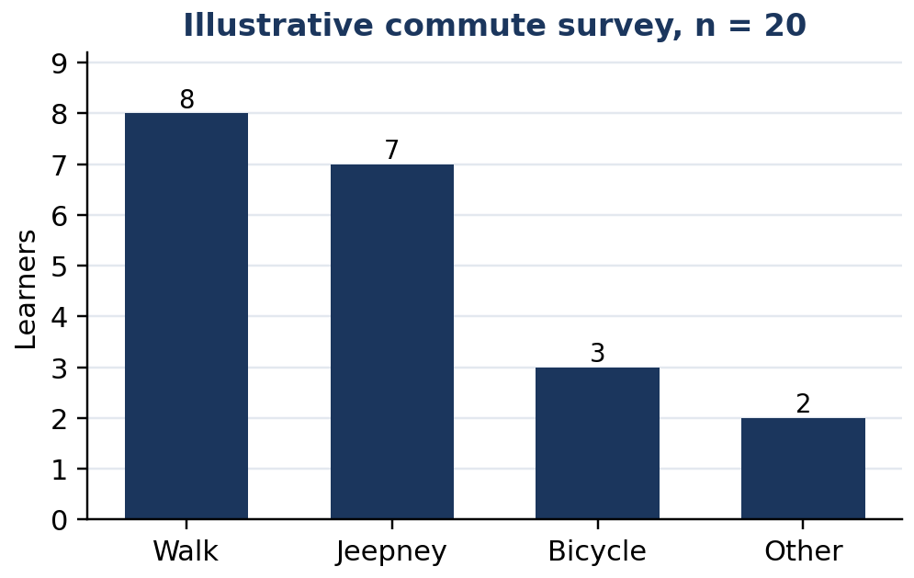
Figure 3.1.1 Figure 3.1.1. Each bar counts one commuting category in a 20-learner sample.
Collection and Sampling Techniques
A questionnaire asks the same written questions; an interview allows spoken clarification; direct observation records what occurs; and an experiment records outcomes under specified conditions. A simple random sample gives every individual an equal selection chance. A systematic sample selects every kth member after a random start. A stratified sample draws from relevant subgroups, such as sections. A convenience sample selects the easiest available respondents and can be unrepresentative.
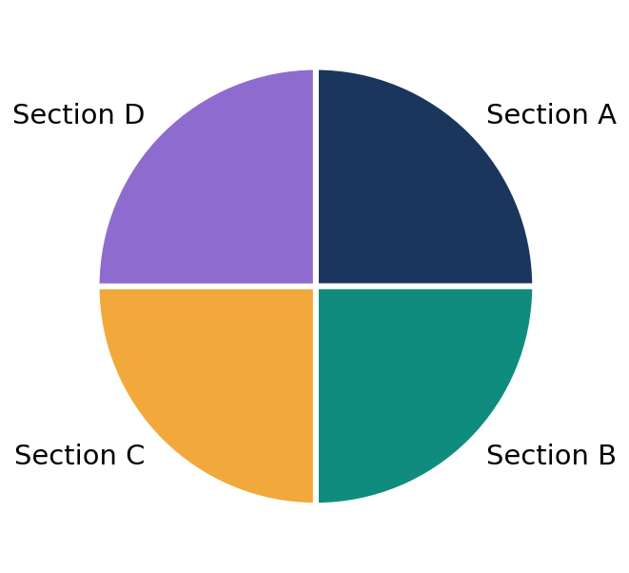
Figure 3.1.2 Figure 3.1.2. Equal sample counts from four sections illustrate proportional selection when sections are equally sized.
KEY CONCEPT: REPRESENTATIVENESS
A sample should reflect the population for the question being studied. Random selection can reduce selection bias, but no technique guarantees a perfect sample. A questionnaire must also avoid leading questions.

Quick Check 3.1A
1. Identify the population and sample when 30 of 150 learners are surveyed about travel time.
2. Classify “favorite fruit” and “number of siblings” by data type.
3. Explain why asking only members of the school cycling club would bias a survey of schoolwide travel modes.

3.1.2 — FROM RAW DATA TO FREQUENCY TABLES

Raw data are original observations before counting or grouping. A frequency distribution table lists distinct values or categories with their frequencies. Tally marks help ensure that no observation is counted twice or omitted. The sum of all frequencies equals the number of observations, written as $n$.
Consider the following 20 responses for days of reading in a week: $2,3,2,4,3,2,5,4,3,2,4,3,5,2,3,4,2,3,4,3. First identify the observed values $2,3,4,5; then count each occurrence and verify the total.
Days of reading ($x$) | Tally | Frequency ($f$) | Relative frequency
2 | ` |  |  |  |  |  | ` | 6 | 30%
3 | ` |  |  |  |  |  |  | ` | 7 | 35%
4 | ` |  |  |  |  | ` | 5 | 25%
5 | ` |  | ` | 2 | 10%
Total |  | 20 | 100%

FORMULA CARD: FREQUENCY AND PERCENTAGE
$$n=sum f$$
$$Relative frequency=\frac{f}{n}$$
$$Percentage=\frac{f}{n}×100\%$$
Here $f$ is the count in one category; $n$ is the total number of observations. Both are counts with no physical unit.

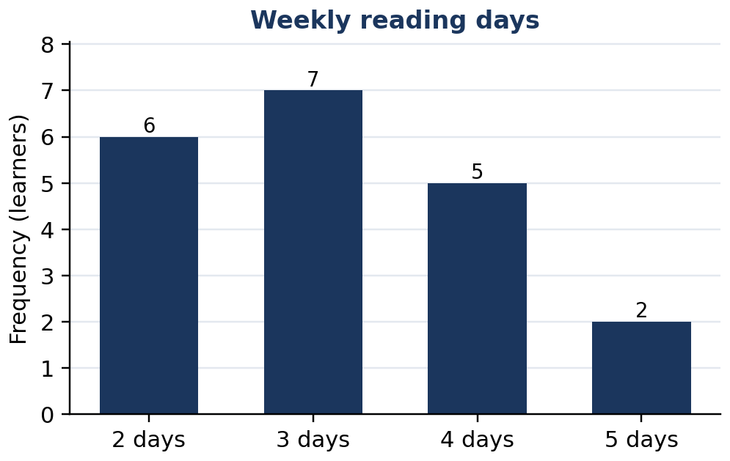
Figure 3.1.3 Figure 3.1.3. A bar graph represents the four frequency-table entries, total 20.
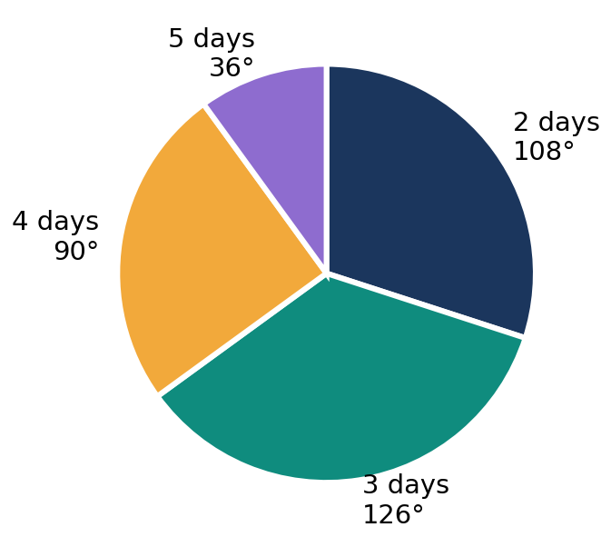
Figure 3.1.4 Figure 3.1.4. A pie graph uses the same 20 observations; sectors represent 30%, 35%, 25%, and 10%.
A bar graph compares counts across distinct categories; bars have equal width and are separated. A pie graph shows parts of one whole, so the percentages must total 100%. A line graph shows change across meaningful ordered positions, especially time. A stem-and-leaf plot preserves numerical observations by splitting each value into a stem and leaf.
Display | Appropriate purpose | Important check
Frequency table | Organize exact counts | Sum frequencies to $n$
Bar graph | Compare categories | Equal bar widths; common scale
Pie graph | Compare parts of one whole | Sectors total 360°
Line graph | Show change over time | Points in correct time order
Stem-and-leaf | Retain sorted numerical values | Include a key for place value

Quick Check 3.1B
1. What percentage corresponds to 5 observations in a sample of 20?
2. Which display is most suitable for monthly attendance over six months? Explain.
3. Why would a pie graph be inappropriate if categories overlap and learners can choose several answers?

3.1.3 — RULES, FORMULAS, AND WORKED EXAMPLES

FORMULA CARD: PIE-SECTOR ANGLE
$$θ=\frac{f}{n}×{360}^{°}$$
Here $θ$ is the sector angle in degrees, $f$ is the category frequency, and $n$ is the total frequency. The sum of all sector angles must equal ${360}^{°}$.

💡 Worked Example 1 — Construct a Frequency Distribution
Problem: Twenty learners report reading on 2, 3, 4, or 5 days per week using the raw values above. Construct the table and identify the modal category.
Given: 20 observations. Find: Frequencies and most common value. Rule: Count every value once and check $sum f=n$.
$2 days: f$ | $= 6$ | count each 2
$3 days: f$ | $= 7$ | count each 3
$4 days: f$ | $= 5$ | count each 4
$5 days: f$ | $= 2$ | count each 5
$6 + 7 + 5 + 2$ | $= 20$ | totals agree with n

Final Answer: Frequencies are 6, 7, 5, 2; the mode is 3 days because it occurs seven times.

💡 Worked Example 2 — Calculate a Pie-Sector Angle
Problem: Seven of 20 learners read on three days. Find their percentage and pie-sector angle.
Given: $f=7$, $n=20$. Find: percentage and angle. Formula: $100f/n and ${360}^{°} f/n$.
$7 / 20$ | $= 0.35$ | form the relative frequency
$0.35 × 100\%$ | $= 35\%$ | convert to percent
$0.35 × 360°$ | $= 126°$ | determine the pie angle

Final Answer: 35% and 126°.

Figure 3.1.5 Figure 3.1.5. The 3-day sector occupies 126 degrees of the circle.
💡 Worked Example 3 — Interpret a Line Graph
Problem: Attendance at a learning club is 12, 15, 14, 18, and 21 from Monday through Friday. Calculate Monday-to-Friday change and identify the day-to-day decrease.
Given: Five ordered counts. Find: net change and decreasing interval. Rule: final value minus initial value.
$21 − 12$ | $= 9$ | Friday count minus Monday count
$14 − 15$ | $= −1$ | Wednesday minus Tuesday

Final Answer: Attendance increases by 9 learners overall; it decreases by 1 learner from Tuesday to Wednesday.

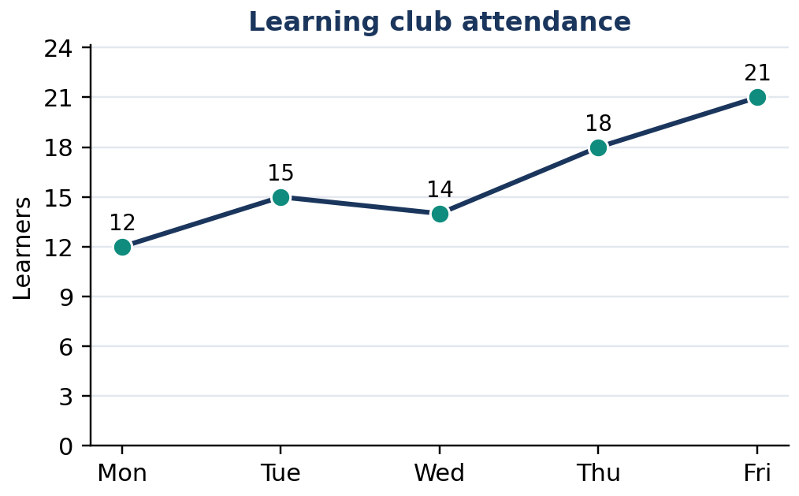
Figure 3.1.6 Figure 3.1.6. The line shows a one-learner fall from Tuesday to Wednesday despite an overall increase.
💡 Worked Example 4 — Read a Stem-and-Leaf Plot
Problem: Organize $12,15,17,21,22,24,31,33 into tens stems and ones leaves. Identify the smallest and largest values.
Given: Eight two-digit observations. Find: plot, minimum, maximum. Rule: stem = tens digit; leaf = ones digit.
$Stem 1: leaves 2, 5, 7$ |  | values 12, 15, 17
$Stem 2: leaves 1, 2, 4$ |  | values 21, 22, 24
$Stem 3: leaves 1, 3$ |  | values 31, 33
$Minimum$ | $= 12; maximum = 33$ | inspect the first and last ordered values

Final Answer: The smallest observation is 12, the largest is 33, and the range is 21.

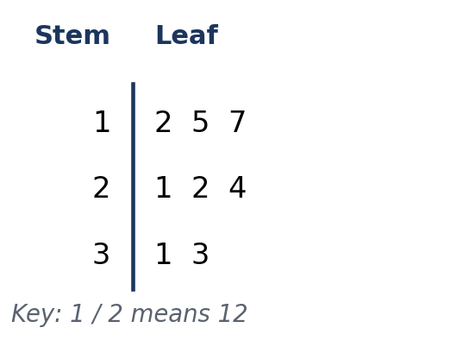
Figure 3.1.7 Figure 3.1.7. Each leaf retains one original numerical observation.

3.1.4 — MATHEMATICAL REASONING AND ERROR ANALYSIS

A graph communicates data through position, length, slope, or area. If a vertical axis starts at 10 rather than zero, a difference between 12 and 14 can look far larger than it really is. Bar lengths should generally be read against a zero baseline. A line graph may use a narrower scale when clearly labeled, but readers must not confuse steepness with the size of an actual numerical change.
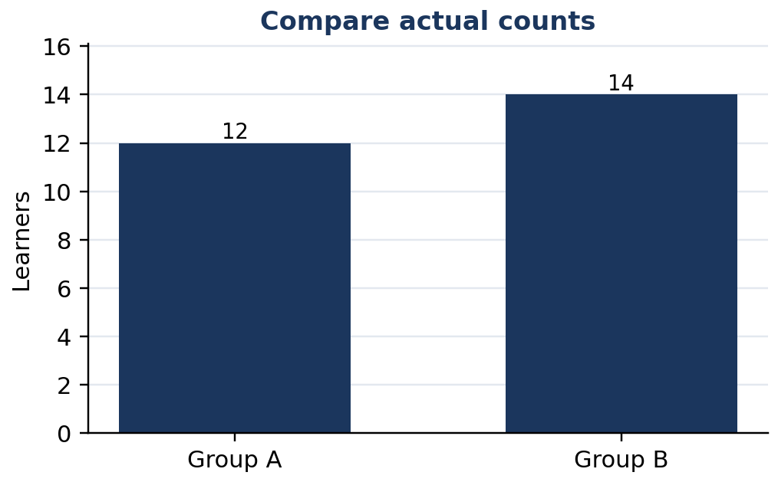
Figure 3.1.8 Figure 3.1.8. A zero-based bar comparison makes the difference of two learners proportional.
WATCH OUT — WRONG → RIGHT
Wrong: “The largest sector proves most learners read on three days.” Right: The largest single category is three days (35%), but 35% is not a majority.
Wrong: “A sample of ten close friends represents the whole grade.” Right: Convenience sampling can overrepresent similar learners.
Wrong: “The line graph proves that attendance will keep rising.” Right: A graph describes observed changes; a future trend requires further evidence.

Reasoning Challenge: Two classes each survey 20 learners. Class A selects names randomly from the grade list; Class B surveys only library visitors. Both obtain identical frequency tables about weekly reading. Do identical totals guarantee equally dependable conclusions about the entire grade? Explain using selection bias, the population, and sampling methods.

3.1.5 — APPLIED GRAPH SELECTION AND INTERPRETATION

A sound graph begins with a clear question. For transportation categories, a bar graph compares counts. For a class budget divided into nonoverlapping parts, a pie graph shows shares. For water use across consecutive days, a line graph emphasizes change with time. For an ordered set of quiz scores, a stem-and-leaf plot preserves individual values while showing distribution.
Graphs must have informative titles, appropriate axes, consistent units, and legible labels. For each conclusion, identify the data used and state only what they establish. Saying “seven learners chose the category” is supported by a frequency count; saying “all learners prefer that category” exceeds the evidence of a 20-person sample.
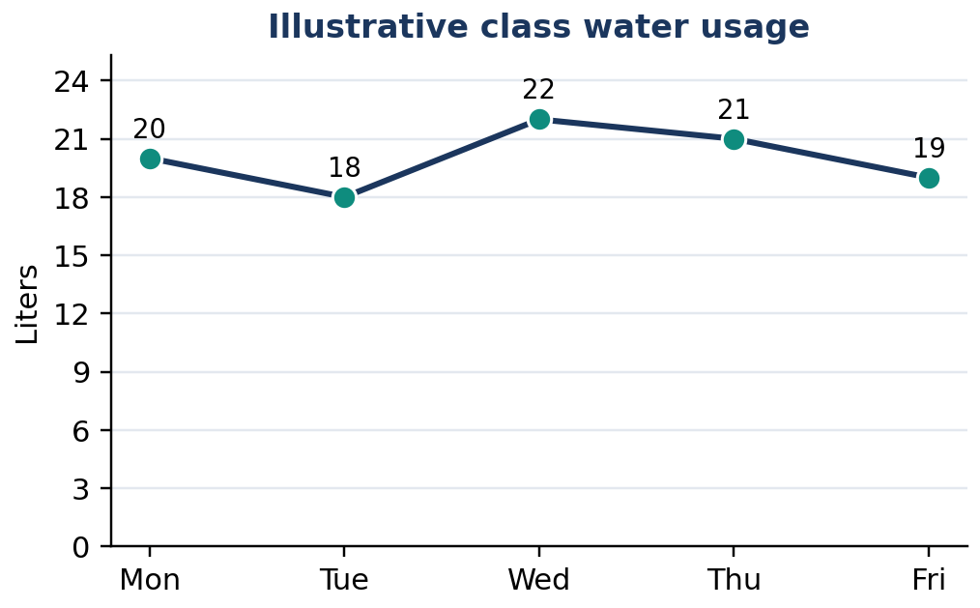
Figure 3.1.9 Figure 3.1.9. Daily water-use data are ordered in time, so a line graph is appropriate.
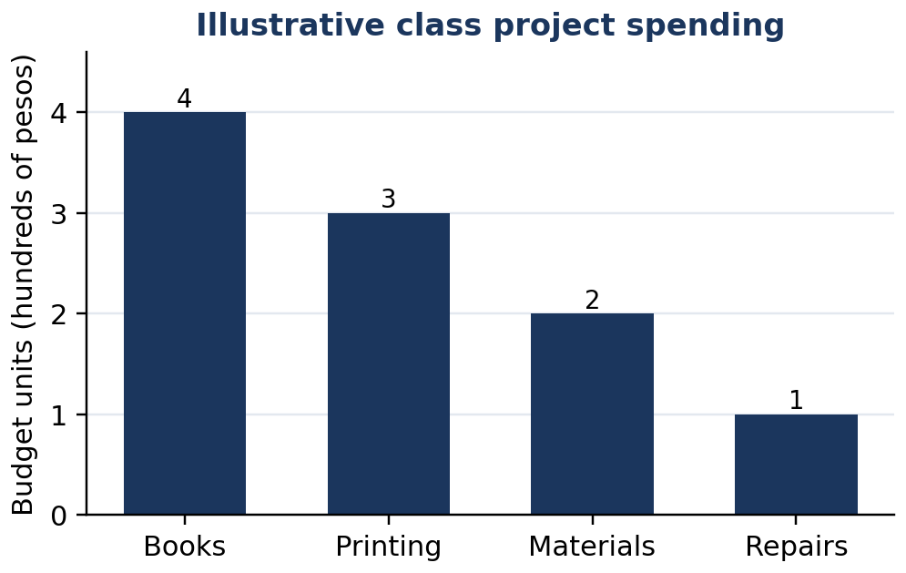
Figure 3.1.10 Figure 3.1.10. Separate bars allow direct comparison of budget categories.
Statistical task | Procedure | Accuracy check
Define question | Specify a measurable variable and population | Avoid ambiguous or leading wording
Select respondents | Choose a feasible and fair sampling method | Explain who could be excluded
Record responses | Use a uniform recording sheet | No duplicated or missing responses
Organize data | Tally and compute frequencies | Verify $sum f=n$
Represent data | Choose a suitable display | Confirm title, axes, scale, key
Interpret | State comparisons and limits | Do not generalize beyond evidence

Quick Check 3.1C
1. Give one valid conclusion from Figure 3.1.9 and show the difference used.
2. Which budget category in Figure 3.1.10 is the smallest and by how much is it less than the largest?
3. Explain why a chart title and a sample description are both necessary.

3.1.6 — GUIDED AND INDEPENDENT PRACTICE

Task 3.1.1 — Graded Exercises. Complete all 22 exercises. For computational items, show the relevant counts or formulas.
Basic (1–12):
1. Identify the population: all 240 Grade 7 learners are studied. | 2. Identify the sample: 35 of 240 learners answer a questionnaire.
3. Classify favorite sport as categorical or numerical. | 4. Classify number of notebooks as categorical or numerical.
5. State the frequency of 4 in 2, 4, 4, 5, 4, 2. | 6. Find n when frequencies are 3, 5, 6, 2.
7. Convert 4 out of 20 to a percentage. | 8. Convert 9 out of 30 to a percentage.
9. Find the pie angle for 5 out of 20. | 10. Find the pie angle for 3 out of 12.
11. Choose a graph to compare four bus-route categories. | 12. Choose a graph to show monthly rainfall over six months.

Intermediate (13–18):
13. Construct a frequency table for 1, 2, 1, 3, 2, 1, 3, 2. | 14. For frequencies 4, 6, 10, calculate all category percentages.
15. For frequencies 2, 3, 5, calculate all pie-sector angles. | 16. Write the ordered stem-and-leaf plot for 11, 13, 17, 22, 26, 29.
17. From 8, 10, 7, 12, 15 across Monday–Friday, find net change and largest daily increase. | 18. A table shows frequencies 7, 9, and 5 for 20 respondents. Diagnose the mistake.

Challenge and Word Problems (19–22):
19. A class of 40 reports 12 walkers, 18 jeepney riders, 6 cyclists, and 4 other commuters. Construct a frequency table, calculate each percentage, and determine the four pie-sector angles.
20. A school wants opinions on library hours. Explain how to sample fairly from four equally sized Grade 7 sections, and identify one possible source of nonresponse bias.
21. Monthly recyclable collections are 25, 30, 28, and 36 kg. Select a graph; calculate overall change and identify the only decreasing interval.
22. A bar graph begins its vertical scale at 90 and shows 94 and 98 learners. Explain why it may exaggerate the difference and redesign its scale.
Task 3.1.2 — Analysis Matrix. Supply the missing decision and justification in each row.
Situation | Most useful display | Reason or limitation
Weekly temperature across five days | ________ | ________
Favorite school meals in four categories | ________ | ________
Shares of one fixed activity budget | ________ | ________
Individual quiz scores such as 12, 13, 18, 21 | ________ | ________
Responses from 20 library visitors about all students | ________ | ________

3.1.7 — CONTEXTUAL APPLICATION: SCHOOL READING SURVEY

Goal: Construct an evidence-based summary of reading frequency. Work with 10–20 consenting classmates; do not request names, contact details, or sensitive information. Ask exactly: “On how many of the past seven days did you read for at least twenty minutes outside required classwork?” Record one integer from 0 to 7 for each respondent.
Procedure: (1) State the population and describe how respondents were selected. (2) Record all responses and make a frequency distribution with values 0–7, including zero-frequency categories. (3) Check that the frequencies equal the sample size. (4) Construct a labeled bar graph; if suitable, construct a pie graph with correctly calculated sectors. (5) Write two supported findings and one limitation of the sample. Anonymize all displayed responses.
Focused scoring criteria (12 points): Accurate collection and ethical recording—3; complete frequencies and checked total—3; mathematically correct labeled graph—4; justified conclusions and limitation—2.

3.1.8 — METACOGNITIVE EXIT TICKET AND LESSON SUMMARY

3–2–1 Exit Ticket: Write 3 mathematical ideas you can now explain, 2 questions you still have about sampling or displays, and 1 action you will take to avoid misleading statistical claims.
LESSON SUMMARY
Statistical investigations proceed from a clear question to appropriate collection, organization, representation, and cautious interpretation. A population is the group of interest; a sample is a selected part. Frequencies total the number of observations. Percentages and pie-sector angles express parts of a whole, whereas bars compare categories, lines track ordered changes, and stem-and-leaf plots preserve numerical observations. Every conclusion should respect the sample, scale, and variable actually studied.

3.1.9 — FORMATIVE ASSESSMENT (15 ITEMS)

Part I — Multiple Choice (1–10). Select one answer per item.
1. [ ] All 160 Grade 7 learners are the focus of a study; 32 are surveyed. What is the population?
A. The 32 surveyed learners B. All 160 Grade 7 learners C. Only absent learners D. The 128 not surveyed
2. [ ] Which variable is categorical?
A. Height in centimeters B. Minutes spent studying C. Number of siblings D. Preferred school subject
3. [ ] A class chooses every fifth name from an alphabetized list after choosing a random starting position. Which technique is used?
A. Systematic sampling B. Convenience sampling C. Census D. Direct observation
4. [ ] Frequencies are 3, 7, 5, and 5. What is the total sample size?
A. 15 B. 18 C. 20 D. 25
5. [ ] Six of 24 learners choose cycling. What percentage is this?
A. 25% B. 20% C. 30% D. 40%
6. [ ] What pie-sector angle corresponds to 8 of 40 observations?
A. 36° B. 90° C. 144° D. 72°
7. [ ] Which display most directly represents a series of daily attendance counts?
A. Pie graph B. Line graph C. Pictogram with no labels D. Venn diagram
8. [ ] Which conclusion is supported when 9 of 25 surveyed learners prefer a topic?
A. Most learners definitely prefer it. B. Everyone prefers it. C. Nine surveyed learners prefer it. D. The school population has exactly 9 supporters.
9. [ ] Which practice best improves the interpretability of a bar graph?
A. Omit the axis labels B. Use unequal bar widths C. Hide the sample size D. Use a labeled common scale
10. [ ] A stem-and-leaf plot contains 2 | 4 7 9, with key 2 | 4 = 24. Which values are represented?
A. 2, 4, 7, 9 B. 24, 27, 29 C. 20, 40, 70, 90 D. 42, 72, 92
Part II — Open Response (11–15). Show calculations and explain your reasoning.
11. A survey has categories with frequencies 4, 8, and 8. Find all percentages and verify their total.
12. Determine the pie-sector angles for categories with frequencies 3, 5, and 2. Verify the angle sum.
13. Produce a stem-and-leaf plot for 14, 18, 21, 22, 27, 31. Include a key, minimum, and maximum.
14. Explain why surveying the first 20 people entering a library might misrepresent the reading habits of an entire grade. Recommend one better method.
15. Daily recycling quantities are 12, 16, 14, 17, and 20 kg. Identify the best graph, net change, largest increase between consecutive days, and one limitation of conclusions from only five observations.

LESSON 3.2 — THE SET OF INTEGERS

Mathematics 7 | Quarter 3 | Number and Algebra (NA)

Curriculum Alignment

Content Standard: The set of integers, comparison and ordering of integers, and the absolute value of an integer.
Learning Competencies: Describe integers; represent directions and opposites using signed numbers; locate, compare, and order integers on a number line; identify absolute value and explain its number-line meaning.
Essential Questions: Why do negative numbers extend the whole-number system? How does the number line determine integer order? Why is absolute value nonnegative?
🎥 INTERACTIVE MULTIMEDIA: Introduction to Negative Numbers
Channel: Khan Academy
Concepts: Signed directions; zero as origin; negative and positive locations.
Questions: What does −3 mean in temperature? Which side of zero contains negative values? Why is −8 smaller than −2?

Background

Whole numbers describe counting, but measurements and situations often require values below zero. The integers include negative whole numbers, zero, and positive whole numbers. Temperature, elevation, building levels, and account changes become understandable when the zero reference and sign convention are stated. Integer notation does not itself specify a unit: a signed value must be interpreted using its context.

Subtopic 1 — Classification and Meaning

📐 KEY CONCEPT: The Set of Integers
$$Z=\{…,−3,−2,−1,0,1,2,3,…\}$$
Positive integers are greater than 0; negative integers are less than 0. Zero is neither positive nor negative. Every integer has no fractional part.

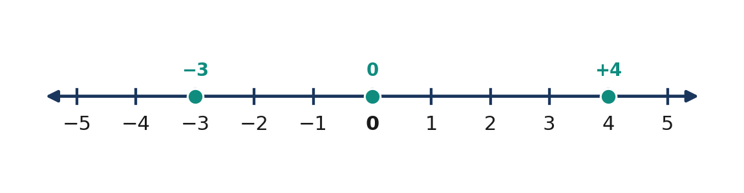
Figure 3.2.1 Integer positions extend in both directions from zero.
The sequence has no smallest or largest integer. A positive sign is optional: +5 and 5 are the same number. Fractions such as 7/4 and decimal values such as 2.5 are not integers, although 8/4 is equal to integer 2. A numerical label like −15 m requires a reference level to be meaningful.
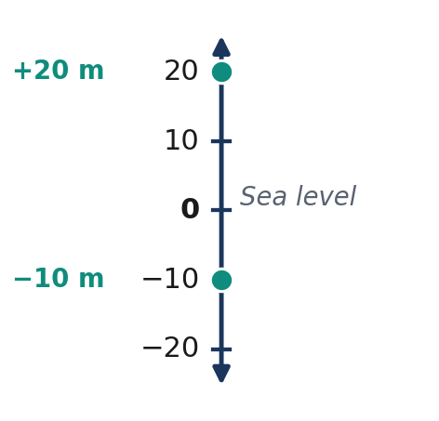
Figure 3.2.2 Signed elevations are measured above and below sea level.
Term | Meaning | Example
Positive integer | Greater than zero | +6
Negative integer | Less than zero | −9
Zero | Neither positive nor negative | 0
Signed quantity | Number measured from a reference | −12°C

Quick Check A: 1. Classify −17, 0, +25. 2. Explain why 8/4 is an integer but 7/4 is not. 3. Interpret an elevation of −30 m.

Subtopic 2 — Number-Line Locations, Opposites, and Ordering

A number line displays integers at equally spaced intervals. Values increase left to right. To locate −4, begin at zero and count four units left; for +3, count three units right. The distance between consecutive integer tick marks is one unit, so tick spacing must be consistent.
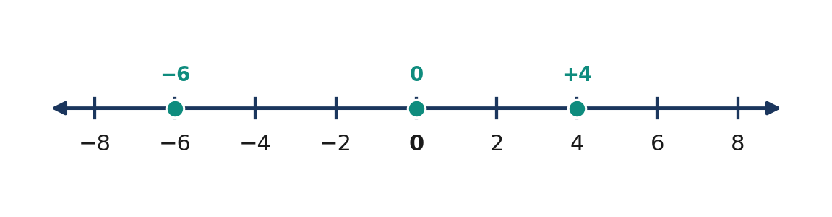
Figure 3.2.3 Correctly spaced number-line ticks make comparisons possible.
Opposite integers occupy equal distances on opposite sides of zero. The opposite of −6 is +6 and the opposite of zero is zero. Because opposite signed values cancel when added, the sum of an integer and its opposite is zero, a property that prepares learners for integer addition.
📐 KEY CONCEPT: Opposites and Ordering
$$opposite(a)=−a$$
$$a+(−a)=0$$
$$a<b if a lies to the left of b on the number line$$
Here a and b are integers.

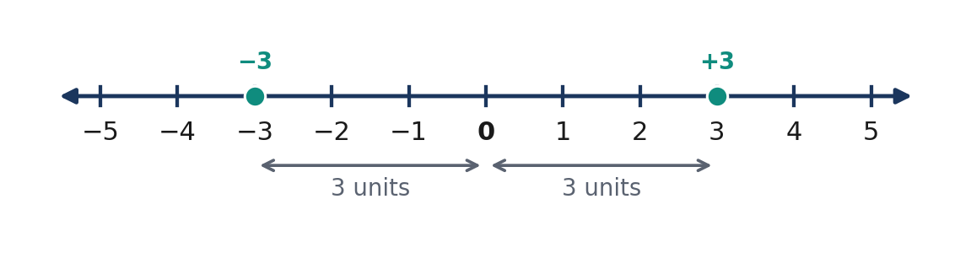
Figure 3.2.4 Opposite integers −3 and +3 lie three units from zero.
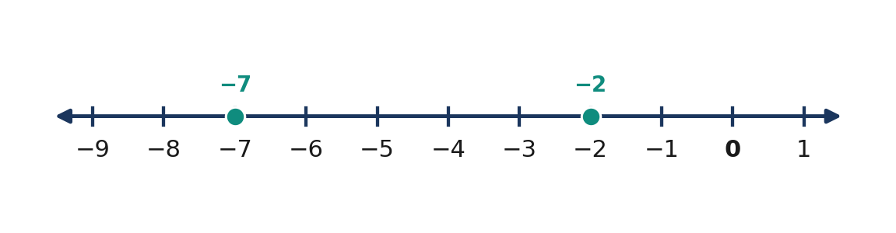
Figure 3.2.5 −7 is less than −2 because it lies farther left.
Comparison | Conclusion | Justification
−5 and +3 | −5 < +3 | Negative precedes positive
−8 and −2 | −8 < −2 | −8 is farther left
0 and −6 | 0 > −6 | Zero follows negatives
4 and 7 | 4 < 7 | 4 is farther left

Quick Check B: 1. Order −4, 2, 0, −7, 5 from least to greatest. 2. Find the opposites of −11, 16, and 0. 3. Explain why −9 < −3.

Formula Cards and Worked Examples

💡 Worked Example 1 — Locate Signed Values
Problem: Locate −5 and +2 on a number line.
Given: −5, +2. Find: Their locations. Rule: Negative is left and positive is right of zero.
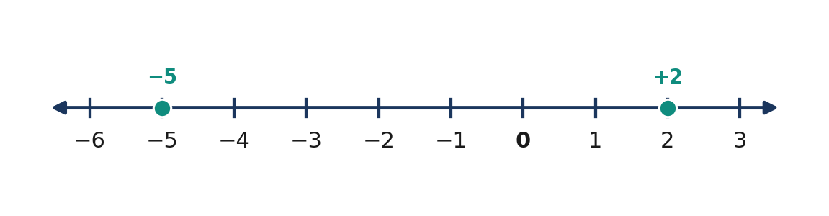
Figure 3.2.6 Locating −5 and +2 relative to zero.
$0 − 5$ | $= −5$ | move five unit intervals left
$0 + 2$ | $= 2$ | move two unit intervals right

Final Answer: −5 is five units left; +2 is two units right of zero.

💡 Worked Example 2 — Order Five Integers
Problem: Arrange −3, 8, −9, 0, and 4 in ascending order.
Given: Five values. Find: Least to greatest. Rule: Move from left to right.
$−9 < −3$ |  | compare negative integers
$−3 < 0$ |  | all negative integers precede zero
$0 < 4 < 8$ |  | place positive integers in ascending order

Final Answer: −9, −3, 0, 4, 8.

Mathematical Reasoning and Common Misconceptions

A common mistake is to compare only unsigned magnitudes. Since 12 is larger than 3, a learner might incorrectly write −12 > −3; the correct number-line conclusion is −12 < −3. Similarly, zero should not be classified as positive merely because it is not negative. Always distinguish a number's sign, position, and distance from zero.
WATCH OUT: Wrong: −12 > −3 because 12 > 3. Right: −12 < −3 because −12 is farther left. Wrong: 0 is positive. Right: 0 is neither positive nor negative.

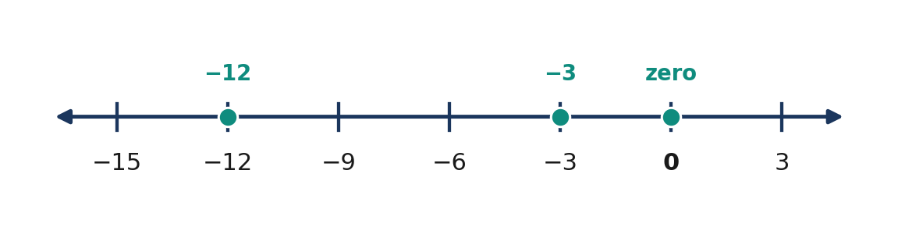
Figure 3.2.7 −12 is to the left of −3, even though 12 exceeds 3.

Subtopic 3 — Absolute Value and Signed Quantities

Absolute value is the distance of a number from zero, not its direction. The absolute value of −7 and +7 is 7 because each lies seven units away. Absolute value cannot be negative. Notation such as |−7| asks for a distance, while a minus sign outside the bars changes the sign of that distance.
📐 KEY CONCEPT: Absolute Value
$|a|$ | $= a,a≥0$
$−a,a<0$

$$|−8|=8, |8|=8, |0|=0$$
Here a is any integer; |a| is its distance from zero in units.

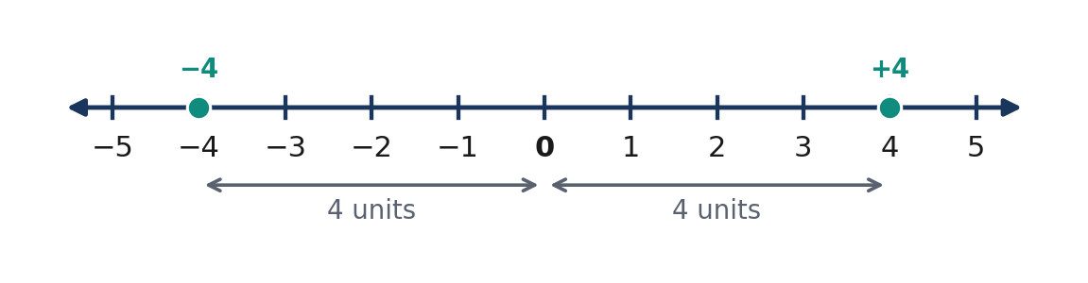
Figure 3.2.8 Both −4 and +4 have absolute value 4.
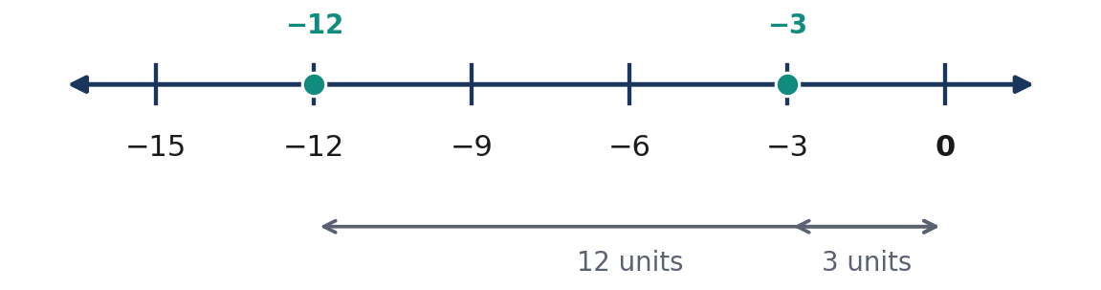
Figure 3.2.9 −12 is smaller than −3 but has greater absolute value.
💡 Worked Example 3 — Find Absolute Values
Problem: Evaluate |−14|, |9|, and |0|.
Given: −14, 9, 0. Find: Absolute values. Rule: Distance from zero.
$|−14|$ | $= 14$ | distance is positive
$|9|$ | $= 9$ | positive integer's distance equals its value
$|0|$ | $= 0$ | zero distance

Final Answer: 14, 9, and 0.

💡 Worked Example 4 — Compare Values and Distances
Problem: Compare |−12| and |−7|; then compare −12 and −7.
Given: −12 and −7. Find: Two comparisons. Rule: Compare distance and position separately.
$|−12|$ | $= 12$ | distance from zero
$|−7|$ | $= 7$ | distance from zero
$12 > 7$ |  | compare absolute values
$−12 < −7$ |  | compare number-line positions

Final Answer: |−12| > |−7|, but −12 < −7.

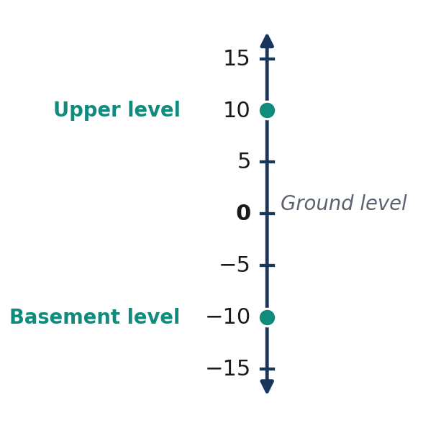
Figure 3.2.10 Signed building elevations use a common zero reference.
Situation | Signed quantity | Meaning
Temperature | −6°C | Six degrees below zero
Altitude | +25 m | Twenty-five metres above datum
Depth | −18 m | Eighteen metres below sea level
Account change | −₱120 | Decrease of ₱120

Quick Check C: 1. Which is lower, −16 m or −9 m? 2. What is the absolute value of a diver's position at −12 m? 3. Why are the opposite and absolute value of −6 both 6, while the operations are different?

Guided and Independent Practice

Task 3.2.1 — Basic (1–12):
1. Classify −15. | 2. Classify +4. | 3. Classify 0.
4. Opposite of −9. | 5. Opposite of +13. | 6. Opposite of 0.
7. Compare −3 and 6. | 8. Compare −8 and −2. | 9. Compare 0 and −5.
10. Find |−12|. | 11. Find |7|. | 12. Find |0|.

Intermediate (13–18):
13. Order −4, 2, −7, 0, 5 ascending. | 14. Order −1, −9, 4, 8, 0 descending.
15. Compare |−13| and |9|. | 16. Find all integers with absolute value 5.
17. List the integers strictly between −4 and 2. | 18. Evaluate |−6| + |−2|.

Challenge / Word Problems (19–22):
19. A diver is at −18 m and a drone is at +35 m relative to sea level. Identify the lower position and the absolute distance of each position from sea level.
20. Temperatures at dawn are −2°C, −7°C, 0°C, and +4°C. Order them and name the coldest temperature.
21. Determine whether there exists any integer that is smaller than every negative integer. Explain.
22. A learner claims |−9| < |−3| because −9 < −3. Correct the claim using a number-line explanation.
Task 3.2.2 — Analysis Matrix
Given | Integer comparison | Reason
−12 and −4 | ____ | ____
0 and −8 | ____ | ____
+6 and −6 | ____ | ____
 | −10 | and | −7 |  | ____ | ____
−15 and | −15 |  | ____ | ____

Contextual Application — Elevation and Temperature Report

Goal: Construct and explain a signed-number report about five realistic measurements.
Context: Measurements are −12 m, +8 m, −4 m, 0 m, and +15 m relative to sea level. Prepare a number line, order the values, identify opposite possibilities, and report all absolute distances. Explain why an elevation of −12 m is lower than −4 m despite its larger distance from the reference.
Procedure: 1. Write a title and zero reference. 2. Draw evenly spaced number-line ticks. 3. Plot all five points and label them. 4. Order and find absolute values. 5. Explain one possible misconception.
Scoring (12 points): Accurate reference and scale (3), correct positions and order (3), correct absolute values (3), coherent mathematical explanation (3).

Metacognitive 3–2–1 Exit Ticket

Write three facts that distinguish integers from whole numbers; two remaining questions about signs or distance; and one practical situation where a negative integer gives more accurate information than an unsigned number.
LESSON SUMMARY: The integers extend whole numbers by including negative counterparts. A number line orders integers from least on the left to greatest on the right. Opposites lie at equal distances on opposite sides of zero. Absolute value measures nonnegative distance from zero, so |−a|=|a|. These ideas support comparisons and all four integer operations.

Formative Assessment (15 Items)

Part I — Multiple Choice. Select one answer for each item.
1. [ ] Which number is an integer? A. 3/2 B. −7 C. 1.25 D. 0.4
2. [ ] Which statement about zero is true? A. It is negative. B. It is positive. C. It is less than every integer. D. It is neither positive nor negative.
3. [ ] The opposite of −11 is: A. +11 B. −11 C. 0 D. 1/11
4. [ ] Which is the least integer? A. −2 B. 0 C. −9 D. 4
5. [ ] Which is true? A. −4 > −1 B. −4 < −1 C. 0 < −4 D. −1 = 1
6. [ ] What is |−15|? A. 15 B. −15 C. 0 D. 1/15
7. [ ] Which integer is three units to the left of zero? A. +3 B. 0 C. +6 D. −3
8. [ ] Which pair contains opposites? A. −2 and −2 B. 0 and 1 C. −8 and +8 D. +4 and +8
9. [ ] Which statement is true? A. |−6| = −6 B. |−6| = 6 C. |−6| < 0 D. −6 > 0
10. [ ] Which is greatest? A. −1 B. −3 C. 0 D. +2
Part II — Open Response
11. Plot −6, −2, 0, +3 on a correctly labeled number line, and justify their ascending order.
12. Give the opposites and absolute values of −12, +5, and 0. Explain the difference between the two operations.
13. Compare −15 and −8, then compare their absolute values. Explain why the inequality directions differ.
14. A building has floors −3, −1, 0, 2, and 5. Describe the reference floor, order the floors, and state the distance in levels from zero for −3 and 5.
15. Explain why there is no smallest integer and why every nonzero integer has a distinct opposite.

LESSON 3.3 — ADDING INTEGERS

Mathematics 7 | Quarter 3 | Number and Algebra (NA)

1. Curriculum Alignment and Learning Objectives

Content Standard: Understanding of the four operations involving integers.
Learning Competency: Add integers using concrete counters, number lines, pictorial models and numerical notation (Grade 7 Quarter 3 competency 9, addition component).
Performance Standard: Perform and explain integer operations accurately.
Essential Questions: (1) How do number lines and counters model signed addition? (2) Why do same-sign and different-sign sums follow distinct rules? (3) How do properties help verify answers?
🎥 INTERACTIVE MULTIMEDIA: Adding Integers on the Number Line
Channel: Khan Academy
Direct Link: https://www.youtube.com/watch?v=jA1vyOrzlOE
Observe: Positive addends move right; negative addends move left; missing addends correspond to distances between positions.
Questions: What happens when a positive number is added to a negative one? How does the sign of the second addend determine direction? How could the model represent elevation?

Addition combines signed quantities. On a number line the first addend provides a starting position and the second a signed movement. Integer counters provide an equivalent model. One positive counter paired with one negative counter makes zero; after all zero pairs have formed, the uncancelled counters determine the sum. These two models justify sign rules and prepare learners to solve problems involving increases, decreases, gains and losses.

2. Subtopic 3.3.1 — Number-Line Addition

A positive second addend moves right, while a negative second addend moves left. Start at the first addend and count the magnitude of the second addend in the indicated direction. For instance, $(−3)+(+5)=+2$ and $(+2)+(−6)=−4$. Movement direction describes the sign of the added quantity, not the sign of the initial position.
📐 KEY CONCEPT 3.3A — Number-Line Addition
$$a+b=final number-line position$$
Here $a$ is the initial position and $b$ is the signed displacement in unit intervals.

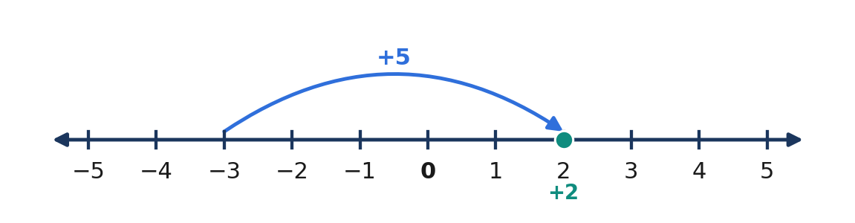
Figure 3.3.1 Figure 3.3.1 — From −3, move five units right to reach +2.
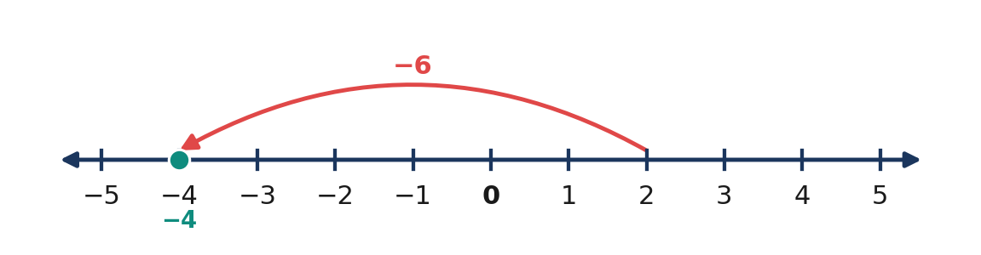
Figure 3.3.2 Figure 3.3.2 — From +2, move six units left to reach −4.
First addend | Second addend | Movement | Result
$+4$ | $+3$ | Three right | $+7$
$−5$ | $+2$ | Two right | $−3$
$+2$ | $−6$ | Six left | $−4$
$−3$ | $−4$ | Four left | $−7$

Quick Check 3.3A: 1. Start at −4 and move seven right. 2. Find $(+6)+(−9)$. 3. Why does $(−2)+(−5)$ end farther left than −2?

3. Subtopic 3.3.2 — Integer Counters and Zero Pairs

Let a positive counter represent $+1$ and a negative counter represent $−1$. A positive and a negative counter make a zero pair, because their combined value is zero. Five positive and three negative counters form three zero pairs and leave two positives. Four negative and two positive counters form two zero pairs and leave two negatives. If every counter has the same sign, no zero pairs can form.
📐 KEY CONCEPT 3.3B — Zero Pairs
$$(+1)+(−1)=0$$
$$a+(−a)=0$$
The value $−a$ is the additive inverse of the integer $a$.

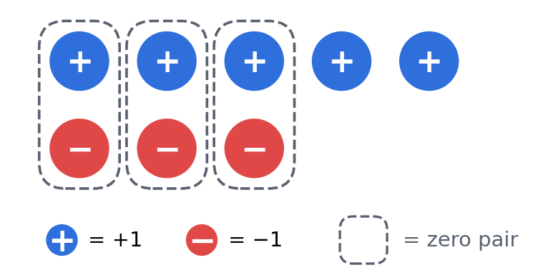
Figure 3.3.3 Figure 3.3.3 — Three zero pairs cancel and leave two positive counters.
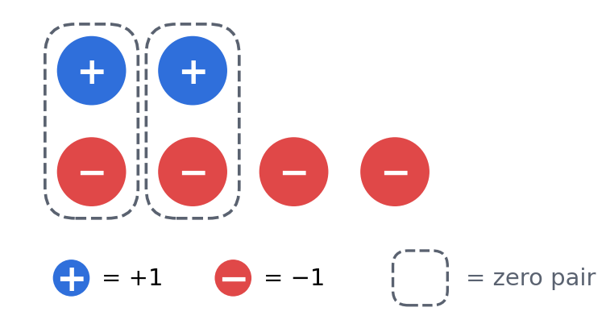
Figure 3.3.4 Figure 3.3.4 — Two zero pairs cancel and leave two negative counters.
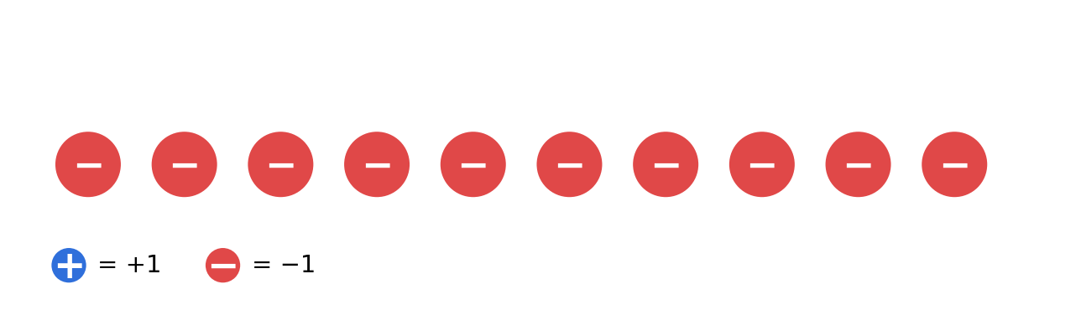
Figure 3.3.5 Figure 3.3.5 — Six negative and four negative counters make ten negative counters.
Counter groups | Zero pairs | Remainder | Sum
5 positive and 3 negative | 3 | 2 positive | $+2$
4 negative and 2 positive | 2 | 2 negative | $−2$
6 negative and 4 negative | 0 | 10 negative | $−10$
3 positive and 3 negative | 3 | None | $0

Quick Check 3.3B: 1. How many zero pairs form from seven positives and four negatives? 2. What value is represented by six negatives and two positives? 3. Why does five positive plus five negative equal zero?

4. Core Rules and Four Worked Examples

📐 KEY CONCEPT 3.3C — Addition Rules
For nonnegative whole numbers $a$ and $b$:
$$(+a)+(+b)=a+b$$
$$(−a)+(−b)=−(a+b)$$
If $a≥ b$:
$$(+a)+(−b)=a-b$$
$$(−a)+(+b)=−(a-b)$$
For opposite signs, subtract absolute values and keep the sign of the addend with greater absolute value. If absolute values are equal, the sum is zero.

💡 Worked Example 1 — Same-Sign Addition
Problem: Evaluate $(−8)+(−5)$.
Given: $−8$, $−5$. Find: Sum.
Rule: Add magnitudes and retain the common negative sign.
$(−8)+(−5)$ | $= −(8+5)$ | same-sign rule
 | $= −13$ | simplify

Final Answer: −13.

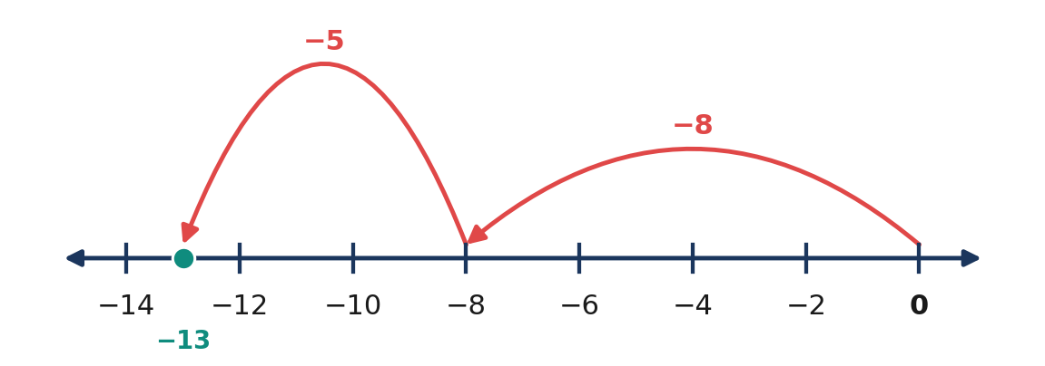
Figure 3.3.6 Figure 3.3.6 — Two negative movements end at −13.
💡 Worked Example 2 — Different-Sign Addition
Problem: Evaluate $(+17)+(−24)$.
Given: $+17$, $−24$. Find: Sum.
Rule: Subtract magnitudes and keep the sign of the larger magnitude.
$(+17)+(−24)$ | $= −(24-17)$ | the negative addend has greater magnitude
 | $= −7$ | simplify

Final Answer: −7.

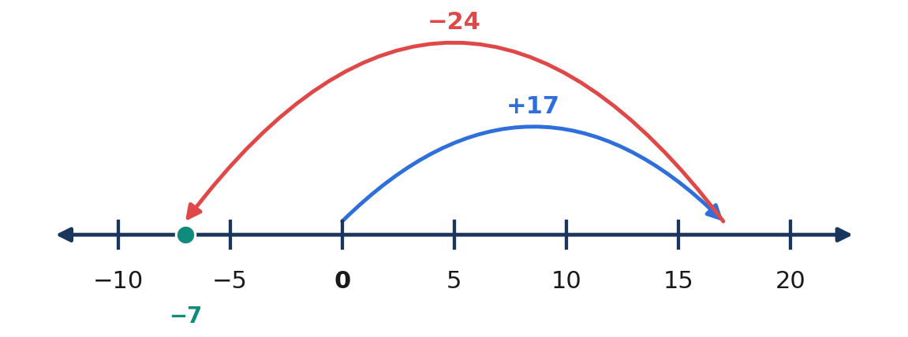
Figure 3.3.7 Figure 3.3.7 — Rightward 17 and leftward 24 produce a net movement of −7.
💡 Worked Example 3 — Savings Change
Problem: A learner receives ₱350 and spends ₱475. Find the net change.
Given: $+350$ pesos and $−475$ pesos. Find: Net change in pesos.
Rule: Add the two signed changes.
$(+350)+(−475)$ | $= −(475-350)$ | opposite signs, greater negative magnitude
 | $= −125$ | simplify

Final Answer: A decrease of ₱125.

💡 Worked Example 4 — Three Addends
Problem: Evaluate $(−12)+(+7)+(−9)$.
Given: Three integers. Find: Sum.
Rule: Group negative addends by the associative and commutative properties.
$(−12)+(+7)+(−9)$ | $= [(−12)+(−9)]+(+7)$ | regroup addends
 | $= (−21)+(+7)$ | combine negatives
 | $= −(21-7)$ | opposite-sign rule
 | $= −14$ | simplify

Final Answer: −14.

5. Mathematical Reasoning and Common Misconceptions

Addition is commutative and associative. Therefore, addends may be reordered and regrouped to simplify a computation. Adding zero leaves an integer unchanged, whereas adding its opposite gives zero. These properties explain why the total of several signed changes does not depend on their order.
📐 KEY CONCEPT 3.3D — Addition Properties
$$a+b=b+a$$
$$(a+b)+c=a+(b+c)$$
$$a+0=a$$
$$a+(−a)=0$$
All variables represent integers.

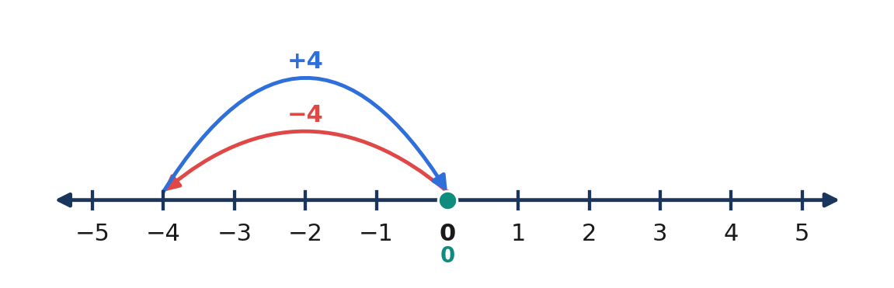
Figure 3.3.8 Figure 3.3.8 — An integer and its opposite return to zero.
WATCH OUT — WRONG → RIGHT: $(−6)+(−8)=+14$ is wrong; it equals $−14$. $(+5)+(−9)=+4$ is wrong; it equals $−4$. $(−7)+(+7)=14$ is wrong; it equals $0. $(−12)+0=0$ is wrong; it equals $−12$. The positive product of two negatives is a multiplication rule, not an addition rule.

Reasoning Challenge: Can two negative integers have a positive sum? Explain using the number line and the same-sign rule.

6. Subtopic 3.3.3 — Multi-Step Integer Addition

When every operation is addition, positive changes and negative changes may be grouped separately. For example, $(−10)+(+6)+(−4)$ becomes $(−10)+(−4)+(+6)$, then $(−14)+(+6)=−8$. The properties of addition preserve the result while reducing sign errors. Interpret the sign in context: a negative inventory change or temperature change means a net decrease, not necessarily a negative final quantity.
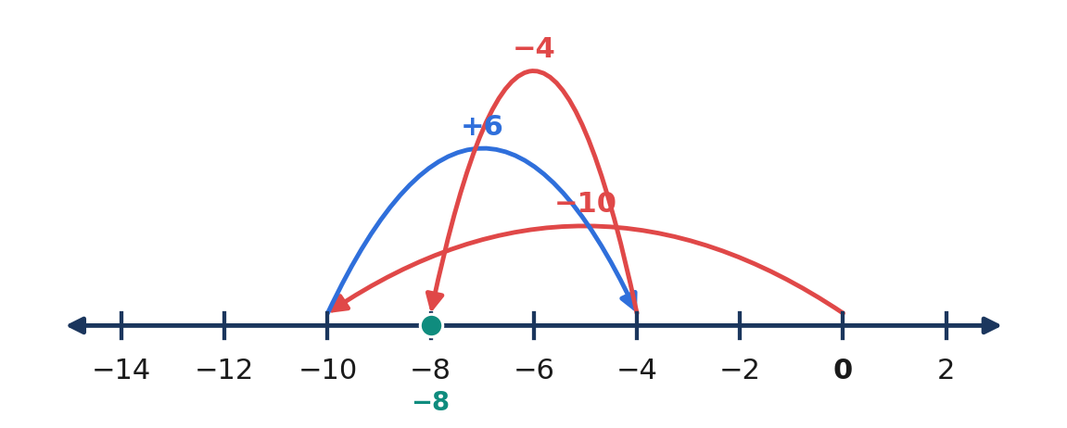
Figure 3.3.9 Figure 3.3.9 — Three signed movements yield a net displacement of −8.
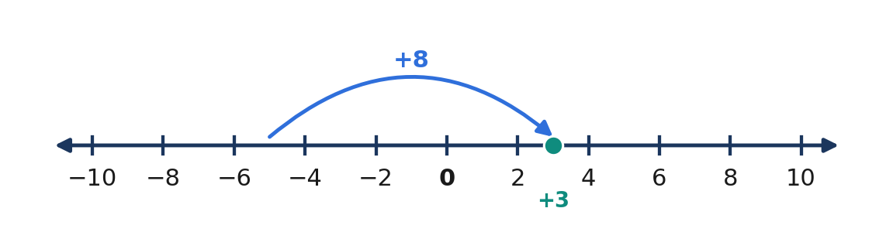
Figure 3.3.10 Figure 3.3.10 — A temperature of −5°C rises 8°C to +3°C.
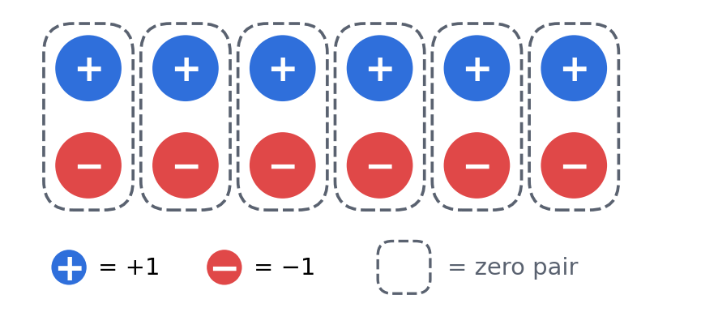
Figure 3.3.11 Figure 3.3.11 — Six positive and six negative counters form six zero pairs.
Expression type | Procedure | Result example
Two positive | Add magnitudes | $(+6)+(+3)=+9$
Two negative | Add magnitudes; retain negative | $(−6)+(−3)=−9$
Mixed; positive greater | Subtract and retain positive | $(+9)+(−4)=+5$
Mixed; negative greater | Subtract and retain negative | $(−9)+(+4)=−5$
Opposites | Add to zero | $(−11)+(+11)=0$
Several integers | Regroup conveniently | $(−7)+(+3)+(−2)=−6$

Quick Check 3.3C: 1. Calculate $(−14)+(+9)+(−3)$. 2. Explain grouping in $(−8)+(+5)+(−2)$. 3. Starting from $−{10}^{°}C$, increase by $6^{°}C$.

7. Guided Practice and Independent Exercises

Task 3.3.1 — Basic Exercises (1–12)
1. (+4)+(+7) | 2. (−5)+(−8) | 3. (+9)+(−3)
4. (−12)+(+4) | 5. (−6)+(+6) | 6. 0+(−15)
7. (−9)+(−2) | 8. (+13)+(−17) | 9. (−20)+(+5)
10. (+8)+(+11) | 11. (−14)+(−7) | 12. (+16)+(−9)

Intermediate Exercises (13–18)
13. (−8)+(+14)+(−5) | 14. (+21)+(−16)+(−9)
15. (−13)+(−7)+(+25) | 16. (−30)+(+12)+(+8)
17. (−9)+x=−3; find x | 18. x+(+7)=−12; find x

Challenge and Context Problems (19–22)
19. A learner receives ₱250, spends ₱380, and receives another ₱100. Find the net change.
20. The temperature starts at −6°C, rises 11°C, and falls 4°C. Find the final temperature.
21. A robot is at −35 m, rises 18 m, and descends 12 m. Find its final elevation.
22. Three consecutive integers sum to −18. Identify them and verify the total.
Task 3.3.2 — Analytical Matrix
Expression | Sign of sum | Explanation to complete
$(−15)+(−7)$ | __ | __
$(+24)+(−10)$ | __ | __
$(−18)+(+25)$ | __ | __
$(+12)+(−12)$ | __ | __
$(−6)+(+3)+(−4)$ | __ | __

8. Contextual Application — Community Resource Ledger

A school club records daily reusable-material changes: Monday $+18$ kg, Tuesday $−7$ kg, Wednesday $+12$ kg, Thursday $−15$ kg, Friday $+9$ kg. Form the signed expression, group positive and negative changes, compute the net weekly change, and check with a number line. Explain what the sign means for inventory. Scoring (12 points): signed model 3, computation 4, verification 3, interpretation with units 2.

9. Metacognitive Reflection and Lesson Summary

3–2–1 Exit Ticket: Identify three integer addition rules or properties, two possible errors, and one realistic application.
LESSON SUMMARY: A positive added integer moves right on the number line; a negative added integer moves left. A positive-negative counter pair has value zero. Same-sign integers add their absolute values and keep their sign. Opposite-sign integers require subtraction of absolute values and the sign of the greater magnitude. Opposite integers sum to zero. Addition is commutative and associative, and zero is its identity.

10. Formative Assessment — 15 Items

Part I: Multiple Choice
1. [ ] What is $(+7)+(+9)$? A. $+2$ B. $+16$ C. $−16$ D. $−2$
2. [ ] What is $(−6)+(−8)$? A. $+14$ B. $−2$ C. $+2$ D. $−14$
3. [ ] Evaluate $(−12)+(+5)$. A. $−7$ B. $+7$ C. $−17$ D. $+17$
4. [ ] Which equals zero? A. $(−4)+(−4)$ B. $(+8)+(+3)$ C. $(−9)+(+9)$ D. $(−7)+(+2)$
5. [ ] Compute $(+18)+(−25)$. A. $−7$ B. $+7$ C. $−43$ D. $+43$
6. [ ] Which property is $(−3)+(+8)=(+8)+(−3)$? A. Associative B. Commutative C. Identity D. Distributive
7. [ ] Find $(−5)+(+11)+(−4)$. A. $−20$ B. $+20$ C. $−2$ D. $+2$
8. [ ] A temperature of −3°C rises 8°C. Final temperature? A. −11°C B. −5°C C. +5°C D. +11°C
9. [ ] Additive inverse of −17? A. +17 B. −17 C. 0 D. +1
10. [ ] If $(−9)+x=−2$, find $x$. A. −11 B. −7 C. +11 D. +7
Part II: Open Responses
11. On a number line, show $(−7)+(+12)$ and justify the movements.
12. Use counters for $(+6)+(−9)$; identify zero pairs and leftovers.
13. Calculate $(−18)+(+7)+(−5)$ by regrouping addends.
14. A learner earns ₱180, spends ₱240, and earns ₱90. Find net change and interpret its sign.
15. Explain why both $(−8)+(−6)$ and $(−8)+(+6)$ are negative, using the relevant rules.

LESSON 3.4 — SUBTRACTING INTEGERS

Mathematics 7 • Quarter 3 • Number and Algebra (NA)

1. Curriculum Alignment and Essential Questions

Content standard: Knowledge and understanding of operations with integers. Learning competency: Grade 7 Quarter 3, competency 9 (subtraction component): subtract integers using concrete counter models, pictorial number-line models, and symbolic notation. Performance standard: Perform the four integer operations and interpret results in realistic contexts.
Learning objectives: (1) Explain subtraction as finding an unknown addend and as a signed change; (2) apply the add-the-opposite rule; (3) represent subtraction with number lines and counters, including zero pairs; (4) solve multi-step numerical and contextual problems; and (5) verify subtraction using addition.
Essential questions: How does subtracting a signed number change a position? Why is subtracting a negative number equivalent to adding a positive number? How can models and inverse operations test an answer?
🎥 INTERACTIVE MULTIMEDIA: Subtracting Integers Using Models
Channel: Khan Academy. Direct lesson video: https://www.youtube.com/watch?v=3LWuQkbQxew
Observe: (1) Number-line direction after rewriting subtraction; (2) the role of opposite integers; (3) checking subtraction with addition.
Viewing questions: How do the signs in an expression determine movement? Why do a subtraction expression and its add-the-opposite form agree? Which representation would best explain a change in elevation?

Background
Subtraction initially represents taking objects away or finding the difference between two counts. With integers, the same operation must account for signed changes and quantities that can lie on opposite sides of zero. Removing a negative amount is not the same as moving farther into negative territory. For example, a temperature change of minus negative five degrees is an increase of five degrees. The mathematical structure becomes clear by connecting subtraction to the corresponding addition sentence.
Every subtraction problem can be rewritten as an addition of the opposite. Counter diagrams, number-line diagrams, and inverse checks provide independent ways to justify this rule. The method also prepares learners to simplify sequences of signed changes accurately. The sign of the number being subtracted must be considered separately from the subtraction operator itself. Learning this distinction prevents a common Grade 7 misconception: treating every visible minus mark as a command to make the final answer negative.

2. Subtopic 3.4.1 — Subtraction as Difference and Change

For integers $a$ and $b$, the difference $a-b$ is the integer which, when added to $b$, yields $a$. This inverse definition works for positive, negative, and zero values. The expression $7-3$ asks what number added to $3 produces $7; the expression $2-(−4)$ asks what number added to $−4$ produces $2. Because $(−4)+6=2$, the latter answer is $6.
📐 KEY CONCEPT 3.4A — Meaning of Subtraction
$$a-b=c Longleftrightarrow b+c=a$$
where $a$ is the minuend, $b$ the subtrahend, and $c$ the difference, all in the same numerical units.

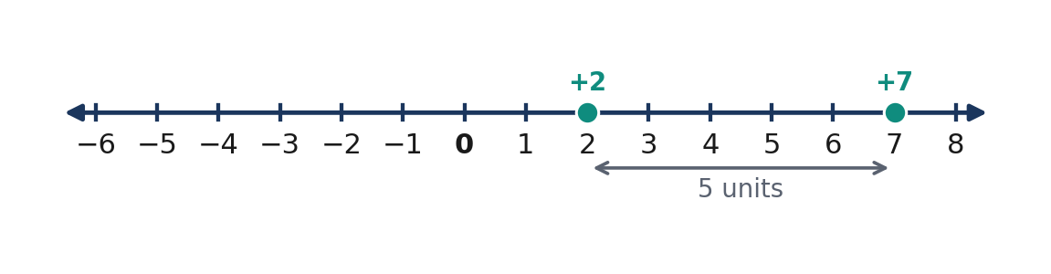
Figure 3.4.1 Figure 3.4.1 — The difference 7 − 2 is five units to the right from +2 to +7.
A number line also shows the directed difference from the subtrahend $b$ to the minuend $a$. Starting at $b$ and moving to $a$ gives the signed result $a-b$. This direction is important: $2-7=−5$, whereas $7-2=+5$. The absolute distance between the two points is five units in either order, but directed subtraction depends on which endpoint is first.
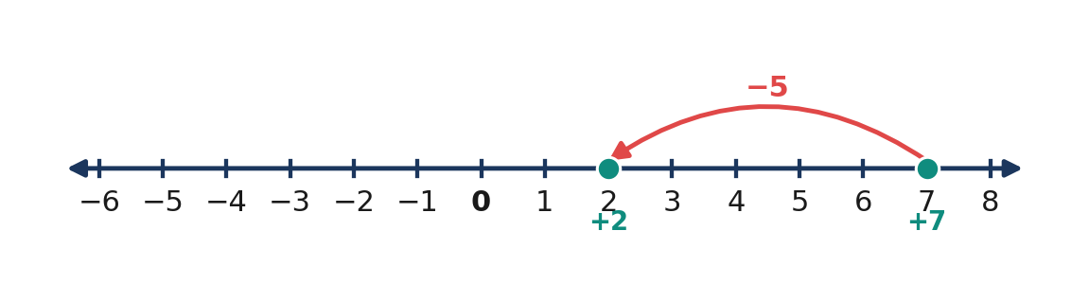
Figure 3.4.2 Figure 3.4.2 — The directed difference 2 − 7 is −5, moving five units left from 7 to 2.
Question | Integer expression | Interpretation
What is five less than +3? | $3-5=−2$ | Move five units left
How much greater is +6 than −2? | $6-(−2)=8$ | Eight-unit directed difference
What remains after removing zero? | $−4-0=−4$ | No numerical change
What results from removing −3 from −3? | $−3-(−3)=0$ | The entire negative amount is removed

Quick Check 3.4A: (1) Rewrite $8-5=3$ as an addition equation. (2) Find the directed difference $−2-4$ using the number line. (3) Explain why $7-2$ and $2-7$ have opposite signs.

3. Subtopic 3.4.2 — The Add-the-Opposite Principle

The add-the-opposite rule replaces subtraction of any integer by addition of its additive inverse. To subtract $+5$, add $−5$; to subtract $−5$, add $+5$. The second case explains why subtracting a negative number can yield a greater result. The rule does not depend on the first integer or whether the final answer is positive, negative, or zero.
📐 KEY CONCEPT 3.4B — Subtract by Adding the Opposite
$$a-b=a+(−b)$$
where a,b are integers; $−b$ is the additive inverse of the integer $b$. For example, $a-(−k)=a+k$ for every integer $k$.

The rule follows from inverse operations. Let $c=a+(−b)$. Then $b+c=b+a+(−b)=a+[b+(−b)]=a+0=a$. Since $c$ is the number that must be added to $b$ to obtain $a$, $c$ is the difference $a-b$. This argument establishes the rule for every integer, rather than just for isolated patterns in examples.
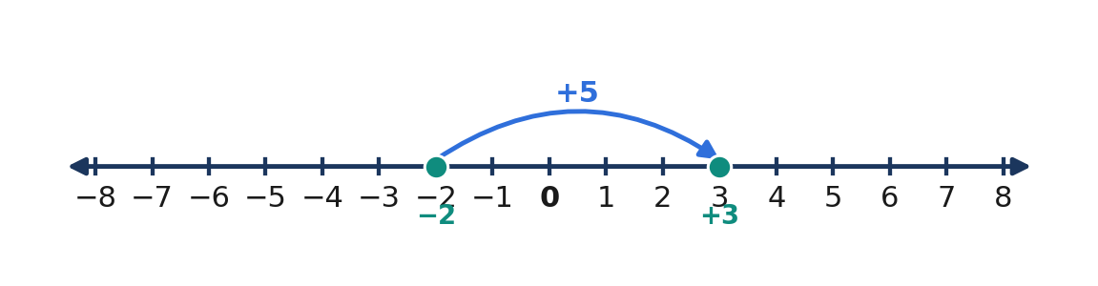
Figure 3.4.3 Figure 3.4.3 — Subtracting −5 from −2 is equivalent to moving five units right: −2 − (−5) = +3.
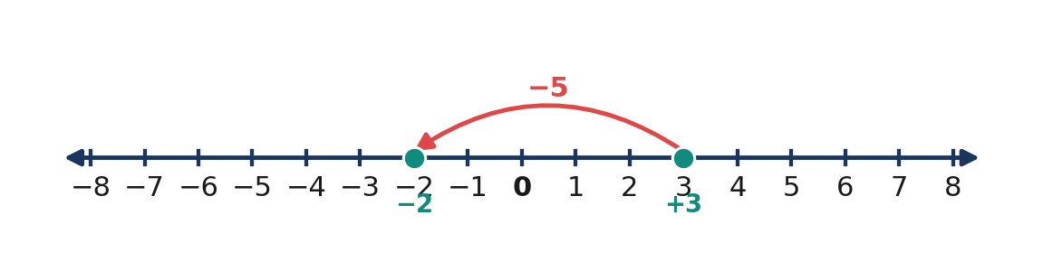
Figure 3.4.4 Figure 3.4.4 — Subtracting +5 from +3 is equivalent to moving five units left: 3 − 5 = −2.
Expression | Rewrite as addition | Difference
$9-4$ | $9+(−4)$ | $5
$9-(−4)$ | $9+(+4)$ | $13
$−9-4$ | $−9+(−4)$ | $−13$
$−9-(−4)$ | $−9+(+4)$ | $−5$
$0-(−7)$ | $0+(+7)$ | $7

Quick Check 3.4B: (1) Rewrite $−6-(−8)$ without subtraction. (2) Calculate $4-(−11)$ and explain the sign. (3) Explain why changing $7-(−3)$ directly to $7+(−3)$ is invalid.

4. Core Anchor — Four Worked Examples

💡 Worked Example 1 — Subtracting a Positive Integer
Problem: Find $(−4)-(+7)$.
Given: Minuend $−4$; subtrahend $+7$. Find: Difference in integer units. Formula/Rule: $a-b=a+(−b)$.
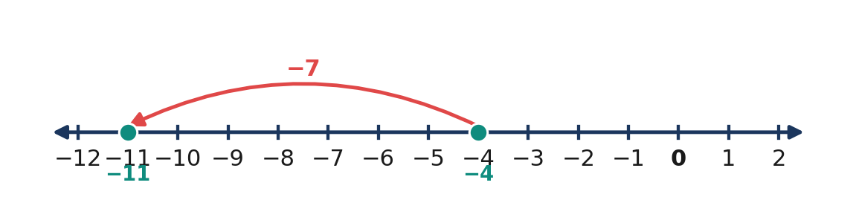
Figure 3.4.5 Figure 3.4.5 — From −4, the movement for adding −7 ends at −11.
$(−4) − (+7)$ | $= (−4) + (−7)$ | add the opposite of +7
 | $= −(4 + 7)$ | add negative integers
 | $= −11$ | simplify

Final Answer: **$−11$ units**. Check: $(−11)+(+7)=−4$, the original minuend.

💡 Worked Example 2 — Subtracting a Negative Integer
Problem: Compute $(+6)-(−9)$.
Given: $+6$, $−9$. Find: Difference. Formula/Rule: Add the opposite of the subtrahend.
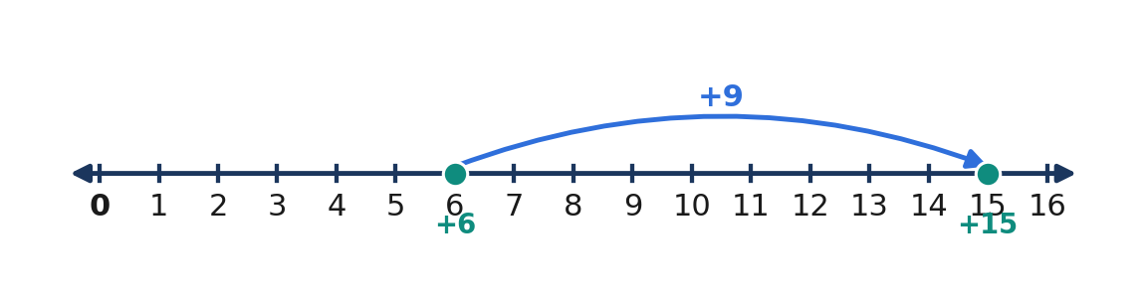
Figure 3.4.6 Figure 3.4.6 — Subtracting −9 is equivalent to adding +9, moving from 6 to 15.
$(+6) − (−9)$ | $= (+6) + (+9)$ | change subtraction to addition of the opposite
 | $= 15$ | add two positive integers

Final Answer: **$+15$ units**. Check: $15+(−9)=6$.

💡 Worked Example 3 — Temperature Difference
Problem: A thermometer reads $−7^{°}C$ early in the day and $+4^{°}C$ later. Find the later temperature minus the earlier temperature.
Given: Later $+4^{°}C$; earlier $−7^{°}C$. Find: Signed temperature change, in °C. Rule: Final minus initial.
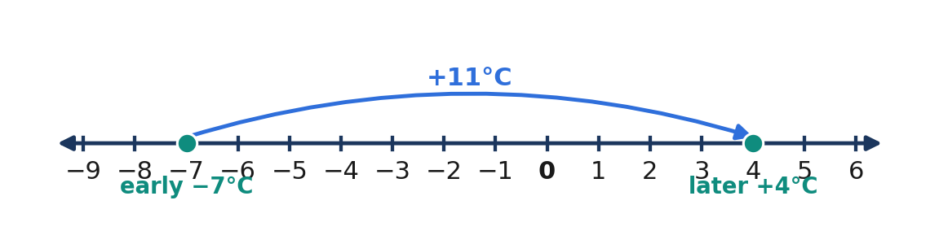
Figure 3.4.7 Figure 3.4.7 — The thermometer reading rises 11°C from −7°C to +4°C.
$(+4) − (−7)$ | $= (+4) + (+7)$ | subtracting the initial negative temperature
 | $= +11$ | add positive integers

Final Answer: **The temperature increased by ${11}^{°}C$**. Check: $−7^{°}C+{11}^{°}C=+4^{°}C$.

💡 Worked Example 4 — Multiple Subtractions and Parentheses
Problem: Evaluate $(−8)-(−5)-(+9)$ from left to right.
Given: Three signed integers. Find: The numerical value. Rule: Replace each subtraction by addition of the opposite, or work sequentially from left to right.
$(−8) − (−5) − (+9)$ | $= (−8) + (+5) + (−9)$ | replace both subtraction operations
 | $= (−3) + (−9)$ | add the first two numbers
 | $= −12$ | add negative integers

Final Answer: **$−12$**. Check: $(−12)+9=−3$ and $(−3)+(−5)=−8$.

5. Inquiry, Properties, and Common Misconceptions

Addition is commutative, but subtraction generally is not. Reversing the order changes the directed difference: $10-4=6$ but $4-10=−6$. Likewise, subtraction is not associative: $(10-4)-3=3$ but $10-(4-3)=9$. Whenever parentheses are present, preserve them while applying the add-the-opposite rule.
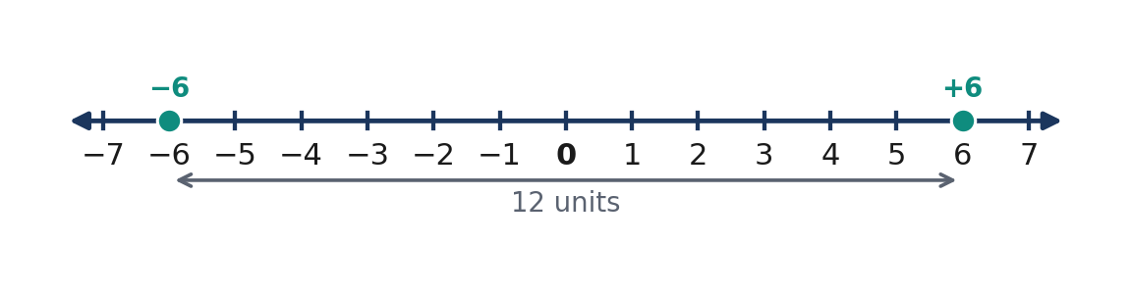
Figure 3.4.8 Figure 3.4.8 — Reversing 6 − (−6) to (−6) − 6 changes +12 to −12, even though both have magnitude 12.
📐 KEY CONCEPT 3.4C — Subtraction and Inverse Checking
$$(a-b)+b=a$$
where a,b are integers. The difference plus the original subtrahend must reproduce the minuend; all quantities must use the same unit.

WATCH OUT — Wrong → Right
- Wrong: $4-(−6)=4+(−6)=−2$. Right: $4-(−6)=4+6=10$; the opposite of $−6$ is $+6$.
- Wrong: $(−3)-(+8)=+11$. Right: $(−3)+(−8)=−11$; adding two negatives remains negative.
- Wrong: $7-2=2-7$. Right: $7-2=5$ and $2-7=−5$; subtraction is not commutative.
- Wrong: $−8-0=0$. Right: $−8-0=−8$; subtracting zero changes nothing.

Reasoning challenge: Without simply stating a memorized rule, explain why $a-(−b)=a+b$ when $b$ is positive. Show (i) an inverse-check argument and (ii) a directed number-line explanation. Then explain why $−a-b$ may still be negative.

6. Subtopic 3.4.3 — Counter Models and Applied Mastery

Counter subtraction models removal rather than only movement. A positive counter is $+1$ and a negative counter is $−1$. To evaluate $3-(−2)$, start with three positive counters. There are no negative counters to remove, so add two zero pairs without changing the represented value. Remove the two negative counters. Five positive counters remain, proving $3-(−2)=5$.
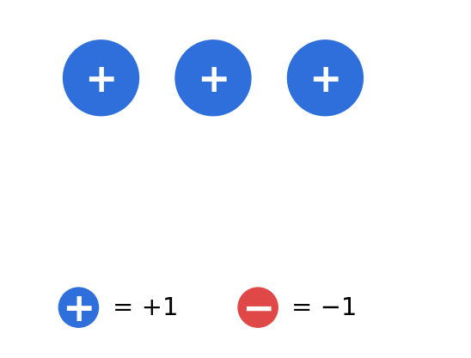
Figure 3.4.9 Figure 3.4.9 — Begin with three positive counters, representing +3.
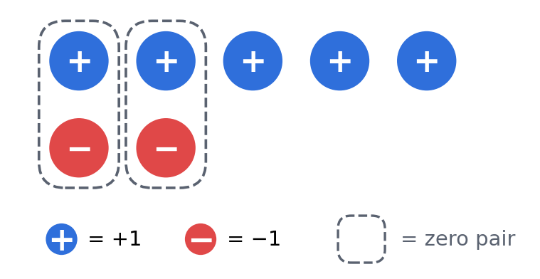
Figure 3.4.10 Figure 3.4.10 — Add two zero pairs; five positive and two negative counters still represent +3.
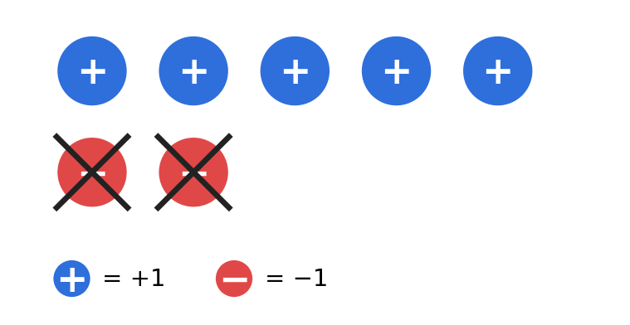
Figure 3.4.11 Figure 3.4.11 — Removing two negative counters leaves five positive counters: 3 − (−2) = +5.
A similar idea works when subtracting a positive number from a smaller positive number. To evaluate $2-5$, begin with two positive counters, add three zero pairs, and remove five positive counters. Three negative counters remain. Adding zero pairs is mathematically legitimate because each pair has total value zero; removing counters represents subtraction rather than a new addition.
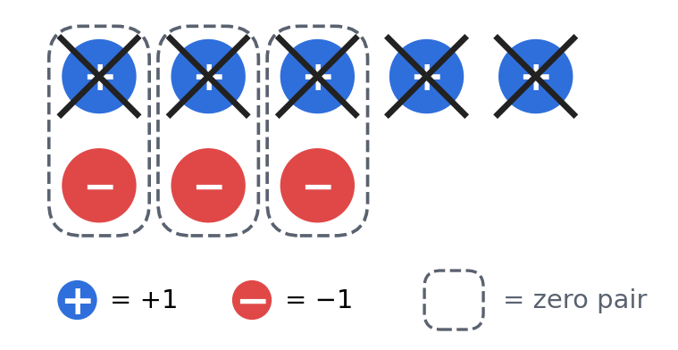
Figure 3.4.12 Figure 3.4.12 — To model 2 − 5, add three zero pairs to +2 and remove five positive counters; −3 remains.
Stage | Counter method | Numerical statement
Establish starting value | Display counters for minuend | $+3$
Make removable counters available | Insert opposite-colored zero pairs | $3+(+2-2)=3$
Remove specified counters | Remove two negative counters | $3-(−2)$
Count counters remaining | Five positive remain | $+5$
Verify | Add removed amount back to result | $5+(−2)=3$

Quick Check 3.4C: (1) How many zero pairs are needed to model $+1-(+4)$ using counters? (2) Explain the leftover counters for $(−2)-(−5)$. (3) Verify $(−11)-(−7)=−4$ with addition.

7. Guided Practice — Task 3.4.1 and Task 3.4.2

Task 3.4.1: Graded subtraction practice (22 items). Write the add-the-opposite step, then the answer. For questions 1, 4, and 10, also sketch a number line.
Basic (1–12)
1. (+8) − (+3) | 2. (+7) − (−2) | 3. (−6) − (+5)
4. (−9) − (−4) | 5. 0 − (+11) | 6. 0 − (−6)
7. (+12) − (+17) | 8. (−14) − (−14) | 9. (+5) − (−9)
10. (−3) − (+8) | 11. (−20) − (−7) | 12. (+16) − 0

Intermediate (13–18)
13. (−8) − (−3) − (+5) | 14. (+12) − (+18) − (−7)
15. (−6) − [(+4) − (+9)] | 16. (+15) − [(−2) − (−5)]
17. Find x: x − (−6) = +2 | 18. Find x: (−7) − x = +4

Challenge and word problems (19–22)
19. A temperature rises from $−{11}^{°}C$ to $+3^{°}C$. Find the change, stating the direction and unit.
20. A school cooperative's account changes from a balance of $−₱180$ to $+₱75$. Calculate final balance minus initial balance, and interpret the improvement.
21. A diver rises from $−24 m$ to $−9 m$. Find the vertical displacement; explain why the signed result is positive.
22. Is $(a-b)-c=a-(b-c)$ true for every triple of integers? Provide a counterexample with three integers and explain what fails.
Task 3.4.2: Analytical matrix
Expression | Addition-of-opposite form | Result and reason
$(−7)-(+6)$ | ____ | ____
$(+9)-(−12)$ | ____ | ____
$(−15)-(−15)$ | ____ | ____
$(+2)-(+10)$ | ____ | ____
$(−4)-(−9)-(+3)$ | ____ | ____

8. Contextual Application — Weekly Temperature Log

Goal: Determine temperature changes using signed subtraction and explain what each sign means. A weather station records morning and afternoon temperatures across four days. These are sample mathematical values, not measured observations from a real locality.
Day | Morning | Afternoon
Monday | $−4^{°}C$ | $+3^{°}C$
Tuesday | $+2^{°}C$ | $−5^{°}C$
Wednesday | $−8^{°}C$ | $−2^{°}C$
Thursday | $+6^{°}C$ | $+1^{°}C$

Procedure: For each day, (1) write afternoon minus morning; (2) rewrite the subtraction as addition; (3) compute signed temperature change; (4) classify rise or fall; and (5) check by adding the change to the morning temperature. Finally rank the four days by signed temperature change and explain why the largest absolute change need not be a temperature rise.
Scoring (12 points): Four correct models (4), four correct changes and units (4), clear rise/fall interpretations (2), and one defensible comparison with verification (2).

9. Metacognition and Lesson Summary

3–2–1 exit ticket: Write three subtraction rules or facts you can justify, two common sign errors you will actively check, and one practical situation where subtraction of a negative number describes an increase.
LESSON SUMMARY — Subtracting Integers
To subtract an integer, add its opposite: $a-b=a+(−b)$. Number-line motion follows the rewritten second addend. Counter models use zero pairs whenever the necessary color of counters is unavailable for removal. Subtraction is not commutative or associative; parentheses and original order must be respected. Check the result by adding the original subtrahend to the difference and confirming the minuend.

10. Formative Assessment (15 Items)

Part I: Multiple choice (1–10, one point each). Choose one answer and mark [ ].
1. [ ] Compute $(+9)-(+4)$. A. $+5$ B. $−5$ C. $+13$ D. $−13$
2. [ ] Compute $(+6)-(−3)$. A. $+3$ B. $−9$ C. $+9$ D. $−3$
3. [ ] What is $(−7)-(+5)$? A. $−2$ B. $−12$ C. $+12$ D. $+2$
4. [ ] Evaluate $(−10)-(−6)$. A. $−16$ B. $+16$ C. $+4$ D. $−4$
5. [ ] Which is the correct addition equivalent of $8-(−11)$? A. $8+(−11)$ B. $8+(+11)$ C. $−8+11$ D. $−8-11$
6. [ ] Calculate $0-(−14)$. A. $+14$ B. $−14$ C. $0 D. $+1$
7. [ ] What is $(+3)-(+8)$? A. $+11$ B. $+5$ C. $−5$ D. $−11$
8. [ ] Which calculation is a correct inverse check for $(−4)-(−9)=5$? A. $5+9=14$ B. $−4+9=5$ C. $5-9=−4$ D. $5+(−9)=−4$
9. [ ] Find $(+5)-(−2)-(+4)$. A. $+3$ B. $−3$ C. $+11$ D. $−11$
10. [ ] A reading changes from $−6^{°}C$ to $+1^{°}C$. What is the temperature change? A. $−7^{°}C$ B. $−5^{°}C$ C. $+5^{°}C$ D. $+7^{°}C$
Part II: Open calculation and reasoning (11–15). Show your work and explanation.
11. Evaluate $(−12)-(−19)$ using the add-the-opposite rule. Check your answer by addition.
12. Represent $(+2)-(+6)$ with integer counters. Identify the number of zero pairs added and the counters remaining.
13. Evaluate $(+8)-[(−3)-(+7)]$ carefully, preserving the grouping symbols. Explain each transformation.
14. An account balance changes from $−₱225$ to $+₱80$. Calculate the signed change and interpret it in pesos.
15. Explain with a numerical counterexample why integer subtraction is not commutative. State the correct relation between $a-b$ and $b-a$.

LESSON 3.5 — MULTIPLYING INTEGERS

Mathematics 7 | Quarter 3 | Number and Algebra (NA)

1. Curriculum Alignment and Mathematical Background

Content standard: Knowledge and understanding of the four operations with integers and simplification of numerical expressions involving integers.
Learning competency: Multiply integers (Grade 7, Quarter 3, Learning Competency 10). Supporting connections: use signed quantities in real situations and simplify numerical expressions using number properties.
Performance standard: Perform the four operations with integers accurately and explain the calculations with mathematical representations.
Learning objectives: Represent integer multiplication with equal groups and patterns; determine product signs; apply multiplication properties; solve signed-rate and repeated-change problems; verify results using inverse operations.
Essential questions: (1) How does multiplication represent repeated equal changes? (2) Why do two negative factors produce a positive product? (3) How can properties and estimates verify products of integers?
🎥 INTERACTIVE MULTIMEDIA: MULTIPLYING POSITIVE AND NEGATIVE NUMBERS
Channel: Khan Academy.
Direct lesson video: https://www.youtube.com/watch?v=47wjId9k2Hs
Concepts to observe: multiplication of signed factors; product sign patterns; the difference between magnitude and direction.
Viewing questions: How can repeated addition show a positive number of negative groups? What pattern appears when a factor decreases by one? How does the product's sign help describe a repeated financial loss?

Multiplication compresses repeated addition of equal quantities. When a signed change of $−3$ degrees occurs four times, its cumulative change is $4×(−3)=−12$ degrees. Integer multiplication combines the magnitude of repeated changes and the sign of the result. Positive and negative signs describe direction or orientation relative to a reference, not whether an event is desirable.
Repeated addition directly explains a positive number of groups. To understand a negative number of groups, mathematical patterns and the distributive property extend the operation consistently. The resulting sign rules are not arbitrary: they preserve relationships that already hold among whole numbers and integers.

2. Subtopic 3.5.1 — Equal Groups and Repeated Addition

For a nonnegative integer $n$ and any integer $a$, the product $n× a$ means adding $a$ to itself $n$ times. For example, three equal losses of ₱4 form $(−4)+(−4)+(−4)=−12$. Counting three groups of four negative counters produces twelve negative counters. Equal groups establish both the magnitude and the meaning of the negative product.
📐 KEY CONCEPT 3.5A — Multiplication as Repeated Addition
For a positive whole number $n$ and any integer $a$,
$$n× a=underbracea+a+⋯+a_{n terms}.$$
When $n=0$, the product is zero: $0× a=0.$ Here $n$ counts groups and $a$ is the signed value of each group.

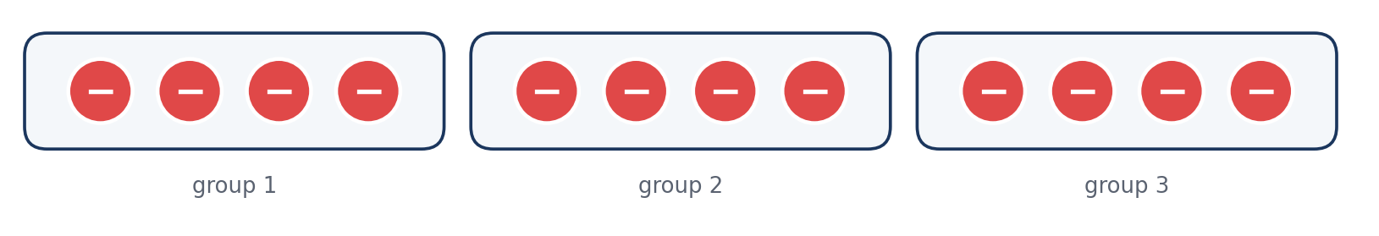
Figure 3.5.1 Figure 3.5.1. Three groups of four negative counters represent 3 × (−4) = −12.
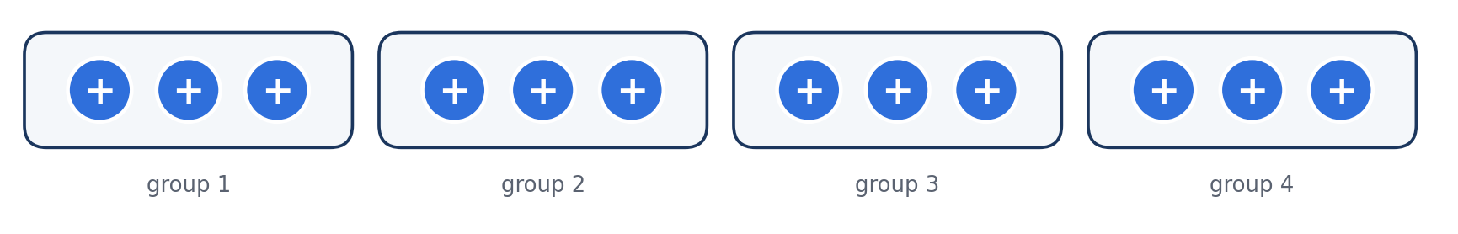
Figure 3.5.2 Figure 3.5.2. Four groups of three positive counters represent 4 × (+3) = +12.
The commutative property allows factors to exchange positions, so $3×(−4)=(−4)×3$. Nevertheless, “negative four groups” should not be interpreted literally as a negative count of objects. The equal-group model is a starting representation; the extension to negative multipliers must be justified by number patterns or algebraic properties.
Representation | Expression | Meaning
Three groups of four losses | $3×(−4)$ | Total change $−12$
Four groups of three gains | $4×(+3)$ | Total change $+12$
Zero groups of five losses | $0×(−5)$ | No change, $0
Five groups of zero | $5×0$ | Total $0

Quick Check 3.5A: (1) Write $4×(−6)$ as repeated addition. (2) What does $0×(−13)$ equal, and why? (3) Identify the product and units for five losses of ₱7 each.

3. Subtopic 3.5.2 — Deriving the Rules for Signs

When a positive multiplier repeatedly combines negative values, the product is negative. To extend multiplication to negative multipliers, examine a consistent sequence: $3(−4)=−12$, $2(−4)=−8$, $1(−4)=−4$, and $0(−4)=0$. Decreasing the first factor by one increases the product by four each time. The next term, $(−1)(−4)$, must therefore be $+4$.
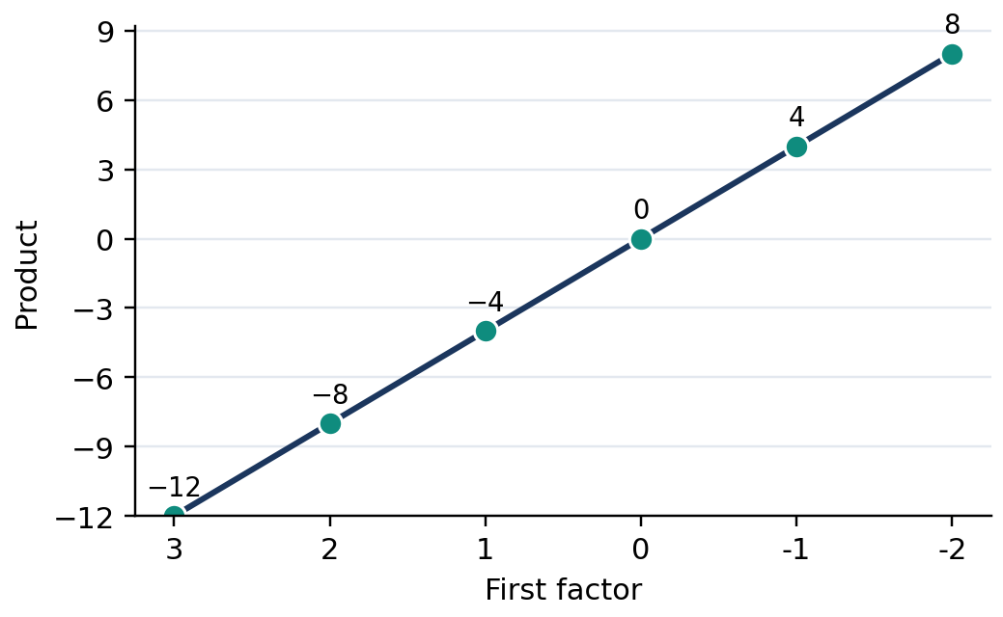
Figure 3.5.3 Figure 3.5.3. As the first factor decreases by 1, products of (first factor) × (−4) increase by 4.
The distributive property confirms the sign rule without relying on a picture. Because $(−3)+(+3)=0$, multiplying this sum by $−4$ must give zero. The positive-times-negative part equals $−12$, so the other product must be $+12$. This shows why two negative factors produce a positive product if multiplication is to remain consistent with addition and distribution.
$$[(−3)+(+3)]×(−4)=0$$
$$(−3)×(−4)+(+3)×(−4)=0$$
$$(−3)×(−4)+(−12)=0$$
$$(−3)×(−4)=+12$$
📐 KEY CONCEPT 3.5B — Rules for Product Signs
$$(+a)(+b)=+ab, (+a)(−b)=−ab$$
$$(−a)(+b)=−ab, (−a)(−b)=+ab$$
Here $a$ and $b$ are nonnegative magnitudes. Same signs produce a positive product; different signs produce a negative product. A zero factor always gives zero.

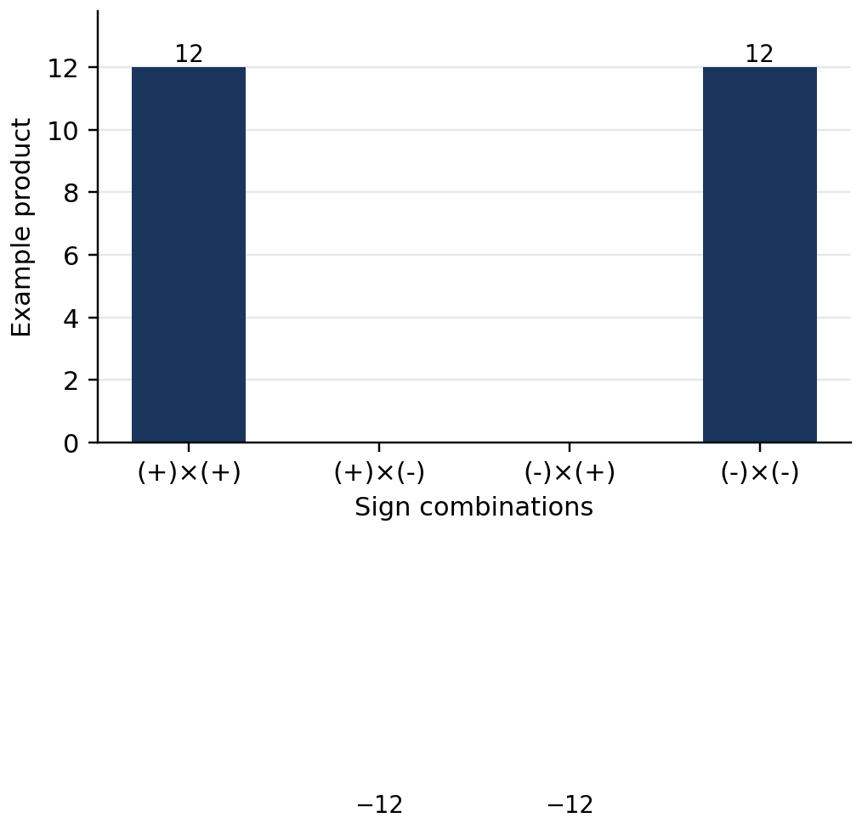
Figure 3.5.4 Figure 3.5.4. For factors with magnitudes 3 and 4, sign choices give products +12 or −12.
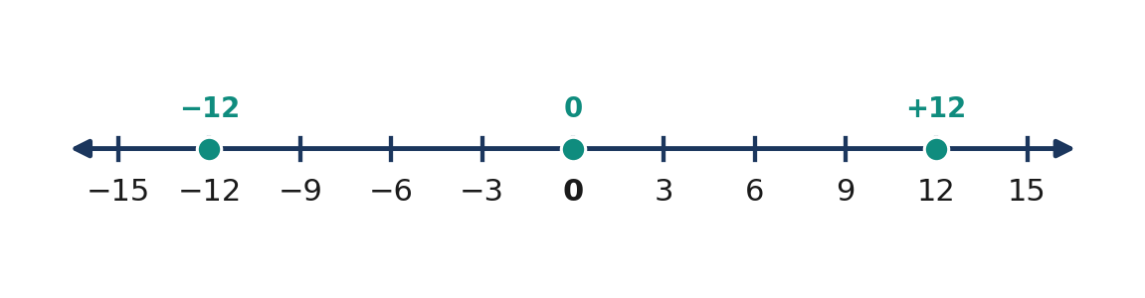
Figure 3.5.5 Figure 3.5.5. The values −12 and +12 have equal magnitudes but opposite positions.
First factor | Second factor | Sign | Example
Positive | Positive | Positive | $(+5)(+2)=+10$
Positive | Negative | Negative | $(+5)(−2)=−10$
Negative | Positive | Negative | $(−5)(+2)=−10$
Negative | Negative | Positive | $(−5)(−2)=+10$
Any integer | Zero | Zero | $(−5)(0)=0$

Quick Check 3.5B: (1) Evaluate $(−7)(−6)$ and justify its sign. (2) What happens to the product when exactly one nonzero factor changes sign? (3) Complete the pattern $2(−5),1(−5),0(−5),(−1)(−5)$.

4. Core Anchor — Four Fully Worked Examples

💡 Worked Example 1 — Repeated Temperature Decreases
Problem: A temperature falls by $3^{°}C$ every hour for five hours. Find the net change.
Given: Five equal changes, each $−3^{°}C$. Find: The cumulative temperature change in degrees Celsius.
Formula/Rule: $n× a=underbracea+a+⋯+a_{n terms}.$
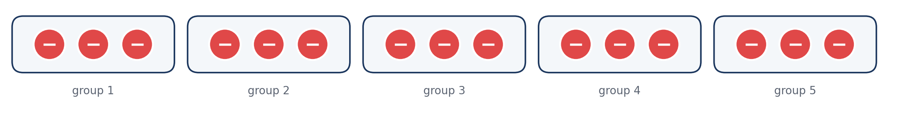
Figure 3.5.6 Figure 3.5.6. Five groups of three negative counters model five successive temperature decreases.
$5 × (−3)$ | $= (−3)+(−3)+(−3)+(−3)+(−3)$ | use repeated addition
 | $= −15$ | add five equal negative changes

Final Answer: **The net change is $−{15}^{°}C$, a decrease of ${15}^{°}C$.**

💡 Worked Example 2 — Product of Two Negative Integers
Problem: Compute $(−8)(−7)$.
Given: Factors $−8$ and $−7$. Find: Their product.
Formula/Rule: The product of two negative factors is positive; multiply their absolute values.
$(−8)(−7)$ | $= +(8 × 7)$ | equal negative signs give a positive product
 | $= +56$ | multiply the magnitudes

Final Answer: **$+56$.**
Check: Since $56÷(−7)=−8$, the factors and product are consistent.

💡 Worked Example 3 — Multiple Signed Factors
Problem: Evaluate $(−2)(+3)(−5)$.
Given: Three nonzero integer factors. Find: The product.
Formula/Rule: Multiply in sequence or group factors using associativity; each pair of negative factors gives a positive product.
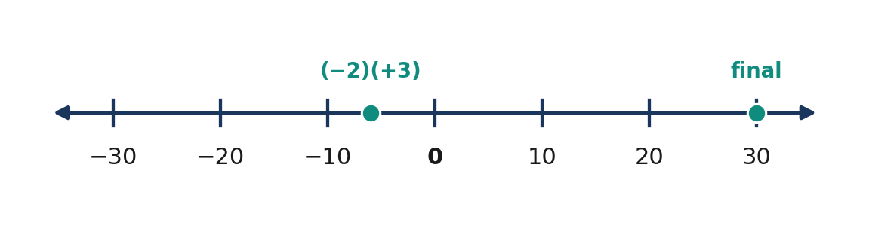
Figure 3.5.7 Figure 3.5.7. The intermediate product is −6 and the final product after multiplying by −5 is +30.
$(−2)(+3)(−5)$ | $= (−6)(−5)$ | multiply the first two factors
 | $= +(6 × 5)$ | two negative factors give a positive product
 | $= +30$ | calculate the magnitude

Final Answer: **$+30$.**

💡 Worked Example 4 — A Savings Change Over Several Days
Problem: A learner spends ₱45 each day for six days. Represent the net change in savings, assuming no other changes.
Given: Six days, each change $−₱45$. Find: Total change in pesos.
Formula/Rule: Total repeated change equals number of days times signed daily change.
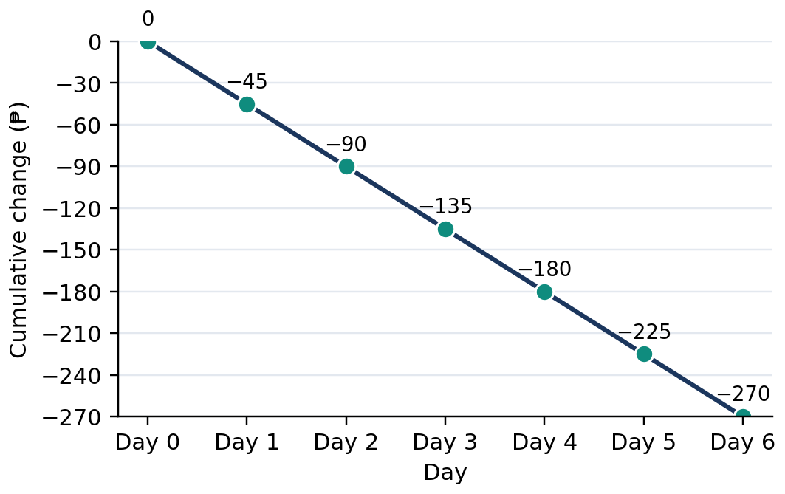
Figure 3.5.8 Figure 3.5.8. The cumulative savings change decreases by ₱45 each day, reaching −₱270.
$6 × (−45)$ | $= −(6 × 45)$ | different signs give a negative product
 | $= −270$ | multiply the magnitudes

Final Answer: **The net change is $−₱270$, a decrease of ₱270.**

5. Mathematical Reasoning and Common Misconceptions

The sign of a product with several nonzero integer factors depends on how many factors are negative. Pairing two negative factors produces one positive product. Therefore, an even number of negative factors gives a positive result, while an odd number gives a negative result. For example, $(−2)(−3)(−4)$ contains three negative factors and has product $−24$. If any factor is zero, the entire product is zero regardless of the other factors.
📐 KEY CONCEPT 3.5C — Multiple Factors
For products of nonzero integers: an even number of negative factors gives a positive product; an odd number gives a negative product. If any factor is zero, the result is zero.

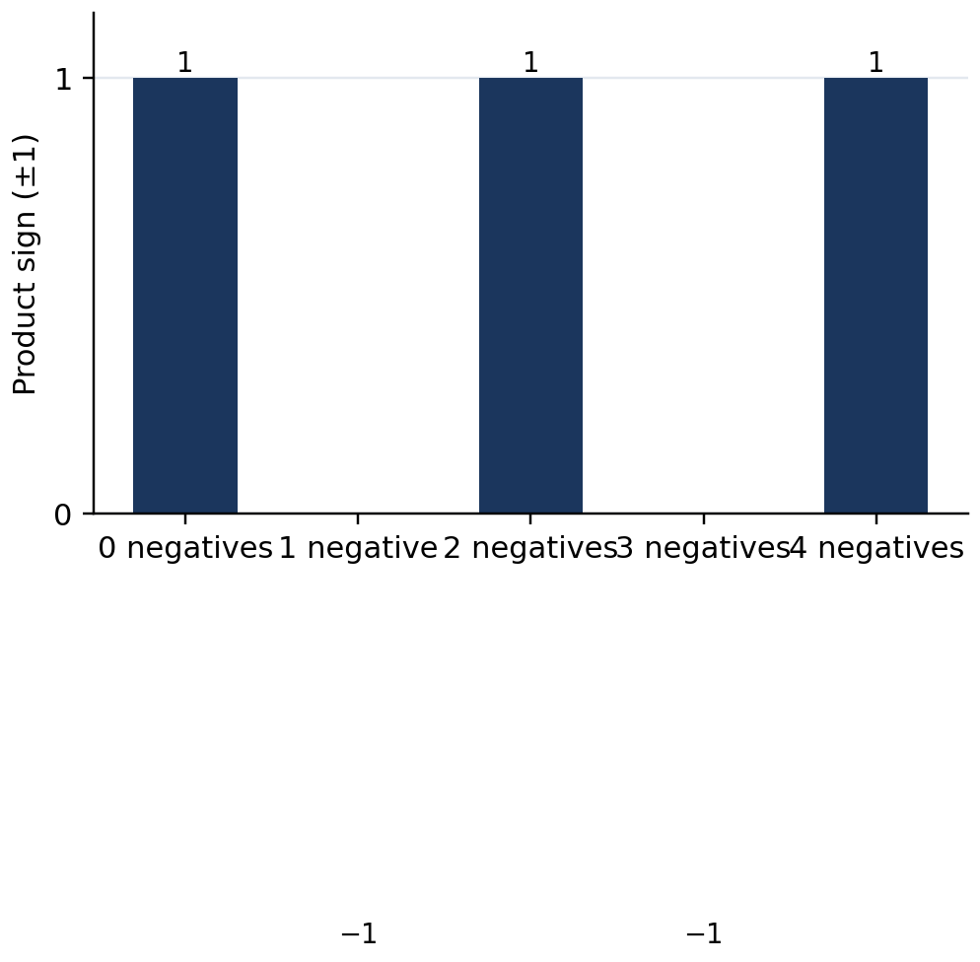
Figure 3.5.9 Figure 3.5.9. The sign alternates with the parity of the count of negative factors.
WATCH OUT — Wrong → Right
Wrong: $(−4)(−5)=−20$ because both numbers are negative. Right: $(−4)(−5)=+20$: equal nonzero signs give a positive product.
Wrong: $(−4)+(−5)=+20$. Right: Addition is not multiplication: the sum is $−9$.
Wrong: $(−7)(0)=−7$. Right: Any number multiplied by zero gives zero.
Wrong: Three negative factors produce a positive product. Right: Three is odd, so the product is negative.

Reasoning challenge: Explain, using the distributive property, why $(−1)(−1)=+1$. Then determine the sign of $(−2)(−3)(−4)(−5)$ without first calculating the magnitude. Explain why the product changes sign when one factor is replaced by its opposite.

6. Subtopic 3.5.3 — Multiplication Properties and Efficient Computation

Integer multiplication is commutative and associative. The order and grouping of factors can change without changing the product. The identity factor is $1, while zero makes the product zero. Distribution connects multiplication and addition and supports mental calculation. These properties also enable independent checks of arithmetic work.
📐 KEY CONCEPT 3.5D — Multiplication Properties
$$ab=ba (commutative)$$
$$(ab)c=a(bc) (associative)$$
$$a(b+c)=ab+ac (distributive)$$
$$a×1=a, a×0=0$$
Here a,b,c are integers.

For example, $(−4)(25)=25(−4)=−100$. For $(−6)(18)$, write $18=20-2$ to obtain $(−6)(20)+(−6)(−2)=−120+12=−108$. Distribution does not change the answer; it changes the calculation into two manageable products. Be careful that both terms inside the parentheses are multiplied by the outside factor.
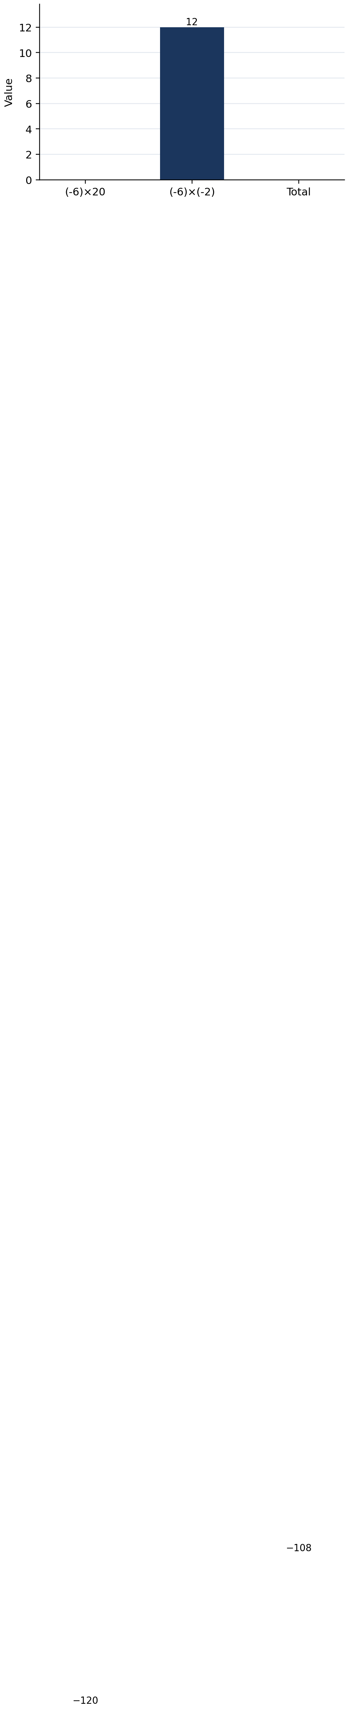
Figure 3.5.10 Figure 3.5.10. Distribution decomposes (−6)(18) into −120 and +12, totaling −108.
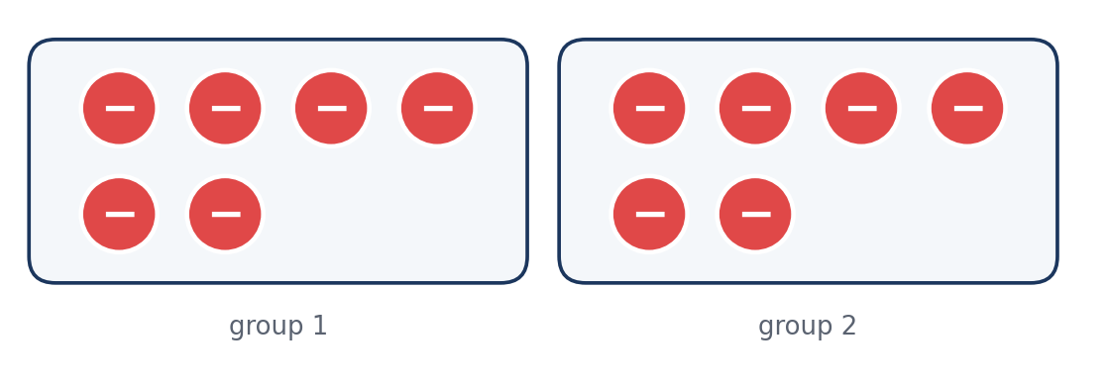
Figure 3.5.11 Figure 3.5.11. Two groups of six negative counters total −12, illustrating equivalent factor order for 2 × (−6).
A further check uses the inverse relationship between multiplication and division: if $a× b=c$ and $b≠0$, then $c÷ b=a$. Estimation checks the magnitude of larger products; for example, $(−19)(+6)$ should be near $−120$, so a reported answer of $+114$ has the wrong sign even though its magnitude is plausible.
Strategy | Expression | Result
Commute factors | $(−5)(12)=12(−5)$ | $−60$
Associate factors | $(−2)(−5)(3)=10(3)$ | $+30$
Distribute | $(−3)(10+2)=(−30)+(−6)$ | $−36$
Use identity | $(−17)(1)$ | $−17$
Use zero property | $(−17)(0)$ | $0

Quick Check 3.5C: (1) Evaluate $(−5)(−2)(−3)$ and explain the sign. (2) Use distribution to calculate $(−4)(19)$. (3) Identify the property behind $(−8)(1)=−8$.

7. Guided and Independent Practice

Task 3.5.1 — Graded Exercises (22 items). Show multiplication signs and, when requested, the reason for each sign.
Basic (1–12):
1. (+4)(+6) | 2. (−3)(+8) | 3. (+7)(−5)
4. (−6)(−9) | 5. (−12)(0) | 6. (0)(+25)
7. (−1)(+14) | 8. (−8)(−2) | 9. (+9)(+3)
10. (−11)(+4) | 11. (+5)(−12) | 12. (−10)(−10)

Intermediate (13–18):
13. (−2)(+3)(−4) | 14. (−3)(−5)(−2)
15. (−6)(18) using distribution | 16. (−4)(−7)(+2)
17. Find x: (−9)x=+63 | 18. Find x: x(+8)=−96

Challenge and word problems (19–22):
19. A school club spends ₱35 for each of 8 identical supplies. Model and calculate the change in its budget.
20. A temperature changes by $−4^{°}C$ each hour for 7 hours. Find the total change and explain the sign.
21. A submarine changes elevation by $−12 m$ in each of 5 equal stages. What is the total elevation change?
22. Without multiplying first, determine the sign of $(−2)(−3)(+4)(−5)(−1)$. Then calculate its exact product and justify the sign.
Task 3.5.2 — Analytical Matrix: Complete five entries.
Expression | Sign before calculation | Property or rule | Exact product
$(−7)(+6)$ | __ | __ | __
$(−7)(−6)$ | __ | __ | __
$(−2)(−3)(−4)$ | __ | __ | __
$(−9)(0)(+5)$ | __ | __ | __
$(−4)(20-3)$ | __ | __ | __

8. Contextual Application — Community Cleanup Budget

A student-led cleanup group makes six identical purchases of garbage bags at ₱38 per purchase. Represent each expenditure as a negative signed change in the club's funds. Calculate the total change using multiplication, verify it by repeated addition, and explain how the sign describes the direction of the change rather than the value of the activity. The group begins with ₱500; calculate its remaining funds assuming no other transactions.
Scoring criteria (12 points): Accurate signed mathematical model—3 points; correct multiplication—3; independent verification—3; remaining balance and interpretation with pesos—3. Show enough steps to distinguish total expenditure from money remaining.
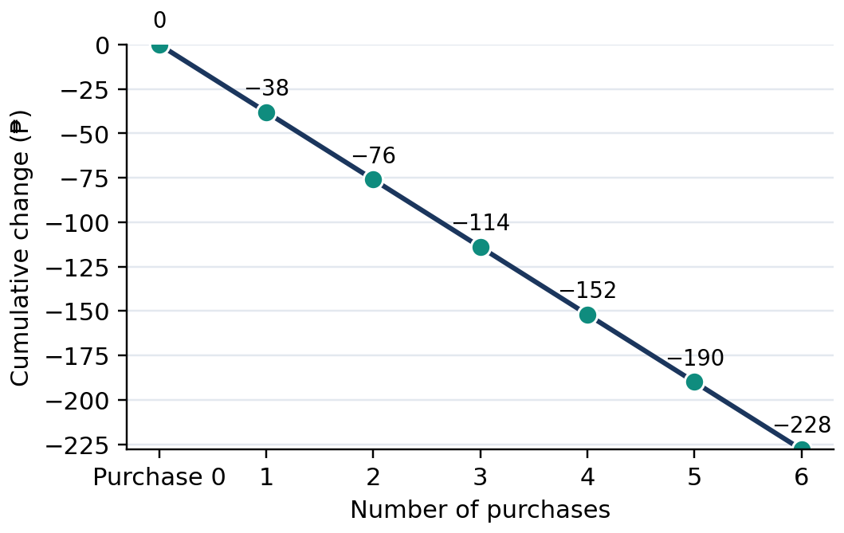
Figure 3.5.12 Figure 3.5.12. Each purchase decreases the fund balance by ₱38; the total change is −₱228.

9. Metacognitive Reflection and Lesson Summary

3–2–1 Exit Ticket: Write three multiplication rules or properties you can prove or explain; two common sign mistakes and how to correct them; and one context in which a signed product is meaningful. For one rule, provide a numerical example and explain why the answer has its sign.
LESSON SUMMARY
Integer multiplication extends repeated equal changes. The magnitude of a product comes from multiplying absolute values. Two factors with equal nonzero signs produce a positive result; different signs produce a negative result. Zero makes the entire product zero. For several nonzero factors, an even number of negative factors makes a positive product and an odd number makes a negative product. Commutative, associative, and distributive properties support efficient calculation and verification.

10. Formative Assessment — 15 Items

Part I — Multiple Choice (10 points). Choose one answer for each item.
1. [ ] What is $(+6)(+7)$? A. $+42$ B. $−42$ C. $+13$ D. $−13$
2. [ ] What is $(−8)(+5)$? A. $+40$ B. $−13$ C. $−40$ D. $+13$
3. [ ] Calculate $(−9)(−4)$. A. $−36$ B. $+36$ C. $−13$ D. $+13$
4. [ ] What is $(−15)(0)$? A. $−15$ B. $+15$ C. $1 D. $0
5. [ ] Which expression demonstrates the commutative property? A. $(−3)(4)=4(−3)$ B. $(−3)(1)=−3$ C. $(−3)(0)=0$ D. $(−3)(4+2)=(−3)(4)+(−3)(2)$
6. [ ] Evaluate $(−2)(−3)(−4)$. A. $+24$ B. $−24$ C. $−9$ D. $+9$
7. [ ] A loss of ₱12 occurs every day for five days. What is the net change? A. $+₱60$ B. $−₱17$ C. $+₱17$ D. $−₱60$
8. [ ] Evaluate $(−4)(18)$ using the sign rule. A. $+72$ B. $−22$ C. $−72$ D. $+22$
9. [ ] Find $x$ if $(−7)x=+56$. A. $+8$ B. $−8$ C. $−49$ D. $+49$
10. [ ] Which product is positive? A. $(−2)(−3)(−4)$ B. $(−2)(+3)$ C. $(−2)(0)$ D. $(−2)(−3)(−4)(−5)$
Part II — Open Calculation and Reasoning (Items 11–15; show the mathematical model and steps).
11. Represent $4(−5)$ using repeated addition and integer counters. Give the final product and explain the sign.
12. Derive $(−2)(−6)=+12$ from the pattern $2(−6),1(−6),0(−6),(−1)(−6),(−2)(−6)$, and explain why each successive product changes by six.
13. Evaluate $(−3)(+4)(−5)$ by grouping convenient factors. Name the property that justifies regrouping.
14. A class purchases seven packs at ₱48 each. Represent the spending as a signed product; calculate the net change and check by addition.
15. A classmate claims $(−8)(−9)=−72$ because the factors are negative. Identify the error, give the correct product, and justify it using a mathematical rule or the distributive property.

LESSON 3.6 — DIVIDING INTEGERS

Mathematics 7 • Quarter 3 • Number and Algebra (NA)

1. Curriculum Alignment and Background

Content Standard: Knowledge and understanding of the four operations with integers and simplifying numerical expressions involving integers.
Learning Competencies: Grade 7 Quarter 3 LC 10: multiply and divide integers; LC 11: simplify numerical expressions involving integers using number properties and the order of operations (GEMDAS). This lesson consolidates prior addition and subtraction and the meaning of absolute value.
Performance Standard: Perform integer operations, simplify expressions accurately, and explain the steps.
Essential Questions: (1) How does inverse multiplication explain integer division and its signs? (2) Why is division by zero undefined? (3) How does GEMDAS determine one defensible value for an expression?
🎥 INTERACTIVE MULTIMEDIA: Dividing Positive and Negative Numbers
Channel: Khan Academy Brasil (English-titled instructional video)
Direct link: https://www.youtube.com/watch?v=LUX3R7Dhhyk
Concepts to observe: the signs of integer quotients; inverse multiplication; checking results.
Viewing questions: 1. How can multiplication check a division result? 2. Why does a negative divided by a negative give a positive answer? 3. How could division describe an equal decrease over several days?

Division answers the question: Which number, when multiplied by the divisor, gives the dividend? This question extends equal sharing to signed quantities. A total loss of twenty units over four equal periods means a loss of five units per period. Integer division needs both magnitude and sign, and a complete answer should be checked by reversing the operation.
Not all divisions of two integers give integers. For example, $7÷2$ is defined but equals $3.5. Division by zero is undefined, while zero divided by any nonzero integer is zero. Learners must recognize these exceptions before applying division rules within expressions that also contain addition, subtraction, multiplication, grouping, and exponents.

2. Subtopic 3.6.1 — Division Is Inverse Multiplication

A division statement is true when its quotient produces the dividend after multiplication by the divisor. In $(−24)÷(+6)=−4$, the check is $(+6)(−4)=−24$. Since the product matches the dividend, the quotient is correct. A positive number of equal groups containing negative amounts provides a concrete model of a negative quotient.
📐 KEY CONCEPT 3.6A — Inverse Multiplication
$$a÷ b=q Longleftrightarrow bq=a, b≠0$$
Here $a$ is the dividend, $b$ the divisor, and $q$ the quotient. If amounts carry units, the quotient units equal dividend units divided by divisor units.

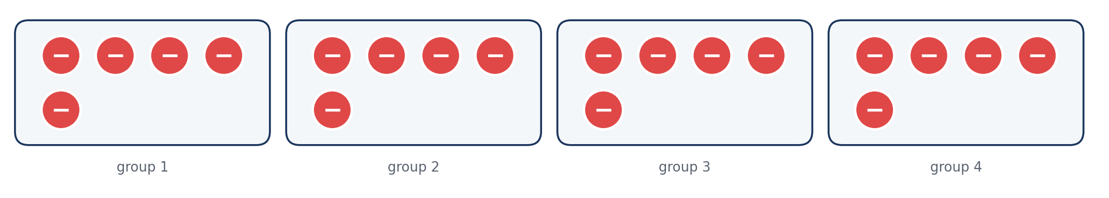
Figure 3.6.1 Figure 3.6.1. Four groups of −5 total −20; therefore (−20) ÷ (+4) = −5.
Figure 3.6.2 Figure 3.6.2. Three equal groups of −4 total −12, so (−12) ÷ (+3) = −4.
The signs in multiplication force the corresponding quotient signs. A positive times a negative is negative, so dividing a negative dividend by a positive divisor produces a negative quotient. A negative times a positive is also negative, so a negative dividend divided by a negative divisor needs a positive quotient. Reasoning through the check makes the rules easier to reconstruct after forgetting a memorized phrase.
Division | Multiplication check | Quotient
$(+24)÷(+6)$ | $(+6)(+4)=+24$ | $+4$
$(−24)÷(+6)$ | $(+6)(−4)=−24$ | $−4$
$(+24)÷(−6)$ | $(−6)(−4)=+24$ | $−4$
$(−24)÷(−6)$ | $(−6)(+4)=−24$ | $+4$

Quick Check 3.6A: 1. Solve $(+8)q=−56$. 2. Verify $(−45)÷(−9)=+5$ by multiplication. 3. Explain the sign of $(+30)÷(−6)$.

3. Subtopic 3.6.2 — Sign Rules and Division by Zero

To divide nonzero integers, divide the absolute values and assign the sign determined by the operands. Same signs give a positive quotient; different signs give a negative quotient. The sign rule still applies to non-integer quotients, such as $(−7)÷(+2)=−3.5$. However, an exact quotient is an integer only when the divisor divides the dividend evenly.
📐 KEY CONCEPT 3.6B — Division Sign Rules
For positive integers $a$ and $b$:
$$\frac{+a}{+b}=+\frac{a}{b}, \frac{−a}{−b}=+\frac{a}{b}$$
$$\frac{+a}{−b}=−\frac{a}{b}, \frac{−a}{+b}=−\frac{a}{b}$$
Here the fractions denote the quotient; the results are integers when $b$ is a factor of $a$.

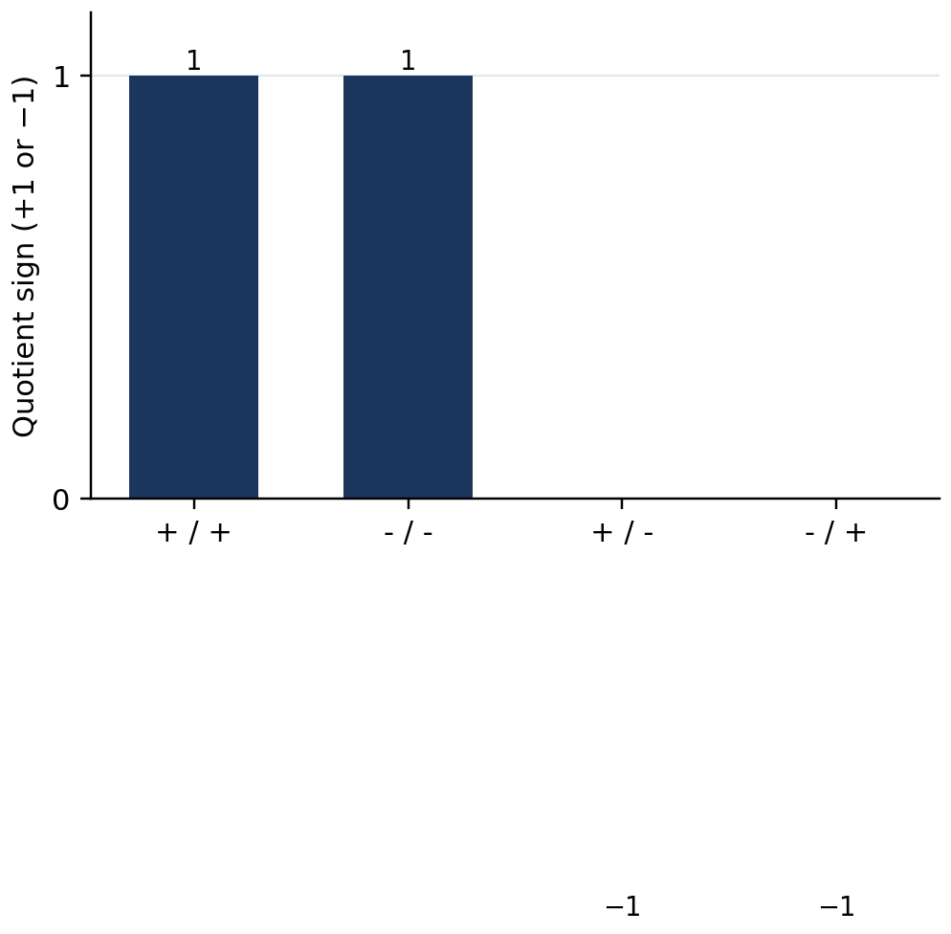
Figure 3.6.3 Figure 3.6.3. Same signs yield a positive quotient; different signs yield a negative quotient.
There is no value of $q$ for which $0q=7$, so $7÷0$ cannot be defined. The case $0÷0$ is also undefined: every number satisfies $0q=0$, leaving no unique quotient. In contrast, dividing a zero total into any nonzero number of equal groups gives zero per group. These cases are logically different and must not be confused.
📐 KEY CONCEPT 3.6C — Zero and Division
$$0÷ b=0 (b≠0)$$
$$a÷0 is undefined for every integer a$$
Undefined is not the same as zero or infinity.

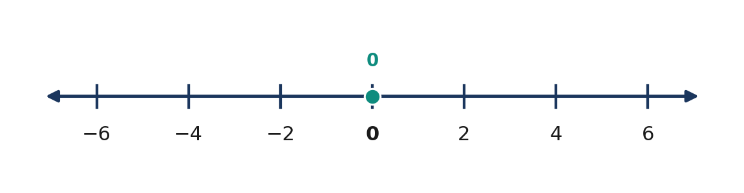
Figure 3.6.4 Figure 3.6.4. A zero total divided into a nonzero number of equal groups yields zero in each group.
Expression | Result | Justification
$0÷(+7)$ | $0 | $(+7)(0)=0$
$0÷(−7)$ | $0 | $(−7)(0)=0$
$7÷0$ | Undefined | No number times zero is seven
$0÷0$ | Undefined | No unique quotient exists
$7÷2$ | $3.5 | Defined but not an integer

Quick Check 3.6B: 1. Calculate $0÷(−19)$. 2. Why is $(−11)÷0$ undefined? 3. Find the exact value of $(−15)÷(+4)$ and identify whether it is an integer.

4. Four Worked Examples

💡 WORKED EXAMPLE 1 — Different-Sign Division
Problem: Evaluate $(−72)÷(+9)$.
Given: Dividend $−72$ and divisor $+9$.
Find: Quotient.
Rule: Divide magnitudes; different signs produce a negative result.
Figure 3.6.5 Figure 3.6.5. Nine equal groups of −8 produce −72.
$(−72) ÷ (+9)$ | $= −(72 ÷ 9)$ | unlike signs produce a negative quotient
 | $= −8$ | divide magnitudes
$(+9)(−8)$ | $= −72$ | verify by multiplication

Final Answer: −8.

💡 WORKED EXAMPLE 2 — Two Negative Operands
Problem: Calculate $(−84)÷(−7)$.
Given: Dividend $−84$ and divisor $−7$.
Find: Quotient.
Rule: Same nonzero signs produce a positive result.
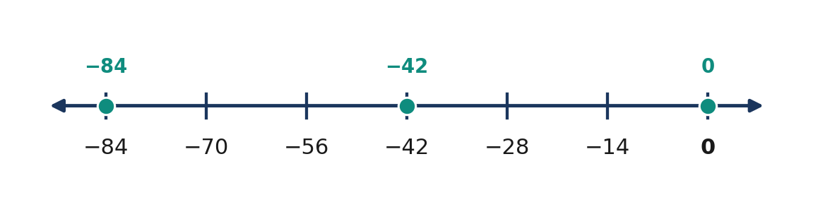
Figure 3.6.6 Figure 3.6.6. The dividend −84 and the origin are shown; multiplication verifies the positive quotient.
$(−84) ÷ (−7)$ | $= +(84 ÷ 7)$ | same signs produce a positive quotient
 | $= +12$ | divide magnitudes
$(−7)(+12)$ | $= −84$ | verify by multiplication

Final Answer: +12.

💡 WORKED EXAMPLE 3 — Equal Changes in Inventory
Problem: An inventory decreases by 48 kg over six equal reporting periods. Determine the change per period.
Given: Total change $−48$ kg; six periods.
Find: Change in kg/period.
Formula: $change per period=total change÷number of periods$.
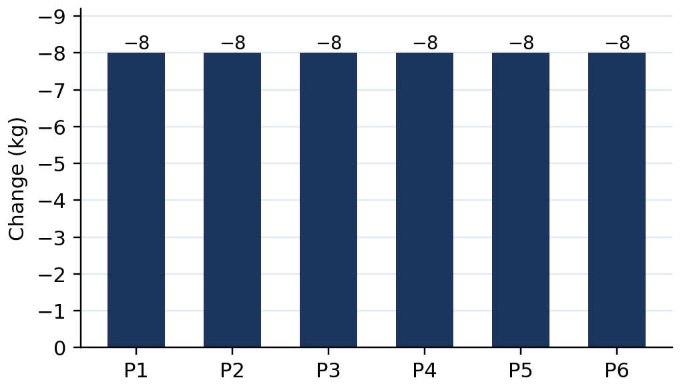
Figure 3.6.7 Figure 3.6.7. Six daily changes of −8 kg give a total decrease of 48 kg.
$(−48) ÷ (+6)$ | $= −(48 ÷ 6)$ | different signs yield a negative quotient
 | $= −8$ | divide magnitudes
$(+6)(−8)$ | $= −48$ | check the total

Final Answer: −8 kg per period.

💡 WORKED EXAMPLE 4 — Order of Operations
Problem: Evaluate $18-(−24)÷(+6)×3+(−5)$.
Given: Mixed integer expression.
Find: Value.
Rule: Grouping, exponents, multiplication and division left to right, addition and subtraction left to right.
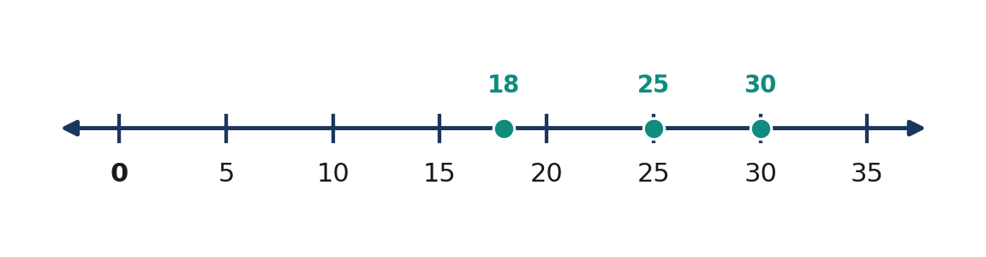
Figure 3.6.8 Figure 3.6.8. After simplifying the quotient and product, the remaining sum moves 18 to 30 and then 25.
$18 − (−24) ÷ (+6) × 3 + (−5)$ | $= 18 − (−4) × 3 + (−5)$ | division first in the left-to-right chain
 | $= 18 − (−12) + (−5)$ | multiply
 | $= 18 + 12 − 5$ | subtract the opposite
 | $= 30 − 5$ | combine left to right
 | $= 25$ | final subtraction

Final Answer: 25.

5. Mathematical Reasoning and Common Misconceptions

A quotient's sign can be established by a multiplication equation, not simply recalled as a slogan. For example, if $(−36)÷(−9)=q$, then $(−9)q=−36$. Since multiplying $−9$ by $+4$ produces $−36$, the quotient is positive four. The incorrect answer $−4$ would give $+36$ when multiplied by $−9$, so it fails the inverse-operation test.
Units also help interpret division. If inventory changes by $−60$ kg across five days, the daily change is $−12$ kg/day. If total change is $−60$ kg and each day's change is $−12$ kg/day, the elapsed time is $+5$ days. The quotient sign is not a label for whether the situation is good or bad; it has a precise mathematical meaning determined by the dividend and divisor.
WATCH OUT — Wrong → Right
- Wrong: $(−42)÷(−7)=−6$. Right: $+6$, because $(−7)(+6)=−42$.
- Wrong: $(+30)÷(−5)=+6$. Right: $−6$, because the signs differ.
- Wrong: $0÷(−8)$ is undefined. Right: It is zero because the divisor is not zero.
- Wrong: $(−5)÷0=0$. Right: Division by zero is undefined.
- Wrong: In $12÷3×2$, multiplication must occur first. Right: Multiplication and division have equal priority: proceed left to right to obtain $8.

Reasoning Challenge: Decide whether dividing any two integers produces an integer. Compare $(−18)÷(+3)$ with $(−18)÷(+4)$. Explain why both quotients are defined and negative, but only one is an integer. Explain how the multiplication check works even for non-integer quotients.

6. Subtopic 3.6.3 — GEMDAS and Multi-Step Integer Expressions

GEMDAS sets a consistent order for evaluating numerical expressions: Grouping symbols, Exponents, Multiplication and Division at equal priority from left to right, then Addition and Subtraction at equal priority from left to right. The letters do not mean multiplication always precedes division or addition always precedes subtraction. Work within grouping symbols first, repeating the rules if groups are nested.
📐 KEY CONCEPT 3.6D — GEMDAS
$$Grouping→Exponents→Multiplication/Division (left to right)→Addition/Subtraction (left to right)$$
Parentheses determine which parts of an expression must be evaluated together. A negative sign may belong to a number or indicate subtraction; careful transcription preserves the difference.

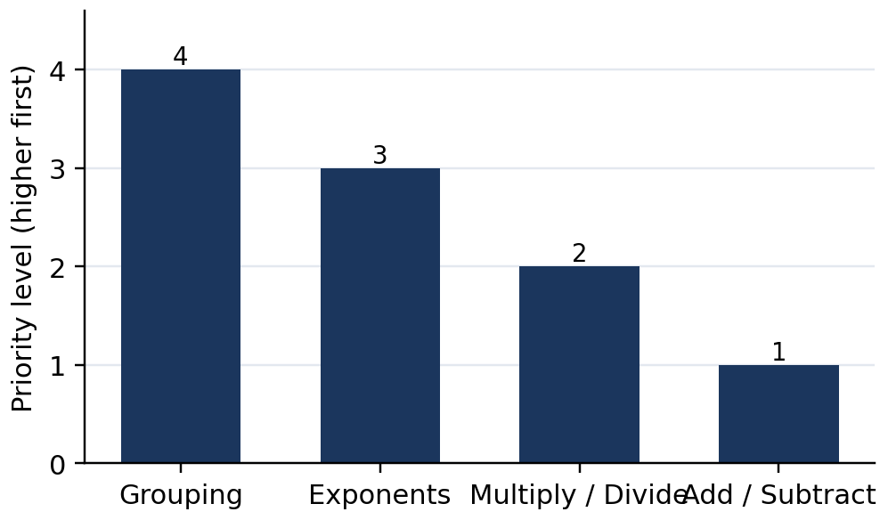
Figure 3.6.9 Figure 3.6.9. Grouping and exponents precede the two equal-priority operation pairs.
Consider $36÷(−6)+4(−3)$. Division gives $−6$, multiplication gives $−12$, and addition then gives $−18$. In contrast, $(36÷(−6)+4)(−3)$ must be evaluated inside parentheses: $(−6+4)(−3)=(−2)(−3)=+6$. Thus, parentheses affect the result by changing which expression is multiplied by $−3$.
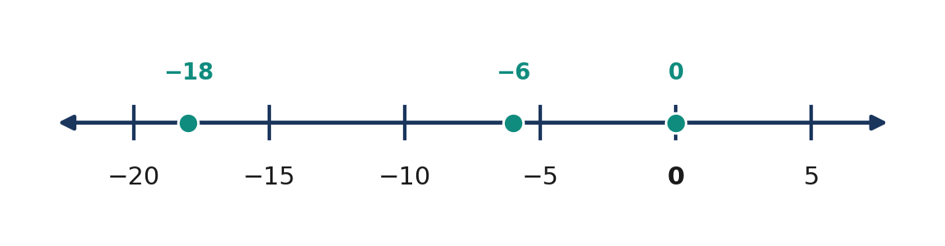
Figure 3.6.10 Figure 3.6.10. Adding the calculated terms −6 and −12 reaches −18 on the number line.
Exponents require special care with signs. In $(−3)^{2}$, the negative integer is the base and the result is positive nine. In $−3^{2}$, the exponent applies to $3 before the leading negative sign, giving negative nine. Parentheses distinguish a negative base raised to a power from the negative of a power.
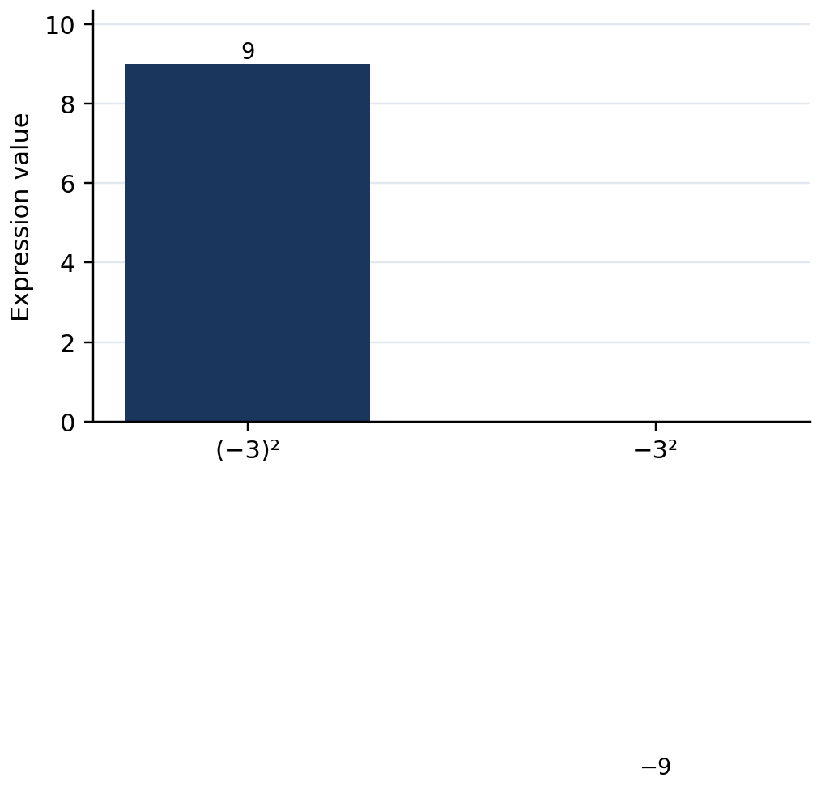
Figure 3.6.11 Figure 3.6.11. Different placement of parentheses gives +9 and −9.
Numerical expression | First simplification | Final value
$(−48)÷(+8)×(−2)$ | $−6×(−2)$ | $+12$
$(−48)÷[(+8)×(−2)]$ | $−48÷(−16)$ | $+3$
$16-24÷(−6)$ | $16-(−4)$ | $20
$(−3)^{2}-(−12)÷(+4)$ | $9-(−3)$ | $12
$18÷3×2$ | $6×2$ | $12

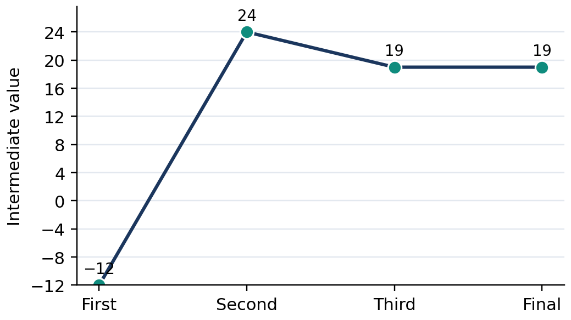
Figure 3.6.12 Figure 3.6.12. A calculation trace: −60 ÷ 5 = −12; then ×(−2) = 24; then add −5 to reach 19; verify 19.
Quick Check 3.6C: 1. Evaluate $(−60)÷(+5)×(−2)$. 2. Explain why $(−4)^{2}$ differs from $−4^{2}$. 3. Identify the first operation in $24-[(−12)÷(−3)+5]$.

7. Guided and Independent Practice

Task 3.6.1 — Graded Exercises (22 items). Show division calculations and sign decisions. Use inverse multiplication to verify at least four answers.
Basic (1–12):
1. (+56) ÷ (+7) | 2. (−56) ÷ (+7) | 3. (+56) ÷ (−7)
4. (−56) ÷ (−7) | 5. (−81) ÷ (+9) | 6. (−81) ÷ (−9)
7. 0 ÷ (+13) | 8. 0 ÷ (−13) | 9. (+45) ÷ (−5)
10. (−96) ÷ (+12) | 11. (+64) ÷ (+8) | 12. (−100) ÷ (−10)

Intermediate (13–18):
13. (−48) ÷ (+6) × (−3) | 14. 24 − (−30) ÷ (+5)
15. (−5)² + (−36) ÷ (+9) | 16. [18 + (−42)] ÷ (−6)
17. Find x: (−7)x = +63. | 18. Determine whether (+15) ÷ (−4) is an integer; give the exact quotient.

Challenge and Word Problems (19–22):
19. A total inventory decrease of 144 kg is distributed evenly across eight days. Model the signed daily change and check by multiplication.
20. A temperature falls by 30°C over six equal hourly intervals. Determine the change per hour and explain its negative sign.
21. Evaluate $48÷[−3(2+2)]+(−5)^{2}$ using GEMDAS and justify each operation.
22. Two learners disagree about $36÷6×3$. One obtains $2 and the other obtains $18. Identify and explain the correct calculation.
Task 3.6.2 — Analytical Matrix. Complete every blank and justify each decision.
Expression or claim | Correct result or decision | Mathematical justification
$(−54)÷(−9)$ | ________ | ________
$0÷(−12)$ | ________ | ________
$(−12)÷0$ | ________ | ________
$24÷4×2$ | ________ | ________
$(−2)^{3}+(−18)÷(+3)$ | ________ | ________

8. Contextual Application — Recycling Collection Ledger

Task 3.6.3 (12 points). A school recycling project records a total inventory change of $−108$ kg over nine equally productive collection days. After those days, a delivery adds $+35$ kg to inventory. Determine the daily signed change during the nine days and the project's overall change after the delivery. State whether the final change is an increase or decrease relative to the starting inventory.
Procedure: (1) Write the signed division equation for nine days. (2) Apply the quotient sign rule. (3) Check the daily change by multiplication. (4) Combine the original total change with $+35$ kg. (5) Interpret the two answers using kg/day and kg. Scoring: signed model (3), quotient and multiplication verification (4), final net change (3), explanation and units (2).

9. Metacognitive Reflection and Lesson Summary

3–2–1 Exit Ticket: Explain three division or GEMDAS principles, identify two common mistakes you know how to correct, and name one situation in which a signed quotient helps communicate an accurate conclusion. For one mathematical rule, give a numerical example and verify it.
LESSON SUMMARY
Integer division is the inverse of multiplication. Nonzero operands with equal signs produce a positive quotient; different signs produce a negative quotient. Zero divided by a nonzero integer is zero, whereas any division by zero is undefined. Quotients need not be integers. GEMDAS evaluates grouping symbols and exponents before multiplication and division left to right, followed by addition and subtraction left to right. Clear units, sign decisions, and inverse checks support accurate problem solving.

10. Formative Assessment — 15 Items

Part I — Multiple Choice (1–10; one point each). Choose one answer for each item.
1. [ ] Calculate $(−63)÷(+9)$. A. $+7$ B. $−9$ C. $−7$ D. $+9$
2. [ ] Calculate $(−72)÷(−8)$. A. $+9$ B. $−9$ C. $+8$ D. $−8$
3. [ ] Which expression is undefined? A. $0÷(−5)$ B. $(−5)÷(+1)$ C. $(−5)÷(−5)$ D. $(−5)÷0$
4. [ ] Calculate $0÷(−14)$. A. Undefined B. $0 C. $−14$ D. $+14$
5. [ ] What is $(+56)÷(−7)$? A. $+8$ B. $−7$ C. $−8$ D. $+7$
6. [ ] Evaluate $24÷(−6)×(−2)$. A. $−8$ B. $+2$ C. $−2$ D. $+8$
7. [ ] Which statement is correct? A. Division and multiplication have equal priority and are performed left to right. B. All division must occur after multiplication. C. Addition always precedes subtraction. D. Division by zero equals zero.
8. [ ] Calculate $(−3)^{2}+(−20)÷(+5)$. A. $−13$ B. $+5$ C. $+13$ D. $−5$
9. [ ] A total change of $−45$ kg occurs over five equal days. What is the daily change? A. $+9$ kg/day B. $−5$ kg/day C. $−9$ kg/day D. $+5$ kg/day
10. [ ] Calculate $(−36)÷[(−3)(+4)]$. A. $−12$ B. $+12$ C. $−3$ D. $+3$
Part II — Open Calculation and Reasoning (11–15). Show complete work and brief justification.
11. Compute $(−96)÷(−12)$ and show how inverse multiplication verifies your answer.
12. A learner claims that both $0÷(−8)$ and $(−8)÷0$ equal zero. State which expression equals zero and explain why the other is undefined.
13. Evaluate $30-(−48)÷(+6)×(−2)$ using GEMDAS. Show the order of operations.
14. A project records an inventory change of $−126$ kg over seven equal days. Determine the signed daily change with units and verify by multiplication.
15. Evaluate and compare $(−4)^{2}$ and $−4^{2}$. Explain the role of parentheses and determine the difference between the two values.

COMPREHENSIVE QUARTER 3 ASSESSMENT — 50 POINTS

Mathematics 7 • Data and Probability / Number and Algebra
Directions: Work independently. Part I has 30 multiple-choice items worth one point each (30 points). Part II is one culminating performance task worth 20 points. Mark one choice [ ] for each item. Calculators may be used only when directed by the teacher; show supporting work on scratch paper.

PART I — MULTIPLE CHOICE (30 POINTS)

1. [ ] In a study of all 200 Grade 7 learners, 40 learners respond. What is the sample?
A. The 200 learners B. The 40 respondents C. The teachers D. The population
2. [ ] Which variable is categorical?
A. Travel method B. Height in cm C. Daily minutes D. Number of siblings
3. [ ] Which method selects members at a regular interval after a random start?
A. Convenience sampling B. Census C. Observation D. Systematic sampling
4. [ ] Frequencies 4, 6, 5, 5 give which total?
A. 15 B. 19 C. 20 D. 25
5. [ ] What percent is 6 of 24?
A. 20% B. 25% C. 30% D. 40%
6. [ ] A pie category with 4 of 20 observations has what sector angle?
A. 36° B. 54° C. 60° D. 72°
7. [ ] Which graph best shows attendance Monday to Friday?
A. Line graph B. Pie graph C. Venn diagram D. Unlabeled drawing
8. [ ] What does the key 2 | 5 = 25 mean on a stem-and-leaf plot?
A. 2.5 B. 7 C. 25 D. 52
9. [ ] Which is an integer?
A. −8 B. 2.5 C. ¾ D. 0.2
10. [ ] Which number is neither positive nor negative?
A. −1 B. +1 C. −10 D. 0
11. [ ] Which statement is correct?
A. −9 > −4 B. −9 < −4 C. 0 < −9 D. −4 = +4
12. [ ] What is the opposite of −13?
A. −13 B. 0 C. +13 D. 1/13
13. [ ] What is |−17|?
A. −17 B. 0 C. 1/17 D. 17
14. [ ] Arrange −3, +2, −7 in increasing order.
A. −7, −3, +2 B. −3, −7, +2 C. +2, −3, −7 D. −7, +2, −3
15. [ ] What is (−7)+(−6)?
A. +13 B. −13 C. −1 D. +1
16. [ ] Find (+15)+(−22).
A. +7 B. −37 C. −7 D. +37
17. [ ] What is (−9)+(+9)?
A. −18 B. +18 C. 9 D. 0
18. [ ] What is (+6)−(−8)?
A. +14 B. −2 C. +2 D. −14
19. [ ] Compute (−12)−(+5).
A. −7 B. +17 C. −17 D. +7
20. [ ] What is (−10)−(−6)?
A. −16 B. −4 C. +4 D. +16
21. [ ] What is (+7)(−8)?
A. +56 B. −15 C. +15 D. −56
22. [ ] What is (−9)(−5)?
A. −45 B. −14 C. +45 D. +14
23. [ ] Find (−4)(+3)(−2).
A. +24 B. −24 C. −9 D. +9
24. [ ] What is (−72)÷(+9)?
A. +8 B. −8 C. −9 D. +9
25. [ ] What is (−64)÷(−8)?
A. −8 B. −7 C. +7 D. +8
26. [ ] Which expression is undefined?
A. 0÷(−4) B. (−4)÷1 C. (−4)÷0 D. 0÷8
27. [ ] Evaluate 18÷(−3)×(−2).
A. +12 B. −12 C. +3 D. −3
28. [ ] Evaluate (−3)²−8÷(−4).
A. +7 B. +11 C. −11 D. −7
29. [ ] A temperature of −5°C rises 12°C. Final temperature?
A. −17°C B. −7°C C. +7°C D. +17°C
30. [ ] Evaluate [−12+(+4)]÷(−2).
A. −8 B. −4 C. +8 D. +4

PART II — ONE CULMINATING PERFORMANCE TASK (20 POINTS)

GRASPS — Grade 7 Data and Integer Operations Investigation
Goal: Produce a reliable class resource-use report that combines a data display and a signed-change ledger to support a realistic recommendation.
Role: You are a student mathematics analyst assisting a school environmental club.
Audience: The club committee and school advisers, who will decide whether to adjust collection schedules and storage capacity.
Situation: The club monitored reusable paper collected or distributed over five school days. The class has 20 anonymous responses for preferred collection time: Morning, 9; Lunch, 5; Afternoon, 4; After classes, 2. A separate stock-change ledger records Monday +18 kg, Tuesday −7 kg, Wednesday +12 kg, Thursday −15 kg, Friday +9 kg. Positive means material added to stock; negative means material removed. These are fictional learning data, not actual school records.
Product: Prepare a two-page mathematical report showing (1) a titled frequency table with frequencies, proportions, and percentages; (2) one appropriately labeled bar graph and a pie chart with angles calculated in degrees; (3) a five-step signed-change number-line model; (4) a worked integer sum showing the net stock change; (5) one justified practical recommendation grounded in the figures; and (6) a limitations statement discussing the small number of respondents, the sampling process, and the five-day monitoring period.
Standards: Mathematical accuracy, truthful statistical interpretation, labeled and consistent representations, and clear reasoning. Use appropriate units, include a table-total check, and never imply that the 20 responses establish the preferences of an entire school.
Required computations: Frequency total n = 20. Percentages: 45%, 25%, 20%, 10%. Pie angles: 162°, 90°, 72°, 36° (sum 360°). Signed net change: (+18)+(−7)+(+12)+(−15)+(+9)=+17 kg. A correct interpretation is an increase of 17 kg in stock during the recorded week.
Analytical Rubric (4 × 4; 20 Points)
Each of four criteria receives a performance level 1–4. Convert the 16-point raw rubric to 20 using (raw score ÷ 16) × 20, rounded to the nearest half point. This supplies the required 20-point component without changing the four-level descriptions.
Criterion | Level 4 — Excellent | Level 3 — Proficient | Level 2 — Developing | Level 1 — Beginning
Data collection and table | All categories, counts, percentages and total check accurate; sample limitation precise | One minor recording or presentation issue; total correct | Several category or percentage inaccuracies; partial total check | Missing categories or unreliable table
Graphs and sector angles | Both graphs accurate, proportionate, titled and labeled; all angles correct | Graphs interpretable with one minor label or angle issue | Several graph scale, angle or labeling errors | Graphs missing, misleading or mostly incorrect
Signed-integer model | All five changes represented and accurately summed to +17 kg; verification explicit | Correct total and credible model with minor omission | Partial model or arithmetic error; reasoning incomplete | No usable signed model or incorrect direction throughout
Explanation and recommendation | Fully supported recommendation, units, limitations, and clear mathematical reasoning | Appropriate recommendation with limited discussion of caveats | Weak evidence link or incomplete limitations | Unsupported conclusion or no interpretation

Teacher scoring guide: 16 raw points = 20/20; 12 raw points = 15/20; 8 raw points = 10/20; 4 raw points = 5/20. This task is the sole full GRASPS culminating performance task for the quarter.

QUARTER 3 SYNTHESIS AND GLOSSARY

Integrated Mathematical Synthesis

Statistics and integer operations belong to different mathematical domains, but both depend on precise definitions, consistent representations, and careful reasoning. Statistical work begins by specifying the population, the variable being examined, and the procedures for obtaining observations. Without these foundations, a frequency table or graph may be attractive but misleading. A population refers to the full group of interest. A sample is the selected subset from which observations are collected. Sampling choices determine how cautiously conclusions may extend beyond the respondents. Random, systematic, and stratified procedures can be appropriate when their assumptions and implementation are clearly stated, while convenience samples require particular caution because availability is not the same as representativeness.
After collection, the observations become mathematically manageable through sorting, tallying, and counting. Every frequency table must account for the observations once and only once: the sum of the category frequencies is the sample size. Dividing a frequency by the total yields a relative frequency, while multiplying that quotient by 100 gives the corresponding percentage. Bar graphs compare categories using a consistent scale. Pie graphs represent nonoverlapping parts of one whole, with a sector angle equal to its proportion times 360 degrees. Line graphs communicate change across ordered positions, usually time. Stem-and-leaf plots retain individual numerical values while revealing patterns in a distribution. Interpretation requires attention to labels, baselines, sample size, context, and possible misrepresentation.
The number system used in the second strand extends whole numbers to the integers: negative whole numbers, zero, and positive whole numbers. Signs express relative direction and reference, not the intrinsic desirability of a quantity. On a standard horizontal number line, integers increase from left to right. A negative integer farther from zero is smaller than one closer to zero. Opposite integers occupy symmetric positions. Absolute value measures distance from zero and is therefore nonnegative; it is not a substitute for the original signed value. These distinctions explain why the numerical order −12 < −3 coexists with the distance comparison |−12| > |−3|.
Addition may be shown by moving along the number line or combining positive and negative counters. An opposite-sign pair has value zero, a visual expression of the additive inverse property. Same-sign addends combine their absolute values and preserve the common sign; different-sign addends require subtracting magnitudes and retaining the sign associated with the larger magnitude. Subtraction is equivalent to addition of the opposite, a rule that follows from the inverse relationship between addition and subtraction. This transformation prevents the common error of treating every minus sign as a negative result. Subtraction is not generally commutative, so the order of the operands matters.
Multiplication represents equal signed groups and obeys established number properties. A product of factors with equal signs is positive, while different signs produce a negative product. The distributive property and consistent number patterns explain why multiplying two negative numbers yields a positive result. Division reverses multiplication: checking a quotient requires multiplying the proposed quotient by the divisor. Identical signs produce a positive quotient, while different signs produce a negative quotient. A zero dividend divided by a nonzero divisor equals zero; division by zero is undefined. Not every quotient of integers is itself an integer.
When expressions contain several operations, GEMDAS establishes a reliable sequence: grouping, exponents, multiplication and division from left to right, and addition and subtraction from left to right. Parentheses can change the meaning of a signed power: (−4)² is positive sixteen, while −4² is negative sixteen. Reliable mathematicians do more than find answers. They represent conditions carefully, justify operation choices, preserve signs and units, test arithmetic with inverse operations, and evaluate whether a conclusion is supported by the evidence. These habits are useful in evaluating surveys, budgets, environmental inventories, temperature records, and many other daily situations.

Glossary

Term | Precise Grade 7 Definition
Population | Entire collection of persons or objects of interest in a study
Sample | Subset selected from the population for observation
Census | Collection of data from every population member
Sampling | Procedure for selecting observations from a population
Variable | Characteristic recorded or measured
Categorical data | Values identifying groups rather than measurements
Numerical data | Values expressing numerical quantities
Frequency | Number of times a value or category occurs
Relative frequency | Category frequency divided by the total count
Frequency distribution | Organized table of categories or values and their counts
Bar graph | Display comparing category frequencies by bar length
Pie graph | Circular display of parts of a nonoverlapping whole
Line graph | Connected plot of observations in a meaningful order
Stem-and-leaf plot | Display splitting place-value digits while retaining observations
Integer | Whole-number value, its negative, or zero
Origin | Zero reference point on a number line
Opposite integers | Numbers equally far from zero on opposite sides
Absolute value | Nonnegative distance of a number from zero
Additive inverse | Number that sums with the original to zero
Zero pair | Positive and negative counters whose sum is zero
Sum | Result of addition
Difference | Result of subtraction
Product | Result of multiplication
Quotient | Result of division
GEMDAS | Grouping, exponents, multiplication/division left to right, addition/subtraction left to right

STRUCTURED ANSWER KEYS AND TEACHER GUIDANCE

Conventions: MCQ keys are arranged in tables. For open responses, equivalent correct reasoning and justified notation earn credit. The practice keys correspond to the question wording in Lessons 3.1–3.6, not to newly rewritten exercises.

Lesson 3.1 — Formative Assessment MCQ Key

Item | 1 | 2 | 3 | 4 | 5 | 6 | 7 | 8 | 9 | 10
Answer | B | D | A | C | A | D | B | C | D | B

Lesson 3.2 — Formative Assessment MCQ Key

Item | 1 | 2 | 3 | 4 | 5 | 6 | 7 | 8 | 9 | 10
Answer | B | D | A | C | B | A | D | C | B | D

Lesson 3.3 — Formative Assessment MCQ Key

Item | 1 | 2 | 3 | 4 | 5 | 6 | 7 | 8 | 9 | 10
Answer | B | D | A | C | A | B | D | C | A | D

Lesson 3.4 — Formative Assessment MCQ Key

Item | 1 | 2 | 3 | 4 | 5 | 6 | 7 | 8 | 9 | 10
Answer | A | C | B | D | B | A | C | D | A | D

Lesson 3.5 — Formative Assessment MCQ Key

Item | 1 | 2 | 3 | 4 | 5 | 6 | 7 | 8 | 9 | 10
Answer | A | C | B | D | A | B | D | C | B | D

Lesson 3.6 — Formative Assessment MCQ Key

Item | 1 | 2 | 3 | 4 | 5 | 6 | 7 | 8 | 9 | 10
Answer | C | A | D | B | C | D | A | B | C | D

Lesson 3.1 — Open Responses (11–15)
Item | Model response and rationale
11 | 20%, 40%, 40%; n=20; percentages total 100%.
12 | 108°, 180°, 72°; sum 360°.
13 | Stem 1: 4,8; stem 2: 1,2,7; stem 3: 1; key 1 | 4=14, minimum 14, maximum 31.
14 | Library visitors may read more frequently than other learners. Select an appropriately randomized cross-section of the grade and report nonresponses.
15 | Line graph; net +8 kg (20−12); largest single increase +4 kg (12→16, 14→17 is +3, 17→20 is +3); five observations cannot prove a long-term trend.

Lesson 3.2 — Open Responses (11–15)
Item | Model response and rationale
11 | −6<−2<0<+3; label equal unit intervals.
12 | Opposites: +12, −5, 0; absolute values: 12, 5, 0. Opposites change signs; absolute values give distances.
13 | −15<−8, but 15>8; positions and distances answer different questions.
14 | Floor zero is reference; −3<−1<0<2<5; distances 3 and 5 levels.
15 | For any integer n, n−1 is smaller, so there is no least integer; n and −n differ unless n=0.

Lesson 3.3 — Open Responses (11–15)
Item | Model response and rationale
11 | Start −7 and move 12 right to +5.
12 | Six zero pairs form; three negative counters remain; sum −3.
13 | (−18)+(−5)+(+7)=−23+7=−16 (associative/commutative).
14 | +180−240+90=+30 pesos, a net increase.
15 | −8−6=−14 (same negative signs); −8+6=−2 (opposing signs; 8 larger).

Lesson 3.4 — Open Responses (11–15)
Item | Model response and rationale
11 | −12−(−19)=−12+19=+7; check 7+(−19)=−12.
12 | Begin with two positive counters, add four zero pairs, remove six positive counters; four negative counters remain: −4.
13 | (−3)−(+7)=−10; 8−(−10)=+18.
14 | 80−(−225)=+305 pesos, an increase of ₱305.
15 | 3−5=−2 but 5−3=+2, so not commutative; b−a=−(a−b).

Lesson 3.5 — Open Responses (11–15)
Item | Model response and rationale
11 | 4(−5)=−5−5−5−5=−20; four groups of five negative counters.
12 | Products −12, −6, 0, +6, +12; moving the multiplier down by one raises the product by six.
13 | (−3)(+4)(−5)=(−12)(−5)=+60; associative property.
14 | 7(−48)=−₱336; repeated addition of seven −₱48 changes verifies.
15 | (−8)(−9)=+72; two negative factors have a positive product, supported by distributivity or sign pattern.

Lesson 3.6 — Open Responses (11–15)
Item | Model response and rationale
11 | (−96)÷(−12)=+8, and (+8)(−12)=−96.
12 | 0÷(−8)=0; (−8)÷0 undefined because no x satisfies 0x=−8.
13 | (−48)÷6=−8; −8×(−2)=+16; 30−16=14.
14 | (−126)÷7=−18 kg/day; (−18)(7)=−126 kg.
15 | (−4)²=16; −4²=−16; difference 32; parentheses include the sign in the base.

Lesson Practice Keys — Items 1–22

The entries below are ordered to match the Basic (1–12), Intermediate (13–18), and Challenge (19–22) problems in each chapter. Where questions call for an illustration, show an appropriately labeled model in addition to the mathematical result.
Lesson 3.1 — Guided Practice
Item | Key / expected result
1 | All 240 Grade 7 learners
2 | 35 surveyed learners
3 | Categorical
4 | Numerical discrete
5 | 3
6 | 16
7 | 20%
8 | 30%
9 | 90°
10 | 90°
11 | Bar graph
12 | Line graph
13 | 1:3; 2:3; 3:2
14 | 20%, 30%, 50%
15 | 72°, 108°, 180°
16 | Stem 1: 1,3,7; stem 2: 2,6,9
17 | Net +7; largest increase +5 (Wednesday→Thursday)
18 | 21 observations are listed, not 20
19 | 12/40=30%,18/40=45%,6/40=15%,4/40=10%; angles 108°,162°,54°,36°
20 | Sample randomly across four sections; recognize nonresponse and sampling limitations
21 | Line graph; net +11 kg; decrease 30→28 kg
22 | Difference 4 learners; use zero baseline to avoid exaggeration

Lesson 3.2 — Guided Practice
Item | Key / expected result
1 | Negative integer
2 | Positive integer
3 | Zero; neither sign
4 | +9
5 | −13
6 | 0
7 | −3<+6
8 | −8<−2
9 | 0>−5
10 | 12
11 | 7
12 | 0
13 | −7,−4,0,2,5
14 | 8,4,0,−1,−9
15 | 13>9
16 | −5 and +5
17 | −3,−2,−1,0,1
18 | 8
19 | −18 m lower; distances 18 m and 35 m
20 | −7°C,−2°C,0°C,+4°C; −7°C coldest
21 | No; for any integer there exists a smaller integer
22 |  | −9 | =9> | −3 | =3

Lesson 3.3 — Guided Practice
Item | Key / expected result
1 | +11
2 | −13
3 | +6
4 | −8
5 | 0
6 | −15
7 | −11
8 | −4
9 | −15
10 | +19
11 | −21
12 | +7
13 | +1
14 | −4
15 | +5
16 | −10
17 | +6
18 | −19
19 | −₱30
20 | +1°C
21 | −29 m
22 | −7, −6, −5

Lesson 3.4 — Guided Practice
Item | Key / expected result
1 | +5
2 | +9
3 | −11
4 | −5
5 | −11
6 | +6
7 | −5
8 | 0
9 | +14
10 | −11
11 | −13
12 | +16
13 | −10
14 | +1
15 | −1
16 | +12
17 | x=−4
18 | x=−11
19 | +3−(−11)=+14°C; temperature rises by 14°C.
20 | +75−(−180)=+₱255; improvement of ₱255.
21 | −9−(−24)=+15 m; the diver rises 15 m.
22 | False: (5−3)−1=1, whereas 5−(3−1)=3; regrouping subtraction changes the result.

Lesson 3.5 — Guided Practice
Item | Key / expected result
1 | +24
2 | −24
3 | −35
4 | +54
5 | 0
6 | 0
7 | −14
8 | +16
9 | +27
10 | −44
11 | −60
12 | +100
13 | +24
14 | −30
15 | −108
16 | +56
17 | x=−7
18 | x=−12
19 | 8(−₱35)=−₱280; budget decreases ₱280.
20 | 7(−4°C)=−28°C total temperature change.
21 | 5(−12 m)=−60 m total elevation change.
22 | Four negative factors give a positive product: (−2)(−3)(+4)(−5)(−1)=+120.

Lesson 3.6 — Guided Practice
Item | Key / expected result
1 | +8
2 | −8
3 | −8
4 | +8
5 | −9
6 | +9
7 | 0
8 | 0
9 | −9
10 | −8
11 | +8
12 | +10
13 | +24
14 | +30
15 | +21
16 | +4
17 | x=−9
18 | −15/4 (not integer)
19 | (−144 kg)÷8 days=−18 kg/day; 8(−18 kg)=−144 kg.
20 | (−30°C)÷6 h=−5°C per hour; sign indicates a fall.
21 | 2+2=4; −3(4)=−12; 48÷(−12)=−4; (−5)²=25; total +21.
22 | 36÷6×3=6×3=18; multiply and divide left to right.

Comprehensive Assessment — Part I Structured Answer Key

Items 1–15
Item | 1 | 2 | 3 | 4 | 5 | 6 | 7 | 8 | 9 | 10 | 11 | 12 | 13 | 14 | 15
Answer | B | A | D | C | B | D | A | C | A | D | B | C | D | A | B

Items 16–30
Item | 16 | 17 | 18 | 19 | 20 | 21 | 22 | 23 | 24 | 25 | 26 | 27 | 28 | 29 | 30
Answer | C | D | A | C | B | D | C | A | B | D | C | A | B | C | D

Comprehensive MCQ Rationale Matrix
Item | Reason for correct choice

1 (B) | The respondents are the selected subset.

2 (A) | Travel method names categories.

3 (D) | Systematic sampling takes a fixed interval after a random start.

4 (C) | 4+6+5+5=20.

5 (B) | 6/24 × 100%=25%.

6 (D) | 4/20 × 360°=72°.

7 (A) | A line graph represents ordered time changes.

8 (C) | Stem two tens and leaf five ones represent 25.

9 (A) | −8 is a negative whole number.

10 (D) | Zero is neither positive nor negative.

11 (B) | −9 lies left of −4.

12 (C) | The opposite reverses the sign.

13 (D) | Absolute value is distance from zero.

14 (A) | Move left to right on a number line.

15 (B) | Same negative signs: add magnitudes and keep negative.

16 (C) | 22 is the greater magnitude, so the sum is −7.

17 (D) | Additive inverses sum to zero.

18 (A) | Subtracting a negative equals adding a positive.

19 (C) | −12−5=−17.

20 (B) | −10+6=−4.

21 (D) | Different factor signs yield a negative product.

22 (C) | Two negative factors yield a positive product.

23 (A) | Two negative factors give positive 24.

24 (B) | Different signs give a negative quotient.

25 (D) | Same signs give +8.

26 (C) | Division by zero is undefined.

27 (A) | Perform ÷ then × from left to right: −6×−2=12.

28 (B) | 9−(−2)=11.

29 (C) | −5+12=+7°C.

30 (D) | −8÷−2=+4.

Culminating Performance Task — Model Checking Matrix

Required product | Expected solution / check
Sample-frequency table | Morning 9, Lunch 5, Afternoon 4, After classes 2; sum 20
Percentages | 45%, 25%, 20%, 10%; sum 100%
Sector angles | 162°, 90°, 72°, 36°; sum 360°
Bar chart | Four bars of height 9, 5, 4, 2; vertical scale begins at zero
Signed ledger | (+18)+(−7)+(+12)+(−15)+(+9)=+17 kg
Verifiable computation | Positive total 39 kg; negative total −22 kg; net +17 kg
Interpretive claim | Net inventory increased 17 kg during these five days; Morning is the most common preferred time within this sample
Limitation | Twenty anonymized responses and five monitored days do not guarantee schoolwide or long-term representation

Teacher moderation guidance: Credit mathematically equivalent representations. For a misplaced but clearly labeled graph axis, reduce only the graph criterion. The statistical data and inventory ledger are distinct; the former cannot be treated as a direct measure of the latter. For interpretation, distinguish an observed highest frequency (45%) from an absolute majority (>50%).

EDITORIAL QUALITY AND CURRICULUM AUDIT

This is a provisional editorial checklist, not a certified pass. Each row must be verified against the final rendered Word document and its mathematical content before assigning a score.
Dimension | Maximum | Verification status
Curriculum alignment and explicit learning targets | 20 | Review all six lessons against Grade 7 Quarter 3 competencies 1–12; verify zero omissions
Grade 7 readability and appropriateness | 20 | Inspect prose, figures, real-world contexts, and task difficulty
Mathematical correctness and answer concordance | 20 | Independently recalculate all worked examples, exercises and assessments
Instructional balance, chapter structure, and length | 20 | Check all chapters; measure rendered 45–70 page target
Layout, figures, direct video links, answer-table structure | 20 | Verify figure compilation, equation typography, links, headings and TOC
Total | 100 | PENDING: no score assigned before completed validation

Publication gate: Do not declare a 95/100 pass unless all substantive checks are completed and the Word document has a verified rendered page count. The working manuscript is intended for final compilation without abbreviating any authored passages.

