MATHEMATICS 8 • QUARTER 3

WORD PROBLEMS, LINEAR EQUATIONS, AND LINEAR INEQUALITIES

Linear Models • Graphs of Lines • Systems and Solution Regions
[FRONT COVER AI IMAGE PROMPT / COVER SPECIFICATION]
Book Title: Mathematics 8
Grade and Quarter: Grade 8 • Quarter 3
Unit Title: Word Problems, Linear Equations, and Linear Inequalities
Scope: Word Problems • Linear Inequalities • Linear Equations in Two Variables • Graphing Lines • Equations of Lines • Systems of Linear Equations • Systems of Linear Inequalities
AI Generation Prompt (Midjourney v6 / DALL-E 3):
A prestigious educational textbook cover in a warm hand-painted Studio Ghibli-inspired watercolor aesthetic. At the top, a clean deep navy three-tier title banner with crisp centered typography: Tier 1 in bold white capital letters reads "MATHEMATICS 8"; Tier 2 in warm gold letters reads "QUARTER 3: LINEAR EQUATIONS & INEQUALITIES"; Tier 3 in light silver text reads "Word Problems • Linear Graphs • Systems and Solutions". In the lower two-thirds, two Filipino Grade 8 learners in neat modern school uniforms without badges study a large floating coordinate-plane visualization made of luminous straight lines, intersecting graphs, shaded half-planes, ordered pairs, and simple equation cards. The visual mathematics should be geometrically coherent, with one pair of intersecting lines, one parallel-line motif, and one shaded feasible region. Background: a calm Philippine school garden with tropical greenery and soft mountain silhouettes, warm watercolor sky, gentle expressive linework, polished educational cover composition, no extraneous text beyond the specified three-tier title banner, no logos, no watermark, no branding --ar 8.5:11 --v 6.0
Replacement Note: Replace this complete prompt box with the final generated cover artwork during Word production.

Mathematics 8 • Quarter 3

PREFACE AND PEDAGOGICAL FRAMEWORK

Quarter 3 develops a connected understanding of linear relationships by moving from verbal situations to symbolic equations, inequalities, coordinate graphs, and systems. The seven lessons follow the sequence of the supplied table of contents: 3.1 Word Problems; 3.2 Linear Inequalities and Open Sentences in One Variable; 3.3 Linear Equations in Two Variables; 3.4 Graphing Linear Equations; 3.5 Writing Equations of Lines; 3.6 Systems of Linear Equations and Their Solutions; and 3.7 Solving Systems of Linear Inequalities. Across this progression, learners solve linear equations and inequalities in one variable, interpret their solutions, represent linear equations in two variables with ordered pairs and graphs, determine slope and intercepts, write equations of lines from given information, solve systems graphically and algebraically, and use inequalities in two variables to analyze regions that satisfy stated constraints.
The instructional design follows an approximately 70% concept-building and reasoning / 30% guided practice and assessment balance. Mathematics is treated as a system of connected representations rather than a collection of isolated procedures. A verbal condition becomes an algebraic statement; an equation becomes a set of ordered-pair solutions; a table becomes a graph; a graph reveals slope and intercepts; and two or more equations or inequalities can be compared through their common solutions. This structure emphasizes conceptual understanding, procedural fluency, strategic competence, adaptive reasoning, and productive mathematical disposition. Learners are repeatedly asked not only to obtain an answer but also to explain why a step is valid, check whether a result satisfies the original condition, and identify the mathematical meaning of a solution.
Because mathematics is learned by doing, the quarter is designed around short explanatory blocks followed immediately by formulas, exact diagrams, worked examples, and exercises. Important equations are displayed as editable mathematical expressions. Coordinate-plane diagrams, number lines, line segments, intercept models, and shaded regions are specified as code-drawn figures so numerical values, scales, points, and lines remain exact. Each lesson will include four fully worked examples using the pattern Problem → Given → Find → Formula or Rule → Step Solution → Final Answer, with aligned solution steps and explicit reasons. Common-error boxes will contrast incorrect and correct reasoning, especially when distributing negative signs, reversing inequality symbols, computing slope, selecting intercepts, and interpreting the number of solutions of a system.
Assessment is integrated throughout the learning process. Quick checks provide immediate diagnostic evidence, while graded exercise sets move from basic fluency to intermediate reasoning and challenge problems. Contextual applications use realistic number, geometry, money, and constraint situations so algebra serves as a modeling tool rather than a purely symbolic exercise. Each lesson ends with a 3-2-1 metacognitive exit ticket, a concise lesson summary, and a 15-item formative assessment containing 10 balanced multiple-choice questions and five open analytical or calculation items. The quarter concludes with a comprehensive 50-point assessment, one culminating GRASPS performance task with a 4×4 analytic rubric, a synthesis and glossary, structured answer keys, and a quality-assurance audit.
This book is paced for a complete 45–70 page quarterly publication. With seven lessons, the layout targets the lower end of the mathematics lesson word range while preserving the required density of figures, worked examples, and exercises. No lesson in the confirmed scope will be omitted. The instructional sequence is intentionally cumulative: mastery of one-variable equations supports inequality reasoning; ordered pairs support graphing; slope and intercepts support writing line equations; and line equations become the foundation for analyzing systems and feasible regions. By the end of the quarter, learners should be able to move flexibly among words, symbols, tables, graphs, and contextual interpretations and to justify the mathematical decisions they make.

TABLE OF CONTENTS

Mathematics 8 • Quarter 3 • Lessons 3.1–3.7
Preface and Pedagogical Framework .......................................................... 2
Table of Contents ...................................................................................... 3
Lesson 3.1 — Word Problems .................................................................... 4
Translating Verbal Conditions into Linear Equations ....................................... 4
Solving One-Variable Equations and Checking Solutions .................................. 6
Number, Geometry, and Money Models ........................................................ 8
Guided Practice, Application, Reflection, and Formative Assessment ..................... 9
Lesson 3.2 — Linear Inequalities and Open Sentences in One Variable ................. 11
Open Sentences, Solution Sets, and Inequality Symbols .................................. 11
Solving and Graphing One-Variable Inequalities ......................................... 13
Reversing the Inequality Sign and Error Analysis ....................................... 15
Guided Practice, Application, Reflection, and Formative Assessment .................... 16
Lesson 3.3 — Linear Equations in Two Variables ....................................... 18
Ordered Pairs as Solutions ................................................................ 18
Tables of Values and Equivalent Representations ........................................ 20
Testing and Interpreting Solutions ...................................................... 22
Guided Practice, Application, Reflection, and Formative Assessment .................... 23
Lesson 3.4 — Graphing Linear Equations ............................................... 25
Slope as Rate of Change ................................................................... 25
x- and y-Intercepts ....................................................................... 27
Graphing by Points, Intercepts, and Slope ............................................... 29
Guided Practice, Application, Reflection, and Formative Assessment .................... 30
Lesson 3.5 — Writing Equations of Lines .............................................. 32
Slope-Intercept and Point-Slope Reasoning ............................................... 32
Equation from Two Points or from a Point and Slope ..................................... 34
Equation from x- and y-Intercepts ....................................................... 36
Guided Practice, Application, Reflection, and Formative Assessment .................... 37
Lesson 3.6 — Systems of Linear Equations and Their Solutions ......................... 39
Meaning and Classification of Linear Systems ........................................... 39
Solving Systems by Graphing ............................................................. 41
Algebraic Solution Methods and Contextual Problems ..................................... 43
Guided Practice, Application, Reflection, and Formative Assessment .................... 44
Lesson 3.7 — Solving Systems of Linear Inequalities .................................. 46
Linear Inequalities in Two Variables .................................................... 46
Boundary Lines, Half-Planes, and Test Points ............................................ 48
Common Solution Regions and Constraint Models ........................................... 50
Guided Practice, Application, Reflection, and Formative Assessment ..................... 51
Comprehensive Quarter Assessment — 50 Points ......................................... 53
Part I: 30-Item Multiple-Choice Assessment
Part II: Culminating GRASPS Performance Task and 4×4 Analytic Rubric
Quarter Synthesis and Glossary ......................................................... 59
Structured Answer Keys and Teacher Guidance ........................................... 62
Editorial Quality and Curriculum Audit ................................................ 70

LESSON 3.1 — WORD PROBLEMS

Domain: Number and Algebra (NA)
Quarter 3 learning competencies: (1) Solve linear equations in one variable; (2) solve number, geometry, and money problems involving linear equations in one variable. These are competency numbers from the official Grade 8 guide, not invented alphanumeric codes.
Essential questions
1. How can a verbal relationship be represented by an equation without changing its meaning?
2. Why must each algebraic transformation preserve equality, and how can a solution be checked?
3. How can mathematical models reveal and test answers to number, geometry, and money problems?
🎥 INTERACTIVE MULTIMEDIA: Translating Words into Algebra
Educational channel: Khan Academy
Direct video: https://www.youtube.com/watch?v=unSBFwK881s
Concepts to observe: How symbols replace unknown quantities; how operations describe relationships; why interpreting a result matters.
Viewing questions: (1) What quantity was represented by a variable? (2) Which words signaled an operation or relationship? (3) How would you confirm that a proposed algebraic statement accurately represents a purchase or measurement?

1. Mathematical Background

Real situations often give relationships rather than ready-made equations. A fare may consist of a fixed charge plus a cost per kilometer; the perimeter of a rectangle depends on two dimensions; and a purchase total depends on price and quantity. Mathematical modeling turns such information into relationships that can be calculated and checked. An equation in one variable is especially useful when one unknown quantity controls all other quantities in the problem.
A reliable solution follows a cycle: understand the question, assign a variable with units, translate each condition, solve the resulting equation, and interpret the answer against the original situation. The equation is a model, not the situation itself. A correct manipulation of a poorly translated equation can still produce a wrong real-world answer. Units, restrictions, and the wording of the question therefore remain important through the final check.

2. Subtopic 1 — Translating Verbal Statements into Equations

Choose a variable for the unknown quantity, then express related quantities using that same variable. If a number is $x$, five more than the number is $x+5$, three times the number is $3x, and seven less than twice the number is $2x-7$. Order matters: “five less than a number” means $x-5$, not $5-x$. The word is often indicates an equality, but it must connect two complete expressions.
A linear equation in one variable can be arranged into the form $ax+b=0$ with $a≠0$. Linear equations contain a first-power variable, not $x^{2}$, $1/x, or a product of two unknown variables. Equivalent equations have identical solution sets. Translating accurately requires first identifying what stays constant, what changes, and what is being compared.
📐 KEY CONCEPT — Translation and Equality
Let $x$ represent an unknown number. The sentence “four times a number decreased by six is eighteen” is modeled by
$$4x-6=18.$$
The coefficient $4 means four equal groups of the unknown; $−6$ means subtract six from that product. Parentheses change the meaning: $4(x-6)=18$ means four times the quantity obtained after subtracting six.

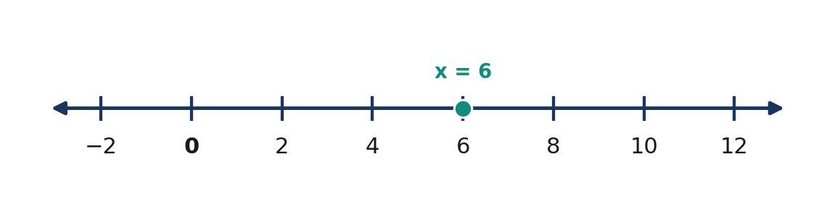
Figure 3.1.1 Figure 3.1.1. The value x = 6 satisfies 4x − 6 = 18.
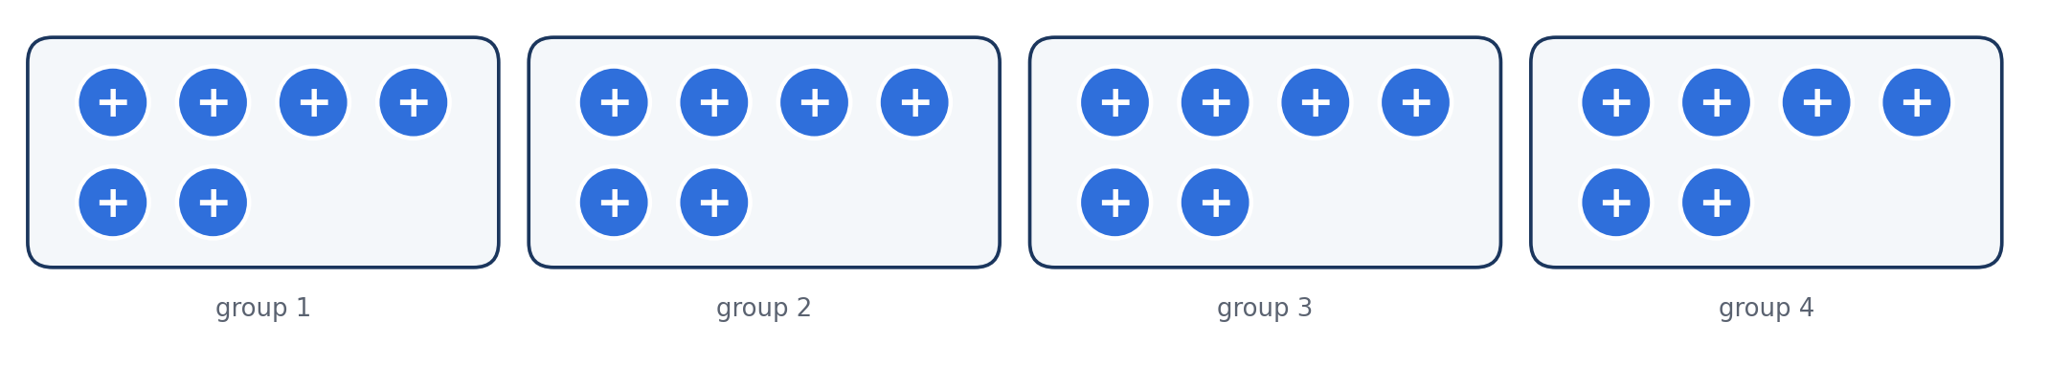
Figure 3.1.2 Figure 3.1.2. Four groups of six model 4x when x = 6.
Verbal statement | Algebraic expression or equation | Important distinction
Nine more than a number | $x+9$ | Addition follows the number.
Twice a number minus five | $2x-5$ | Multiply before subtracting.
Five less than twice a number | $2x-5$ | “Less than” reverses the spoken order.
Twice the difference of a number and five | $2(x-5)$ | Parentheses group the difference.
A number and seven total twenty | $x+7=20$ | The total gives the right-hand side.

Quick Check 3.1A: (1) Express “eight more than three times a number.” (2) Explain the difference between $3x-8$ and $3(x-8)$. (3) Write an equation for “one-half of a number is twelve.”

3. Subtopic 2 — Solving and Verifying Linear Equations

The equality principle states that adding or subtracting the same quantity on both sides preserves equality, as does multiplying or dividing both sides by the same nonzero number. Such operations isolate the unknown without changing the solution set. For $3x+5=20$, subtract five to get $3x=15$, then divide by three to obtain $x=5$. Each transformation is reversible; hence the final equation remains equivalent to the original.
Some equations require distributing a factor, collecting like terms, or clearing denominators before isolating the variable. When removing fractions, multiply every term on both sides by a common nonzero denominator. Always substitute the proposed value into the original equation, not merely the last simplified line. A true numerical statement establishes verification, while an absurd measurement or negative item count may signal an inappropriate model even when the algebra is correct.
📐 KEY CONCEPT — Equivalent Equations
For any expressions $A$ and $B$ and any number $c$,
$$A=B⇔ A+c=B+c.$$
If $c≠0$, then
$$A=B⇔ cA=cB.$$
A valid solution makes both sides of the original equation equal.

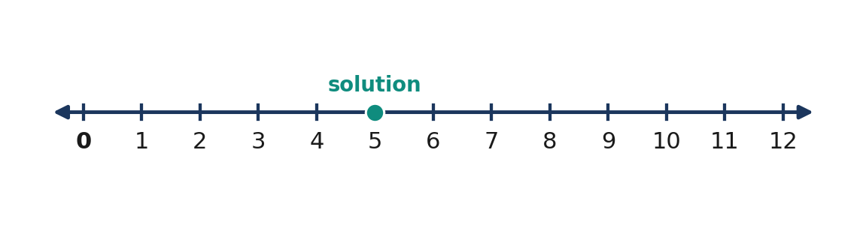
Figure 3.1.3 Figure 3.1.3. The unique solution of 3x + 5 = 20 is 5.
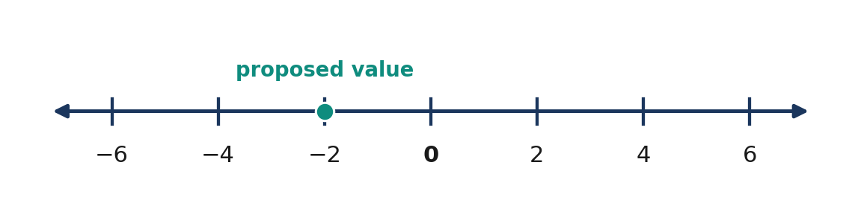
Figure 3.1.4 Figure 3.1.4. Negative numbers can solve linear equations; acceptability depends on the context.
Procedure | Correct transformation | Reason
Remove an added constant | $x+9=14⇒ x=5$ | Subtract $9 from both sides.
Remove a multiplied coefficient | $5x=35⇒ x=7$ | Divide both sides by $5.
Distribute | $2(x+3)=18⇒ 2x+6=18$ | Multiply each term inside parentheses.
Clear simple fractions | $x/3+2=6⇒ x+6=18$ | Multiply both sides by $3.
Check | $5(7)=35$ | Both original sides equal $35.

Quick Check 3.1B: (1) Solve $5x-9=26$. (2) Solve $3(x-2)=18$. (3) Why does dividing by zero never constitute a valid equation-solving step?

4. Core Anchor — Four Worked Examples

💡 Worked Example 1 — Consecutive Integers
Problem: The sum of three consecutive integers is $66. Find the integers.
Given: Three consecutive integers have sum $66.
Find: All three integers.
Formula or model: $x+(x+1)+(x+2)=66$.
$x+(x+1)+(x+2)$ | $= 66$ | represent the three consecutive integers
$3x+3$ | $= 66$ | collect like terms
$3x$ | $= 63$ | subtract 3 from both sides
$x$ | $= 21$ | divide both sides by 3

Final answer: 21, 22, and 23. Check: $21+22+23=66$.

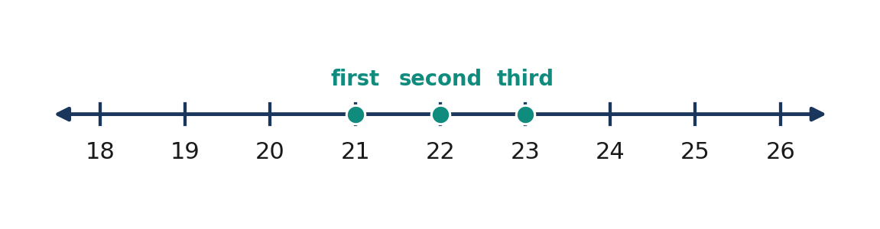
Figure 3.1.5 Figure 3.1.5. Consecutive integers differ by one unit.
💡 Worked Example 2 — Rectangle Dimensions
Problem: A rectangle has a length $5 cm greater than its width. Its perimeter is $50 cm. Determine its dimensions.
Given: Length $=w+5$ cm; perimeter $=50$ cm.
Find: Length and width.
Formula or model: $P=2l+2w$ and $50=2(w+5)+2w$.
$50$ | $= 2(w+5)+2w$ | substitute the expressions into the perimeter rule
$50$ | $= 4w+10$ | distribute and combine like terms
$40$ | $= 4w$ | subtract 10 from both sides
$w$ | $= 10$ | divide both sides by 4
$l$ | $= 10+5=15$ | use the length relationship

Final answer: Width = 10 cm; length = 15 cm. Check: $2(15)+2(10)=50$ cm.

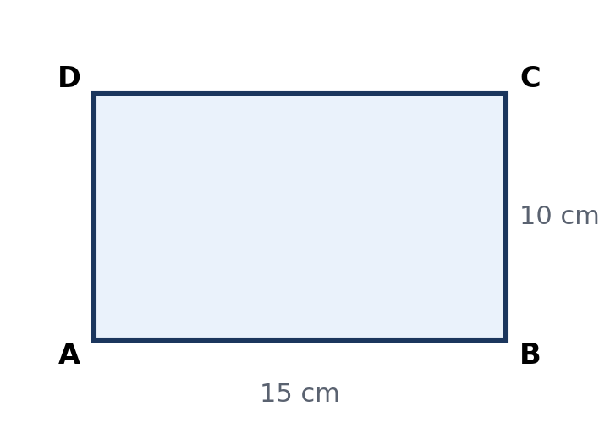
Figure 3.1.6 Figure 3.1.6. Rectangle dimensions satisfy a perimeter of 50 cm.
💡 Worked Example 3 — Savings and Spending
Problem: Mika has ₱125. After saving the same amount each week for $6 weeks, she has ₱485. How much does she save per week?
Given: Starting balance ₱125; final balance ₱485; $6 equal weekly deposits.
Find: Weekly deposit $s$ in pesos.
Formula or model: $125+6s=485$.
$125+6s$ | $= 485$ | starting balance plus six deposits
$6s$ | $= 360$ | subtract 125 from both sides
$s$ | $= 60$ | divide both sides by 6
$125+6(60)$ | $= 485$ | verify the original balance equation

Final answer: ₱60 per week. This is a positive savings amount and is realistic for the stated situation.

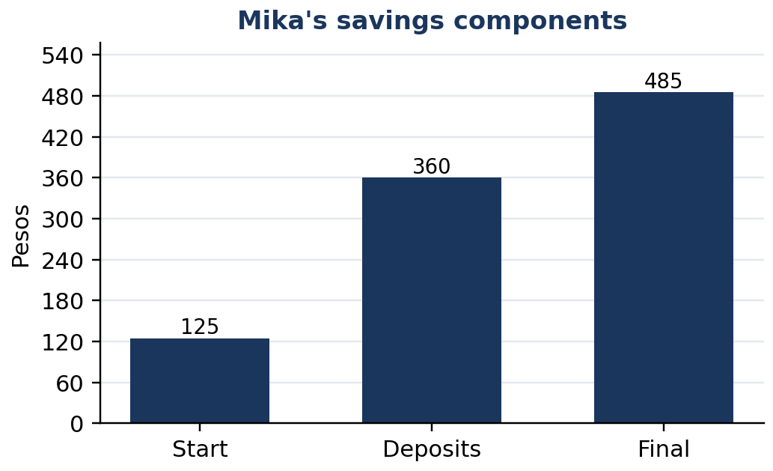
Figure 3.1.7 Figure 3.1.7. Starting money plus new savings equals the final balance.
💡 Worked Example 4 — Fare Model
Problem: A transport fare is ₱18 plus ₱7 for each kilometer traveled. A passenger pays ₱67. Find the distance.
Given: Fixed charge ₱18; variable charge ₱7/km; total ₱67.
Find: Distance $d$ in kilometers.
Formula or model: $18+7d=67$.
$18+7d$ | $= 67$ | fixed fare plus distance charge
$7d$ | $= 49$ | subtract 18 from both sides
$d$ | $= 7$ | divide both sides by 7
$18+7(7)$ | $= 67$ | check the total charge

Final answer: 7 km. The unit follows because dividing pesos by pesos per kilometer gives kilometers.

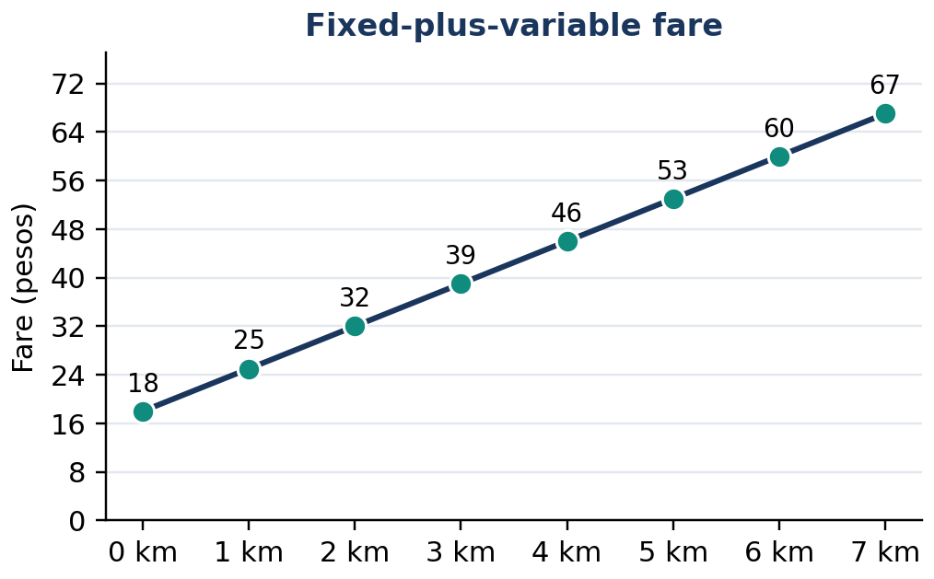
Figure 3.1.8 Figure 3.1.8. The fare increases by ₱7 with each additional kilometer.

5. Mathematical Reasoning and Error Analysis

Reasoning challenge: Two learners interpret “twice a number, less five, equals nineteen” differently. One writes $2x-5=19$; another writes $2(x-5)=19$. Which reading fits the intended grouping? Rewrite the original sentence unambiguously for each equation, then solve both. Algebra faithfully manipulates symbols; it cannot repair ambiguous language. A strong model begins by clarifying the meaning of the words.
WATCH OUT — Incorrect versus correct
Wrong: $4x+7=31⇒4x=38$ because seven was “moved.”
Right: $4x+7=31⇒4x=24$ because $7 is subtracted from both sides.
Wrong: $3(x+2)=3x+2$.
Right: $3(x+2)=3x+6$ because the multiplier applies to both terms.
Wrong: A negative answer is always invalid.
Right: A negative temperature or debt may be meaningful, but a negative number of notebooks is not.

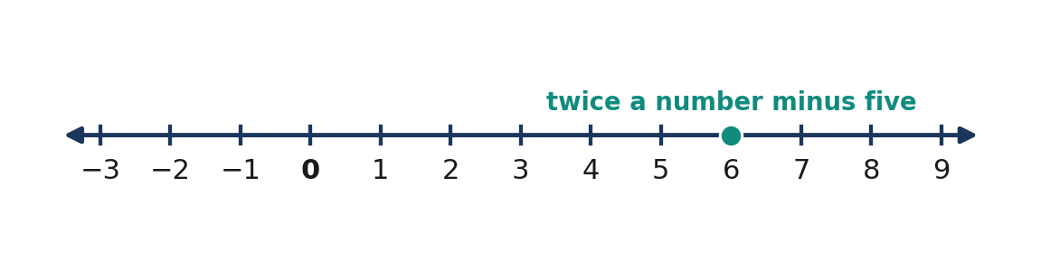
Figure 3.1.9 Figure 3.1.9. Number lines support interpretation of candidate values and checks.

6. Subtopic 3 — Modeling Problems Systematically

A word problem must be solved in the units and domain appropriate to the question. In a number problem, the unknown may be an integer or an unrestricted real number. A length generally must be positive. A number of objects must be a whole number, even when an equation initially admits fractions. Write any restriction when defining the variable; it becomes part of the interpretation and prevents an otherwise correct computation from being mistaken for a valid practical answer.
For multi-step situations, organize the data into a relationship table before constructing the equation. A money problem often follows starting amount + increase − decrease = ending amount. A geometry problem begins with the correct formula, followed by substitution of all known quantities. Finally, compare the result to the problem statement: Did the question ask for one quantity or several? A rectangle problem may ask for both dimensions, not merely the width used as the variable.
📐 KEY CONCEPT — Modeling Workflow
Read → Define → Relate → Form an Equation → Solve → Check → Interpret.
For a rectangle, $P=2l+2w,$ where $P$ is perimeter in centimeters, $l$ is length in centimeters, and $w$ is width in centimeters. Units must agree on both sides.

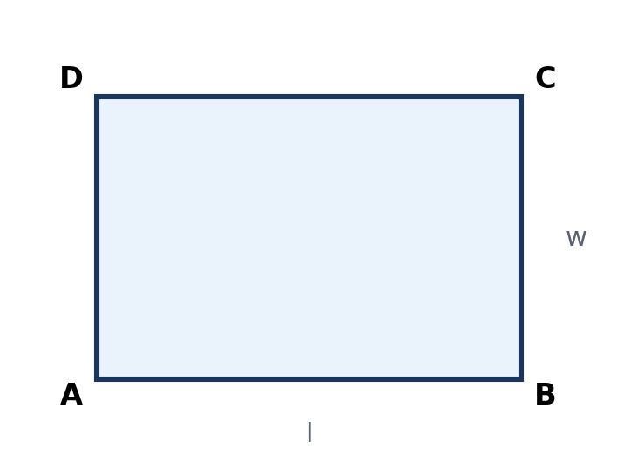
Figure 3.1.10 Figure 3.1.10. A rectangle model identifies the two repeated dimensions.
Problem type | Useful relationship | Final check
Consecutive integers | $x$, $x+1$, $x+2$ | Terms differ by exactly one.
Perimeter | $P=2l+2w$ | Sum of all sides matches the perimeter.
Money balance | $start+added-spent=end$ | Amounts are in pesos and transactions match.
Constant-rate fare | $T=F+rd$ | Fixed fee, rate, and distance reproduce the charge.

Quick Check 3.1C: (1) Write a model for two consecutive even integers totaling $54. (2) A rectangle has length twice its width and perimeter $36 cm; what variable would you define? (3) Why must a calculated number of people be a whole number?

7. Guided and Independent Practice

Task 3.1 — Graded Exercises. Define variables where needed; show equivalent-equation steps and check every answer. The first twelve questions develop basic fluency, the next six require multiple steps, and the last four demand contextual interpretation.
Basic (1–12)
1. $x+7=18$ | 2. $4x=36$ | 3. $2x+5=23$
4. $3x-4=17$ | 5. $x/5=6$ | 6. $7+x=2$
7. $5x+10=0$ | 8. $2(x+3)=20$ | 9. $x/2+4=11$
10. $6x-8=28$ | 11. $10-3x=1$ | 12. $4(x-2)=12$

Intermediate (13–18)
13. $3x+8=x+22$ | 14. $5(x-2)=2x+11$
15. $x/3+5=12$ | 16. $2(x+4)-3=17$
17. $4x-7=2x+9$ | 18. $3(x-1)+2=2(x+5)$

Challenge and word problems (19–22)
19. Two consecutive integers have a sum of $95. Find both.
20. A rectangular garden has length $4 m more than its width and perimeter $48 m. Find its dimensions.
21. A mobile-load account begins with ₱50 and receives equal weekly additions for four weeks. The final balance is ₱230. Find each addition.
22. A delivery company charges ₱35 plus ₱12 per kilometer. If a delivery costs ₱131, how many kilometers were traveled?
Task 3.2 — Analytical Completion Matrix. Fill in the missing model or conclusion and explain your reasoning.
Situation | Equation or method | Interpretation to complete
Five more than twice a number is $31 | $2x+5=31$ | Find and check $x$: ______
A rectangle: $l=w+3$ and $P=34$ cm | ____ | Dimensions: ______
A fare is ₱20 plus ₱8/km, total ₱68 | ____ | Distance: ______
Three consecutive numbers sum to $42 | ____ | Three numbers: ______
Twice a number minus four is the same as that number plus nine | ____ | Solve and explain: ______

8. Contextual Application — School Supply Budget

A learning group has ₱620 to buy ten identical notebooks and pay a fixed ₱70 delivery charge. Goal: Determine the notebook price if the money is used exactly. Procedure: (1) Define $p$ as the price per notebook, in pesos. (2) Express the total as the delivery fee plus ten notebook prices. (3) Write and solve the equation. (4) Verify the total. (5) Explain whether the resulting price is reasonable and identify an assumption of the model. Scoring (10 points): variable and units (2), valid equation (2), correct algebra (3), substitution check (2), interpretation (1).

9. Metacognitive 3–2–1 Exit Ticket and Summary

Record 3 translation or equation-solving ideas you can now use confidently; 2 mistakes you will check for in future solutions; and 1 real-life situation in which a one-variable equation would support a decision. In one sentence, explain why verifying the original relationship is a mathematical responsibility rather than an optional extra step.
LESSON SUMMARY: A linear equation in one variable models an unknown linked to known quantities. Choose a variable with units, translate relationships faithfully, preserve equality through reversible operations, and check the proposed answer in the original model. Interpret the result using practical restrictions. Number, geometry, money, and constant-rate problems share this same reasoning process.

10. Formative Assessment — 15 Items

Part I. Multiple Choice (Items 1–10). Mark one answer per question.
Item | Question and choices
1 | [ ] Which equation represents “nine less than three times a number is twenty-four”? A. $3(x-9)=24$ B. $9-3x=24$ C. $3x-9=24$ D. $3x+9=24$
2 | [ ] Solve $4x+7=35$. A. $x=7$ B. $x=8$ C. $x=9$ D. $x=6$
3 | [ ] Three consecutive integers sum to $51. What is the smallest? A. $15 B. $18 C. $19 D. $16
4 | [ ] A rectangle has width $w$ and length $w+4$. Its perimeter is $32 cm. What is $w$? A. $8 cm B. $6 cm C. $10 cm D. $12 cm
5 | [ ] What operation isolates $x$ in $−3x=18$? A. Add $3 B. Multiply by $3 C. Subtract $3 D. Divide by $−3$
6 | [ ] Solve $2(x+5)=26$. A. $x=8$ B. $x=18$ C. $x=13$ D. $x=3$
7 | [ ] A fare is ₱25 plus ₱5/km. What distance costs ₱60? A. $7 km B. $12 km C. $5 km D. $17 km
8 | [ ] Which equation matches “half a number increased by six equals fourteen”? A. $(x+6)/2=14$ B. $x/2+6=14$ C. $2x+6=14$ D. $x/(2+6)=14$
9 | [ ] Solve $5x-4=2x+11$. A. $x=5$ B. $x=3$ C. $x=−5$ D. $x=7$
10 | [ ] Which check confirms that $x=4$ solves $3x-2=10$? A. $3+4-2=5$ B. $3(4)-2=10$ C. $3(4)+2=14$ D. $3(4-2)=6$

Part II. Open Analytical and Calculation Items (11–15). Show an equation, steps, units when applicable, and a verification statement.
11. A number increased by $13 is $40. Write and solve an equation; verify the solution.
12. The sum of two consecutive odd integers is $72. Find both integers and justify why they are odd and consecutive.
13. A rectangle is three times as long as it is wide. Its perimeter is $64 cm. Calculate both dimensions and verify the perimeter.
14. A learner saves ₱90 initially and ₱45 weekly. After how many whole weeks will the savings equal ₱405? Give a complete model and check.
15. Explain the modeling error in writing $3(x-4)=21$ for “four less than three times a number is twenty-one.” Write the correct equation, solve it, and compare the two possible answers.

LESSON 3.2 — LINEAR INEQUALITIES AND OPEN SENTENCES IN ONE VARIABLE

Mathematics 8 • Quarter 3 | Domain: Number and Algebra (NA)
Curriculum alignment: Grade 8 Quarter 3 learning competencies 3–5: solve linear inequalities in one variable; graph their solutions on a number line; solve problems involving linear inequalities in one variable. The preceding lesson on linear equations provides the algebraic foundation.
Essential questions:
1. Why does an inequality describe a set of possible values rather than necessarily one value?
2. Which operations preserve the direction of an inequality, and why does multiplying or dividing by a negative number reverse it?
3. How can solution intervals be graphed and interpreted as real-world restrictions?
🎥 INTERACTIVE MULTIMEDIA: Solving and Graphing Inequalities
Channel: Khan Academy. Direct video: Multiplying and Dividing with Inequalities Example.
Concepts to observe: How inequalities differ from equations; open and closed endpoints; why multiplying or dividing by a negative changes the inequality direction.
Viewing questions: (1) How do you test whether a number belongs to a solution set? (2) Why is a boundary point sometimes excluded? (3) How could you use an inequality to plan a purchase within a fixed budget?

An equation such as $x+3=8$ asks for values that make two expressions equal; it has the solution $x=5$. The related inequality $x+3<8$ asks for every value whose sum with three is less than eight. Its solution is $x<5$, which represents infinitely many real numbers. A linear inequality in one variable uses $<$, $>$, $≤$, or $≥$ to compare first-degree expressions involving a single unknown. Such a statement is an open sentence because its truth depends on the substituted value of the variable.
The key skill is to move among four representations: a verbal condition, a symbolic inequality, a solution set, and a number-line graph. Exact boundary values matter. A strict inequality excludes its boundary; an inclusive inequality includes it. In everyday decision-making, the difference between “below ₱300” and “at most ₱300” determines whether ₱300 is permissible. Students should identify the domain of the variable as well: the mathematical solution may contain decimals, while the number of items purchased must be a nonnegative whole number.

2. Subtopic 3.2.1 — Open Sentences, Inequality Symbols, and Solution Sets

An open sentence becomes true or false when a value replaces its variable. In $2x+1>9$, substituting $x=5$ yields $11>9$, a true statement; substituting $x=3$ yields $7>9$, a false statement. Therefore, a solution to an inequality is not a single computed value alone: it is any value that makes the statement true. The entire collection of such values is called the solution set.
Read inequality language carefully: less than means $<$; greater than means $>$; at most means $≤$; at least means $≥$. “No more than” is also $≤$, while “not below” is $≥$. The inequality $x≤4$ contains the endpoint $4; $x<4$ does not. These distinctions affect both the written solution and its graph.
📐 KEY CONCEPT: Reading and Testing Inequalities
A number $c$ satisfies an inequality if substitution makes the comparison true. For example:
$$2(3)+1<8 ⇒ 7<8$$
The domain is the set of values allowed for the unknown; the solution set consists of the domain values that satisfy the sentence.

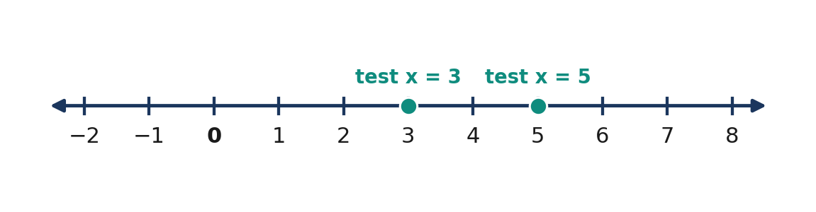
Figure 3.2.1 Test candidates on a number line for 2x + 1 > 9: x = 3 fails, while x = 5 satisfies the inequality.
Language | Symbol | Example and boundary
Less than / fewer than | $<$ | $x<6$ excludes $6
Greater than / more than | $>$ | $x>6$ excludes $6
At most / no more than | $≤$ | $x≤6$ includes $6
At least / not below | $≥$ | $x≥6$ includes $6

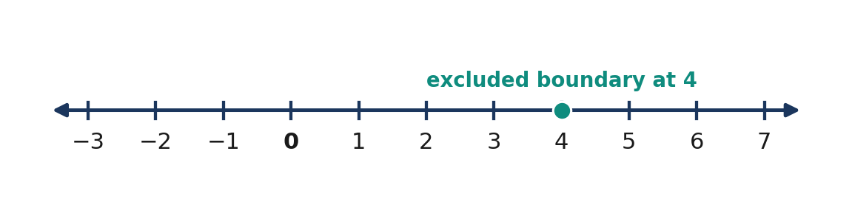
Figure 3.2.2 The inequality x < 4 excludes its endpoint; a number-line representation uses an open circle at 4 and extends left.
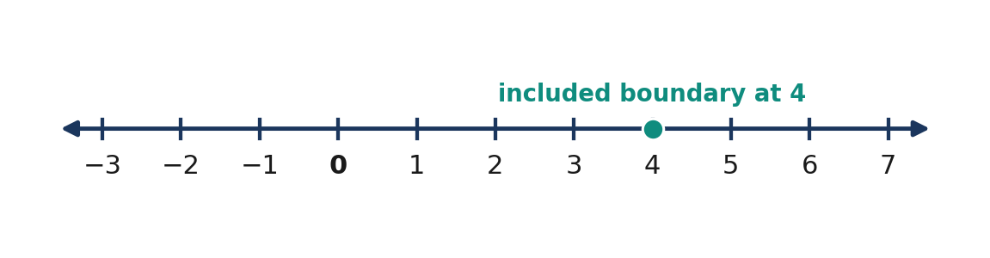
Figure 3.2.3 The inequality x ≤ 4 includes 4; a number-line representation uses a filled circle at 4 and extends left.
Quick Check 3.2A. (1) Translate “a number is at least $−2$.” (2) Decide whether $x=4$ satisfies $3x-1>10$. (3) Explain the difference between $x<1$ and $x≤1$.

3. Subtopic 3.2.2 — Equivalent Inequalities and Number-Line Graphs

Adding or subtracting the same number on both sides preserves an inequality. Multiplication or division by a positive number also preserves its direction. For example, $3x+2≤14$ becomes $3x≤12$ after subtracting $2, and then $x≤4$ after division by $3. Every stage describes the same set of permissible values, so these are equivalent inequalities.
Negative multiplication requires a different rule. If $2<5$, multiplying both sides by $−1$ gives $−2>−5$, not $−2<−5$. On a number line, negation reflects values across zero, reversing their order. Therefore, if $−2x<8$, division by $−2$ gives $x>−4$. Failing to reverse the comparison creates an incorrect solution set even if the arithmetic is otherwise accurate.
📐 KEY CONCEPT: Operations on Inequalities
For real numbers a,b,c:
$$a<b Longrightarrow a+c<b+c$$
If $c>0$:
$$a<b Longrightarrow ac<bc$$
If $c<0$:
$$a<b Longrightarrow ac>bc$$
The same direction rules apply to $≤$, $>$ and $≥$.

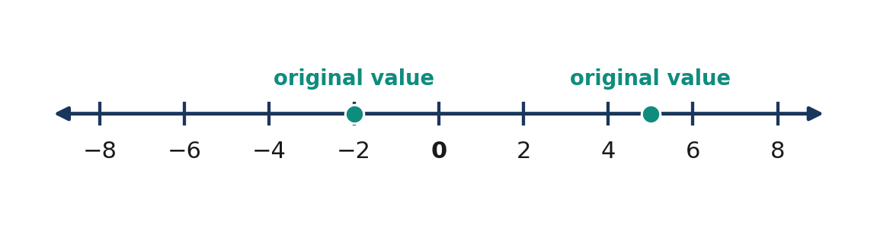
Figure 3.2.4 Two values on the number line satisfy −2 < 5; their positions establish order.
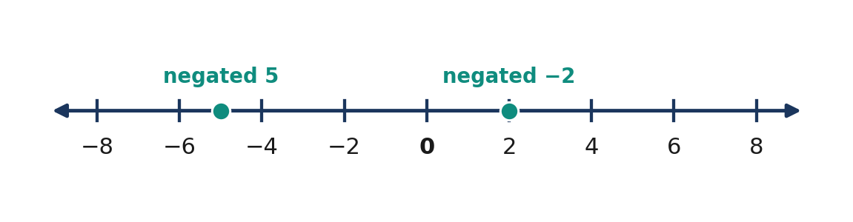
Figure 3.2.5 Negating the values reverses the comparison: 2 > −5.
Operation on both sides | Direction | Illustrative result
Add or subtract any real number | Unchanged | $x-5>2⇒ x>7$
Multiply/divide by a positive number | Unchanged | $4x≤12⇒ x≤3$
Multiply/divide by a negative number | Reverse | $−3x≥12⇒ x≤−4$
Substitute a test value | Determine truth | $x=−5$ satisfies $x≤−4$

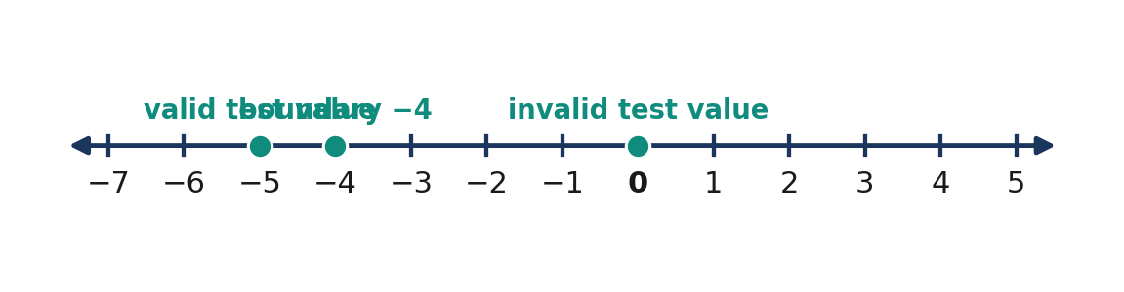
Figure 3.2.6 For x ≤ −4, −5 is in the solution set, −4 is included, and 0 is excluded.
Quick Check 3.2B. (1) Solve $5x+3<18$. (2) Solve $−4x≥20$. (3) Explain what goes wrong if $−2x≤6$ is rewritten as $x≤−3$.

4. Core Anchor — Four Fully Worked Examples

💡 Worked Example 1 — Two-Step Inclusive Inequality
Problem: Solve $3x+5≤20$ and represent its solution.
Given: $3x+5≤20$. Find: All real values of $x$.
Formula/Rule: Subtract equally; divide by a positive number without changing $≤$.
$3x + 5 ≤ 20$ |  | original inequality
$3x ≤ 15$ |  | subtract 5 from both sides
$x ≤ 5$ |  | divide both sides by positive 3

Final Answer: **$x≤5$**, including $5 and every smaller real number.
Verification: $x=5$ gives $20≤20$ (true); $x=6$ gives $23≤20$ (false).

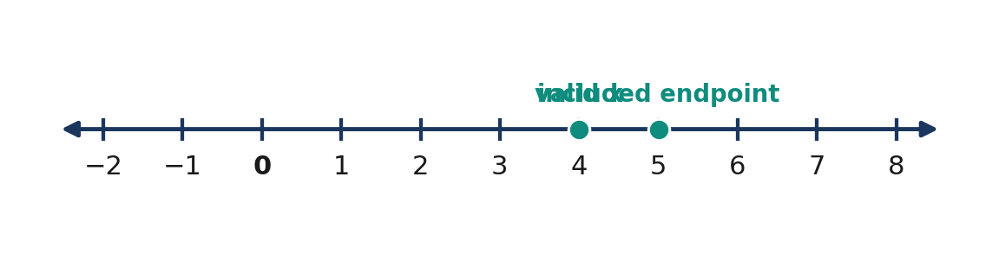
Figure 3.2.7 The solution x ≤ 5 includes the endpoint and extends to the left.
💡 Worked Example 2 — Negative Coefficient
Problem: Solve $−4x+7>19$.
Given: $−4x+7>19$. Find: Its complete solution set.
Formula/Rule: Reverse the inequality when dividing by a negative number.
$−4x + 7 > 19$ |  | original inequality
$−4x > 12$ |  | subtract 7 from both sides
$x < −3$ |  | divide by −4 and reverse > to <

Final Answer: **$x<−3$**, excluding $−3$.
Verification: $x=−4$ produces $23>19$ (true); $x=−3$ produces $19>19$ (false).

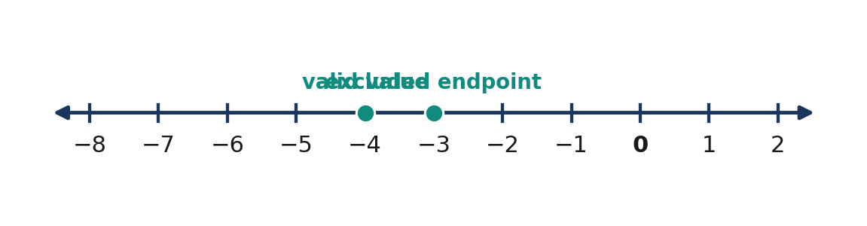
Figure 3.2.8 The strict solution x < −3 extends left from an open endpoint at −3.
💡 Worked Example 3 — Distribution and Variables on Both Sides
Problem: Solve $2(x-3)≥5x+9$.
Given: $2(x-3)≥5x+9$. Find: All values satisfying the condition.
Formula/Rule: Distribute, collect variable terms, reverse on negative division.
$2(x − 3) ≥ 5x + 9$ |  | original inequality
$2x − 6 ≥ 5x + 9$ |  | distribute
$−3x ≥ 15$ |  | subtract 5x and add 6
$x ≤ −5$ |  | divide by −3 and reverse ≥ to ≤

Final Answer: **$x≤−5$**.
Verification: At $x=−5$, both sides equal $−16$. At $x=0$, $−6≥9$ is false.

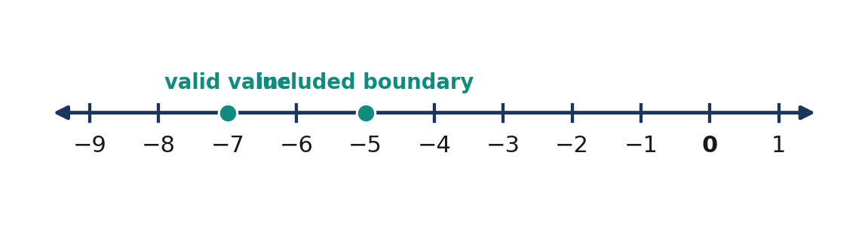
Figure 3.2.9 The inequality with variables on both sides has an included boundary at −5.
💡 Worked Example 4 — Budget with a Whole-Number Restriction
Problem: A group has ₱250. A fixed delivery fee is ₱40, and each notebook costs ₱35. How many notebooks can it buy without exceeding the budget?
Given: ₱250 total, ₱40 delivery, ₱35 per notebook. Find: Greatest permissible whole number $n$ of notebooks.
Formula/Model:
$$40+35n≤250$$
$40 + 35n ≤ 250$ |  | total must not exceed budget
$35n ≤ 210$ |  | subtract fixed fee
$n ≤ 6$ |  | divide by positive 35

Final Answer: At most 6 notebooks. The contextual solution set is $n∈\{0,1,2,3,4,5,6\}$.
Verification: Six notebooks cost ₱250; seven would cost ₱285 and exceed the budget.

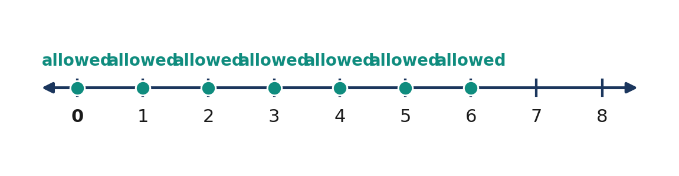
Figure 3.2.10 Only the whole-number counts 0 through 6 are valid when n represents notebooks.

5. Mathematical Reasoning and Common Misconceptions

Reasoning challenge: A student claims that $−3x<12$ means $x<−4$. Test $x=0$ in the original inequality and in the student's conclusion. Explain why a counterexample is sufficient to disprove the claimed equivalence. Derive the correct solution and mark its endpoint as open or closed.
WATCH OUT — Wrong → Right
- Wrong: $−5x≤10⇒ x≤−2$. Right: $x≥−2$. Dividing by $−5$ reverses $≤$.
- Wrong: “At most 8” means $x<8$. Right: $x≤8$, because eight is allowed.
- Wrong: Every decimal between 0 and 6 is an allowed notebook count. Right: Only whole numbers work when the variable counts notebooks.
- Wrong: An open circle means no solution exists. Right: It excludes only the boundary point; many other values may still satisfy the inequality.

A compound condition may restrict a variable from two sides. For example, a qualifying age between 12 and 18 inclusive is written $12≤ a≤18$. The two boundaries are included because of the words “inclusive” and the symbols $≤$. When the variable represents age in whole years, only integer ages are counted; when it represents a continuous measurement, fractional values may also be meaningful.
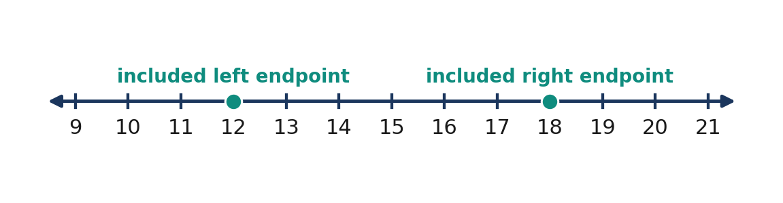
Figure 3.2.11 A bounded solution such as 12 ≤ a ≤ 18 includes both endpoints and all values between them in the real-number domain.

6. Subtopic 3.2.3 — Applying Inequalities to Constraints

Word problems involving inequalities often use maximum, minimum, capacity, budget, and threshold language. Begin by identifying the quantity that is limited, the fixed amount, and the amount per item. For a total-cost restriction, add fixed and variable costs, then compare with the available money. “Must not exceed” calls for $≤$; “must reach at least” calls for $≥$.
For geometry, distinguish lower or upper bounds from precise measurements. A triangle perimeter required to be below $30 cm gives an inequality, whereas a perimeter equal to $30 cm gives an equation. Units must agree before terms can be combined. After solving, intersect the algebraic solution with physical constraints such as positive length, whole-number quantity, or permitted time.
📐 KEY CONCEPT: Interpreting a Linear Constraint
$$F+rn≤ B$$
Here $F$ is a fixed cost (₱), $r$ is the cost per item (₱/item), $n$ is the number of items, and $B$ is the budget (₱). For a count, require $n$ to be a nonnegative integer in addition to satisfying the inequality.

Situation | Symbolic constraint | Interpretation
At least ₱500 saved | $s≥500$ | ₱500 qualifies
Below 40 kg | $m<40$ | 40 kg does not qualify
No more than 20 seats | $p≤20$ | At most 20 people
Above 75 points | $t>75$ | A score of 75 is insufficient

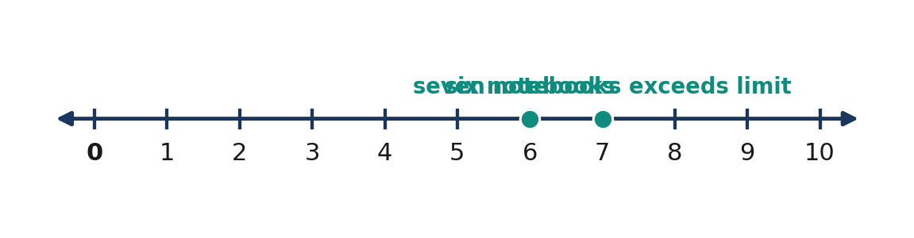
Figure 3.2.12 A purchase limit can be checked by comparing a maximum allowed integer with the next integer.
Quick Check 3.2C. (1) Write a condition for “no more than 12 participants.” (2) A service costs ₱80 plus ₱15 per hour; write an inequality for a ₱200 budget. (3) If $n≤8.6$ and $n$ counts books, what is the greatest permissible count?

7. Guided and Independent Practice

Task 3.2.1 — Graded exercises. Solve every inequality, indicate whether the boundary is included, and sketch a number-line graph for items 1, 3, 6, 9, 12, 14, 17, and 18.
Basic: Items 1–12
1. x + 4 < 11 | 2. x − 6 ≥ 2 | 3. 3x ≤ 18
4. −2x > 10 | 5. x / 5 ≥ 3 | 6. −x ≤ 7
7. 7 + x > 1 | 8. 4x − 5 ≤ 15 | 9. −3x ≥ 9
10. x / (−2) < 4 | 11. 5x + 2 > 17 | 12. 12 − 2x ≥ 4

Intermediate: Items 13–18
13. 2(x + 3) < 18 | 14. −4(x − 2) ≥ 20
15. 3x + 7 ≤ x + 15 | 16. 5(x − 1) > 2x + 7
17. −2x + 3 < x − 9 | 18. (x − 2) / 3 ≥ 4

Challenge: Items 19–22
19. A prepaid card has ₱300. Each trip costs ₱28. How many complete trips can be paid for without reloading?
20. A hall accommodates at most 180 people. There are already 47 occupants. Write and solve an inequality for additional entrants.
21. A school club earns ₱45 per item sold and pays ₱360 for supplies. How many items must be sold to make a profit of at least ₱540?
22. A rectangle has width $w$ cm and length $(w+4)$ cm. Its perimeter must be less than 40 cm. Give all permissible positive widths.
Task 3.2.2 — Analytical matrix. Complete both the algebraic solution and contextual interpretation.
Scenario | Inequality | Solution and meaning
No more than ₱600 may be spent; tickets cost ₱75 each | $75t≤600$ | ________
A score needs to be at least 70 after adding 12 bonus points | $s+12≥70$ | ________
A tank holds less than 45 L after 3 L is added | $v+3<45$ | ________
A transport pass starts at ₱60, then ₱20 per trip, within ₱260 | $60+20n≤260$ | ________
A number divided by $−3$ is greater than 4 | $x/(−3)>4$ | ________

8. Contextual Application — Community Reading Event

An organizing team has ₱1,500 for printing. Setup costs ₱180 and each reading packet costs ₱22. Determine the greatest number of packets it can print without exceeding the allocation.
Procedure: (1) Define an integer variable for the packet count. (2) Form the total-cost inequality with pesos as units. (3) Solve using equivalent inequalities. (4) Test the maximum proposed count and the next integer. (5) Write a one-sentence recommendation explaining the unused balance, if any.
Focused scoring guide (10 points): Correct variable and unit (2); accurate inequality (2); justified solution (3); maximum-count and next-count check (2); contextual recommendation (1).

9. Metacognitive 3-2-1 Exit Ticket and Lesson Summary

Record three rules you used correctly, two incorrect habits you now know how to avoid, and one everyday decision in which a minimum or maximum constraint would matter.
LESSON SUMMARY: Linear inequalities describe solution sets rather than necessarily one value. Adding or subtracting equal numbers preserves order; multiplication or division by a negative reverses the inequality sign. A strict comparison uses an open endpoint, while an inclusive comparison uses a filled endpoint. The practical solution is the algebraic set restricted to meaningful units and domains.

10. Formative Assessment — 15 Items

Part I — Multiple choice (1–10). Select one answer per item and mark it with [ ].
Item | Question and options
1 | Which represents “at least nine”? A [ ] $x>9$ · B [ ] $x≤9$ · C [ ] $x<9$ · D [ ] $x≥9$
2 | Solve $x-7<5$. A [ ] $x<12$ · B [ ] $x>12$ · C [ ] $x<−2$ · D [ ] $x≤12$
3 | Solve $−3x≤15$. A [ ] $x≤−5$ · B [ ] $x≥−5$ · C [ ] $x<5$ · D [ ] $x≥5$
4 | Which number satisfies $2x+1>11$? A [ ] $4 · B [ ] $5 · C [ ] $7 · D [ ] $−7$
5 | Solve $4x+3≥19$. A [ ] $x≤4$ · B [ ] $x>4$ · C [ ] $x≥4$ · D [ ] $x<4$
6 | Which graph describes $x<−2$? A [ ] Open at $−2$, right · B [ ] Filled at $−2$, left · C [ ] Filled at $−2$, right · D [ ] Open at $−2$, left
7 | Solve $2(x-1)≤10$. A [ ] $x≤6$ · B [ ] $x≥6$ · C [ ] $x≤4$ · D [ ] $x<6$
8 | A fee of ₱30 plus ₱25 per item must not exceed ₱155. What is the greatest whole-number item count? A [ ] $4 · B [ ] $5 · C [ ] $6 · D [ ] $7
9 | Solve $5x-4>2x+8$. A [ ] $x<4$ · B [ ] $x≥4$ · C [ ] $x>4$ · D [ ] $x≤4$
10 | Solve $−2(x+3)>8$. A [ ] $x>−7$ · B [ ] $x<−7$ · C [ ] $x<−1$ · D [ ] $x>1$

Part II — Open analytical and calculation items (11–15). Write the model, justify each transformation, and check a boundary or test value.
11. Solve $7-2x≥17$ and describe the endpoint of its number-line graph.
12. Solve $3(2x-1)<4x+9$, explaining each algebraic operation.
13. A learner has ₱480; a ticket costs ₱65 and transport costs ₱90. Determine the greatest whole number of tickets that can be bought.
14. The perimeter of a rectangle whose length is $x+5$ cm and width is $x$ cm must be at most $50 cm. State all possible positive widths.
15. A learner solves $−5x>20$ and writes $x> −4$. Identify the invalid step, give the correct solution, and verify with one positive and one negative test number.

LESSON 3.3 — LINEAR EQUATIONS IN TWO VARIABLES

Mathematics 8 • Quarter 3 | Domain: Number and Algebra (NA)
Curriculum alignment: Grade 8 Quarter 3, Number and Algebra, Learning Competency 6: Describe a linear equation in two variables and express its solution using ordered pairs. This lesson prepares learners for slope, intercepts, equations of lines, and graphing in Lessons 3.4–3.5. The official curriculum guide does not assign an individual alphanumeric code to this competency; the competency number refers to its position in the Quarter 3 list.
Essential questions: (1) What distinguishes a linear equation in two variables from a one-variable equation? (2) How can ordered pairs, tables, and graphs represent the same relationship? (3) How can a linear model describe a realistic situation while respecting the domain of its variables?
🎥 INTERACTIVE MULTIMEDIA: Linear Equations as Sets of Ordered-Pair Solutions
Channel: Khan Academy. Direct link: https://www.youtube.com/watch?v=NybHckSEQBI
Concepts to observe: variables as changing quantities; translating relationships into algebraic forms; distinguishing expressions from equations. Questions: 1. What does a variable represent in the examples? 2. What additional information is required to find a unique ordered pair rather than one number? 3. How might a store use an equation involving two quantities?

A quantity often depends on another quantity. A school supply bill depends on how many notebooks and pens are bought. A taxi fare depends on the distance traveled and possibly other charges. These situations can be modeled with linear equations in two variables: equations whose solution consists of two numbers taken together. A single linear equation in two variables usually has infinitely many real-number solutions. Each solution is an ordered pair and can be plotted as a point. The graph of a linear equation in two variables is a straight line. Unlike solving a one-variable equation for one unknown, solving a two-variable linear equation means identifying one or more ordered pairs that make the statement true. In applications, the possible inputs may be restricted to nonnegative numbers or whole numbers. The distinction between an algebraic solution and a meaningful practical solution is a central concern of this lesson.

2. SUBTOPIC 1 — WHAT IS A LINEAR EQUATION IN TWO VARIABLES?

A linear equation in two variables can be written in standard form:
📐 KEY CONCEPT: Standard Form of a Linear Equation
$$Ax+By=C$$
Here $A$, $B$, and $C$ are real constants; $A$ and $B$ are not both zero. Variables $x$ and $y$ occur only to the first power, and there are no products such as xy. The values of $x$ and $y$ form an ordered pair $(x,y)$.

For example, $2x+y=8$ is linear because each variable has degree one. By contrast, $x^{2}+y=8$ and $xy=8$ are not linear equations in two variables. The equation $x=3$ is a linear equation in two variables when understood as $x+0y=3$; its graph is a vertical line. The equation $y=−2$ is a horizontal line. Thus, a linear equation need not have both variables explicitly visible, provided its graph and definition are considered correctly.
An ordered pair $(x,y)$ records the value of $x$ first and $y$ second. The order matters: $(2,4)$ is generally different from $(4,2)$. To test $(2,4)$ in $2x+y=8$, substitute $x=2$ and $y=4$: $2(2)+4=8$, which is true. To test $(4,2)$, compute $2(4)+2=10$, which is not equal to eight. A point belongs to the solution set if, and only if, its coordinates make the original equation true.
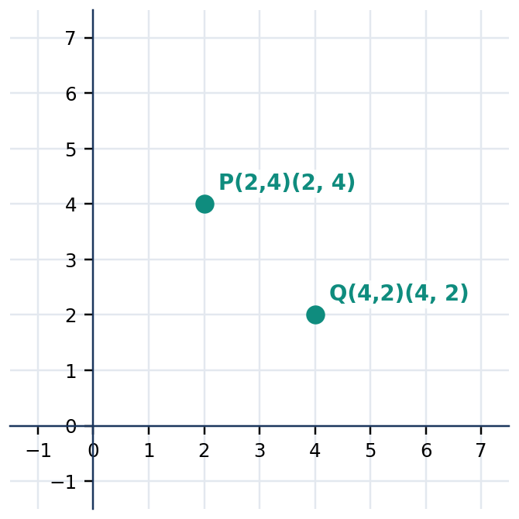
Figure 3.3.1 The location of a point depends on the order of its two coordinates.
Form | Example | What to check
Standard form | $2x+y=8$ | Variables have degree one
Rearranged form | $y=8-2x$ | Same solutions after subtracting $2x
Ordered pair | $(2,4)$ | Substitute both coordinates
Nonexample | $x^{2}+y=8$ | Squared variable makes it nonlinear

Quick Check 3.3A: 1. Which of $3x-2y=7$, $x^{2}+y=7$, and $xy=7$ are linear? 2. Does $(1,5)$ satisfy $3x+y=8$? Show the substitution. 3. Explain why $(5,1)$ must be checked separately from $(1,5)$.
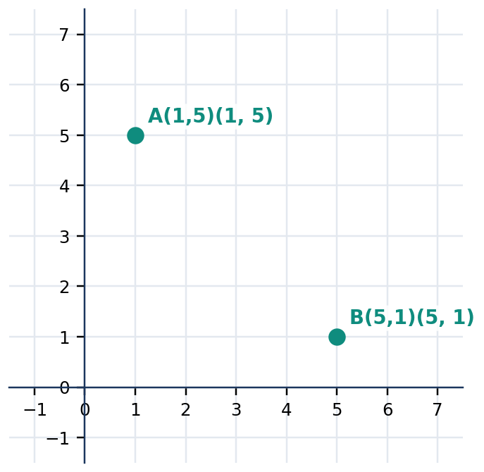
Figure 3.3.2 Reversing coordinate order changes the location of the point.

3. SUBTOPIC 2 — FINDING ORDERED-PAIR SOLUTIONS

A linear equation in two variables can be used to find one coordinate when the other is supplied. To find points on $x+2y=10$, choose a value for $x$ and solve for $y$. If $x=0$, then $2y=10$ and $y=5$, giving $(0,5)$. If $x=2$, then $2+2y=10$, so $y=4$ and the pair is $(2,4)$. Repeating the process creates a table of values. The table lists examples of the solution set, not necessarily every solution.
For the equation $x+2y=10$, solving for $y$ gives a convenient rule:
$$y=\frac{10-x}{2}=5-\frac{x}{2}$$
Every selected real value of $x$ produces exactly one corresponding real value of $y$. Since there are infinitely many real values of $x$, this equation has infinitely many ordered-pair solutions. However, not every randomly chosen pair satisfies the equation: each must pass the substitution test. This is why a table of values is an organized sampling of solutions rather than a list of arbitrary coordinates.
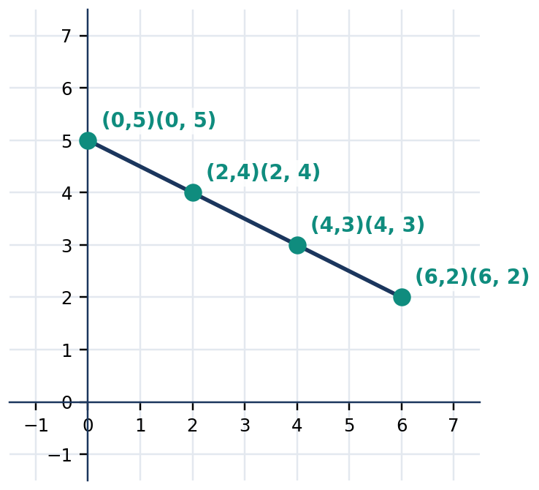
Figure 3.3.3 Four solution pairs for x + 2y = 10 lie on one straight line.
Chosen $x$ | Calculated $y$ | Ordered pair | Check
$0 | $5 | $(0,5)$ | $0+2(5)=10$
$2 | $4 | $(2,4)$ | $2+2(4)=10$
$4 | $3 | $(4,3)$ | $4+2(3)=10$
$6 | $2 | $(6,2)$ | $6+2(2)=10$

Quick Check 3.3B: 1. Complete $(3, _ )$ as a solution of $x+y=9$. 2. Complete $(_ ,2)$ as a solution of $2x+y=12$. 3. Explain why finding two different solutions does not mean the equation has only two solutions.
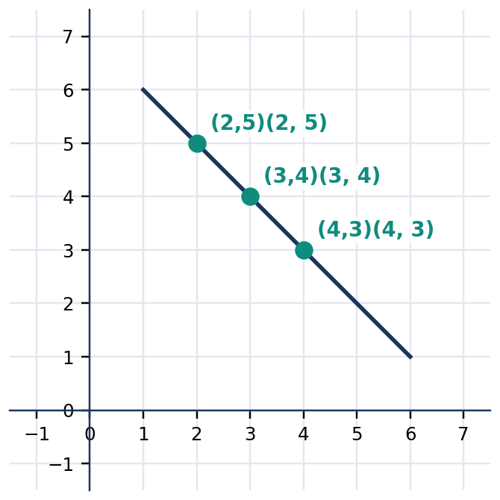
Figure 3.3.4 Distinct points can represent distinct solutions of the same equation x + y = 7.

4. CORE ANCHOR — FOUR FIVE-STEP WORKED EXAMPLES

💡 WORKED EXAMPLE 1 — Testing an Ordered Pair
Problem: Determine whether $(3,2)$ satisfies $2x+3y=12$.
Given: $x=3$ and $y=2$. Find: Whether the pair is a solution.
Formula/Rule: Substitute coordinates into $2x+3y=12$.
$2(3)+3(2)$ | $= 6+6$ | substitute the given coordinates
 | $= 12$ | simplify the left side
$12$ | $= 12$ | compare with the right side

**Final Answer: $(3,2)$ is a solution.** The equality is true.

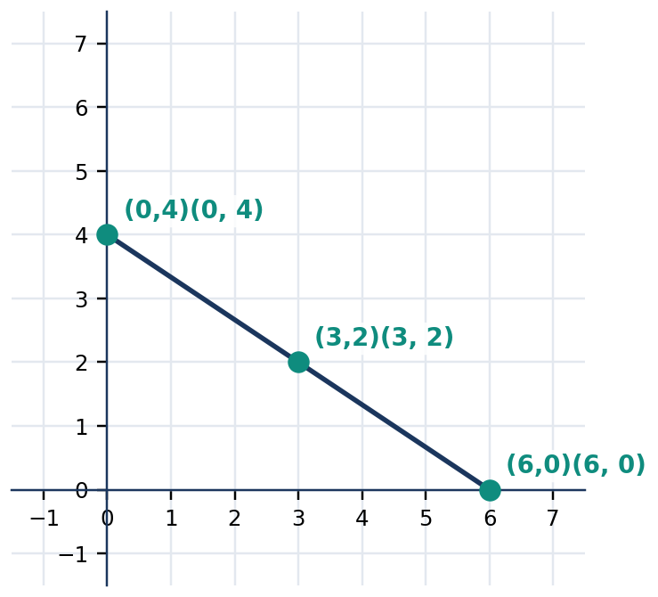
Figure 3.3.5 The tested point (3,2) is on the line 2x + 3y = 12.
💡 WORKED EXAMPLE 2 — Completing a Missing Coordinate
Problem: Find $y$ when $x=−2$ in $3x+2y=8$.
Given: $x=−2$. Find: The corresponding $y$ and ordered pair.
Formula/Rule: $3x+2y=8$.
$3(−2)+2y$ | $= 8$ | substitute x = -2
$−6+2y$ | $= 8$ | multiply
$2y$ | $= 14$ | add 6 to each side
$y$ | $= 7$ | divide both sides by 2

**Final Answer: $y=7$ and the ordered pair is $(−2,7)$.** Check: $3(−2)+2(7)=8$.

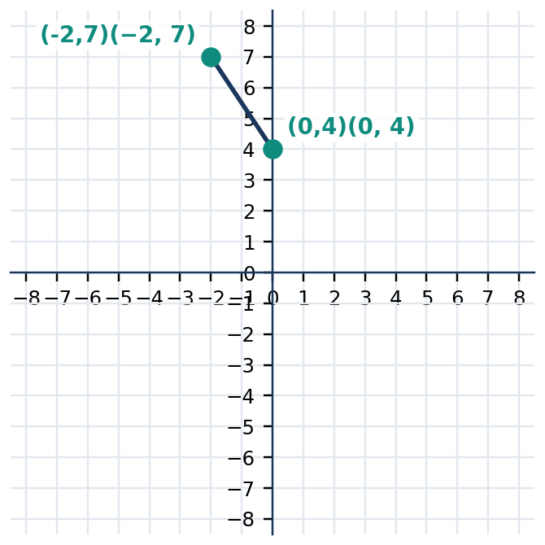
Figure 3.3.6 The pair (−2,7) satisfies the equation 3x + 2y = 8.
💡 WORKED EXAMPLE 3 — Generating a Table
Problem: List four ordered-pair solutions of $y=2x-1$.
Given: The linear rule $y=2x-1$. Find: Four valid solution pairs.
Formula/Rule: Substitute selected values of $x$.
$x$ | $= 0: y = 2(0)-1 = −1$ | substitute zero
$x$ | $= 1: y = 2(1)-1 = 1$ | substitute one
$x$ | $= 2: y = 2(2)-1 = 3$ | substitute two
$x$ | $= 3: y = 2(3)-1 = 5$ | substitute three

**Final Answer: $(0,−1)$, $(1,1)$, $(2,3)$, and $(3,5)$.** All satisfy the same linear rule.

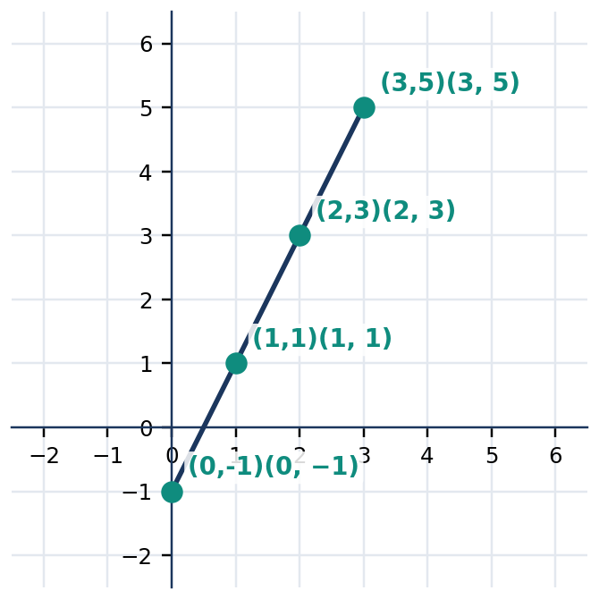
Figure 3.3.7 Four points from the rule y = 2x − 1 lie on a straight line.
💡 WORKED EXAMPLE 4 — School Supply Combinations
Problem: A notebook costs ₱25 and a pen costs ₱10. Find two different whole-number combinations costing ₱100.
Given: $25n+10p=100$, where $n$ and $p$ count notebooks and pens. Find: Two nonnegative integer solutions.
Formula/Rule: Substitute a selected value of $n$ and solve for $p$.
$n$ | $= 0: 25(0)+10p = 100$ | choose zero notebooks
$p$ | $= 10$ | divide by 10
$n$ | $= 2: 25(2)+10p = 100$ | choose two notebooks
$10p$ | $= 50$ | subtract 50
$p$ | $= 5$ | divide by 10

**Final Answer: $(n,p)=(0,10)$ or $(2,5)$.** Both combinations cost ₱100. Other valid pairs may exist.

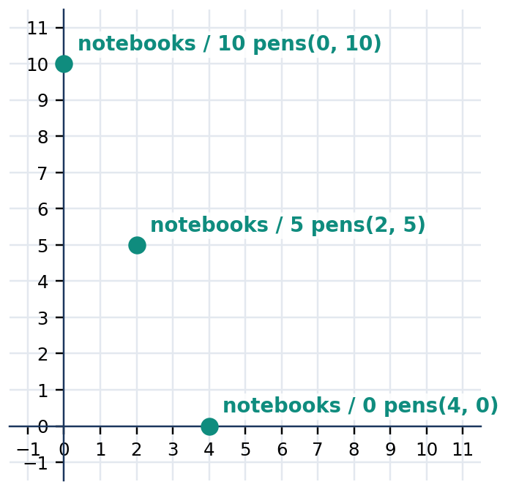
Figure 3.3.8 Integer solutions for purchases of notebooks and pens are discrete points, not fractional purchases.

5. MATHEMATICAL REASONING AND COMMON MISCONCEPTIONS

Reasoning challenge: An equation in two variables may have infinitely many real solutions, yet a purchase problem can have only a few valid combinations. Explain why $25n+10p=100$ permits the algebraic pair $(1,7.5)$ but a store cannot sell 7.5 individually sold pens when only whole pens are allowed. Distinguish an algebraic solution from a contextually valid solution.
WATCH OUT — Incorrect vs Correct Reasoning
Wrong: If $(2,4)$ solves an equation, $(4,2)$ must solve it too. Right: Substitution must be tested in the stated order.
Wrong: A table with four rows proves there are exactly four solutions. Right: A linear equation in two variables generally has infinitely many real solutions.
Wrong: Every point between two valid whole-number purchase combinations is a valid purchase. Right: A continuous line represents real solutions; counts of objects require nonnegative integers.

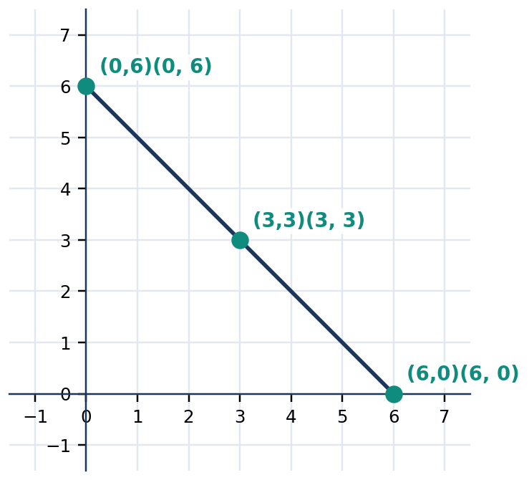
Figure 3.3.9 A real-valued linear model includes all points on its line, not just the three labeled samples.

6. SUBTOPIC 3 — INTERPRETING AND MODELING LINEAR RELATIONSHIPS

In the equation $y=50+12x$, the value $50 represents an initial amount, and each increase of one unit in $x$ adds 12 units to $y$. For example, when $x$ is the number of kilometers traveled, $y$ may represent a transport charge in pesos. The ordered pairs $(0,50)$, $(1,62)$, and $(3,86)$ describe specific amounts. These are points on one line, but their meaning comes from the labels and units assigned to the variables. A model must therefore identify not only its rule but also what each coordinate measures.
A table connects the verbal situation with numerical and graphical representations. If distance cannot be negative, restrict the domain to $x≥0$. If the model describes whole tickets, only nonnegative integer inputs make sense. In a real problem, the graph may therefore be a ray or a set of discrete points rather than an unrestricted infinite line. Explicitly stating constraints avoids misleading interpretations even when an algebraic calculation is correct.
📐 KEY CONCEPT: Variable Meaning and Domain
$$y=mx+b$$
Here $x$ is the independent quantity, $y$ the dependent quantity, $m$ the amount $y$ changes when $x$ increases by one, and $b$ the value of $y$ when $x=0$. This form is used for initial-value-plus-rate models; graphing and determining slope are studied in depth in Lesson 3.4.

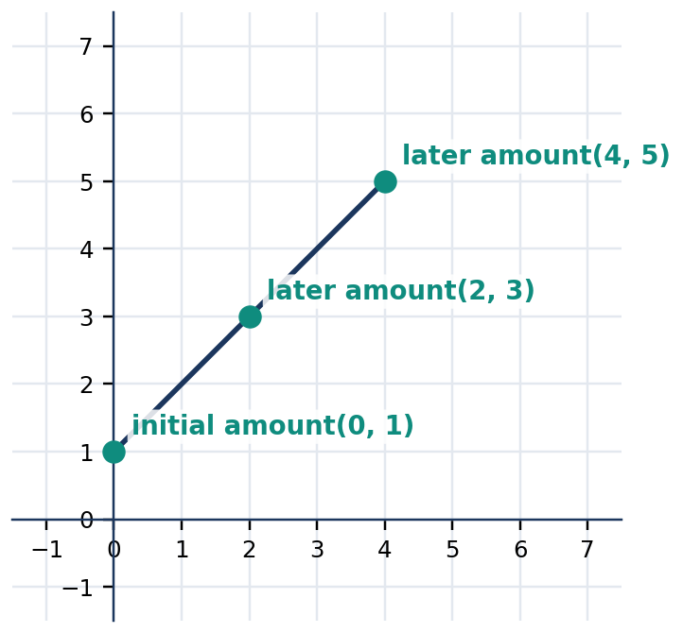
Figure 3.3.10 A line can represent an initial value and a constant rate of change in scaled units.
Modeling step | Mathematical action | Example
Define quantities | State variables and units | $x$: kilometers; $y$: pesos
Express relationship | Write an equation | $y=50+12x$
Generate a solution | Substitute a value | $x=3$ gives $y=86$
Interpret and restrict | Check feasible values | Distance must satisfy $x≥0$

Quick Check 3.3C: 1. In $y=30+5x$, explain the meaning of 30 and 5 for a delivery fee. 2. Is $(−2,20)$ an algebraic solution of this rule? Would negative distance be practical? 3. A vendor sells shirts for ₱180 each. Write a two-variable equation for the number sold and total revenue.
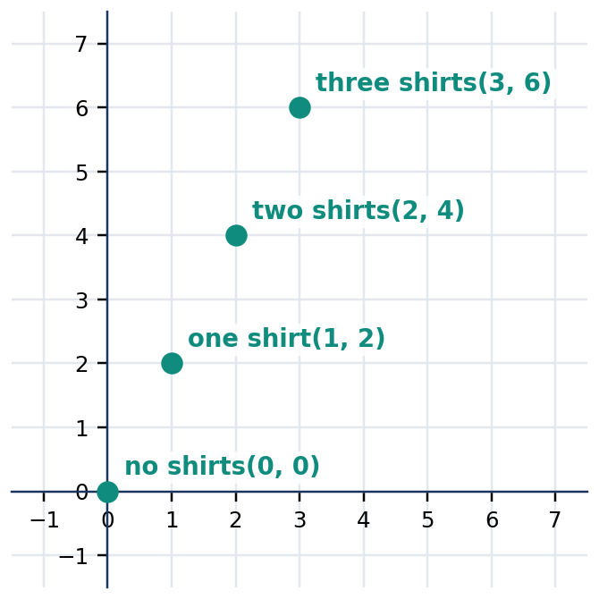
Figure 3.3.11 Scaled vertical coordinates can show increasing revenue; exact monetary values must be stated separately.

7. GUIDED AND INDEPENDENT PRACTICE

Task 3.3.1 — Basic (12 items). For Items 1–6, decide whether the stated pair satisfies the equation. For Items 7–12, complete the missing coordinate.
1. $(1,3)$ in $2x+y=5$ | 2. $(2,1)$ in $x+2y=7$
3. $(0,−2)$ in $3x-y=2$ | 4. $(−1,4)$ in $x+y=3$
5. $(3,2)$ in $2x-y=4$ | 6. $(4,0)$ in $x-y=4$
7. $(2,_)$ in $x+y=9$ | 8. $(_,4)$ in $2x+y=10$
9. $(0,_)$ in $3x-2y=8$ | 10. $(_,1)$ in $x-3y=−2$
11. $(−2,_)$ in $y=2x+5$ | 12. $(_,−3)$ in $y=−x+1$

Task 3.3.2 — Intermediate (6 items). Supply the required solution pairs, test them, and explain your method.
13. Find three pairs for $x+y=6$. | 14. Find three pairs for $2x-y=4$.
15. Rewrite $3x+y=9$ as $y=$ a rule. | 16. Does $(2,1)$ satisfy both $x+y=3$ and $2x-y=3$?
17. Find the $x$- and $y$−coordinates of two distinct points on $y=−x+4$. | 18. Write a linear equation satisfied by both $(0,3)$ and $(2,7)$.

Task 3.3.3 — Challenge (4 items). Justify the model and any restrictions.
19. A snack costs ₱20 and a drink costs ₱15. Write an equation for combinations totaling ₱120 and find three nonnegative whole-number combinations.
20. A trip costs ₱45 initially plus ₱8 per kilometer. Write an equation connecting fare $y$ to distance $x$ and find three realistic pairs.
21. Two numbers total 18. Write an equation and identify four integer ordered pairs where both coordinates are nonnegative.
22. Create two different real-world interpretations of $y=2x+10$. Explain the units and the practical domain of each.
Task 3.3.4 — Analytical matrix
Situation | Required reasoning
$x+3y=12$ | Test $(3,3)$ and $(6,2)$; explain each result.
$y=4x-2$ | Construct a table for $x=−1,0,1,2$.
$2a+5b=20$ | Find two nonnegative integer solutions.
A fixed fee of ₱25 plus ₱6 per kilometer | Define variables; create an equation and three valid pairs.
$x+y=8$ | Explain why the point $(10,−2)$ works algebraically but may not represent two counts of goods.

8. CONTEXTUAL APPLICATION — A SCHOOL FAIR PURCHASE MODEL

A class prepares souvenir packs. Each notebook costs ₱30 and each bookmark costs ₱10. Its supply budget is exactly ₱180. Define $n$ as the number of notebooks and $b$ as the number of bookmarks. Write a linear equation, find at least four valid nonnegative integer ordered pairs, and present the solutions in a table. Plot these points on a coordinate plane and explain why the line between them represents additional real-valued mathematical solutions but not necessarily possible item counts. Scoring (12 points): variable definitions and units (2); correct equation (2); four verified combinations (4); correct labeled graph (2); context explanation (2).
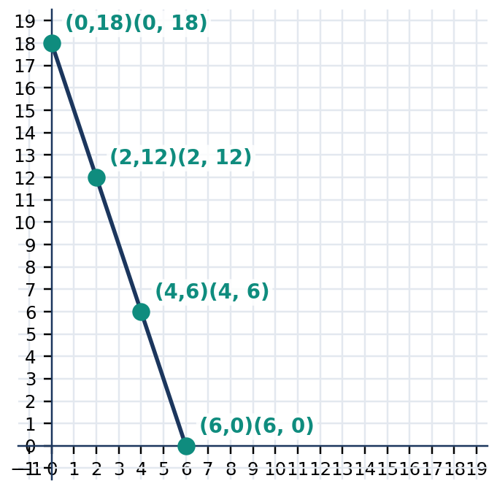
Figure 3.3.12 Four whole-number purchase combinations for 30n + 10b = 180.

9. METACOGNITIVE EXIT TICKET AND LESSON SUMMARY

3–2–1 Exit Ticket: List three different representations of a linear relationship; identify two ways a candidate ordered pair can fail a test; and describe one practical situation where the solution set needs a restriction to whole numbers or nonnegative values.
LESSON SUMMARY: A linear equation in two variables has the form $Ax+By=C$, where $A$ and $B$ are not both zero. Each solution is an ordered pair $(x,y)$ whose substitution makes the equation true. A table lists selected solutions; the full real-number solution set forms a straight line. Models must include appropriate units and contextual restrictions.

10. FORMATIVE ASSESSMENT — 15 ITEMS

Part I: Multiple Choice. Select one answer per question. [ ]
1. Which equation is linear in two variables? [ ] A. $xy=6$ B. $x^{2}+y=6$ C. $2x+3y=6$ D. $1/x+y=6$
2. Does $(2,3)$ satisfy $x+2y=8$? [ ] A. Yes, because $2+2(3)=8$ B. No, because $2+3=5$ C. Yes, because $2(2)+3=7$ D. No, because $2(3)+2=9$
3. If $x=4$ in $x+y=11$, what is $y$? [ ] A. 15 B. 4 C. 11 D. 7
4. Which pair solves $2x-y=5$? [ ] A. $(2,1)$ B. $(3,1)$ C. $(1,3)$ D. $(0,5)$
5. The solution of a linear equation in two variables is represented by a(n) [ ] A. ordered pair B. single coefficient C. inequality symbol D. exponent
6. For $y=3x+2$, what is $y$ when $x=−1$? [ ] A. 5 B. $−5$ C. $−1$ D. 1
7. Which equation describes the total ₱$t$ paid for $n$ tickets at ₱40 each? [ ] A. $n=40t$ B. $t=40+n$ C. $t=40n$ D. $t=n/40$
8. Why does $x+y=6$ have infinitely many real solutions? [ ] A. It contains no unknowns B. Each real $x$ gives a corresponding $y$ C. Every ordered pair works D. It cannot be graphed
9. Which pair is NOT a solution of $y=2x+1$? [ ] A. $(0,1)$ B. $(1,3)$ C. $(2,5)$ D. $(3,6)$
10. In a problem counting individual notebooks, which restriction is appropriate? [ ] A. Quantity must be any negative integer B. Quantity must be any real number C. Quantity must be a nonnegative integer D. Quantity must be a decimal between zero and one
Part II: Open Analytical / Calculation Items. Show calculations, explain your reasoning, and include units when needed.
11. Determine whether $(3,4)$ and $(4,3)$ are solutions of $2x+y=10$. Show both substitutions and explain why order matters.
12. Find four ordered-pair solutions of $y=5-2x$ and organize them in a table of values.
13. A student buys ₱20 notebooks and ₱5 pencils with a total of ₱100. Write an equation and find three nonnegative whole-number solutions, verifying each.
14. Explain why the equation $x+y=9$ has infinitely many real solutions but may have only ten nonnegative whole-number ordered-pair solutions. List the ten pairs or explain a counting method that gives ten.
15. A learner claims $(5,0)$ is the only solution of $x+2y=5$. Evaluate the claim, give two counterexamples, and describe what the entire real-number solution set looks like.

LESSON 3.4 — GRAPHING LINEAR EQUATIONS

Mathematics 8 • Quarter 3 | Domain: Number and Algebra (NA)
Curriculum alignment: Grade 8 Quarter 3 learning competencies 7 (define and determine the slope and intercepts of a line) and 9 (sketch the graph of a linear equation given two points, its intercepts, or its slope and a point). Competency 6, ordered-pair solutions, is prerequisite. These are official sequence numbers, not invented alphanumeric codes.
Essential questions: (1) How does slope quantify direction and steepness? (2) How do intercepts and ordered pairs determine a unique straight line? (3) How do different graphing methods represent the same mathematical relationship, and how can their accuracy be checked?
🎥 INTERACTIVE MULTIMEDIA: Coordinate Graphs and Linear Relationships
Channel: Khan Academy. Direct video: https://www.youtube.com/watch?v=unSBFwK881s
Concepts to observe: variables as quantities, relationships between quantities, and algebraic representations useful for later coordinate plotting. Viewing questions: 1. What quantities vary? 2. How can a set of ordered pairs help visualize an equation? 3. What does a graph show that an isolated numerical answer cannot show?

A linear equation in two variables is represented graphically by a straight line consisting of all the ordered pairs that satisfy it. In Lesson 3.3, a table of values was used to construct valid ordered pairs. This lesson extends that reasoning into a coordinate graph, where horizontal displacement measures change in $x$ and vertical displacement measures change in $y$. The graph reveals features that are difficult to see from a single table entry: whether a line rises or falls, where it meets the axes, and how rapidly one quantity changes in relation to another. Three methods will be developed: plotting two points, using intercepts, and starting from a point with a known slope. Every method must produce the same line for an equivalent equation. Accuracy requires consistent scales, correct ordered-pair placement, and a straightedge when drawing by hand. The lesson also examines horizontal and vertical lines and identifies why a vertical line has undefined slope.

2. SUBTOPIC 1 — SLOPE AS RATE OF CHANGE

The slope of a nonvertical line measures the ratio of vertical change to horizontal change between any two distinct points on that line. If the coordinates are $(x_{1},y_{1})$ and $(x_{2},y_{2})$, subtract the $y$-coordinates in the same order as the $x$-coordinates. A positive slope means the line rises from left to right; a negative slope means it falls. A slope of zero indicates a horizontal line. A vertical line has no defined slope because its horizontal change is zero, and division by zero is undefined.
📐 KEY CONCEPT: Slope of a Nonvertical Line
$$m=\frac{y_{2}-y_{1}}{x_{2}-x_{1}}, x_{2}≠ x_{1}$$
$m$ = slope (vertical units per horizontal unit); $(x_{1},y_{1})$ and $(x_{2},y_{2})$ = distinct points. For a horizontal line $y=k$, $m=0$; for a vertical line $x=k$, slope is undefined.

The slope of a straight line is constant: selecting two different pairs of its points yields the same ratio, provided the pairs are ordered consistently. This follows because right triangles drawn along a line share the same acute angle and have proportional corresponding sides. When the coordinates refer to physical quantities, slope has units. For example, in a graph of accumulated savings in pesos against time in weeks, slope is pesos per week, not simply pesos.
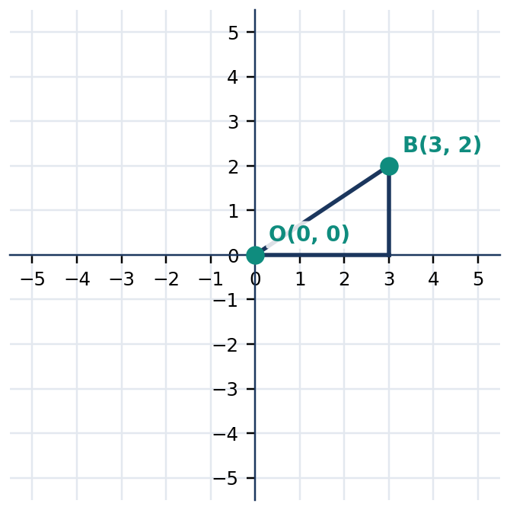
Figure 3.4.1 Figure 3.4.1. The slope triangle shows a rise of 2 for a run of 3, so the slope is 2/3.
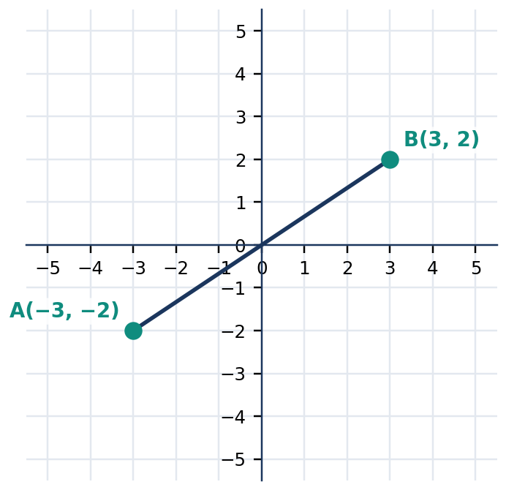
Figure 3.4.2 Figure 3.4.2. Positive slope: the line rises as x increases.
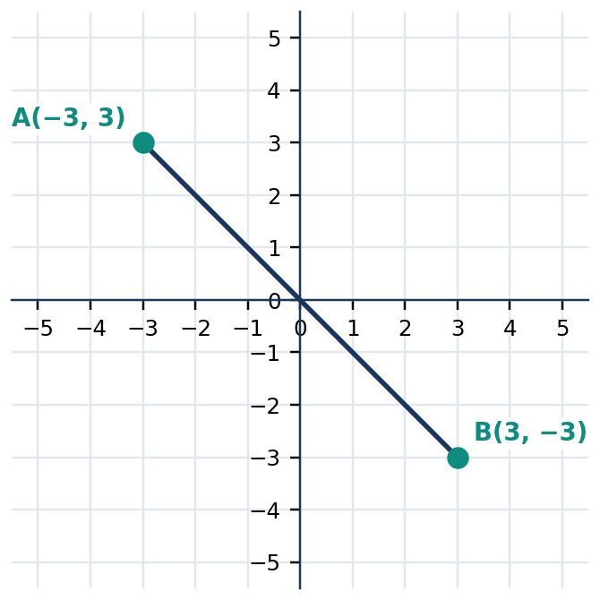
Figure 3.4.3 Figure 3.4.3. Negative slope: the line falls as x increases.
Line feature | Algebraic test | Visual meaning
Positive slope | $m>0$ | Rising from left to right
Negative slope | $m<0$ | Falling from left to right
Zero slope | $y=k$ | Horizontal line
Undefined slope | $x=k$ | Vertical line; run equals zero

Quick Check 3.4A. (1) Determine the slope through $(1,2)$ and $(4,8)$. (2) What is the slope of $y=−3$? (3) Explain why the line $x=4$ has undefined slope instead of slope zero.

3. SUBTOPIC 2 — INTERCEPTS AND THE GRAPH OF A LINE

The **$x$-intercept** is where a graph meets the horizontal axis; its $y$-coordinate is zero. The **$y$-intercept** is where a graph meets the vertical axis; its $x$-coordinate is zero. For a line in standard form $Ax+By=C$, find the $x$-intercept by substituting $y=0$, and find the $y$-intercept by substituting $x=0$, provided these intercepts exist. Once two distinct points have been located, draw the unique straight line through them and extend it in both directions.
📐 KEY CONCEPT: Axis Intercepts
$$x-intercept: set y=0; y-intercept: set x=0.$$
For $Ax+By=C$ with $A≠0$ and $B≠0$, the intercept points are $(C/A,0)$ and $(0,C/B)$ respectively. An intercept is a point, not only a coordinate value.

The intercept method is efficient when intercepts are whole numbers, but it requires special attention when both intercepts coincide at the origin. The equation $2x-3y=0$, for example, has both intercepts at $(0,0)$. One point alone does not determine a unique line; obtain another solution such as $(3,2)$. Horizontal lines typically lack an $x$-intercept unless they are the $x$-axis; vertical lines typically lack a $y$-intercept unless they are the $y$-axis. Therefore, intercepts are powerful but not universally sufficient without checking the geometry.
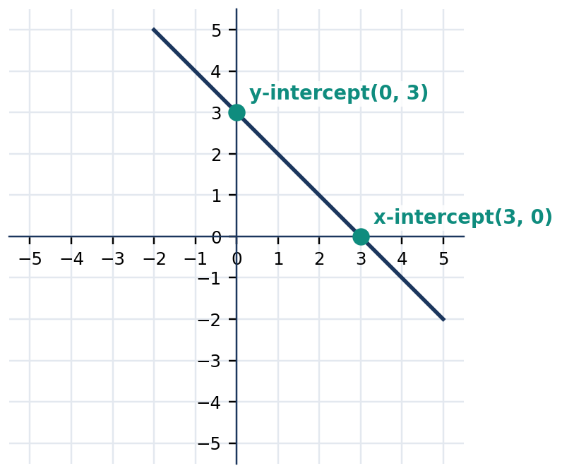
Figure 3.4.4 Figure 3.4.4. The line x + y = 3 crosses the axes at (3,0) and (0,3).
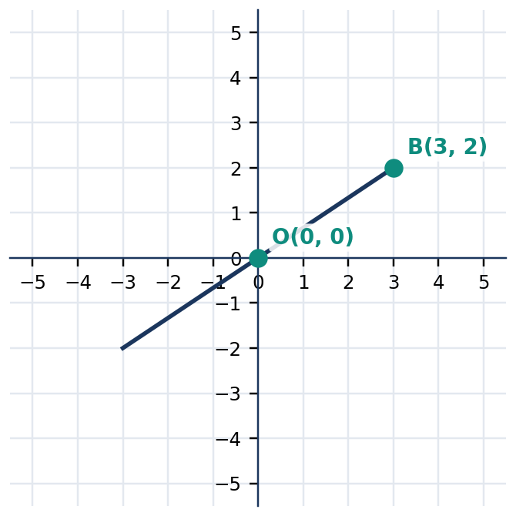
Figure 3.4.5 Figure 3.4.5. A line through the origin needs a second distinct point to determine its direction.
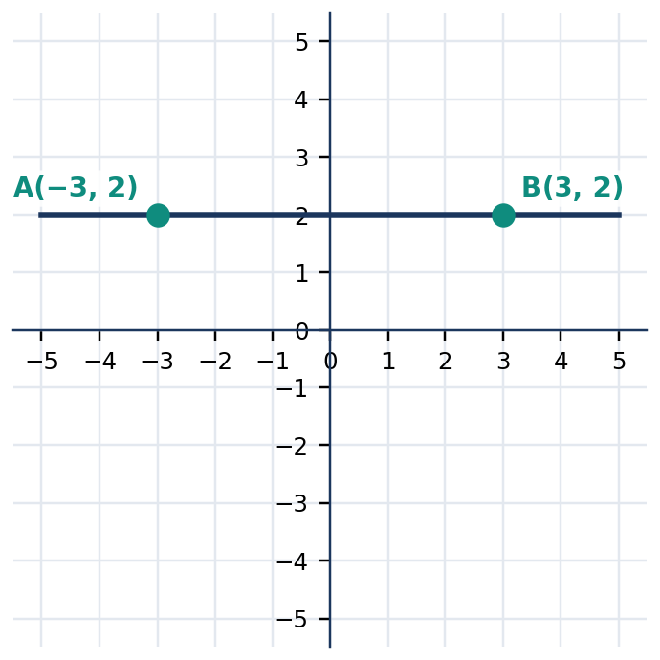
Figure 3.4.6 Figure 3.4.6. The horizontal line y = 2 has slope 0 and y-intercept (0,2).
Equation | $x$-intercept | $y$-intercept | Special observation
$2x+y=6$ | $(3,0)$ | $(0,6)$ | Two distinct intercepts
$x+y=0$ | $(0,0)$ | $(0,0)$ | Obtain another point
$y=2$ | None | $(0,2)$ | Horizontal
$x=−3$ | $(−3,0)$ | None | Vertical

Quick Check 3.4B. (1) Find the intercepts of $3x+2y=12$. (2) Why cannot you graph $x-y=0$ using only its intercepts? (3) State the slope and the existing intercept of $x=−2$.

4. CORE ANCHOR — FOUR FULLY WORKED EXAMPLES

💡 WORKED EXAMPLE 1: Slope from Two Points
Problem: Determine the slope of the line through $A(−2,1)$ and $B(4,4)$.
Given: $A(−2,1)$ and $B(4,4)$. Find: Slope $m$. Formula/Rule: $m=(y_{2}-y_{1})/(x_{2}-x_{1})$.
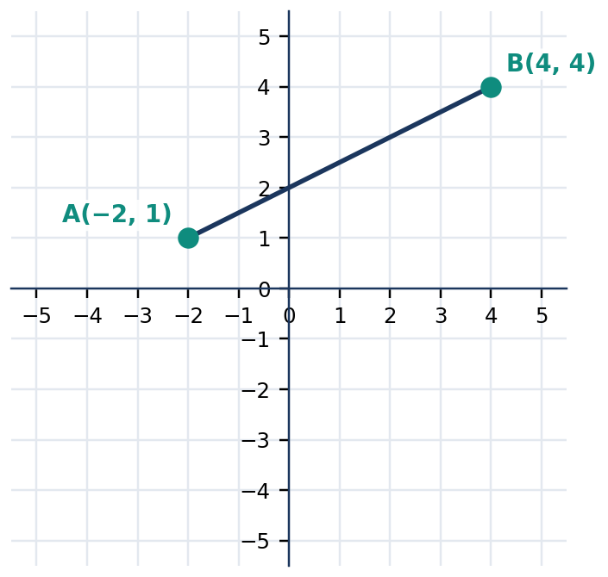
Figure 3.4.7 Figure 3.4.7. The line rises 3 units while running 6 units to the right.
$m$ | $= (4-1)/(4-(−2))$ | subtract y and x coordinates in the same order
 | $= 3/6$ | calculate rise and run
 | $= 1/2$ | simplify the fraction

Final answer: **$m=\frac{1}{2}$**; each 2-unit increase in $x$ accompanies a 1-unit increase in $y$. Check: Reversing point order gives $(1-4)/(−2-4)=(−3)/(−6)=1/2$.

💡 WORKED EXAMPLE 2: Graph Using a Table
Problem: Graph $y=−x+2$ using two or more ordered pairs.
Given: $y=−x+2$. Find: Its straight-line graph. Formula/Rule: Substitute chosen $x$-values into $y=−x+2$.
$x$ | Substitution | $y$ | Point
$0 | $y=−0+2$ | $2 | $(0,2)$
$2 | $y=−2+2$ | $0 | $(2,0)$
$−2$ | $y=−(−2)+2$ | $4 | $(−2,4)$

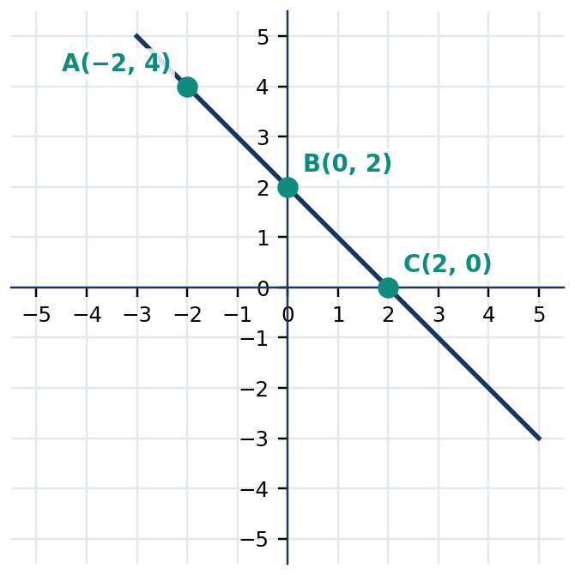
Figure 3.4.8 Figure 3.4.8. Three valid ordered pairs lie on y = −x + 2, confirming a straight line.
$y$ | $= −(0)+2 = 2$ | obtain the first point
$y$ | $= −(2)+2 = 0$ | obtain the second point
$y$ | $= −(−2)+2 = 4$ | check with a third point

Final answer: **Draw the line through $(−2,4)$, $(0,2)$, and $(2,0)$. Check:** Every listed pair satisfies the original equation.

💡 WORKED EXAMPLE 3: Graph by Intercepts
Problem: Graph $2x+3y=12$.
Given: $2x+3y=12$. Find: Its intercepts and graph. Formula/Rule: Substitute $y=0$ and $x=0$.
$2x + 3(0)$ | $= 12$ | set y = 0 to find the x-intercept
$2x$ | $= 12$ | simplify
$x$ | $= 6$ | divide by 2
$2(0) + 3y$ | $= 12$ | set x = 0 to find the y-intercept
$y$ | $= 4$ | divide by 3

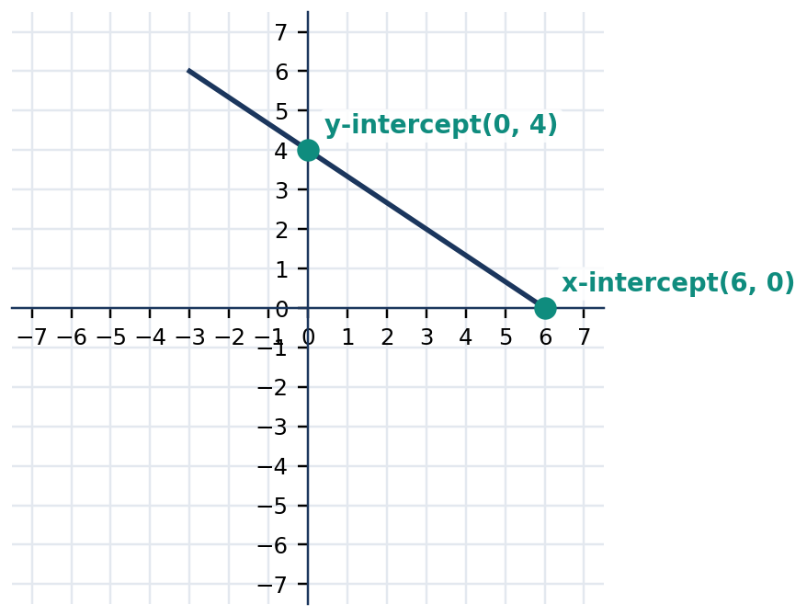
Figure 3.4.9 Figure 3.4.9. The line passes through (6,0) and (0,4); slope is −2/3.
Final answer: **The intercepts are $(6,0)$ and $(0,4)$; connect these points and extend the straight line. Check:** $2(6)+3(0)=12$ and $2(0)+3(4)=12$.

💡 WORKED EXAMPLE 4: Graph from a Point and Slope
Problem: Graph the line through $(1,−2)$ with slope $3/2.
Given: Point $(1,−2)$; $m=3/2$. Find: Two points and the line. Formula/Rule: $m=rise/run$.
$m$ | $= 3/2$ | interpret slope as rise 3 and run 2
$x_{2}$ | $= 1+2 = 3$ | move 2 units right
$y_{2}$ | $= −2+3 = 1$ | move 3 units upward

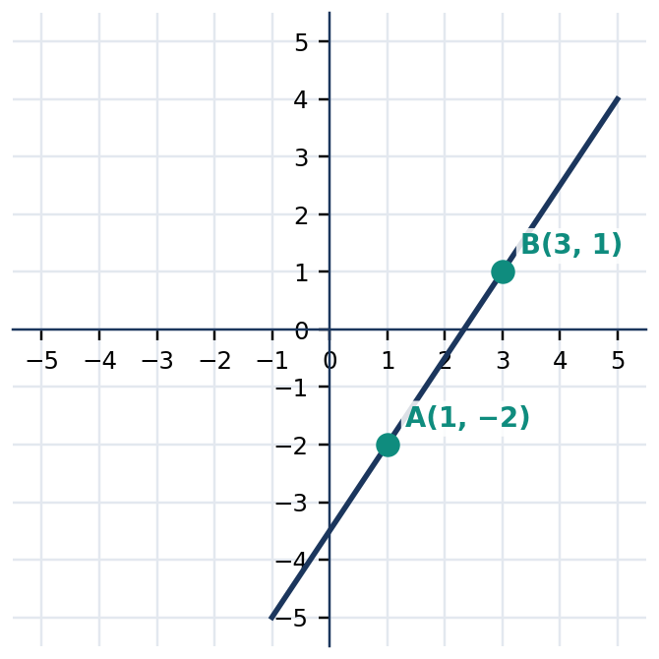
Figure 3.4.10 Figure 3.4.10. Starting at (1,−2), run 2 and rise 3 to locate (3,1).
Final answer: **Plot $(1,−2)$ and $(3,1)$, then draw the straight line through them. Check:** $(1-(−2))/(3-1)=3/2$.

5. MATHEMATICAL REASONING AND COMMON MISCONCEPTIONS

Reasoning challenge. A learner claims the line through $(1,2)$ and $(3,6)$ has slope $4/(−2)=−2$ because the learner subtracted the $y$-coordinates in one order and the $x$-coordinates in reverse order. Explain the mismatch and calculate the correct slope. Then write the correct slope using the opposite order for both differences. A second learner says every line crosses both axes. Use a horizontal or vertical line to disprove that claim.
WATCH OUT: Wrong → Right
Wrong: $m=(6-2)/(1-3)=−2$ for points $(1,2)$ and $(3,6)$. Right: $m=(6-2)/(3-1)=2$ because coordinate subtraction must have consistent order.
Wrong: A vertical line has slope $0. Right: A vertical line has undefined slope; a horizontal line has slope $0.
Wrong: The $x$-intercept of $2x+y=6$ is $x=3$ only. Right: The intercept point is $(3,0)$.
Wrong: A line is reliably determined by plotting a single point. Right: Two distinct points determine a unique line.

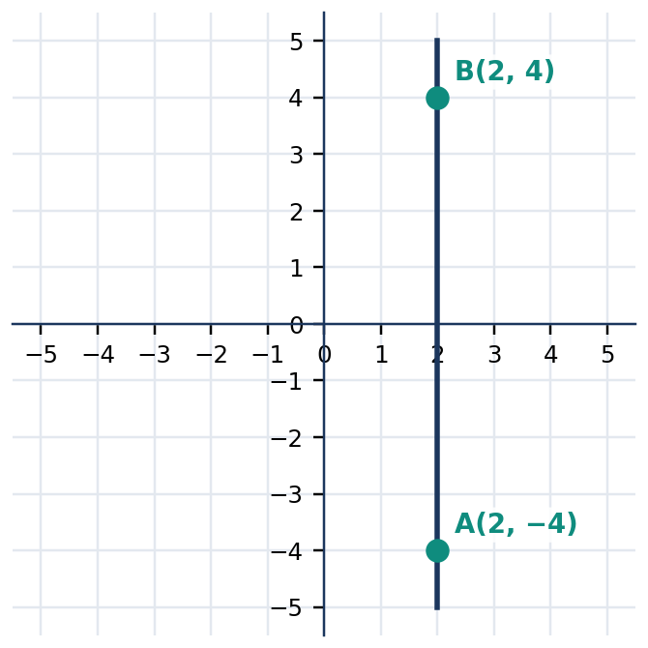
Figure 3.4.11 Figure 3.4.11. The vertical line x = 2 has undefined slope, since its run equals zero.

6. SUBTOPIC 3 — CHOOSING AND CHECKING GRAPHING METHODS

Choose a method based on the information supplied. Two-point graphing is appropriate when two distinct solutions are known. Intercept graphing is efficient when the equation makes its intercepts easy to calculate. Slope-and-point graphing uses a given point, then constructs a second point by the rise/run ratio. In each case, the result is a complete straight line, not merely a segment joining two plotted points. The graph continues beyond the displayed region, although axes scales restrict what is visible on the page.
A reliable graphing check uses algebra and geometry together. Substitute plotted coordinates into the original equation; inspect whether the graph rises or falls in the direction predicted by slope; and verify the plotted axis crossings. A coordinate scale may use increments greater than one when the numbers are large, but intervals must be equally spaced along each axis. Unequal units between the $x$- and $y$-axes are permitted if clearly labeled, although they can change the apparent angle of inclination. Slope is computed from coordinate values, not visual steepness alone.
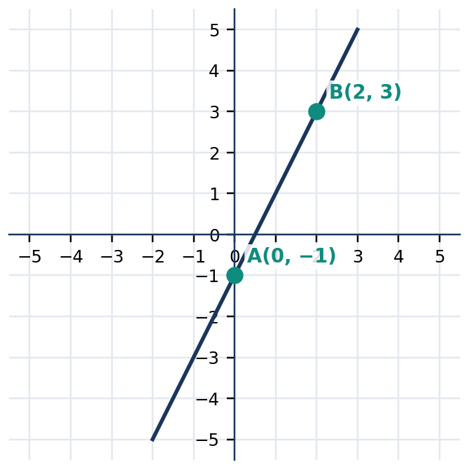
Figure 3.4.12 Figure 3.4.12. A line with slope 2 can be constructed from the point (0,−1) using rise 2, run 1.
Given information | Recommended method | Verification
Two distinct ordered pairs | Plot two points | Both pairs satisfy the equation
Noncoincident axis intercepts | Graph by intercepts | Substitute $x=0$ and $y=0$
Slope and one point | Rise/run construction | Recompute slope from plotted pair
Equation in $y=mx+b$ form | Begin at $(0,b)$, use $m$ | Check intercept and another point
Horizontal or vertical equation | Constant $y$ or constant $x$ | Ensure slope classification is correct

Quick Check 3.4C. (1) Which method would you use for $4x+2y=8$? Explain. (2) Plot a second point on a line through $(0,1)$ with slope $−2$. (3) Give a reason why a graph with correctly located points can still be misleading if axis tick spacing is inconsistent.

7. GUIDED AND INDEPENDENT PRACTICE

Task 3.4.1: Graded Exercises (22 items). Show the slope calculations or tables required, and draw a clearly labeled coordinate graph whenever requested.
Basic — Items 1–12
1. Find m through (0,0) and (2,4). | 2. Find m through (1,3) and (4,3).
3. Find m through (−2,−1) and (2,3). | 4. Find m through (0,5) and (5,0).
5. Find m through (2,−4) and (2,3). | 6. Find the y-intercept of y=3x-2.
7. Find the x-intercept of x+2y=8. | 8. Find both intercepts of 2x+y=10.
9. Find both intercepts of 3x-2y=6. | 10. State the slope of y=−4.
11. State the slope of x=3. | 12. Plot (0,1) and (2,5); draw their line.

Intermediate — Items 13–18
13. Graph y=2x+1 using three points. | 14. Graph y=−x-2 using two intercepts or a table.
15. Graph 3x+y=6 using intercepts. | 16. Graph 2x-3y=0 using the origin and another point.
17. Graph the line through (−1,1) with m=−2. | 18. Graph the line through (2,−2) with m=1/2.

Challenge / Word Problems — Items 19–22
19. A learner begins with ₱80 and saves ₱30 each week. Graph total savings against weeks $0 to $5, then identify the slope and $y$-intercept with units.
20. A water tank contains 120 L and drains at a constant rate of 15 L per minute. Graph remaining water for $0≤ t≤ 8$ and explain both intercepts.
21. Two points are $(1,4)$ and $(5,−2)$. Determine the slope and describe why the line cannot be horizontal. Graph the line and check one additional point on it.
22. The line $x+y=0$ has both intercepts at the origin. Explain why this gives insufficient graphing information and find a second point to determine the graph.
Task 3.4.2: Analytical Matrix. Complete the missing entries and justify your graphing choices.
Equation or data | Slope | $x$-intercept | $y$-intercept | Recommended approach
$y=2x+4$ | __ | __ | __ | __
$x+3y=6$ | __ | __ | __ | __
$y=−3$ | __ | __ | __ | __
$x=4$ | __ | __ | __ | __
Points $(−2,0),(0,4)$ | __ | __ | __ | __

8. CONTEXTUAL APPLICATION — TRANSPORT FARE GRAPH

A local transport service charges a fixed ₱25 booking fee plus ₱12 for each kilometer traveled. Let $d$ be distance in kilometers and $F$ be the total fare in pesos. Goal: Develop a table for $d=0,1,2,3,4,5$, write the equation, and graph $F$ against $d$. Label each axis with units, identify the slope and vertical intercept, and explain their meanings. The modeled distance should satisfy $d≥0$; a negative distance is not meaningful in this situation. Focused scoring (10 points): correct model (2), complete and accurate table (2), correctly scaled graph (3), slope/intercept meanings (2), contextual restriction (1).

9. METACOGNITIVE 3–2–1 EXIT TICKET AND LESSON SUMMARY

Record three graphing ideas you can use correctly, two mistakes you will actively check for, and one real-life relationship whose graph has a meaningful slope. Compare your notes with a partner, then revise any interpretation that confuses a coordinate value with an intercept point.
LESSON SUMMARY: A linear equation in two variables graphs as a straight line. Slope is a consistent ratio of vertical to horizontal change for nonvertical lines. Axis intercepts are ordered pairs with one coordinate zero. Two distinct points, two distinct intercepts, or one point and slope can determine a line. Always verify plotted points by substitution and interpret slope and intercepts with appropriate units and domain restrictions.

10. FORMATIVE ASSESSMENT — 15 ITEMS

Part I: Multiple Choice. Choose the best answer. Record a single answer for every item.
Item | Question and options
1 | What is the slope through $(1,1)$ and $(3,5)$? [ ] A. $1/2 B. $2 C. $−2$ D. $4
2 | The $y$-intercept of $y=−4x+7$ is: [ ] A. $(0,7)$ B. $(7,0)$ C. $(0,−4)$ D. $(−4,0)$
3 | The slope of $y=5$ is: [ ] A. undefined B. $5 C. $−5$ D. $0
4 | What is the $x$-intercept of $2x+y=8$? [ ] A. $(0,8)$ B. $(8,0)$ C. $(4,0)$ D. $(0,4)$
5 | Which pair of points lies on $y=−x+3$? [ ] A. $(0,3)$ and $(3,0)$ B. $(0,−3)$ and $(3,0)$ C. $(1,3)$ and $(2,1)$ D. $(0,3)$ and $(3,3)$
6 | A line through $(0,−2)$ has slope $3. Which second point is on it? [ ] A. $(1,−5)$ B. $(2,1)$ C. $(1,1)$ D. $(−1,1)$
7 | A vertical line has undefined slope because: [ ] A. its rise is zero B. its run is zero C. all points are the origin D. $y$ is constant
8 | Which equation has intercepts $(6,0)$ and $(0,3)$? [ ] A. $x+y=6$ B. $3x+6y=12$ C. $2x+y=6$ D. $x+2y=6$
9 | Slope $−1/2$ describes a line that: [ ] A. falls 1 unit as $x$ increases 2 units B. rises 1 as $x$ increases 2 C. is vertical D. is horizontal
10 | To graph $x-y=0$ using two points, which pair works? [ ] A. $(0,0)$ and $(0,3)$ B. $(0,0)$ and $(2,2)$ C. $(1,0)$ and $(0,1)$ D. $(2,0)$ and $(0,2)$

Part II: Open Analytical and Calculation Items. Show complete solutions and explanations.
11. Find the slope between $A(−3,2)$ and $B(3,−4)$. Explain why changing the subtraction order for only one coordinate difference creates an incorrect answer.
12. Find and graph both intercepts of $3x+2y=12$. Check both points by substitution.
13. The line passes through $(−1,2)$ with slope $−3$. Determine a second point using rise/run and sketch the line.
14. A water tank has 80 L and drains by 10 L every minute. Write the relationship between remaining volume and time, graph it for physically possible nonnegative values, and explain slope and intercepts with units.
15. A learner says $x=4$ has slope $0 and $y$-intercept $(0,4)$. Diagnose both errors and describe the correct graph.

LESSON 3.5 — WRITING EQUATIONS OF LINES

Mathematics 8 • Quarter 3 | Domain: Number and Algebra (NA)
Curriculum alignment (Grade 8, Quarter 3, Competency 8): Find the equation of a line given (a) two points; (b) slope and a point; (c) slope and y-intercept; or (d) x- and y-intercepts. This lesson also consolidates Competencies 7 and 9 on slope, intercepts, and sketching lines.
Essential questions: (1) What information uniquely determines a line? (2) How do slope-intercept, point-slope, and standard forms encode the same geometric relationship? (3) How can an equation be tested against its given points and contextual units?
🎥 INTERACTIVE MULTIMEDIA: Forms of Linear Equations
Channel: Khan Academy (Algebra)
Direct link: https://www.youtube.com/watch?v=NybHckSEQBI
Concept focus: Algebraic representations of variable relationships; equality and equivalent expressions; translating a rule into an equation.
Viewing questions: Which quantities are constants? How does an equation encode a relationship? What check would confirm that an equation fits two measured points?

A straight line can be described through an equation connecting the coordinates of every point on it. In Lesson 3.4, equations were used to construct graphs. This lesson reverses that process: given geometric information, determine an equation. The data might be the slope and a point, two distinct points, or the locations where a line crosses both axes. The ability to reverse between graph and equation is central to modeling transport fares, savings, consumption, and other relationships with a constant rate of change.
The central test is substitution. If a proposed line passes through $(a,b)$, replacing $x$ with $a$ and $y$ with $b$ must produce a true equality. For a line determined by two points, check both points, not just one. Finally, distinguish a line extending forever in both directions from the restricted interval relevant to a real-life situation.

2. SUBTOPIC 3.5.1 — SLOPE AND Y-INTERCEPT

The slope is the constant change in $y$ per unit change in $x$. For two distinct points $(x_{1},y_{1})$ and $(x_{2},y_{2})$ with $x_{1}≠ x_{2}$, the slope is the ratio of vertical change to horizontal change. Positive slope rises from left to right; negative slope falls. A horizontal line has zero slope, whereas the slope of a vertical line is undefined. Slope is not the same as the y-intercept: they encode different information.
📐 KEY CONCEPT — Slope-Intercept Form
$$y=mx+b$$
Here $m$ is the slope (change in $y$ divided by change in $x$), $b$ is the y-coordinate of the intercept $(0,b)$, and $(x,y)$ is any point on the line. When coordinates are measured in units, the slope has units of y-units per x-unit.

Given a slope and a y-intercept, substitute directly into the formula. The resulting equation can be tested using the intercept and a second point obtained by following the slope. For example, slope $2 means a rise of two units for each run of one. Starting at $(0,1)$ gives $(1,3)$, so the equation is $y=2x+1$. A line with slope $−1$ through the same intercept is different: it falls as $x$ increases.
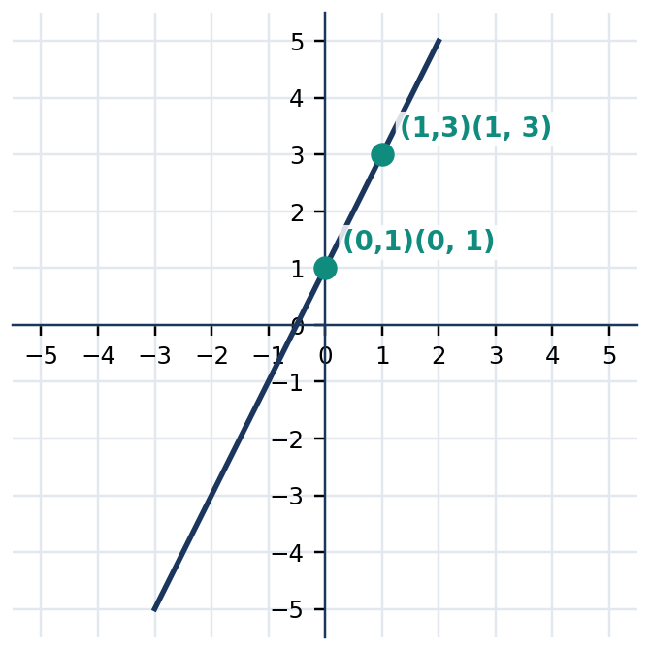
Figure 3.5.1 Figure 3.5.1. A line through (0,1) and (1,3) has slope 2 and equation y=2x+1.
Figure 3.5.2 Figure 3.5.2. The line y=−x+3 crosses the axes at (0,3) and (3,0).
Known information | Mathematical expression | Check
Slope 3, y-intercept -2 | $y=3x-2$ | $(0,−2)$ satisfies it
Slope -2, y-intercept 4 | $y=−2x+4$ | $(1,2)$ satisfies it
Slope 0, y-intercept 5 | $y=5$ | Every point has y-coordinate 5
Slope 1/2, y-intercept -1 | $y=\frac{1}{2}x-1$ | $(2,0)$ satisfies it

Quick Check 3.5A: (1) Write the equation with slope $4 and y-intercept $−3$. (2) Does $(2,3)$ satisfy $y=2x-1$? (3) Explain the difference between $y=−4$ and $x=−4$.

3. SUBTOPIC 3.5.2 — POINT-SLOPE FORM AND TWO POINTS

A slope and a single point determine a unique nonvertical line. Use point-slope form when the given point is not necessarily on the y-axis. It comes from the slope ratio: the change in $y$ from the known point is the slope multiplied by the change in $x$. Rearrange the resulting expression only after checking that the given point and numerical slope were substituted correctly.
📐 KEY CONCEPT — Point-Slope Form
$$y-y_{1}=m(x-x_{1})$$
Here $(x_{1},y_{1})$ is a known point, $m$ is the slope, and $(x,y)$ represents any point on the line. For two distinct points, calculate:
$$m=\frac{y_{2}-y_{1}}{x_{2}-x_{1}} (x_{2}≠ x_{1})$$

A particularly useful property is that either of the two known points may serve as $(x_{1},y_{1})$; both lead to equivalent equations. For instance, the points $(1,2)$ and $(3,6)$ give slope $2. Using $(1,2)$ gives $y-2=2(x-1)$; using $(3,6)$ gives $y-6=2(x-3)$. Both simplify to $y=2x$. The equation is not a new line merely because its algebraic appearance has changed.
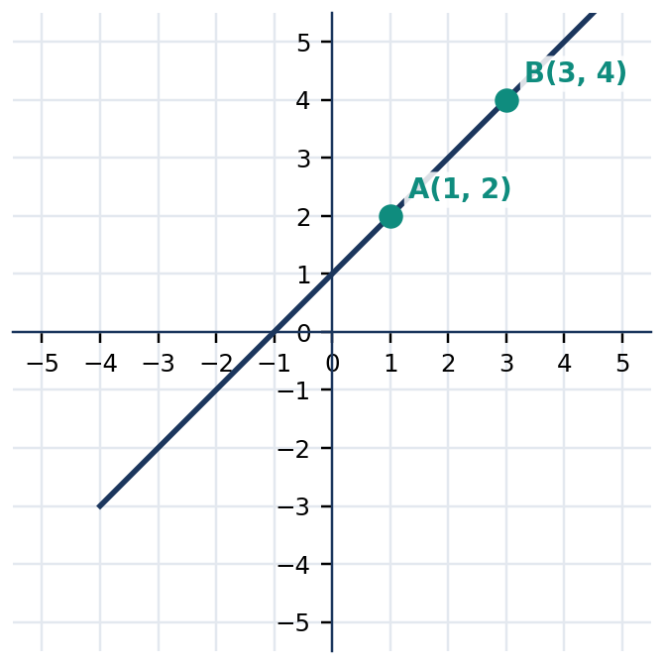
Figure 3.5.3 Figure 3.5.3. Two given points determine a slope of 1 and the line y=x+1.
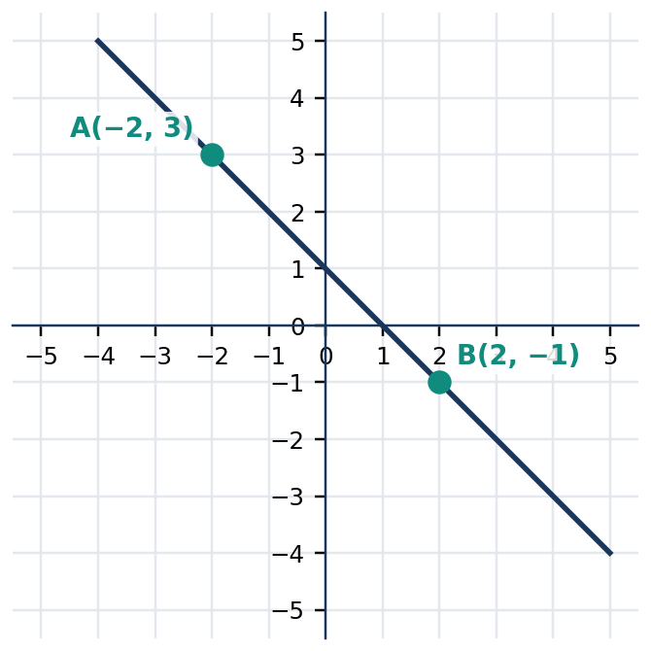
Figure 3.5.4 Figure 3.5.4. A negative slope can be computed in either point order.
Data | First step | Result
Slope $3, point $(2,1)$ | $y-1=3(x-2)$ | $y=3x-5$
Points $(0,2),(2,6)$ | $m=(6-2)/(2-0)=2$ | $y=2x+2$
Points $(1,4),(3,4)$ | $m=0$ | $y=4$
Points $(2,−1),(2,3)$ | Same x-coordinate | $x=2$

Quick Check 3.5B: (1) Find the slope between $(2,5)$ and $(4,9)$. (2) Write a point-slope equation through $(−1,4)$ with slope $3. (3) What equation passes through $(3,1)$ and $(3,6)$?

4. CORE ANCHOR — FOUR FULLY WORKED EXAMPLES

💡 Worked Example 1 — Slope and Y-Intercept
Problem: Write the equation of the line with slope $−2$ and y-intercept $5.
Given: $m=−2$, $b=5$.
Find: An equation of the line.
Formula: $y=mx+b$
$y$ | $= (−2)x+5$ | substitute the given slope and intercept
 | $= −2x+5$ | simplify the coefficient

Final Answer: **$y=−2x+5$**. Check: $(0,5)$ satisfies the equation and each increase of 1 in $x$ decreases $y$ by 2.

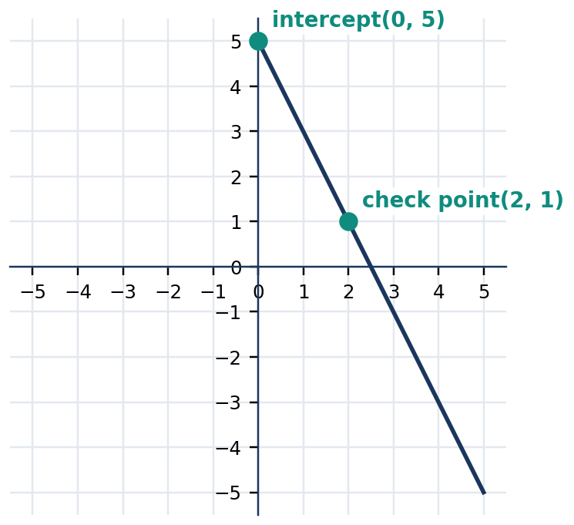
Figure 3.5.5 Figure 3.5.5. Slope −2 from the y-intercept (0,5) to (2,1).
💡 Worked Example 2 — Slope and a Point
Problem: Find the equation through $(2,−1)$ with slope $3.
Given: $(x_{1},y_{1})=(2,−1)$ and $m=3$.
Find: An equation in slope-intercept form.
Formula: $y-y_{1}=m(x-x_{1})$
$y-(−1)$ | $= 3(x-2)$ | substitute the slope and point
$y+1$ | $= 3x-6$ | distribute
$y$ | $= 3x-7$ | subtract 1 from both sides

Final Answer: **$y=3x-7$**. Check: $3(2)-7=−1$.

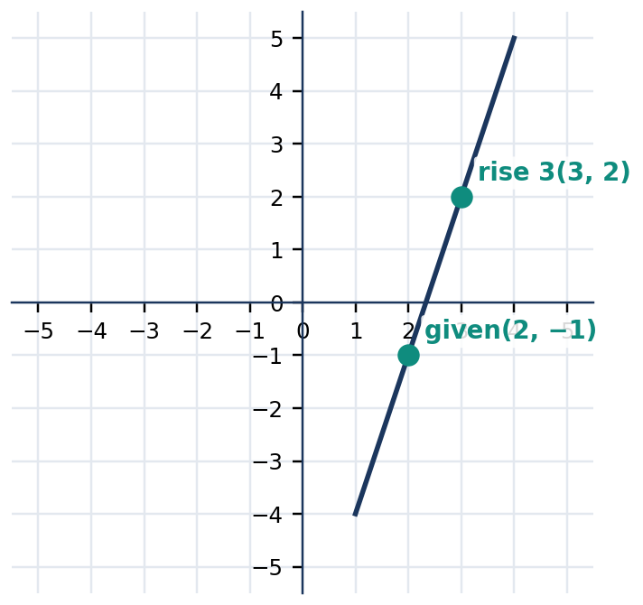
Figure 3.5.6 Figure 3.5.6. Rise 3 and run 1 from the given point confirms slope 3.
💡 Worked Example 3 — Two Points
Problem: Find an equation through $(−1,2)$ and $(3,−2)$.
Given: $(−1,2)$ and $(3,−2)$.
Find: The slope and line equation.
Formula: $m=\frac{y_{2}-y_{1}}{x_{2}-x_{1}}, y-y_{1}=m(x-x_{1})$
$m$ | $= (−2-2)/(3-(−1))$ | compute rise over run
 | $= −4/4$ | simplify numerator and denominator
 | $= −1$ | reduce fraction
$y-2$ | $= −(x+1)$ | use point (-1,2)
$y$ | $= −x+1$ | distribute and solve for y

Final Answer: **$y=−x+1$**. Checks: $−(−1)+1=2$, and $−(3)+1=−2$.

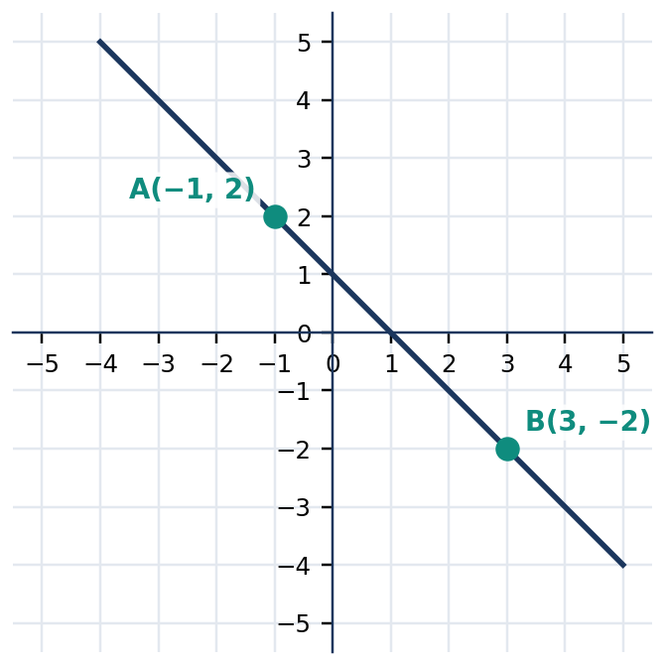
Figure 3.5.7 Figure 3.5.7. The straight line passes through both required points.
💡 Worked Example 4 — Given Both Intercepts
Problem: Find an equation of the line with x-intercept $(6,0)$ and y-intercept $(0,3)$.
Given: $(6,0)$ and $(0,3)$.
Find: Standard and slope-intercept equations.
Formula: $\frac{x}{a}+\frac{y}{b}=1 (a≠ 0, b≠0)$
$x/6+y/3$ | $= 1$ | substitute intercepts a=6 and b=3
$x+2y$ | $= 6$ | multiply each term by 6
$2y$ | $= −x+6$ | subtract x
$y$ | $= −x/2+3$ | divide by 2

Final Answer: **$x+2y=6$, equivalently $y=−\frac{1}{2}x+3$**. Both intercepts satisfy the result.

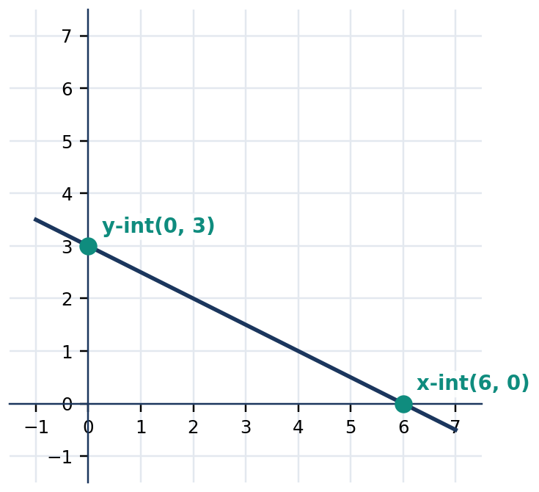
Figure 3.5.8 Figure 3.5.8. The x- and y-intercepts define a line with slope −1/2.

5. MATHEMATICAL REASONING AND COMMON MISCONCEPTIONS

Reasoning challenge: A learner argues that the two equations $2y=4x+6$ and $y=2x+3$ represent different lines because they look different. Explain algebraically why the equations describe the same solution set. Give two ordered pairs that satisfy both; then identify their common slope and y-intercept. Next, explain why multiplying an entire equation by a nonzero constant preserves the line but adding a constant to only one side generally changes the line.
WATCH OUT — Wrong → Right
Wrong: Slope between $(1,2)$ and $(4,8)$ is $(4-1)/(8-2)=1/2$.
Right: $m=(8-2)/(4-1)=6/3=2$; vertical change is the numerator.
Wrong: $y-(−3)=2(x-4)$ becomes $y=2x-11$.
Right: $y+3=2x-8$ so $y=2x-11$ — correct conclusion, but confirm every intermediate sign rather than relying on a guessed intercept.
Wrong: Every line has a defined slope and can be expressed as $y=mx+b$.
Right: Vertical lines have equations $x=c$ and undefined slope.
Wrong: The intercept formula is always usable even when an intercept equals zero.
Right: The fractional intercept form requires nonzero intercept values; use two points or another form when either denominator would be zero.

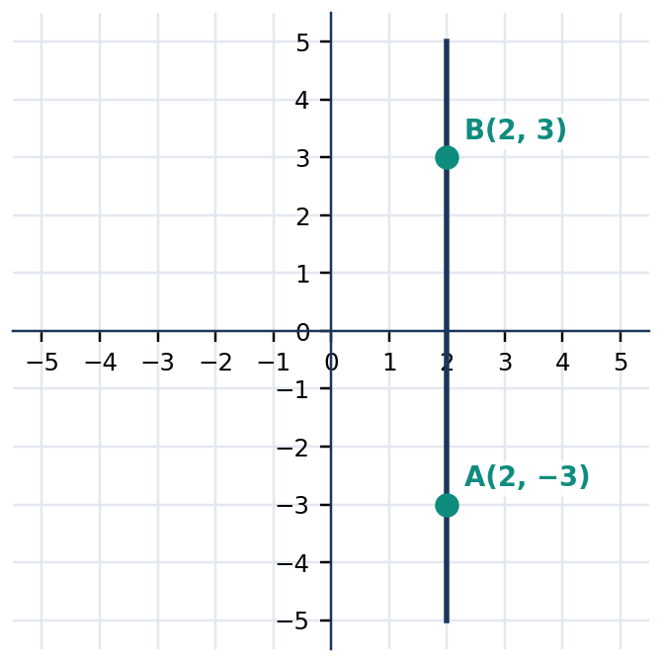
Figure 3.5.9 Figure 3.5.9. A vertical line through two points with x-coordinate 2 is x=2.

6. SUBTOPIC 3.5.3 — EQUIVALENT FORMS AND APPLICATIONS

The same straight line may be expressed in standard form $Ax+By=C$, slope-intercept form $y=mx+b$, or point-slope form $y-y_{1}=m(x-x_{1})$. Choosing a form depends on the available information. If a problem gives a fixed starting amount and a rate of change, slope-intercept form exposes both features. If it gives a known data point and rate, point-slope form avoids first computing the intercept.
For a transport fee, suppose the cost increases by ₱12 per kilometer and the total cost at 4 km is ₱86. Using the point $(4,86)$ and slope $12 pesos/km gives $C-86=12(d-4)$, then $C=12d+38$. The intercept is a fixed fare of ₱38. The graph extends mathematically across all real numbers, but a realistic fare model uses nonnegative distances. The units and domain are part of the interpretation, not optional decoration.
📐 KEY CONCEPT — Forms of a Line
$$Ax+By=C$$
$$y=mx+b$$
$$y-y_{1}=m(x-x_{1})$$
For nonvertical lines, these are equivalent representations after suitable rearrangement. For a vertical line, use $x=c$; for a horizontal line, use $y=c$.

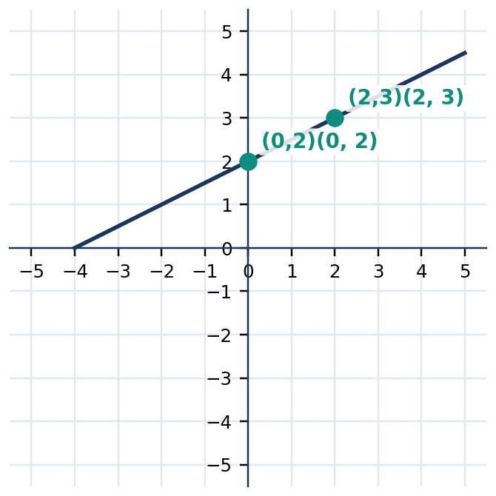
Figure 3.5.10 Figure 3.5.10. Two points show the slope 1/2 and intercept 2 for y=(1/2)x+2.
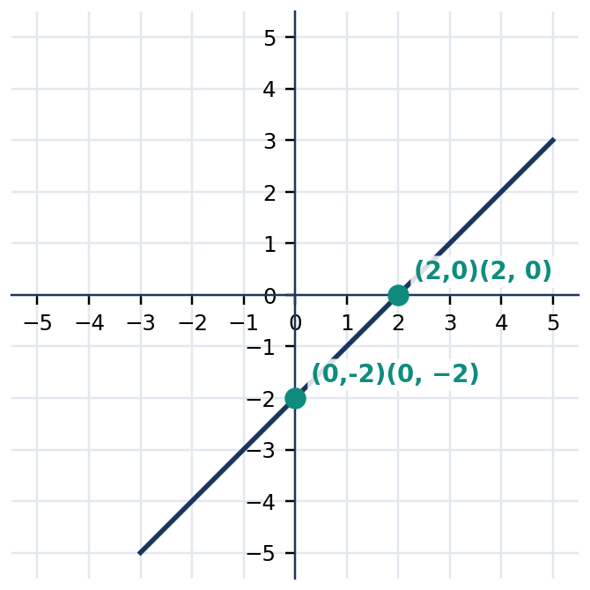
Figure 3.5.11 Figure 3.5.11. Equation x-y=2 is the same line as y=x-2.
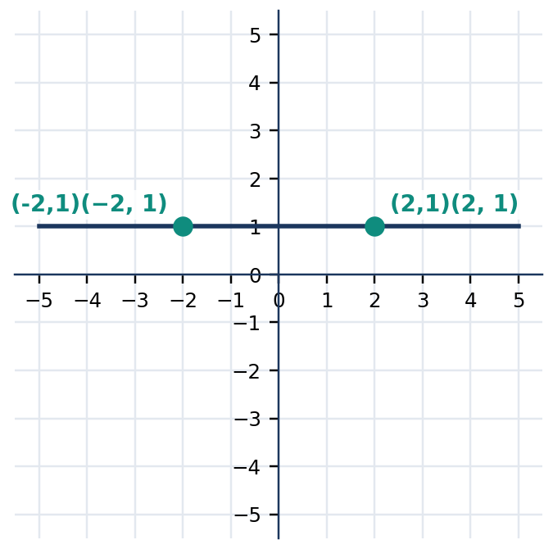
Figure 3.5.12 Figure 3.5.12. Horizontal line y=1 has slope 0 regardless of the x-coordinate.
Given | Efficient equation form | Why
Slope and y-intercept | $y=mx+b$ | Direct substitution
Slope and any point | $y-y_{1}=m(x-x_{1})$ | No intercept calculation needed
Two points | Compute slope, then point-slope | Uses only supplied data
Two nonzero intercepts | $x/a+y/b=1$ | Both crossings immediately visible
Two points with equal x | $x=c$ | Vertical special case

Quick Check 3.5C: (1) Rewrite $3x+2y=12$ in slope-intercept form. (2) Write the line with x-intercept $(4,0)$ and y-intercept $(0,2)$. (3) A service charges ₱15 per hour plus a fixed ₱40 fee: write the cost model and name the units of its slope.

7. GUIDED AND INDEPENDENT PRACTICE

Task 3.5.1 — 22 Graded Exercises. Write an equation for each line. Use slope-intercept form when possible, and check the supplied data.
Basic (1–12)
1. Slope 2; y-intercept 3 | 2. Slope −1; y-intercept 4
3. Slope 0; y-intercept −5 | 4. Slope 1/2; y-intercept 2
5. Slope −3; y-intercept 0 | 6. Slope 4; point (0,−2)
7. Slope 2; point (1,5) | 8. Slope −1; point (2,3)
9. Slope 3; point (−1,1) | 10. Slope −2; point (3,−4)
11. Through (0,4) and (2,8) | 12. Through (0,−1) and (3,2)

Intermediate (13–18)
13. Through (1,2) and (4,8) | 14. Through (−2,5) and (2,−3)
15. Through (3,7) and (3,−1) | 16. Through (−4,2) and (1,2)
17. x-intercept (6,0); y-intercept (0,2) | 18. x-intercept (−3,0); y-intercept (0,6)

Challenge / Word Problems (19–22)
19. At 2 km a fare is ₱54; at 5 km it is ₱90. Find the fare equation and interpret its slope and intercept.
20. A tank contains 150 L initially and 110 L after 4 minutes. Assuming constant flow, write the volume model and identify the physically meaningful time interval before the tank empties.
21. A subscription costs ₱110 at 3 months and ₱230 at 7 months. Find the linear cost model, then explain whether the intercept represents an enrollment fee.
22. A line passes through $(2,5)$ and $(2,−3)$. Explain why slope-intercept form fails; write its correct equation and graph it.
Task 3.5.2 — Analytical Matrix
Given information | Find the slope | Write an equation | Verify
$(1,1),(3,5)$ | ____ | ____ | ____
$(2,−2),(4,−6)$ | ____ | ____ | ____
Slope 3, point $(−1,0)$ | ____ | ____ | ____
Intercepts $(4,0),(0,−4)$ | ____ | ____ | ____
$(5,2),(5,−2)$ | ____ | ____ | ____

8. CONTEXTUAL APPLICATION — COMMUNITY WATER-REFILL SERVICE

Situation: A refill service quotes ₱95 for a 3-container order and ₱155 for a 5-container order. Assume the charge depends linearly on the number of containers. Determine a price rule, the per-container rate, the fixed fee, and the total charge for 8 containers. Explain whether the model makes sense for a non-integer number of containers.
Procedure: (1) Represent orders as ordered pairs $(n,C)$. (2) Calculate the slope and its units. (3) Use point-slope form to obtain $C=mn+b$. (4) Verify both original quotations. (5) Evaluate $C$ at $n=8$ and state an appropriate domain.
Scoring guide (12 points): Correct ordered pairs and units (2); slope calculation (3); equation and interpretation (3); checks (2); contextual domain and final quotation (2).

9. METACOGNITIVE REFLECTION AND LESSON SUMMARY

3–2–1 Exit Ticket: Record (3) three methods of finding a line equation; (2) two ways of verifying an equation; and (1) one real-life situation where a slope must include units to avoid a misleading answer.
LESSON SUMMARY: A nonvertical line can be written as $y=mx+b$ when slope and intercept are known. Use $y-y_{1}=m(x-x_{1})$ when a point and slope are given; for two points, compute $m=(y_{2}-y_{1})/(x_{2}-x_{1})$ first. Two nonzero intercepts may be substituted into $x/a+y/b=1$. Vertical lines have the special form $x=c$. Equivalent equations must describe the same point set, and every derived equation should be verified by substitution.

10. FORMATIVE ASSESSMENT — 15 ITEMS

Part I — Multiple Choice. Choose one answer per item.
1. [ ] Which is the equation of a line with slope 3 and y-intercept -2?
A. $y=3x+2$ B. $y=−2x+3$ C. $y=3x-2$ D. $y=−3x-2$
2. [ ] Which line passes through $(2,1)$ and has slope 2?
A. $y=2x-3$ B. $y=2x+3$ C. $y=x-1$ D. $y=−2x+5$
3. [ ] Find the slope between $(−1,4)$ and $(3,−4)$.
A. $2 B. $−1/2$ C. $1/2 D. $−2$
4. [ ] What is the equation through $(0,5)$ and $(2,5)$?
A. $x=5$ B. $y=5$ C. $y=2x+5$ D. $x=2$
5. [ ] Which equation passes through $(3,1)$ and $(3,8)$?
A. $y=3$ B. $y=x+3$ C. $x=3$ D. $x=1$
6. [ ] Find the equation with intercepts $(4,0)$ and $(0,2)$.
A. $x+2y=4$ B. $2x+y=4$ C. $x-y=2$ D. $x+y=6$
7. [ ] Which is equivalent to $2x+4y=8$?
A. $y=2x+4$ B. $y=−2x+8$ C. $y=4-2x$ D. $y=−x/2+2$
8. [ ] For $y=−3x+7$, what is the y-intercept?
A. $(−3,0)$ B. $(0,7)$ C. $(7,0)$ D. $(0,−3)$
9. [ ] A line has slope -1 and goes through $(1,4)$. What is its equation?
A. $y=−x+5$ B. $y=x+3$ C. $y=−x+3$ D. $y=x+5$
10. [ ] The costs are ₱80 for 2 units and ₱140 for 4 units. What is the constant cost increase per unit?
A. ₱20 B. ₱40 C. ₱30 D. ₱60
Part II — Written Analysis and Calculation
11. Find the equation through $(−2,−1)$ and $(2,7)$. Verify both coordinates.
12. Find the line with slope $−3/2$ through $(4,1)$; give both point-slope and slope-intercept forms.
13. A line crosses the x-axis at $(−6,0)$ and the y-axis at $(0,3)$. Find its equation in standard form and verify the crossings.
14. A delivery bill rises from ₱74 at 2 km to ₱122 at 6 km. Write the model and interpret both slope and intercept with units.
15. A learner writes $y=4x+1$ for a line through $(2,6)$ with slope $4. Show by substitution why this is incorrect, then derive the correct equation and name a second point.

LESSON 3.6 — SYSTEMS OF LINEAR EQUATIONS AND THEIR SOLUTIONS

Mathematics 8 • Quarter 3 | Domain: Number and Algebra (NA)
Curriculum alignment (official Grade 8 Quarter 3, Competencies 10–14): Define and illustrate systems of linear equations in two variables; solve systems with integer solutions graphically; classify systems by number of solutions; solve systems algebraically; and solve contextual problems involving systems.
Essential questions: (1) What makes an ordered pair a solution of two equations simultaneously? (2) How do graphing, substitution, and elimination reveal the same solution, and when is each efficient? (3) How do intersecting, parallel, and coincident lines determine the number of solutions to a system?
🎥 INTERACTIVE MULTIMEDIA: Systems of Linear Equations
Channel: Khan Academy — Algebra
Direct video: https://www.youtube.com/watch?v=unSBFwK881s
Concepts to investigate: Representing unknown quantities through equations; equivalence-preserving algebraic operations; translating mathematical answers into context.
Viewing questions: What quantities are unknown and what relationships constrain them? Why is substituting a candidate answer a valid verification? How could a second independent condition narrow the possible answers?

A single linear equation in two variables has infinitely many ordered-pair solutions, represented by points on a straight line. A second equation supplies an additional condition. If both conditions must hold at the same time, their common solution is the intersection of their solution sets. For example, a school stall may know the number of snacks sold and the total sales amount. Each statement becomes one equation, and together they determine the number sold of each snack type. The two equations are not alternatives: the sought quantities must make both true.
The graphical and algebraic approaches provide complementary views. Graphing makes the common point visible but may be imprecise if lines meet between grid points. Substitution and elimination yield exact values and provide efficient checks. A system may also have no solution or infinitely many solutions; such outcomes are mathematically meaningful, not automatically mistakes. This chapter builds exact procedures and comparison criteria so learners can choose a method, interpret its outcome, and justify the number of solutions.

2. SUBTOPIC 3.6.1 — WHAT A SYSTEM MEANS

A system of linear equations in two variables consists of two or more linear equations involving the same variables. A solution is an ordered pair that satisfies every equation simultaneously. In the system $x+y=7$ and $x-y=1$, the pair $(4,3)$ works because $4+3=7$ and $4-3=1$. The pair $(5,2)$ satisfies the first equation but not the second, and therefore is not a solution of the system. Testing one equation only is insufficient.
📐 KEY CONCEPT — Simultaneous Solution
$a_{()1}x+b_{()1}y$ | $= c_{()1}$
$a_{()2}x+b_{()2}y$ | $= c_{()2}$

A solution $(x,y)$ must satisfy BOTH equations. The coefficients $a_{i},b_{i},c_{i}$ are constants; each equation is linear because the variables occur to the first power and are not multiplied together.

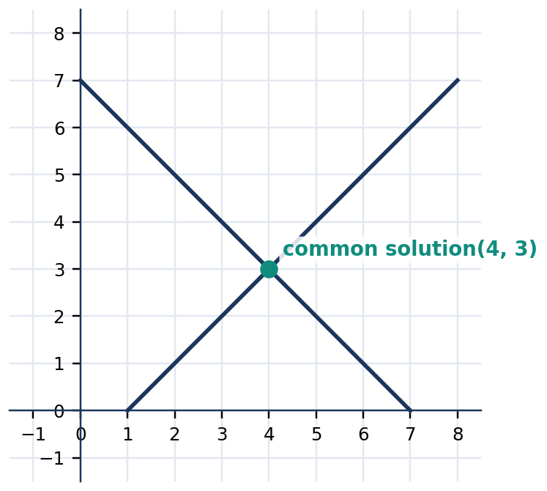
Figure 3.6.1 Figure 3.6.1. Lines x+y=7 and x-y=1 intersect at the common solution (4,3).
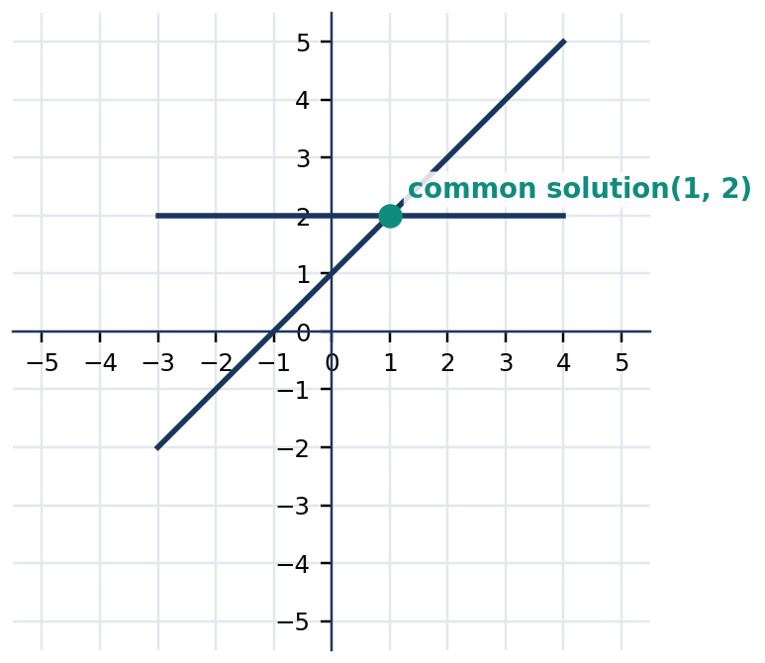
Figure 3.6.2 Figure 3.6.2. The point (1,2) is where y=x+1 and y=2 meet.
Candidate pair | $x+y=7$ | $x-y=1$ | Solution of system?
$(4,3)$ | $4+3=7$ | $4-3=1$ | Yes
$(5,2)$ | $5+2=7$ | $5-2=3$ | No
$(3,4)$ | $3+4=7$ | $3-4=−1$ | No
$(4,−3)$ | $4-3=1$ | $4-(−3)=7$ | No

Quick Check 3.6A: (1) Test $(2,5)$ in $x+y=7$ and $2x+y=9$. (2) Give a pair satisfying $x+y=7$ but not $x-y=1$. (3) Explain why two equations are needed when two unknown item counts must satisfy two independent totals.
A coordinate graph visualizes the full solution set of each equation. The graph of a system is a pair of lines drawn on the same axes using the same scale. If the lines cross, the intersection coordinates solve both equations. If their crossings are not obvious, first calculate a table of values or find the slope and intercepts for each line. A graph is evidence for the solution, but substitution in the original equations gives the decisive numerical check.

3. SUBTOPIC 3.6.2 — GRAPHING AND THE NUMBER OF SOLUTIONS

Two distinct nonparallel lines intersect at exactly one point. Their system is consistent and independent. Parallel lines never intersect, making the system inconsistent with no solution. Coincident lines describe precisely the same set of points, so there are infinitely many solutions; the system is consistent and dependent. One equation may be a multiple of another without creating a new restriction. For instance, $2x+2y=10$ and $x+y=5$ describe the same line.
📐 KEY CONCEPT — Slope Classification
For nonvertical lines $y=m_{1}x+b_{1}$ and $y=m_{2}x+b_{2}$:
• If $m_{1}≠ m_{2}$, exactly one solution exists.
• If $m_{1}=m_{2}$ and $b_{1}≠ b_{2}$, no solution exists.
• If $m_{1}=m_{2}$ and $b_{1}=b_{2}$, infinitely many solutions exist.
For vertical lines, compare their constant $x$-coordinates instead.

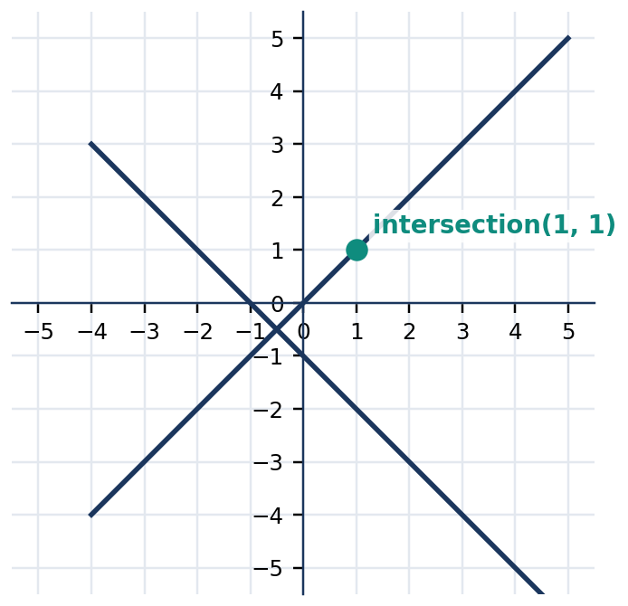
Figure 3.6.3 Figure 3.6.3. Nonparallel lines y=x and y=−x+2 meet exactly once at (1,1).
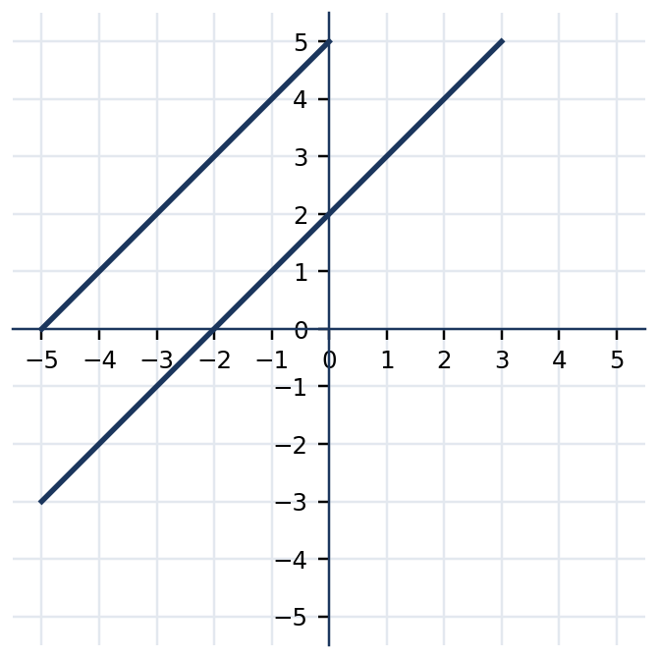
Figure 3.6.4 Figure 3.6.4. Lines y=x+2 and y=x+5 have equal slope, distinct intercepts, and no intersection.
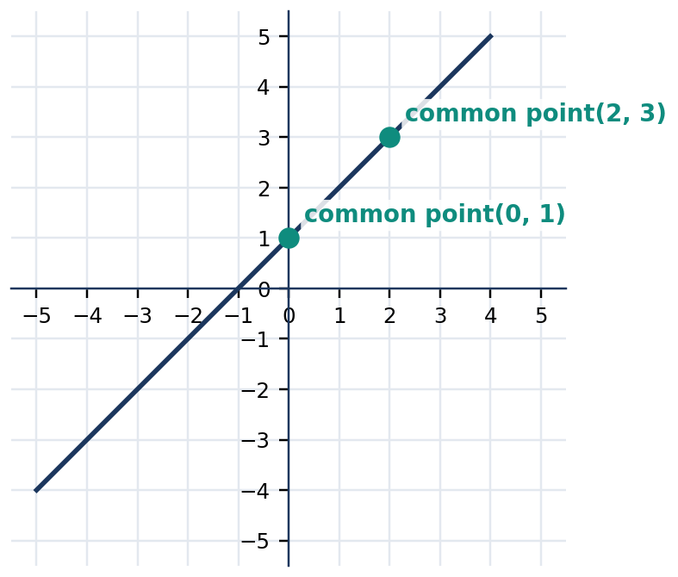
Figure 3.6.5 Figure 3.6.5. The equations y=x+1 and 2y=2x+2 produce the same line and infinitely many solutions.
Line relationship | Algebraic indicator | Number of solutions | Classification
Intersecting | Different slopes | Exactly one | Consistent, independent
Parallel distinct | Same slope, different intercept | Zero | Inconsistent
Coincident | Equivalent equations | Infinitely many | Consistent, dependent

Quick Check 3.6B: (1) Classify $y=2x+1$ and $y=2x-4$. (2) Explain how $3x+3y=12$ and $x+y=4$ relate. (3) Without solving, predict the number of solutions of $y=−x+5$ and $y=2x-1$.

4. CORE ANCHOR — FOUR WORKED EXAMPLES

💡 Worked Example 1 — Graphing a System
Problem: Solve $x+y=6$ and $y=x$ graphically and check the answer.
Given: Two linear equations: $x+y=6$ and $y=x$.
Find: The ordered pair satisfying both equations.
Formula / Rule: The common point of the lines is the solution. Rearrange the first line as $y=6-x$.
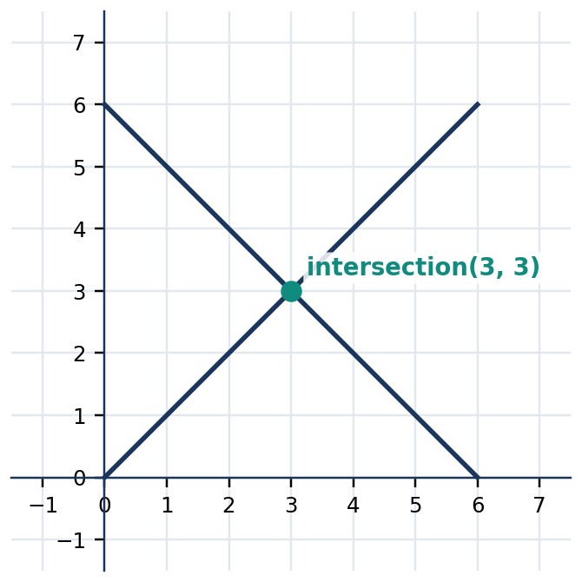
Figure 3.6.6 Figure 3.6.6. The lines y=6-x and y=x meet at (3,3).
$x+y$ | $= 6$ | rewrite as y=6-x and plot (0,6), (6,0)
$y$ | $= x$ | plot (0,0), (3,3)
$(x,y)$ | $= (3,3)$ | read intersection of the lines
$3+3$ | $= 6$ | verify first equation
$3$ | $= 3$ | verify second equation

Final Answer: **$(3,3)$** is the exact solution.

💡 Worked Example 2 — Substitution
Problem: Solve $y=2x+1$ and $x+y=10$.
Given: $y=2x+1$ and $x+y=10$.
Find: $x$ and $y$.
Formula / Rule: Replace $y$ in the second equation with the equivalent expression $2x+1$.
$x+(2x+1)$ | $= 10$ | substitute y=2x+1
$3x+1$ | $= 10$ | combine like terms
$3x$ | $= 9$ | subtract 1
$x$ | $= 3$ | divide by 3
$y$ | $= 2(3)+1 = 7$ | substitute back

Final Answer: **$(3,7)$**. Check: $7=2(3)+1$ and $3+7=10$.

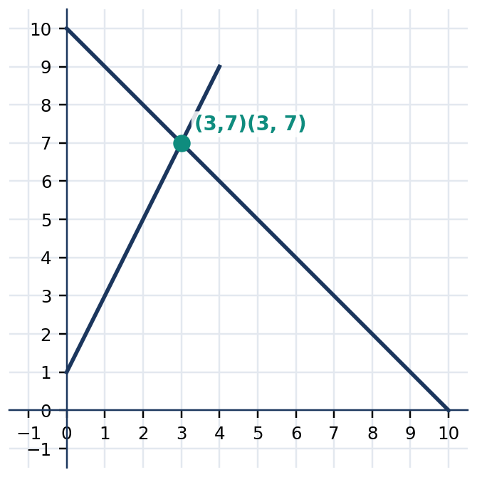
Figure 3.6.7 Figure 3.6.7. The substitution result (3,7) is also the intersection of the lines.
💡 Worked Example 3 — Elimination
Problem: Solve $2x+3y=17$ and $2x-y=5$.
Given: $2x+3y=17$ and $2x-y=5$.
Find: The simultaneous solution.
Formula / Rule: Subtract equations to eliminate the common $2x term.
$(2x+3y)-(2x-y)$ | $= 17-5$ | subtract second equation from first
$4y$ | $= 12$ | distribute minus and combine like terms
$y$ | $= 3$ | divide by 4
$2x-3$ | $= 5$ | substitute y=3 into the second equation
$x$ | $= 4$ | add 3, then divide by 2

Final Answer: **$(4,3)$**. Check: $2(4)+3(3)=17$ and $2(4)-3=5$.

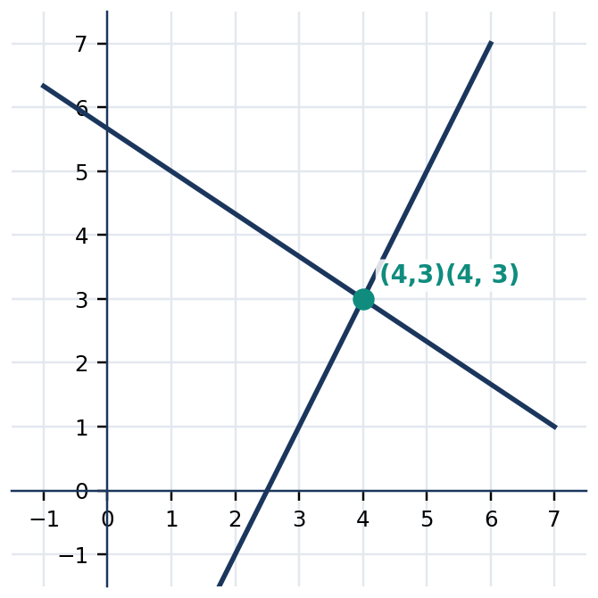
Figure 3.6.8 Figure 3.6.8. The two equation lines meet at (4,3), confirming elimination.
💡 Worked Example 4 — School-Fair Purchases
Problem: A booth sells 25 food items: sandwiches cost ₱40 each and juice cups cost ₱20 each. Total sales are ₱700. How many of each item were sold?
Given: 25 items total, prices ₱40 and ₱20, sales ₱700.
Find: Sandwich count $s$ and juice count $j$.
Formula / Rule: $s+j=25$ and $40s+20j=700$.
$s+j$ | $= 25$ | model the total number of items
$2s+j$ | $= 35$ | divide the sales equation by 20
$(2s+j)-(s+j)$ | $= 35-25$ | subtract the item equation
$s$ | $= 10$ | determine sandwich count
$j$ | $= 25-10 = 15$ | determine juice count

Final Answer: 10 sandwiches and 15 juice cups. Check: $10+15=25$ and $40(10)+20(15)=₱700$.

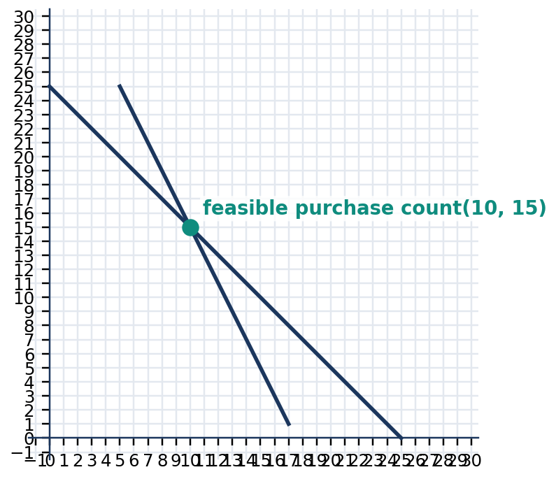
Figure 3.6.9 Figure 3.6.9. The count equation s+j=25 and the sales equation 2s+j=35 intersect at (10,15).

5. INQUIRY, JUSTIFICATION, AND ERROR ANALYSIS

A valid algebraic solution method must preserve the common solution set. In substitution, an expression equal to one variable replaces that variable everywhere it is used. In elimination, add or subtract equations after multiplying an entire equation by a nonzero constant if necessary. Both operations result in statements true for every common solution. However, division by an expression containing an unknown can be unsafe because that expression might equal zero; standard elimination uses constant multipliers instead.
WATCH OUT — Subtraction and distribution
Wrong: $(2x+3y)-(2x-y)=2y$.
Right: $(2x+3y)-(2x-y)=4y$. Subtracting $−y$ is adding $y$.
Wrong: A pair satisfying one equation is enough.
Right: Substitute the candidate into both original equations.
Wrong: Two overlapping line drawings automatically have one solution.
Right: If two equations give the same line, infinitely many ordered pairs satisfy the system.

Reasoning challenge: Compare $x+y=4$, $2x+2y=8$, and $2x+2y=10$. Decide which pairs form dependent systems and which form inconsistent systems. Describe the changes to the graph and explain without listing every possible ordered pair. Investigate what would happen if the first equation were instead paired with $x-y=0$.
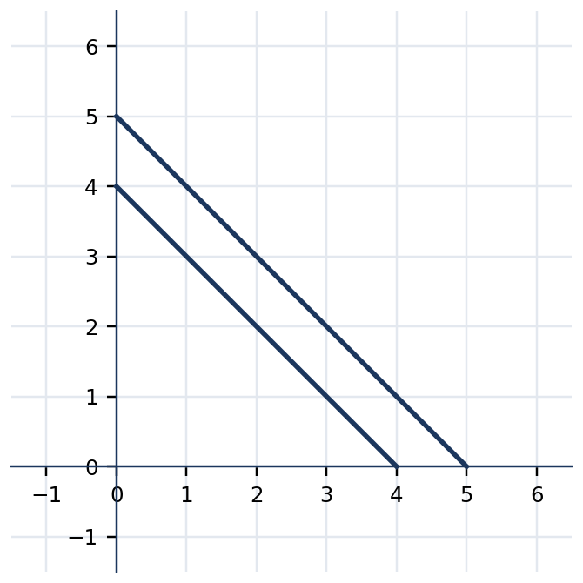
Figure 3.6.10 Figure 3.6.10. Lines x+y=4 and x+y=5 are parallel: the equations cannot both hold.

6. SUBTOPIC 3.6.3 — CHOOSING ALGEBRAIC METHODS AND MODELING

Substitution is usually convenient if one equation is already solved for one variable or a coefficient is $1 or $−1$. Elimination is convenient when corresponding coefficients are equal, opposite, or simple to scale. Graphing is convenient when an approximate answer or graphical explanation is required; it is also essential for seeing that the system may be inconsistent or dependent. The method may vary, but the solution must not. Always verify the original, not merely the transformed, equations.
When both equations are in standard form, adjust one or both using constant multiplication to create opposite coefficients. For $3x+2y=16$ and $x+2y=8$, subtracting eliminates $y$ and gives $2x=8$, so $x=4$ and $y=2$. For $2x+y=9$ and $x-y=3$, adding the equations immediately eliminates $y$ and gives $3x=12$. Efficient method selection depends on the actual coefficients, not a rule that one method is always best.
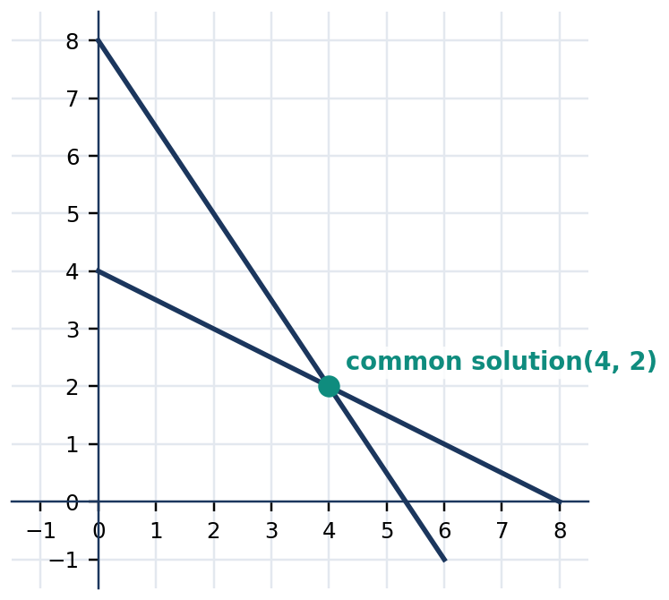
Figure 3.6.11 Figure 3.6.11. The system 3x+2y=16 and x+2y=8 has solution (4,2).
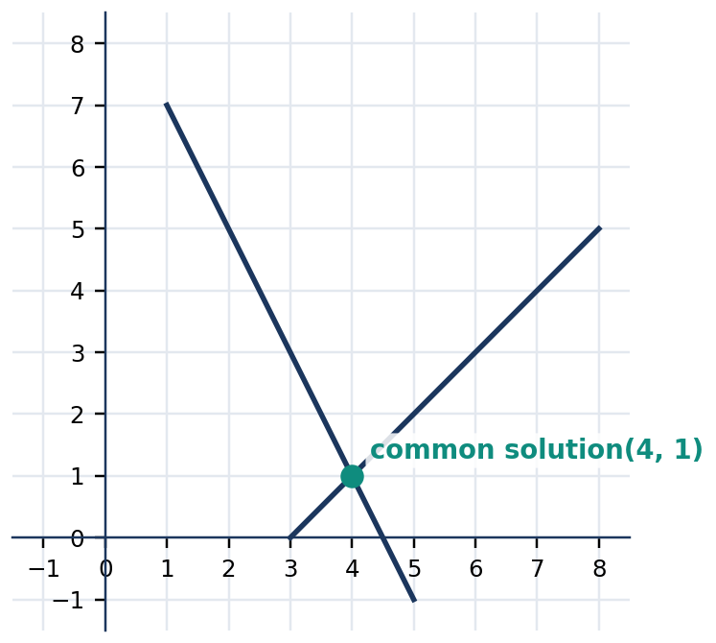
Figure 3.6.12 Figure 3.6.12. The system 2x+y=9 and x-y=3 has intersection (4,1).
Situation | Suggested method | Why it works
$y$ already isolated | Substitution | Replace directly with an equivalent expression
Same $x$-coefficients | Elimination by subtraction | $x$ terms cancel
Opposite $y$-coefficients | Elimination by addition | $y$ terms cancel
Need number of solutions | Graphing / slope analysis | Intersections distinguish all three types
Real-world counts and prices | Either algebraic method | Exact counts can be verified in context

Quick Check 3.6C: (1) Choose and justify a method for $y=x+5$ and $2x+y=14$. (2) Solve $3x+y=17$ and $x+y=9$. (3) Explain why a negative result may be acceptable in a coordinate problem but impossible for a number of sold notebooks.

7. GUIDED AND INDEPENDENT PRACTICE

Task 3.6.1 — Graded Exercises. Solve each system; show the method and substitute into the original equations. For classification tasks, state the number of solutions and why.
Basic fluency (1–12).
1. $x+y=9$, $x-y=1$ | 2. $x+y=11$, $x-y=3$
3. $y=x+2$, $x+y=10$ | 4. $y=2x$, $x+y=12$
5. $2x+y=11$, $x+y=7$ | 6. $x+2y=12$, $x+y=7$
7. $3x+y=14$, $x+y=8$ | 8. $2x-y=5$, $x+y=10$
9. $y=3x-1$, $x+y=11$ | 10. $2x+3y=12$, $x+y=5$
11. $4x+y=17$, $x+y=8$ | 12. $3x-y=5$, $x+y=7$

Intermediate methods and classification (13–18).
13. $2x+3y=18$, $4x-3y=0$ | 14. $5x+2y=24$, $3x-2y=8$
15. $y=2x+3$, $y=2x-1$: classify | 16. $x+y=6$, $2x+2y=12$: classify
17. $3x+2y=17$, $x-y=1$ | 18. $2x+5y=21$, $3x-5y=−1$

Challenge / context problems (19–22).
19. A school fair sells 30 tickets. Student tickets cost ₱20 and adult tickets cost ₱50. Total revenue is ₱900. How many of each ticket were sold?
20. Two quantities total 46, and one exceeds the other by 8. Find both and verify.
21. A vendor sells 22 packs: packs A cost ₱35 and packs B cost ₱50. Total revenue is ₱920. Find the number of each pack.
22. A taxi company offers Plan A at ₱45 plus ₱12/km and Plan B at ₱75 plus ₱7/km. At what distance are costs equal, and what is the common fare?
Task 3.6.2 — Analytical Matrix. Complete each row and justify the indicated conclusion.
System | Recommended method | Solution / classification and reason
$x+y=8$; $x-y=2$ | Elimination | ________
$y=3x$; $x+y=16$ | Substitution | ________
$y=−x+3$; $y=−x+6$ | Compare slopes | ________
$2x+2y=12$; $x+y=6$ | Compare equations | ________
$3x+2y=19$; $x-y=3$ | Algebraic choice | ________

8. CONTEXTUAL APPLICATION — COMMUNITY FUNDRAISER

Task 3.6.3 (10 points): The student council sells 40 fundraising kits. A basic kit costs ₱75; a premium kit costs ₱120. Total collections are ₱3,810. Determine the number of basic and premium kits. Define both variables and their units, write two independent equations, select a solution method, solve and interpret the result, and check the item total and peso total. Then explain why a non-integer kit count would be unacceptable even if an algebraic computation produced one.
Scoring: Correct variables and units (2), both equations (2), valid step-by-step solution (3), substitution checks in both equations (2), contextual interpretation (1). The full quarterly GRASPS rubric is reserved for the culminating assessment.
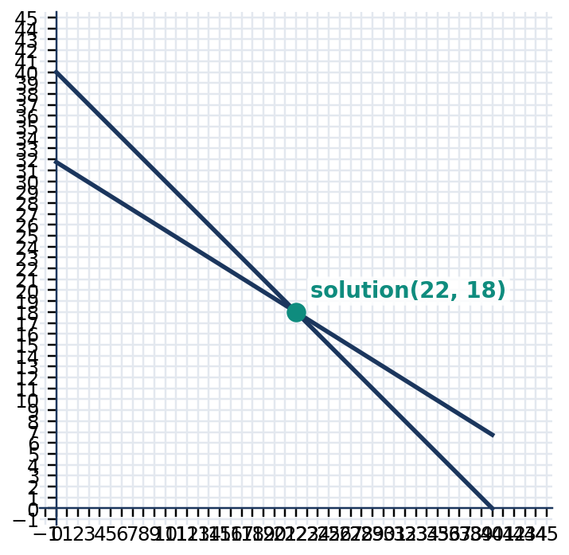
Figure 3.6.13 Figure 3.6.13. The two fundraising-kit constraints are straight lines; solutions must also represent whole-number counts. (Students should obtain the exact intersection algebraically.)

9. METACOGNITIVE 3–2–1 EXIT TICKET AND LESSON SUMMARY

3: Write three mathematical facts distinguishing graphing, substitution, and elimination. 2: State two specific errors you can detect when checking a solution. 1: Describe one community or household problem where two independent conditions would let you calculate two unknown quantities.
LESSON SUMMARY: A system is solved by finding values that satisfy every included equation. Two nonparallel lines have one common point; distinct parallel lines have none; coincident lines have infinitely many. Graphing, substitution, and elimination are linked methods that must agree. Exact algebra and substitution into both original equations support reliable answers, while realistic units and constraints determine whether those answers make contextual sense.

10. FORMATIVE ASSESSMENT — 15 ITEMS

Part I. Multiple Choice (1–10). Select the best answer; record your choice in $[ ]$.
1. $[ ]$ Solve $x+y=10$ and $x-y=2$. A. $(4,6)$ B. $(6,4)$ C. $(5,5)$ D. $(8,2)$
2. $[ ]$ Which pair solves $y=2x+1$ and $x+y=10$? A. $(2,5)$ B. $(4,5)$ C. $(3,7)$ D. $(7,3)$
3. $[ ]$ The lines $y=3x+1$ and $y=3x-4$ have: A. no solution B. one solution C. two solutions D. infinitely many solutions.
4. $[ ]$ The equations $x+y=5$ and $2x+2y=10$ have: A. no solution B. two solutions C. exactly one solution D. infinitely many solutions.
5. $[ ]$ Solve $2x+y=11$ and $x+y=7$. A. $(3,4)$ B. $(4,3)$ C. $(5,1)$ D. $(2,7)$
6. $[ ]$ Which is the best first operation to solve $3x+2y=16$ and $x+2y=8$ by elimination? A. Add equations B. Divide first by $x$ C. Subtract second equation from first D. Subtract $y$ from both sides only.
7. $[ ]$ For $x+y=12$ and $x-y=4$, the value of $y$ is: A. 4 B. 6 C. 8 D. 2.
8. $[ ]$ Which pair is the solution of $2x+y=9$ and $x-y=3$? A. $(5,−1)$ B. $(3,3)$ C. $(2,5)$ D. $(4,1)$
9. $[ ]$ A system with different slopes always has: A. no solution B. infinitely many solutions C. no real coefficients D. exactly one solution.
10. $[ ]$ If a candidate satisfies the first equation but not the second, it is: A. the only solution B. not a solution of the system C. proof of infinite solutions D. an undefined pair.
Part II. Open Calculation and Reasoning (11–15). Show each operation, final answer, and verification as appropriate.
11. Solve $2x+y=13$ and $x-y=2$ using elimination. Check both equations.
12. Solve $y=x+3$ and $2x+y=15$ by substitution. Explain why substitution is efficient.
13. Classify the systems (a) $y=−2x+4$, $y=−2x-1$ and (b) $x+2y=8$, $2x+4y=16$. Defend each classification graphically or algebraically.
14. A stall sold 18 items consisting of ₱30 snacks and ₱50 drinks; collections reached ₱680. Find each item count and verify both totals.
15. An incorrect solution claims $x=4$, $y=2$ solves $2x+y=10$ and $x+y=9$. Test this claim and obtain the correct solution. Explain why verifying both equations matters.

LESSON 3.7 — SOLVING SYSTEMS OF LINEAR INEQUALITIES

Mathematics 8 • Quarter 3 | Domain: Number and Algebra (NA)
Curriculum alignment: Official Grade 8 Quarter 3 Number and Algebra competency 15: recognize and solve problems involving linear inequalities in two variables. The supplied table of contents extends this idea to systems of such inequalities; the present chapter uses overlapping half-planes to interpret simultaneous restrictions. No additional official competency code is assumed.
Essential questions: (1) How does an inequality in two variables divide the coordinate plane into a solution region and its complement? (2) Why do boundary style and test points determine which points satisfy an inequality? (3) How do we locate and interpret the overlap of two or more inequality regions in real constraints?
🎥 INTERACTIVE MULTIMEDIA: Graphing Two-Variable Linear Inequalities
Channel: Khan Academy — Algebra
Direct video: https://www.youtube.com/watch?v=unSBFwK881s
Concepts to observe: Drawing the straight-line boundary; using test points to select a half-plane; including or excluding the boundary.
Viewing questions: How does the shaded region differ from the graph of the corresponding equation? How is a test point used to choose a half-plane? What real restriction might require both an upper and a lower limit?

A linear inequality in two variables resembles a linear equation, but uses $<$, $>$, $≤$, or $≥$ instead of equality. It describes not only points along a straight line but an entire region of the coordinate plane. A particular ordered pair either satisfies the inequality or does not. For example, if $x$ denotes notebooks and $y$ denotes pens, the condition $2x+y≤ 12$ can represent a resource limit when notebook and pen costs are measured in the same units. Many combinations might satisfy the budget, but combinations beyond the limit do not.
When several restrictions apply simultaneously, the valid combinations belong to the intersection of their solution sets. In a graph, this intersection is the overlapping shaded area, sometimes called a feasible region. The boundary lines show exact threshold values; whether those lines are included depends on the inequality symbols. Students must distinguish an algebraic solution region from context-specific answers: if $x$ and $y$ are counts, valid outcomes must also be nonnegative whole numbers, even though the graph includes many other real-number points.

2. SUBTOPIC 3.7.1 — FROM A BOUNDARY LINE TO A HALF-PLANE

Every inequality $Ax+By<C$ or $Ax+By≤ C$, where $A$ and $B$ are not both zero, has a boundary line $Ax+By=C$. The boundary separates the plane into two half-planes. For $y>x+1$, the solutions lie above the line $y=x+1$ because the corresponding $y$-value must be greater than the value of $x+1$. For $y<x+1$, they lie below it. An equation's graph contains only points on its boundary; an inequality's graph contains an entire side of that boundary, plus the boundary when equality is allowed.
📐 KEY CONCEPT — Boundary and Inclusion
$$y>mx+b ⇒ dashed line; shade above$$
$$y≥ mx+b ⇒ solid line; shade above$$
$$y<mx+b ⇒ dashed line; shade below$$
$$y≤ mx+b ⇒ solid line; shade below$$
Here $m$ is slope and $b$ is the y-intercept. Dashed means boundary points are excluded; solid means included. For vertical boundaries $x=c$, shade right for $x>c$ and left for $x<c$.

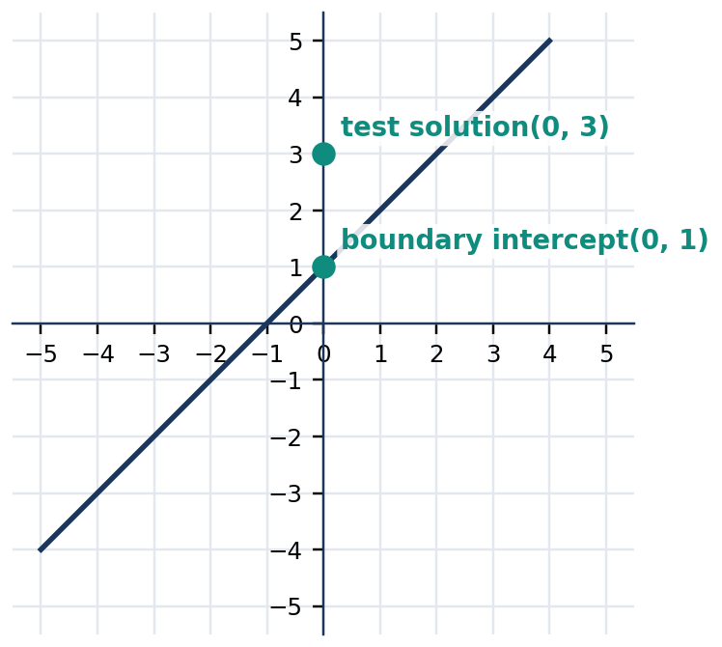
Figure 3.7.1 Figure 3.7.1. The boundary y=x+1; the point (0,3) lies above it and satisfies y>x+1. Draw the boundary dashed and shade the upper half-plane.
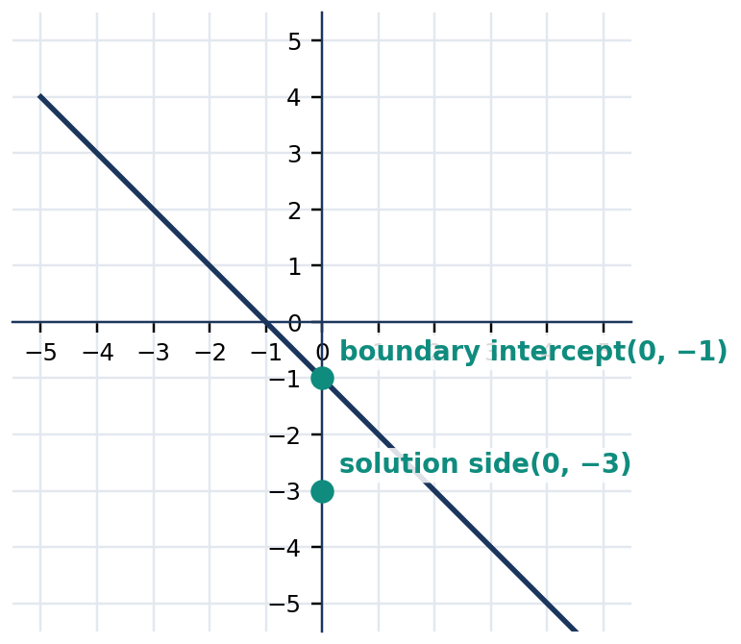
Figure 3.7.2 Figure 3.7.2. The boundary y=−x-1; the point (0,−3) lies below and satisfies y<=−x-1. Draw a solid boundary and shade below.
A test point provides a reliable method even when an inequality has not been rewritten in slope-intercept form. First graph the boundary equation, then choose a point not on the line, usually $(0,0)$. Substitute its coordinates into the original inequality. If the resulting numerical statement is true, shade the side containing the test point; otherwise shade the opposite side. If $(0,0)$ lies on the boundary, select a different point. Testing does not replace checking boundary inclusion; it decides only which side to shade.
Symbol | Boundary | Solution side for $y square mx+b$
$>$ | Dashed | Above
$≥$ | Solid | Above and including line
$<$ | Dashed | Below
$≤$ | Solid | Below and including line

Quick Check 3.7A: (1) Should the boundary of $y≤2x-3$ be solid or dashed? (2) Does $(0,2)$ satisfy $y>x+1$? (3) State which side of the vertical line $x=2$ satisfies $x<2$.

3. SUBTOPIC 3.7.2 — TEST POINTS, REVERSAL, AND GRAPH ACCURACY

It is often efficient to solve for $y$ before graphing. However, multiplying or dividing an inequality by a negative number reverses the inequality sign, just as it does in one-variable inequalities. For example, $2x-y<4$ becomes $−y<4-2x$, then $y>2x-4$ after multiplication by $−1$. A graph shaded below $y=2x-4$ would therefore be incorrect. The correct region is above that dashed line. Use a test point to confirm the direction whenever a reversal occurs.
📐 KEY CONCEPT — Negative Multipliers Reverse the Order
$$a<b and c<0 ⇒ ac>bc$$
Example:
$$2x-y<4 ⇒ −y<4-2x ⇒ y>2x-4$$
A boundary is drawn from the corresponding equality, $y=2x-4$. Use two exact points or a slope and intercept to establish the line before deciding which region is shaded.

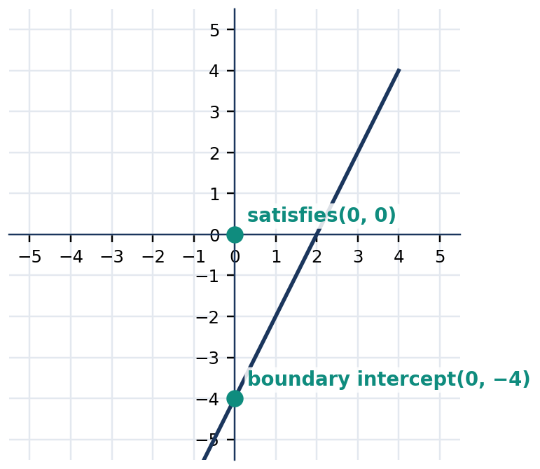
Figure 3.7.3 Figure 3.7.3. The line y=2x-4 is the dashed boundary of 2x-y<4. The origin satisfies the original inequality and lies above the line.
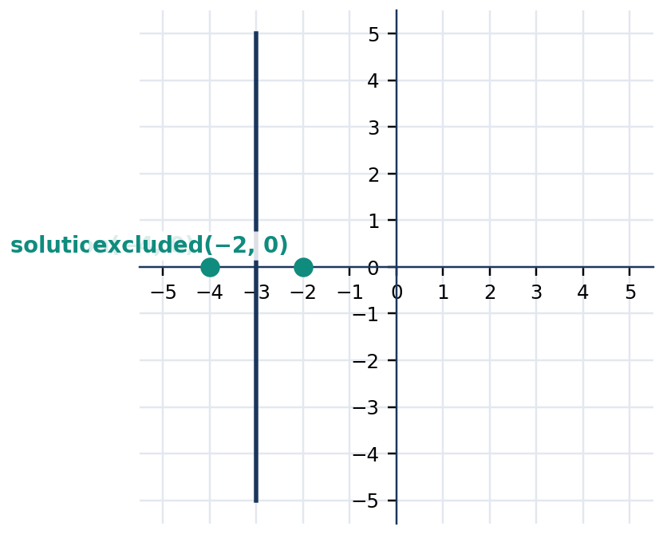
Figure 3.7.4 Figure 3.7.4. A vertical boundary x=−3 illustrates x<−3: shade to the left and exclude the boundary.
Original inequality | Equivalent form | Line style | Suggested test
$y+2x≥4$ | $y≥−2x+4$ | Solid | $(0,0)$ is false
$3y<6x+9$ | $y<2x+3$ | Dashed | $(0,0)$ is true
$−2y≤4x-8$ | $y≥−2x+4$ | Solid | $(0,0)$ is false
$x>−1$ | $x>−1$ | Dashed vertical | $(0,0)$ is true

Quick Check 3.7B: (1) Rearrange $−3y≥6x-9$ to isolate $y$. (2) Test $(0,0)$ in $x+y≤5$. (3) Explain why shading without checking the inequality sign can produce a wrong region.

4. CORE ANCHOR — FOUR WORKED EXAMPLES

💡 Worked Example 1 — Graphing a Single Inequality
Problem: Graph $y≤ x+2$ and test $(1,2)$.
Given: Boundary equation $y=x+2$; inclusive inequality $≤$.
Find: Boundary style, shaded region, and whether $(1,2)$ belongs.
Formula/Rule: The graph is on or below $y=mx+b$ when $y≤ mx+b$.
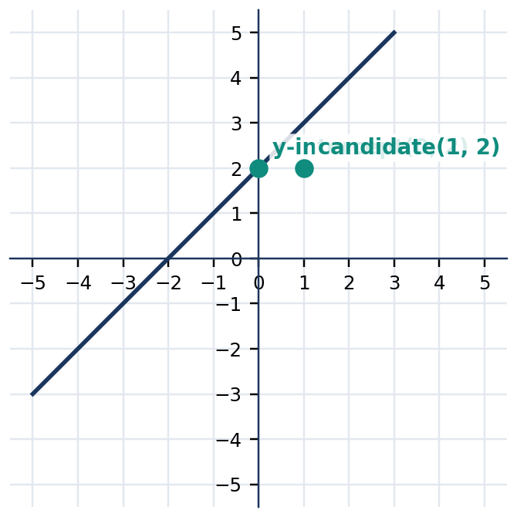
Figure 3.7.5 Figure 3.7.5. Solid boundary y=x+2. Shade below; (1,2) satisfies the inequality since 2<=3.
$2 <$ | $= 1 + 2$ | substitute x=1 and y=2
$2 <$ | $= 3$ | evaluate the right-hand side
$true$ |  | the candidate lies in the solution region

Final Answer: The boundary is solid, the region on or below the line is shaded, and **$(1,2)$ is a solution**.

💡 Worked Example 2 — Inequality with a Negative Coefficient
Problem: Graph $2x-y<4$ and decide whether the origin is a solution.
Given: $2x-y<4$.
Find: Equivalent inequality and correct half-plane.
Formula/Rule: Reverse $<$ when multiplying by $−1$.
$2x-y < 4$ |  | original inequality
$−y < 4-2x$ |  | subtract 2x
$y > 2x-4$ |  | multiply by -1 and reverse the symbol
$0 > 2(0)-4$ |  | test the origin
$0 > −4$ |  | true; shade the origin's side

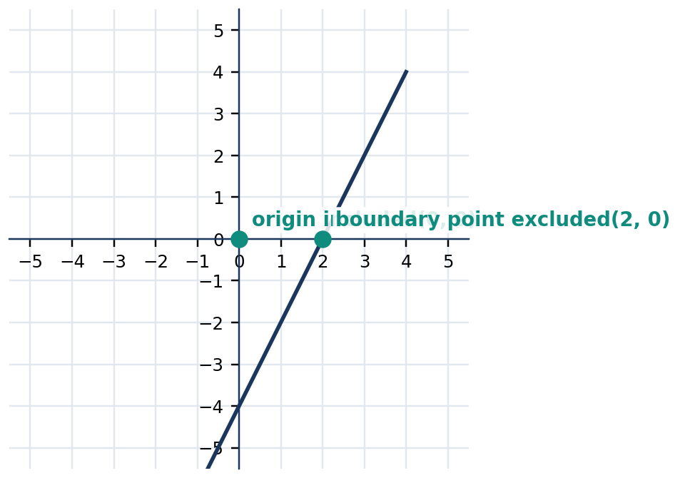
Figure 3.7.6 Figure 3.7.6. Dashed line y=2x-4 with upper half-plane shaded; (0,0) is valid and (2,0) is excluded.
Final Answer: Draw a dashed boundary $y=2x-4$ and shade above it. The origin is a solution.

💡 Worked Example 3 — Common Region of Two Constraints
Problem: Graph the system $y≥ x$ and $y≤4-x$. Find whether $(1,2)$ and $(3,3)$ satisfy both.
Given: Two inclusive inequalities.
Find: Common shaded region and membership of two candidates.
Formula/Rule: Common solutions satisfy every inequality.
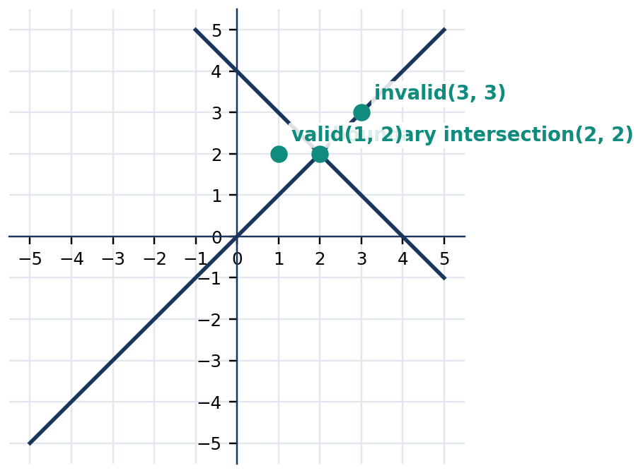
Figure 3.7.7 Figure 3.7.7. Solid lines y=x and y=4-x meet at (2,2). The common region is above y=x and below y=4-x, extending left of their intersection.
$2 >$ | $= 1$ | (1,2) satisfies y>=x
$2 <$ | $= 4-1=3$ | (1,2) satisfies y<=4-x
$3 >$ | $= 3$ | (3,3) satisfies the first restriction
$3 <$ | $= 4-3=1$ | false; it fails the second restriction

Final Answer: **$(1,2)$ is valid, whereas $(3,3)$ is not**. The intersection of the two closed half-planes is the complete solution set.

💡 Worked Example 4 — A Limited School-Supply Budget
Problem: A club buys notebooks costing ₱20 each and pens costing ₱10 each. It may spend at most ₱100 and needs at least six items. Give a valid combination using nonnegative integers.
Given: Costs 20 and 10 pesos; total cost at most ₱100; total count at least six.
Find: A pair $(x,y)$ for notebooks and pens.
Formula/Rule: $20x+10y≤100$, $x+y≥6$, $x≥0$, $y≥0$, with x,y whole numbers.
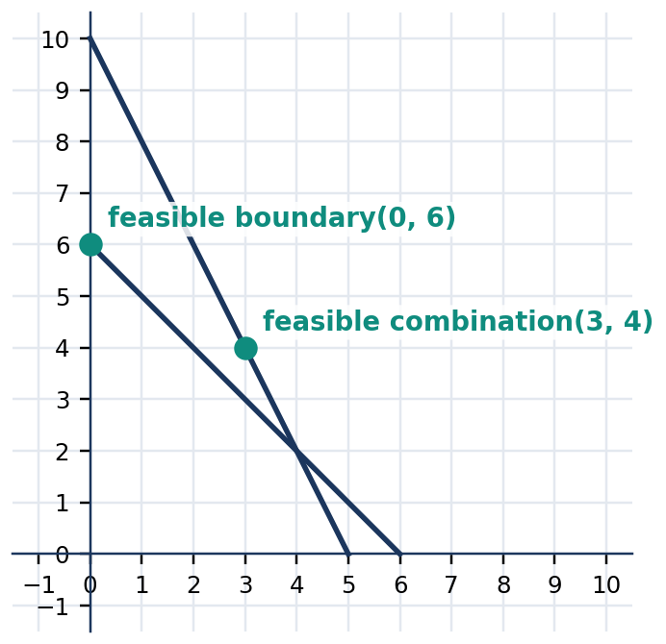
Figure 3.7.8 Figure 3.7.8. Budget boundary 2x+y=10 and item boundary x+y=6. In the first quadrant, shade below the budget line and above the item-count line; whole-number lattice points are valid purchases.
$20(3)+10(4)$ | $= 100$ | spending for 3 notebooks and 4 pens
$100 <$ | $= 100$ | budget condition satisfied
$3+4$ | $= 7$ | count seven items
$7 >$ | $= 6$ | minimum count satisfied

Final Answer: 3 notebooks and 4 pens is valid: ₱100 buys 7 items. Other feasible whole-number combinations may exist.

5. MATHEMATICAL REASONING AND COMMON MISCONCEPTIONS

Reasoning challenge: In the system $y>x$ and $y<2-x$, determine whether the point $(1,1)$ is a solution and whether the boundary intersection belongs to either region. Solve $x=2-x$ to find the intersection abscissa. Explain why two dashed lines may cross without their crossing point being part of the solution. Then identify an ordered pair strictly between the two lines, and check both inequalities. This reasoning shows why an attractive region on a graph is not sufficient evidence unless its boundary conventions are correct.
WATCH OUT — Wrong → Right
Wrong: “$≥$ means use a dashed line because it is an inequality.” Right: $≥$ includes equality, so use a solid line.
Wrong: “The system is solved by any point shaded in the first inequality.” Right: Every condition must hold simultaneously; only overlapping shading counts.
Wrong: “$−y<3$ means $y<−3$.” Right: Multiplying by $−1$ reverses the comparison: $y>−3$.
Wrong: “All visible points in the feasible region are suitable purchase counts.” Right: Counts require nonnegative integers; fractional graph points may not fit the context.

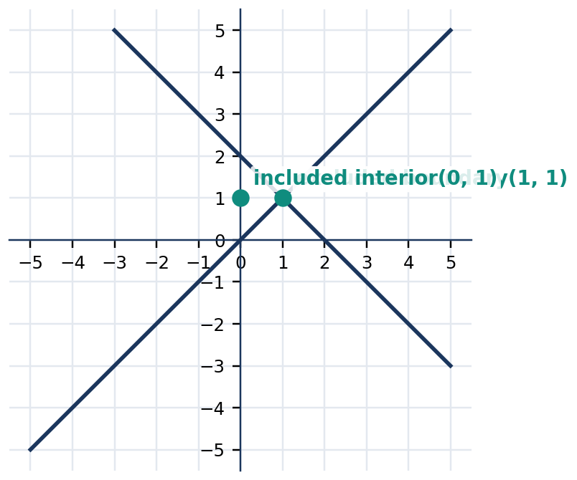
Figure 3.7.9 Figure 3.7.9. Dashed boundaries y=x and y=2-x: the point (1,1) lies on y=x and is excluded, while (0,1) satisfies both strict inequalities.

6. SUBTOPIC 3.7.3 — FEASIBLE REGIONS AND REAL-WORLD RESTRICTIONS

A practical modeling problem may involve three or more inequalities. Plot each boundary accurately; shade according to its symbol, and retain only the common region. The first quadrant is frequently relevant because quantities such as products, hours, and distances cannot be negative. Vertical or horizontal inequalities such as $x≥0$ and $y≥0$ can be graphed without solving for $y$. The result may be bounded, unbounded, empty, or reduced to a line segment or point depending on the conditions. This lesson focuses on describing and testing feasibility; optimizing a profit function is beyond its central requirement.
📐 KEY CONCEPT — Feasible Region
A pair $(x,y)$ is feasible when it satisfies every mathematical restriction and every contextual restriction. For example, $x≥0$, $y≥0$, $x+y≤8$, and $2x+y≤12$ define a closed common region in the first quadrant. Graphical boundary lines are included because each inequality is non-strict.

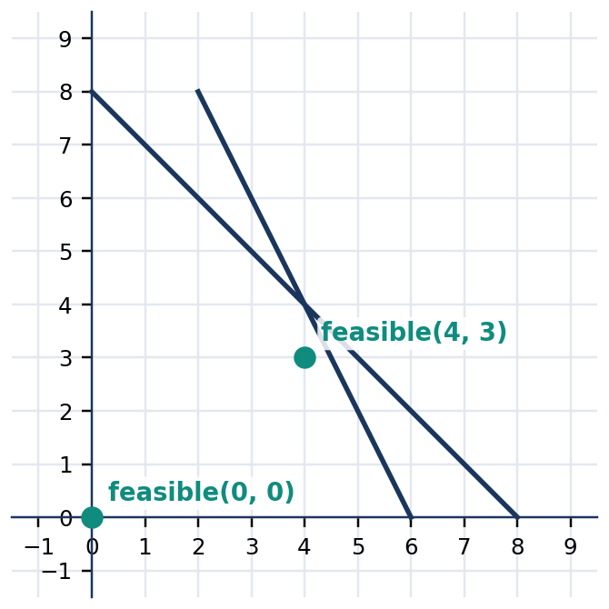
Figure 3.7.10 Figure 3.7.10. The feasible first-quadrant region lies below x+y=8 and below 2x+y=12. The point (4,3) satisfies both.
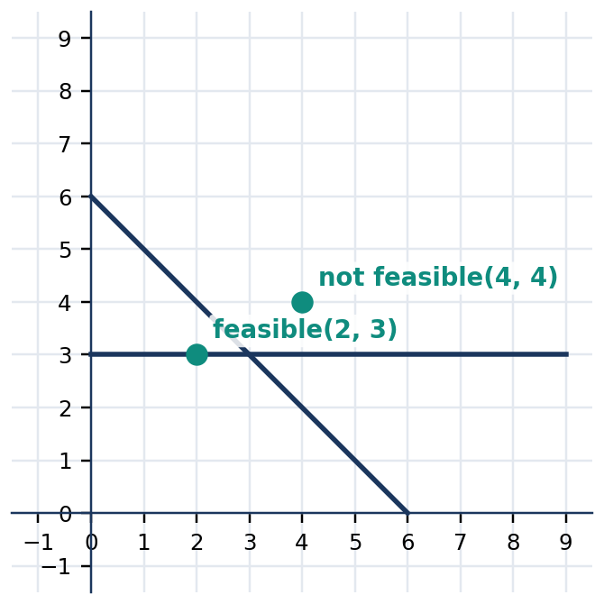
Figure 3.7.11 Figure 3.7.11. First-quadrant region below x+y=6 and above y=3; candidate (2,3) satisfies both boundaries but (4,4) exceeds the total.
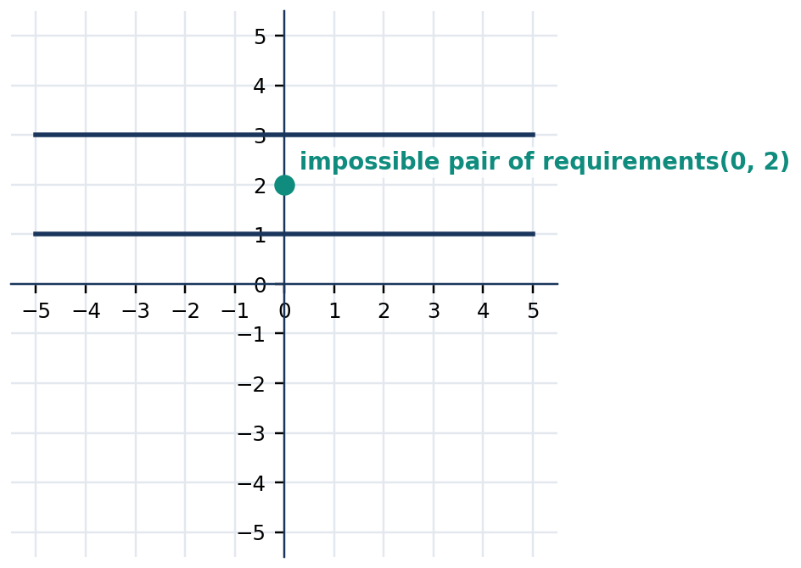
Figure 3.7.12 Figure 3.7.12. Conditions y<=1 and y>=3 have no common shaded area. The system is infeasible.
Step | Operation | Check
1 | Identify variables and units | Are counts or measurements nonnegative?
2 | Translate every restriction | Is “at most” $≤$ and “at least” $≥$?
3 | Draw boundary equations | Are intercepts and scales exact?
4 | Determine side and boundary style | Does a test point satisfy the original?
5 | Identify overlap | Does a candidate satisfy all restrictions?

Quick Check 3.7C: (1) Test $(2,3)$ in $x+y≤6$ and $y≥ x$. (2) State why $(−1,4)$ cannot mean a purchase of negative one notebook. (3) Describe the solution set of $y≤1$ and $y≥3$.

7. GUIDED AND INDEPENDENT PRACTICE

Task 3.7.1 — Basic (Items 1–12). For each inequality, identify boundary type and correct shading; for the indicated point, test membership where requested.
1. y > x+1 | 2. y <= 2x-3
3. y >= −x+4 | 4. y < −2x+1
5. x >= 2 | 6. x < −1
7. y >= 0 | 8. y < 3
9. Test (1,3) in y > x+1 | 10. Test (2,1) in y <= 2x-3
11. Test (0,0) in x+y <= 5 | 12. Test (1,1) in y > 2x

Task 3.7.2 — Intermediate (Items 13–18). Rearrange, graph, and justify the shading direction. For systems, supply a valid point or explain why none exists.
13. Graph 2x+y <= 6 | 14. Graph 3x-y > 2
15. Graph −2y <= 4x-8 | 16. Graph y >= x and y <= 4-x
17. Find two solutions of x>=0, y>=0, x+y<=4 | 18. Decide feasibility of y>4 and y<1

Task 3.7.3 — Challenge / Word Problems (19–22). Show the inequality system, a labeled graph, a tested feasible point, and an interpretation.
19. A student buys $x$ ₱15 pencils and $y$ ₱20 notebooks, with at most ₱120 to spend and at least four items in total. Give one integer combination.
20. A school garden uses $x$ square meters for vegetables and $y$ square meters for flowers. The combined area is at most 30 m², and vegetables must receive at least 12 m². Identify a feasible allocation.
21. A class prepares $x$ snack packs and $y$ drink packs. It needs at least 20 packs and has materials for at most 28. Find three nonnegative whole-number solutions.
22. The inequalities $x+y≤8$, $x≥0$, and $y≥0$ model available seats. Explain whether $(5,4)$ is feasible, and give a feasible replacement.
Task 3.7.4 — Analytical Matrix. Complete the table with a true/false determination and a substitution-based justification.
Candidate and system | Satisfies first? | Satisfies second? | Feasible?
$(1,2)$; $y≥ x$, $y≤3-x$ | ____ | ____ | ____
$(3,0)$; $x≥0$, $x+y<3$ | ____ | ____ | ____
$(2,2)$; $x+y≤5$, $2x+y≥6$ | ____ | ____ | ____
$(−1,4)$; $x≥0$, $x+y≤5$ | ____ | ____ | ____
$(0,0)$; $y>x+1$, $x≤2$ | ____ | ____ | ____

8. CONTEXTUAL APPLICATION — COMMUNITY READING KITS

A student council has ₱300 to prepare reading kits. A notebook costs ₱30 and a pen costs ₱10. The council wants at least twelve total items, with the quantities $x$ and $y$ representing notebooks and pens. Write the restrictions $30x+10y≤300$, $x+y≥12$, $x≥0$, $y≥0$, with both counts whole numbers. Determine whether $(6,10)$ is feasible; then find one different feasible combination. Draw the boundary lines, show the overlapping region, and label two tested integer points.
Focused scoring guide (12 points): Correct variables and inequalities (4); accurate boundaries and common region (4); numerical checking of two whole-number combinations (2); interpretation with pesos and item counts (2).

9. METACOGNITIVE 3–2–1 EXIT TICKET AND LESSON SUMMARY

3: Write three differences among equations, individual inequalities, and systems of inequalities. 2: Identify two errors a graphing student might make with boundaries or negative coefficients. 1: Name one resource-allocation decision that could be improved by identifying a feasible region.
LESSON SUMMARY: A two-variable linear inequality describes a half-plane bounded by a line. Solid boundaries include equality; dashed boundaries exclude it. To graph, draw the corresponding equation, test an off-line point, and shade the appropriate side. A system's solutions lie in the overlap of all regions. Candidate points must pass every inequality and any contextual limitations such as whole-number counts and nonnegative quantities.

10. FORMATIVE ASSESSMENT — 15 ITEMS

Part I. Multiple Choice (1–10). Mark one option for each item; each question is worth one point.
1. $[ ]$ The boundary of $y≤2x+1$ is: A. dashed B. solid C. vertical D. absent.
2. $[ ]$ Which point satisfies $y>x+2$? A. $(0,1)$ B. $(2,2)$ C. $(1,3)$ D. $(0,3)$.
3. $[ ]$ Solving $−2y<6$ gives: A. $y>−3$ B. $y<−3$ C. $y>3$ D. $y<3$.
4. $[ ]$ Which statement is true for $x≥2$? A. Shade left of a dashed line B. Shade left of a solid line C. Shade right of a solid vertical line D. Shade above a horizontal line.
5. $[ ]$ The pair $(2,1)$ satisfies both $x+y≤4$ and: A. $y>x$ B. $x≥ y$ C. $y≥3$ D. $x<0$.
6. $[ ]$ Which point is NOT feasible for $x≥0$, $y≥0$, $x+y≤5$? A. $(3,3)$ B. $(0,5)$ C. $(2,2)$ D. $(1,0)$.
7. $[ ]$ For $y>x-1$, which region is shaded? A. below a solid line B. above a solid line C. below a dashed line D. above a dashed line.
8. $[ ]$ The system $y≤1$ and $y≥3$ has: A. infinitely many solutions B. exactly one solution C. no solutions D. all points as solutions.
9. $[ ]$ An “at most ₱200” spending limit is represented by: A. $c≤200$ B. $c≥200$ C. $c>200$ D. $c=200$ only.
10. $[ ]$ Which of these points satisfies $y≥ x$ and $y≤4-x$? A. $(3,3)$ B. $(1,2)$ C. $(4,1)$ D. $(2,3)$.
Part II. Open Calculation and Reasoning (11–15). Show all work, relevant graph details, and verification.
11. Convert $3x-y≥5$ into slope-intercept inequality form. State whether the boundary is solid or dashed and use a test point to determine the shaded side.
12. For $y≥ x$ and $y≤6-x$, determine the intersection of the boundary lines and test whether $(2,3)$ is feasible.
13. Graph $x≥0$, $y≥0$, and $x+y≤5$. Name three feasible whole-number ordered pairs and one point that is outside the region.
14. A youth group can spend at most ₱240 on ₱30 booklets and ₱20 pens. It needs at least nine items. Write a system for counts $x$ and $y$, and check whether $(4,6)$ is feasible.
15. A learner graphs $−y≤2x-6$ by writing $y≤−2x+6$. Diagnose the error, correct the inequality, and use $(0,0)$ to determine which side of the boundary is shaded.

COMPREHENSIVE QUARTER ASSESSMENT — 50 POINTS

Mathematics 8 • Quarter 3 • Lessons 3.1–3.7

Part I — Multiple-Choice Assessment (30 points)

Directions: Choose the best answer. Each question earns one point. Use separate paper for computations.
1. [ ] Three more than twice a number is 19. Which equation represents the statement?
A. 2(x+3)=19 B. 2x+3=19 C. 3x-2=19 D. 2x-3=19
2. [ ] Solve $5x-12=23$.
A. $x=5$ B. $x=11$ C. $x=7$ D. $x=9$
3. [ ] Two consecutive integers sum to 57. What is the smaller?
A. $27 B. $29 C. $28 D. $30
4. [ ] A rectangle has length 3 cm longer than its width and perimeter 34 cm. Find its width.
A. 7 cm B. 10 cm C. 8 cm D. 14 cm
5. [ ] Which expression represents “at most 12 students”?
A. $n>12$ B. $n<12$ C. $n≥12$ D. $n≤12$
6. [ ] Solve $−4x>20$.
A. $x> −5$ B. $x< −5$ C. $x<5$ D. $x≥−5$
7. [ ] Which number-line graph represents $x≥−2$?
A. Open circle at −2, shade right B. Filled circle at −2, shade left C. Filled circle at −2, shade right D. Open circle at −2, shade left
8. [ ] A ₱40 fixed fee plus ₱15 per entry must be no more than ₱160. What is the maximum number of entries?
A. 8 B. 7 C. 9 D. 6
9. [ ] Which ordered pair satisfies $3x+y=11$?
A. (1,5) B. (2,4) C. (3,2) D. (3,3)
10. [ ] If $x=2$ in $y=4x-3$, find $y$.
A. 5 B. 8 C. 11 D. −5
11. [ ] How many real ordered pairs solve $x+y=6$?
A. Exactly six B. Exactly one C. None D. Infinitely many
12. [ ] What is the slope through $(1,2)$ and $(4,8)$?
A. 3 B. 2 C. −2 D. 1/2
13. [ ] What is the y-intercept of $y=−2x+5$?
A. (5,0) B. (0,−2) C. (−2,0) D. (0,5)
14. [ ] What is the slope of a horizontal line?
A. Undefined B. 0 C. 1 D. −1
15. [ ] Find the x-intercept of $3x+2y=12$.
A. (4,0) B. (0,6) C. (6,0) D. (0,4)
16. [ ] Which equation has slope 3 and y-intercept −1?
A. $y=3x+1$ B. $y=−x+3$ C. $y=3x-1$ D. $y=−3x-1$
17. [ ] A line through $(2,5)$ has slope 2. Find its equation.
A. $y=2x+1$ B. $y=2x-1$ C. $y=x+3$ D. $y=−2x+9$
18. [ ] Which is the equation of the vertical line through $(−3,2)$?
A. $y=−3$ B. $y=2$ C. $x=2$ D. $x=−3$
19. [ ] The line through $(0,4)$ and $(2,0)$ has slope:
A. 2 B. −2 C. −1/2 D. 4
20. [ ] The system $x+y=9$, $x-y=3$ has solution:
A. (3,6) B. (6,3) C. (9,3) D. (5,4)
21. [ ] Which method immediately uses $y=2x+1$ in $x+y=10$?
A. Elimination only B. Graphing only C. Substitution D. Trial without verification
22. [ ] The lines $y=3x+2$ and $y=3x-1$ have:
A. Exactly one solution B. No solution C. Two solutions D. Infinitely many solutions
23. [ ] The equations $x+2y=6$ and $2x+4y=12$ have:
A. No solution B. Two solutions C. Exactly one solution D. Infinitely many solutions
24. [ ] Solve $2x+y=12$ and $x+y=7$.
A. (5,2) B. (4,3) C. (7,0) D. (3,4)
25. [ ] What is the boundary style for $y>2x-1$?
A. Solid B. Horizontal only C. Dashed D. No boundary
26. [ ] Which point satisfies $y≤ x+1$?
A. (0,3) B. (1,4) C. (−1,2) D. (2,2)
27. [ ] Solve $−y≤ x-4$.
A. $y≤−x+4$ B. $y≥−x+4$ C. $y≥ x-4$ D. $y<−x+4$
28. [ ] The feasible region of $x≥0$, $y≥0$, $x+y≤4$ lies:
A. In the first quadrant on or below x+y=4 B. Below both coordinate axes C. Only on x+y=4 D. In every quadrant
29. [ ] Which ordered pair satisfies both $y≥ x$ and $y≤4-x$?
A. (3,3) B. (2,3) C. (1,2) D. (4,0)
30. [ ] A project requires at least eight units: $x$ notebooks and $y$ pens. Which inequality is correct?
A. $x+y<8$ B. $x+y≥8$ C. $x+y≤8$ D. $x+y=8$

Part II — Culminating Performance Task (20 points)

Title: Community Learning-Kit Allocation Plan
Goal: Develop and justify a mathematically feasible purchase plan for supplies for a community learning activity.
Role: Student logistics planner and mathematical modeler.
Audience: School learning-resource committee and parent volunteers.
Situation: The committee has at most ₱1,800 to purchase ₱120 reading kits and ₱60 writing kits. It must supply at least 20 kits in total. The available storage space holds at most 24 kits. At least eight must be reading kits.
Product: Submit a one-page modeling report with a labeled coordinate graph, clearly written inequalities, three tested integer purchase plans, a recommended plan with its full cost, and a brief explanation of how the requirements are satisfied.
Standards: Accurate modeling, graphing, integer feasibility, and communication. Use nonnegative integer quantities throughout.
Required mathematics: Let $x$ be reading kits and $y$ writing kits. Express and graph all constraints:
$$120x+60y≤1800$$
$$x+y≥20$$
$$x+y≤24$$
$$x≥8, y≥0$$
Construct the feasible region and distinguish continuous graph solutions from admissible nonnegative integer purchases. Test at least three feasible integer ordered pairs. Compare two practical choices on cost and supply mix.
Analytic Rubric (4 criteria × up to 5 points = 20 points; four performance levels)
Criterion | Level 4 (5 pts) | Level 3 (4 pts) | Level 2 (3 pts) | Level 1 (1–2 pts)
Model and constraints | All five bounds correct and units explained | One minor label error | More than one error but recognizable model | Missing or largely incorrect constraints
Graph and feasible region | Correct scaled lines, shaded intersection and boundary inclusion | Minor graphing imprecision | Partly correct boundaries or intersection | Region unrecognizable or not plotted
Integer solution and verification | Three feasible integer plans, all constraints checked | Three plans, one small computation error | Only one or two correctly checked plans | No defensible feasible plan
Recommendation and mathematical communication | Clear justified choice, cost and trade-offs correctly discussed | Clear choice with limited comparison | Weak justification or incomplete unit references | Unclear or unsupported recommendation

Model feasibility check: $(10,10)$ has 20 kits and costs ₱1,800; $(8,12)$ has 20 kits and costs ₱1,680; $(9,11)$ has 20 kits and costs ₱1,740. Each meets the bounds; additional plans may be valid. Score this project once for the quarter, not once per lesson.

QUARTER SYNTHESIS AND GLOSSARY

Integrated Synthesis

Linear equations and inequalities describe quantitative relationships while expressing distinct logical conditions. An equation states that two expressions have equal values; an inequality states that one expression is greater or less than another, possibly including equality. The process of mathematical modeling begins by defining variables and translating verbal relationships accurately. For one-variable equations, equality-preserving operations make it possible to isolate an unknown. Checks made against the original equation confirm whether a proposed value is mathematically valid; interpretation then determines whether the value is physically sensible. A solution representing an object count, for example, must satisfy whole-number and nonnegativity restrictions in addition to the equation.
One-variable inequalities extend this reasoning to entire solution sets. Addition and subtraction preserve inequality direction, as do multiplication and division by positive values. Multiplication or division by a negative value reverses the inequality sign because it reverses order on the number line. Open circles represent excluded endpoints and filled circles included endpoints. A number-line graph communicates infinitely many possible real-number solutions compactly. Practical contexts may narrow these sets to whole numbers or positive values, and boundary values must be tested carefully when determining a maximum allowable cost or minimum required quantity.
Linear equations in two variables make ordered pairs central. When a point satisfies an equation, substituting both coordinates gives a true statement. A linear equation has infinitely many real ordered-pair solutions, and those solutions form a straight line. Tables of values organize sample coordinates but do not exhaust the solution set. Graphing makes relationships visible: slope describes the constant rate of vertical change per unit horizontal change, and the x- and y-intercepts show where the line meets the coordinate axes. Horizontal and vertical lines require particular attention because their slopes are zero and undefined, respectively.
Writing equations of lines reverses the graphing process. A slope and y-intercept determine a line in slope-intercept form; a slope and point determine a line using point-slope form; two points determine a nonvertical line after calculating its slope. Two nonzero axis intercepts can supply an intercept equation. Equivalent forms must describe the same set of points, and substitution provides a reliable verification. As in practical pricing or consumption models, the sign and magnitude of the slope describe how a quantity grows or decreases, while the y-intercept may represent a starting amount or fixed fee.
Systems connect multiple relationships. The solution of a system of linear equations must satisfy every equation simultaneously. Graphing identifies intersections; substitution replaces a variable by an equal expression; and elimination combines equations to remove a variable. Two distinct nonparallel lines meet once, distinct parallel lines never meet, and coincident lines have infinitely many common solutions. Systems of inequalities instead share a common region. Solid and dashed boundaries tell whether equality is allowed, test points determine which half-plane satisfies each inequality, and the overlap represents all simultaneous feasible conditions. In budgeting and allocation tasks, the final answer must satisfy every algebraic, graphical, and real-world constraint.

Glossary — 25 Terms

Term | Working definition
Variable | A symbol representing a quantity whose value may be unknown or may change.
Constant | A fixed numerical value in an expression or equation.
Coefficient | A number multiplying a variable.
Linear equation | An equation whose graph, in two variables, is a straight line and whose variable terms have degree one.
Linear inequality | An inequality involving an expression linear in its variables.
Open sentence | A mathematical statement with a variable whose truth depends on the chosen value.
Equivalent equations | Equations with exactly the same solution set.
Solution set | All values or ordered pairs satisfying a statement.
Verification | Substitution or another check that establishes whether a proposed solution satisfies the original statement.
Number line | A one-dimensional representation of ordered real numbers.
Endpoint | The boundary value of a one-variable inequality solution interval.
Ordered pair | Two numbers (x,y) giving horizontal and vertical coordinates.
Cartesian plane | A coordinate system formed by perpendicular x- and y-axes.
Slope | The ratio of vertical change to horizontal change for a nonvertical line.
Rise | Difference in vertical coordinates.
Run | Difference in horizontal coordinates.
x-intercept | Point at which a graph meets the horizontal axis.
y-intercept | Point at which a graph meets the vertical axis.
Slope-intercept form | Line equation y=mx+b for slope m and y-intercept b.
Point-slope form | Line equation y−y₁=m(x−x₁) through a specified point.
Substitution | Solving a system by replacing a variable with an equivalent expression.
Elimination | Solving a system by combining equations to remove one variable.
Consistent system | A system with at least one common solution.
Boundary line | The equality line associated with a two-variable linear inequality.
Feasible region | The common region satisfying all inequalities and applicable contextual restrictions.

STRUCTURED ANSWER KEYS AND TEACHER GUIDANCE

Quarterly Assessment — Multiple-Choice Key

Item | 1 | 2 | 3 | 4 | 5 | 6 | 7 | 8 | 9 | 10 | 11 | 12 | 13 | 14 | 15
Answer | B | C | C | A | D | B | C | A | C | A | D | B | D | B | A

Item | 16 | 17 | 18 | 19 | 20 | 21 | 22 | 23 | 24 | 25 | 26 | 27 | 28 | 29 | 30
Answer | C | A | D | B | B | C | B | D | A | C | D | B | A | C | B

Quarterly Assessment — Item Rationales

Item | Correct answer and mathematical justification
1 | B. Two times the unknown, followed by adding three, gives 19.
2 | C. Add 12, then divide 35 by five.
3 | C. If the integers are x and x+1, then 2x+1=57 and x=28.
4 | A. 2w+2(w+3)=34 gives w=7 cm.
5 | D. At most includes 12 and all smaller permissible counts.
6 | B. Divide by negative four and reverse the inequality.
7 | C. The endpoint is included, and the numbers extend to the right.
8 | A. 40+15n≤160 implies n≤8.
9 | C. 3(3)+2=11.
10 | A. 4(2)−3=5.
11 | D. Every real x determines y=6−x.
12 | B. (8−2)/(4−1)=6/3=2.
13 | D. Set x=0 to get y=5.
14 | B. Its vertical change is zero.
15 | A. Set y=0 and solve 3x=12.
16 | C. Use y=mx+b with m=3 and b=−1.
17 | A. Point-slope form y−5=2(x−2) yields y=2x+1.
18 | D. Every point on a vertical line has x-coordinate −3.
19 | B. (0−4)/(2−0)=−2.
20 | B. Adding equations gives 2x=12, x=6 and y=3.
21 | C. Replace y by 2x+1.
22 | B. Equal slopes and different y-intercepts imply parallel distinct lines.
23 | D. The second equation is twice the first.
24 | A. Subtract the equations: x=5; then y=2.
25 | C. Strict inequality excludes equality, so the line is dashed.
26 | D. At (2,2), 2≤3.
27 | B. Multiply by −1 and reverse the sign.
28 | A. Nonnegative x and y restrict to the first quadrant and the sum bound forms a triangle.
29 | C. For (1,2), 2≥1 and 2≤3.
30 | B. At least means eight or more units.

Lesson Formative Assessment — Multiple-Choice Key Grids

Lesson 3.1 — Questions 1–10
Item | 1 | 2 | 3 | 4 | 5 | 6 | 7 | 8 | 9 | 10
Answer | C | A | D | B | D | A | A | B | A | B

Lesson 3.2 — Questions 1–10
Item | 1 | 2 | 3 | 4 | 5 | 6 | 7 | 8 | 9 | 10
Answer | D | A | B | C | C | D | A | B | C | B

Lesson 3.3 — Questions 1–10
Item | 1 | 2 | 3 | 4 | 5 | 6 | 7 | 8 | 9 | 10
Answer | C | A | D | B | A | C | C | B | D | C

Lesson 3.4 — Questions 1–10
Item | 1 | 2 | 3 | 4 | 5 | 6 | 7 | 8 | 9 | 10
Answer | B | A | D | C | A | C | B | D | A | B

Lesson 3.5 — Questions 1–10
Item | 1 | 2 | 3 | 4 | 5 | 6 | 7 | 8 | 9 | 10
Answer | C | A | D | B | C | A | D | B | A | C

Lesson 3.6 — Questions 1–10
Item | 1 | 2 | 3 | 4 | 5 | 6 | 7 | 8 | 9 | 10
Answer | B | C | A | D | B | C | A | D | D | B

Lesson 3.7 — Questions 1–10
Item | 1 | 2 | 3 | 4 | 5 | 6 | 7 | 8 | 9 | 10
Answer | B | D | A | C | B | A | D | C | A | B

Formative Open-Response Key — Items 11–15

Lesson 3.1
Item | Model response | Verification and scoring focus
11 | x+13=40; x=27; 27+13=40. | Subtract 13 from both sides.
12 | 35 and 37; 35+37=72. | Consecutive odds differ by two.
13 | Width 8 cm; length 24 cm. | 2(8+24)=64 cm.
14 | 7 weeks. | 90+45(7)=405 pesos.
15 | The wording is 3x−4=21, giving x=25/3; the incorrect 3(x−4)=21 gives x=11. | Parentheses change what is multiplied.

Lesson 3.2
Item | Model response | Verification and scoring focus
11 | x≤−5; closed at −5, shading left. | Reverse the sign when dividing by −2.
12 | x<6. | 6x−3<4x+9 implies 2x<12.
13 | Six tickets. | 65t+90≤480 implies t≤6.
14 | 0<x≤10 cm. | 4x+10≤50; physical widths positive.
15 | x<−4, not x>−4. | −5(−5)>20 is true; −5(1)>20 is false.

Lesson 3.3
Item | Model response | Verification and scoring focus
11 | (3,4) satisfies 2(3)+4=10; (4,3) does not, since 8+3=11. | Ordered pairs cannot swap coordinates indiscriminately.
12 | For x=0,1,2,3: y=5,3,1,−1. | Use y=5−2x for each entry.
13 | 20n+5p=100; (n,p)=(0,20),(1,16),(2,12). | All pairs nonnegative integers and satisfy the total.
14 | There are ten nonnegative integer pairs (0,9),(1,8),…,(9,0). | For real x, every real value gives y=9−x.
15 | False; (1,2) and (3,1) also satisfy x+2y=5. | The real solutions lie on a straight line.

Lesson 3.4
Item | Model response | Verification and scoring focus
11 | Slope −1. | (−4−2)/(3−(−3))=−6/6=−1.
12 | Intercepts (4,0) and (0,6). | 3(4)+0=12 and 0+2(6)=12.
13 | A second point is (0,−1). | From (−1,2), move right 1 and down 3.
14 | V=80−10t liters, 0≤t≤8 min; intercepts (0,80) and (8,0). | Slope −10 L/min; initial 80 L.
15 | x=4 is vertical and its slope is undefined; no y-intercept. | The vertical line does not cross x=0.

Lesson 3.5
Item | Model response | Verification and scoring focus
11 | y=2x+3. | Slope (7−(−1))/(2−(−2))=2; test both points.
12 | y−1=−3/2(x−4), or y=−3x/2+7. | Substitution of (4,1) confirms.
13 | x−2y=−6. | Check (−6,0) and (0,3).
14 | C=12d+50 pesos. | Slope (122−74)/(6−2)=12 pesos/km; fixed fee ₱50.
15 | y=4x−2; another point (0,−2). | At (2,6), the wrong model yields 9 rather than 6.

Lesson 3.6
Item | Model response | Verification and scoring focus
11 | (5,3). | Add 2x+y=13 and x−y=2 to obtain 3x=15.
12 | (4,7). | Substitute y=x+3 into 2x+y=15.
13 | (a) no solutions; (b) infinitely many. | Parallel distinct versus coincident lines.
14 | 11 snacks and 7 drinks. | s+d=18 and 30s+50d=680 imply d=7 and s=11.
15 | (1,8). | At (4,2), x+y=6≠9; subtract x+y=9 from 2x+y=10 to get x=1 and y=8.

Lesson 3.7
Item | Model response | Verification and scoring focus
11 | y≤3x−5; solid boundary; (0,0) fails. | Dividing −y≤5−3x by −1 reverses inequality.
12 | Boundary crossing (3,3); (2,3) feasible. | 3≥2 and 3≤4.
13 | (0,0),(2,2),(5,0) feasible; (4,4) outside. | All feasible points have nonnegative coordinates and sum≤5.
14 | 30x+20y≤240, x+y≥9, x,y nonnegative whole numbers; (4,6) is feasible. | 30(4)+20(6)=240 and 4+6=10≥9.
15 | y≥−2x+6; (0,0) fails so shade above the solid line. | Multiplying by −1 reverses inequality.

Guided Practice and Contextual Tasks — Checking Guide

The numerical answers to all routine exercises should be checked against each learner’s shown equation and substituted into the source problem. For number-line solutions, check the endpoint inclusion and direction; for coordinate graphs, check plotted points, axis scales, and intercepts. For contextual tasks, award credit only when the mathematical answer also satisfies practical integer, nonnegative, and unit restrictions.
Recommended marking: For a five-point extended calculation, award one point each for identifying unknowns, constructing the model, valid transformations, the correct result with units, and a verification or interpretation. Apply alternative correct methods consistently.

EDITORIAL QUALITY AND CURRICULUM AUDIT

Quarter: Mathematics 8 • Quarter 3 • Seven lessons
Audit dimension | Maximum | Verified at manuscript stage
Curriculum alignment to the 15 official Quarter 3 competencies | 20 | Scope mapped; code audit remains open
Grade 8 cognitive demand, language, and accessibility | 20 | Editorial review required
Equation, figure, and answer-key numerical accuracy | 20 | Targeted computational checks completed; full verification pending
Pedagogical density and 45–70 page target | 20 | Page count cannot be confirmed until Word rendering; word ceiling exceeded
Cover, videos, assessment distribution, layout and keys | 20 | Structural items present; publishing checks required

Verified audit score: Not assigned. Certification status: PENDING.
Open checks before distribution: (1) Render the DOCX and verify 45–70 pages and page-numbered table of contents; (2) independently verify all 7×22 exercises and seven formative test sets against their original question options; (3) review code-rendered figures and embedded equations; (4) confirm all multimedia links; (5) reconcile final word total against the 25,000-word ceiling without deleting any published lesson text; (6) visually inspect the cover and tables.
Manuscript integrity: Existing front matter and seven lessons remain unchanged; the back matter is appended as additional material.

