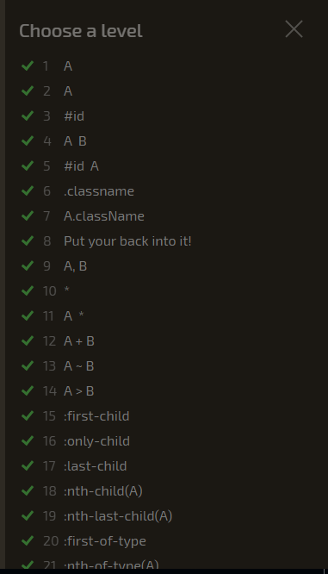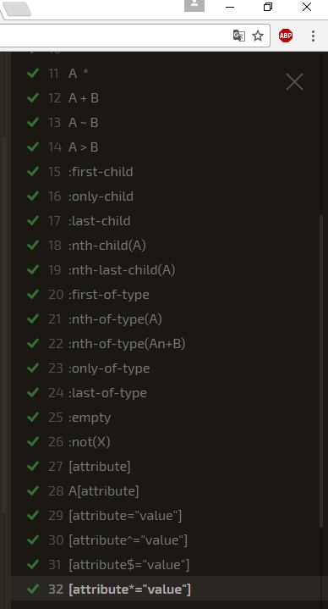

Level 1: plate Level 16: apple:only-child, plate pickle:only-child Level 31: [for$="ato"]

Level 2: bento Level 17: .small:last-child Level 32: [for*="bb"]

Level 3: #fancy Level 18: plate:nth-child(3)

Level 4: plate apple Level 19: bento:last-child(2)

Level 5: #fancy pickle Level 20: apple:first-of-type

Level 6: .small Level 21: :nth-child(even)

Level 7: orange.small Level 22: :nth-child(2n+3)

Level 8: bento orange.small Level 23: .small:only-of-type

Level 9: plate, bento Level 24: .small:last-of-type

Level 10: * Level 25: bento:empty

Level 11: plate * Level 26: apple:not(.small)

Level 12: plate + apple Level 27: [for]

Level 13: bento ~ pickle Level 28: [for="Luke"], [for="Sarah"]

Level 14: plate > apple Level 29: [for="Vitaly"]

Level 15: orange:first-child Level 30: [for^="S”]

**TASK 3**

1. 0   
2. 1   
3. 1   
4. 3   
5. 11   
6. 13   
7. 21   
8. 100   
9. 111   
10. 111   
11. 103   
12. 101   
13. 2   
14. 1   
15. 203   
16. 24   
17. 122   
18. 21   
19. 211   
20. 21   
21. 10