**LAB 7b: EXPLOITING XSS (cont.)**

**Class:** IA1701

**Name:**  Đoàn Phúc Hiếu

**Student ID:** SE171493

**Objectives:**

1. This lab reflects your input in a JavaScript URL, but all is not as it seems. This initially seems like a trivial challenge; however, the application is blocking some characters in an attempt to prevent XSS attacks.
2. This lab using a strict CSP that blocks outgoing requests to external web sites.

In this lab, you need to:

* Perform these challenges:
  + [Reflected XSS in a JavaScript URL with some characters blocked](https://portswigger.net/web-security/cross-site-scripting/contexts/lab-javascript-url-some-characters-blocked)
  + [Reflected XSS protected by very strict CSP, with dangling markup attack](https://portswigger.net/web-security/cross-site-scripting/content-security-policy/lab-very-strict-csp-with-dangling-markup-attack)
* Provide captured results.
* Report file name: **Class_ YourName_ YourStudentID_Lab7b**.(pdf or docx).

***Recommendation (optional)****: finish all labs here*

[*https://portswigger.net/web-security/all-labs#cross-site-scripting*](https://portswigger.net/web-security/all-labs#cross-site-scripting)

**1. Reflected XSS in a JavaScript URL with some characters blocked**

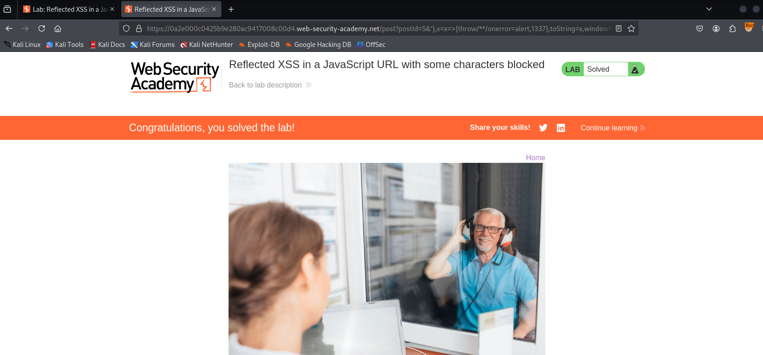

**2. Reflected XSS protected by very strict CSP, with dangling markup attack**

