Power localization of cochlear implant recipients with preserved acoustic hearing in the implanted ear (EAS) & contralateral hearing aid

# Bimodal (1 CI & contra HA) vs best aided (1 CI & 2 HA)

# Subjects: 30 40 14

# Repetitions: 2 1 18

***Population:***

Gain improves (HDI>0.1): 77% 81% 54%

Bias improves (HDI<0): 36% 47% 13%

MAE improves (t-test): 17% 19% 11%

RMS improves (t-test): 19% 25% 12%

***Individual “hit” (estimate improvement/deterioration if actual/simulated improvement/deterioration):***

Gain (HDI>0.1): 66% 59% 78%

Bias (HDI<0): 85% 78% 95%

***Individually precise estimate (bias HDI<12 deg, gain HDI<0.2):***

Gain Bimodal: 95% 0% 100%

Gain Best-aided: 95% 0% 100%

Gain Improvement: 0% 0% 100%

Bias Bimodal: 100% 44% 100%

Bias Best-aided: 100% 36% 100%

Bias Improvement: 40% 0% 100%

# Notes

HDI = highest-density interval (cf. confidence interval)

Data taken from: (Gifford et al., 2014)

Analysis adapted from:

- (Kruschke, 2014) Chapter 13 (Goals, power and sample size) and chapter 17 (Metric Predicted Variable with Multiple Metric Predictors)

- (Rucker, McShane, & Preacher, 2015)

Analysis scripts can be found at:

<https://gitlab.science.ru.nl/marcw/bayesian-data-analysis.git>

(ss_gifford_regresspower.m)

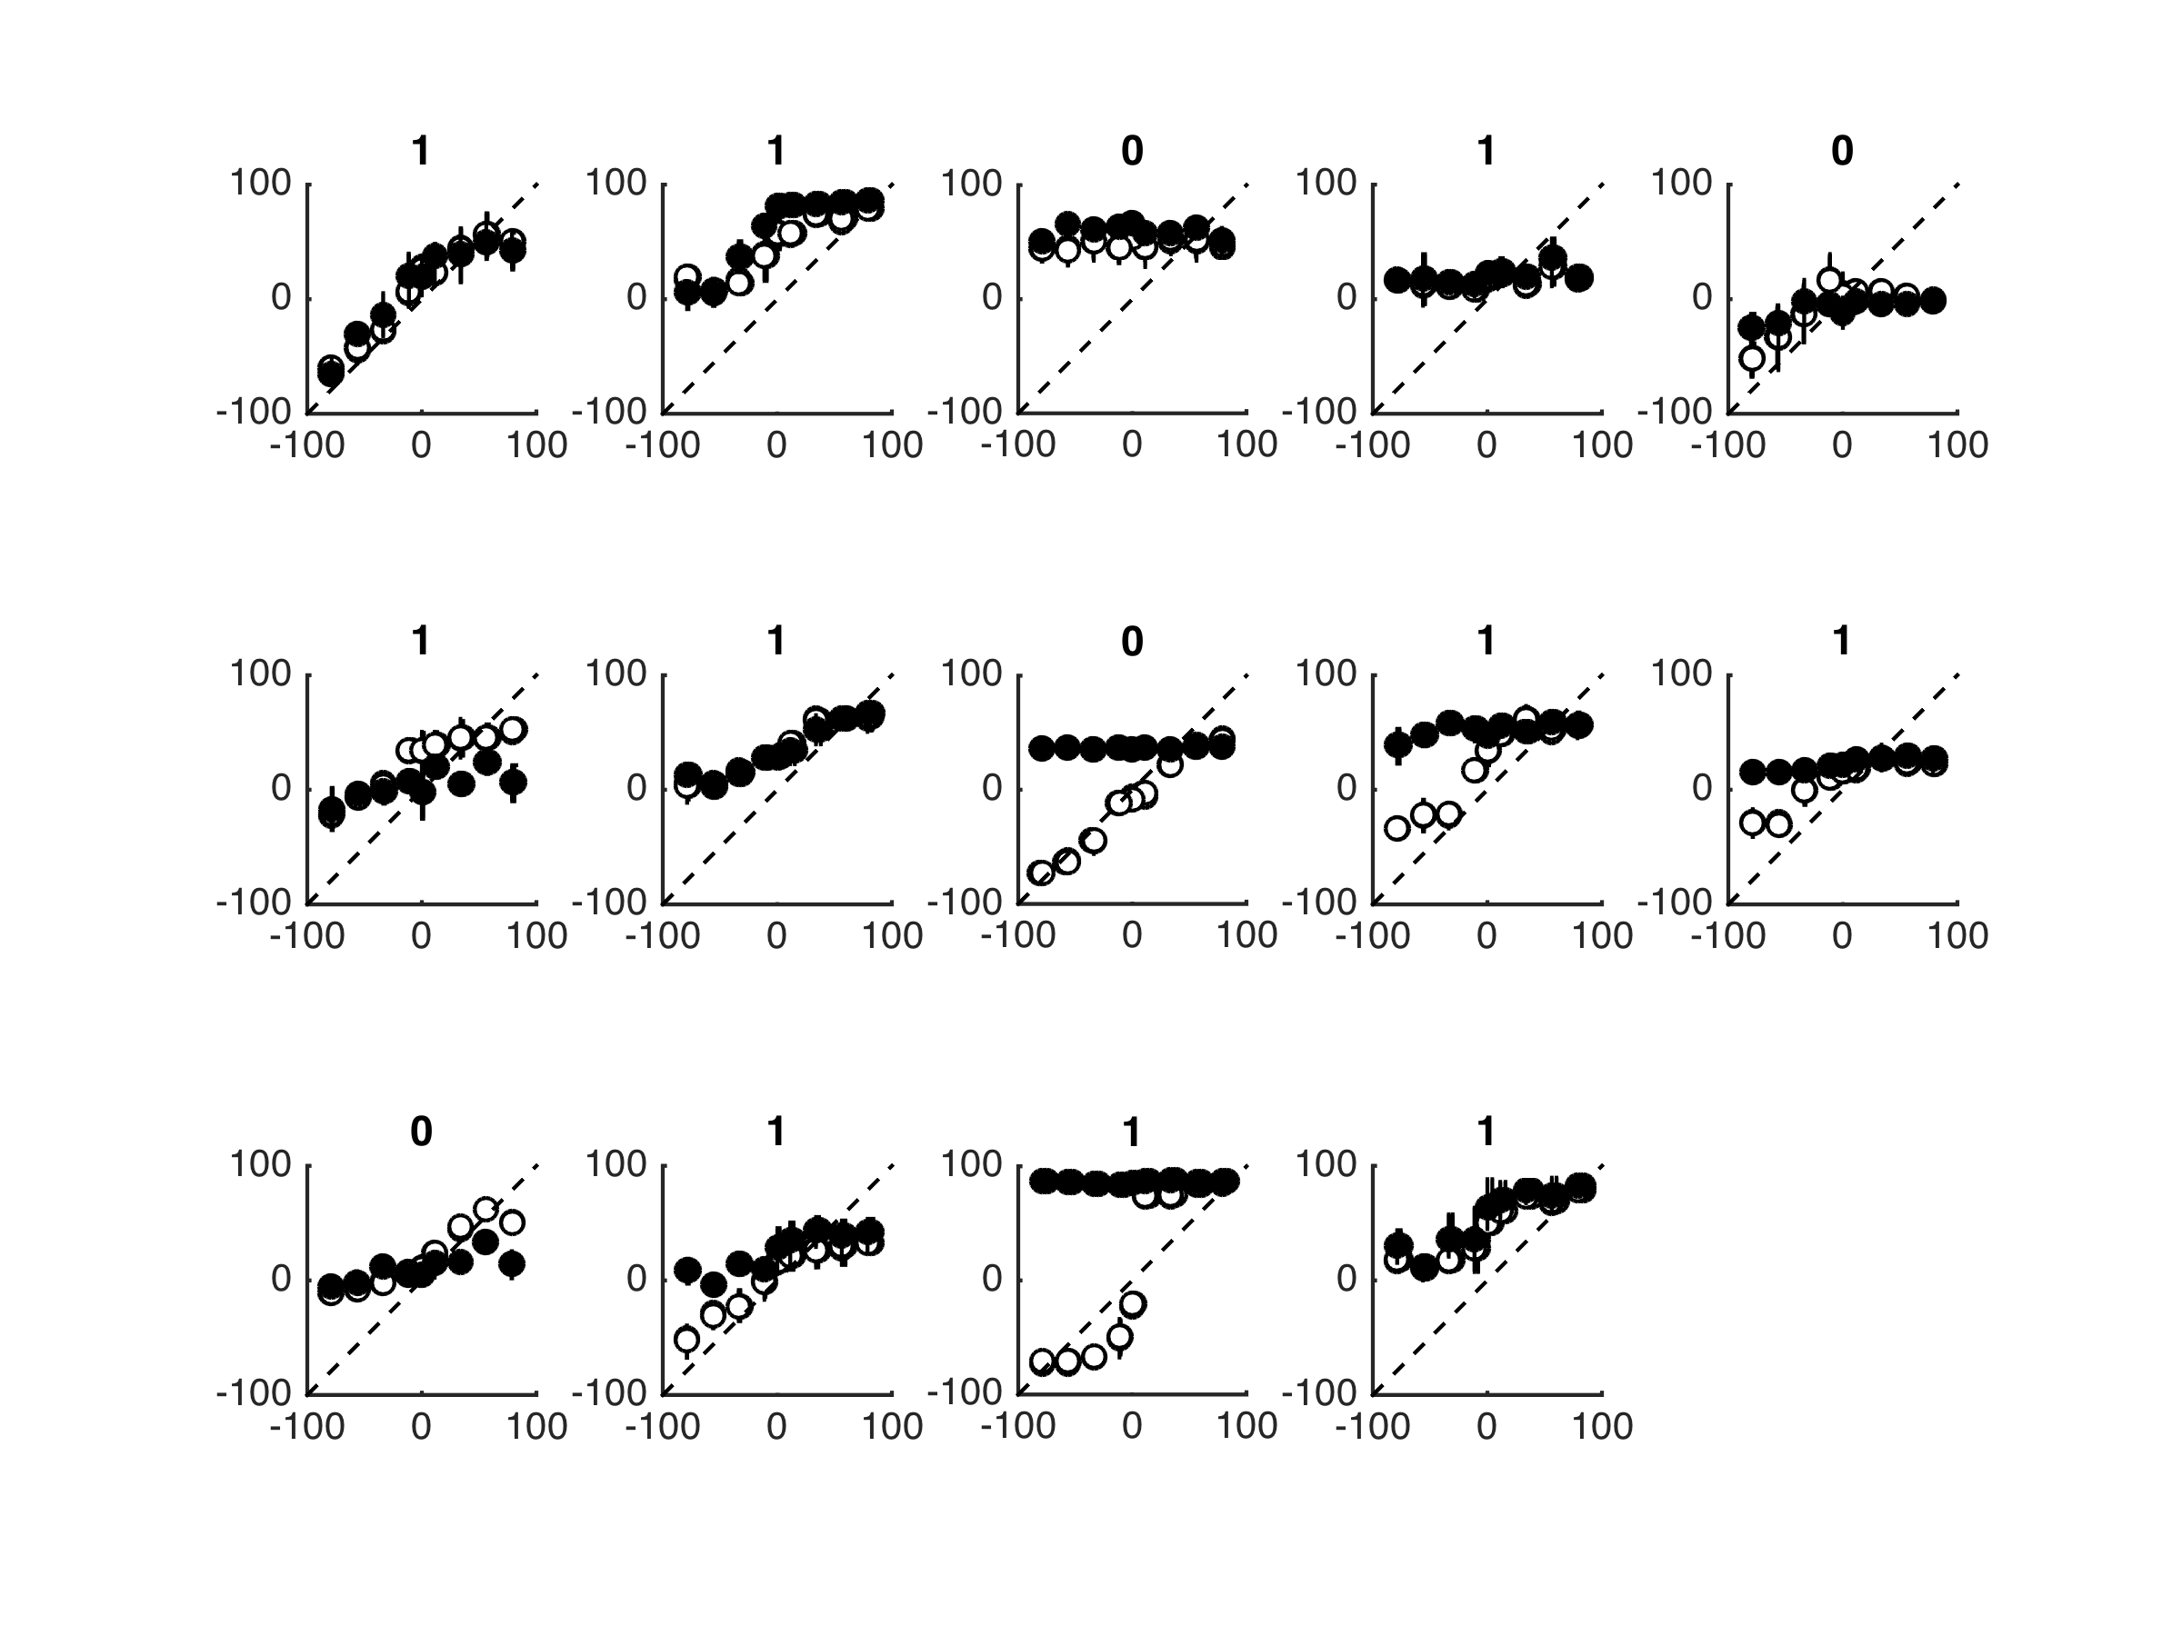

Fig.1 Gifford data. Cf Fig. 4 in (Gifford et al., 2014)

# Literature

Gifford, R. H., Grantham, D. W., Sheffield, S. W., Davis, T. J., Dwyer, R., & Dorman, M. F. (2014). Localization and interaural time difference (ITD) thresholds for cochlear implant recipients with preserved acoustic hearing in the implanted ear. *Hearing Research*, *312*, 28–37.

Kruschke, J. K. (2014). *Doing Bayesian Data Analysis* (2nd ed.). Academic Press. Retrieved from http://store.elsevier.com/Doing-Bayesian-Data-Analysis/John-Kruschke/isbn-9780124058880/

Rucker, D. D., McShane, B. B., & Preacher, K. J. (2015). A Researcher’s Guide to Regression, Discretization, and Median Splits of Continuous Variables. *Journal of Consumer Psychology*. doi:10.1016/j.jcps.2015.04.004