

**GAME 2023 GAME ENGINE II**

**Assignment**

**DESCRIPTION:**

The assignment is to create an A.I. agent which follows a spline path using **NavMesh** for pathfinding, and a **Behavior Tree** to determine its next action.

The A.I. will have “moods” based on player interaction with it. eg. Scared, Worried, Calm. This mood will be apparent through an aura around the actor, that ranges in colour from Green (calm), Yellow (worried), Red (scared).

**REQUIREMENTS:**

1. Start a new First Person project (C++ or blueprints, your choice), with the naming convention: *LastName_FirstName*_Assign01 (eg. Bellemare_Al_Assign01)
2. Your level must have a looping **Spline** path that your A.I. will use as a *guide* for where to walk next.
   1. Make sure that it is obvious that your ai is using a spline to guide its movement. Eg: Do not draw a straight line with your spline. Give it some form, like a deformed circle.
3. Create an A.I. character with the following behaviour using **BehaviorTrees** and a **NavMesh**
   1. If the player is close by (eg. 500 cm) and fires their gun, stop moving and be **[SCARED]** for 3-5 seconds
   2. If the player is close by (eg. 500 cm), act normally but be **[WORRIED]**
   3. Otherwise, act normally and be **[CALM]**
   4. Normal behaviour is:
      1. Find the next point along the spline (eg. move forward by 20cm increments)
      2. Walk to that next point on the spline
      3. After arriving at this point, goto i)
   5. **NOTE:** You may wish to [migrate](https://docs.unrealengine.com/en-US/Engine/Content/Browser/UserGuide/Migrate/index.html) the Third Person character assets from another project
4. A coloured ‘aura’ surrounds the A.I. to tell us their Mood.
   1. Using a mesh that surrounds the actor (eg. scale a Sphere mesh into an elliptical shape or a duplicate of the skeletal mesh applying the same animation blueprint)
   2. Only the ‘backface’ should be drawn for this actor, so that it doesn’t cover your character. Accomplish this with an **Opacity Masked** material in **TwoSided** mode and the **TwoSidedSign** node.  
      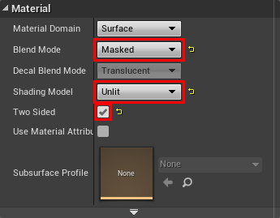  
      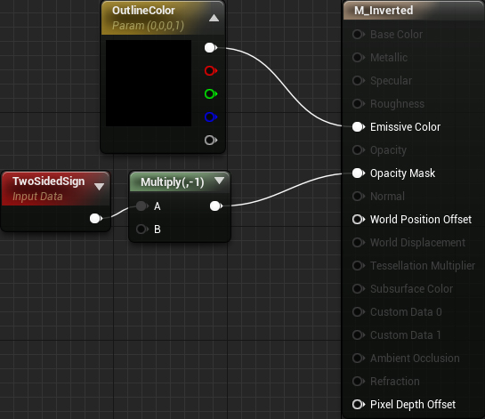
   3. You may also want to extrude the vertices a bit along the normals, so that it is larger than the original mesh. This can be done using the **VertexNormalWS** node  
      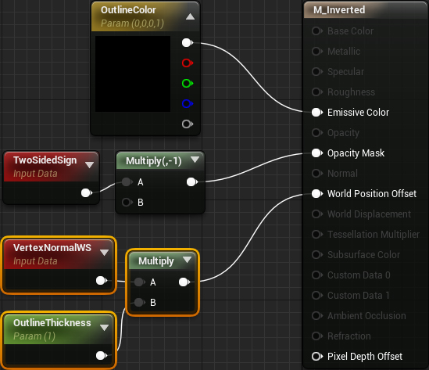
   4. Change the aura’s colour based on the character mood. See Week 9 notes for how to use [**CreateDynamicMaterialInstance**](https://docs.unrealengine.com/en-US/BlueprintAPI/Rendering/Material/CreateDynamicMaterialInstance/index.html)and setting material parameters from C++ or Blueprints
5. Package your project
   1. in **DEVELOPMENT** build configuration mode
   2. Win64
   3. Please delete all *.pdb debug files to reduce package size
6. Follow submission instructions on the next page carefully!

**DUE DATE:**

The Friday of Week 14, 11:59pm

**DELIVERABLES:**

**To be submitted to Perforce:**

1. Project files (see submission guidelines below)
2. Packaged SHIPPING build (Win64)

**To be submitted to Blackboard:**

Screenshot of the Perforce Depot tab, displaying the submitted content

**RECOMMENDED: REGULAR SOURCE CONTROL BACKUPS**

***IMPORTANT! READ THIS CAREFULLY. Be sure you’re not including large and unnecessary directories.***

|  |
| --- |
| **\*\*\*\*\*\*\*\*\*\*\*\*\*\*\*\*\*\*\*\*\*\*\*\*\*\*\*\*\*\*\*\*\*\*\*\*\*\*\*\*\*\*\*\*\*\*\*\*\*\*\*\*\*\*\*\*\*\*\*\*\*\*\*\*\*\*\*\*\*\***  **IF submitting a C++ Project (not applicable to Blueprint only projects):**  **Close the editor and re-compile your project in visual studio**  **To clear out hot-reload dlls and to make the project usable without needing to recompile.**  **\*\*\*\*\*\*\*\*\*\*\*\*\*\*\*\*\*\*\*\*\*\*\*\*\*\*\*\*\*\*\*\*\*\*\*\*\*\*\*\*\*\*\*\*\*\*\*\*\*\*\*\*\*\*\*\*\*\*\*\*\*\*\*\*\*\*\*\*\*\*** |

In P4V, mark **ONLY** the following files and folders for add:

* The .**uproject**
* The **Content directory**
  + Not the StarterContent directory
* The **Config directory**
* The **Source directory** *(if there is one)*
* Binaries/Win64/UE4Editor.modules *(if available)*
* Binaries/Win64/UE4Editor-ProjectName.dll *(if available)*

Submit the marked files and write a changelist description.

|  |
| --- |
| **\*\*\*\*\*\*\*\*\*\*\*\*\*\*\*\*\*\*\*\*\*\*\*\*\*\*\*\*\*\*\*\*\*\*\*\*\*\*\*\*\*\*\*\*\*\*\*\*\*\*\*\*\*\*\*\*\*\*\*\*\*\*\*\*\*\*\*\*\*\***  **DO NOT Submit the following:**   * **.vs** folder * **intermediate** folder * **binary** folder content, other than the two files listed above * **saved** folder   **\*\*\*\*\*\*\*\*\*\*\*\*\*\*\*\*\*\*\*\*\*\*\*\*\*\*\*\*\*\*\*\*\*\*\*\*\*\*\*\*\*\*\*\*\*\*\*\*\*\*\*\*\*\*\*\*\*\*\*\*\*\*\*\*\*\*\*\*\*\*** |