In the context of 30 meters class telescope, segmented primary mirror are needed. This add the constraint of an extra control system that actively insure the segmented mirror behave like a monolithic one. For this control system require a specific sensor that will look at the segmentation only. This article aim at the comparison of two different sensor: a simple pin hole and a phase contrast sensor. This comparison is done when considering only one single edge common to two segment taken in the center of the pupil.

The starting point is with the segment images stacked (no tip tilt error or very little) and coarsely focused. What only remain are less than a wavelength OPD errors.

The simple pinhole simplified setup is depicted in !!!. it consist of a pinhole placed in the telescope focal plan that has a size comparable to the one of the seeing. The expected effect is the pinhole smears out the image of each segment. The overlapping smeared part will interfere with each other’s. On this overlapping zone there will be constructive interferences when the phase step between the two segment is zero or an integer multiple of the wavelength. And a destructive interference when the phase step is a multiple of half the wavelength.

Now in order to interpret this signal, the observable is the coherence envelope of this signal. The idea is to move the segment with a known modulation, such that the period of the fringe cycle will stand out of the atmospheric noise. Then knowing that recover the coherence envelop and find the middle of it.

The phase contrast sensor, is a device already tested with the APE experiment on sky under the Zernike phase contrast Unit Sensor as explained in!!!. It consist of a parallel plate with a dip in the middle of it, aligned in the focal plan with optical axis of the telescope. This dip is circular shaped with a depth of in the ideal case. The size of this dip is also similar to the seeing. Like the pin hole the dip must be placed where the PSF form (see fig!!!)

The way to interpret this signal is extensively explained by Surdej et al (2011), and in short consist in fitting the signal which one is plotted in figure !!!.

The rest of this article will compare only the signals themselves under ideal condition, then adding only the atmosphere. There will be a quick comparison with experimental result. The third part will be a discussion on what is the optimal compromise between sampling of both signals and performance.

# The fisher information and the Cramer Rao Lower bound

This article make the use of the fisher information as developed in Noethe et al(2007) and used in Surdej et al (2011). This section only remind the reader of the essential point used in this article.

The fisher is defined as:

With being the probability that a photon will land at any given position knowing that the relative piston step is . In practice, a single photon has an equal probability to enter at any given the entrance pupil but after going through the sensor will have a probability to land on the exit pupil plan. Then a very broad way of interpreting the fisher information, is to say that for any given the probability will vary of the fisher information. Another way of looking at it is to use the link between the fisher information and the Cramer Rao lower bound:

(1)

Hence this define that for a given number for photon and piston step it is impossible to do a measurement better than the Cramer Rao bound. But more generally for any given sensor the absolute limit is:

(2)

This bound is reached when the Fischer information is 1. Please note that the unit of (1) is the unit of while the unit of (2) is the unit of .

# Comparison between ideal pin hole and phase contrast

## Diffraction limited case

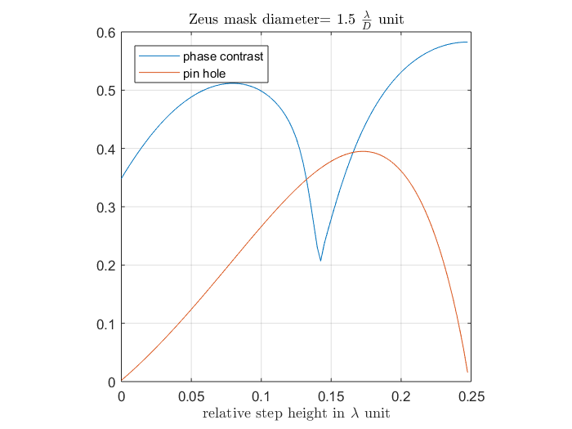

Figure : left the sensitivity of the pin hole with respect to the relative piston step between the segment, right the same for the phase contrast sensor

In Figure 1 both sensor are placed in ideal condition: no atmosphere using a diffraction limited telescope and no aberration. Both graph show the fisher information content as the relative phase step between the two segment change. In both cases the chosen size of the pinhole has been chosen , being the diffraction limit of the telescope. This is not a random pick: in Surdej et al 2011, it is demonstrated that the optimal size of the phase mask is 1.5 times the PSF. The assumption here is that this should be equivalent for the pin hole. The main observation to do here is that the phase contrast mask has a sensitivity to the signal all along the dynamic range. Especially when the relative piston step approaches zero. While the pinhole sensitivity to the piston step from the pin hole become null when the piston step goes toward zero. In term of cramer Rao limit it means that the pin hole sensor a much higher error.

This difference can be most easily interpreted when looking at the ideal signal themselves. Fig!!! show that when the piston step goes to zero the variation in the signal start to be extremely difficult to see with the pin hole. While for the phase contrast sensor as soon as there is the tiniest phase step the very characteristic signal appear.

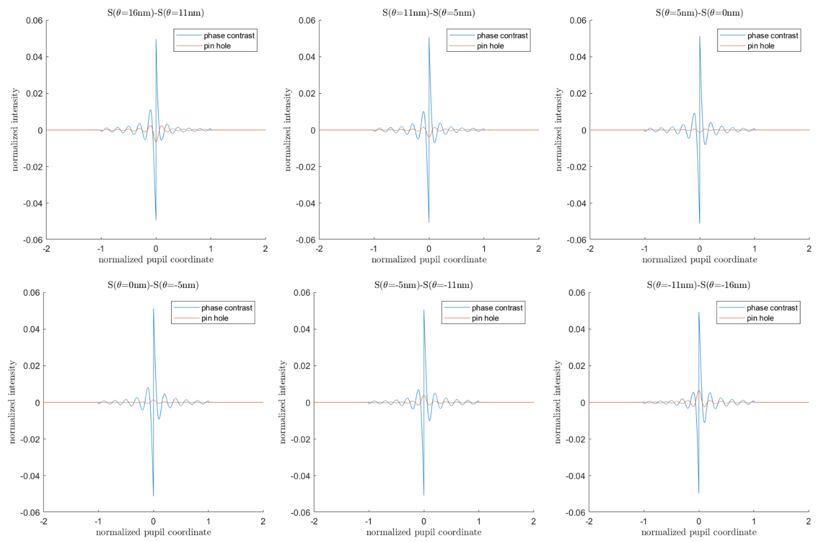

In ideal condition, the phase contrast sensor would be more appropriate to deal with really small phase step. The pin hole sensor would also be so provided a x time longer exposure time.

## Seeing limited case

# Experimental result

# Optimal sampling for phasing with phase mask

In all the previous result, were obtain using simulation that sample the signal at least a 100 time better than what is realistic. What follow study the impact of sampling on the precision of the sensor.

The sampling has already been defined by Yaistkova et al 2005 as the width for which the signal drop under 10% of its local maxima. Then they also give a formula to describe that width in the space of the segmented pupil:

With the wavelength in micrometer and the angular diameter of the phase mask in arc second. Hence the sampling is defined as the number of point inside the signal width . As an example: the working wavelength is 0.65 and the pin hole 1”. The signal width is then ~165 mm. one segment being 1420 mm (edge2edge?) this represent about 1/10 of a segment.

Lets consider the most stringent ELT: the 39 meter build by ESO. Along one line there are 30 segment , the central obstruction is composed of 9 segment. All the 39 segment has to fit inside the camera, while providing sufficient sampling for the signal. Yaistskova et al 2010 recommend using 4 point across the signal width. This means the detector will have to be at least a 1600*1600 pixels detectors. I term of the Cramer Rao bound this means that the lowest possible error of the sensor change from to . This loss can easily be compensated by capturing twice the number of photon.

For the pin hole sensor, using the same sampling, this represent a loss of .

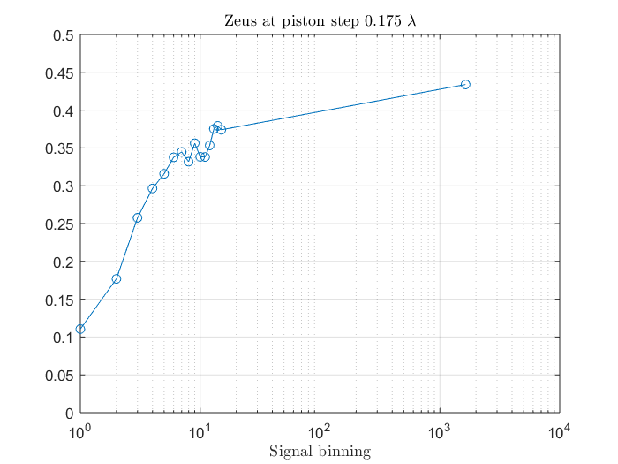

For this, in the context of the ZEUS sensor Surdej et al 2011 has defined There has already been estimate for the zeus sensor in yaistkova et al 2010.

