9-2 Capstone Component 2: IT Project Report
Tevin Davis
Southern New Hampshire University
IT 700 Capstone in Information Technology
Professor Kenneth Barr
September 3, 2026

Section 1: Project Design
Problem Statement
Many individuals and families in Indiana face challenges in finding food assistance resources when they need them most. While numerous food banks, churches, nonprofit organizations, and government agencies provide food assistance, the information is often scattered across various websites and directories. As a result, users frequently spend a significant amount of time searching multiple sources to identify nearby organizations, determine eligibility requirements, and check the availability of services. In many instances, the information can be outdated or inconsistent due to organizations independently managing their own websites and communication channels. This fragmented process creates unnecessary barriers for people seeking essential food assistance.
The Indiana Food Locator project aims to address this issue by developing a centralized web application that allows users to search for food assistance resources from a single location. Instead of navigating multiple websites, users can quickly search by ZIP code, city, county, or service type to find organizations nearby. The application will also provide standardized information for each resource, including contact details, operating hours, eligibility requirements, and available services. By consolidating publicly available information into a single searchable platform, the application aims to reduce search time and improve access to critical community resources.
Stakeholder Needs
The primary stakeholders for this project include Indiana residents seeking food assistance, nonprofit organizations, food pantries, churches, local government agencies, and application administrators responsible for maintaining resource information. Each stakeholder group has unique needs that have influenced the overall design of the system.
Residents need an application that is user-friendly, accessible on both desktop and mobile devices, and capable of delivering accurate search results quickly. Since many users may be facing financial hardships or stressful situations, the interface should be intuitive and require minimal technical knowledge. The search functionality should enable users to efficiently locate nearby food resources while providing complete and up-to-date information.
Food assistance organizations require an effective way to keep their information accurate without needing developers to make updates. To address this need, the project includes a secure administrator portal where authorized users can update organizational information, including addresses, operating hours, available services, and eligibility requirements. This design enhances data accuracy while reducing administrative overhead.
System administrators need a secure and maintainable solution that protects organizational data from unauthorized access. For this reason, the application will implement Spring Security, which includes role-based authentication, encrypted passwords, and secure administrative access. These security measures help protect the integrity of the application and support long-term maintainability.
Accessibility is also a crucial consideration for stakeholders. The application is being designed in accordance with the Web Content Accessibility Guidelines (World Wide Web Consortium [W3C], 2023) to ensure that individuals with disabilities can effectively navigate and use the system. This includes responsive layouts, keyboard navigation, readable typography, and adequate color contrast to ensure equal access for all users.
Overview of Project Design
The Indiana Food Locator was developed as a web application using Java Spring Boot and will follow an Agile software development methodology (Project Management Institute [PMI], 2021). Agile supports incremental development through short iterations, allowing for the design, testing, evaluation, and refinement of new features throughout the project. This approach is particularly advantageous as it enables continuous feedback while keeping the project within the constraints of the limited capstone timeline.
The Indiana Food Locator utilizes a layered architecture that includes a presentation layer, a business logic layer, and a data layer. This design promotes scalability, maintainability, and a clear separation of concerns, while also supporting future enhancements (Spring, 2025).
The project began with gathering requirements, identifying stakeholder needs, and creating the overall system architecture. During the planning phase, database tables and relationships were established using MySQL to ensure consistent storage of organizational information. The Entity Relationship Diagram (ERD), illustrated in Figure 1, depicts the database structure and relationships that support the application's food resource search functionality and administrative management features.
Wireframes were created to outline the application's navigation, search capabilities, and administrative interface before development begins.
Figure 1: Entity Relationship Diagram for the Indiana Food Locator Database
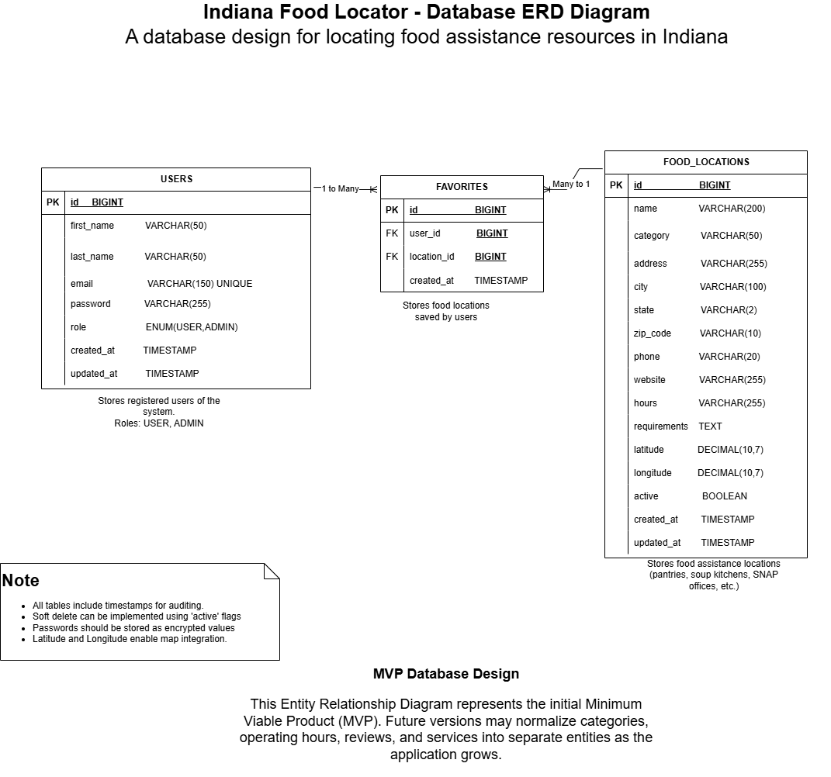The ERD serves as the foundation for the application's relational database by defining how user accounts, food resource records, and favorite locations are connected, ensuring data integrity and supporting efficient query performance.
The next stage focused on backend development using Spring Boot, Spring MVC, Spring Data JPA, and Hibernate. During this phase, the application was enhanced to include search capabilities, filtering options, and features for administrator management. To ensure a responsive user interface that performs well on both desktop and mobile devices, I utilized Bootstrap, HTML5, CSS3, and JavaScript.
Security was integrated throughout the development process rather than being added later. Spring Security was used to provide administrator authentication, password encryption, session management, and role-based authorization (Spring, 2025). Moreover, input validation and secure coding practices were employed to defend against common web application vulnerabilities such as SQL injection and cross-site scripting.
After implementation, the project entered a testing and evaluation phase. I conducted unit testing, integration testing, usability testing, and accessibility testing to verify that the system functions correctly and meets stakeholder expectations. Feedback collected during testing informed improvements in navigation, performance, and usability before the final deployment.
Several challenges were encountered during development. One challenge was maintaining accurate food resource information, as participating organizations frequently change their operating hours, eligibility requirements, and available services. Another challenge was preventing scope creep, given that many additional features could be added beyond the project's limited timeline. To address these challenges, the project concentrated on delivering a Minimum Viable Product (MVP) that includes the core search functionality and administrator portal, reserving advanced features like user accounts and AI-powered recommendations for future development.
The project followed a phased development process. Module 4 focused on project design and planning, Modules 5 through 7 focused on implementation and testing, and the final modules concentrated on documentation, quality assurance, and completion of the prototype.
Section 2: Project Implementation
Project Implementation
The Indiana Food Locator was successfully developed as a Java-based web application using the Spring Boot framework. The project followed an Agile software development methodology, which allowed for the design, implementation, testing, and refinement of features through iterative development cycles (Project Management Institute [PMI], 2021). The finished application provides Indiana residents with a centralized platform for locating food assistance resources while offering administrators secure tools to manage food location information.
Development commenced with project planning and requirements analysis to identify the core functionality needed for the application's Minimum Viable Product (MVP). Based on stakeholder needs, a MySQL relational database was designed to store food location information, user accounts, and favorite locations. An Entity Relationship Diagram (ERD) was created to define the relationships between these entities and served as the basis for the database implementation.
After the planning phase, the Spring Boot project was initiated using Maven within Visual Studio Code. GitHub was utilized throughout the development process for version control, enabling the tracking of source code, documentation, and project artifacts, while supporting incremental development and change management. Early in the implementation process, low-fidelity wireframes were designed to visualize the application's user interface and administrator portal before coding. These wireframes helped validate stakeholder requirements and guided the final interface design.
The application was built using a layered architecture consisting of a presentation layer, business logic layer, and data access layer. Spring MVC manages HTTP requests, Spring Data JPA and Hibernate facilitate communication with the MySQL database, and Spring Security enforces authentication and authorization. Technologies such as Bootstrap, HTML5, CSS3, Thymeleaf, and JavaScript were employed to create a responsive interface that functions effectively on both desktop and mobile devices.
The application's object-oriented design is depicted in the UML Class Diagram (see Appendix C). This diagram illustrates the relationships among the primary domain entities, services, repositories, and controllers that comprise the application's layered architecture and business logic.
During implementation, several significant features were completed. Public users can search for food assistance locations by city, ZIP code, county, or food category, view detailed information about each organization, and save favorite locations after registering for an account. User registration and authentication are secured using Spring Security, which includes BCrypt password encryption and role-based authorization. An administrator portal was also established, allowing authorized users to create, update, and deactivate food location records through a secure web interface.
Security was integrated throughout the development lifecycle rather than being implemented after development was complete. Spring Security provides secure authentication, session management, password encryption, and role-based access control to protect administrative functionality (Spring, 2025). Input validation and secure coding practices were implemented to minimize the risk of common web application vulnerabilities, such as SQL injection and cross-site scripting.
Throughout development, the application was continuously refined based on testing results and usability feedback. Minor issues identified during functional testing, such as page layout inconsistencies and user feedback during authentication, were addressed before finalizing the application. The completed prototype effectively demonstrates the core functionality originally proposed while maintaining a realistic scope for the capstone project.
Although the application meets the objectives set for the Minimum Viable Product, several enhancements have been intentionally deferred for future development. These include Google Maps integration, advanced search filters, organization self-service portals, real-time resource updates, and personalized notifications. Limiting the project to core functionality ensured that a stable, fully tested application could be completed within the capstone timeline while providing a solid foundation for future enhancements.
Figure 2
Indiana Food Locator Wireframes
Note. The wireframes illustrate the initial design that guided development of the completed application.
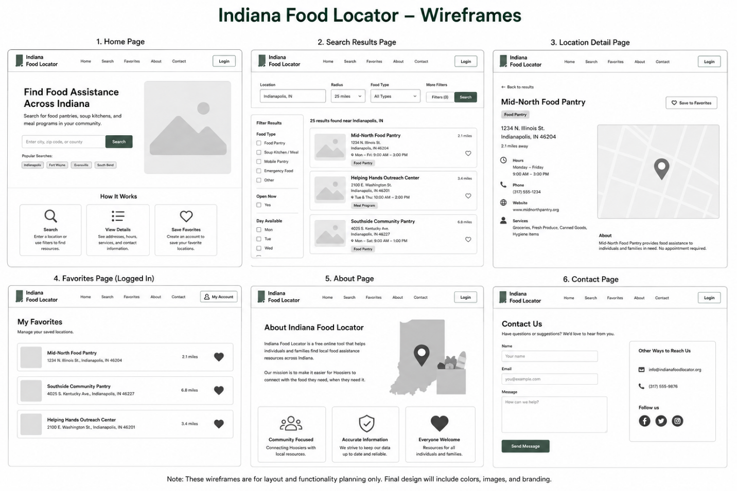Figure 3
Indiana Food Locator Admin Portal Wireframes
Note. The wireframes illustrate the initial design that guided the completed administrator portal.
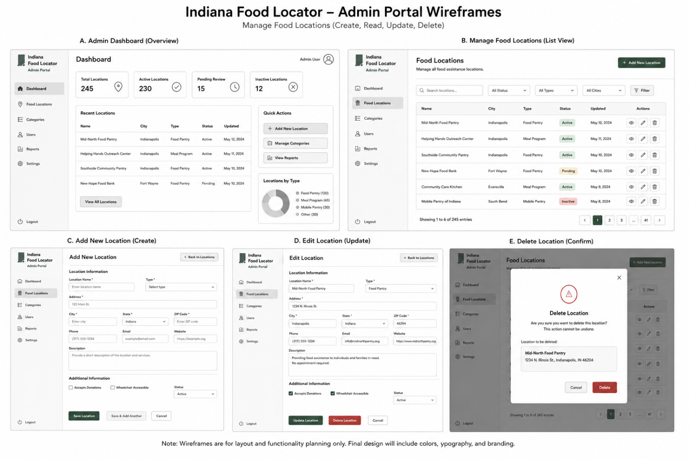
The application was developed using a layered architecture that includes a presentation layer, a business logic layer, and a data layer. Figure 4 illustrates the overall system architecture, showing how users interact with the web interface, how requests are processed through the Spring Boot application, and how data is stored and retrieved from the MySQL database. Spring MVC manages the application's request processing, while Spring Data JPA and Hibernate provide object-relational mapping between the application and the MySQL database. Bootstrap, HTML5, CSS3, and JavaScript are used to create a responsive user interface that functions across desktop and mobile devices.
Figure 4
System Architecture for the Indiana Food Locator
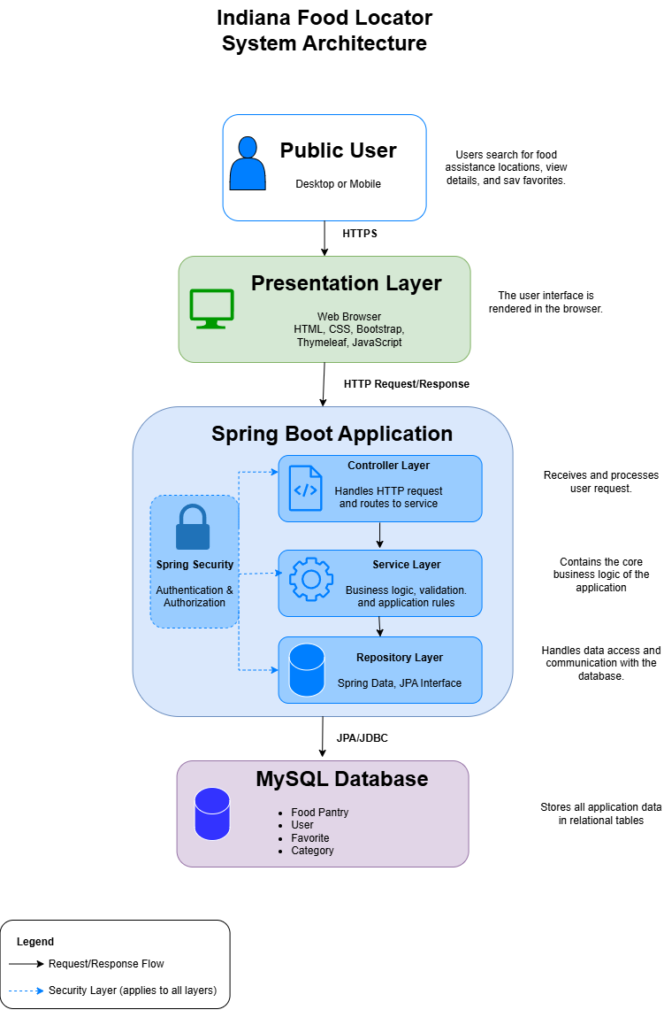
Note. The system architecture illustrates the interaction between users, the presentation layer, the Spring Boot application, the business logic layer, and the MySQL database. Future versions may integrate external services such as Google Maps.
The project repository was established on GitHub to support version control, source code management, and project organization throughout the development lifecycle. GitHub enables tracking changes over time while providing a centralized location for the Spring Boot project and related documentation. Figure 5 shows the GitHub repository used throughout the development of the Indiana Food Locator.
Figure 5
Indiana Food Locator GitHub Repository
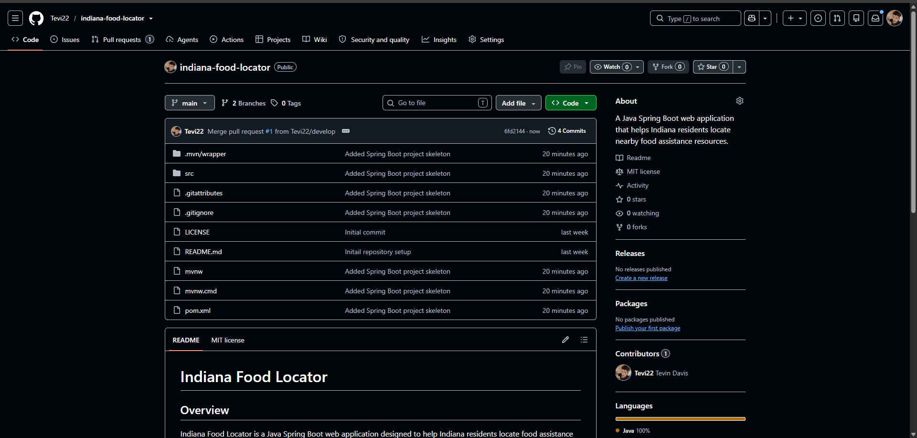Note. The GitHub repository provides centralized version control for the Indiana Food Locator, allowing source code, documentation, and future development activities to be tracked throughout the project lifecycle.

The completed Minimum Viable Product (MVP) includes the following functionality:
- Search food assistance locations by ZIP code, city, county, or category.
- View detailed organization information, including addresses, operating hours, contact information, and available services.
- Register and authenticate users using Spring Security.
- Save and remove favorite food assistance locations.
- Provide a responsive interface for desktop and mobile users.
- Secure administrator access using role-based authentication.
- Create, edit, and deactivate food location records through the administrator portal.
- Protect application data using encrypted passwords, session management, and input validation.
Security has been integrated throughout the development process instead of being a final step. Spring Security offers features such as password encryption, role-based authorization, session management, and secure authentication for administrator accounts (Spring, 2025). Additionally, Input validation was incorporated throughout development to reduce the risk of SQL injection and cross-site scripting attacks.
Future enhancements will include integration with Google Maps, more search filters, and expanded user features. Screenshots of the completed applications, including the public homepage, search results, and the administrator dashboard, can be found in Appendices H through J.
Section 3: Project Test Plans and Results
Project Testing and Results
Testing was conducted throughout the development of the Indiana Food Locator using an Agile approach. Instead of waiting until the implementation was complete, testing occurred during each development iteration to ensure that new features functioned correctly before adding more functionality. This strategy helped identify defects early, improve application stability, and ensure that the final product met stakeholder requirements.
The testing process included functional testing, unit testing, integration testing, security testing, usability testing, and accessibility testing. Together, these activities confirmed the application's core functionality, data integrity, security controls, and overall user experience.
Functional Testing
Functional testing verified that each feature performs as expected. Test cases included:
- Searching by ZIP code
- Searching by city
- Filtering by service category
- Returning no-result searches correctly
- Administrator login
- Creating new food resource records
- Updating existing resource information
- Deleting food resource records
All functions were tested using valid, invalid, and boundary-value inputs to ensure the system's reliability. Detailed results from the functional testing can be found in Appendix K, while a summary of testing results generated through Maven and JUnit is included in Appendix L.
Unit Testing
JUnit and Spring Boot Test were used to thoroughly verify the functionality of each component within the application. This involves conducting independent tests on repository methods, service classes, and controller endpoints. By isolating these components, this testing ensured that the underlying business logic performs as intended and meets the specified requirements before moving on to integration testing. This detailed testing process not only helped identify potential issues early on but also boosted the overall reliability and stability of the application before it was fully integrated.
Integration Testing
Integration testing verified the effective communication between the web interface, the Spring Boot application, and the MySQL database. These tests ensured that search requests returned accurate information, updates made by administrators were correctly stored, and that data remained consistent throughout the application.
Security Testing
Security testing played a crucial role in confirming the robustness of various protective measures within this application. It thoroughly evaluated the effectiveness of administrator authentication mechanisms to ensure that only authorized personnel can gain access. Additionally, it assesses role-based authorization to verify that users are granted appropriate permissions based on their defined roles.
Another key focus of this testing is on password encryption, making certain that sensitive authentication information is securely stored and transmitted, thereby minimizing the risk of exposure. The security assessment also scrutinized the safeguarding of administrative pages to prevent unauthorized access.
Moreover, the testing process encompasses measures to ensure that unauthorized users are completely barred from performing administrative functions. The security testing strategy also aligns with guidance from the National Institute of Standards and Technology (NIST) Cybersecurity Framework 2.0 by verifying that authentication, access control, and application security measures help protect the confidentiality, integrity, and availability of system data (National Institute of Standards and Technology [NIST], 2024; Spring, 2025).
Usability Testing
A group of representative users conducted a thorough assessment of the application's navigation, readability, and overall usability. Their feedback focused on several critical areas, including how well the search function performs, the effectiveness of the interface design, and the accessibility features offered. The insights gained from this usability testing were used to pinpoint specific areas for improvement, which were then integrated into future iterations of the product through our Agile development process.
Accessibility Testing
Accessibility testing ensured that digital content meets the standards set by WCAG 2.2 Level AA. This involves a thorough evaluation of several key components:
- Keyboard Navigation: Verifying that users can navigate the entire site using only a keyboard, which is essential for individuals who cannot use a mouse.
- Color Contrast: Assessing the color contrast between text and background to guarantee readability for users with visual impairments.
- Responsive Layouts: Ensuring that the design adapts effectively to various screen sizes and devices, providing a seamless user experience across platforms.
- Compatibility with Assistive Technologies: Testing the site’s functionality with tools such as screen readers, magnifiers, and other assistive devices to confirm that all users can access the content without barriers.
By conducting this comprehensive testing, I ensured that our digital environments are inclusive and accessible to all users, as outlined by the World Wide Web Consortium (W3C, 2023).
Report Summary
The Indiana Food Locator successfully progressed from project design through implementation, testing, and validation. Significant progress was made in establishing the project's technical foundation through the completion of key design artifacts. These artifacts included the System Architecture Diagram, Entity Relationship Diagram (ERD), user interface wireframes, UML Class Diagram, and GitHub project repository. Together, they provided the framework needed to successfully implement and validate the application while ensuring that it met stakeholder requirements and software engineering best practices.
The implementation focused on developing a Minimum Viable Product (MVP) using Java Spring Boot, Spring Security, MySQL, Thymeleaf, Bootstrap, and Maven. Core functionality included searching for food assistance resources, displaying organization information, user registration and authentication, favorites management, and providing a secure administrator portal for maintaining food resource records. The completed application successfully met the objectives established for the capstone while leaving opportunities for future enhancements such as Google Maps integration, advanced search filters, and organization self-service portals.
A comprehensive testing strategy was implemented throughout the development lifecycle. Functional, unit, integration, security, usability, accessibility, and automated testing were conducted to verify that the application met stakeholder requirements, operated reliably, and complied with accessibility and security best practices. Following an Agile development methodology allowed testing results and stakeholder feedback to be incorporated continuously, resulting in a more stable and user-friendly application.
Overall, the Indiana Food Locator demonstrates the successful application of software engineering principles, secure web application development, database integration, and Agile project management practices. The completed prototype provides a solid foundation for future expansion while fulfilling the objectives established in the original project proposal.
Section 4: Recommendations for Future Enhancements
Successes, Challenges, and Lessons Learned
The Indiana Food Locator project has provided valuable experience in applying software engineering principles to develop a practical web application that addresses a real community need. Throughout the project, I encountered several successes, challenges, and lessons learned that can improve both the current application and future software development efforts.
One of the project's greatest successes was completing a comprehensive planning and design phase before beginning implementation. By establishing project requirements, identifying stakeholder needs, designing the database with an Entity Relationship Diagram (ERD), developing system architecture, and creating user interface wireframes, I established a structured roadmap for development. These design activities reduced uncertainty during implementation and laid a strong technical foundation for the application. Additionally, selecting Java Spring Boot as the primary development framework provided a scalable and maintainable architecture that supports future enhancements and enterprise-level development.
Another success was incorporating security and accessibility requirements early in the development process rather than treating them as afterthoughts. Implementing Spring Security within the application design promotes secure administrator authentication and role-based authorization, while planning for compliance with the Web Content Accessibility Guidelines (WCAG) ensures that individuals with disabilities can effectively use the application (Spring, 2025; World Wide Web Consortium [W3C], 2023).
Despite these accomplishments, several challenges arose throughout the project. The primary challenge was balancing the desired feature set with the limited timeframe available for the capstone project. Numerous enhancements, including Google Maps integration, user accounts, advanced search filters, organization self-service portals, and real-time resource updates, were identified during planning. However, implementing all these features would have significantly exceeded the project's schedule. To address this challenge, I adopted a Minimum Viable Product (MVP) approach that prioritizes the most essential functionality while reserving additional features for future development.
Another challenge was learning and implementing new technologies simultaneously. Although Spring Boot offers a powerful framework for enterprise application development, Spring MVC, Spring Security, Spring Data JPA, Thymeleaf, and MySQL required additional research and careful planning. This experience reinforced the importance of incremental development, continuous learning, and thorough documentation when adopting unfamiliar technologies.
Several important lessons emerged during the development process. Firstly, investing significant time in planning before implementation greatly reduced the likelihood of needing to redesign the database or application architecture later in the project. Secondly, developing wireframes before coding clarified stakeholder expectations and improved the overall user experience. Finally, integrating security, accessibility, and testing considerations throughout development proved more effective than adding these features after implementation had begun. These lessons will continue to guide future software development projects.
Modification Strategies and Actionable Steps
Although the Indiana Food Locator meets the objectives established for the capstone project, there are several opportunities to expand and improve the application beyond the initial MVP. Future development should follow a phased enhancement strategy that gradually introduces additional functionality while maintaining system stability and usability.
Phase 1: Completed MVP Implementation
The initial phase focused on completing Minimum Viable Product (MVP) functionality. This involved finalizing administrator authentication using Spring Security, implementing full Create, Read, Update, and Delete (CRUD) functionality for managing food resources, integrating the MySQL database with the application, and completing the testing activities outlined in the project testing plan.
Figure 6
Indiana Food Locator – Working Home Page Screenshot
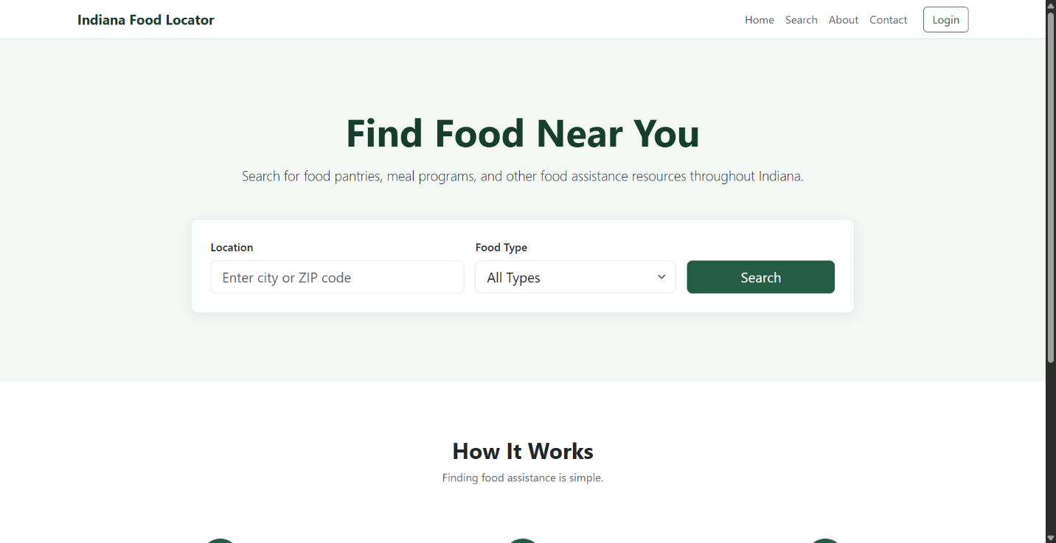
Figure 7
Indiana Food Locator– Food Search Results Screenshot
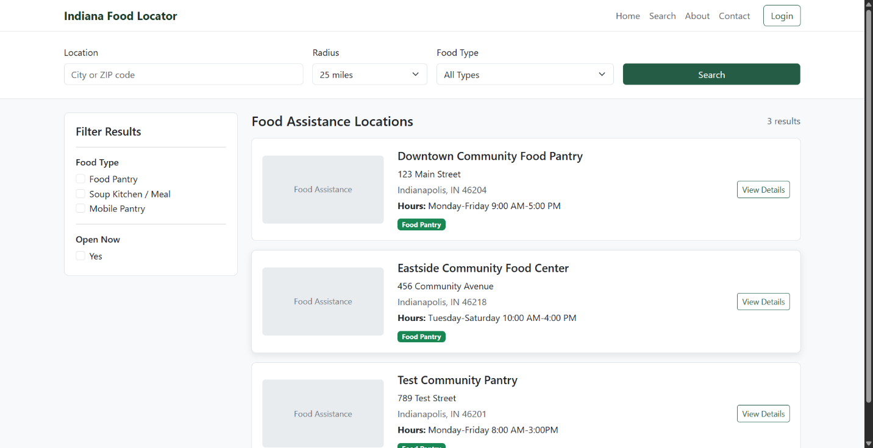
Phase 2: Improve User Experience
After completing the Minimum Viable Product (MVP), development efforts should shift towards enhancing usability and accessibility. Planned improvements include integrating Google Maps to visually display resource locations, expanding search filters to include operating hours and eligibility criteria, enhancing mobile responsiveness, and continuing to develop accessibility features that comply with WCAG 2.2 Level AA standards (World Wide Web Consortium [W3C], 2023).
Phase 3: Expand Application Features
Once the core application has been fully developed, additional features can be added to enhance value for both users and participating organizations. Recommended enhancements include the ability for users to create accounts, save favorite locations, receive personalized notifications for resource updates, and provide organizations with self-service portals for managing their resource information. Additionally, developing a REST API will support future mobile applications.
Figure 8
Indiana Food Locator – Administrator Dashboard Screenshot
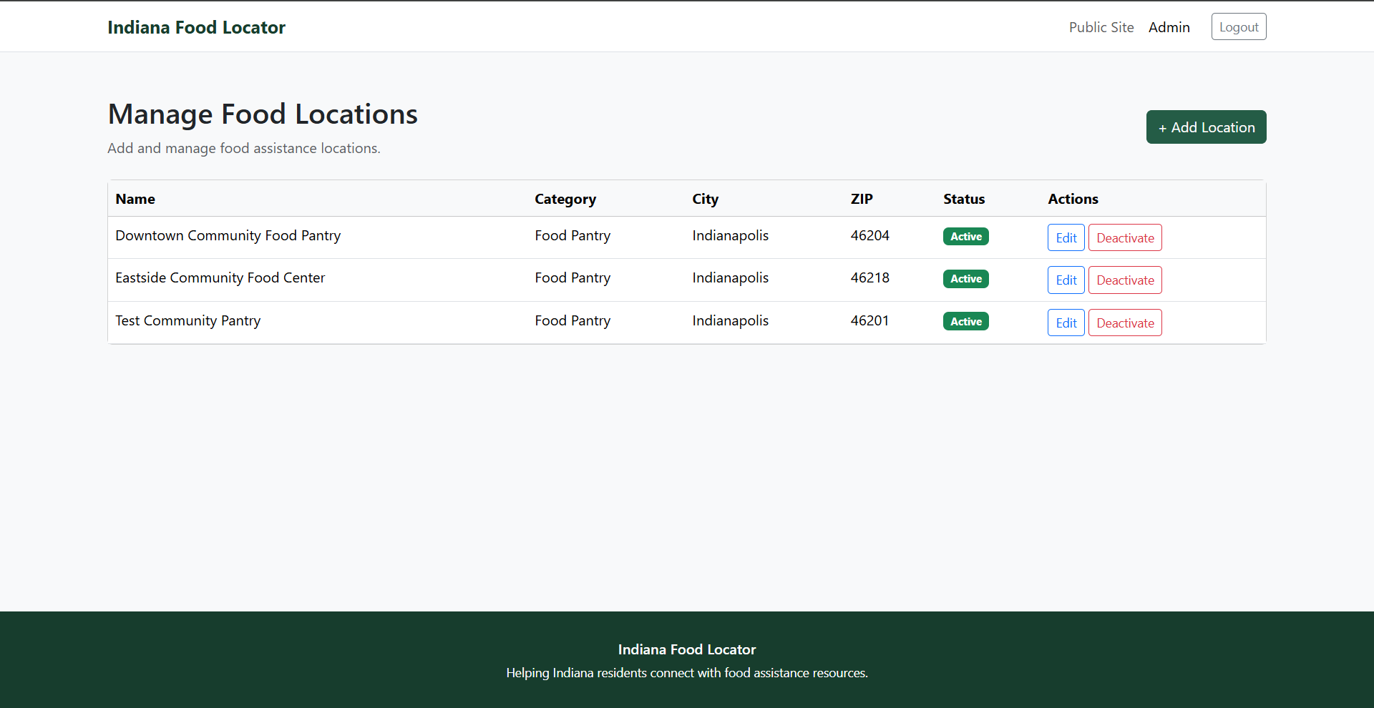
Phase 4: Deployment and Long-Term Growth
The final phase is centered on getting the application ready for production deployment and ensuring its long-term sustainability. Recommended improvements include deploying the application on a cloud hosting platform, implementing automated backups, monitoring application performance, enhancing security audits, and expanding the database to support food assistance organizations across the entire state of Indiana. Additionally, continuous feedback from stakeholders should be gathered to inform future software updates and prioritize new features.
Potential Issues
As development progresses beyond the capstone project, several important issues should be considered.
One key issue is the need to maintain accurate information for participating food assistance organizations. Since operating hours, eligibility requirements, contact information, and available services frequently change, the application will require ongoing administrative oversight to ensure data accuracy. Without regular updates, outdated information could undermine user confidence in the application.
Another potential issue is stakeholder adoption. Food assistance organizations must be willing to regularly update their information, and users must view the application as a reliable source of food assistance information for it to remain effective.
Scalability is also an important consideration. As the application expands to include more organizations, users, and geographic locations, there may be a need to optimize database performance and application response times. Future enhancements, such as database indexing, query optimization, caching strategies, and cloud-based infrastructure, may be necessary to support increased user demand.
Security remains an ongoing concern. While Spring Security provides a robust framework for authentication and authorization, future development must include regular software updates, vulnerability assessments, enforcement of secure password policies, and server-side validation to protect application data. These efforts align with the recommendations of the National Institute of Standards and Technology Cybersecurity Framework 2.0 (NIST, 2024).
Resource limitations should also be acknowledged. The capstone project was completed within a restricted academic timeline using a Minimum Viable Product approach. Additional development time, funding, stakeholder participation, and testing resources would enable the implementation of several advanced features that were intentionally deferred to maintain the project's scope.
Overall, these potential issues do not detract from the value of the Indiana Food Locator; rather, they highlight realistic opportunities for continuous improvement in future development.
Project Conclusion
The Indiana Food Locator project successfully achieved the objectives outlined in the original proposal by delivering a fully functional web application that centralizes food assistance resources for residents of Indiana. This application features secure user authentication, searchable food locations, favorites management, administrative CRUD (Create, Read, Update, Delete) functionality, and a responsive user interface. It was developed using technologies such as Java Spring Boot, Spring Security, MySQL, Bootstrap, and Thymeleaf.
Throughout the project, I adhered to Agile development practices, ongoing testing, and a design focused on stakeholder needs. Both functional and automated testing confirmed that the core features of the application operate reliably and securely. There are opportunities for future enhancements, including Google Maps integration, self-service portals for organizations, and advanced search capabilities. Nevertheless, the completed prototype serves as a strong foundation for further development.
This capstone project strengthened my knowledge of enterprise software development, secure web application design, Spring Boot architecture, database integration, software testing, Agile project management, and secure authentication using Spring Security. The experience provided valuable hands-on practice in designing, implementing, testing, and documenting a complete enterprise web application from concept through deployment planning.
References
Feeding America. (2025). Map the Meal Gap: Indiana. https://map.feedingamerica.org/
National Institute of Standards and Technology. (2024). Cybersecurity Framework (CSF) 2.0. https://www.nist.gov/cyberframework
Project Management Institute. (2021). A guide to the project management body of knowledge (PMBOK® Guide) (7th ed.). Project Management Institute.
Spring. (2025). Spring Framework Documentation. https://docs.spring.io/spring-framework/reference/
Spring. (2025). Spring Security Reference Documentation. https://docs.spring.io/spring-security/reference/
World Wide Web Consortium. (2023). Web Content Accessibility Guidelines (WCAG) 2.2. https://www.w3.org/TR/WCAG21/

Section 5: Appendix
The appendices contain the supporting artifacts, diagrams, implementation screenshots, and testing evidence referenced throughout this report. Together, these materials illustrate the design, implementation, testing, and validation of the Indiana Food Locator application.
Appendix A
Entity Relationship Diagram (ERD)
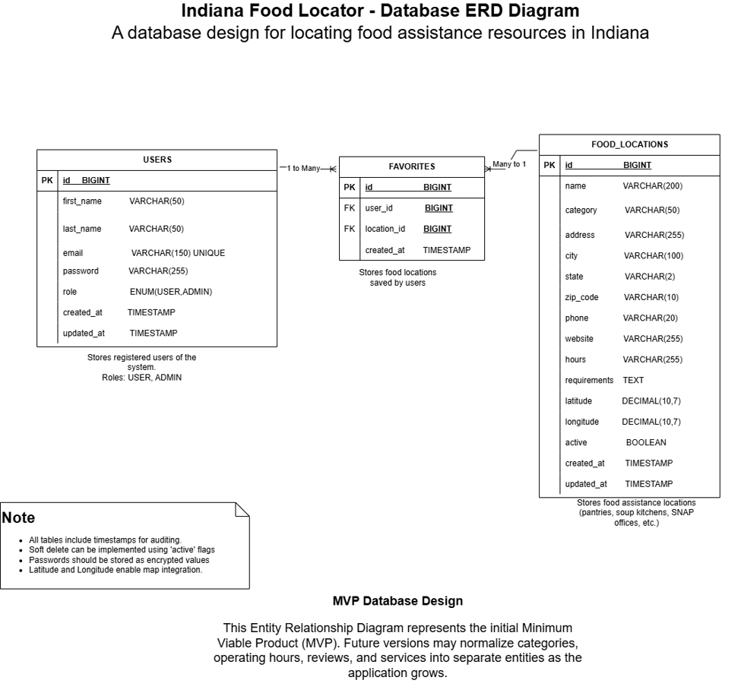
Appendix B
System Architecture Diagram


Appendix C
UML Class Diagram
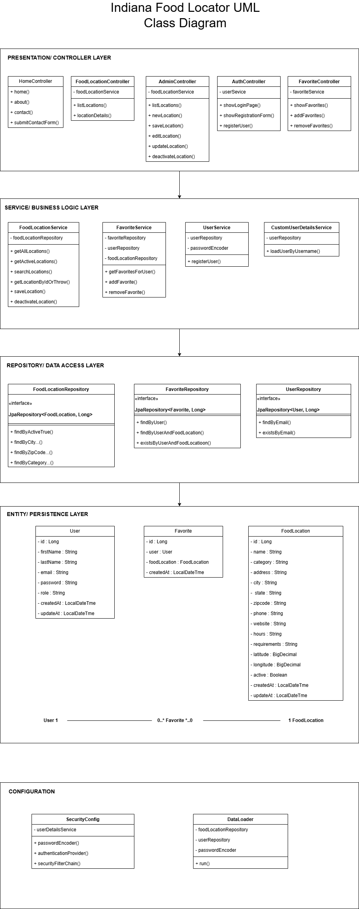
Appendix D
Home Page Wireframe
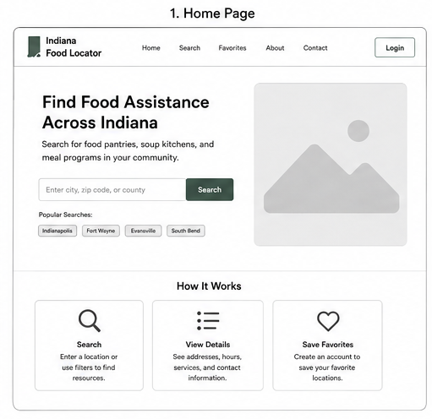

Appendix E
Food Search Page Wireframe
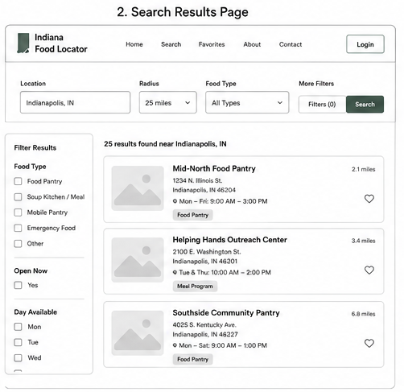

Appendix F
Administrator Portal Wireframe
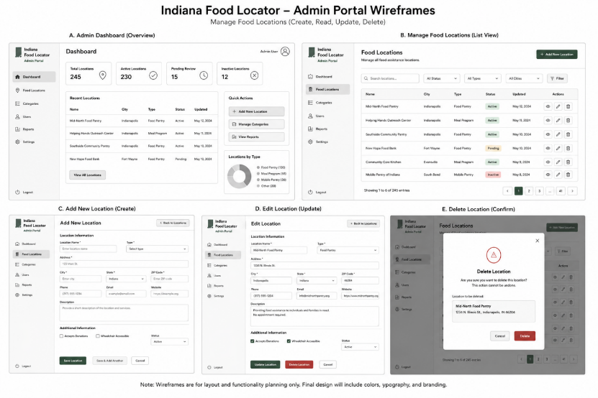

Appendix G
GitHub Repository
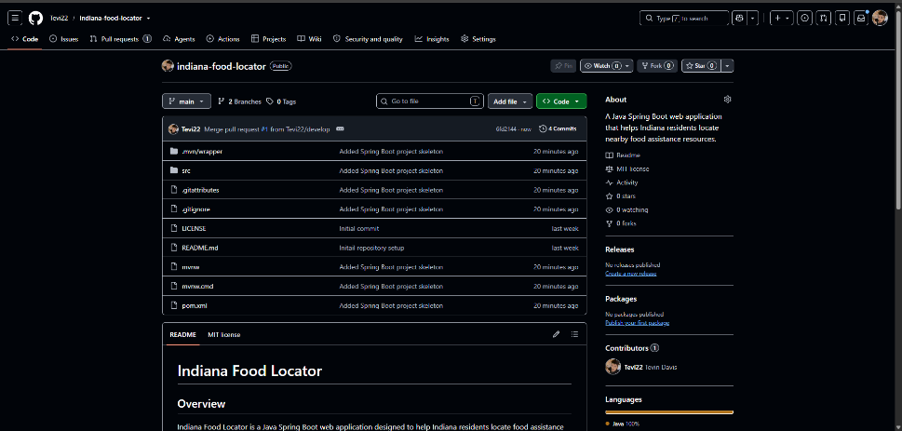

Appendix H
Working Home Page


Appendix I
Food Search Results


Appendix J
Administrator Dashboard


Appendix K
Functional Testing Results
Table K-1 summarizes the functional testing completed for the Indiana Food Locator application. Testing verified the application's public interface, user authentication, administrator functionality, favorites management, and session security. Minor issues identified during testing were corrected and successfully retested before project completion.
Table K-1 Functional Testing Summary
Test ID | Functional Test | Result | Evidence
FT-01 | Public Home Page | PASS | Figure K-1
FT-02 | Food Location Search | PASS | Figure K-2
FT-03 | Location Details | PASS (footer issue corrected and retested) | Figure K-3
FT-04 | User Registration | PASS | Figure K-4
FT-05 | User Login | PASS (success message added and retested) | Figure K-5
FT-06 | Add Favorite | PASS | Figure K-6
FT-07 | Remove Favorite | PASS | Figure K-7
FT-08 | USER Blocked From Admin | PASS | Figure K-8
FT-09 | ADMIN Portal Access | PASS | Figure K-9
FT-10 | Admin Add Location | PASS | Figure K-10
FT-11 | Admin Edit Location | PASS | Figure K-11
FT-12 | Admin Deactivate Location | PASS | Figure K-12
FT-13 | Logout / Session Protection | PASS | Figure K-13
FT-14 | Contact Form | PASS | Figure K-14

Figure K-1. Public Home Page
Description:
The Indiana Food Locator public home page displayed successfully with the navigation menu, search functionality, and responsive user interface, verifying that users can access the application without authentication.
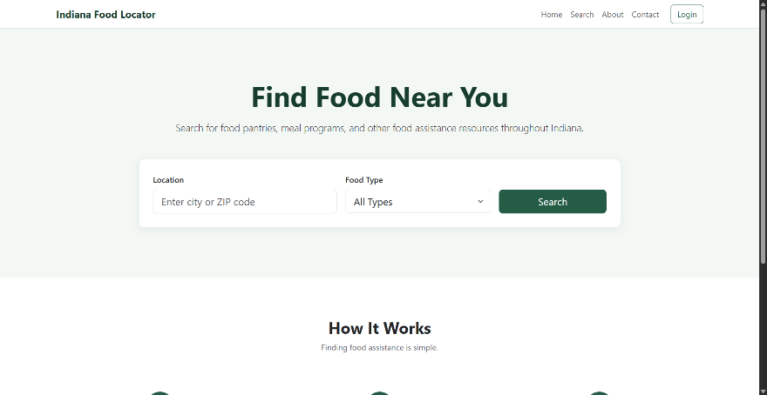
Figure K-2. Food Location Search Results
Description:
Search functionality successfully returned matching food assistance locations based on the user's search criteria, demonstrating proper communication between the application and the database.
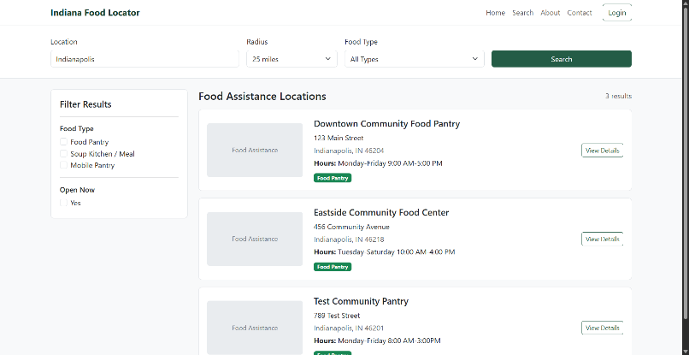
Figure K-3. Location Details
Description:
The Location Details page displayed complete organization information, including address, contact information, available services, and operating hours. The page layout was retested after correcting the footer display issue.
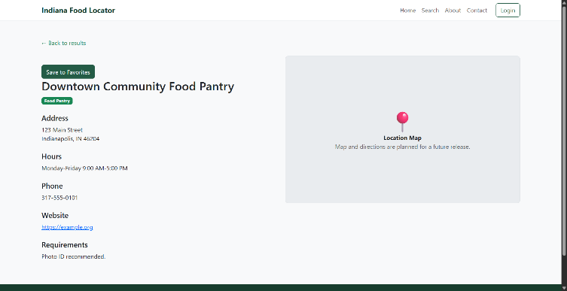
Figure K-4. User Registration
Description:
The user registration page successfully created a new user account after validating all required fields and securely storing encrypted credentials within the database.
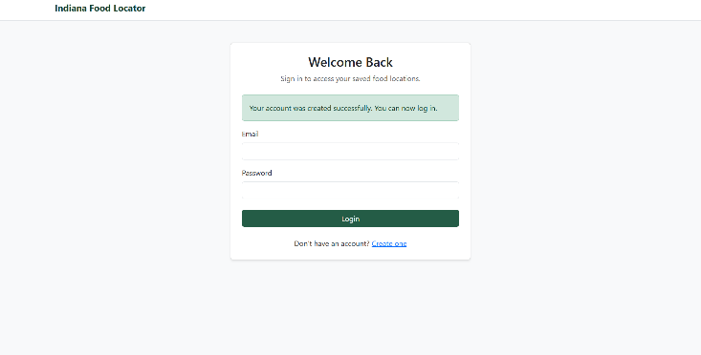
Figure K-5. User Login
Description:
User authentication completed successfully using Spring Security. The application displayed a successful login confirmation before redirecting the authenticated user to the appropriate page.
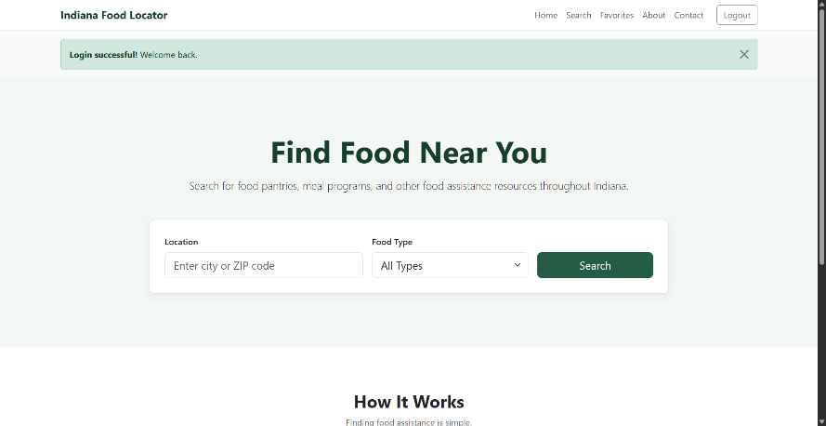
Figure K-6. Add Favorite
Description:
An authenticated user successfully added a food assistance location to the Favorites list, confirming that favorite records were correctly stored and displayed.
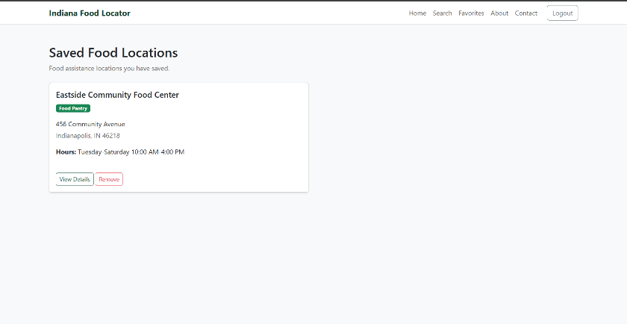
Figure K-7. Remove Favorite
Description:
A previously saved favorite location was successfully removed from the user's Favorites list, confirming proper deletion of the associated database record.
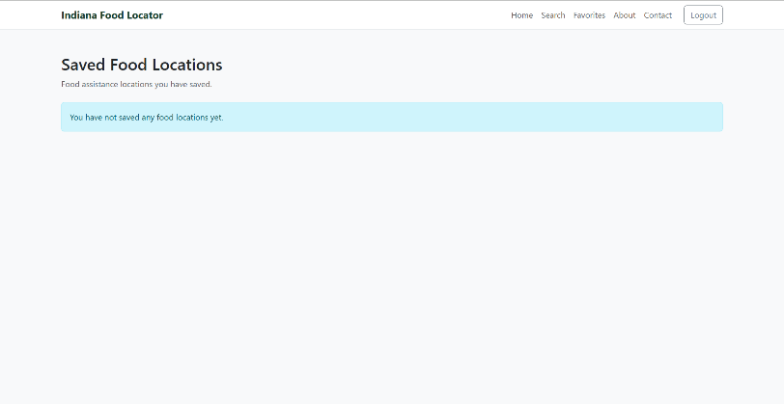
Figure K-8. User Access Denied (Administrator Portal)
Description:
A standard USER account was correctly prevented from accessing administrator functions. Spring Security enforced role-based authorization and displayed an Access Denied page.

Figure K-9. Administrator Dashboard
Description:
An authenticated ADMIN account successfully accessed the administrator dashboard, verifying role-based authorization and secure administrative access.
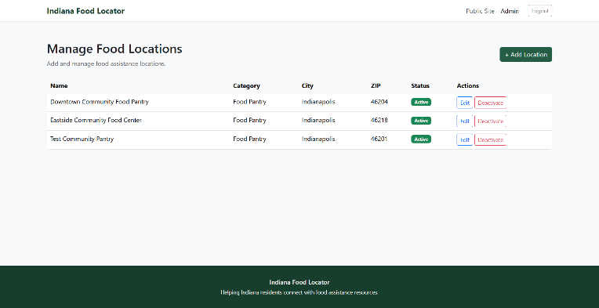
Figure K-10. Add Food Location
Description:
An administrator successfully added a new food assistance location through the administrative interface. The new record was stored in the database and became available through public search.
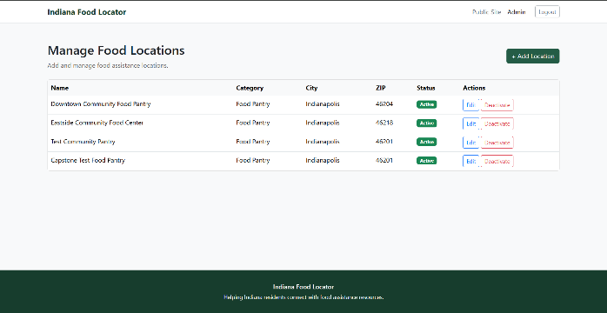
Figure K-11. Edit Food Location
Description:
An existing food assistance location was successfully updated through the administrator portal, confirming that edit functionality correctly modified the stored database record.
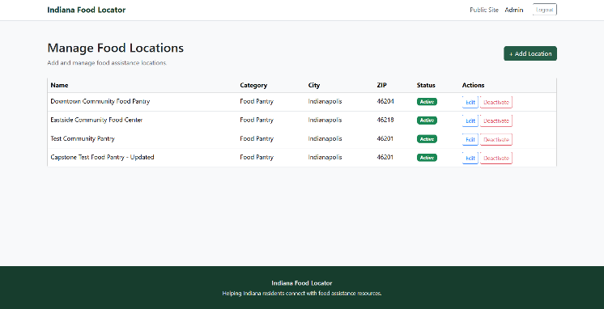
Figure K-12. Deactivate Food Location
Description:
An administrator successfully deactivated a food assistance location. The location was removed from active public search results while remaining stored within the database.
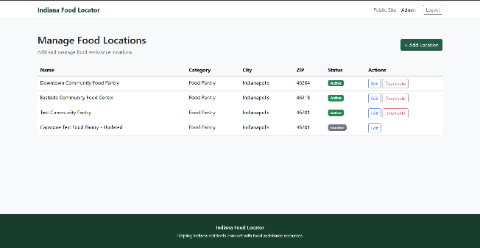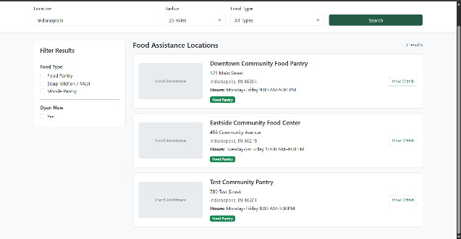
Figure K-13. Logout and Session Protection
Description:
User logout successfully terminated the authenticated session. Attempting to revisit protected administrative pages required users to authenticate again, confirming proper session management.
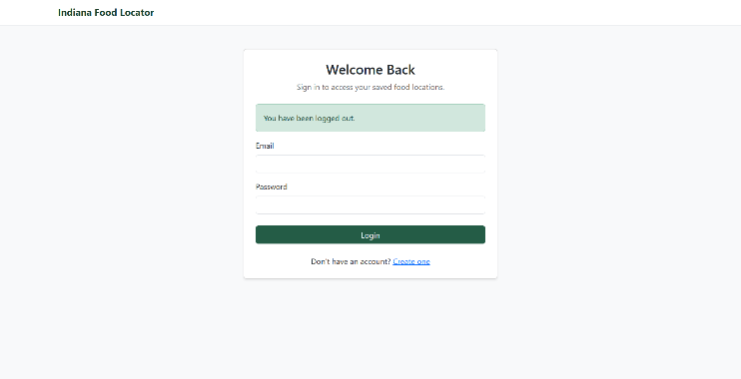
Figure K-14. Contact Page
Description:
The Contact page loaded successfully and displayed the organization's contact information and communication form, confirming proper page navigation and presentation.
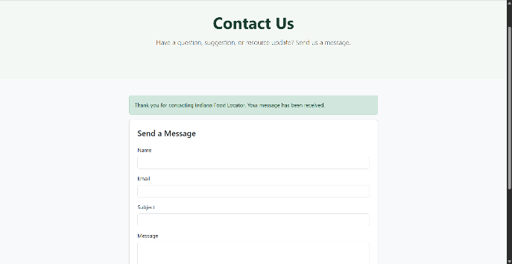

Appendix L
Automated Testing Results
Automated testing was completed using JUnit 5, Spring Boot Test, Mockito, and MockMvc. Repository, service, security, and application context tests were executed through Maven to verify the application's business logic and security configuration.
Table L-1 Automated Test Summary
Test Suite | Tests Run | Result
Application Context | 1 | PASS
Repository Tests | 5 | PASS
Security Integration Tests | 5 | PASS
Favorite Service Tests | 4 | PASS
Food Location Service Tests | 7 | PASS
User Service Tests | 3 | PASS
Total | 25 | PASS (0 Failures, 0 Errors, 0 Skipped)

Figure L-1
Maven Automated Test Results (BUILD SUCCESS)
Description:
The Maven test execution confirms that all automated JUnit and Spring Boot tests completed successfully with 25 tests passed, zero failures, zero errors, and zero skipped tests, validating the stability of the application.
