4-2 IT Project Report: Draft I
Tevin Davis
Southern New Hampshire University
IT 700 Capstone in Information Technology
Professor Kenneth Barr
July 29, 2026

Section 1: Project Design
Problem Statement
Many individuals and families in Indiana face challenges in finding food assistance resources when they need them most. While numerous food banks, churches, nonprofit organizations, and government agencies provide food assistance, the information is often scattered across various websites and directories. As a result, users frequently spend a significant amount of time searching multiple sources to identify nearby organizations, determine eligibility requirements, and check the availability of services. In many instances, the information can be outdated or inconsistent due to organizations independently managing their own websites and communication channels. This fragmented process creates unnecessary barriers for people seeking essential food assistance.
The Indiana Food Locator project aims to address this issue by developing a centralized web application that allows users to search for food assistance resources from a single location. Instead of navigating multiple websites, users can quickly search by ZIP code, city, county, or service type to find organizations nearby. The application will also provide standardized information for each resource, including contact details, operating hours, eligibility requirements, and available services. By consolidating publicly available information into a single searchable platform, the application aims to reduce search time and improve access to critical community resources.
Stakeholder Needs
The primary stakeholders for this project include Indiana residents seeking food assistance, nonprofit organizations, food pantries, churches, local government agencies, and application administrators responsible for maintaining resource information. Each stakeholder group has unique needs that have influenced the overall design of the system.
Residents need an application that is user-friendly, accessible on both desktop and mobile devices, and capable of delivering accurate search results quickly. Since many users may be facing financial hardships or stressful situations, the interface should be intuitive and require minimal technical knowledge. The search functionality should enable users to efficiently locate nearby food resources while providing complete and up-to-date information.
Food assistance organizations require an effective way to keep their information accurate without needing developers to make updates. To address this need, the project includes a secure administrator portal where authorized users can update organizational information, including addresses, operating hours, available services, and eligibility requirements. This design enhances data accuracy while reducing administrative overhead.
System administrators need a secure and maintainable solution that protects organizational data from unauthorized access. For this reason, the application will implement Spring Security, which includes role-based authentication, encrypted passwords, and secure administrative access. These security measures help protect the integrity of the application and support long-term maintainability.
Accessibility is also a crucial consideration for stakeholders. The application is being designed in accordance with the Web Content Accessibility Guidelines (World Wide Web Consortium [W3C], 2023) to ensure that individuals with disabilities can effectively navigate and use the system. This includes responsive layouts, keyboard navigation, readable typography, and adequate color contrast to ensure equal access for all users.
Overview of Project Design
The Indiana Food Locator will be developed as a web application using Java Spring Boot and will follow an Agile software development methodology (Project Management Institute [PMI], 2021). Agile supports incremental development through short iterations, allowing for the design, testing, evaluation, and refinement of new features throughout the project. This approach is particularly advantageous as it enables continuous feedback while keeping the project within the constraints of the limited capstone timeline.
The Indiana Food Locator will utilize a layered architecture that includes a presentation layer, a business logic layer, and a data layer. This design promotes scalability, maintainability, and a clear separation of concerns, while also supporting future enhancements (Spring, 2025).
The project begins with gathering requirements, identifying stakeholder needs, and creating the overall system architecture. During the planning phase, we will establish database tables and relationships using MySQL to ensure consistent storage of organizational information. The Entity Relationship Diagram (ERD), illustrated in Figure 1, depicts the database structure and relationships that support the application's food resource search functionality and administrative management features.
Additionally, we will create wireframes to outline the application's navigation, search capabilities, and administrative interface before development begins.
Figure 1: Entity Relationship Diagram for the Indiana Food Locator Database
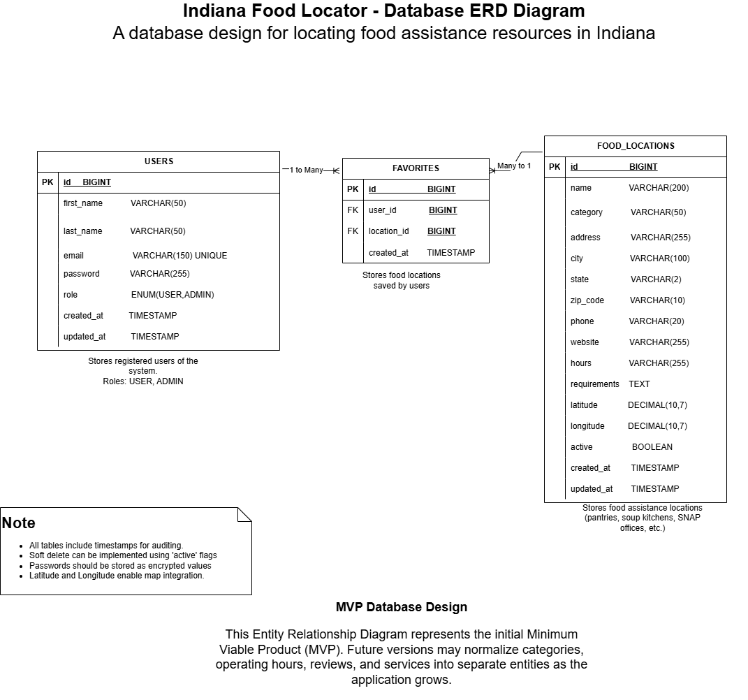The ERD serves as the foundation for the application's relational database by defining how user accounts, food resource records, and favorite locations are connected, ensuring data integrity and supporting efficient query performance.
The next stage will focus on backend development using Spring Boot, Spring MVC, Spring Data JPA, and Hibernate. During this phase, the application will implement search capabilities, filtering options, and administrator management features. To create a responsive user interface that works effectively across both desktop and mobile devices, we will use Bootstrap, HTML5, CSS3, and JavaScript.
Security will be integrated throughout the design process rather than being added later. Spring Security will handle administrator authentication, password encryption, session management, and role-based authorization (Spring, 2025). Moreover, input validation and secure coding practices will be employed to defend against common web application vulnerabilities such as SQL injection and cross-site scripting.
After implementation, the project will enter a testing and evaluation phase. We will conduct unit testing, integration testing, usability testing, and accessibility testing to verify that the system functions correctly and meets stakeholder expectations. Feedback collected during testing will inform improvements in navigation, performance, and usability before the final deployment.
Several challenges are anticipated during development. One challenge is maintaining accurate food resource information, as participating organizations frequently change their operating hours, eligibility requirements, and available services. Another challenge is preventing scope creep, given that many additional features could be added beyond the project's limited timeline. To address these challenges, the project will concentrate on delivering a minimum viable product (MVP) that includes the core search functionality and administrator portal, reserving advanced features like user accounts and AI-powered recommendations for future development.
The project timeline aligns with this phased development process. Module 4 will focus on completing design documentation, the database schema, wireframes, and project planning. Modules 5 through 7 will emphasize application development, the implementation of security features, testing, and user evaluation. The remaining modules will concentrate on documentation, quality assurance, and the final deployment of the completed prototype.

References
Feeding America. (2025). Map the Meal Gap: Indiana. https://map.feedingamerica.org/
National Institute of Standards and Technology. (2024). Cybersecurity Framework (CSF) 2.0. https://www.nist.gov/cyberframework
Project Management Institute. (2021). A guide to the project management body of knowledge (PMBOK® Guide) (7th ed.).
Spring. (2025). Spring Security Reference Documentation. https://docs.spring.io/spring-security/reference/
World Wide Web Consortium. (2023). Web Content Accessibility Guidelines (WCAG) 2.1. https://www.w3.org/TR/WCAG21/

