7-2 IT Project Report: Draft III
Tevin Davis
Southern New Hampshire University
IT 700 Capstone in Information Technology
Professor Kenneth Barr
August 21, 2026

Section 1: Project Design
Problem Statement
Many individuals and families in Indiana face challenges in finding food assistance resources when they need them most. While numerous food banks, churches, nonprofit organizations, and government agencies provide food assistance, the information is often scattered across various websites and directories. As a result, users frequently spend a significant amount of time searching multiple sources to identify nearby organizations, determine eligibility requirements, and check the availability of services. In many instances, the information can be outdated or inconsistent due to organizations independently managing their own websites and communication channels. This fragmented process creates unnecessary barriers for people seeking essential food assistance.
The Indiana Food Locator project aims to address this issue by developing a centralized web application that allows users to search for food assistance resources from a single location. Instead of navigating multiple websites, users can quickly search by ZIP code, city, county, or service type to find organizations nearby. The application will also provide standardized information for each resource, including contact details, operating hours, eligibility requirements, and available services. By consolidating publicly available information into a single searchable platform, the application aims to reduce search time and improve access to critical community resources.
Stakeholder Needs
The primary stakeholders for this project include Indiana residents seeking food assistance, nonprofit organizations, food pantries, churches, local government agencies, and application administrators responsible for maintaining resource information. Each stakeholder group has unique needs that have influenced the overall design of the system.
Residents need an application that is user-friendly, accessible on both desktop and mobile devices, and capable of delivering accurate search results quickly. Since many users may be facing financial hardships or stressful situations, the interface should be intuitive and require minimal technical knowledge. The search functionality should enable users to efficiently locate nearby food resources while providing complete and up-to-date information.
Food assistance organizations require an effective way to keep their information accurate without needing developers to make updates. To address this need, the project includes a secure administrator portal where authorized users can update organizational information, including addresses, operating hours, available services, and eligibility requirements. This design enhances data accuracy while reducing administrative overhead.
System administrators need a secure and maintainable solution that protects organizational data from unauthorized access. For this reason, the application will implement Spring Security, which includes role-based authentication, encrypted passwords, and secure administrative access. These security measures help protect the integrity of the application and support long-term maintainability.
Accessibility is also a crucial consideration for stakeholders. The application is being designed in accordance with the Web Content Accessibility Guidelines (World Wide Web Consortium [W3C], 2023) to ensure that individuals with disabilities can effectively navigate and use the system. This includes responsive layouts, keyboard navigation, readable typography, and adequate color contrast to ensure equal access for all users.
Overview of Project Design
The Indiana Food Locator will be developed as a web application using Java Spring Boot and will follow an Agile software development methodology (Project Management Institute [PMI], 2021). Agile supports incremental development through short iterations, allowing for the design, testing, evaluation, and refinement of new features throughout the project. This approach is particularly advantageous as it enables continuous feedback while keeping the project within the constraints of the limited capstone timeline.
The Indiana Food Locator will utilize a layered architecture that includes a presentation layer, a business logic layer, and a data layer. This design promotes scalability, maintainability, and a clear separation of concerns, while also supporting future enhancements (Spring, 2025).
The project begins with gathering requirements, identifying stakeholder needs, and creating the overall system architecture. During the planning phase, we will establish database tables and relationships using MySQL to ensure consistent storage of organizational information. The Entity Relationship Diagram (ERD), illustrated in Figure 1, depicts the database structure and relationships that support the application's food resource search functionality and administrative management features.
Additionally, we will create wireframes to outline the application's navigation, search capabilities, and administrative interface before development begins.
Figure 1: Entity Relationship Diagram for the Indiana Food Locator Database
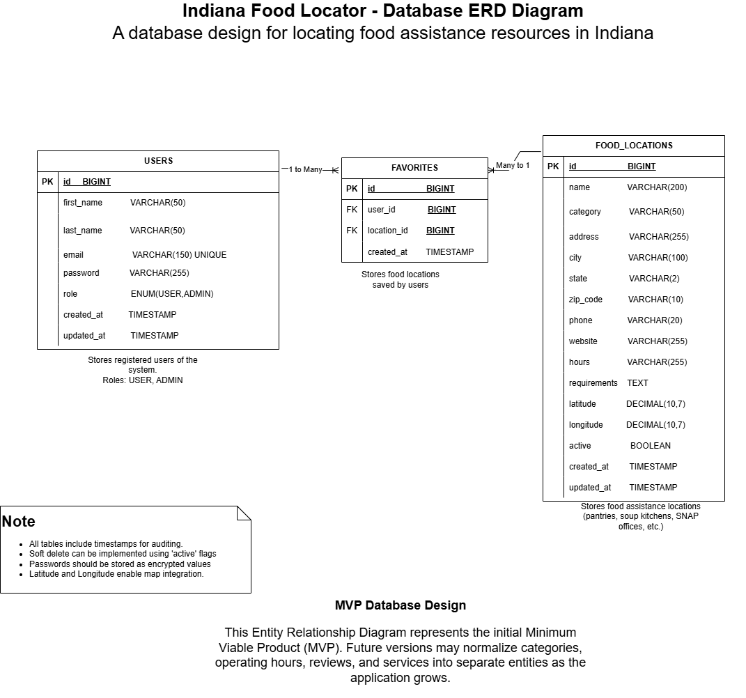The ERD serves as the foundation for the application's relational database by defining how user accounts, food resource records, and favorite locations are connected, ensuring data integrity and supporting efficient query performance.
The next stage will focus on backend development using Spring Boot, Spring MVC, Spring Data JPA, and Hibernate. During this phase, the application will implement search capabilities, filtering options, and administrator management features. To create a responsive user interface that works effectively across both desktop and mobile devices, we will use Bootstrap, HTML5, CSS3, and JavaScript.
Security will be integrated throughout the design process rather than being added later. Spring Security will handle administrator authentication, password encryption, session management, and role-based authorization (Spring, 2025). Moreover, input validation and secure coding practices will be employed to defend against common web application vulnerabilities such as SQL injection and cross-site scripting.
After implementation, the project will enter a testing and evaluation phase. We will conduct unit testing, integration testing, usability testing, and accessibility testing to verify that the system functions correctly and meets stakeholder expectations. Feedback collected during testing will inform improvements in navigation, performance, and usability before the final deployment.
Several challenges are anticipated during development. One challenge is maintaining accurate food resource information, as participating organizations frequently change their operating hours, eligibility requirements, and available services. Another challenge is preventing scope creep, given that many additional features could be added beyond the project's limited timeline. To address these challenges, the project will concentrate on delivering a minimum viable product (MVP) that includes the core search functionality and administrator portal, reserving advanced features like user accounts and AI-powered recommendations for future development.
The project timeline aligns with this phased development process. Module 4 will focus on completing design documentation, the database schema, wireframes, and project planning. Modules 5 through 7 will emphasize application development, the implementation of security features, testing, and user evaluation. The remaining modules will concentrate on documentation, quality assurance, and the final deployment of the completed prototype.
Section 2: Project Implementation
Project Implementation
The Indiana Food Locator is currently in the early implementation phase of development as a Java-based web application using the Spring Boot framework. Development follows an Agile software development methodology, allowing the project to progress through small, iterative cycles while continuously incorporating stakeholder feedback (Project Management Institute [PMI], 2021). At this stage, the primary focus has been on establishing the technical foundation of the application, including project planning, system design, database modeling, and development environment configuration. Rather than implementing every planned feature during the ten-week capstone, the project is focused on building a Minimum Viable Product (MVP) that will demonstrate the application's core search functionality and secure administrative features.
The implementation process began with project planning and requirements gathering. During this stage, stakeholder needs were analyzed to identify the essential features required for the MVP. A MySQL database was designed, and an Entity Relationship Diagram (ERD) was created to define the relationships between users, food resource locations, and saved favorites. This design establishes a foundation for efficient data storage and future scalability.
Following the planning phase, a Spring Boot project was generated using Maven in Visual Studio Code. GitHub was configured as the version control repository to manage the source code, document development progress, and maintain the project’s history throughout the implementation process.
As part of the implementation planning process, low-fidelity wireframes were created to define the application's user interface and navigation before development began. These wireframes served as visual blueprints for the application's primary pages, including the home page, search results page, and administrator portal. Developing these interface designs early in the project helped ensure that stakeholder requirements were incorporated into the overall user experience before coding commenced. Figures 2 and 3 present the initial wireframe designs for the Indiana Food Locator.
Figure 2
Indiana Food Locator Wireframes
Note. The wireframes illustrate the planned user interfaces for the home page and food search page before implementation.
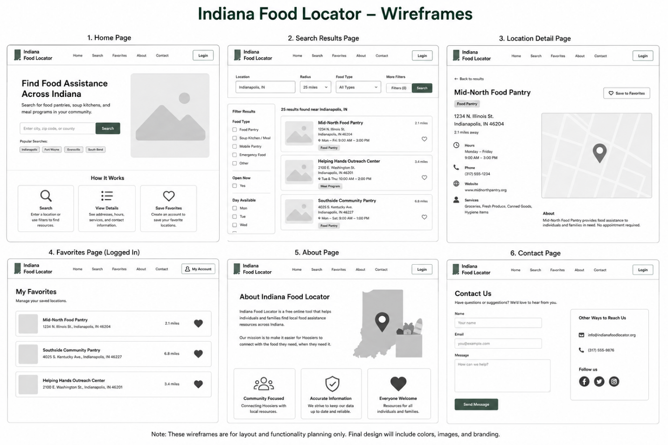Figure 3
Indiana Food Locator Admin Portal Wireframes
Note. The wireframes illustrate the planned administrator portal before implementation.
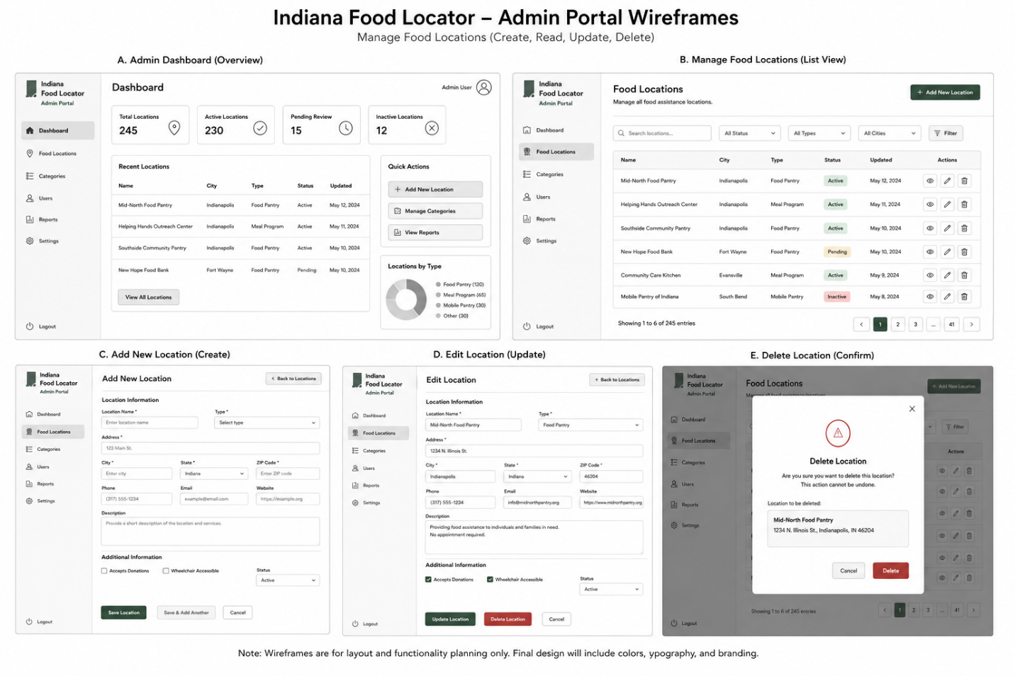
Development is being conducted using a layered architecture that includes a presentation layer, a business logic layer, and a data layer. Figure 4 illustrates the overall system architecture, showing how users interact with the web interface, how requests are processed through the Spring Boot application, and how data is stored and retrieved from the MySQL database. Spring MVC manages the application's request processing, while Spring Data JPA and Hibernate provide object-relational mapping between the application and the MySQL database. Bootstrap, HTML5, CSS3, and JavaScript are used to create a responsive user interface that functions across desktop and mobile devices.
Figure 4
System Architecture for the Indiana Food Locator
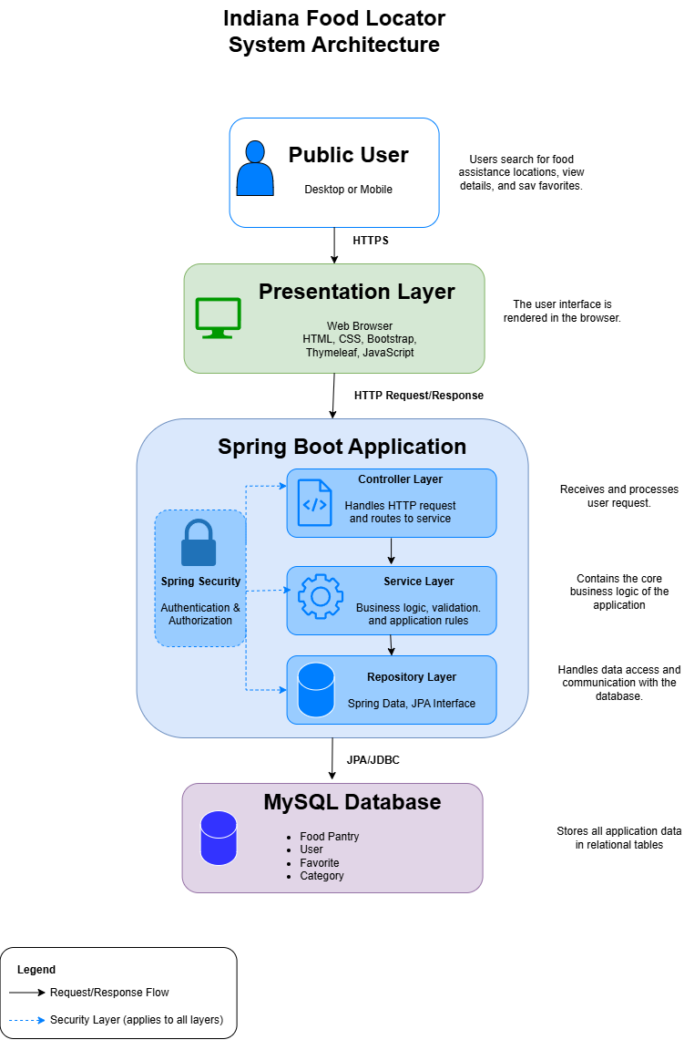
Note. The system architecture illustrates the interaction between users, the presentation layer, the Spring Boot application, the business logic layer, and the MySQL database. This will be updated with external services such as Google Maps.
The project repository was established on GitHub to support version control, source code management, and project organization throughout the development lifecycle. GitHub enables tracking changes over time while providing a centralized location for the Spring Boot project and related documentation. Figure 5 shows the GitHub repository that will be used throughout the development of the Indiana Food Locator.
Figure 5
Indiana Food Locator GitHub Repository
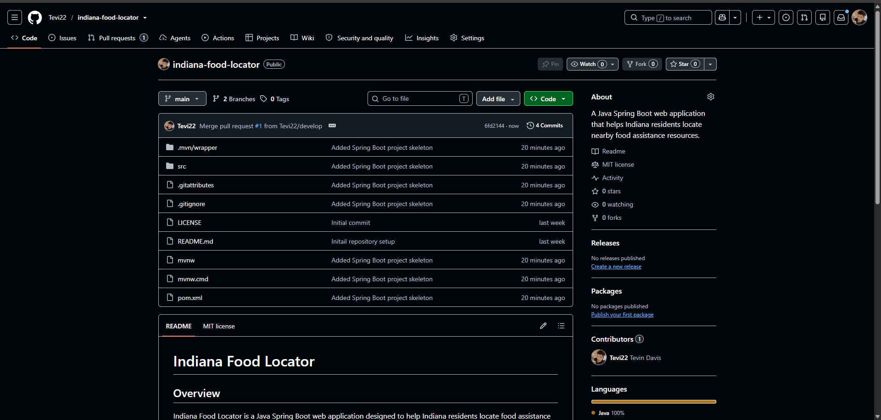Note. The GitHub repository provides centralized version control for the Indiana Food Locator, allowing source code, documentation, and future development activities to be tracked throughout the project lifecycle.

The current implementation prioritizes the following MVP features:
- Search food assistance locations by ZIP code, city, county, or category.
- Display organization information, including addresses, operating hours, contact information, and available services.
- Provide a responsive web interface that supports desktop and mobile users.
- Secure an administrator portal using Spring Security authentication.
- Allow administrators to create, update, and delete food resource information.
Security has been integrated throughout the development process instead of being a final step. Spring Security offers features such as password encryption, role-based authorization, session management, and secure authentication for administrator accounts (Spring, 2025). Additionally, Input validation will be incorporated throughout development to reduce the risk of SQL injection and cross-site scripting attacks.
The remaining implementation tasks include completing the administrator portal, integrating Google Maps for location visualization, refining the user interface, and preparing the application for comprehensive system testing.
Section 3: Project Test Plans and Results
Project Testing Plan
The Indiana Food Locator is currently in development, and as a result, testing will take place during each Agile iteration instead of only after the implementation is finished. This approach of continuous testing enables us to identify defects early and ensures that each new feature meets stakeholder requirements.
Functional Testing
Functional testing will verify that each feature performs as expected. Test cases will include:
- Searching by ZIP code
- Searching by city
- Filtering by service category
- Returning no-result searches correctly
- Administrator login
- Creating new food resource records
- Updating existing resource information
- Deleting food resource records
Each function will be tested using valid, invalid, and boundary-value inputs to verify system reliability.
Unit Testing
JUnit and Spring Boot Test will be used to thoroughly verify the functionality of each component within the application. This involves conducting independent tests on repository methods, service classes, and controller endpoints. By isolating these components, we can ensure that the underlying business logic performs as intended and meets the specified requirements before moving on to integration testing. This detailed testing process not only helps identify potential issues early on but also boosts the overall reliability and stability of the application before it is fully integrated.
Integration Testing
Integration testing will verify effective communication between the web interface, the Spring Boot application, and the MySQL database. These tests will ensure that search requests return accurate information, that updates made by administrators are correctly stored, and that data remains consistent throughout the application.
Security Testing
Security testing plays a crucial role in confirming the robustness of various protective measures within an application. It will thoroughly evaluate the effectiveness of administrator authentication mechanisms to ensure that only authorized personnel can gain access. Additionally, it assesses role-based authorization to verify that users are granted appropriate permissions based on their defined roles.
Another key focus of this testing is on password encryption, making certain that sensitive authentication information is securely stored and transmitted, thereby minimizing the risk of exposure. The security assessment will also scrutinize the safeguarding of administrative pages to prevent unauthorized access.
Moreover, the testing process will encompass measures to ensure that unauthorized users are completely barred from performing administrative functions. The security testing strategy will also align with guidance from the National Institute of Standards and Technology (NIST) Cybersecurity Framework 2.0 by verifying that authentication, access control, and application security measures help protect the confidentiality, integrity, and availability of system data (National Institute of Standards and Technology [NIST], 2024; Spring, 2025).
Usability Testing
A group of representative users will conduct a thorough assessment of the application's navigation, readability, and overall usability. Their feedback will focus on several critical areas, including how well the search function performs, the effectiveness of the interface design, and the accessibility features offered. The insights gained from this usability testing will be used to pinpoint specific areas for improvement, which will then be integrated into future iterations of the product through our Agile development process.
Accessibility Testing
Accessibility testing aims to ensure that digital content meets the standards set by WCAG 2.1 Level AA. This involves a thorough evaluation of several key components:
- Keyboard Navigation: Verifying that users can navigate the entire site using only a keyboard, which is essential for individuals who cannot use a mouse.
- Color Contrast: Assessing the color contrast between text and background to guarantee readability for users with visual impairments.
- Responsive Layouts: Ensuring that the design adapts effectively to various screen sizes and devices, providing a seamless user experience across platforms.

- Compatibility with Assistive Technologies: Testing the site’s functionality with tools such as screen readers, magnifiers, and other assistive devices to confirm that all users can access the content without barriers.
By conducting this comprehensive testing, we can ensure that our digital environments are inclusive and accessible to all users, as outlined by the World Wide Web Consortium (W3C, 2023).
Report Summary
The Indiana Food Locator is currently moving from the design phase into the implementation phase of development. Significant progress has been made in establishing the project’s technical foundation through the completion of key design artifacts. These artifacts include the system architecture, Entity Relationship Diagram (ERD), user interface wireframes, and the GitHub project repository. Together, they provide the necessary framework to support the remaining development activities and ensure that the application meets stakeholder requirements and adheres to software engineering best practices.
The implementation plan focuses on developing a Minimum Viable Product (MVP) using Java Spring Boot, Spring Security, MySQL, and Bootstrap. Core functionalities will include searching for food assistance resources, displaying organization information, and providing a secure administrator portal for maintaining resource records. Future development iterations will include additional features such as Google Maps integration and expanded search capabilities.
A comprehensive testing strategy has been established to support the remainder of the project. Throughout development, functional, unit, integration, security, usability, and accessibility testing will be conducted to ensure that the application meets stakeholder expectations, performs reliably, and complies with accessibility and security best practices. By following an Agile development methodology, testing results and stakeholder feedback will guide future iterations and improvements.
Although the application is still under active development, the planning, design, and implementation activities completed thus far demonstrate the technical feasibility of the proposed solution and create a strong foundation for completing the Indiana Food Locator during the remaining capstone milestones.
Section 4: Recommendations for Future Enhancements
Successes, Challenges, and Lessons Learned
The Indiana Food Locator project has provided valuable experience in applying software engineering principles to develop a practical web application that addresses a real community need. Throughout the project, we encountered several successes, challenges, and lessons learned that can improve both the current application and future software development efforts.
One of the project's greatest successes was completing a comprehensive planning and design phase before beginning implementation. By establishing project requirements, identifying stakeholder needs, designing the database with an Entity Relationship Diagram (ERD), developing system architecture, and creating user interface wireframes, we established a structured roadmap for development. These design activities reduced uncertainty during implementation and laid a strong technical foundation for the application. Additionally, selecting Java Spring Boot as the primary development framework provided a scalable and maintainable architecture that supports future enhancements and enterprise-level development.
Another success was incorporating security and accessibility requirements early in the development process rather than treating them as afterthoughts. Implementing Spring Security within the application design promotes secure administrator authentication and role-based authorization, while planning for compliance with the Web Content Accessibility Guidelines (WCAG) ensures that individuals with disabilities can effectively use the application (Spring, 2025; World Wide Web Consortium [W3C], 2023).
Despite these accomplishments, several challenges arose throughout the project. The primary challenge was balancing the desired feature set with the limited timeframe available for the capstone project. Numerous enhancements, including Google Maps integration, user accounts, advanced search filters, organization self-service portals, and real-time resource updates, were identified during planning. However, implementing all these features would have significantly exceeded the project's schedule. To address this challenge, we adopted a Minimum Viable Product (MVP) approach that prioritizes the most essential functionality while reserving additional features for future development.
Another challenge was learning and implementing new technologies simultaneously. Although Spring Boot offers a powerful framework for enterprise application development, Spring MVC, Spring Security, Spring Data JPA, Thymeleaf, and MySQL required additional research and careful planning. This experience reinforced the importance of incremental development, continuous learning, and thorough documentation when adopting unfamiliar technologies.
Several important lessons emerged during the development process. Firstly, investing significant time in planning before implementation greatly reduced the likelihood of needing to redesign the database or application architecture later in the project. Secondly, developing wireframes before coding clarified stakeholder expectations and improved the overall user experience. Finally, integrating security, accessibility, and testing considerations throughout development proved more effective than adding these features after implementation had begun. These lessons will continue to guide future software development projects.
Modification Strategies and Actionable Steps
Although the Indiana Food Locator meets the objectives established for the capstone project, there are several opportunities to expand and improve the application beyond the initial MVP. Future development should follow a phased enhancement strategy that gradually introduces additional functionality while maintaining system stability and usability.
Phase 1: Complete the Minimum Viable Product
The top priority is to complete the remaining Minimum Viable Product (MVP) functionality. This involves finalizing administrator authentication using Spring Security, implementing full Create, Read, Update, and Delete (CRUD) functionality for managing food resources, integrating the MySQL database with the application, and completing the testing activities outlined in the project testing plan.
Figure 6
Indiana Food Locator – Working Home Page Screenshot
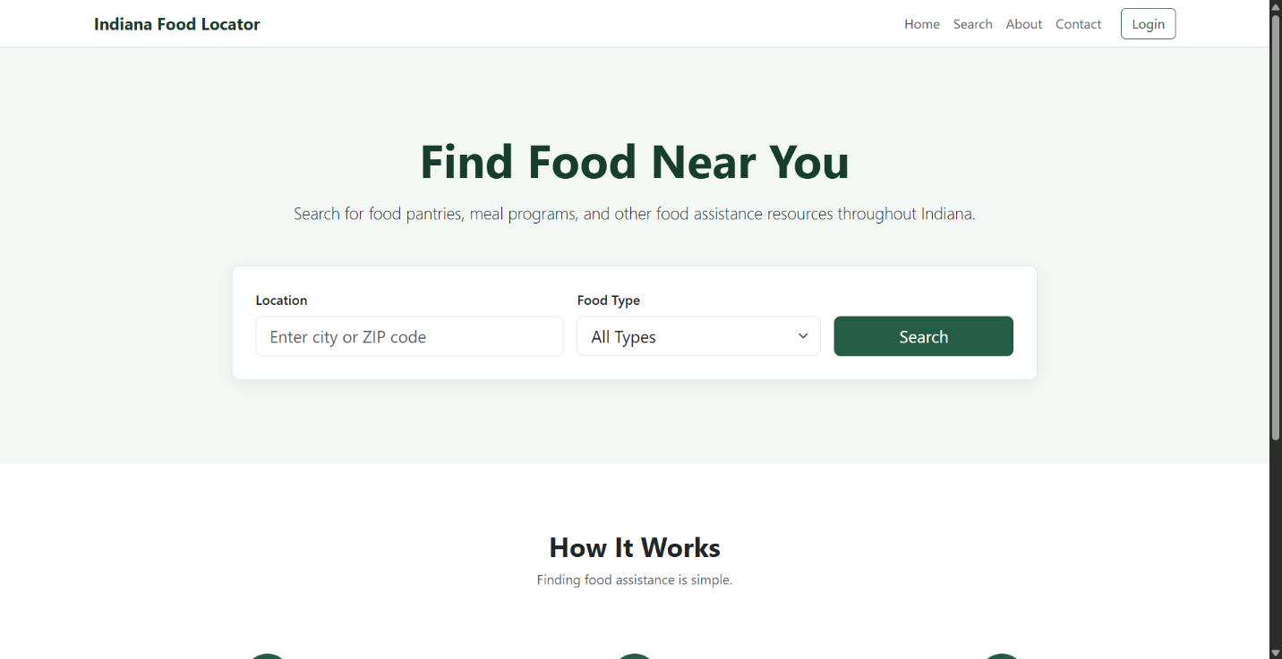
Figure 7
Indiana Food Locator– Food Search Results Screenshot
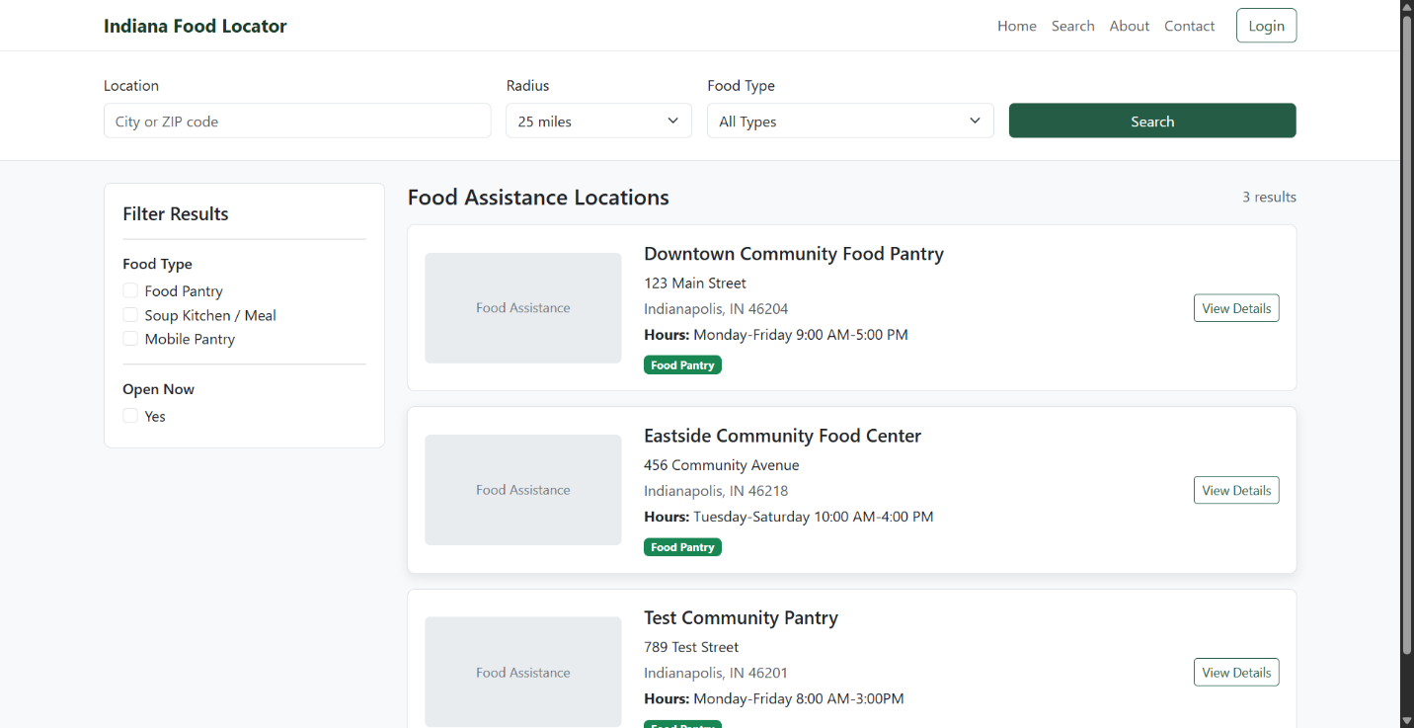
Phase 2: Improve User Experience
After completing the Minimum Viable Product (MVP), development efforts should shift towards enhancing usability and accessibility. Planned improvements include integrating Google Maps to visually display resource locations, expanding search filters to include operating hours and eligibility criteria, enhancing mobile responsiveness, and continuing to develop accessibility features that comply with WCAG 2.1 Level AA standards (World Wide Web Consortium [W3C], 2023).
Phase 3: Expand Application Features
Once the core application has been fully developed, additional features can be added to enhance value for both users and participating organizations. Recommended enhancements include the ability for users to create accounts, save favorite locations, receive personalized notifications for resource updates, and provide organizations with self-service portals for managing their resource information. Additionally, developing a REST API will support future mobile applications.
Figure 8
Indiana Food Locator – Administrator Dashboard Screenshot
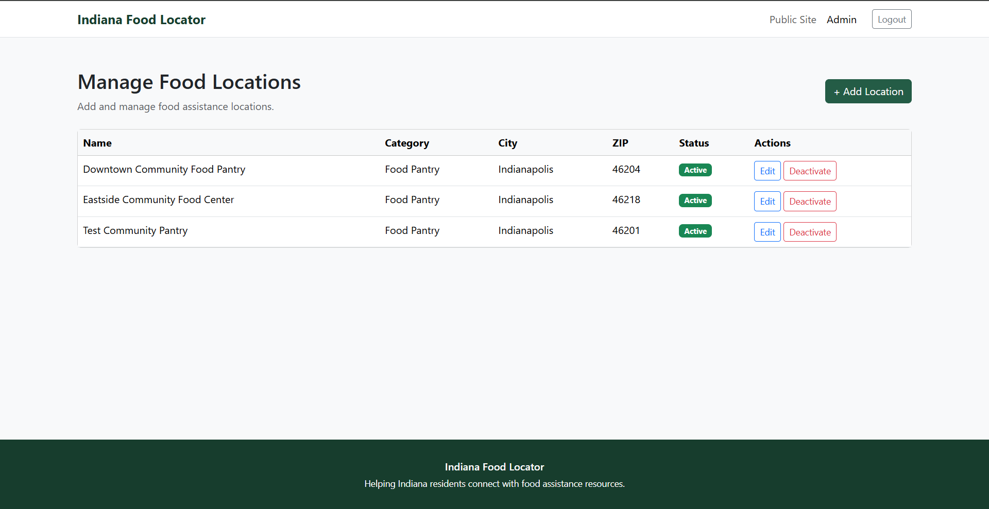
Phase 4: Deployment and Long-Term Growth
The final phase is centered on getting the application ready for production deployment and ensuring its long-term sustainability. Recommended improvements include deploying the application on a cloud hosting platform, implementing automated backups, monitoring application performance, enhancing security audits, and expanding the database to support food assistance organizations across the entire state of Indiana. Additionally, continuous feedback from stakeholders should be gathered to inform future software updates and prioritize new features.
Potential Issues
As development progresses beyond the capstone project, several important issues should be considered.
One key issue is the need to maintain accurate information for participating food assistance organizations. Since operating hours, eligibility requirements, contact information, and available services frequently change, the application will require ongoing administrative oversight to ensure data accuracy. Without regular updates, outdated information could undermine user confidence in the application.
Another potential issue is stakeholder adoption. Food assistance organizations must be willing to regularly update their information, and users must view the application as a reliable source of food assistance information for it to remain effective.
Scalability is also an important consideration. As the application expands to include more organizations, users, and geographic locations, there may be a need to optimize database performance and application response times. Future enhancements, such as database indexing, query optimization, caching strategies, and cloud-based infrastructure, may be necessary to support increased user demand.
Security remains an ongoing concern. While Spring Security provides a robust framework for authentication and authorization, future development must include regular software updates, vulnerability assessments, enforcement of secure password policies, and server-side validation to protect application data. These efforts align with the recommendations of the National Institute of Standards and Technology Cybersecurity Framework 2.0 (NIST, 2024).
Resource limitations should also be acknowledged. The capstone project was completed within a restricted academic timeline using a Minimum Viable Product approach. Additional development time, funding, stakeholder participation, and testing resources would enable the implementation of several advanced features that were intentionally deferred to maintain the project's scope.
Overall, these potential issues do not detract from the value of the Indiana Food Locator; rather, they highlight realistic opportunities for continuous improvement in future development.
Section 5: Appendix
The following supporting materials are included to provide additional documentation and evidence supporting the project design, implementation, and testing activities.
Appendix A
Entity Relationship Diagram (ERD)
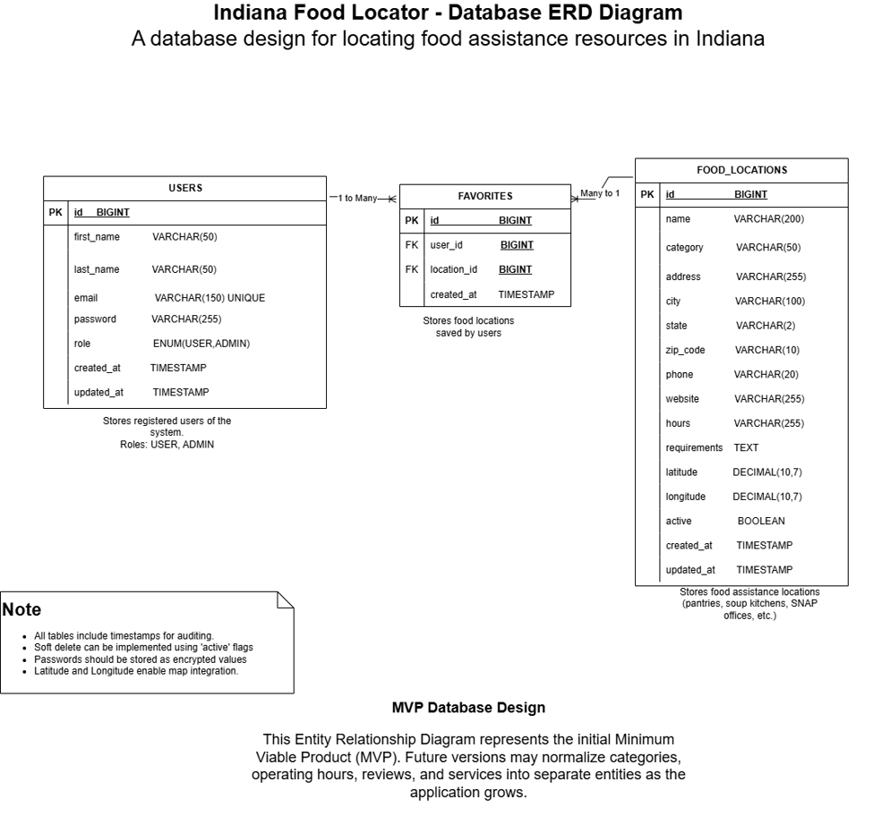
Appendix B
System Architecture Diagram

Appendix C
Home Page Wireframe
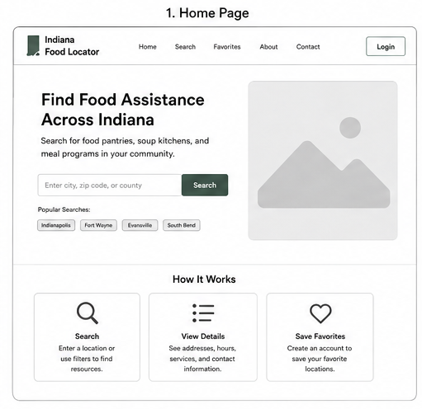
Appendix D
Food Search Page Wireframe
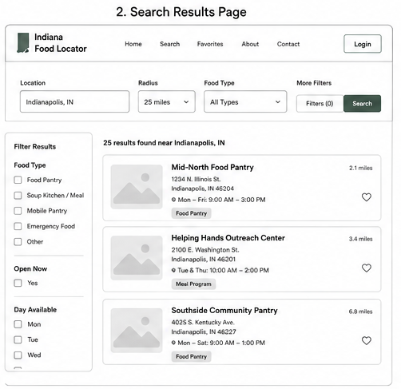
Appendix E
Administrator Portal Wireframe

Appendix F
GitHub Repository

Appendix G
Working Home Page

Appendix H
Food Search Results

Appendix I
Administrator Dashboard

Appendix J
Testing Results
Planned Testing Results
Formal testing is currently in progress as application development continues. Because the Indiana Food Locator is being developed using an Agile methodology, testing activities will be performed throughout the remaining implementation phase rather than after all development is complete. Final testing documentation will include:
- Unit testing results using JUnit
- Functional testing checklist
- Integration testing results
- Security testing outcomes
- Accessibility testing results
- User acceptance testing (UAT) feedback
- Summary of defects identified and resolutions implemented
These materials will be incorporated into the final IT Project Report after development and testing have been completed.

References
Feeding America. (2025). Map the Meal Gap: Indiana. https://map.feedingamerica.org/
National Institute of Standards and Technology. (2024). Cybersecurity Framework (CSF) 2.0. https://www.nist.gov/cyberframework
Project Management Institute. (2021). A guide to the project management body of knowledge (PMBOK® Guide) (7th ed.). Project Management Institute.
Spring. (2025). Spring Framework Documentation. https://docs.spring.io/spring-framework/reference/
Spring. (2025). Spring Security Reference Documentation. https://docs.spring.io/spring-security/reference/
World Wide Web Consortium. (2023). Web Content Accessibility Guidelines (WCAG) 2.1. https://www.w3.org/TR/WCAG21/

