SETHATEVY BONG

CMSC 140

Project 5

Pseudocode or Algorithm for the program:

1.Prompt and ask user to input numbers in each row and column

2.create Boolean value and check if it is unique using for loop

3.Test the magic array and display the result

4.Determine if the array is a Lo Shu Magic Square.

5.If so, display a message indicating that the array is a magic square.

6. If not, display a message indicating that the array is not a magic square.

7.Prompt user by y/n question whether to continue the program or not

8.If the input is "y", the program will ask user to input the numbers

9.If the input is "n", the program will proceed to Farwell message

10.Display Programmer’s name and project's information as the farewell message

OUTPUT

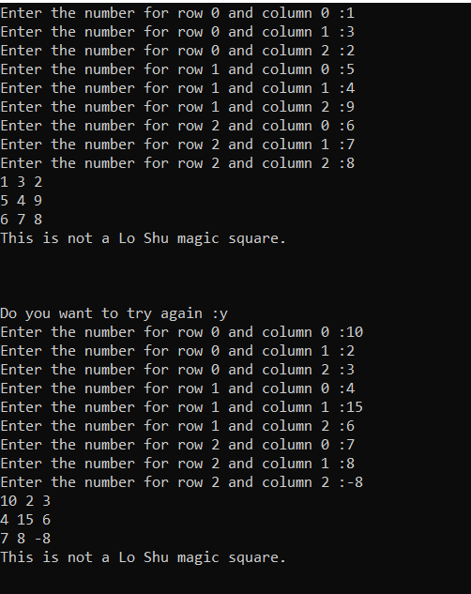

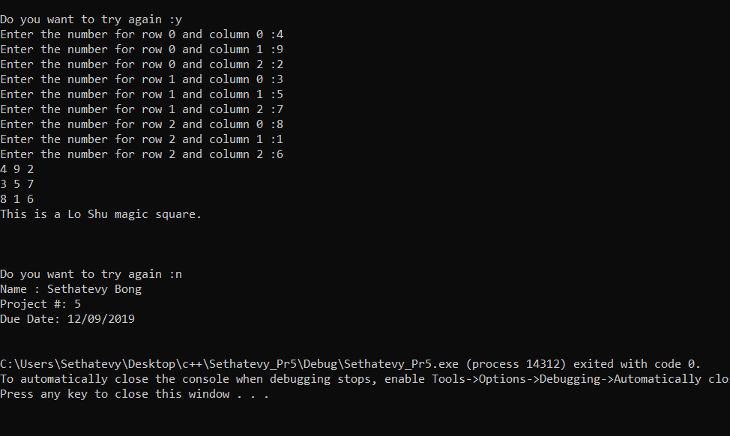

|  |  |  |  |  |  |
| --- | --- | --- | --- | --- | --- |
| **Test Case #** | **Input** | **Actual Input** | **Expected Output**  **Is Magic?** | **Actual Output**  **Is Magic?** | **Did the test pass?** |
| 1 | 1 3 2  5 4 9  6 7 8 | 1  3  2  5  4  9  6  7  8 | No | 1 3 2  5 4 9  6 7 8 | YES |
| 2 | 10 2 3  4 15 6  7 8 -8 | 10  2  3  4  15  6  7  8  -8 | No | 10 2 3  4 15 6  7 8 -8 | YES |
| 3 | 4 9 2  3 5 7  8 1 6 | 4  9  2  3  5  7  8  1  6 | Yes | 4 9 2  3 5 7  8 1 6 | YES |
| 4 |  |  |  |  |  |

**Lesson Learned**

Through project 5, I learn how to use functions, loops, conditional statements, and how to work with one dimensional parallel array. Personally, I prefer previous project because I think this project done not have a real-world application, where I can apply; yet, I feel like I haven’t fully grasped the concept. I had a better experience with doing previous projects that this project.

I feel confused about this project. After I went to the tutoring center and received some help from the tutors and other students, I think I begin to understand it better. However, I still don’t fully understand this exercise. This project takes much more time than I anticipated. Fortunately, I started it early and managed to finish it before the deadline. I think with am in-person help with learning these concepts, It will be easier to write this program. In my opinion, I think this project should be made simpler for students. I might be better if there is a smaller project before this project for students to get the gist than move to writing this program.