SETHATEVY BONG

PROJECT 4

Pseudocode:

1. PRINT title "Calculate the average number of days a company's employees are absent."

2. CALL NumOfEmployees() function

3. PROMPT "Please enter the number of employee in the company: "

4. WHILE number of employees < 1

5. PRINT error "Please re-enter the number of employees: "

6. PROMPT "Please re-enter the number of employees: "

7. END WHILE

8. RETURN number of employees

9. CALL TotDaysAbsent() function. PASS number of employees.

10. FOR i < number of employees

11. PROMPT "Please enter an employee ID: "

12. PROMPT "Please enter the number of days this employee was absent: "

13. WHILE days absent < 0

14. PRINT error "The number of days must not be negative"

15. PROMPT "Please re-enter the number of days this employee was absent: "

16. END WHILE

17. CALCULATE total absent

18. WRITE employee ID and days absent to file.

19. RETURN total absent.

20. CALL AverageAbsent() function, PASS number of employee and total absent

21. CALCULATE average numbers of absent

22. COVERT total absent to double by static_cast <double>

23. RETURN average absent

24. CALL main function

25. PRINT introduction "Calculate the average number of days a company's employees are absent."

26. CALL outfile ("employeeAbsences.txt")

27. WRITE "EMPLOYEE ABSENCE REPORT" to file

28. WRITE "employee id" and "days absent" in file

29. PASS the number of employee and CALL NumOfEmployees() function

30. CALCULATE total days absent

31. PASS average days absent and CALL AverageAbsent() function

32. WRITE number of employee and total days absent to file

33. WRITE average days Absent to file

34. PROMPT programmer's name

**SAMPLE OUTPUT**

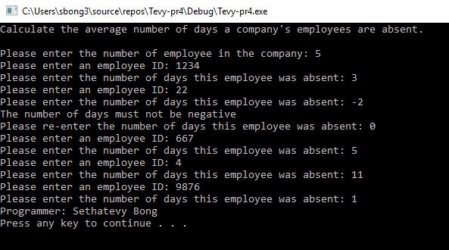

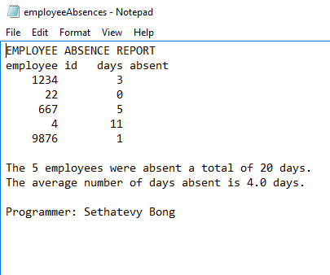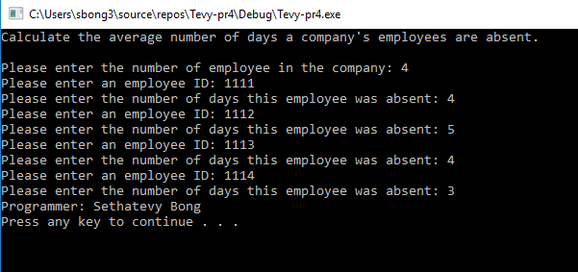

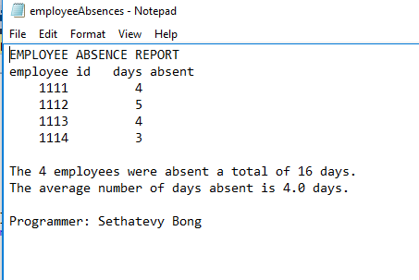

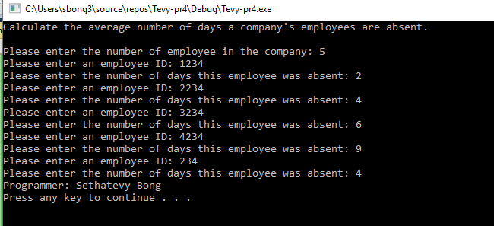

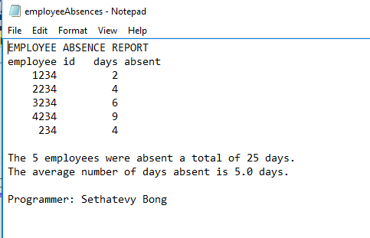

**TEST PLAN**

|  |  |  |  |  |  |
| --- | --- | --- | --- | --- | --- |
| Test case # | Input | Actual Input | Expected Output | Actual Output | Did the test pass? |
| 1 | No. of employees :  5  Employee ID’s/Days of absence :  1234 3  22 -2  0  667 5  4 11  9876 1 | No. of employees :  5  Employee ID’s/Days of absence :  1234 3  22 -2  0  667 5  4 11  9876 1 | Total: 20  Average: 4.0 | Total: 20  Average: 4.0 | YES |
| 2 | No. of employees :4  Employee ID’s/Days of absence : 1111 4  1112 5  1113 4  1114 3 | No. of employees :4  Employee ID’s/Days of absence : 1111 4  1112 5  1113 4  1114 3 | Total:16  Average: 4.0 | Total:16  Average: 4.0 | YES |
| 3 | No. of employees :5  Employee ID’s/Days of absence : 1234 2  2234 4 3234 6 4234 9  234 4 | No. of employees :5  Employee ID’s/Days of absence : 1234 2  2234 4 3234 6 4234 9  234 4 | Total: 25  Average: 5.0 | Total: 25  Average: 5.0 | YES |

Lesson Learned

I learn how to organize code by using multiple functions, pass data to and return data from a function. I also learn how to use of loops and use output file processing. In my opinion, write an output file is the most challenging part of the project, I spent over 5 hours looking through sources, but I still have a hard time getting the correct thoughts. I am certain I have to spend more time practicing chapter 5 and 6, but, overall, this project really helps me understanding concepts and use it in a clear way,

For this project, I really like how it is very realistic. Writing a program for real life setting encourage me to learn programming in a deeper level. Although this is the first course of programming, I think the project really demonstrates the real life application of C++.

Once again, I could do this project without the help from the tutor at the Ackerman learning center. It’s extremely helpful for me to interact with others to understand the best way that they approach the questions. I feel that the power of group works also help me writing and understanding this program because I got to meet with other CMSC 140 students, who are working on this project.