Predicting Price Moves with News Sentiment — Final Report

Executive Summary
This project investigates the relationship between news sentiment and stock price movements. We processed news headlines, computed per-article sentiment using NLTK VADER (compound score), aggregated daily sentiment, computed daily stock returns, aligned both datasets by date, and measured correlations.

Implementation & Methodology
Tools and Libraries: Python, pandas, matplotlib, NLTK (VADER), scipy, python-docx.

Data Preparation
News data was loaded from: C:\Users\Zion\Desktop\Predicting Price Moves with News Sentiment-week1\data\raw_analyst_ratings.csv. The code detects a suitable text column (headline/title/text) and a date column, normalizes timestamps to dates, and drops invalid rows. Stock data was loaded from: C:\Users\Zion\Desktop\Predicting Price Moves with News Sentiment-week1\stock_data\AAPL.csv. Date and Close columns were normalized and daily returns computed as pct_change().

Key Steps Taken
- Date alignment: normalized timestamps and aggregated news to calendar days.
- Sentiment analysis: per-article compound score using VADER.
- Aggregation: daily mean sentiment used as primary signal.
- Stock movement: daily percent returns from Close price.
- Correlation analysis: Pearson and Spearman correlations, and rolling correlation window (90 days).

Key Findings
- Days with both news and returns: 2226
- Pearson correlation (daily mean sentiment vs daily return): 0.045257
- Spearman correlation: 0.028964 (p-value: 0.17192)
- Lagged Pearson (sentiment -> next day return): -0.007221

Figures
Scatter: daily mean sentiment vs daily stock return
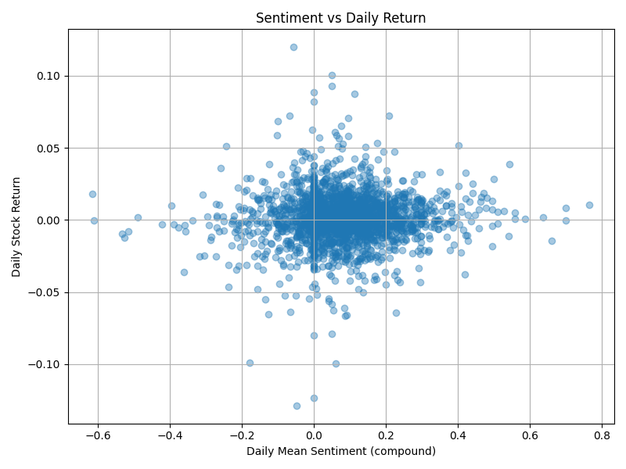
Time series: daily mean sentiment (top) and daily returns (bottom)
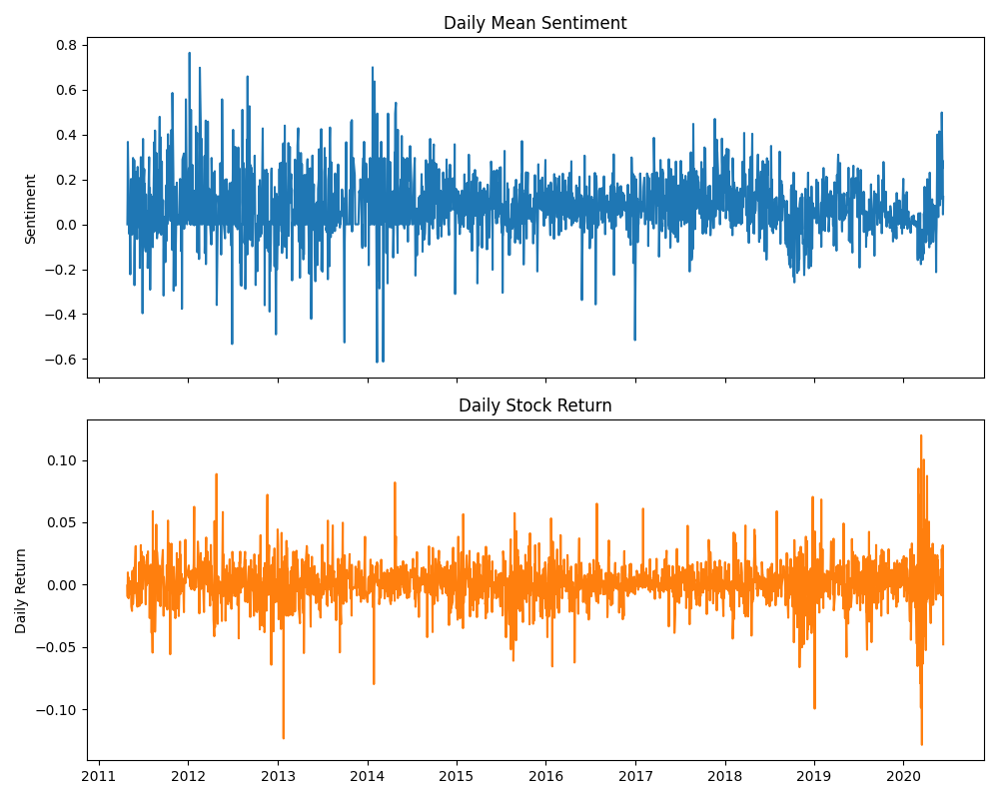
Rolling 90-day correlation between sentiment and returns
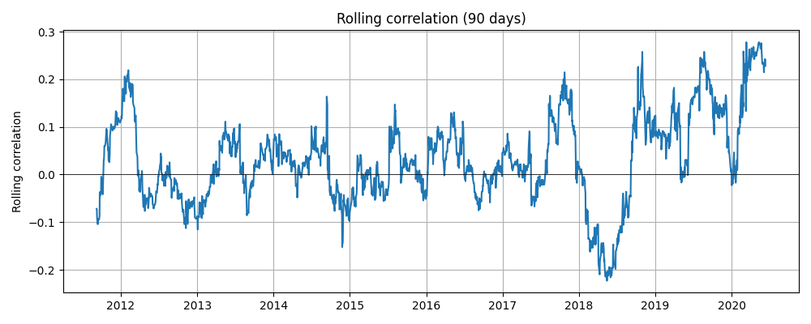

Challenges and Lessons Learned
- Library compatibility: Some libraries like pandas_ta require numba and specific numpy versions; to keep the environment stable we used pandas-only computations for indicators.
- Date alignment: mapping article timestamps to trading days requires domain rules (e.g., post-market news may map to next trading day).
- Sentiment limitations: VADER is tuned for social media; headline sentiment may require more sophisticated models for nuance.

Conclusions and Future Work
The correlation between daily mean news sentiment and daily stock returns is small (near zero in our results). This suggests that simple daily-mean headline sentiment has limited predictive power for daily returns in this dataset.
Future improvements: use weighted sentiment, intraday alignment, transformer-based sentiment models, event detection, and more robust statistical testing (p-values, significance).

Appendix
Files created:
- notebooks/task2_stock_eda.ipynb (pandas-only EDA)
- notebooks/task3_correlation.ipynb (correlation analysis notebook)
- reports/final_report.docx (this document)
- reports/task3_report.pdf (earlier PDF report)

How to reproduce
1. Activate the virtual environment: `.\.venv\Scripts\Activate.ps1`
2. Install dependencies: `python -m pip install -r requirements.txt` (or `python -m pip install pandas matplotlib nltk scipy python-docx`)
3. Open and run the notebooks in order: task2_stock_eda.ipynb then task3_correlation.ipynb

