Mohammad Abu Shariha
CMPENG 331
Lab 4
Section 002
Mmaa7020@psu.edu

Schematics:
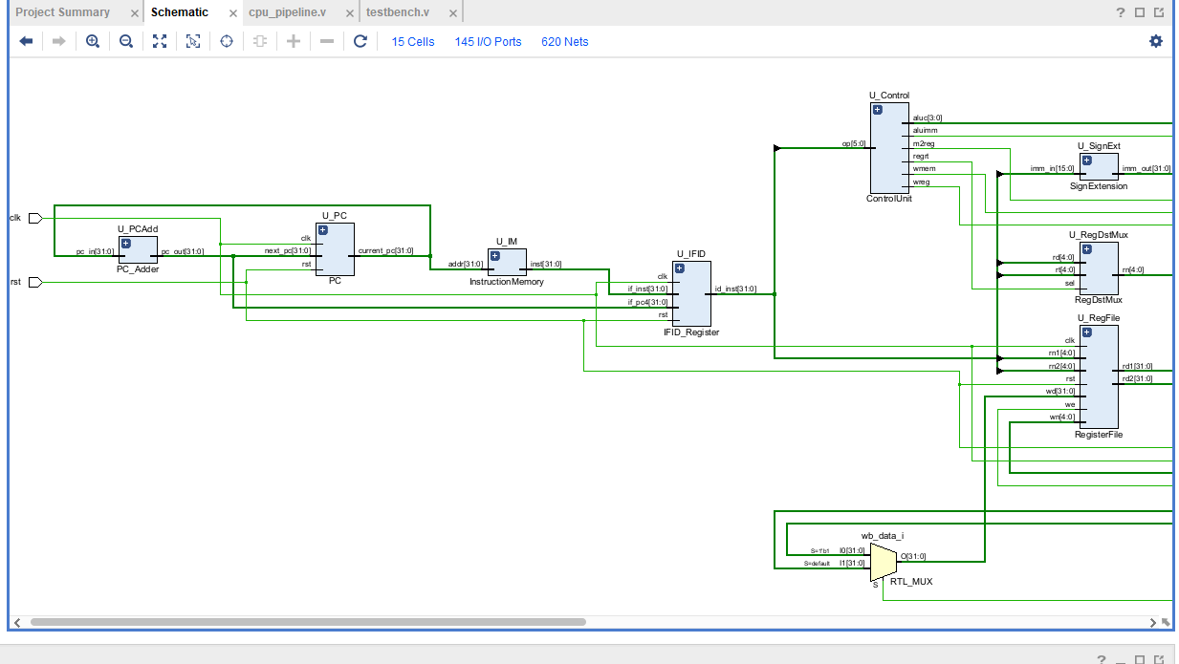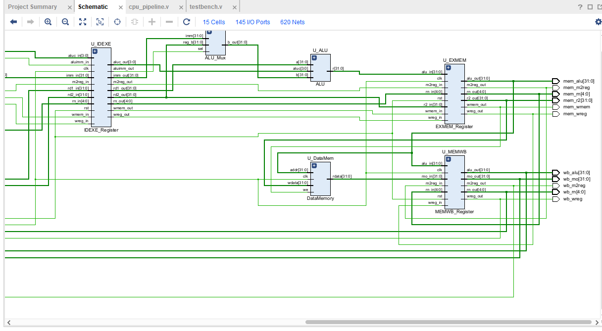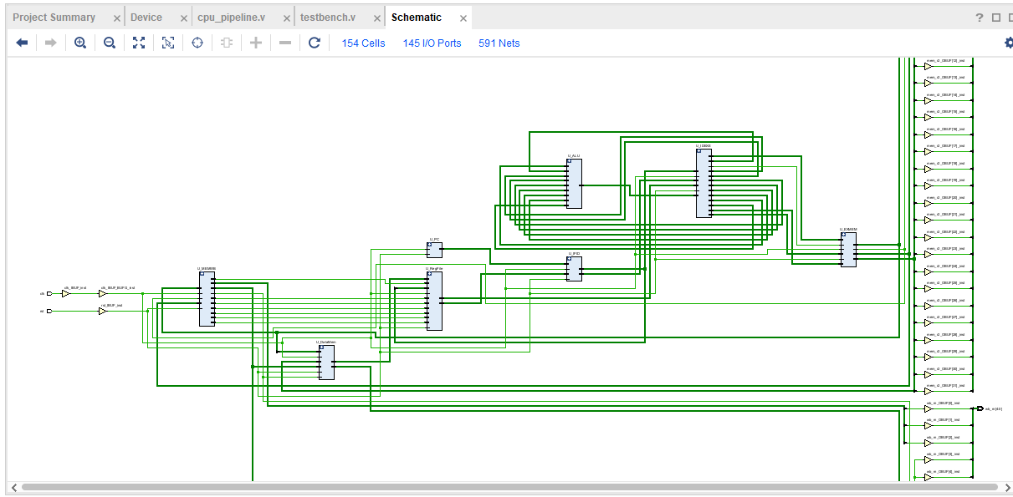
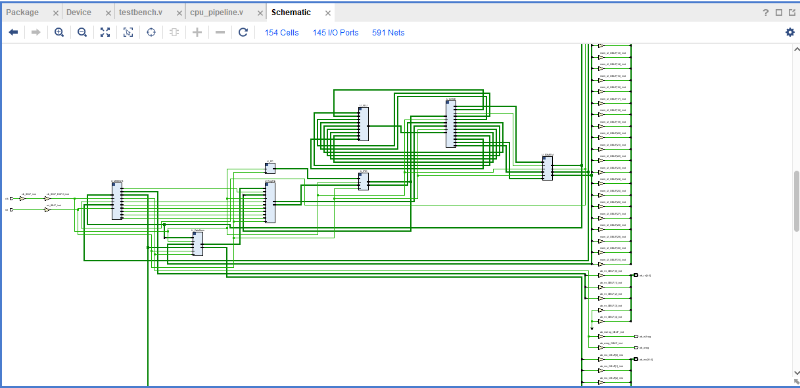
I/O planning:
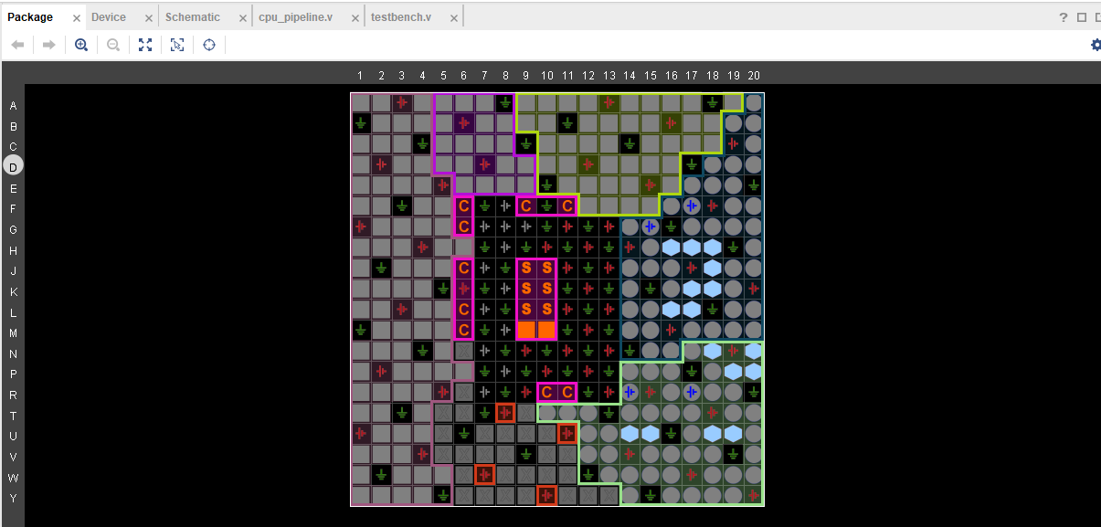
Floor Plan: 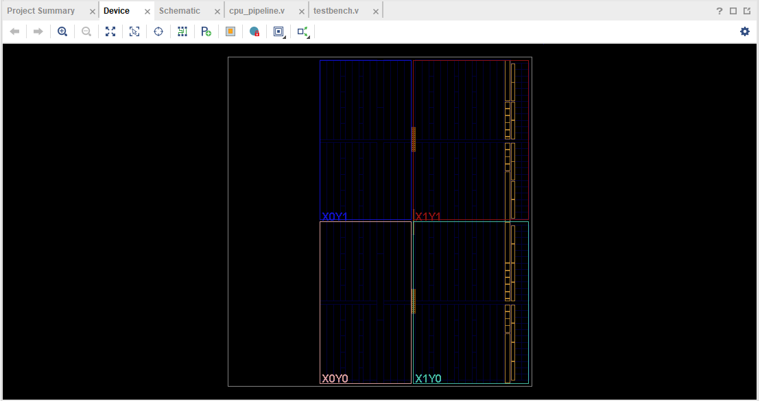
Waveform:
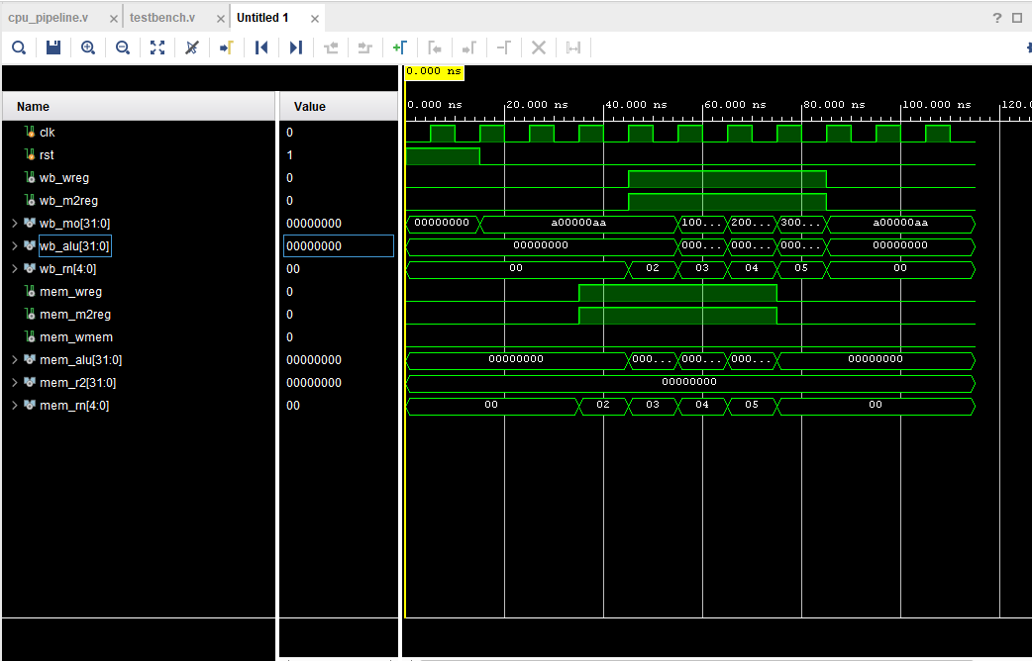
Waveform log:
Time resolution is 1 ps
Time | PC | EX/MEM: ALU Out | MEM/WB: Mem Out (wb_mo) | WB Dest Reg
-----------------------------------------------------------------------
Time=0 | PC=00000064 | MEM_ALU=00000000 | WB_MO=00000000 | WB_RN= 0
Time=15000 | PC=00000068 | MEM_ALU=00000000 | WB_MO=a00000aa | WB_RN= 0
Time=25000 | PC=0000006c | MEM_ALU=00000000 | WB_MO=a00000aa | WB_RN= 0
Time=35000 | PC=00000070 | MEM_ALU=00000000 | WB_MO=a00000aa | WB_RN= 0
Time=45000 | PC=00000074 | MEM_ALU=00000004 | WB_MO=a00000aa | WB_RN= 2
Time=55000 | PC=00000078 | MEM_ALU=00000008 | WB_MO=10000011 | WB_RN= 3
Time=65000 | PC=0000007c | MEM_ALU=0000000c | WB_MO=20000022 | WB_RN= 4
Time=75000 | PC=00000080 | MEM_ALU=00000000 | WB_MO=30000033 | WB_RN= 5
Time=85000 | PC=00000084 | MEM_ALU=00000000 | WB_MO=a00000aa | WB_RN= 0
Time=95000 | PC=00000088 | MEM_ALU=00000000 | WB_MO=a00000aa | WB_RN= 0
Time=105000 | PC=0000008c | MEM_ALU=00000000 | WB_MO=a00000aa | WB_RN= 0
$finish called at time : 115 ns : File "C:/Users/mma7020/Desktop/Lab4/Lab4.srcs/sources_1/new/testbench.v" Line 74
Verilog design code:
/*
* CMPEN 331 - Lab 4
verilog Design Code for IF, ID, EXE, and MEM Stages

*/

// Top-Level Module: cpu_pipeline
module cpu_pipeline (
input clk,
input rst,

//ignals written into MEM/WB (Output of MEM stage)
output wb_wreg, // RegWrite
output wb_m2reg, // MemToReg
output [31:0] wb_mo, // Memory Output Data
output [31:0] wb_alu,// ALU Result (bypass from MEM)
output [4:0] wb_rn, // Destination Register Number

// Signals output from EX/MEM (Input to MEM stage)
output mem_wreg,
output mem_m2reg,
output mem_wmem,
output [31:0] mem_alu,
output [31:0] mem_r2,
output [4:0] mem_rn
);

//Wires & Interconnects

// IF Stage
wire [31:0] pc_current;
wire [31:0] pc_next;
wire [31:0] inst_if;

// IF/ID Register
wire [31:0] id_inst;
wire [31:0] id_pc4;

//ID
wire [5:0] id_op;
wire [4:0] id_rs;
wire [4:0] id_rt;
wire [4:0] id_rd;
wire [15:0] id_imm16;

wire ctrl_wreg, ctrl_m2reg, ctrl_wmem, ctrl_aluimm, ctrl_regrt;
wire [3:0] ctrl_aluc;

wire [31:0] rf_rd1, rf_rd2;
wire [31:0] imm_ext;
wire [4:0] reg_dest_id;

//ID/EXE Regist-
wire exe_wreg, exe_m2reg, exe_wmem, exe_aluimm;
wire [3:0] exe_aluc;
wire [31:0] exe_rd1, exe_rd2, exe_imm;
wire [4:0] exe_rn;

// EXE Stage
wire [31:0] alu_b_input;
wire [31:0] alu_result_exe;

wire [31:0] mem_data_out;

wire [31:0] wb_data;

assign id_op = id_inst[31:26];
assign id_rs = id_inst[25:21];
assign id_rt = id_inst[20:16];
assign id_rd = id_inst[15:11];
assign id_imm16 = id_inst[15:0];
assign wb_data = (wb_m2reg == 1'b1) ? wb_mo : wb_alu;

// 1.Instruction Fetch (IF) Stage
PC U_PC (
.clk(clk),
.rst(rst),
.next_pc(pc_next),
.current_pc(pc_current)
);

PC_Adder U_PCAdd (
.pc_in(pc_current),
.pc_out(pc_next)
);

InstructionMemory U_IM (
.addr(pc_current),
.inst(inst_if)
);

IFID_Register U_IFID (
.clk(clk),
.rst(rst),
.if_inst(inst_if),
.if_pc4(pc_next),
.id_inst(id_inst),
.id_pc4(id_pc4)
);

//2. Instruction Decode (ID) Stage
ControlUnit U_Control (
.op(id_op),
.wreg(ctrl_wreg),
.m2reg(ctrl_m2reg),
.wmem(ctrl_wmem),
.aluc(ctrl_aluc),
.aluimm(ctrl_aluimm),
.regrt(ctrl_regrt)
);

RegisterFile U_RegFile (
.clk(clk),
.rst(rst),
.rn1(id_rs),
.rn2(id_rt),
.wn(wb_rn),
.wd(wb_data),
.we(wb_wreg),
.rd1(rf_rd1),
.rd2(rf_rd2)
);

SignExtension U_SignExt (
.imm_in(id_imm16),
.imm_out(imm_ext)
);

RegDstMux U_RegDstMux (
.rt(id_rt),
.rd(id_rd),
.sel(ctrl_regrt),
.rn(reg_dest_id)
);

IDEXE_Register U_IDEXE (
.clk(clk),
.rst(rst),
.wreg_in(ctrl_wreg), .m2reg_in(ctrl_m2reg), .wmem_in(ctrl_wmem),
.aluc_in(ctrl_aluc), .aluimm_in(ctrl_aluimm),
.rd1_in(rf_rd1), .rd2_in(rf_rd2), .imm_in(imm_ext), .rn_in(reg_dest_id),
.wreg_out(exe_wreg), .m2reg_out(exe_m2reg), .wmem_out(exe_wmem),
.aluc_out(exe_aluc), .aluimm_out(exe_aluimm),
.rd1_out(exe_rd1), .rd2_out(exe_rd2), .imm_out(exe_imm), .rn_out(exe_rn)
);

// 3Execute (EXE) Stage
ALU_Mux U_ALUMux (
.reg_b(exe_rd2),
.imm(exe_imm),
.sel(exe_aluimm),
.b_out(alu_b_input)
);

ALU U_ALU (
.a(exe_rd1),
.b(alu_b_input),
.aluc(exe_aluc),
.r(alu_result_exe)
);

EXMEM_Register U_EXMEM (
.clk(clk),
.rst(rst),
//nputs
.wreg_in(exe_wreg), .m2reg_in(exe_m2reg), .wmem_in(exe_wmem),
.alu_in(alu_result_exe), .r2_in(exe_rd2), .rn_in(exe_rn),
//Outputs
.wreg_out(mem_wreg), .m2reg_out(mem_m2reg), .wmem_out(mem_wmem),
.alu_out(mem_alu), .r2_out(mem_r2), .rn_out(mem_rn)
);

//4.Memory (MEM) Stage
DataMemory U_DataMem (
.clk(clk),
.addr(mem_alu),
.wdata(mem_r2),
.we(mem_wmem),
.rdata(mem_data_out)
);

MEMWB_Register U_MEMWB (
.clk(clk),
.rst(rst),
.wreg_in(mem_wreg), .m2reg_in(mem_m2reg),
.mo_in(mem_data_out), .alu_in(mem_alu), .rn_in(mem_rn),
.wreg_out(wb_wreg), .m2reg_out(wb_m2reg),
.mo_out(wb_mo), .alu_out(wb_alu), .rn_out(wb_rn)
);

endmodule

// 1. Program Counter
module PC (input clk, rst, input [31:0] next_pc, output reg [31:0] current_pc);
always @(posedge clk, posedge rst) begin
if (rst) current_pc <= 32'd100;
else current_pc <= next_pc;
end
endmodule

// 2.PC Adder
module PC_Adder (input [31:0] pc_in, output [31:0] pc_out);
assign pc_out = pc_in + 32'd4;
endmodule

//3 Instruction Memory
module InstructionMemory (input [31:0] addr, output [31:0] inst);
reg [31:0] rom[0:63];
integer i;
initial begin
for (i=0; i<64; i=i+1) rom[i] = 32'h0;
// 100: lw $2, 00($1) -> rs=1, rt=2, imm=0 -> 8C220000
// 104: lw $3, 04($1) -> rs=1, rt=3, imm=4 -> 8C230004
// 108: lw $4, 08($1) -> rs=1, rt=4, imm=8 -> 8C240008
// 112: lw $5, 12($1) -> rs=1, rt=5, imm=12 -> 8C25000C
rom[25] = 32'h8C220000;
rom[26] = 32'h8C230004;
rom[27] = 32'h8C240008;
rom[28] = 32'h8C25000C;
end
assign inst = rom[addr[7:2]];
endmodule

// 4.IF/ID Register
module IFID_Register (input clk, rst, input [31:0] if_inst, if_pc4, output reg [31:0] id_inst, id_pc4);
always @(posedge clk, posedge rst) begin
if (rst) begin id_inst <= 0; id_pc4 <= 0; end
else begin id_inst <= if_inst; id_pc4 <= if_pc4; end
end
endmodule

// 5Control Unit
module ControlUnit (
input [5:0] op,
output reg wreg, m2reg, wmem, aluimm, regrt,
output reg [3:0] aluc
);
parameter OP_LW = 6'b100011;
parameter ALU_ADD = 4'b0010;

always @(*) begin
if (op == OP_LW) begin
wreg = 1; m2reg = 1; wmem = 0; aluimm = 1; regrt = 0; aluc = ALU_ADD;
end else begin
wreg = 0; m2reg = 0; wmem = 0; aluimm = 0; regrt = 0; aluc = 4'b0000;
end
end
endmodule

// 6.Register File (Initialize to 0)
module RegisterFile (
input clk, rst,
input [4:0] rn1, rn2, wn,
input [31:0] wd,
input we,
output [31:0] rd1, rd2
);
reg [31:0] regs[0:31];
integer i;
always @(posedge clk, posedge rst) begin
if (rst) for (i=0; i<32; i=i+1) regs[i] <= 0;
else if (we && wn != 0) regs[wn] <= wd;
end
assign rd1 = (rn1 == 0) ? 0 : regs[rn1];
assign rd2 = (rn2 == 0) ? 0 : regs[rn2];
endmodule

// 7.Sign Extension
module SignExtension (input [15:0] imm_in, output [31:0] imm_out);
assign imm_out = {{16{imm_in[15]}}, imm_in};
endmodule

// 8.RegDst Mux
module RegDstMux (input [4:0] rt, rd, input sel, output [4:0] rn);
assign rn = (sel == 1) ? rd : rt;
endmodule

// 9.ID/EXE Register
module IDEXE_Register (
input clk, rst,
input wreg_in, m2reg_in, wmem_in, aluimm_in,
input [3:0] aluc_in,
input [31:0] rd1_in, rd2_in, imm_in,
input [4:0] rn_in,
output reg wreg_out, m2reg_out, wmem_out, aluimm_out,
output reg [3:0] aluc_out,
output reg [31:0] rd1_out, rd2_out, imm_out,
output reg [4:0] rn_out
);
always @(posedge clk, posedge rst) begin
if (rst) begin
wreg_out<=0; m2reg_out<=0; wmem_out<=0; aluimm_out<=0; aluc_out<=0;
rd1_out<=0; rd2_out<=0; imm_out<=0; rn_out<=0;
end else begin
wreg_out<=wreg_in; m2reg_out<=m2reg_in; wmem_out<=wmem_in;
aluimm_out<=aluimm_in; aluc_out<=aluc_in;
rd1_out<=rd1_in; rd2_out<=rd2_in; imm_out<=imm_in; rn_out<=rn_in;
end
end
endmodule

// 10. ALU Mu
module ALU_Mux (input [31:0] reg_b, imm, input sel, output [31:0] b_out);
assign b_out = (sel == 1) ? imm : reg_b;
endmodule

//11. ALU
module ALU (input [31:0] a, b, input [3:0] aluc, output reg [31:0] r);
always @(*) begin
case (aluc)
4'b0010: r = a + b; // ADD
default: r = 0;
endcase
end
endmodule

// 12. E/MEM Register
module EXMEM_Register (
input clk, rst,
input wreg_in, m2reg_in, wmem_in,
input [31:0] alu_in, r2_in,
input [4:0] rn_in,
output reg wreg_out, m2reg_out, wmem_out,
output reg [31:0] alu_out, r2_out,
output reg [4:0] rn_out
);
always @(posedge clk, posedge rst) begin
if (rst) begin
wreg_out<=0; m2reg_out<=0; wmem_out<=0; alu_out<=0; r2_out<=0; rn_out<=0;
end else begin
wreg_out<=wreg_in; m2reg_out<=m2reg_in; wmem_out<=wmem_in;
alu_out<=alu_in; r2_out<=r2_in; rn_out<=rn_in;
end
end
endmodule

// 13. Data Memory
module DataMemory (
input clk,
input [31:0] addr, wdata,
input we,
output [31:0] rdata
);
reg [31:0] dmem [0:63];
integer i;
initial begin
for (i=0; i<64; i=i+1) dmem[i] = 32'h0;
dmem[0] = 32'hA00000AA;
dmem[1] = 32'h10000011;
dmem[2] = 32'h20000022;
dmem[3] = 32'h30000033;
dmem[4] = 32'h40000044;
dmem[5] = 32'h50000055;
dmem[6] = 32'h60000066;
dmem[7] = 32'h70000077;
dmem[8] = 32'h80000088;
dmem[9] = 32'h90000099;
end

// Synchronous write (Verilog_3.pdf slide 8)
always @(posedge clk) begin
if (we) dmem[addr[7:2]] <= wdata;
end

assign rdata = dmem[addr[7:2]];
endmodule

// 14.MEM/WB Register
module MEMWB_Register (
input clk, rst,
input wreg_in, m2reg_in,
input [31:0] mo_in, alu_in,
input [4:0] rn_in,
output reg wreg_out, m2reg_out,
output reg [31:0] mo_out, alu_out,
output reg [4:0] rn_out
);
always @(posedge clk, posedge rst) begin
if (rst) begin
wreg_out<=0; m2reg_out<=0; mo_out<=0; alu_out<=0; rn_out<=0;
end else begin
wreg_out<=wreg_in; m2reg_out<=m2reg_in;
mo_out<=mo_in; alu_out<=alu_in; rn_out<=rn_in;
end
end
endmodule

Test bench code:
/*
* CMPEN 331 - Lab 4 Test Bench
*/

`timescale 1ns/1ps

module testbench;

//Stimulus Signals
reg clk;
reg rst;

wire wb_wreg;
wire wb_m2reg;
wire [31:0] wb_mo;
wire [31:0] wb_alu;
wire [4:0] wb_rn;

wire mem_wreg;
wire mem_m2reg;
wire mem_wmem;
wire [31:0] mem_alu;
wire [31:0] mem_r2;
wire [4:0] mem_rn;

cpu_pipeline UUT (
.clk(clk),
.rst(rst),

.wb_wreg(wb_wreg),
.wb_m2reg(wb_m2reg),
.wb_mo(wb_mo),
.wb_alu(wb_alu),
.wb_rn(wb_rn),

//EX/MEM Outputs
.mem_wreg(mem_wreg),
.mem_m2reg(mem_m2reg),
.mem_wmem(mem_wmem),
.mem_alu(mem_alu),
.mem_r2(mem_r2),
.mem_rn(mem_rn)
);

initial begin
clk = 0;
end
always #5 clk = ~clk;

initial begin
rst = 1'b1;

#15;

rst = 1'b0;

#100;

$finish;
end

initial begin
$display("Time | PC | EX/MEM: ALU Out | MEM/WB: Mem Out (wb_mo) | WB Dest Reg");
$display("-----------------------------------------------------------------------");

$monitor("Time=%0t | PC=%h | MEM_ALU=%h | WB_MO=%h | WB_RN=%d",
$time,
UUT.U_PC.current_pc,
mem_alu,
wb_mo,
wb_rn);
end

endmodule

