Lab 5 CMPENG 331
Section 002
Mohammad Abu Shariha
Mma7020@psu.edu

Waveform:
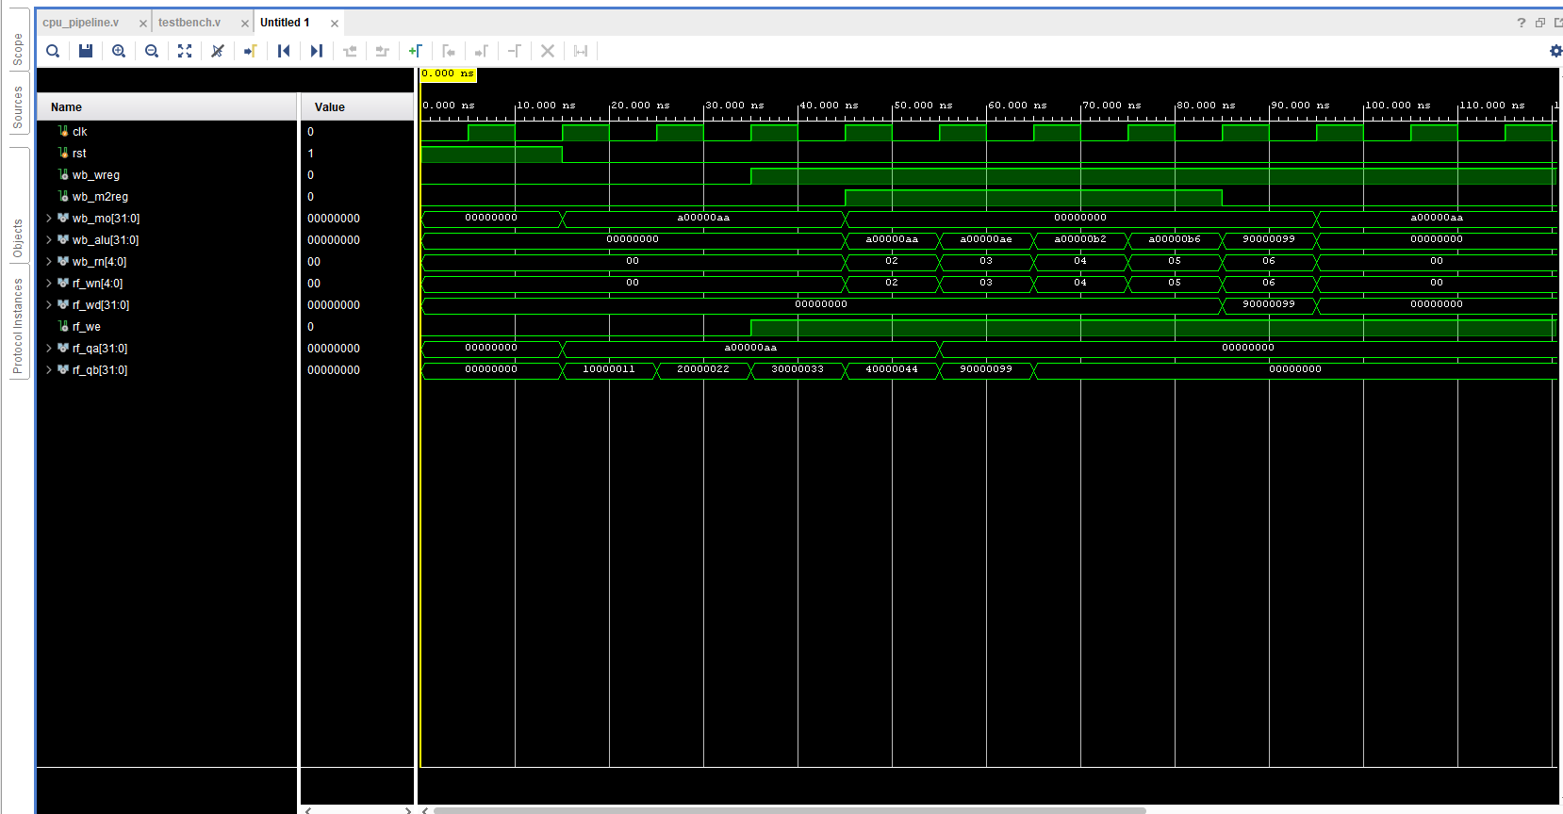
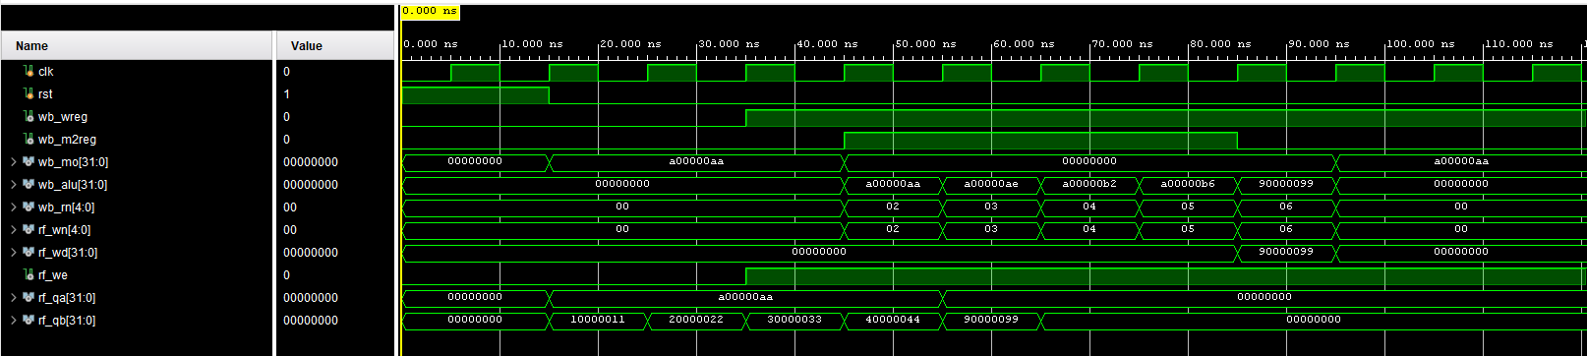
Design schematics:
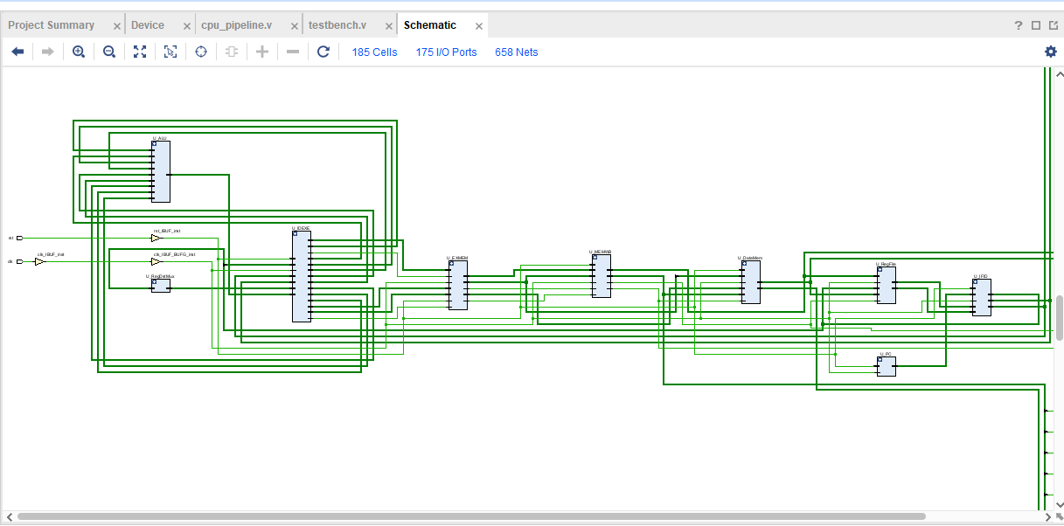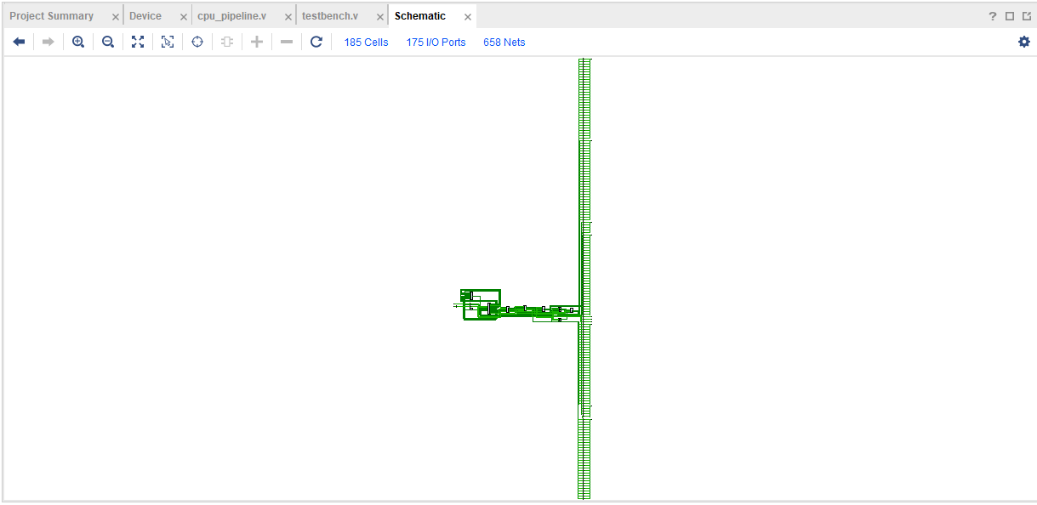
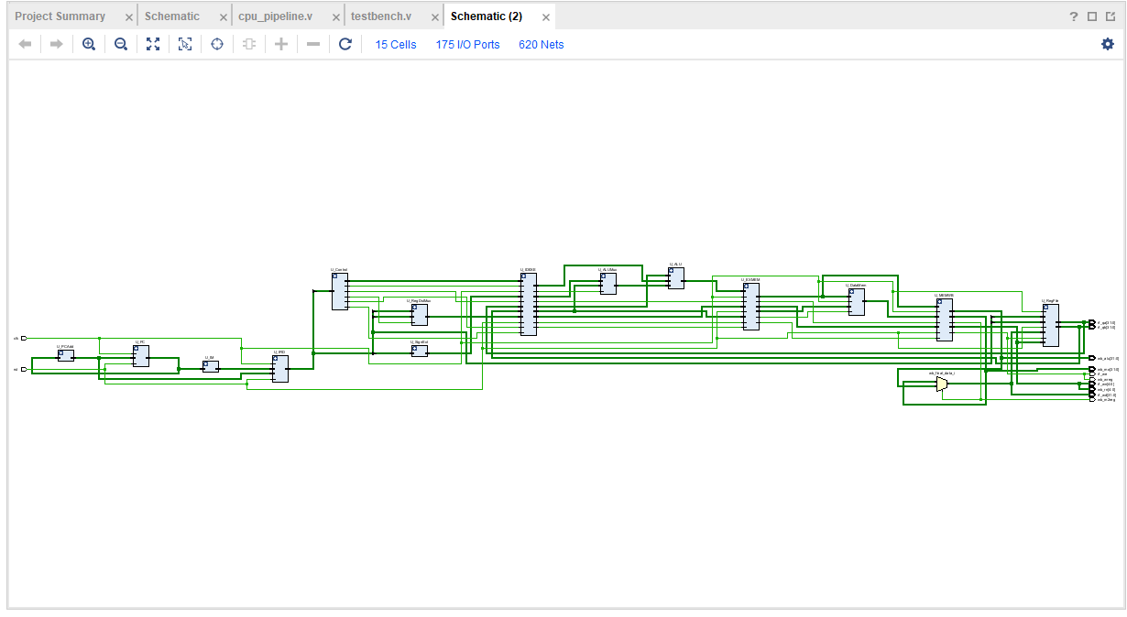
IO planning:
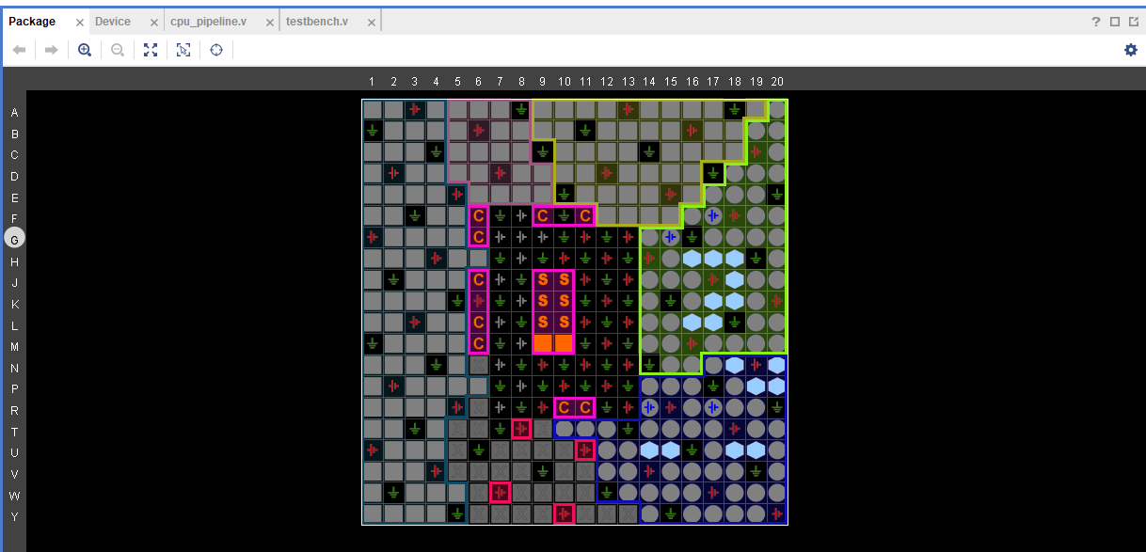
Floor Planning:
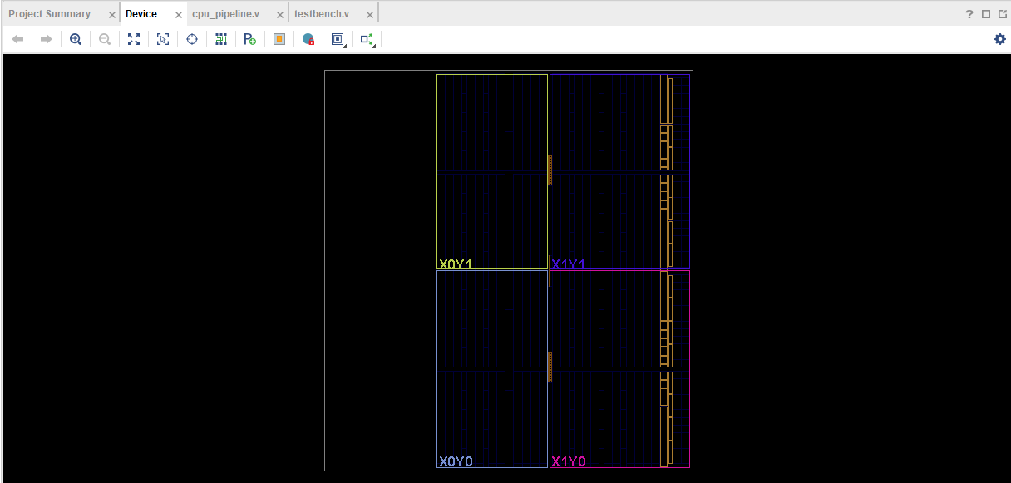
Verilog design code:

// TopLevel Module: cpu_pipeline
module cpu_pipeline (
input clk,
input rst,

output wb_wreg,
output wb_m2reg,
output [31:0] wb_mo,
output [31:0] wb_alu,
output [4:0] wb_rn,

output [4:0] rf_wn,
output [31:0] rf_wd,
output rf_we,

output [31:0] rf_qa,
output [31:0] rf_qb
);

//IF Stag
wire [31:0] pc_current;
wire [31:0] pc_next;
wire [31:0] inst_if;

//IF/ID Register
wire [31:0] id_inst;
wire [31:0] id_pc4;

//ID Stage
wire [5:0] id_op;
wire [4:0] id_rs;
wire [4:0] id_rt;
wire [4:0] id_rd;
wire [15:0] id_imm16;

wire ctrl_wreg, ctrl_m2reg, ctrl_wmem, ctrl_aluimm, ctrl_regrt;
wire [3:0] ctrl_aluc;

wire [31:0] imm_ext;
wire [4:0] reg_dest_id;

// ID/EXE Register
wire exe_wreg, exe_m2reg, exe_wmem, exe_aluimm;
wire [3:0] exe_aluc;
wire [31:0] exe_rd1, exe_rd2, exe_imm;
wire [4:0] exe_rn;

//EXE Stage
wire [31:0] alu_b_input;
wire [31:0] alu_result_exe;

//EX/MEM Register
wire mem_wreg, mem_m2reg, mem_wmem;
wire [31:0] mem_alu, mem_r2;
wire [4:0] mem_rn;

//MEM Stage
wire [31:0] mem_data_out;

//WB Stage
wire [31:0] wb_final_data;

// Decode Assignments
assign id_op = id_inst[31:26];
assign id_rs = id_inst[25:21];
assign id_rt = id_inst[20:16];
assign id_rd = id_inst[15:11];
assign id_imm16 = id_inst[15:0];

// WB Mux Logic (lects between emory Data and ALU Result)
assign wb_final_data = (wb_m2reg == 1'b1) ? wb_mo : wb_alu;

// Inputs to Register File (for reporting)
assign rf_wn = wb_rn;
assign rf_wd = wb_final_data;
assign rf_we = wb_wreg;

//IF Stage
PC U_PC (
.clk(clk), .rst(rst), .next_pc(pc_next), .current_pc(pc_current)
);
PC_Adder U_PCAdd (
.pc_in(pc_current), .pc_out(pc_next)
);
InstructionMemory U_IM (
.addr(pc_current), .inst(inst_if)
);
IFID_Register U_IFID (
.clk(clk), .rst(rst), .if_inst(inst_if), .if_pc4(pc_next),
.id_inst(id_inst), .id_pc4(id_pc4)
);

// 2 ID Stage
ControlUnit U_Control (
.op(id_op), .wreg(ctrl_wreg), .m2reg(ctrl_m2reg), .wmem(ctrl_wmem),
.aluc(ctrl_aluc), .aluimm(ctrl_aluimm), .regrt(ctrl_regrt)
);
RegisterFile U_RegFile (
.clk(clk), .rst(rst),
.rn1(id_rs), .rn2(id_rt),
.wn(rf_wn), .wd(rf_wd), .we(rf_we),
.rd1(rf_qa), .rd2(rf_qb) // Outputs mapped to module ports
);
SignExtension U_SignExt (
.imm_in(id_imm16), .imm_out(imm_ext)
);
RegDstMux U_RegDstMux (
.rt(id_rt), .rd(id_rd), .sel(ctrl_regrt), .rn(reg_dest_id)
);
IDEXE_Register U_IDEXE (
.clk(clk), .rst(rst),
.wreg_in(ctrl_wreg), .m2reg_in(ctrl_m2reg), .wmem_in(ctrl_wmem),
.aluc_in(ctrl_aluc), .aluimm_in(ctrl_aluimm),
.rd1_in(rf_qa), .rd2_in(rf_qb), .imm_in(imm_ext), .rn_in(reg_dest_id),
.wreg_out(exe_wreg), .m2reg_out(exe_m2reg), .wmem_out(exe_wmem),
.aluc_out(exe_aluc), .aluimm_out(exe_aluimm),
.rd1_out(exe_rd1), .rd2_out(exe_rd2), .imm_out(exe_imm), .rn_out(exe_rn)
);

// EXE Stage
ALU_Mux U_ALUMux (
.reg_b(exe_rd2), .imm(exe_imm), .sel(exe_aluimm), .b_out(alu_b_input)
);
ALU U_ALU (
.a(exe_rd1), .b(alu_b_input), .aluc(exe_aluc), .r(alu_result_exe)
);
EXMEM_Register U_EXMEM (
.clk(clk), .rst(rst),
.wreg_in(exe_wreg), .m2reg_in(exe_m2reg), .wmem_in(exe_wmem),
.alu_in(alu_result_exe), .r2_in(exe_rd2), .rn_in(exe_rn),
.wreg_out(mem_wreg), .m2reg_out(mem_m2reg), .wmem_out(mem_wmem),
.alu_out(mem_alu), .r2_out(mem_r2), .rn_out(mem_rn)
);

// 4. MEM Stage
DataMemory U_DataMem (
.clk(clk), .addr(mem_alu), .wdata(mem_r2), .we(mem_wmem), .rdata(mem_data_out)
);
MEMWB_Register U_MEMWB (
.clk(clk), .rst(rst),
.wreg_in(mem_wreg), .m2reg_in(mem_m2reg),
.mo_in(mem_data_out), .alu_in(mem_alu), .rn_in(mem_rn),
.wreg_out(wb_wreg), .m2reg_out(wb_m2reg),
.mo_out(wb_mo), .alu_out(wb_alu), .rn_out(wb_rn)
);

endmodule

// SubModules

module PC (input clk, rst, input [31:0] next_pc, output reg [31:0] current_pc);
always @(posedge clk, posedge rst) begin
if (rst) current_pc <= 32'd100;
else current_pc <= next_pc;
end
endmodule

module PC_Adder (input [31:0] pc_in, output [31:0] pc_out);
assign pc_out = pc_in + 32'd4;
endmodule

module InstructionMemory (input [31:0] addr, output [31:0] inst);
reg [31:0] rom[0:63];
integer i;
initial begin
for (i=0; i<64; i=i+1) rom[i] = 32'h0;
// 100: lw $2, 00($1) -> 8C220000
// 104: lw $3, 04($1) -> 8C230004
// 108: lw $4, 08($1) -> 8C240008
// 112: lw $5, 12($1) -> 8C25000C
// 116: add $6, $2, $10 -> rs=2, rt=10(0xA), rd=6, func=32(0x20) -> 004A3020
rom[25] = 32'h8C220000;
rom[26] = 32'h8C230004;
rom[27] = 32'h8C240008;
rom[28] = 32'h8C25000C;
rom[29] = 32'h004A3020;
end
assign inst = rom[addr[7:2]];
endmodule

module IFID_Register (input clk, rst, input [31:0] if_inst, if_pc4, output reg [31:0] id_inst, id_pc4);
always @(posedge clk, posedge rst) begin
if (rst) begin id_inst <= 0; id_pc4 <= 0; end
else begin id_inst <= if_inst; id_pc4 <= if_pc4; end
end
endmodule

module ControlUnit (
input [5:0] op,
output reg wreg, m2reg, wmem, aluimm, regrt,
output reg [3:0] aluc
);
parameter OP_LW = 6'b100011;
parameter OP_R_TYPE = 6'b000000;
parameter ALU_ADD = 4'b0010;

always @(*) begin
if (op == OP_LW) begin
wreg=1; m2reg=1; wmem=0; aluimm=1; regrt=0; aluc=ALU_ADD;
end else if (op == OP_R_TYPE) begin
// RType (add)
wreg=1; m2reg=0; wmem=0; aluimm=0; regrt=1; aluc=ALU_ADD;
end else begin
wreg=0; m2reg=0; wmem=0; aluimm=0; regrt=0; aluc=4'b0000;
end
end
endmodule

module RegisterFile (
input clk, rst,
input [4:0] rn1, rn2, wn,
input [31:0] wd,
input we,
output [31:0] rd1, rd2
);
reg [31:0] regs[0:31];
integer i;
initial begin
for (i=0; i<32; i=i+1) regs[i] = 32'h0;
regs[0] = 32'h00000000;
regs[1] = 32'hA00000AA;
regs[2] = 32'h10000011;
regs[3] = 32'h20000022;
regs[4] = 32'h30000033;
regs[5] = 32'h40000044;
regs[6] = 32'h50000055;
regs[7] = 32'h60000066;
regs[8] = 32'h70000077;
regs[9] = 32'h80000088;
regs[10] = 32'h90000099;
end
always @(posedge clk) begin
if (we && wn != 0) regs[wn] <= wd;
end
assign rd1 = (rn1 == 0) ? 0 : regs[rn1];
assign rd2 = (rn2 == 0) ? 0 : regs[rn2];
endmodule

module SignExtension (input [15:0] imm_in, output [31:0] imm_out);
assign imm_out = {{16{imm_in[15]}}, imm_in};
endmodule

module RegDstMux (input [4:0] rt, rd, input sel, output [4:0] rn);
assign rn = (sel == 1) ? rd : rt;
endmodule

module IDEXE_Register (
input clk, rst,
input wreg_in, m2reg_in, wmem_in, aluimm_in,
input [3:0] aluc_in,
input [31:0] rd1_in, rd2_in, imm_in,
input [4:0] rn_in,
output reg wreg_out, m2reg_out, wmem_out, aluimm_out,
output reg [3:0] aluc_out,
output reg [31:0] rd1_out, rd2_out, imm_out,
output reg [4:0] rn_out
);
always @(posedge clk, posedge rst) begin
if (rst) begin
wreg_out<=0; m2reg_out<=0; wmem_out<=0; aluimm_out<=0; aluc_out<=0;
rd1_out<=0; rd2_out<=0; imm_out<=0; rn_out<=0;
end else begin
wreg_out<=wreg_in; m2reg_out<=m2reg_in; wmem_out<=wmem_in;
aluimm_out<=aluimm_in; aluc_out<=aluc_in;
rd1_out<=rd1_in; rd2_out<=rd2_in; imm_out<=imm_in; rn_out<=rn_in;
end
end
endmodule

module ALU_Mux (input [31:0] reg_b, imm, input sel, output [31:0] b_out);
assign b_out = (sel == 1) ? imm : reg_b;
endmodule

module ALU (input [31:0] a, b, input [3:0] aluc, output reg [31:0] r);
always @(*) begin
case (aluc)
4'b0010: r = a + b;
default: r = 0;
endcase
end
endmodule

module EXMEM_Register (
input clk, rst,
input wreg_in, m2reg_in, wmem_in,
input [31:0] alu_in, r2_in,
input [4:0] rn_in,
output reg wreg_out, m2reg_out, wmem_out,
output reg [31:0] alu_out, r2_out,
output reg [4:0] rn_out
);
always @(posedge clk, posedge rst) begin
if (rst) begin
wreg_out<=0; m2reg_out<=0; wmem_out<=0; alu_out<=0; r2_out<=0; rn_out<=0;
end else begin
wreg_out<=wreg_in; m2reg_out<=m2reg_in; wmem_out<=wmem_in;
alu_out<=alu_in; r2_out<=r2_in; rn_out<=rn_in;
end
end
endmodule

module DataMemory (input clk, input [31:0] addr, wdata, input we, output [31:0] rdata);
reg [31:0] dmem [0:63];
integer i;
initial begin
for (i=0; i<64; i=i+1) dmem[i] = 32'h0;
dmem[0] = 32'hA00000AA; dmem[1] = 32'h10000011; dmem[2] = 32'h20000022;
dmem[3] = 32'h30000033; dmem[4] = 32'h40000044; dmem[5] = 32'h50000055;
dmem[6] = 32'h60000066; dmem[7] = 32'h70000077; dmem[8] = 32'h80000088;
dmem[9] = 32'h90000099;
end
always @(posedge clk) if (we) dmem[addr[7:2]] <= wdata;
assign rdata = dmem[addr[7:2]];
endmodule

module MEMWB_Register (
input clk, rst,
input wreg_in, m2reg_in,
input [31:0] mo_in, alu_in,
input [4:0] rn_in,
output reg wreg_out, m2reg_out,
output reg [31:0] mo_out, alu_out,
output reg [4:0] rn_out
);
always @(posedge clk, posedge rst) begin
if (rst) begin
wreg_out<=0; m2reg_out<=0; mo_out<=0; alu_out<=0; rn_out<=0;
end else begin
wreg_out<=wreg_in; m2reg_out<=m2reg_in;
mo_out<=mo_in; alu_out<=alu_in; rn_out<=rn_in;
end
end
endmodule
Test bench code:

`timescale 1ns/1ps

module testbench;

reg clk;
reg rst;

//Monitored ignals
//rom MEM/WB Register
wire wb_wreg;
wire wb_m2reg;
wire [31:0] wb_mo; // Memory Output
wire [31:0] wb_alu;// ALU Output
wire [4:0] wb_rn; // Des Register

wire [4:0] rf_wn;
wire [31:0] rf_wd;
wire rf_we;

wire [31:0] rf_qa;
wire [31:0] rf_qb;

//-UUT
cpu_pipeline UUT (
.clk(clk),
.rst(rst),

.wb_wreg(wb_wreg),
.wb_m2reg(wb_m2reg),
.wb_mo(wb_mo),
.wb_alu(wb_alu),
.wb_rn(wb_rn),

.rf_wn(rf_wn),
.rf_wd(rf_wd),
.rf_we(rf_we),
.rf_qa(rf_qa),
.rf_qb(rf_qb)
);

initial begin
clk = 0;
end
always #5 clk = ~clk;

initial begin
rst = 1'b1;
#15;
rst = 1'b0;

#150;

$finish;
end

//onitor
initial begin
$display("Time | PC | WB_MO (Load Result) | WB_ALU (Add Result) | WB_RN | RF_QA | RF_QB");
$display("-----------------------------------------------------------------------------------");

$monitor("Time=%0t | PC=%h | WB_MO=%h | WB_ALU=%h | RN=%d | QA=%h | QB=%h",
$time,
UUT.U_PC.current_pc,
wb_mo,
wb_alu,
wb_rn,
rf_qa,
rf_qb);
end

endmodule

