2.1 Packing Configuration for Cargo Container Positioned at and

Since medicine at and are self-sufficient, drones at these two places only need to conduct reconnaissance tasks. Therefore, we package drone which has the best scouting performance, along with required medicine packages, into their cargo containers. According to our analysis before, *Drone Type B*, with its highest speed, farthest flight and relatively small volume, is the best choice. Besides all the required medicine packages and a *Drone Type H*, we should pack B into containers as many as possible and minimize the unused space at the same time. Now this problem is simplified to find the best solution to load five different cuboids into Ω, where four of them are fixed, so we only need to determine the number of *Drone Type B.*

To address this problem, we use *EasyCargo* to simulate. For position P1 and P5, given all the size data of drones and medicine packages shown in Attachment2 and Attachment5, we set the number of SC8 to 1 and M1, M2, M3 to (60,0,60), (60,0,0) separately. We choose the *Ignore Separation into Priority Groups* mode to get the optimal packing configuration for P1 and P5, which is shown as below:

Table 1 P1 packing configuration detail

|  |  |  |  |  |
| --- | --- | --- | --- | --- |
| P1 Packing Configuration | | | | |
| B(pcs) | H(pcs) | MED1(pcs) | MED3(pcs) | Total Volume(ft^3) |
| 74 | 1 | 60 | 60 | 992.27 (86%) |

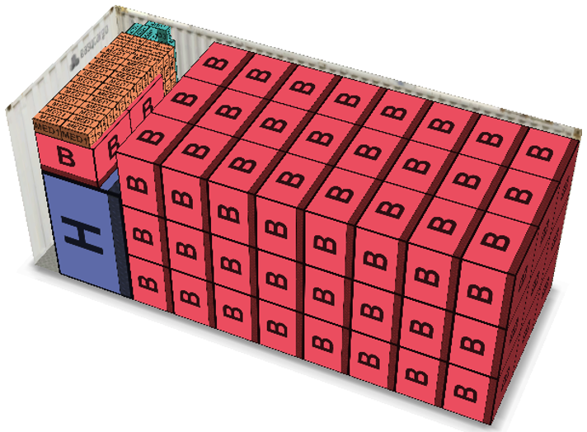

Figure 1 P1 packing configuration

For the cargo container transported to P1, we could clearly see from Figure 1 and Table 1 that the packing result is in line with our analysis and expectation.

Table 2 P5 packing configuration detail

|  |  |  |  |
| --- | --- | --- | --- |
| P5 Packing Configuration | | | |
| B(pcs) | H(pcs) | MED1(pcs) | Total Volume(ft^3) |
| 74 | 1 | 60 | 980.86 (85%) |

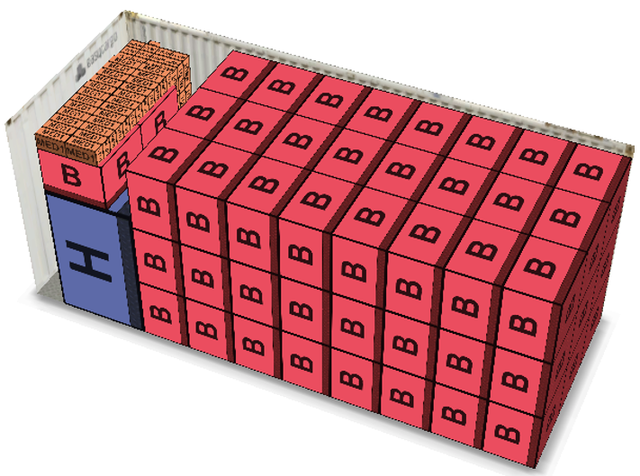

Figure 2 P5 packing configuration

For the cargo container transported to P5, we could see its packing configuration clearly from Table 2 and Figure 2.

In the case of closest packing, the result above shows that the space utilizations are 86%, 85%, and the number of Drone Type B packed is 74.

2.2 Packing Configuration for Cargo Container Positioned at

P4 has to deliver medicine packages to P2 and P3, apparently Drone Type B is not the best choice for transportation task, so we need to analyze the specific situation and the transport performance of each drone type in detail.

First, it is apparent that Type A is not better than Type B in all aspects of volume, maximum speed, flight duration, etc. so under no circumstance will we take Type A as our candidate drone. From Figure 1. we could know that the straight-line distance between P2 and P4 is 24.27km. Only Type B, C and D can cover such a distance. Using *EasyCargo* to analyze Drone Cargo Bay Type2, we find that for those drones equipped with this kind of cargo bay, their cargo capacity totally depends on their max payload capability, which means they can load all the goods within their load-bearing range. Applying the analysis above, we could find that Drone Type F is better than C in all aspects. Despite its relatively large volume, its cargo capacity far exceeds B. so F is the optimal type to deliver medicine packages to P2. Furthermore, from Attachment 2 we could know that the max payload capability of F is 22 lbs. Given the weight and quantity of MED1(120 pcs, 2 lbs.) and MED2(60 pcs, 3 lbs.), we get the following optimal arrangement: nine F loaded with eleven MED1, ten F loaded with six MED3 and two MED1 by simply calculation.

Second, the straight-line distance between P3 and P4 is 10.48km, which is reachable for all drone types, so we just need to choose the drone which performs best in transporting. We finally choose Drone Type G, which has the relatively small volume and strong delivery capacity (second only to F). The max payload capability of G is 20 lbs. and the weight and quantity of MED1 is 120 pcs, 2 lbs. while MED2 is 60 pcs, 2lbs. For each G, we just put MED1 and MED2 in equal proportions, which is to say, we finally have 12 G and each is loaded with 5 MED1 and 5 MED2.

After loading all of medicine packages, transportation drones and a Drone Type H, we need to load B in the rest space as many as possible to ensure scouting tasks and minimize unused space. Now this problem is simplified to find the best solution to load 7 different cuboids into Ω, where 6 of them are fixed, so we only need to determine the number of *Drone Type B.*

Same as above, to address this problem, we use *EasyCargo* to simulate. We choose the *Ignore Separation into Priority Groups* mode to get the optimal packing configuration for P1 and P5, which is shown as below:

Table 3 P4 packing configuration detail

|  |  |  |  |  |  |  |  |
| --- | --- | --- | --- | --- | --- | --- | --- |
| P4 Packing Configuration | | | | | | | |
| B  (pcs) | F  (pcs) | G  (pcs) | H  (pcs) | MED1  (pcs) | MED2  (pcs) | MED3  (pcs) | Total Volume  (ft^3) |
| 18 | 19 | 12 | 1 | 300 | 120 | 180 | 1006.51 (88%) |

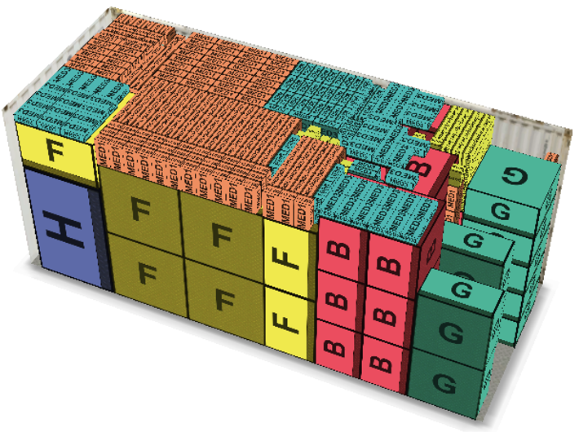

Figure 3 P4 packing configuration

From the result we could see clearly how drones and medicine packages are packed in the container. We finally loaded 18 Type B and the space utilization is 88%.