MEMORANDUM

TO: the CEO of HELP, Inc.

FROM: Team#1900068

Our team has designed a DroneGo disaster response system to support the Puerto Rico hurricane disaster scenario.

Considering the severe damage caused by the hurricane, we plan to provide two months of medicine packages supply to the five cities in the disaster area. As up to three locations can be chosen as transportation point, we recommend Fajardo, Bayamon, Arecibo as the best three positions to transport cargo containers. The reason why we choose Arecibo is that it is so far from the other cities that none of the potential drones can deliver medicine package to it. As for the rest four locations, we prefer to choose a combination which has the lowest delivery cost and can cover the largest scouting area. Applying the principles above, we find Fajardo and Bayamon are optimal.

Since the situation varies, the packing configuration of each container is quite different. We properly arrange the number of drones and medicine packages to ensure that all work can be carried out smoothly and efficiently. Specifically, we evaluate the performance of each candidate drone type and select the best transport and reconnaissance drones. We optimize the configuration of each container transported to minimize unused space. The configuration of each container is shown as below:

|  |  |  |  |  |  |  |  |
| --- | --- | --- | --- | --- | --- | --- | --- |
|  | B(pcs) | F(pcs) | G(pcs) | H(pcs) | MED1(pcs) | MED2(pcs) | MED3(pcs) |
| Fajardo | 74 |  |  | 1 | 60 |  | 60 |
| Bayamon | 18 | 19 | 12 | 1 | 300 | 120 | 180 |
| Arecibo | 74 |  |  | 1 |  |  | 60 |

For the transportation plan, we calculate that Fajardo and Arecibo do not need to consider transportation issues, only need to consider the problem of reconnaissance road conditions. Moreover, since there are few main roads around these two locations, the road network is relatively simple, and the non-main road area has mountain barriers. Therefore, it is only necessary to send drones to reconnaissance along the main road.

For Bayamon, we recommend that all 19 F-type drones be used to load medicines to San Pablo, and 12 G-type drones to deliver medicines to San Juan, one of which will Fly on the main road between San Juan and Bayamon, and transport the medicine while detecting the road surface. All the other drones will fly in a straight line, ensuring that they reach the destination as fast as possible. Specifically, the charging method for the Cargo bay of each drone is given in the following table.

|  |  |  |  |  |  |
| --- | --- | --- | --- | --- | --- |
| F drone payload packing configurations | | |  | G drone payload packing configurations | |
| 9 pcs | 10 pcs | |  | 12 pcs | |
| MED1 | MED1 | MED3 |  | MED1 | MED2 |
| 11 | 2 | 6 |  | 5 | 5 |

In order to reduce the cost of congestion, we recommend that the drone take-off schedule is scheduled at uniform intervals based on the unloading time. Of course, the specific time will be adjusted according to the parameters of your local unloading capacity.

For the reconnaissance situation, we have established a reconnaissance model for the dense road traffic network near the capital of San Juan. We have planned an optimal route for 18 B-type drones for reconnaissance so that they can start from Bayamon and fully explore the main roads in the shortest 18.4 minutes. The specific drone trajectory is as follows. The left picture shows the total route map of the drone formation, and the right picture shows some typical route maps.

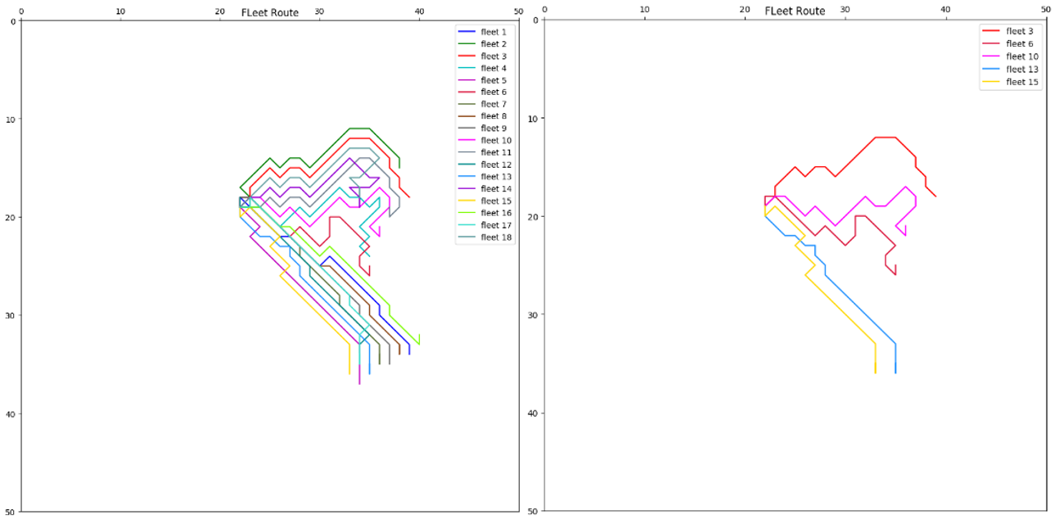

Finally, we need to emphasize that the results of the model are based on the assumption that the drug demand is 2 months. If the demand for drugs is significantly increased, our model will not be able to carry enough drones to transport medicines at each location. In this regard, we give two trade-offs for your reference.

If you give priority to medicine delivery, we recommend changing the location to San Pablo, San Juan, and Arecibo. We recommend using F-type drone to deliver medicines from San Pablo to Bayamon. For the rest space, load type B drone as many as possible. In this way, at the expense of reconnaissance capabilities, the drug can be delivered to the designated location as much as possible. As for Arecibo, the situation remains the same.

If you want to get quick access to the main road traffic information, we recommend that the container shipping points be still Fajardo, Bayamon and Arecibo. At this point, you may sacrifice San Pablo and San Juan's drug supply, carry as many B-type drones as possible, in order to return the ground information as soon as possible.

We believe our system is able to conduct both medical supply delivery and video reconnaissance of road networks.

Thank you for your consultation.

Sincerely,

Team#1900068