TX Text Control - Reporting and Word Processing Components
This document has been created with TX Text Control Trial Version 21.0.NET

- Tables and Nested Tables
TX Text Control enables you to include tables in your documents. Text in a table can contain virtually any kind of formatting that normal text can: multiple paragraphs with different fonts, indents and line spacing. Even images and, merge fields can be inserted. Frames and shading can be separately adjusted for each individual table cell. Making the table frames invisible allows text to be set in columns.
Sample:
Financial Overview
(Dollars In Thousands) | 2012 over 2013 | September 30, 2013 | September 30, 2014
Fund Balance with Treasury | 9.5% | $1,240.798 | $1,135.268
Property, Plant, and Equipment, Net | 8.1% | $148.401 | $137.303
Other Assets | 8.1% | $19.950 | $24.741
Total Assets | 8.6% | $1,409.149 | $1,297.312
- Bullets and Structured Numbered Lists
TX Text Control provides comprehensive support for bullets and numbered lists, which can be incremented and numbered automatically. Virtually every conceivable attribute of the bullets and numbered lists can be user defined - including the type and shape of bullet.
Sample:
- Main Heading
  - Sub-Heading
  - Sub-Heading
    - Sub-Sub-Heading
    - Sub-Sub-Heading
- Text Frames
Freely placeable and programmable text frames can be inserted and positioned as a character or geometrically relative to a paragraph or a page.
Sample:
The text can flow around an inserted text frame. The distance between the text and the text frame can be specified and the text frame can be aligned.
Right-aligned blue text frame.
- MS Word Compatible Merge Fields
Using text fields allows developers to build applications, such as mail merge, in which text is retrieved from a database. Additionally, all values of the standard form fields can be imported and manipulated.

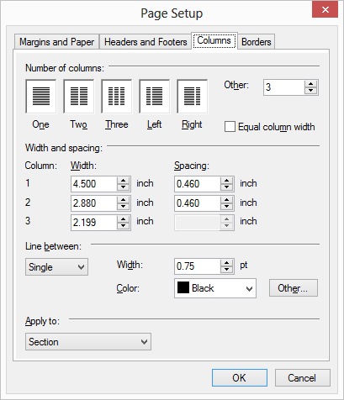
- Dialog boxes
Integrated dialog boxes, for setting paragraph, text and table formatting, page setup, bullets and numbered lists, as well as for searching and replacing are an integrated component of TX Text Control. All dialog box settings are also available as properties.
- Hyperlinks and Targets
TX Text Control supports document targets, bookmarks and hyperlinks that are 100% compatible to MS Word. You can insert a document link that points to another target. On clicking on the link, TX Text Control jumps to the specified position automatically.
Sample:
Read more about Text Frames here.
- File Formats

Load and save Text (ANSI and Unicode), DOCX, RTF, DOC, HTML and XML. RTF and HTML clipboard formats supported. Export documents to fully featured PDF and PDF/A. Extract text from Adobe PDF documents.

- Images

Images and can be inserted as a character within a line of text, or as a fixed-positioned object anchored to a paragraph. Filters for TIFF, GIF, BMP, WMF, JPEG and PNG are included. TX Text Control is especially powerful for positioning images in a text. They can be positioned as characters within a line of text, or at a given position on a page. The flow of text around an image or object is controlled via a dialog box. Images can be re-scaled.
- Headers and Footers
Programmable headers and footers for each section, with automatic page numbering and import / export as RTF, DOC and DOCX. You can insert all elements into a header or footer like in the main text. Additionally, a first page header or footer can be defined for each page section of the document.
- Paragraph Formatting
Paragraph indents left, right, top, bottom, and first line are available, as well as four types of tab, paragraph frames, alignment left, right, centered and justified. Line spacing in inch or %.
Sample:
This paragraph is left-aligned
This paragraph is right-aligned
This paragraph is centered
This paragraph is justified
Tabs: Right Tab Left Tab Centered Tab 10.50
Technical Support
If you have technical questions about installing, deploying or programming with TX Text Control, our professional support engineers are glad to help you. Visit our support area for your options:
http://support.textcontrol.com/

