Construction of the Turk

**Kempelen was inspired to build the Turk following his attendance at the court of Maria Theresa of Austria at Schönbrunn Palace, where François Pelletier was performing an illusion act. An exchange afterward resulted in Kempelen promising to return to the Palace with an invention that would top the illusions.**

The result of the challenge was the Automaton Chess-player, known in modern times as the Turk. The machine consisted of a life-sized model of a human head and torso, with a black beard and grey eyes, and dressed in Ottoman robes and a turban – *the traditional costume*, according to journalist and author Tom Standage, *of an oriental sorcerer*. Its left arm held a long Ottoman smoking pipe while at rest, while its right lay on the top of a large cabinet that measured about three-and-a-half feet (110 cm) long, two feet (60 cm) wide, and two-and-a-half feet (75 cm) high. Placed on the top of the cabinet was a chessboard, which measured eighteen inches square. The front of the cabinet consisted of three doors, an opening, and a drawer, which could be opened to reveal a red and white ivory chess set.

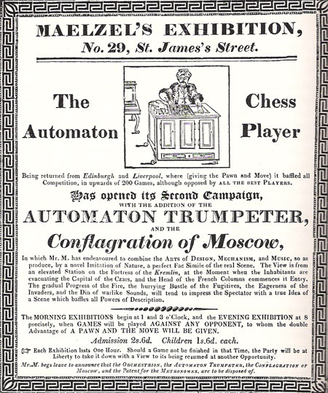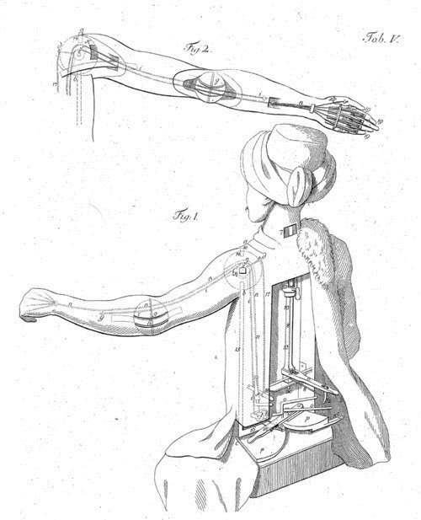

The interior of the machine was very complicated and designed to mislead those who observed it. When opened on the left, the front doors of the cabinet exposed a number of gears and cogs similar to clockwork. The section was designed so that if the back doors of the cabinet were open at the same time one could see through the machine. The other side of the cabinet did not house machinery; instead it contained a red cushion and some removable parts, as well as brass structures. This area was also designed to provide a clear line of vision through the machine. Underneath the robes of the Ottoman model, two other doors were hidden. These also exposed clockwork machinery and provided a similarly unobstructed view through the machine. The design allowed the presenter of the machine to open every available door to the public, to maintain the illusion.

**Source:** [**https://en.wikipedia.org/wiki/The_Turk**](https://en.wikipedia.org/wiki/The_Turk)