Literature Classification and its Text Summarization
Laxmi Yadav, Harsha Vardhan Kuruva, and Bryan Dilone
University of Maryland, Baltimore County
1000 Hilltop Cir, Baltimore, MD 21250

(Dated: May 15th, 2023)

Abstract
The COVID-19 Open Research Dataset Challenge (CORD-19) is a vast collection of scholarly articles related to COVID-19 and other coronaviruses that has been made available to the scientific community. In this dataset, literature classification and text summarization are crucial research areas that aid researchers in identifying relevant articles and extracting key information from them. Machine learning-based techniques such as topic modeling and text clustering, as well as natural language processing techniques such as K-means clustering, T5 model, and sentiment analysis have been utilized to improve literature classification and text summarization. Overall, these approaches facilitate scientific progress and improve our understanding of COVID-19 and related coronaviruses.

Introduction

The ongoing COVID-19 pandemic continues to have devastating impacts across multiple fronts worldwide ranging from widespread illness to economic turmoil & loss of life. Amidst these challenges though, there remain signs of hope from relentless efforts within the scientific community aimed at understanding & mitigating these impacts effectively - including those by some organizations such as The Allen Institute for AI through their creation of CORD 19 Research Challenge dataset consisting of scholarly articles and metadata focused on COVID 19 and SARS CoV 2 the virus responsible for it. This dataset is accessible to researchers and data scientists worldwide via Kaggle - a valuable resource that has already yielded significant insights into various aspects of COVID 19 from epidemiology to clinical management.[5]

The topic Literature Classification and Text Summarization
The field of machine Learning relies heavily on natural language processing (NLP) tasks such as literature classification, text summarization, and sentiment analysis for interpreting human language. Machine-learning-based literature classification involves characterizing written works through algorithmic analysis employing techniques like supervised learning and unsupervised learning to identify genre variations between texts. [3]
Text summarization via extractive methods identifies important textual clauses and sentences while abstractive methods generate fresh, meaning-expressing sentences in a shortened format. Both techniques may be trained using supervised learning. [7]
Training models to automatically recognize and categorize the sentiment represented in a piece of text is the basis of sentiment analysis in machine learning. This may be accomplished using a variety of machine learning methods, including supervised learning, unsupervised learning, and deep learning. Models are trained on labeled data to learn the patterns and features that differentiate between positive, negative, or neutral sentiments in text.
These NLP based tools hold potential in domains like marketing insights and analytics by using consumer sentiment towards brand image and improving customer experience across different industries by analyzing user feedback across social networks and reviewing websites etc. [4]

The Significance of NLP Techniques

Understanding NLP Techniques
Using Natural Language Processing, or NLP, analyzes, comprehends, and produces human language. Sentiment Analysis, Text Summarization, Topic Modeling, and Text Classification are some of the methods used. NLP empowers data scientists to extract valuable insights from text data. It empowers them to leverage the full potential of textual data for actionable insights and data-driven decision-making.[4]

Importance of Literature Classification
Literature classification is crucial in organizing vast information by categorizing research articles into relevant topics or clusters. This enables researchers, scholars, and medical professionals to easily navigate the literature and locate related publications, staying current with the latest advancements in their field. It helps uncover patterns and connections between studies, leading to a deeper understanding of the subject matter. Literature classification facilitates efficient literature reviews, promotes knowledge sharing, and fosters research collaboration. In the context of COVID-19, literature classification becomes particularly important for organizing and accessing up-to-date information, contributing to evidence-based practices, and driving advancements in COVID-19 research.

Importance of Text Summarization
Text summarization is an essential technique for extracting essential information from a given text and condensing it concisely. It helps individuals deal with large amounts of information, streamlines document processing, improves accessibility, automates information extraction, facilitates language learning, enables multi-document analysis, and aids SEO initiatives. Due to its ability to manage information overload, expedite document processing, improve accessibility, automate information extraction, facilitate language learning, enable multi-document analysis, and support SEO initiatives, summarization is of the utmost importance.

Importance of Sentiment Analysis
Sentiment analysis is an essential method used to comprehend public opinion, brand perception and emotion presence input from textual data. The process of automatically classifying sentiments as positive, negative, or neutral provides vital insights for companies. These insights have resulted in compressing large amounts of data in just minutes. Sentiment analysis is an effective tool in proactive issue management by understanding the emotional context within text data. [6]

Research Project Dataset
CORD-19 is a vast dataset of nearly one million scholarly works on COVID-19, SARS-CoV-2, and related coronaviruses. It includes over 400,000 full-text articles and is available on Kaggle. This 20-GB resource is valuable for researchers and practitioners studying different aspects of the pandemic. It enables in-depth analysis, data-driven insights, and the discovery of patterns within COVID-19 research. CORD-19 is highly relevant for academic reports, such as capstone projects, providing extensive information to contribute to understanding and managing the global health crisis. [5]

Understanding the Dataset
The project utilizes the Metadata.csv file, which contains relevant values corresponding to the full-text JSON files. These JSON files encompass comprehensive information, including the full text of the articles, titles, authors, abstracts, and other pertinent details. A subset file named ArticlesText1000.csv was created to streamline the analysis process, consisting of a subset of 1000 articles extracted from the original dataset.
The original dataset is extensive, comprising nearly 1,000,000 work articles with a size of 20 GB. In contrast, the subset dataset is more manageable, containing 1000 articles and having a reduced size of approximately 30 MB. The analysis focuses on the articles as the unit of analysis, allowing for targeted exploration and examination of the selected subset while leveraging the extensive features of the original dataset.

Methodology

Data Cleaning
The data cleaning process for text summarization involved using various natural language processing (NLP) techniques. Initially, text preprocessing was conducted to transform the raw text data into a standardized readable format. This involved removing special characters, punctuation, and converting the text to lowercase. Stop word removal was then implemented to eliminate common words that do not contribute significant meaning to the text. Tokenization was performed to split the text into individual words or tokens, facilitating subsequent analysis and feature extraction. Additionally, missing or incomplete data points were addressed by either imputing missing values or making informed decisions on how to handle such instances. By applying these techniques, the dataset was refined, ensuring a clean and standardized text corpus for subsequent text summarization tasks within the capstone project.

Data Preprocessing
The initial phase of our data analysis involved Data Cleaning, which prepared the dataset for further processing. Following this, we proceeded with the Data Preprocessing Step, a data mining technique aimed at transforming raw data into a more comprehensible format.[10] This report highlights the advantages of graphing data, specifically in relation to displaying multiple classes of data through charts. Graphs provide a visually appealing and informative representation of large volumes of data, facilitating easier comprehension and enhancing data accuracy.
In this report, we will focus on Sentiment Analysis, and Exploratory Data Analysis (EDA) for the following topics: Number of Journals published by year, which organization most articles were published from, authors who’ve published the greatest number of articles, which licenses published the highest number of articles, which articles have the lowest and highest number of words, and lastly display the top twenty most used common words found in the data.

Sentiment Analysis
As we embarked on the task of Sentiment Analysis, our primary focus was on the two key sentiment classifiers: Polarity and Subjectivity. Sentiment Analysis, a natural language processing technique, is employed to determine the positive, negative, or neutral orientation of data. Its application is commonly observed in the analysis of textual data, aiding companies in monitoring brand and product sentiment through customer reviews and facilitating a deeper understanding of customer requirements. The versatility of Sentiment Analysis makes it highly valuable in a wide range of scenarios, as it enables us to gain a comprehensive understanding of public sentiment towards a specific topic. By considering the emotions and opinions of individuals, Sentiment Analysis plays a crucial role in enhancing future strategies and plans. [1]
- Polarity
  - In Sentiment Analysis, Polarity is used to determine if the text expresses a positive, negative, or neutral sentiment.[8]
  - Polarity of the word data lies in the range of [-1,1] where one would indicate a positive statement, while negative one would indicate a negative statement.
- Subjectivity
  - Subjectivity is used for individual sentences to determine whether a sentence expresses an opinion or not.[8] The Subjectivity of the word data lies in the range of [0,1], where when Subjectivity is close to zero, the sentence is more about facts. When Subjectivity is close to 1, the sentence comes close to being an opinion.
- Python Package: TextBlob
  - Another Python package that we used was Textblob. Textblob is a Python Library for processing textual data. Textblob’s sentiment function returns the two properties, the polarity, and subjectivity of a sentence.

Literature Classification
Staying updated on the latest virus-related information poses a challenge for medical practitioners. However, the task can be made more accessible by grouping research articles based on their similarities through clustering. This involves representing the literature collection as a scatter plot, where clustering techniques are employed to assign labels and reduce the dimensionality for better visualization. As a result, publications with similar topics are given the same label and are positioned near each other on the plot. This approach enables medical practitioners to quickly identify and access publications that share common themes, allowing them to gain valuable insights from related studies. By leveraging clustering and visual representation, practitioners can effectively navigate a vast amount of literature and stay informed about the latest developments in their field.
The approach for literature clustering begins by randomly selecting a subset of the dataset containing 1000 articles. The next step involves data pre-processing, where the articles are prepared for analysis. Each document is transformed into a feature vector using the Tf-IDF (Term Frequency-Inverse Document Frequency) technique. Next, Principal Component Analysis (PCA) is applied to reduce the dimensionality of the data and capture essential information. K-means clustering is then employed to label each cluster based on the article's similarities. Finally, dimensionality reduction using t-SNE (t-Distributed Stochastic Neighbor Embedding) is applied to enhance the visualization further. This process reduces the high-dimensional feature vectors to a lower-dimensional representation while preserving the similarities between articles. Overall, this approach allows for effective clustering and visualization of literature, aiding in identifying patterns and relationships among research articles.

Text Summarization
The T5 transformer model is a powerful tool for text summarization tasks. It consists of an encoder system that reads the input text and a decoder system that generates the summary. The model utilizes an attention mechanism to understand the contextual relationships between words or sub words in a text. With its ability to generalize to new and unseen data, the T5 model can generate accurate and informative summaries, making it well-suited for summarizing COVID-19-related information. Additionally, the model can handle long and complex texts while producing high-quality summaries.[9]
The T5 model for text summarization involves several key steps. Firstly, the data is preprocessed to ensure it is formatted so the model can comprehend it. The T5 model, specifically designed for generating summaries, is then selected. It has undergone extensive training on a large text corpus, enabling it to summarize information effectively. The model is fine-tuned using a dataset specifically tailored for text summarization, allowing it to learn patterns and nuances related to summarization tasks. Finally, an evaluation is conducted to measure the model's performance and accuracy in generating summaries, utilizing metrics such as ROUGE scores that assess the similarity between generated and reference summaries. These steps collectively form a robust approach to text summarization using the T5 model.[9]

Experimental Results
We will commence with an overview of our Experimental Result procedures, specifically focusing on the Data Preprocessing tests conducted.
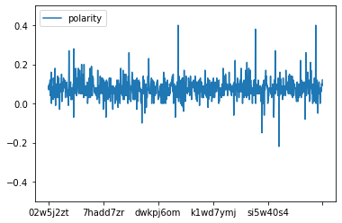FIG. 1: Understanding Polarity Values where Polarity lies in the range of [-1,1].
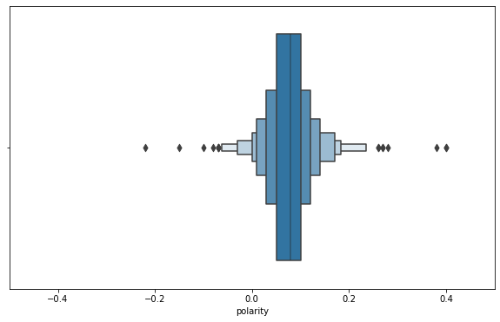
FIG. 2: In the above figure, the range of Polarity are displayed in a [-0.4,0.4] range where the range [0,0.2] would have the most Polarity values.
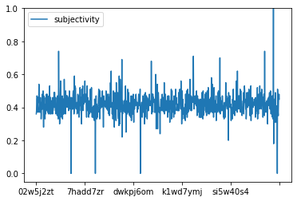
FIG.3: Understanding Subjectivity values where Subjectivity lies in the range of [0,1].
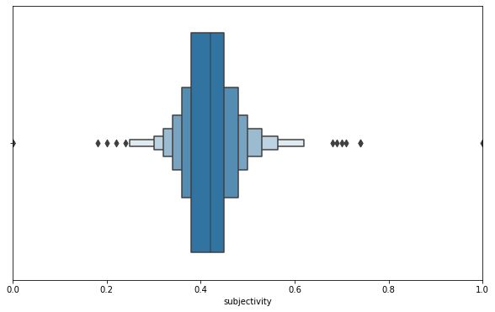
FIG. 4: Understanding the range of Subjectivity. The range of Subjectivity values are displayed in a [0,1] range.
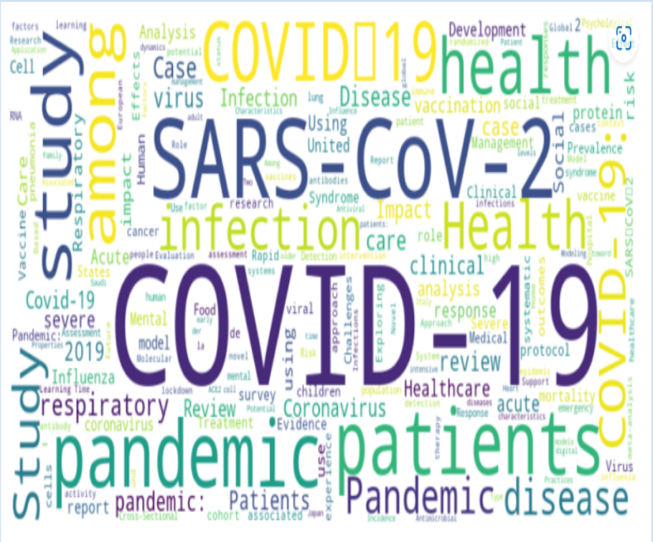
FIG. 5: The top twenty most used common words found in the data plotted using word cloud.
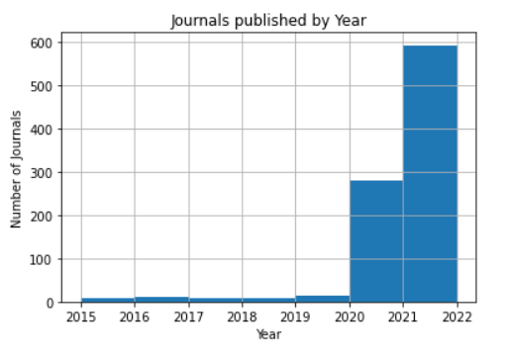
FIG. 6: Most of the articles published in which year.
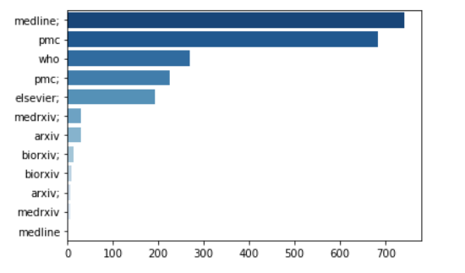
FIG. 7: From which organization most of the articles were published from.
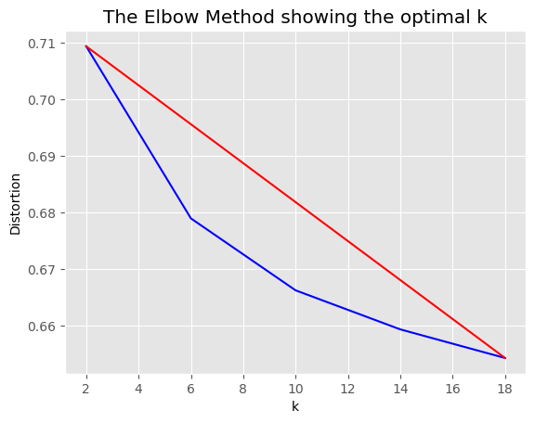
FIG. 8: In the above figure, K-means Clustering method has been plotted.
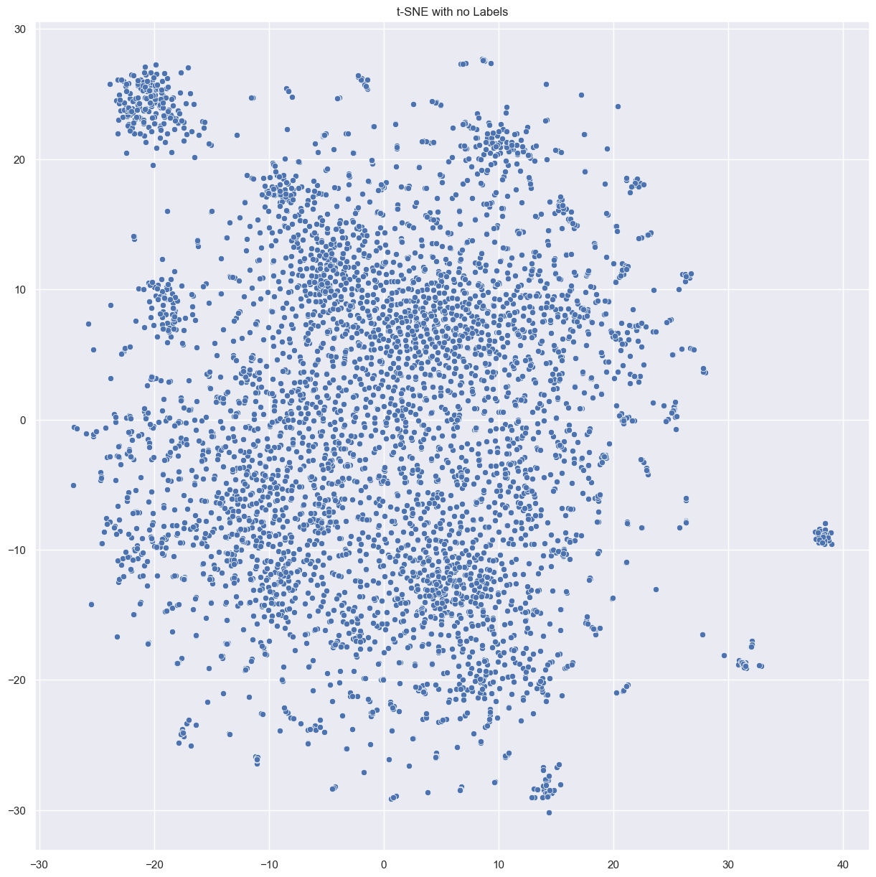
FIG. 9: K-means clustering clusters with no identification labels.
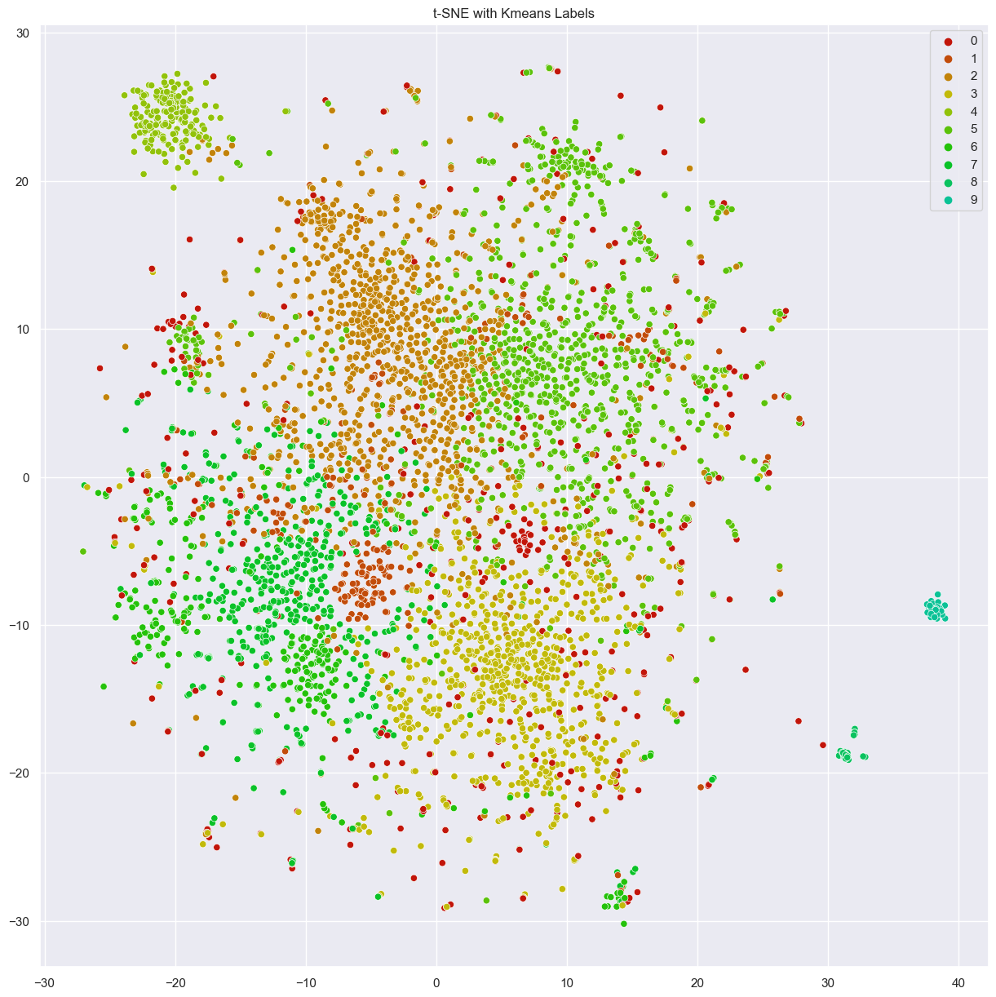
FIG. 10: K-means clustering discovered clusters with identification labels.

Conclusion
In conclusion, literature classification and text summarization are crucial for extracting valuable insights from the vast number of scholarly articles in the COVID-19 Open Research Dataset Challenge (CORD-19). Through machine learning and natural language processing techniques, researchers have made significant progress in improving the accuracy and efficiency of literature classification and text summarization. Researchers can easily access relevant information and accelerate scientific progress in understanding COVID-19 and related coronaviruses by organizing and categorizing articles. Furthermore, future work can focus on scaling the analysis using more powerful hardware and larger datasets to enhance clustering results and text summarization accuracy. These advancements contribute to the collective effort to combat the pandemic and drive further research.

REFERENCES
- “Everything There Is to Know about Sentiment Analysis.”MonkeyLearn,monkeylearn.com/sentiment-analysis/.
- Wolff, Rachel. “Natural Language Processing (NLP): 7 Key Techniques.” MonkeyLearn Blog, 19 Oct. 2021, monkeylearn.com/blog/natural-language-processing-techniques/.
- Robbins, Tony. “5 Most Effective NLP (Neuro Linguistic Programming) Techniques.” Tonyrobbins.Com, 18 Jan. 2023, www.tonyrobbins.com/leadership-impact/nlp-techniques/.
- Vlerick, Alejandra. “9 Functions That Make Natural Language Pre-Processing a Piece of Cake.” Medium, 4 Oct. 2021, towardsdatascience.com/9-functions-that-make-natural-language-pre-processing-a-piece-of-cake-8b885c151955.
- Allen Institute For AI. “Covid-19 Open Research Dataset Challenge (Cord-19).” Kaggle, 6 June 2022, www.kaggle.com/datasets/allen-institute-for-ai/CORD-19-research-challenge?datasetId=551982.
- Robinson, Scott, and Kentucky Farm Bureau. “Sentiment Analysis: Why It’s Necessary and How It Improves CX: TechTarget.” Customer Experience, 12Apr.2021, www.techtarget.com/searchcustomerexperience/tip/Sentiment-analysis-Why-its-necessary-and-how-it-improves-CX.
- Mishra, Utsav. “What Is Text Summarization in NLP?” Analytics Steps,9 Jan. 2022, www.analyticssteps.com/blogs/what-text-summarization-nlp.
- “Sentiment Analysis Guide.” MonkeyLearn, monkeylearn.com/sentiment-analysis/.
- Mishra, Prakhar. “Understanding T5 Model: Text to Text Transfer Transformer Model.” Understanding T5 Model: Text to Text Transfer Transformer Model, 27 May 2021 towardsdatascience.com/understanding-t5-model-text-to-text-transfer-transformer-model-69ce4c165023.
- “What Is Data Preprocessing &amp; What Are The Steps Involved?” MonkeyLearn Blog, 24 May 2021, monkeylearn.com/blog/data-preprocessing/.

