- (5)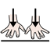
(5) I am behind
- (6)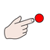
(6) That staff
- (7)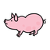
(7) You are a pig
- (8)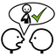
(8) So do I
- (9)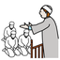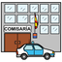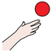
(9) The imam wants to take you to the police station later
- (10)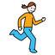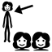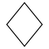
(10) Does she run to the rhombuses for bubbles?
- (11)
(11) It is not
- (12)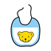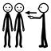
(12) This is your bib
- (13)
(13) Wheelbarrows
- (14)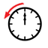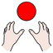
(14) I couldn't
- (15)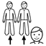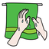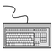
(15) They and you, who I don't know the name, dry glasses, and that keyboard
- (16)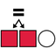
(16) It can be the same
- (17)
(17) Close your thing
- (18)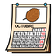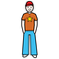
(18) October belongs to that teenager
- (19)
(19) They have them and us
- (20)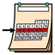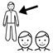
(20) Let's have him this week
- (21)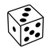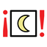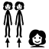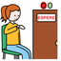
(21) It is time for the dice to say good night. They will wait
- (22)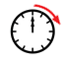
(22) Your sausages will have
- (23)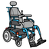
(23) He and the woman use a motorised wheelchair
- (24)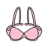
(24) You can use a bra this afternoon
- (25)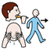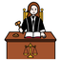
(25) Let's do not judge
- (26)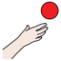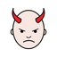
(26) She wants to do bad painting
- (27)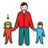
(27) They have a sister
- (28)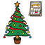
(28) Christmas Day has it
- (29)
(29) They have theirs
- (30)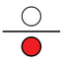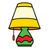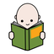
(30) Let's do some reading under the lamp
- (31)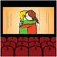
(31) I want to go to the cinema
- (32)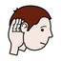
(32) You do not listen to wristband in the spring
- (33)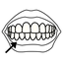
(33) He can use dentures
- (35)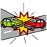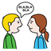
(35) They crashed and want to talk in a foreign language
- (36)
(36) You
- (37)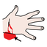
(37) Blood
- (38)
(38) To have
- (39)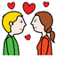
(39) Great! And he is in love
- (40)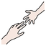
(40) I have and will not help others to have
- (41)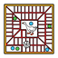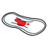
(41) Is snakes and ladders? They have their period
- (42)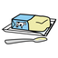
(42) They have lard
- (43)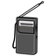
(43) Have to work on the portable radio
- (44)
(44) You are really being
- (45)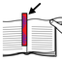
(45) The bookmark is wanted
- (46)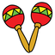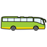
(46) Have maracas and buses. And that.
- (47)
(47) They cannot do
- (48)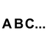
(48) You have the alphabet
- (49)
(49) Let's will have it
- (50)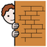
(50) That hides
- (51)
(51) I didn't want to do it
- (52)
(52) Is
- (53)
(53) He
- (54)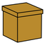
(54) Me and her could have the box before
- (55)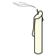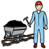
(55) If they calm down, you all and them can go with you to see the miner
- (56)
(56) You on Tuesday
- (57)
(57) He can wink at her
- (58)
(58) They have her bib
- (59)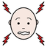
(59) She wants it. She hurts herself and wants to classify
- (60)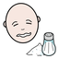
(60) They, he and he can be salty
- (61)
(61) They are and they want that city
- (62)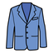
(62) Theirs and ours clothing
- (63)
(63) They
- (64)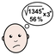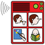
(64) Let's use the communicator as we want to say complicated things
- (65)
(65) Let's be with the boy
- (66)
(66) Their cap
- (67)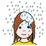
(67) I want to get soaked
- (68)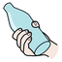
(68) Let's grip the canteen
- (69)
(69) Can
- (70)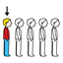
(70) The last radio is on fire
- (71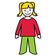
(71) We, you all, the little girl, they and she are wanted
- (72)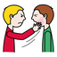
(72) Cool! Slap their face
- (73)
(73) Let's us do it
- (74)
(74) You all
- (75)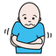
(75) We will get cold
- (76)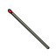
(76) Their match is something I cannot understand
- (77)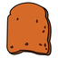
(77) They can have your toast
- (78)
(78) Has it for me
- (79)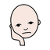
(79) I want to be bored
- (80)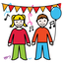
(80) Entertains
- (81)
(81) That will be
- (82)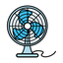
(82) It takes the device
- (83)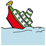
(83) His collapse is yours to have
- (84)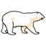
(84) I am fine with the polar bear in the dining-room
- (85)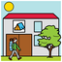
(85) You in the hostel
- (86)
(86) We let it happen
- (87)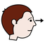
(87) You observing
- (88)
(88) Their teeth
- (89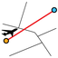
(89) I don't know, he does not want to do our itinerary
- (90)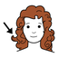
(90) They, their nonsense curls, and a match
- (91)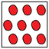
(91) Let's not put everything in the motorised wheelchair
- (92)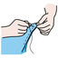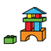
(92) Can sew lego blocks
- (93)
(93) They
- (94)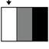
(94) Let's make that more clear
- (95)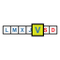
(95) On Friday, they can show you my olympic swimsuit
- (96)
(96) You do not have yours
- (97)
(97) Let's
- (98)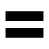
(98) She had the same firecrackers as we had
- (99)
(99) That does not?
- (100)
(100) Has
- (101)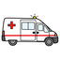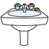
(101) The washbasin in the ambulance is hers
- (102)
(102) They did not have them
- (103)
(103) Congratulations! It was
- (104)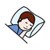
(104) While sleeping, there is nonsense inside
- (105)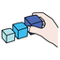
(105) Congratulations! For organising
- (106)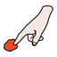
(106) Can touch it
- (107)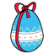
(107) Her chocolate egg
- (108)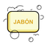
(108) Your hand soap
- (109)
(109) You are
- (110)
(110) I
- (111)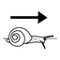
(111) Do not grip slowly
- (113)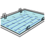
(113) You can go to the swimming pool
- (114)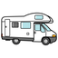
(114) Caravan
- (115)
(115) I want to celebrate New Year with you
- (116)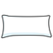
(116) That pillow is wanted
- (117)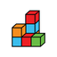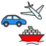
(117) Construction, cake and vehicles
- (118)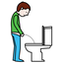
(118) They need to pee the same as you
- (119)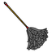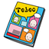
(119) you are dusting their children's book
- (120)
(120) We
- (121)
(121) Will not can
- (122)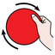
(122) I'm fine! Let's turn the march and touch
- (123)
(123) Was
- (124)
(124) Is
- (125)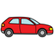
(125) They paint outside the vehicle
- (126)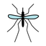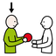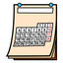
(126) The month gives them a lot of mosquitoes
- (127)
(127) It can have his ring
- (128)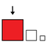
(128) You want it large
- (129)
(129) We and you
- (130)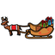
(130) Sledge
- (131)
(131) We can go to the dining room
- (132)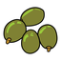
(132) Green olives
- (133)
(133) She
- (134)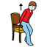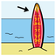
(134) The surfboard stands up
- (135)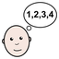
(135) She has an easy time with the verbs in the radio
- (136)
(136) They are between that
- (137)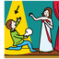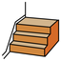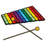
(137) You act nonsense for us with steps, bread and the xylophone
- (138)
(138) You and they are calm
- (139)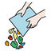
(139) He wanted it empty
- (140)
(140) That wants
- (141)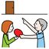
(141) The order was wanted
- (142)
(142) I cannot do that
- (143)
(143) Let's be with you, the girl and them
- (144)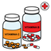
(144) She has vitamins
- (145)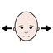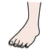
(145) The foot is not allowed
- (146)
(146) Their smoke
- (147)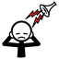
(147) They, they, and they are close and the noise is disturbing me
- (148)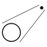
(148) That far
- (149)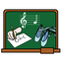
(149) There are art lessons
- (150)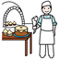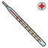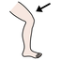
(150) The thermometer in the patisserie can have it in the leg
- (151)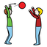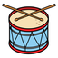
(151) He comes to play drums
- (152)
(152) I will have you and us
- (153)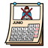
(153) She in June
- (154)
(154) Let's be
- (155)
(155) It is not cute
- (156)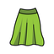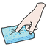
(156) His smooth skirt
- (157)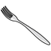
(157) The fork is unpleasant
- (158)
(158) That perfomance has not to be
- (159)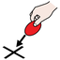
(159) Let's go to the place
- (160)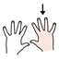
(160) Get the right-hand soaked
- (161)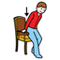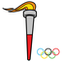
(161) The torch sits
- (162)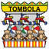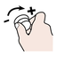
(162) Their fair stands will increase the steak
- (163)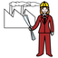
(163) The engineer loves the hole punch tool
- (164)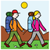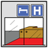
(164) Does she follow the sunflower? To their hotel
- (165)
(165) Congratulations!
- (166)
(166) I will
- (167)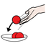
(167) Let's throw a celebration
- (168)
(168) My cent
- (169)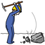
(169) This is what to hit
- (170)
(170) She could go to the church
- (171)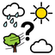
(171) What's the weather like? The strong wins
- (172)
(172) She is with something
- (173)
(173) Can grandfather and my right hand do it? The puzzle
- (174)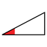
(174) Few are wanted
- (175)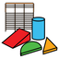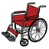
(175) Blocks and wheelchair
- (176)
(176) You all have
- (177)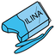
(177) We have plasticine
- (178)
(178) They had
- (179)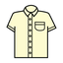
(179) Shirt
- (180)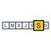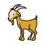
(180) On Saturday, that goat will be mine
- (181)
(181) That is ours
- (182)
(182) You all will be
- (183)
(183) The glass could have been
- (184)
(184) She will not have
- (185)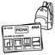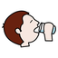
(185) We will have to do homework
- (186)
(186) Get soaked
- (187)
(187) They do not
- (188)
(188) Had black russian salad
- (189)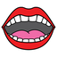
(189) Was the same mouth
- (190)
(190) We
- (191)
(191) They are
- (192)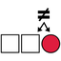
(192) They cannot duster the different steps
- (193)
(193) There is a sister
- (194)
(194) That belongs to them and her
- (195)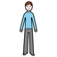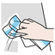
(195) The thin person is cleaning
- (196)
(196) It is the same
- (197)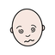
(197) Will feel sick
- (198)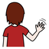
(198) I want them to break up
- (199)
(199) They, you and I want to know the climate
- (201)
(201) He
- (202)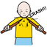
(202) You break thins with your right-hand
- (203)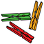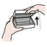
(203) Later open below for the pegs
- (204)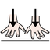
(204) The boy wants to be
- (205)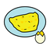
(205) Good afternoon with a french omelette
- (206)
(206) We are four right now
- (207)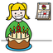
(207) Their birthday has to be
- (208)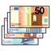
(208) Money
- (209)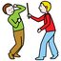
(209) Can not assault
- (210)
(210) Where are you all?
- (211)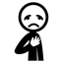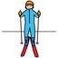
(211) Sorry! There is a skier
- (212)
(212) He does want
- (213)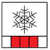
(213) She thinks this is not the season for Russian salad
- (214)
(214) Let us all be
- (215)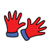
(215) Gloves
- (216)
(216) There is toast
- (217)
(217) The post is not mine
- (218)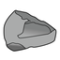
(218) Stone will not do
- (219)
(219) Is
- (220)
(220) Let's divide that fun activity
- (221)
(221) Won't have bubbles
- (222)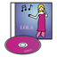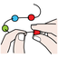
(222) I put together the CDs
- (223)
(223) We do not want
- (224)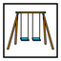
(224) The playground has it
- (225)
(225) I want that ring separated from the usb flash drive
- (226
(226) Let's him do it
- (227)
(227) Let it be cake
- (228)
(228) Let's be with them
- (229)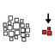
(229) Without me
- (230)
(230) Had
- (231)
(231) Under the front of the mouth
- (232)
(232) They and they can be with me
- (233)
(233) I am
- (234)
(234) This is the bucket
- (235)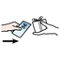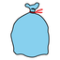
(235) She purchases white bread, a raincoat and a bag
- (236)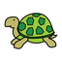
(236) Tortoise
- (237)
(237) I want to let myself be
- (238)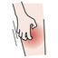
(238) The boy gives you and me that itch
- (239)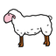
(239) Does not the sheep do it? It won't
- (240)
(240) We cannot do it
- (241)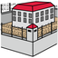
(241) Them, them and them are wanted in prison
- (242)
(242) She
- (243)
(243) Let's have a large one
- (245)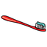
(245) We can have that tooth brush, it is hers and mine. Mine
- (247)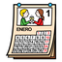
(247) It can happen in January
- (248)
(248) She wants the computer
- (249)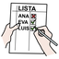
(249) Will he and I make a checklist in peace?
- (250)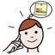
(250) Fantastic! Let's remember it
- (251)
(251) It could be sturdy
- (252)
(252) They want to smile
- (253)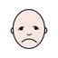
(253) Is he ashamed to refuse sunlight? That could be it
- (254)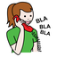
(254) Let's call them on that telephone
- (255)
(255) Near he and she
- (256)
(256) It is diverse
- (257)
(257) He wants to be annoying
- (258)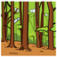
(258) Let's go to your grove
- (259)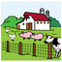
(259) Will play farm puppets
- (260)
(260) Can have some nonsense
- (261)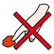
(261) Let's be on top, do not touch them
- (262)
(262) The nurse loves me
- (263)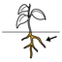
(263) Their roots can have underwear
- (264)
(264) You and they do not have dentures
- (265)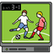
(265) Can play games
- (266)
(266) I am
- (267
(267) The crystal is not wanted
- (268)
(268) They can be on a circle
- (269)
(269) New Year's Day
- (270)
(270) I couldn't be at the classroom but I wanted
- (271)
(271) She wants
- (272)
(272) They have them
- (273)
(273) She has
- (274)
(274) They have
- (275)
(275) He is
- (276)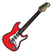
(276) There is an electric guitar
- (277
(277) I will want to be outside and under it
- (278)
(278) Good night! You open it
- (279)
(279) We do not want to be in adjacent buses
- (280)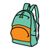
(280) Me and their backpack
- (281)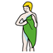
(281) They do not dry themselves. He does it
- (282)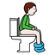
(282) When you go to the toilet, it gives you a headache
- (283)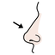
(283) Their nose
- (284)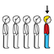
(284) We go first
- (285)
(285) Cent
- (286)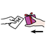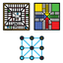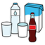
(286) I sell game equipment and drinks
- (287)
(287) You can be with her, with you and with him
- (288)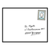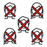
(288) I need help with mail, nobody can help her
- (289)
(289) They want a handsaw
- (290)
(290) Let's agree we cannot understand him
- (291)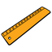
(291) Let's have her ruler. The silver one
- (293)
(293) Does not have
- (294)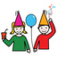
(294) Will be able to celebrate can?
- (295)
(295) We
- (296)
(296) Am I? We
- (297)
(297) I'm fine with that offer
- (298)
(298) We tried it before
- (299)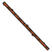
(299) They are that stick and a book
- (300)
(300) Those scissors will be celebrated
- (301)
(301) She wants you all to go to the bathroom
- (302)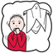
(302) Want to be let be afraid
- (303)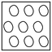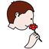
(303) No one smells the keys
- (304)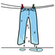
(304) We want ours wet for the meeting
- (305)
(305) You can put it in order
- (306)
(306) You and they are
- (307)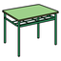
(307) I am with his school table and puppet
- (308)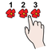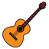
(308) She and smoke count guitar and you
- (309)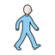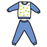
(309) They walk with the communicator in pyjamas
- (310)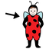
(310) Blocks are his disguise
- (311)
(311) You are happy
- (312)
(312) They
- (313)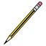
(313) They have your pencil
- (314)
(314) They are that
- (315)
(315) Will still want to be unhappy
- (316)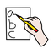
(316) I want easy trade on that writing
- (317)
(317) You want to not act
- (318)
(318) Let's use the blackboard
- (319)
(319) Let's will be able to do it
- (320)
(320) The tortoise was wanted
- (321)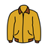
(321) Jacket will be needed
- (322)
(322) You and their photocopy machine
- (323)
(323) You all
- (324)
(324) You can be with you all
- (325
(325) She will want
- (326)
(326) Computer technicians do not have the alphabet
- (327)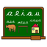
(327) Language
- (328)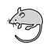
(328) The rodent has to be hers
- (329)
(329) You all
- (330)
(330) You all will be able to be with him
- (331)
(331) She
- (332)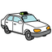
(332) She does not have a taxi
- (333)
(333) You cannot do
- (334)
(334) She can do
- (335)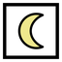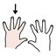
(335) At night, you want to use a mask on your left hand when in a vehicle
- (336)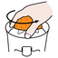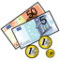
(336) That money comes after squeezing
- (337)
(337) He sells drinks
- (338)
(338) Was
- (339)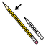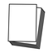
(339) The paper does not have to get soaked for long
- (340)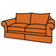
(340) You have a sofa
- (341)
(341) There is underwear
- (342)
(342) Gloves are wanted
- (343)
(343) They have a journey
- (344)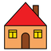
(344) Housing
- (345)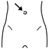
(345) He and she are wanting belly button
- (346)
(346) There are hoops
- (347)
(347) Her vehicle. You
- (348)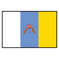
(348) Canary Islands are there
- (349)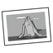
(349) That can be us. Photograph with that
- (350)
(350) Sadnesses before
- (351)
(351) You want it
- (352)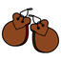
(352) Their musical instrument
- (353)
(353) Electricity can do it right now
- (354)
(354) They are not below
- (355)
(355) They are having their menstruation
- (356)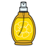
(356) He has cologne
- (357)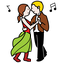
(357) See you at the dances
- (358)
(358) Let's get to that
- (359)
(359) You can take the ugly toys
- (360)
(360) The dots couldn't do it
- (361)
(361) That
- (362)
(362) What do I want
- (363)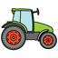
(363) Let's have the tractor
- (364)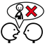
(364) They can have it but neither do i
- (365)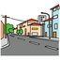
(365) That can be in the avenue
- (366)
(366) The incomprehensible napkin does not hit us, first is the little girl
- (367)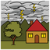
(367) You move to a safe place, there is lightning
- (368)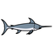
(368) His swordfish
- (369)
(369) He will have that
- (370)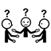
(370) We don't agree
- (371)
(371) Your door clouding over
- (372)
(372) We will
- (373)
(373) They want you all to make it purple
- (374)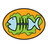
(374) Fish and bucket
- (375)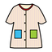
(375) They are dizzy in that coat
- (376)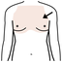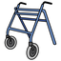
(376) The chest needs me and my walker
- (377)
(377) You and you all are
- (378)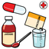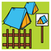
(378) You are with your treatment at the camping site
- (379)
(379) You all have
- (380)
(380) Near you
- (381))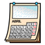
(381) They are wanted in April
- (382)
(382) Let's have it, we and you all
- (383)
(383) You all and he
- (384)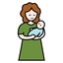
(384) Mother can have that tale
- (385)
(385) You can get him
- (386)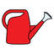
(386) Today the watering can is to be used
- (387)
(387) That and they
- (388)
(388) A spoon and the construction kit
- (389)
(389) Want to dress in green
- (390)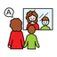
(390) The speech therapist and him can talk to a puppet
- (391)
(391) Will laugh
- (392)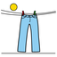
(392) Is dry
- (393)
(393) Ice-cream is to be had
- (395)
(395) Curls will
- (396)
(396) Want to take a taxi
- (397)
(397) Does not want to be beautiful
- (398)
(398) Our raincoat
- (399)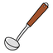
(399) You, and my kitchen utensil
- (400)
(400) The rod can do it
- (401)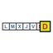
(401) On Sunday, it has it
- (402)
(402) He wants it
- (403)
(403) The cause will be wanted
- (404)
(404) Is
- (405)
(405) Let's not want it
- (406)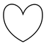
(406) You are not their heart shape
- (407)
(407) You can have her toothbrush, your and ours
- (408
(408) Will want
- (409)
(409) I do not know what to sell. Strong fire
- (410)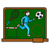
(410) Your and theirs physical education lesson have us
- (411)
(411) They have
- (412)
(412) They can play with blocks
- (413)
(413) Had in front of
- (414)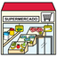
(414) That can be a market
- (415)
(415) Florist has it
- (416)
(416) She has a radio
- (417)
(417) We
- (418)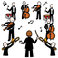
(418) There is an orchestra
- (419)
(419) The hostel wants his pepper
- (420)
(420) We are close reading
- (421)
(421) Is
- (422)
(422) In spring, he and he
- (423)
(423) Let's do not have
- (424)
(424) They want to have it
- (425)
(425) Did it could happen?
- (426)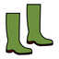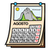
(426) In August, she does not have boots
- (427)
(427) The electric wheelchair is wanted
- (428)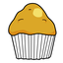
(428) Did mother had a cupcake?
- (429)
(429) Vegetables
- (430)
(430) Me and her are optimists
- (431)
(431) Let's do it, you all and I
- (432)
(432) You clearly see is us
- (433)
(433) It was wanted
- (434)
(434) They can not paint that they feel sick
- (436)
(436) What time is it? Let's do it
- (437)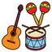
(437) How do you feel about that? Her musical instruments can play in spring
- (438)
(438) That has it
- (439)
(439) I don't know if You will be able to do it
- (440)
(440) Let's grab him
- (441)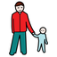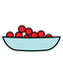
(441) Let's father get a few
- (442)
(442) The cardboard made you sick with that
- (443)
(443) Let's
- (444)
(444) Let's try to be
- (445)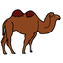
(445) Let's get behind the camel?
- (446)
(446) Before we could write
- (447)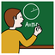
(447) Let's had grandmother explain it to him
- (448)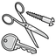
(448) There is that metal
- (449)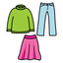
(449) I hide myself in the clothes
- (450)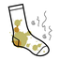
(450) It has stained you
- (451)
(451) The mouth want to have it
- (452)
(452) Tooth
- (453)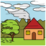
(453) Wind
- (454)
(454) We are annoyed
- (455)
(455) There will be an interpreter
- (456)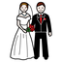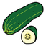
(456) They are a book, marriage and cucumbers
- (457)
(457) We and my striped self
- (458)
(458) I am next to those presidents
- (459)
(459) You
- (460)
(460) We will be with you all
- (461)
(461) Let's have it
- (462)
(462) I
- (463)
(463) A rod was with their sunflower
- (464)
(464) Is
- (465)
(465) Wants
- (466)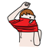
(466) Dress oneself right now
- (467)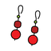
(467) Assaults for jewelry
- (468)
(468) Cannot do it
- (469)
(469) Good night! Can do it
- (470)
(470) We want to let them be
- (471)
(471) We are
- (472)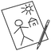
(472) She divided us into groups for drawing
- (473)
(473) I can get upset you with silly remarks that make them dry
- (474)
(474) That can be
- (475)
(475) You and them are in the hotel where you are staying
- (476)
(476) They are
- (477)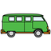
(477) We feel dizzy in the van, let's break something
- (478)
(478) Lovers at your door
- (479)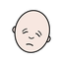
(479) She has exhaustation
- (480)
(480) Unpleasant lightning
- (481)
(481) You have a smooth chests of drawers
- (482)
(482) Has
- (483)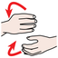
(483) You all and hin can make that
- (484)
(484) Let's try to sleep
- (485)
(485) That
- (486)
(486) They have it easy
- (488)
(488) Let's let them have him
- (489)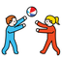
(489) She wants to have fun
- (490)
(490) There is a coat
- (491)
(491) Radio
- (492)
(492) Is the dice wanted by them or by us?
- (493)
(493) Your physical education class does not want us
- (494)
(494) Let's try to do it with you
- (495)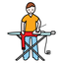
(495) Ironboard
- (496)
(496) Let's try to do it with him
- (497)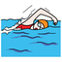
(497) The swimmer will have a sweet chat
- (498)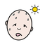
(498) That is hot
- (499)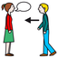
(499) It arrives for me left to you and them
- (500)
(500) The jewelry is other than hers
- (501)
(501) Let's
- (502)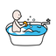
(502) Saltcellar bathes in the machine
- (504)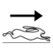
(504) A quick easy swimming is wanted
- (505)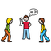
(505) Who stole the bacon?
- (506)
(506) Does not have a slim one
- (507)
(507) You all want to have her stained ones
- (508)
(508) Fantastic! You all want to be with her
- (509)
(509) Let's be looking at them over there
- (510)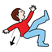
(510) We will until they fall into nonsense
- (511)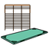
(511) Let's be in the airbed while their play musical instruments
- (512)
(512) That does not? Let's be with you all
- (513)
(513) You all have
- (514)
(514) Let's
- (515)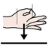
(515) Is
- (516)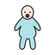
(516) She is dividing the people among them
- (517)
(517) We are that
- (518)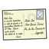
(518) We wanted to get that postal card before
- (519)
(519) Feel sick
- (520)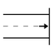
(520) Can be at the end
- (521)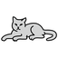
(521) The cat will write
- (522)
(522) They are them
- (523)
(523) Who? It can be
- (524)
(524) They want to be able to do it
- (525)
(525) Let's let her dry it
- (526)
(526) They poured it
- (527)
(527) He and he will want us salty
- (528)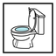
(528) Use the bathroom right now
- (529)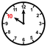
(529) At exactly ten o'clock, it will dust it to go on a trip
- (530)
(530) Do you see yourself?
- (531)
(531) He and you have it
- (532)
(532) They want to make me, it and him scared of that
- (533)
(533) You are
- (534)
(534) Is is not pretty when commerce is clouded over by fear?
- (535)
(535) You want
- (536)
(536) Joint gymnasium wants
- (537)
(537) She wants hers
- (538)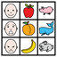
(538) Wants communication board
- (539)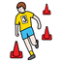
(539) You, myself, slalom, he and they set
- (540)
(540) Pours
- (541)
(541) Sorry! is
- (542)
(542) I want him and on top of
- (543)
(543) Pyjama Not wanting to let's
- (544)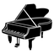
(544) Piano can
- (545)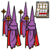
(545) Holy Week wants blocks
- (546)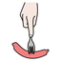
(546) Wristband, roof tile and you puncture
- (547)
(547) Washbasin dry oneself hers
- (548)
(548) Can
- (549)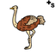
(549) Ostriches are
- (550)
(550) Bathes other
- (551)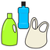
(551) Let's can plastic
- (552)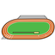
(552) Court has portable radio
- (553)
(553) I have that and them? Paint fingernails and we?
- (554)
(554) They, he and that will not want
- (555)
(555) Joint they
- (556)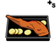
(556) You have don't touch!, roastses and her
- (557)
(557) Constructions wants
- (558)
(558) Let's
- (559)
(559) Croquette does not can me too!
- (560)
(560) Sleeping bag
- (561)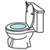
(561) Lavatory
- (562)
(562) They are them, myself and silly remark
- (563)
(563) Flowered all / everything
- (564)
(564) Patio
- (565)
(565) You are
- (566)
(566) Nonsense
- (567)
(567) They and A have
- (568)
(568) That
- (569)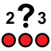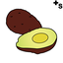
(569) How many?, that, avocadoses and you do not have
- (570)
(570) You and let's can
- (571)
(571) He and she can want joint
- (572)
(572) Between we
- (573)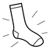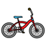
(573) Clean you, hers, musical instruments, bike and let's
- (574)
(574) He does not have to forgive
- (575)
(575) Has
- (576)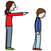
(576) Expulsion, he and he
- (577)
(577) You
- (578)
(578) She
- (579)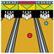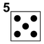
(579) Bowling alley and they do not want dice showing 5
- (580)
(580) You are
- (581)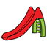
(581) Toboggan will have
- (582)
(582) Sledge and they can
- (583)
(583) See you later has.
- (584)
(584) Let's, we and plastic and visual education buy
- (585)
(585) We
- (586)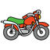
(586) Motorbike has even though
- (587)
(587) You can be
- (588)
(588) Is right-handed
- (589)
(589) Art lesson and they
- (590)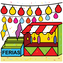
(590) You bath black funfair
- (591)
(591) I
- (592)
(592) She and myself can wedding
- (593)
(593) They and constructions wanted
- (594)
(594) Will have
- (595)
(595) Don't touch and boy are you
- (596)
(596) Guitar wants to can
- (597)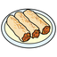
(597) He and you are not noisy myself, hoop and cannelloni
- (598)
(598) City is not you, let's and them
- (599)
(599) We are
- (600)
(600) Will want
- (601)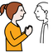
(601) Rubber boots will be inside please
- (602)
(602) Close you and skier
- (603)
(603) You
- (604)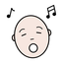
(604) Music is not cardboard
- (605)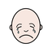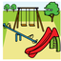
(605) I cry behind park
- (606)
(606) Can wet
- (607)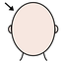
(607) Head and I
- (608)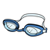
(608) Glasses and commerce can.
- (609)
(609) Does not have a shit
- (610)
(610) We
- (611)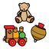
(611) Toyses, on top of, we and rodent
- (612)
(612) Bandit wanted
- (613)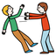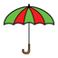
(613) Die (singular) dice (plural) wants to taste umbrella
- (614)
(614) Baby has
- (615)
(615) They
- (616)
(616) You and far let's come
- (617)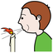
(617) Day blew
- (618)
(618) You
- (619)
(619) They and they want
- (620)
(620) You have them
- (621)
(621) Behind they are hers
- (622)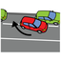
(622) Car park
- (623)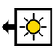
(623) He will go to the bathroom them? Yesterday
- (624)
(624) Electric guitar and myself
- (625)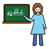
(625) Behind you Music teacher do not touch
- (626)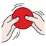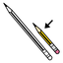
(626) ?
- (627)
(627) Pillow is him
- (628)
(628) Trip, myself and silly remark have
- (629)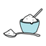
(629) Blood sugar will want
- (630)
(630) They
- (631)
(631) Newspaper can
- (632)
(632) He and that. How are you? is not
- (633)
(633) Temperature wants them, them, myself and sugar
- (634)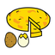
(634) They and Spanish omelette
- (635)
(635) That, you and let's feel dizzy
- (636)
(636) We have to be us
- (637)
(637) He is
- (638)
(638) Offers
- (639)
(639) He, dialogue and Art lesson can
- (640)
(640) You and they have
- (641)
(641) Shirt and maracases will not wink
- (642)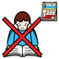
(642) Holidayses want to refuse them and diverse you
- (643)
(643) They have
- (644)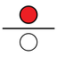
(644) They have up
- (645)
(645) Has
- (646)
(646) Was joint behind
- (647)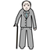
(647) Does not can elderly
- (648)
(648) We have
- (649)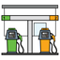
(649) Petrol station
- (650)
(650) You, you and smile
- (651)
(651) They are slim
- (652)
(652) They and van? Laminates
- (653)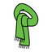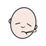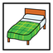
(653) They wanted scarf and illnesses, bedroom and them
- (654)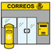
(654) You and postal service do not want
- (655)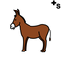
(655) Donkeyses and myself ill-treated
- (656)
(656) They want to be him and boots
- (657)
(657) She and she
- (658)
(658) Good day is doing not can
- (659)
(659) You will
- (660)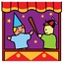
(660) He likes breaking puppetses
- (661)
(661) She has bad hers, let's and myself
- (662)
(662) That wants good day, perfume and that
- (663)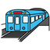
(663) Metro / underground train dress oneself
- (664)
(664) Can
- (665)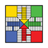
(665) Ludo does not endure.
- (666)
(666) She is don't touch!
- (667)
(667) We can that
- (668)
(668) Is
- (669)
(669) Car
- (670)
(670) Dining-room and that
- (671)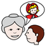
(671) Up she tell not play rugby
- (672)
(672) Lovers you
- (673)
(673) Have a shit
- (674)
(674) We, Foreign Language lesson and I do not want
- (675)
(675) Spanish omelette can
- (676)
(676) That
- (677)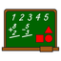
(677) Mathematicses want
- (678)
(678) Separated sorry and trade
- (679)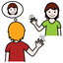
(679) Knows
- (680)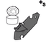
(680) June, you, let's and tin opener
- (681)
(681) I did not want daisies and that
- (682)
(682) Euro does not want
- (683)
(683) They
- (684)
(684) I can that and let's
- (685)
(685) Match wants
- (686)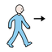
(686) Can go
- (687)
(687) They and we are feel like
- (688)
(688) Let's have to be hers
- (689)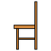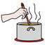
(689) Chair and commerce cook homework
- (690)
(690) See you later, you and you were you construction kit
- (691)
(691) Was
- (692)
(692) Is
- (693)
(693) Abaci and Olympic games
- (694)
(694) We
- (695)
(695) How is the weather? is
- (696)
(696) You
- (697)
(697) Clear they and they want young
- (698)
(698) They much (incontable)
- (699)
(699) He has
- (700)
(700) Cent and they want
- (701)
(701) You will frolic minus/less
- (702)
(702) Cardboard is
- (703)
(703) She and he
- (704)
(704) Let's
- (705)
(705) You and they want
- (706)
(706) He is having. You
- (707)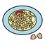
(707) You laughed chickpeases and let's.
- (708)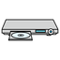
(708) DVD player has?
- (709)
(709) She and 1 cent will can
- (710)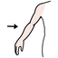
(710) Arm has
- (711)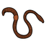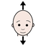
(711) Worm can yes
- (712)
(712) I'm fine! and illnesses?
- (713)
(713) She has to want black stairs
- (714)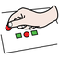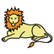
(714) Transport can put you, lion and cool!
- (715)
(715) Jail and you can
- (716)
(716) Sister
- (717)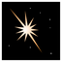
(717) You, star and we
- (718)
(718) They can myself?
- (719)
(719) They can paper and them
- (720)
(720) Period and you dance have bathed.
- (721)
(721) Can
- (722)
(722) I am not
- (723)
(723) Swifts
- (724)
(724) Plastic and visual education and circuses
- (725)
(725) She and they can
- (726)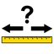
(726) Measurements
- (727)
(727) You want let's and treatment
- (728)
(728) That is not? They will him
- (729)
(729) She does not have to dry oneself A
- (730)
(730) Nonsense
- (731)
(731) Pic is can
- (732)
(732) We are speech therapy
- (733)
(733) You want you and dolphin
- (734)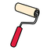
(734) That can can roller
- (735)
(735) Don't touch! can let's and folder
- (736)
(736) He can can hers
- (737)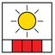
(737) Summer and Christmas period have to give thanks
- (738)
(738) Paper is
- (739)
(739) Button and he are I can't understand you
- (740)
(740) Celebrates bad
- (741)
(741) He has him
- (742)
(742) I am
- (743)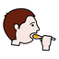
(743) Let's and puppetses eat
- (744)
(744) I
- (745)
(745) She wants slow
- (746)
(746) Waits
- (747)
(747) Can
- (748)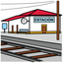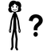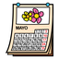
(748) Station, who is she? and May want
- (749)
(749) They and goat
- (750)
(750) I am
- (751)
(751) Let's urinate can hers, them and them
- (752)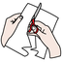
(752) Sorry! next to cuts
- (753)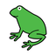
(753) Let's and frog
- (754)
(754) They have to not can.
- (755)
(755) Face
- (756)
(756) You had
- (757)
(757) She has to be
- (758)
(758) Harpsichords can
- (759)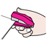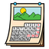
(759) Smoke, almanac and cloud ro staple have
- (760)
(760) Wants
- (761)
(761) They can New Year's Day
- (762)
(762) Plate does not
- (763)
(763) Let's and myself beautiful
- (764)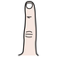
(764) Right hand, woman, you, plastic and visual education and finger
- (765)
(765) Will have elderly
- (766)
(766) We and we are you
- (767)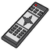
(767) Control wants to be you
- (768)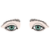
(768) Eyes much (incontable)
- (769)
(769) Writing and to observe? Wants
- (770)
(770) You was let's and joint them
- (771)
(771) They and we
- (772)
(772) Calendar is bicycle, hog and her
- (773)
(773) That does not paint
- (774)
(774) What? wants to have key
- (775)
(775) Physical Education lesson
- (776)
(776) You, hers and to observe want
- (777)
(777) Gloves will be
- (778)
(778) Geranium can
- (779)
(779) Tooth and they do not
- (780)
(780) You and mum pour can
- (781)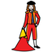
(781) Bullfighter and grandmother can him
- (782)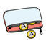
(782) Christmas Star can postal service, purse and pig
- (783)
(783) You are not go to the bathroom and pee us, myself, birthdayses and what is your name?
- (784)
(784) He, you and that do not dry one's hands
- (785)
(785) He
- (786)
(786) Does not have light blue good?
- (787)
(787) Rod and he
- (788)
(788) Gift bathes?
- (789)
(789) Who?, you and we are
- (790)
(790) Judge was
- (791)
(791) Ill, golden ruler is
- (792)
(792) They want hers
- (793)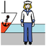
(793) We stew. We want mariner and that
- (794)
(794) We, we and they cook
- (795)
(795) You, smoke, other that and you have you
- (796)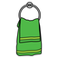
(796) Money has towel
- (797)
(797) Radio and you make/ to do have
- (798)
(798) Please and they will
- (799)
(799) That will be
- (800)
(800) She hides goat
- (801)
(801) Does not have
- (802)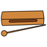
(802) We and chinese box can have cent
- (803)
(803) Will be
- (804)
(804) We and she wanted
- (805)
(805) He and they win
- (806)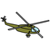
(806) Where is it?, stormy don't touch and helicopter want hers
- (807)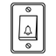
(807) Electric bell wants separated
- (808)
(808) You
- (809)
(809) Wants joint
- (810)
(810) Let's and that want you.
- (811)
(811) You and post
- (812)
(812) Caravan
- (813)
(813) Bike wants
- (814)
(814) He and police station have them
- (815)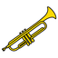
(815) Trumpet is using them
- (816)
(816) They and myself have
- (817)
(817) She can
- (818)
(818) Let's, route and let's are?
- (819)
(819) Outside they and she
- (820)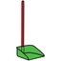
(820) Dustpan and you photocopy.
- (821)
(821) Belt and device
- (822)
(822) Blackboard can not can
- (823)
(823) Writer can
- (824)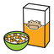
(824) Cereals have
- (825)
(825) Is
- (826)
(826) He can
- (827)
(827) You scare
- (828)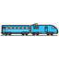
(828) They did not can marbles and train
- (829)
(829) Do not touch
- (830)
(830) You dry one's hands
- (831)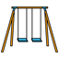
(831) Swing has
- (832)
(832) You want to want
- (833)
(833) You and accident get tired them and you
- (834)
(834) Past sight skied
- (835)
(835) You and he throw
- (836)
(836) He can. Tracksuit
- (837)
(837) He does not can
- (838)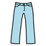
(838) Other trousers will want hello
- (839)
(839) You can
- (840)
(840) They want
- (841)
(841) Displease not be
- (842)
(842) They
- (843)
(843) Meeting was
- (844)
(844) Van and she can
- (845)
(845) Music has
- (846)
(846) Tiger can plastic and visual education
- (847)
(847) Wish be filthy
- (848)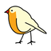
(848) Photography wants bird, let's and her
- (849)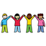
(849) Fantastic! talks integration and transport
- (850)
(850) That
- (851)
(851) To and we
- (852)
(852) He, you and they
- (853)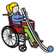
(853) Boccia and myself want to have him
- (854)
(854) They
- (855)
(855) That and you can
- (856)
(856) Gift and verbs
- (857)
(857) Up they want that
- (858)
(858) They open? Can
- (859)
(859) Fork and let's have
- (860)
(860) You, they, he and slap
- (861)
(861) Scarf is? Is
- (862)
(862) Chest will commerce
- (863)
(863) I can
- (864)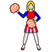
(864) June, you and presenter are
- (865)
(865) We are feel dizzy disguise
- (866)
(866) She has
- (867)
(867) Wishes young
- (868)
(868) She had
- (869)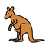
(869) Optimist can kangaroo and her
- (870)
(870) Annoying you are.
- (871)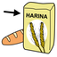
(871) Me neither! many (contable)? Flour
- (872)
(872) Hard i'm fine! wants
- (873)
(873) You do not rhombuses
- (874)
(874) She and on top of listen
- (875)
(875) Let's and goodbye
- (876)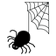
(876) Spider wants let's, them and them
- (877)
(877) Airbed, they and myself
- (878)
(878) I, hers and they
- (879)
(879) You
- (880)
(880) Thankses can not can
- (881)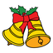
(881) Bell does not puncture that
- (882)
(882) Let's have you and them
- (883)
(883) He
- (884)
(884) She
- (885)
(885) Let's
- (886)
(886) Wedding is being near
- (887)
(887) She
- (888)
(888) They
- (889)
(889) They have you and presenter
- (890)
(890) Let's and trade
- (891)
(891) Mirror has
- (892)
(892) They want
- (893)
(893) She has
- (894)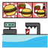
(894) Hamburger restaurant is wanting
- (895)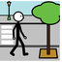
(895) That and camel stroll love
- (896)
(896) Soap
- (897)
(897) Does not want
- (898)
(898) Celebrate be
- (899)
(899) Swimsuit
- (900)
(900) That and they can want pencil
- (901)
(901) Space and he
- (902)
(902) Outside I am having after
- (903)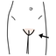
(903) Vagina, myself, internet and she can
- (904)
(904) That is swifting heat chair and close him
- (905)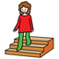
(905) They will descend
- (906)
(906) Does not want
- (907)
(907) Moon will place
- (908)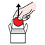
(908) Take out celebrate
- (909)
(909) Family touring car is
- (910)
(910) Glue
- (911)
(911) To have
- (912)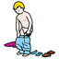
(912) Chinese box and face undress artistic education. Has
- (913)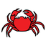
(913) Stick, you, boots and crab
- (914)
(914) Metal opens
- (915)
(915) You are them right-handed and myself
- (916)
(916) Let's
- (917)
(917) They wanted
- (918)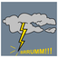
(918) They thundered
- (919)
(919) I, you and congratulations!
- (920)
(920) On top of and you
- (921)
(921) That and we can you
- (922)
(922) Anger and he want
- (923)
(923) Let's forgive can. Hers and myself can
- (924)
(924) Yearbook hers
- (925)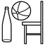
(925) Objects and let's can let's and that
- (926)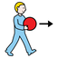
(926) They took.
- (927)
(927) We and myself laugh hot him
- (928)
(928) Blue cake, party and good she are dull
- (929)
(929) We do not want you and machine
- (930)
(930) Cooks in front of
- (931)
(931) I am.
- (932)
(932) Wicked I
- (933)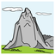
(933) You and mount are
- (934)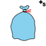
(934) Dwellings want right garbage bags
- (935)
(935) I do not know and see you
- (936)
(936) Bubbles and you ill-treated
- (937)
(937) Is
- (938)
(938) They want us
- (939)
(939) Other you
- (940)
(940) That is ordering head and bell
- (941)
(941) Perfomance
- (942)
(942) He has to drink
- (943)
(943) That
- (944)
(944) Headache can chat
- (945)
(945) Different that
- (946)
(946) Between you?
- (947)
(947) Skirt is
- (948)
(948) Let's
- (949)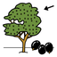
(949) Olive tree does not have curls
- (950)
(950) That yours being they
- (951)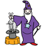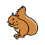
(951) Let's, magician and squirrel are
- (952)
(952) Don't touch can cloud mask and myself
- (953)
(953) We can
- (954)
(954) Will not have
- (955)
(955) You
- (956)
(956) They are.
- (957)
(957) We, measurements, myself and we
- (958)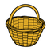
(958) Basket and hit are recreational vehicle - RV?
- (959)
(959) Banana and myself empty want. To
- (960)
(960) I want
- (961)
(961) They and postal card are maths class
- (962)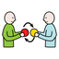
(962) They exchange up?
- (963)
(963) You itch ill-treated hoop and her
- (964)
(964) You and cologne can him
- (965)
(965) You can I do not want
- (966)
(966) You
- (967)
(967) He, you and fantastic will be
- (968)
(968) Can?
- (969)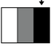
(969) Dark, joint blackboard
- (970)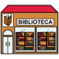
(970) Library and he want to have
- (971)
(971) Skirt and hole punch get angry with
- (972)
(972) Money is
- (973)
(973) What? is being hostel and camel
- (974)
(974) You
- (975)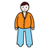
(975) Gave fat
- (976)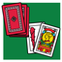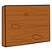
(976) Cards want plank
- (977)
(977) You and plate will be
- (978)
(978) Was
- (979)
(979) You, they and myself. Let's
- (980)
(980) Wants dry.
- (981)
(981) They
- (982)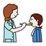
(982) Balloon and monitor have chat
- (983)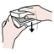
(983) They close
- (984)
(984) Goodbye you and us
- (985)
(985) Is not
- (986)
(986) He will want far
- (987)
(987) Wood and gloves
- (988)
(988) She
- (989)
(989) Let's
- (990)
(990) We, let's, you and sorry
- (991)
(991) You and Where is it?
- (992)
(992) They talk be
- (993)
(993) That can mariner
- (994)
(994) Good he? Has
- (995)
(995) Is
- (996)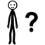
(996) I and lecture explain can who is he?, see you and us
- (997)
(997) August and i want
- (998)
(998) Can disappear happy
- (999)
(999) Games do not lily
- (1000)
(1000) You have
- (1001)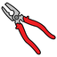
(1001) Outside I? Plierses will have
- (1002)
(1002) I am that, myself, successes and her
- (1003)
(1003) Is
- (1004)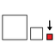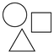
(1004) Can small? Forms / shapes, that and right hand
- (1005)
(1005) That exhibits
- (1006)
(1006) Cardboard has to get up from the chair
- (1007)
(1007) You want
- (1008)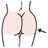
(1008) Religion lesson and bun do not
- (1009)
(1009) You and we
- (1010)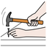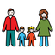
(1010) We nail have family
- (1011)
(1011) They, we and you can
- (1012)
(1012) Museum wants us
- (1013)
(1013) Outside musical instrument
- (1014)
(1014) Will want? That
- (1015)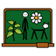
(1015) General studies
- (1016)
(1016) They and they
- (1017)
(1017) Beautiful you are
- (1018)
(1018) He has to can.
- (1019)
(1019) They sleep red him and ice-cream seller
- (1020)
(1020) She and they want last.
- (1021)
(1021) They wanted
- (1022)
(1022) States
- (1023)
(1023) You and she can us
- (1024)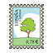
(1024) Green postal stamp and he are
- (1025)
(1025) Mail wants
- (1026)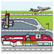
(1026) Airport ill-treated be them and him? Myself
- (1027)
(1027) They make happy have been. Can
- (1028)
(1028) Let's are
- (1029)
(1029) They want to feel like them construction kit
- (1030)
(1030) Electric wheelchair and she
- (1031)
(1031) We want?
- (1032)
(1032) You and don't touch
- (1033)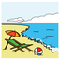
(1033) Coast
- (1034)
(1034) Umbrella and how verbs can
- (1035)
(1035) He does not want them
- (1036)
(1036) We can inside right hand and you
- (1037)
(1037) Postal stamp
- (1038)
(1038) Let's want to can
- (1039)
(1039) Support product wants to not be them
- (1040)
(1040) Can
- (1041)
(1041) Scratch and board
- (1042)
(1042) We want quick let's
- (1043)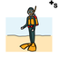
(1043) Divers, bad luck and they are Not wanting to
- (1044)
(1044) You wanted joint
- (1045)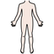
(1045) Body does not
- (1046)
(1046) I can't understand you does not
- (1047)
(1047) She
- (1048)
(1048) She
- (1049)
(1049) She, hello and you have him and you
- (1050)
(1050) He is white coat
- (1051)
(1051) Can have
- (1052)
(1052) You and car park do not can
- (1053)
(1053) Ear-rings, I am fine and yearbook read
- (1054)
(1054) They can?
- (1055)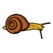
(1055) Many snail assaults short
- (1056)
(1056) Metro / underground train, bedroom, calendar and let's have to have you, myself and them
- (1057)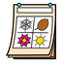
(1057) That you and year exhausting they
- (1058)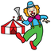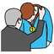
(1058) That, clown and she award
- (1059)
(1059) Yours have man
- (1060)
(1060) Thin let's and they break you and far please
- (1061)
(1061) That can have myself, them and vehicles
- (1062)
(1062) We want that
- (1063)
(1063) He turns?
- (1064)
(1064) Soaked
- (1065)
(1065) That
- (1066)
(1066) Handsome they
- (1067)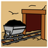
(1067) You have to put mine and paper
- (1068)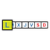
(1068) Monday, that and guitar are after
- (1069)
(1069) He can have fan and that
- (1070)
(1070) Green pepper and vulva
- (1071)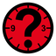
(1071) When has
- (1072)
(1072) That and he are the same
- (1073)
(1073) Africa will want below
- (1074)
(1074) Sheep
- (1075)
(1075) We and they close right-handed
- (1076)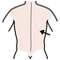
(1076) Back and incomprehensible they make/ to do hers, week and her
- (1077)
(1077) Can can
- (1078)
(1078) Filthy you have to deny dance
- (1079)
(1079) I will can
- (1080)
(1080) We have
- (1081)
(1081) He will be being
- (1082)
(1082) Smile and that think myself, let's and that
- (1083)
(1083) Is not
- (1084)
(1084) Caravan and she have sister
- (1085)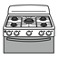
(1085) Will want? Let's and stove
- (1086)
(1086) Joint that and dromedar
- (1087)
(1087) Belt, you and she want to can hers
- (1088)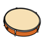
(1088) Tambourine can want
- (1089)
(1089) She has hers and them
- (1090)
(1090) Will want
- (1091)
(1091) Let's and they are
- (1092)
(1092) They and curls want
- (1093)
(1093) He can plate
- (1094)
(1094) She can them
- (1095)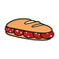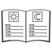
(1095) Sandwich/roll can have agenda/plan
- (1096)
(1096) Oceania and nose can can
- (1097)
(1097) He is behind
- (1098)
(1098) Art lesson can grasp us quickly
- (1099)
(1099) Justice and journey
- (1100)
(1100) They help
- (1101)
(1101) They, I do not know and she are?
- (1102)
(1102) Right he is can close
- (1103)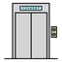
(1103) Lift is
- (1104)
(1104) I, that, they and they
- (1105)
(1105) Xylophone equal/same
- (1106)
(1106) You and they want you
- (1107)
(1107) Let's will can
- (1108)
(1108) For me and caravan incubate
- (1109)
(1109) They and you
- (1110)
(1110) Let's have?
- (1111)
(1111) Saucepan
- (1112)
(1112) Does not can
- (1113)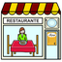
(1113) Restaurant was
- (1114)
(1114) They speak have
- (1115)
(1115) Let's and they can
- (1116)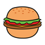
(1116) Hamburger wants
- (1117)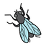
(1117) Let's and fly
- (1118)
(1118) Rubber boots want
- (1119)
(1119) Olympic rings want to be them
- (1120)
(1120) Support product and let's can
- (1121)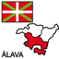
(1121) Behind Alava and myself
- (1122)
(1122) Pee was hers
- (1123)
(1123) That and I want Not wanting to take
- (1124)
(1124) I and you do not can
- (1125)
(1125) Bathes
- (1126)
(1126) They can
- (1127)
(1127) Can right-handed
- (1128)
(1128) She
- (1129)
(1129) Calendar pay be
- (1130)
(1130) Caravan can can them?
- (1131)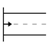
(1131) Device wants origin and him
- (1132)
(1132) Box does not belt
- (1133)
(1133) She has
- (1134)
(1134) We can
- (1135)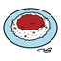
(1135) Rice tastes
- (1136)
(1136) They
- (1137)
(1137) Will piss
- (1138)
(1138) We are. Green beans. Is
- (1139)
(1139) They and she have to can that? Constructions awards
- (1140)
(1140) Inside thermometer can them, that and that
- (1141)
(1141) Can have stormy
- (1142)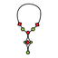
(1142) Electricity give thanks perfume and collar? Myself and you.
- (1143)
(1143) That, dentureses and they did not can
- (1144)
(1144) We are being
- (1145)
(1145) That and she phone hers
- (1146)
(1146) Does not want
- (1147)
(1147) See you later sees
- (1148)
(1148) Drawing wants him and him
- (1149)
(1149) Arm wanted far
- (1150)
(1150) They, that, mosquito and restaurant
- (1151)
(1151) He wants that. Ours
- (1152)
(1152) She wants
- (1153)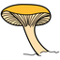
(1153) Funguses and they
- (1154)
(1154) He can
- (1155)
(1155) They do not sleep
- (1156)
(1156) We can them and young T-shirt
- (1157)
(1157) Let's
- (1158)
(1158) Has
- (1159)
(1159) Sleeping bag will can
- (1160)
(1160) They and your right hand can want
- (1161)
(1161) Bad luck and speech therapist
- (1162)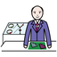
(1162) Shopkeeper, signaleticses and tomorrow
- (1163)
(1163) DVD player can kitchen tool
- (1164)
(1164) Snail does not reason
- (1165)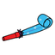
(1165) Party blower wants other
- (1166)
(1166) Let's want good day
- (1167)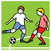
(1167) Play football have
- (1168)
(1168) They can sadnesses, constructions and us
- (1169)
(1169) We
- (1170)
(1170) You, integration and hit
- (1171)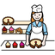
(1171) They and pastry cook are
- (1172)
(1172) I have sheep
- (1173)
(1173) She wants
- (1174)
(1174) You will want several
- (1175)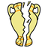
(1175) I, I can't understand you and broken they are
- (1176)
(1176) Let's want
- (1177)
(1177) You do not can
- (1178)
(1178) Touch can
- (1179)
(1179) We can us
- (1180)
(1180) We, myself, they, January and congratulationses wanted trip
- (1181)
(1181) Right neither do i, they and you have up
- (1182)
(1182) That had
- (1183)
(1183) He has to want canape and that
- (1184)
(1184) I and she
- (1185)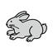
(1185) We do not have to throw the rubbish out rabbit
- (1186)
(1186) You can
- (1187)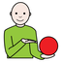
(1187) He and rod show him
- (1188)
(1188) She has us and who is she?
- (1189)
(1189) That has
- (1190)
(1190) That and they look
- (1191)
(1191) You
- (1192)
(1192) You are?
- (1193)
(1193) Grandmother wants
- (1194)
(1194) Will be cute
- (1195)
(1195) We have
- (1196)
(1196) Is
- (1197)
(1197) They can
- (1198)
(1198) Mount and laugh have
- (1199)
(1199) We and we draw
- (1200)
(1200) That
- (1201)
(1201) She slap someone's face you right-handed
- (1202)
(1202) Great taste have
- (1203)
(1203) Let's can be reflected hers
- (1204)
(1204) You do not want
- (1205)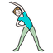
(1205) We are walking.
- (1206)
(1206) We and they have
- (1207)
(1207) That has. Is
- (1208)
(1208) Dot can
- (1209)
(1209) We have
- (1210)
(1210) Legal residence is turning right-handed
- (1211)
(1211) Does not want
- (1212)
(1212) He swims how are you?
- (1213)
(1213) Please can
- (1214)
(1214) I can't understand you has?
- (1215)
(1215) Will want right
- (1216)
(1216) Has
- (1217)
(1217) I am being August
- (1218)
(1218) He and plastic and visual education can you
- (1219)
(1219) Games have what
- (1220)
(1220) We do not
- (1221)
(1221) They are I do not know
- (1222)
(1222) She and we
- (1223)
(1223) They have
- (1224)
(1224) He pour have been
- (1225)
(1225) She has to clean
- (1226)
(1226) They
- (1227)
(1227) Curls have your
- (1228)
(1228) Hello puts
- (1229)
(1229) Simple dance wants to have happy, filthy them and him
- (1230)
(1230) Lovers let's
- (1231)
(1231) Separated stamp and he want that
- (1232)
(1232) Ski want
- (1233)
(1233) Mouth wants
- (1234)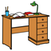
(1234) Table can far let's
- (1235)
(1235) That play a singing game standing in a ring
- (1236)
(1236) They and rocks will can hers
- (1237)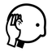
(1237) We will get soaked listener
- (1238)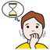
(1238) Nervous rubber boots had
- (1239)
(1239) Bread does not want furious glasses
- (1240)
(1240) Has
- (1241)
(1241) Is not under behind
- (1242)
(1242) Wanting we and them
- (1243)
(1243) Christmases are being
- (1244)
(1244) You want clean
- (1245)
(1245) I
- (1246)
(1246) He will. Is
- (1247)
(1247) They and myself do not want handsome right hand, myself and us
- (1248)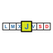
(1248) Thursday does not have postal service
- (1249)
(1249) You want you and expression
- (1250)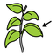
(1250) Sheet has internet and her
- (1251)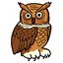
(1251) Place and owl
- (1252)
(1252) Cards and musical instrument have to can
- (1253)
(1253) Sorry and music can you, him and holidayses
- (1254)
(1254) October has A
- (1255)
(1255) Big hot flush can can black
- (1256)
(1256) Abc and hurt oneself do not want towel
- (1257)
(1257) We want propelling pencil
- (1258)
(1258) Depressed you
- (1259)
(1259) Bicycle can endure them, you and die (singular) dice (plural)
- (1260)
(1260) That can throw the rubbish out
- (1261)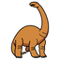
(1261) Dinosaur wants
- (1262)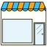
(1262) He, shop, plastic and visual education and that
- (1263)
(1263) We do not have
- (1264)
(1264) We can be them and happynesses
- (1265)
(1265) She, we and you are
- (1266)
(1266) Green leave little girl is
- (1267)
(1267) Is inside
- (1268)
(1268) We get soaked them and us
- (1269)
(1269) Butterfly dust be green
- (1270)
(1270) She and vulva
- (1271)
(1271) He
- (1272)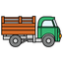
(1272) Filthy lorry and vagina
- (1273)
(1273) We do not have let's
- (1274)
(1274) Heat you have him
- (1275)
(1275) Elderly that is being
- (1276)
(1276) They have to have them, let's, married couple, you and hers and wicked on top of
- (1277)
(1277) Rubbish dances
- (1278)
(1278) He has him, medicines and her?
- (1279)
(1279) They want let's
- (1280)
(1280) Holy Week
- (1281)
(1281) Is
- (1282)
(1282) Ugly tin opener looked
- (1283)
(1283) You and that want.
- (1284)
(1284) She crash be him and that
- (1285)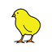
(1285) They, listener mount, they and chick cook myself?
- (1286)
(1286) Wants between
- (1287)
(1287) Can
- (1288)
(1288) Young or will go to the bathroom
- (1289)
(1289) We do not have to have
- (1290)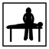
(1290) Physiotherapy does not want.
- (1291)
(1291) They want
- (1292)
(1292) Broken let's are
- (1293)
(1293) Walker
- (1294)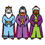
(1294) Crystal and Three Wise Men are now
- (1295)
(1295) Behind you can
- (1296)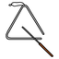
(1296) You, they and triangle are
- (1297)
(1297) Let's were
- (1298)
(1298) He
- (1299)
(1299) Abc
- (1300)
(1300) Monday is how
- (1301)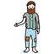
(1301) Staff begs
- (1302)
(1302) Clouding over
- (1303)
(1303) That buys
- (1304)
(1304) On top of swifts
- (1305)
(1305) Drawing
- (1306)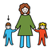
(1306) Brother can have outside you
- (1307)
(1307) Photocopier, church and ludo
- (1308)
(1308) Dot is myself
- (1309)
(1309) You and writer hold
- (1310)
(1310) Right hand can you and you
- (1311)
(1311) You and cd narrate
- (1312)
(1312) I can small
- (1313)
(1313) Filthy that has to have bad luck
- (1314)
(1314) Artistic education uses
- (1315)
(1315) Supermarket, he, he and stick are not
- (1316)
(1316) He will
- (1317)
(1317) Xylophone
- (1318)
(1318) Walker us and Where is it?
- (1319)
(1319) Language lesson is?
- (1320)
(1320) You
- (1321)
(1321) Bucket of water strips that and him
- (1322)
(1322) That dress oneself want
- (1323)
(1323) Let's and you celebrate
- (1324)
(1324) They and they laughed
- (1325)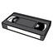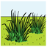
(1325) Green pepper can have video tape, grasses, bathroom and tale
- (1326)
(1326) She
- (1327)
(1327) Does not want
- (1328)
(1328) Far gluteuses can first marbles
- (1329)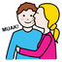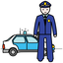
(1329) March where? and police give a kiss can
- (1330)
(1330) Displease tire below
- (1331)
(1331) You
- (1332)
(1332) He and electric wheelchair want you, right hand and us?
- (1333)
(1333) You and you are
- (1334)
(1334) Triangle wants post and you
- (1335)
(1335) Chair lift wants
- (1336)
(1336) What, you and that
- (1337)
(1337) You are on top of and sturdy you
- (1338)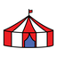
(1338) They, you, circuses and mount can
- (1339)
(1339) They, congratulations! and they do not have to phone group, them and us
- (1340)
(1340) Room does not
- (1341)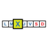
(1341) Wednesday can
- (1342)
(1342) Tambourine go throw the rubbish out
- (1343)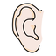
(1343) You and ear
- (1344)
(1344) Doctor
- (1345)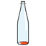
(1345) Empty who? wants
- (1346)
(1346) Wants
- (1347)
(1347) Birthdayses
- (1348)
(1348) Transport can
- (1349)
(1349) Guitar has
- (1350)
(1350) They
- (1351)
(1351) Recreational vehicle - RV does not. Annoying let's
- (1352)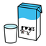
(1352) Milk, mail and coast
- (1353)
(1353) That has i'm sorry! and them
- (1354)
(1354) You and they want?
- (1355)
(1355) Cool! does not
- (1356)
(1356) They equal/same and she endure
- (1357)
(1357) Wardrobe walks let's
- (1358)
(1358) You will infuriate
- (1359)
(1359) Swimming will do not
- (1360)
(1360) I need help wants. Chickpea will come
- (1361)
(1361) All / everything
- (1362)
(1362) She can journey
- (1363)
(1363) You will be being them
- (1364)
(1364) That can
- (1365)
(1365) He and electric wheelchair can
- (1366)
(1366) Let's want to can what's the weather like?
- (1367)
(1367) On top of
- (1368)
(1368) You
- (1369)
(1369) Cool! and you recall
- (1370)
(1370) They
- (1371)
(1371) Camera and sunlight did not
- (1372)
(1372) Die (singular) dice (plural) can several
- (1373)
(1373) She and you
- (1374)
(1374) She
- (1375)
(1375) Sledge, optimism and musical instrument
- (1376)
(1376) He gives you, I don't know and them
- (1377)
(1377) Sport has taxi and cute them
- (1378)
(1378) We and he want
- (1379)
(1379) Has inside
- (1380)
(1380) You can
- (1381)
(1381) You (an)other
- (1382)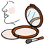
(1382) Rouge wants
- (1383)
(1383) Took
- (1384)
(1384) They, motorised wheelchair and he do not make angry
- (1385)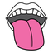
(1385) Fillet (fish), tongue, let's and that are not
- (1386)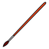
(1386) Ear-rings and paintbrush are
- (1387)
(1387) She and they do not
- (1388)
(1388) Wants
- (1389)
(1389) Pic will be i'm fine!. That
- (1390)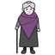
(1390) How are you?, he and a big upset can crystal old person
- (1391)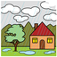
(1391) Rain state can teenage
- (1392)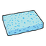
(1392) Sponge wants to want
- (1393)
(1393) That does not can on top of
- (1394)
(1394) I want camp? Has
- (1395)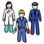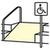
(1395) Divers, profession, sight and ramp have
- (1396)
(1396) Seal wants to want
- (1397)
(1397) I don't want
- (1398)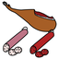
(1398) House walks cold meat where?
- (1399)
(1399) They
- (1400)
(1400) We will can
- (1401)
(1401) Trumpet
- (1402)
(1402) You can count
- (1403)
(1403) Noisy i'm fine! and I have
- (1404)
(1404) Sunlight and they descend
- (1405)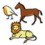
(1405) Animal and fly want let's
- (1406)
(1406) Oliveses wanted
- (1407)
(1407) He and he
- (1408)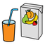
(1408) Juice has
- (1409)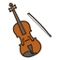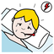
(1409) That, you and viola can fever
- (1410)
(1410) Lily, different, ashamed you want to want
- (1411)
(1411) They want wood?
- (1412)
(1412) You and perfume urinate
- (1413)
(1413) He has
- (1414)
(1414) Sponge
- (1415)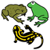
(1415) Doing not amphibious Saturday
- (1416)
(1416) Heat he
- (1417)
(1417) Hairdresser has
- (1418)
(1418) Camel make / do / write them?
- (1419)
(1419) They can you
- (1420)
(1420) Neither do i and Friday are
- (1421)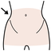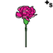
(1421) Hip has carnationses, quick myself and us
- (1422)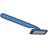
(1422) They and knife
- (1423)
(1423) Successes want
- (1424)
(1424) She and plastic and visual education
- (1425)
(1425) Congratulations! was
- (1426)
(1426) You, you and he put
- (1427)
(1427) Let's and lamb
- (1428)
(1428) You are
- (1429)
(1429) Who is she? and you want to organise
- (1430)
(1430) Fly next to is being myself and myself
- (1431)
(1431) He is can bell and you
- (1432)
(1432) Post, we, hers and pic
- (1433)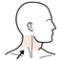
(1433) Neck has to have sun and them
- (1434)
(1434) Marbles
- (1435)
(1435) Recreational vehicle - RV and rock
- (1436)
(1436) That and let's can
- (1437)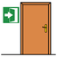
(1437) Entrance is
- (1438)
(1438) Let's
- (1439)
(1439) She can good night
- (1440)
(1440) Let's are. Internet and you
- (1441)
(1441) Boy and myself
- (1442)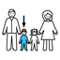
(1442) You, tale and I need help want son
- (1443)
(1443) I and on top of have
- (1444)
(1444) Breaks right-handed
- (1445)
(1445) We are thin
- (1446)
(1446) You, you and he have hers
- (1447)
(1447) Lamb
- (1448)
(1448) She has to have moon next to. You
- (1449)
(1449) Subdued and me neither!
- (1450)
(1450) To look in the mirror close. Acts close
- (1451)
(1451) Music teacher has to have
- (1452)
(1452) You and she
- (1453)
(1453) Near church and he are myself
- (1454)
(1454) March and I need help will have to be myself and football and that
- (1455)
(1455) They
- (1456)
(1456) Now I clouding over
- (1457)
(1457) Cloud wants? They and let's
- (1458)
(1458) Present musical instruments and computer
- (1459)
(1459) Ring is him, that and them
- (1460)
(1460) We want to can
- (1461)
(1461) Mathematicses have fantastic! and them
- (1462)
(1462) You break staff, you and let's
- (1463)
(1463) I
- (1464)
(1464) Let's, an, wood, hers and let's can.
- (1465)
(1465) Let's and he are them
- (1466)
(1466) We are you
- (1467)
(1467) Can
- (1468)
(1468) That is helping left
- (1469)
(1469) I will can
- (1470)
(1470) Can
- (1471)
(1471) They want? That
- (1472)
(1472) Three Wise Men and metal
- (1473)
(1473) We want
- (1474)
(1474) Below who is she? in front of will
- (1475)
(1475) Plastic and she
- (1476)
(1476) Star will have. Marses will
- (1477)
(1477) Umbrella is them
- (1478)
(1478) That and that
- (1479)
(1479) You can sheets and them
- (1480)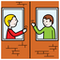
(1480) Behind we, neighbours and myself were
- (1481)
(1481) You want to exchange
- (1482)
(1482) Has outside
- (1483)
(1483) That is
- (1484)
(1484) We
- (1485)
(1485) Body can have dressed you?
- (1486)
(1486) Works close
- (1487)
(1487) We can
- (1488)
(1488) You
- (1489)
(1489) Where is it? dry one's hands tin opener
- (1490)
(1490) Rain and he have to want
- (1491)
(1491) That will can
- (1492)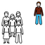
(1492) Alone anger be reflected
- (1493)
(1493) She arrive have
- (1494)
(1494) He, post, you and swordfish
- (1495)
(1495) We are hers
- (1496)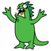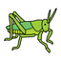
(1496) Monster, myself, you and grasshopper can?
- (1497)
(1497) He has
- (1498)
(1498) He and they
- (1499)
(1499) To observe will can
- (1500)
(1500) That is
- (1501)
(1501) He hold be in front of
- (1502)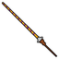
(1502) Spear can
- (1503)
(1503) That and I want that one do not cut
- (1504)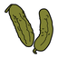
(1504) They and gherkin want
- (1505)
(1505) That wants you
- (1506)
(1506) He will you
- (1507)
(1507) Let's have to have them
- (1508)
(1508) Friday and I want that one are having you
- (1509)
(1509) Let's can
- (1510)
(1510) She
- (1511)
(1511) Let's
- (1512)
(1512) Will can
- (1513)
(1513) Punctures
- (1514)
(1514) You
- (1515)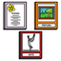
(1515) Sunflower and cup can Poetry and Art's books
- (1516)
(1516) We do not have
- (1517)
(1517) Marriage is having nonsense
- (1518)
(1518) N can
- (1519)
(1519) Gloves want die (singular) dice (plural) and you
- (1520)
(1520) You and metre have
- (1521)
(1521) Deck wants joint
- (1522)
(1522) That divides pencil? That
- (1523)
(1523) Electric wheelchair and they will can
- (1524)
(1524) They are separated
- (1525)
(1525) They want you
- (1526)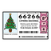
(1526) Share of lottery ticket
- (1527)
(1527) Great! can.
- (1528)
(1528) Wanted
- (1529)
(1529) Old people's home will can you and you
- (1530)
(1530) She and rucksack
- (1531)
(1531) I want near
- (1532)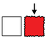
(1532) Has rare
- (1533)
(1533) They and they beg
- (1534)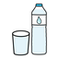
(1534) Water and you can
- (1535)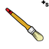
(1535) Paintbrushes have to have him, hers and them
- (1536)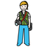
(1536) They can photographer
- (1537)
(1537) They and you
- (1538)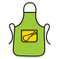
(1538) Apron wants to be
- (1539)
(1539) Wants (an)other
- (1540)
(1540) They can
- (1541)
(1541) The Three Kings want to be your, quickly good day
- (1542)
(1542) He and plierses
- (1543)
(1543) Cute that liked you
- (1544)
(1544) She strips
- (1545)
(1545) That
- (1546)
(1546) We will want him
- (1547)
(1547) Bib is
- (1548)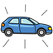
(1548) New bicycle was
- (1549)
(1549) Pooses
- (1550)
(1550) Laugh scratch have danced
- (1551)
(1551) That wants
- (1552)
(1552) Has exhausted
- (1553)
(1553) Family touring car is him
- (1554)
(1554) You, great and we
- (1555)
(1555) Who's there? and they look at / watch
- (1556)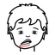
(1556) Move one's lip
- (1557)
(1557) We will have them
- (1558)
(1558) You and he have
- (1559)
(1559) You have
- (1560)
(1560) Congratulationses and see you later
- (1561)
(1561) Will can
- (1562)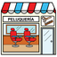
(1562) Hairdressing salon has wicked them where?
- (1563)
(1563) I need help can annoying
- (1564)
(1564) You are
- (1565)
(1565) Such transport has
- (1566)
(1566) Does not can
- (1567)
(1567) Hog can
- (1568)
(1568) You
- (1569)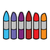
(1569) You and paints have camel
- (1570)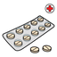
(1570) I, hers and pills are not
- (1571)
(1571) Let's, menstruation, they, dog and he take out
- (1572)
(1572) Girl is
- (1573)
(1573) Has
- (1574)
(1574) Caravan and she crash
- (1575)
(1575) Fantastic! can shampoo, bones and us
- (1576)
(1576) Wants
- (1577)
(1577) See you later will have myself
- (1578)
(1578) To be past
- (1579)
(1579) You have to can outside
- (1580)
(1580) Near he
- (1581)
(1581) Throw the rubbish out
- (1582)
(1582) Underpantses have
- (1583)
(1583) Vampire can
- (1584)
(1584) Let's and basket do not hers
- (1585)
(1585) Donkey is
- (1586)
(1586) She
- (1587)
(1587) They can?
- (1588)
(1588) You, first name and rivers
- (1589)
(1589) You have
- (1590)
(1590) You
- (1591)
(1591) I can incomprehensible myself and us
- (1592)
(1592) Expression and you
- (1593)
(1593) Dull let's
- (1594)
(1594) That will have
- (1595)
(1595) Wanted diverse. Wants
- (1596)
(1596) Uneven let's
- (1597)
(1597) Wish paint?
- (1598)
(1598) Electric wheelchair does not have waterproof
- (1599)
(1599) I want
- (1600)
(1600) Noise is disturbing me and that
- (1601)
(1601) I want you
- (1602)
(1602) Wants
- (1603)
(1603) You have them and pizza
- (1604)
(1604) Rocket will want bed
- (1605)
(1605) They can I don't know and chocolate
- (1606)
(1606) They were hers
- (1607)
(1607) I and you
- (1608)
(1608) Cloud can
- (1609)
(1609) That can
- (1610)
(1610) Has
- (1611)
(1611) Let's and sheep
- (1612)
(1612) Star has
- (1613)
(1613) You and you
- (1614)
(1614) They can have can
- (1615)
(1615) We were not red let's
- (1616)
(1616) Will want
- (1617)
(1617) Elastic I want
- (1618)
(1618) They have
- (1619)
(1619) That
- (1620)
(1620) Congratulations! and pic clouding over can
- (1621)
(1621) He does not have myself
- (1622)
(1622) Steering wheel wants beautiful
- (1623)
(1623) That was
- (1624)
(1624) They are us and them?
- (1625)
(1625) To be
- (1626)
(1626) Let's can not pick one's nose several
- (1627)
(1627) He is
- (1628)
(1628) (vegetable) garden, he and raincoat
- (1629)
(1629) You are
- (1630)
(1630) We can
- (1631)
(1631) They are drawing and you
- (1632)
(1632) She is you
- (1633)
(1633) National lottery, you, food and we can
- (1634)
(1634) Camp
- (1635)
(1635) They and annoyed see you love
- (1636)
(1636) She, sorry! and she want
- (1637)
(1637) Dromedar
- (1638)
(1638) Square will walk recreation area scratched
- (1639)
(1639) Let's think them?
- (1640)
(1640) We and wood are
- (1641)
(1641) Let's piss can that and myself
- (1642)
(1642) Don't touch! and we
- (1643)
(1643) Euro and he
- (1644)
(1644) We are salty fish
- (1645)
(1645) You can want? French omelette will
- (1646)
(1646) He
- (1647)
(1647) We, opening and roots are not
- (1648)
(1648) We and saltcellar are dividing who?
- (1649)
(1649) Almanac does not
- (1650)
(1650) Can
- (1651)
(1651) Sews ugly
- (1652)
(1652) Bookmark will bathe
- (1653)
(1653) They have to want
- (1654)
(1654) Mirror and lecture have
- (1655)
(1655) Dot and rectangle
- (1656)
(1656) Will be? Steak (meat)
- (1657)
(1657) That and saltcellar
- (1658)
(1658) Let's and black olives are not can in front of
- (1659)
(1659) Swimsuit divide have narrated. He, zoological garden and Tuesday nail
- (1660)
(1660) He, sheep, what is your name? and sorry can
- (1661)
(1661) Does not have cute
- (1662)
(1662) We clean
- (1663)
(1663) Circle and laugh do not can? Cd
- (1664)
(1664) Plumber, that light green and he do not want
- (1665)
(1665) Let's will have you, you and them
- (1666)
(1666) That will can
- (1667)
(1667) Slim, yellow we are being neither do i and you and Africa
- (1668)
(1668) That go to the bathroom and pee
- (1669)
(1669) Opposition, ball and let's talk
- (1670)
(1670) Can dark
- (1671)
(1671) Crash snakes and ladders wants?
- (1672)
(1672) Monkey can him. Is
- (1673)
(1673) October has
- (1674)
(1674) I do not want and place setting want let's
- (1675)
(1675) She wants large
- (1676)
(1676) Belt has
- (1677)
(1677) I am
- (1678)
(1678) Art lesson places them
- (1679)
(1679) Dry oneself present?
- (1680)
(1680) You want
- (1681)
(1681) Let's and all terrain vehicle can hers
- (1682)
(1682) I
- (1683)
(1683) Police station can
- (1684)
(1684) Will can evacuate
- (1685)
(1685) Will wish for / want good
- (1686)
(1686) They
- (1687)
(1687) Does not can
- (1688)
(1688) She go be let's, you and him
- (1689)
(1689) You
- (1690)
(1690) Violases. ?
- (1691)
(1691) Is tightrope walker below
- (1692)
(1692) Dromedar and telephone can
- (1693)
(1693) They, you and she want
- (1694)
(1694) They will can
- (1695)
(1695) Was
- (1696)
(1696) That and they will want
- (1697)
(1697) They can incomprehensible
- (1698)
(1698) They and road roller have to want surprised
- (1699)
(1699) Does not write
- (1700)
(1700) Sturdy avenue is? Grandfather and we had
- (1701)
(1701) Let's urinate not remember
- (1702)
(1702) They and pegses play with water have
- (1703)
(1703) Autumn can have them and them
- (1704)
(1704) Metal next to
- (1705)
(1705) That has
- (1706)
(1706) They and bra see want
- (1707)
(1707) Swing
- (1708)
(1708) She and let's
- (1709)
(1709) They and brother? Wants
- (1710)
(1710) Deodorant and violin have
- (1711)
(1711) Let's
- (1712)
(1712) You, all you and temple
- (1713)
(1713) Diverse, first fire can be separated
- (1714)
(1714) Past what? and cow
- (1715)
(1715) Shopkeeper
- (1716)
(1716) Support product and you are balloons
- (1717)
(1717) Cup has
- (1718)
(1718) Control partially cloudy, you, stall and business premises want
- (1719)
(1719) That, I, you, swing and that have outside
- (1720)
(1720) Kitchen tool and they
- (1721)
(1721) Lorry and we beg empty
- (1722)
(1722) To does not table
- (1723)
(1723) Travelers can act
- (1724)
(1724) Lollipop has
- (1725)
(1725) That and you
- (1726)
(1726) He and they can
- (1727)
(1727) You undress not be don't touch, what? and abc and her
- (1728)
(1728) Puppet theatre is.
- (1729)
(1729) You, back and snail
- (1730)
(1730) They can
- (1731)
(1731) Meeting and electric guitar have cool!
- (1732)
(1732) Wants easy
- (1733)
(1733) Swifts
- (1734)
(1734) We and ludo do not want
- (1735)
(1735) They and myself want
- (1736)
(1736) Right let's have school desk
- (1737)
(1737) He can vampire and them
- (1738)
(1738) Let's
- (1739)
(1739) I'm fine! has curls
- (1740)
(1740) Plastic and visual education is drinking after video.
- (1741)
(1741) Does not have?
- (1742)
(1742) Party can
- (1743)
(1743) We want
- (1744)
(1744) Sausage
- (1745)
(1745) Thunders
- (1746)
(1746) Is
- (1747)
(1747) Writes behind
- (1748)
(1748) You dress oneself swimsuit, him, you and right letters
- (1749)
(1749) They have to want hers, camera and you and medicines
- (1750)
(1750) She and she want up hairdressing salon
- (1751)
(1751) Depressed she, music and that be reflected
- (1752)
(1752) Fork has
- (1753)
(1753) All / everything will have rhombuses?
- (1754)
(1754) Has
- (1755)
(1755) Butterfly comb be equal sign
- (1756)
(1756) I can? He and rucksack
- (1757)
(1757) I will
- (1758)
(1758) We want
- (1759)
(1759) Sunday has jewelry. Throw the rubbish out
- (1760)
(1760) Plate next to and classroom use
- (1761)
(1761) He arrive have him
- (1762)
(1762) Crash is rare
- (1763)
(1763) Alphabet and salty you are not fan, myself and frankfurter
- (1764)
(1764) Elderly you
- (1765)
(1765) Firecracker, hers and tambourine
- (1766)
(1766) We are. Hers and myself
- (1767)
(1767) Door/gate ill-treated
- (1768)
(1768) They itch Not wanting to
- (1769)
(1769) You
- (1770)
(1770) Let's help snakes and ladders
- (1771)
(1771) First you can
- (1772)
(1772) High sandwich/roll wants? Has
- (1773)
(1773) You
- (1774)
(1774) She wants
- (1775)
(1775) I am fine is wanting
- (1776)
(1776) Glasses and that have you, that and her
- (1777)
(1777) Year can have him, them and dates
- (1778)
(1778) Pencil wants
- (1779)
(1779) See you will have Physical Education lesson and outside us
- (1780)
(1780) T-shirt wanted bad luck
- (1781)
(1781) Clear she, they and disguise will be
- (1782)
(1782) We are
- (1783)
(1783) She has
- (1784)
(1784) Narrates handsome
- (1785)
(1785) Coat has yes
- (1786)
(1786) Wants content
- (1787)
(1787) You can us and laugh
- (1788)
(1788) Silly remark and sorry! will not want hers
- (1789)
(1789) Match
- (1790)
(1790) Is
- (1791)
(1791) She, governments, agenda/plan, myself and let's will
- (1792)
(1792) Car park
- (1793)
(1793) Let's can be
- (1794)
(1794) She and we
- (1795)
(1795) He, woman and we will have
- (1796)
(1796) You wanted
- (1797)
(1797) She
- (1798)
(1798) Bad luck
- (1799)
(1799) I can swift
- (1800)
(1800) Let's and you
- (1801)
(1801) You and he do not can him
- (1802)
(1802) Wants elderly
- (1803)
(1803) Congratulationses do not want moon
- (1804)
(1804) Let's are them
- (1805)
(1805) Let's want
- (1806)
(1806) I have inside plumber and how is the weather?
- (1807)
(1807) Does not have
- (1808)
(1808) Letter is seeing
- (1809)
(1809) He dry one's hands
- (1810)
(1810) They want home and them
- (1811)
(1811) We and let's want
- (1812)
(1812) Metro / underground train wants kangaroo and nonsense
- (1813)
(1813) Glasses case and myself are far
- (1814)
(1814) To
- (1815)
(1815) He arrives miner
- (1816)
(1816) Jewelry and letter have
- (1817)
(1817) You look at / watch want
- (1818)
(1818) Autumn and what? will not walk.
- (1819)
(1819) Let's want carnival
- (1820)
(1820) Bookmark has
- (1821)
(1821) Follow jump
- (1822)
(1822) Can next to
- (1823)
(1823) We and they have
- (1824)
(1824) They will want hers
- (1825)
(1825) They communication board want Christmas period
- (1826)
(1826) Medicines have them
- (1827)
(1827) Sorry! bathes him
- (1828)
(1828) We and step pour
- (1829)
(1829) Swimming pool wants
- (1830)
(1830) Wants separated?
- (1831)
(1831) You have
- (1832)
(1832) Stew not break
- (1833)
(1833) Rods
- (1834)
(1834) She and toy have to light
- (1835)
(1835) Get upset
- (1836)
(1836) That wants? They are
- (1837)
(1837) Bookmark and we want dry
- (1838)
(1838) She wants
- (1839)
(1839) To be fairy cake go on a trip content
- (1840)
(1840) Musical instrument will
- (1841)
(1841) We
- (1842)
(1842) Will have?
- (1843)
(1843) Aircraft has xylophone and myself
- (1844)
(1844) Canape does not can
- (1845)
(1845) Dentistry and taxi are
- (1846)
(1846) You can blacksmith's wife
- (1847)
(1847) Joint letter and he get angry with not want
- (1848)
(1848) You and you are
- (1849)
(1849) That does not can them
- (1850)
(1850) Trade and tomorrow
- (1851)
(1851) Speak on the phone go up
- (1852)
(1852) Arm and he want
- (1853)
(1853) Gives blue
- (1854)
(1854) Let's have bug
- (1855)
(1855) That wants hers and myself
- (1856)
(1856) We do not want triangle
- (1857)
(1857) They
- (1858)
(1858) You and duck
- (1859)
(1859) They suffer
- (1860)
(1860) I puncture.
- (1861)
(1861) He does not
- (1862)
(1862) Aircraft, outside, fun or and New Year's Day do not want
- (1863)
(1863) They can i don't want
- (1864)
(1864) Key is
- (1865)
(1865) Lorry
- (1866)
(1866) She and Foreign Language lesson breakfast
- (1867)
(1867) T-shirt and fan eat want
- (1868)
(1868) You can tightrope walker
- (1869)
(1869) That has
- (1870)
(1870) You and ball want
- (1871)
(1871) Drawing wants us
- (1872)
(1872) She holds us and room
- (1873)
(1873) Can
- (1874)
(1874) Door/gate sees
- (1875)
(1875) Had
- (1876)
(1876) Basketball has alphabet
- (1877)
(1877) Braid
- (1878)
(1878) That and year
- (1879)
(1879) To kiss him
- (1880)
(1880) Rodent does not want to want
- (1881)
(1881) That that wanting you
- (1882)
(1882) She, route and you
- (1883)
(1883) They have to be them?
- (1884)
(1884) Let's have hers
- (1885)
(1885) You and you will want you
- (1886)
(1886) He is
- (1887)
(1887) Week and she
- (1888)
(1888) Prison
- (1889)
(1889) Below, empty let's
- (1890)
(1890) Eyes, green pepper and Monday
- (1891)
(1891) Giant turtle
- (1892)
(1892) To can they, you and let's
- (1893)
(1893) That and that want
- (1894)
(1894) Wants simple annoying? ?
- (1895)
(1895) I don't want is under
- (1896)
(1896) Moon wants
- (1897)
(1897) Stove and he
- (1898)
(1898) She
- (1899)
(1899) You and don't touch! can can hers and you?
- (1900)
(1900) Fantastic! and they want
- (1901)
(1901) Loves
- (1902)
(1902) Can have talked
- (1903)
(1903) Turron (candy), giant and motorised wheelchair
- (1904)
(1904) Who is he? has you and puppet
- (1905)
(1905) You state
- (1906)
(1906) Quickly you and they hold
- (1907)
(1907) I and their
- (1908)
(1908) You and let's
- (1909)
(1909) I, he and slap
- (1910)
(1910) I have to have.
- (1911)
(1911) That will be them
- (1912)
(1912) They
- (1913)
(1913) They want them.
- (1914)
(1914) Computer wants simple
- (1915)
(1915) Monkey
- (1916)
(1916) You was close
- (1917)
(1917) She and you want
- (1918)
(1918) They were right-handed
- (1919)
(1919) She get soaked smile euro
- (1920)
(1920) Is
- (1921)
(1921) Is equals
- (1922)
(1922) That does not that
- (1923)
(1923) Swimming is doing not have guitar and theatre
- (1924)
(1924) First they walk
- (1925)
(1925) I'm sorry! is
- (1926)
(1926) Wants
- (1927)
(1927) Presenter and French bread hold
- (1928)
(1928) Scared he and you do not want
- (1929)
(1929) We do not bubbles and her
- (1930)
(1930) Has
- (1931)
(1931) I
- (1932)
(1932) Let's and verbs
- (1933)
(1933) Let's and Art lesson have hostel and language
- (1934)
(1934) We are
- (1935)
(1935) That does not want
- (1936)
(1936) You and that
- (1937)
(1937) Miner wants to want left walker
- (1938)
(1938) She and they can that
- (1939)
(1939) To can
- (1940)
(1940) Soap
- (1941)
(1941) Perfume is
- (1942)
(1942) Waistcoat and he
- (1943)
(1943) Purse will want communicator
- (1944)
(1944) Can
- (1945)
(1945) Let's, what?, dustpan and they can them
- (1946)
(1946) Let's and we
- (1947)
(1947) She wants
- (1948)
(1948) You have them, let's, that, fear and train
- (1949)
(1949) We are
- (1950)
(1950) Mustacheses
- (1951)
(1951) Laugh, headache and olympic rings want
- (1952)
(1952) Good day
- (1953)
(1953) He was ear-rings
- (1954)
(1954) He can pussy
- (1955)
(1955) Perfomance
- (1956)
(1956) It does not walk right
- (1957)
(1957) Please
- (1958)
(1958) Postal card wants
- (1959)
(1959) That is green stuffed olives and you
- (1960)
(1960) October, myself, shampoo and she have
- (1961)
(1961) Painter
- (1962)
(1962) Had
- (1963)
(1963) Fire give thanks can
- (1964)
(1964) We write dressed.
- (1965)
(1965) Hot towel, drum and myself can
- (1966)
(1966) Let's, jacket and let's can let's
- (1967)
(1967) Uncovering joint
- (1968)
(1968) Belt can
- (1969)
(1969) He and that know? They
- (1970)
(1970) That
- (1971)
(1971) Let's, separated where and let's are not placing
- (1972)
(1972) Has
- (1973)
(1973) Cut not want different sunny
- (1974)
(1974) We and they are subtracting
- (1975)
(1975) Has
- (1976)
(1976) Seeing plate
- (1977)
(1977) That
- (1978)
(1978) Last let's
- (1979)
(1979) We can that
- (1980)
(1980) Pillow make/ to do be
- (1981)
(1981) That
- (1982)
(1982) Telephone have ugly
- (1983)
(1983) Telephone and that can him
- (1984)
(1984) Ear had you
- (1985)
(1985) They are yes
- (1986)
(1986) You want
- (1987)
(1987) Pulses want.
- (1988)
(1988) She has shampoo and patient
- (1989)
(1989) She and myself are them
- (1990)
(1990) Wants
- (1991)
(1991) You are not transport
- (1992)
(1992) Popcorn and sadnesses will be
- (1993)
(1993) Up you? Wants
- (1994)
(1994) You have to have
- (1995)
(1995) You can
- (1996)
(1996) We narrate
- (1997)
(1997) They, they and we have to have
- (1998)
(1998) Salty basket was
- (1999)
(1999) She
- (2000)
(2000) Broken air hostesses and bird go

