- (5)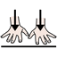
(5) I am behind
- (6)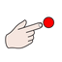
(6) That staff
- (7)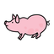
(7) You are a pig
- (8)
(8) So do I
- (9)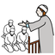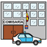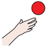
(9) The imam wants to take you to the police station later
- (10)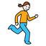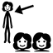
(10) Does she run to the rhombuses for bubbles?
- (11)
(11) It is not
- (12)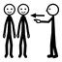
(12) This is your bib
- (13)
(13) Wheelbarrows
- (14)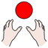
(14) I couldn't
- (15)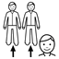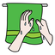
(15) They and you, who I don't know the name, dry glasses, and that keyboard
- (16)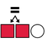
(16) It can be the same
- (17)
(17) Close your thing
- (18)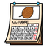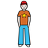
(18) October belongs to that teenager
- (19)
(19) They have them and us
- (20)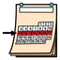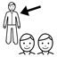
(20) Let's have him this week
- (21)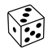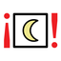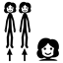
(21) It is time for the dice to say good night. They will wait
- (22)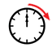
(22) Your sausages will have
- (23)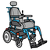
(23) He and the woman use a motorised wheelchair
- (24)
(24) You can use a bra this afternoon
- (25)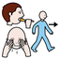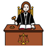
(25) Let's do not judge
- (26)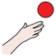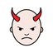
(26) She wants to do bad painting
- (27)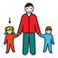
(27) They have a sister
- (28)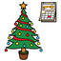
(28) Christmas Day has it
- (29)
(29) They have theirs
- (30)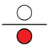
(30) Let's do some reading under the lamp
- (31)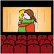
(31) I want to go to the cinema
- (32)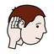
(32) You do not listen to wristband in the spring
- (33)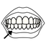
(33) He can use dentures
- (35)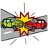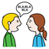
(35) They crashed and want to talk in a foreign language
- (36)
(36) You
- (37)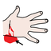
(37) Blood
- (38)
(38) To have
- (39)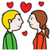
(39) Great! And he is in love
- (40)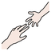
(40) I have and will not help others to have
- (41)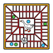
(41) Is snakes and ladders? They have their period
- (42)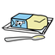
(42) They have lard
- (43)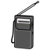
(43) Have to work on the portable radio
- (44)
(44) You are really being
- (45)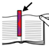
(45) The bookmark is wanted
- (46)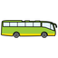
(46) Have maracas and buses. And that.
- (47)
(47) They cannot do
- (48)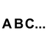
(48) You have the alphabet
- (49)
(49) Let's will have it
- (50)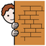
(50) That hides
- (51)
(51) I didn't want to do it
- (52)
(52) Is
- (53)
(53) He
- (54)
(54) Me and her could have the box before
- (55)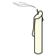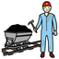
(55) If they calm down, you all and them can go with you to see the miner
- (56)
(56) You on Tuesday
- (57)
(57) He can wink at her
- (58)
(58) They have her bib
- (59)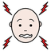
(59) She wants it. She hurts herself and wants to classify
- (60)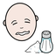
(60) They, he and he can be salty
- (61)
(61) They are and they want that city
- (62)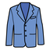
(62) Theirs and ours clothing
- (63)
(63) They
- (64)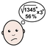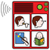
(64) Let's use the communicator as we want to say complicated things
- (65)
(65) Let's be with the boy
- (66)
(66) Their cap
- (67)
(67) I want to get soaked
- (68)
(68) Let's grip the canteen
- (69)
(69) Can
- (70)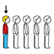
(70) The last radio is on fire
- (71
(71) We, you all, the little girl, they and she are wanted
- (72)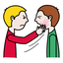
(72) Cool! Slap their face
- (73)
(73) Let's us do it
- (74)
(74) You all
- (75)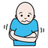
(75) We will get cold
- (76)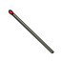
(76) Their match is something I cannot understand
- (77)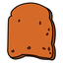
(77) They can have your toast
- (78)
(78) Has it for me
- (79)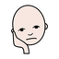
(79) I want to be bored
- (80)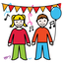
(80) Entertains
- (81)
(81) That will be
- (82)
(82) It takes the device
- (83)
(83) His collapse is yours to have
- (84)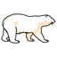
(84) I am fine with the polar bear in the dining-room
- (85)
(85) You in the hostel
- (86)
(86) We let it happen
- (87)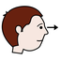
(87) You observing
- (88)
(88) Their teeth
- (89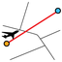
(89) I don't know, he does not want to do our itinerary
- (90)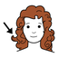
(90) They, their nonsense curls, and a match
- (91)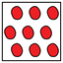
(91) Let's not put everything in the motorised wheelchair
- (92)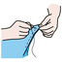
(92) Can sew lego blocks
- (93)
(93) They
- (94)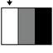
(94) Let's make that more clear
- (95)
(95) On Friday, they can show you my olympic swimsuit
- (96)
(96) You do not have yours
- (97)
(97) Let's
- (98)
(98) She had the same firecrackers as we had
- (99)
(99) That does not?
- (100)
(100) Has
- (101)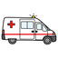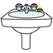
(101) The washbasin in the ambulance is hers
- (102)
(102) They did not have them
- (103)
(103) Congratulations! It was
- (104)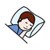
(104) While sleeping, there is nonsense inside
- (105)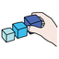
(105) Congratulations! For organising
- (106)
(106) Can touch it
- (107)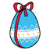
(107) Her chocolate egg
- (108)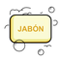
(108) Your hand soap
- (109)
(109) You are
- (110)
(110) I
- (111)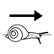
(111) Do not grip slowly
- (113)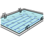
(113) You can go to the swimming pool
- (114)
(114) Caravan
- (115)
(115) I want to celebrate New Year with you
- (116)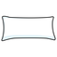
(116) That pillow is wanted
- (117)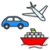
(117) Construction, cake and vehicles
- (118)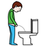
(118) They need to pee the same as you
- (119)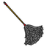
(119) you are dusting their children's book
- (120)
(120) We
- (121)
(121) Will not can
- (122)
(122) I'm fine! Let's turn the march and touch
- (123)
(123) Was
- (124)
(124) Is
- (125)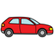
(125) They paint outside the vehicle
- (126)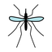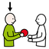
(126) The month gives them a lot of mosquitoes
- (127)
(127) It can have his ring
- (128)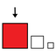
(128) You want it large
- (129)
(129) We and you
- (130)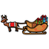
(130) Sledge
- (131)
(131) We can go to the dining room
- (132)
(132) Green olives
- (133)
(133) She
- (134)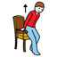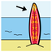
(134) The surfboard stands up
- (135)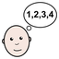
(135) She has an easy time with the verbs in the radio
- (136)
(136) They are between that
- (137)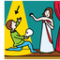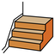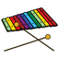
(137) You act nonsense for us with steps, bread and the xylophone
- (138)
(138) You and they are calm
- (139)
(139) He wanted it empty
- (140)
(140) That wants
- (141)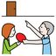
(141) The order was wanted
- (142)
(142) I cannot do that
- (143)
(143) Let's be with you, the girl and them
- (144)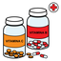
(144) She has vitamins
- (145)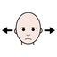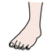
(145) The foot is not allowed
- (146)
(146) Their smoke
- (147)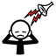
(147) They, they, and they are close and the noise is disturbing me
- (148)
(148) That far
- (149)
(149) There are art lessons
- (150)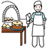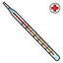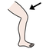
(150) The thermometer in the patisserie can have it in the leg
- (151)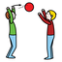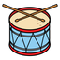
(151) He comes to play drums
- (152)
(152) I will have you and us
- (153)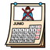
(153) She in June
- (154)
(154) Let's be
- (155)
(155) It is not cute
- (156)
(156) His smooth skirt
- (157)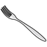
(157) The fork is unpleasant
- (158)
(158) That perfomance has not to be
- (159)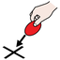
(159) Let's go to the place
- (160)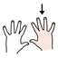
(160) Get the right-hand soaked
- (161)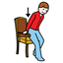
(161) The torch sits
- (162)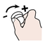
(162) Their fair stands will increase the steak
- (163)
(163) The engineer loves the hole punch tool
- (164)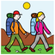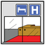
(164) Does she follow the sunflower? To their hotel
- (165)
(165) Congratulations!
- (166)
(166) I will
- (167)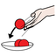
(167) Let's throw a celebration
- (168)
(168) My cent
- (169)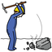
(169) This is what to hit
- (170)
(170) She could go to the church
- (171)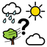
(171) What's the weather like? The strong wins
- (172)
(172) She is with something
- (173)
(173) Can grandfather and my right hand do it? The puzzle
- (174)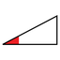
(174) Few are wanted
- (175)
(175) Blocks and wheelchair
- (176)
(176) You all have
- (177)
(177) We have plasticine
- (178)
(178) They had
- (179)
(179) Shirt
- (180)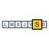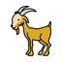
(180) On Saturday, that goat will be mine
- (181)
(181) That is ours
- (182)
(182) You all will be
- (183)
(183) The glass could have been
- (184)
(184) She will not have
- (185)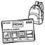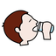
(185) We will have to do homework
- (186)
(186) Get soaked
- (187)
(187) They do not
- (188)
(188) Had black russian salad
- (189)
(189) Was the same mouth
- (190)
(190) We
- (191)
(191) They are
- (192)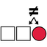
(192) They cannot duster the different steps
- (193)
(193) There is a sister
- (194)
(194) That belongs to them and her
- (195)
(195) The thin person is cleaning
- (196)
(196) It is the same
- (197)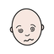
(197) Will feel sick
- (198)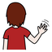
(198) I want them to break up
- (199)
(199) They, you and I want to know the climate
- (201)
(201) He
- (202)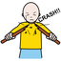
(202) You break thins with your right-hand
- (203)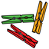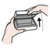
(203) Later open below for the pegs
- (204)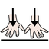
(204) The boy wants to be
- (205)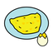
(205) Good afternoon with a french omelette
- (206)
(206) We are four right now
- (207)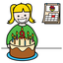
(207) Their birthday has to be
- (208)
(208) Money
- (209)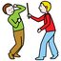
(209) Can not assault
- (210)
(210) Where are you all?
- (211)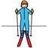
(211) Sorry! There is a skier
- (212)
(212) He does want
- (213)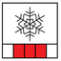
(213) She thinks this is not the season for Russian salad
- (214)
(214) Let us all be
- (215)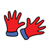
(215) Gloves
- (216)
(216) There is toast
- (217)
(217) The post is not mine
- (218)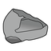
(218) Stone will not do
- (219)
(219) Is
- (220)
(220) Let's divide that fun activity
- (221)
(221) Won't have bubbles
- (222)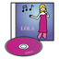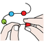
(222) I put together the CDs
- (223)
(223) We do not want
- (224)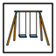
(224) The playground has it
- (225)
(225) I want that ring separated from the usb flash drive
- (226
(226) Let's him do it
- (227)
(227) Let it be cake
- (228)
(228) Let's be with them
- (229)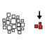
(229) Without me
- (230)
(230) Had
- (231)
(231) Under the front of the mouth
- (232)
(232) They and they can be with me
- (233)
(233) I am
- (234)
(234) This is the bucket
- (235)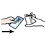
(235) She purchases white bread, a raincoat and a bag
- (236)
(236) Tortoise
- (237)
(237) I want to let myself be
- (238)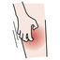
(238) The boy gives you and me that itch
- (239)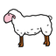
(239) Does not the sheep do it? It won't
- (240)
(240) We cannot do it
- (241)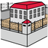
(241) Them, them and them are wanted in prison
- (242)
(242) She
- (243)
(243) Let's have a large one
- (245)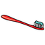
(245) We can have that tooth brush, it is hers and mine. Mine
- (247)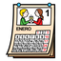
(247) It can happen in January
- (248)
(248) She wants the computer
- (249)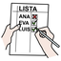
(249) Will he and I make a checklist in peace?
- (250)
(250) Fantastic! Let's remember it
- (251)
(251) It could be sturdy
- (252)
(252) They want to smile
- (253)
(253) Is he ashamed to refuse sunlight? That could be it
- (254)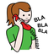
(254) Let's call them on that telephone
- (255)
(255) Near he and she
- (256)
(256) It is diverse
- (257)
(257) He wants to be annoying
- (258)
(258) Let's go to your grove
- (259)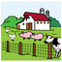
(259) Will play farm puppets
- (260)
(260) Can have some nonsense
- (261)
(261) Let's be on top, do not touch them
- (262)
(262) The nurse loves me
- (263)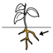
(263) Their roots can have underwear
- (264)
(264) You and they do not have dentures
- (265)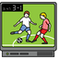
(265) Can play games
- (266)
(266) I am
- (267
(267) The crystal is not wanted
- (268)
(268) They can be on a circle
- (269)
(269) New Year's Day
- (270)
(270) I couldn't be at the classroom but I wanted
- (271)
(271) She wants
- (272)
(272) They have them
- (273)
(273) She has
- (274)
(274) They have
- (275)
(275) He is
- (276)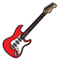
(276) There is an electric guitar
- (277
(277) I will want to be outside and under it
- (278)
(278) Good night! You open it
- (279)
(279) We do not want to be in adjacent buses
- (280)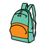
(280) Me and their backpack
- (281)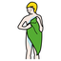
(281) They do not dry themselves. He does it
- (282)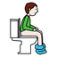
(282) When you go to the toilet, it gives you a headache
- (283)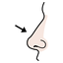
(283) Their nose
- (284)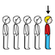
(284) We go first
- (285)
(285) Cent
- (286)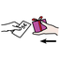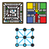
(286) I sell game equipment and drinks
- (287)
(287) You can be with her, with you and with him
- (288)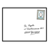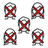
(288) I need help with mail, nobody can help her
- (289)
(289) They want a handsaw
- (290)
(290) Let's agree we cannot understand him
- (291)
(291) Let's have her ruler. The silver one
- (293)
(293) Does not have
- (294)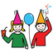
(294) Will be able to celebrate can?
- (295)
(295) We
- (296)
(296) Am I? We
- (297)
(297) I'm fine with that offer
- (298)
(298) We tried it before
- (299)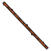
(299) They are that stick and a book
- (300)
(300) Those scissors will be celebrated
- (301)
(301) She wants you all to go to the bathroom
- (302)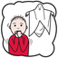
(302) Want to be let be afraid
- (303)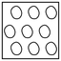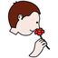
(303) No one smells the keys
- (304)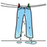
(304) We want ours wet for the meeting
- (305)
(305) You can put it in order
- (306)
(306) You and they are
- (307)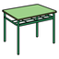
(307) I am with his school table and puppet
- (308)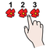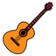
(308) She and smoke count guitar and you
- (309)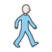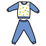
(309) They walk with the communicator in pyjamas
- (310)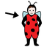
(310) Blocks are his disguise
- (311)
(311) You are happy
- (312)
(312) They
- (313)
(313) They have your pencil
- (314)
(314) They are that
- (315)
(315) Will still want to be unhappy
- (316)
(316) I want easy trade on that writing
- (317)
(317) You want to not act
- (318)
(318) Let's use the blackboard
- (319)
(319) Let's will be able to do it
- (320)
(320) The tortoise was wanted
- (321)
(321) Jacket will be needed
- (322)
(322) You and their photocopy machine
- (323)
(323) You all
- (324)
(324) You can be with you all
- (325
(325) She will want
- (326)
(326) Computer technicians do not have the alphabet
- (327)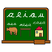
(327) Language
- (328)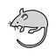
(328) The rodent has to be hers
- (329)
(329) You all
- (330)
(330) You all will be able to be with him
- (331)
(331) She
- (332)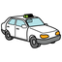
(332) She does not have a taxi
- (333)
(333) You cannot do
- (334)
(334) She can do
- (335)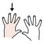
(335) At night, you want to use a mask on your left hand when in a vehicle
- (336)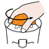
(336) That money comes after squeezing
- (337)
(337) He sells drinks
- (338)
(338) Was
- (339)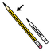
(339) The paper does not have to get soaked for long
- (340)
(340) You have a sofa
- (341)
(341) There is underwear
- (342)
(342) Gloves are wanted
- (343)
(343) They have a journey
- (344)
(344) Housing
- (345)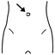
(345) He and she are wanting belly button
- (346)
(346) There are hoops
- (347)
(347) Her vehicle. You
- (348)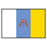
(348) Canary Islands are there
- (349)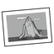
(349) That can be us. Photograph with that
- (350)
(350) Sadnesses before
- (351)
(351) You want it
- (352)
(352) Their musical instrument
- (353)
(353) Electricity can do it right now
- (354)
(354) They are not below
- (355)
(355) They are having their menstruation
- (356)
(356) He has cologne
- (357)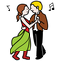
(357) See you at the dances
- (358)
(358) Let's get to that
- (359)
(359) You can take the ugly toys
- (360)
(360) The dots couldn't do it
- (361)
(361) That
- (362)
(362) What do I want
- (363)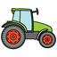
(363) Let's have the tractor
- (364)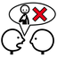
(364) They can have it but neither do i
- (365)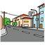
(365) That can be in the avenue
- (366)
(366) The incomprehensible napkin does not hit us, first is the little girl
- (367)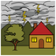
(367) You move to a safe place, there is lightning
- (368)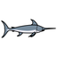
(368) His swordfish
- (369)
(369) He will have that
- (370)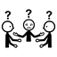
(370) We don't agree
- (371)
(371) Your door clouding over
- (372)
(372) We will
- (373)
(373) They want you all to make it purple
- (374)
(374) Fish and bucket
- (375)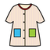
(375) They are dizzy in that coat
- (376)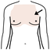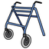
(376) The chest needs me and my walker
- (377)
(377) You and you all are
- (378)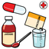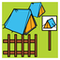
(378) You are with your treatment at the camping site
- (379)
(379) You all have
- (380)
(380) Near you
- (381))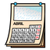
(381) They are wanted in April
- (382)
(382) Let's have it, we and you all
- (383)
(383) You all and he
- (384)
(384) Mother can have that tale
- (385)
(385) You can get him
- (386)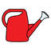
(386) Today the watering can is to be used
- (387)
(387) That and they
- (388)
(388) A spoon and the construction kit
- (389)
(389) Want to dress in green
- (390)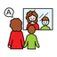
(390) The speech therapist and him can talk to a puppet
- (391)
(391) Will laugh
- (392)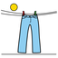
(392) Is dry
- (393)
(393) Ice-cream is to be had
- (395)
(395) Curls will
- (396)
(396) Want to take a taxi
- (397)
(397) Does not want to be beautiful
- (398)
(398) Our raincoat
- (399)
(399) You, and my kitchen utensil
- (400)
(400) The rod can do it
- (401)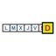
(401) On Sunday, it has it
- (402)
(402) He wants it
- (403)
(403) The cause will be wanted
- (404)
(404) Is
- (405)
(405) Let's not want it
- (406)
(406) You are not their heart shape
- (407)
(407) You can have her toothbrush, your and ours
- (408
(408) Will want
- (409)
(409) I do not know what to sell. Strong fire
- (410)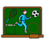
(410) Your and theirs physical education lesson have us
- (411)
(411) They have
- (412)
(412) They can play with blocks
- (413)
(413) Had in front of
- (414)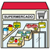
(414) That can be a market
- (415)
(415) Florist has it
- (416)
(416) She has a radio
- (417)
(417) We
- (418)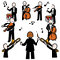
(418) There is an orchestra
- (419)
(419) The hostel wants his pepper
- (420)
(420) We are close reading
- (421)
(421) Is
- (422)
(422) In spring, he and he
- (423)
(423) Let's do not have
- (424)
(424) They want to have it
- (425)
(425) Did it could happen?
- (426)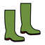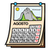
(426) In August, she does not have boots
- (427)
(427) The electric wheelchair is wanted
- (428)
(428) Did mother had a cupcake?
- (429)
(429) Vegetables
- (430)
(430) Me and her are optimists
- (431)
(431) Let's do it, you all and I
- (432)
(432) You clearly see is us
- (433)
(433) It was wanted
- (434)
(434) They can not paint that they feel sick
- (436)
(436) What time is it? Let's do it
- (437)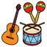
(437) How do you feel about that? Her musical instruments can play in spring
- (438)
(438) That has it
- (439)
(439) I don't know if You will be able to do it
- (440)
(440) Let's grab him
- (441)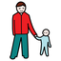
(441) Let's father get a few
- (442)
(442) The cardboard made you sick with that
- (443)
(443) Let's
- (444)
(444) Let's try to be
- (445)
(445) Let's get behind the camel?
- (446)
(446) Before we could write
- (447)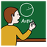
(447) Let's had grandmother explain it to him
- (448)
(448) There is that metal
- (449)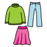
(449) I hide myself in the clothes
- (450)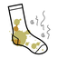
(450) It has stained you
- (451)
(451) The mouth want to have it
- (452)
(452) Tooth
- (453)
(453) Wind
- (454)
(454) We are annoyed
- (455)
(455) There will be an interpreter
- (456)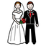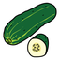
(456) They are a book, marriage and cucumbers
- (457)
(457) We and my striped self
- (458)
(458) I am next to those presidents
- (459)
(459) You
- (460)
(460) We will be with you all
- (461)
(461) Let's have it
- (462)
(462) I
- (463)
(463) A rod was with their sunflower
- (464)
(464) Is
- (465)
(465) Wants
- (466)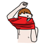
(466) Dress oneself right now
- (467)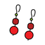
(467) Assaults for jewelry
- (468)
(468) Cannot do it
- (469)
(469) Good night! Can do it
- (470)
(470) We want to let them be
- (471)
(471) We are
- (472)
(472) She divided us into groups for drawing
- (473)
(473) I can get upset you with silly remarks that make them dry
- (474)
(474) That can be
- (475)
(475) You and them are in the hotel where you are staying
- (476)
(476) They are
- (477)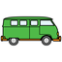
(477) We feel dizzy in the van, let's break something
- (478)
(478) Lovers at your door
- (479)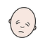
(479) She has exhaustation
- (480)
(480) Unpleasant lightning
- (481)
(481) You have a smooth chests of drawers
- (482)
(482) Has
- (483)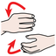
(483) You all and hin can make that
- (484)
(484) Let's try to sleep
- (485)
(485) That
- (486)
(486) They have it easy
- (488)
(488) Let's let them have him
- (489)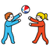
(489) She wants to have fun
- (490)
(490) There is a coat
- (491)
(491) Radio
- (492)
(492) Is the dice wanted by them or by us?
- (493)
(493) Your physical education class does not want us
- (494)
(494) Let's try to do it with you
- (495)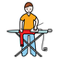
(495) Ironboard
- (496)
(496) Let's try to do it with him
- (497)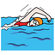
(497) The swimmer will have a sweet chat
- (498)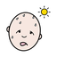
(498) That is hot
- (499)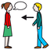
(499) It arrives for me left to you and them
- (500)
(500) The jewelry is other than hers
- (501)
(501) Let's
- (502)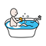
(502) Saltcellar bathes in the machine
- (504)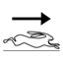
(504) A quick easy swimming is wanted
- (505)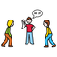
(505) Who stole the bacon?
- (506)
(506) Does not have a slim one
- (507)
(507) You all want to have her stained ones
- (508)
(508) Fantastic! You all want to be with her
- (509)
(509) Let's be looking at them over there
- (510)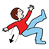
(510) We will until they fall into nonsense
- (511)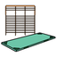
(511) Let's be in the airbed while their play musical instruments
- (512)
(512) That does not? Let's be with you all
- (513)
(513) You all have
- (514)
(514) Let's
- (515)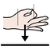
(515) Is
- (516)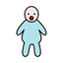
(516) She is dividing the people among them
- (517)
(517) We are that
- (518)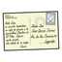
(518) We wanted to get that postal card before
- (519)
(519) Feel sick
- (520)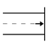
(520) Can be at the end
- (521)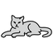
(521) The cat will write
- (522)
(522) They are them
- (523)
(523) Who? It can be
- (524)
(524) They want to be able to do it
- (525)
(525) Let's let her dry it
- (526)
(526) They poured it
- (527)
(527) He and he will want us salty
- (528)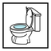
(528) Use the bathroom right now
- (529)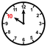
(529) At exactly ten o'clock, it will dust it to go on a trip
- (530)
(530) Do you see yourself?
- (531)
(531) He and you have it
- (532)
(532) They want to make me, it and him scared of that
- (533)
(533) You are
- (534)
(534) Is is not pretty when commerce is clouded over by fear?

