C:\Users\alice\AppData\Local\Microsoft\Windows\INetCache\Content.Word\Rating.png

**Price Recommend Location roommate waiting**

**2 roommate waiting**

**rating**

**£95/week**

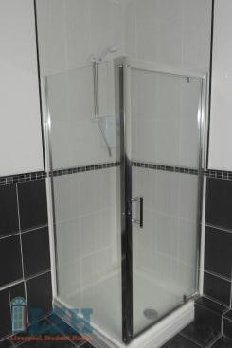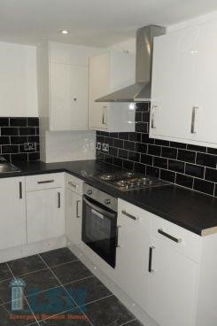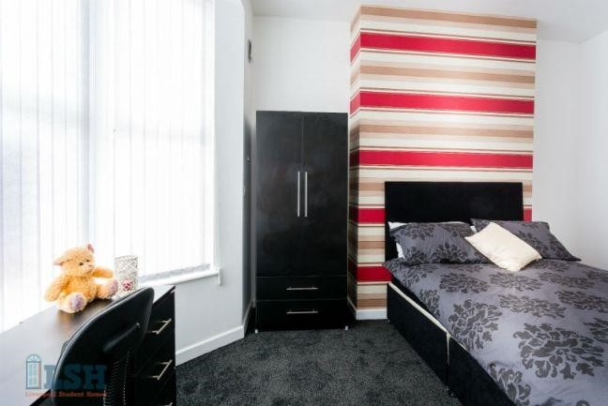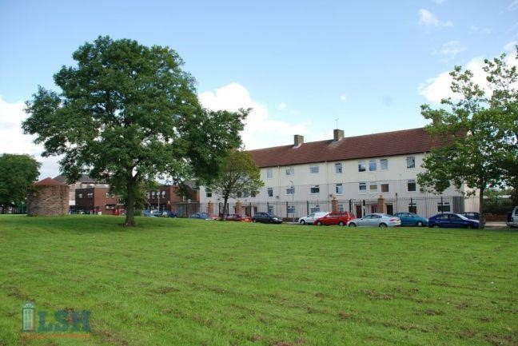

**1 roommate waiting**

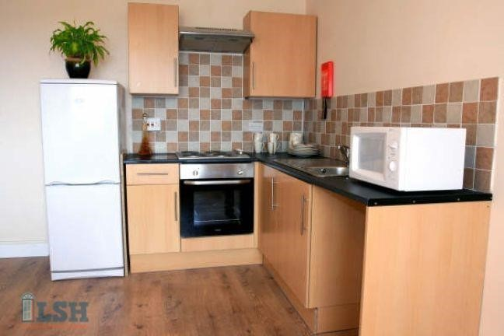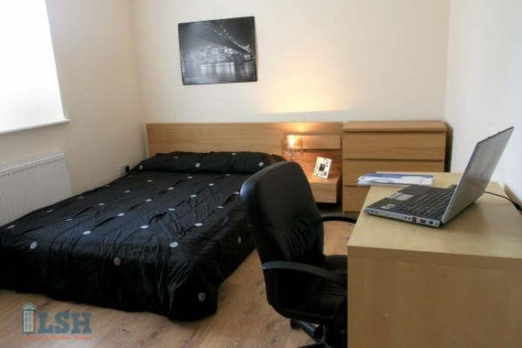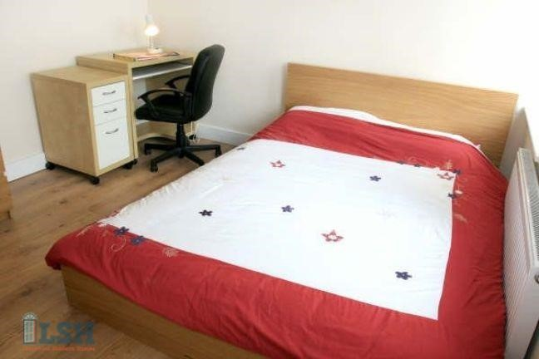

**rating**

**£95/week**

**Log in Sign up**

**Short term · Long term · Leisure**

**Chinese Student House**

One person Find roommate to rent: Sort based on No. of roommate waiting

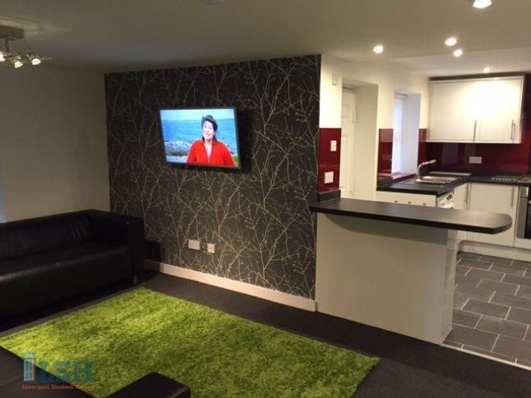

**£95/week**

C:\Users\alice\AppData\Local\Microsoft\Windows\INetCache\Content.Word\Rating.png

**Rating**

**3 roommate waiting**



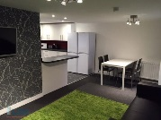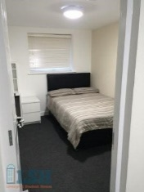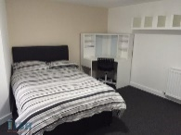



**Price Recommend Location roommate waiting**

**Log in Sign up**

**Short term · Long term · Leisure**

**Chinese Student House**



**Register your interest**

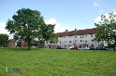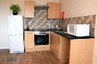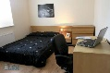

**Already Moved in**



Chat

Information

FEATURES

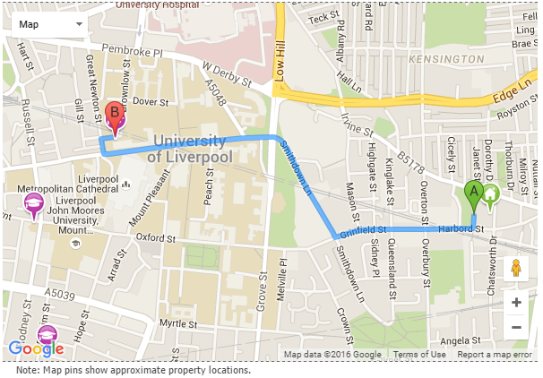

 Education background

C:\Users\alice\AppData\Local\Microsoft\Windows\INetCache\Content.Word\Rating.png Years of renting

C:\Users\alice\AppData\Local\Microsoft\Windows\INetCache\Content.Word\Rating.pngSafety

C:\Users\alice\AppData\Local\Microsoft\Windows\INetCache\Content.Word\Rating.pngDistance

C:\Users\alice\AppData\Local\Microsoft\Windows\INetCache\Content.Word\Rating.pngSpace

C:\Users\alice\AppData\Local\Microsoft\Windows\INetCache\Content.Word\Rating.pngMaintenance

Service

**Customer review**



It is a great place to live!

Personal information

Name Lisa

Gender Female

Study level Undergraduate

Course name International Business

Smoke No

Age 22

Hobby piano, swimming

**A group to Fine one roommate**

Swimming

20-25 years old

International Business

Chinese

Female



Linda

Jenifer