

**FACULTY OF COMPUTING**

**SECD2613**

**SYSTEM ANALYSIS & DESIGN**

**SECTION 02, 2023/2024**

**TOPIC:**

**PROJECT PHASE 2**

**LECTURER’S NAME: DR. MUHAMMAD ALIFF BIN AHMAD**

|  |  |  |
| --- | --- | --- |
| **BIL** | **GROUP MEMBERS** | **MATRIX NO** |
| 1 | MUHAMMAD ZAYYAD BIN BADRUL HISHAM | A23CS3015 |
| 2 | MUHAMMAD SHAHRUL IMAN BIN KAMAL | A23CS3013 |
| 3 | MUHAMMAD AZFAR BIN SHARIFUDDIN | A23CS0123 |
| 4 | AMR YOUSEF HAZAEA ALWAFI | A23CS4005 |

1. Overview of The Project 2

2. Problem Statement 3

3. Proposed Solution 4

4. Information Gathering Process 5

4.1. Method Used 6

4.2. Summary 6

4.3. List of Interview Question 8

5. Requirements Analysis 10

5.1. Current Business Process (AI-IS analysis) 11

5.2. Functional Requirements (scenarios, workflow) 12

5.3. Non-Functional Requirement 15

5.4. Logical DFD AS-IS system (Context Diagram, Diagram 0, Child) 16

6. Summary 19

# Overview of The Project

The Postgraduate Supervision Module is a platform developed to streamline the process of searching and interacting with supervisors specifically for individuals who plan for and currently in their postgraduate studies. This project is developed in response of the common problems and occurrence that postgraduate students in Malaysia go through when their plan or taken their postgraduate studies.

For most potential or postgraduate students in Malaysia, they will go through the moment where they are required to find supervisors so that they will be able to further their postgraduate studies. Often, the moment always comes with struggle, as students often have a hard time finding a suitable potential supervisor, as students need to rely on searching through for personal contact, social media of the supervisor or referrals from people. These regular problems could cause students to feel demotivated, frustrated as well as wasting their time.

The stakeholders, as one of the individuals that also regularly involved and have adequate experience with the manual process of postgraduate supervision decide on developing a dedicated platform for postgraduate students to find and connect with their supervisor. The project consists of features such as Supervisor Directory, Progress Tracking, Scheduling and Appointments, Background information display and many more.

Overall, the development of the module is hoped to transform the postgraduate journey in a good way by removing the unnecessary hurdle or process that they need to overcome when furthering their postgraduate studies. Hence, with the dedicated platform to help students search and interact with their supervisors, it easily eliminates the problem as well achieving the main goal which is to help students and streamline the process of finding and interacting with supervisors among postgraduate students.

# Problem Statement

For the proposed project, the main concern or problem primarily stemmed from the inconvenience or burden that some postgraduate candidates needed to handle, which was to find their supervisor for their postgraduate studies. Unfortunately, in Malaysia, there had not been a platform available that could help postgraduate candidates find and contact their potential supervisors easily and seamlessly. Students, in most cases, were required to search for their supervisors manually. For example, students often had to search for their potential supervisors through social media, personal contacts, or rely on referrals from other people. This problem could lead to demotivation, unnecessary inconvenience for potential candidates, and was time-consuming.

Hence, a module was proposed to help reduce or eliminate this problem for most candidates and ensure that the process of pursuing postgraduate studies became seamless. The proposed module would help candidates find their supervisors by listing all the lecturers or individuals available for supervision. The platform would display their contact information and descriptions so that students could decide whether an individual was suitable to be their supervisor.

Thus, addressing this problem was important, as providing a platform for students to connect with their supervisors ensured that their postgraduate journey would be smooth and free from unnecessary or impractical problems. This, ultimately, allowed them to focus on what was truly important: their studies and research.

# Proposed Solution

Based on the observations and further investigation of the problem, it could not be denied that the best solution was to develop and prepare a website application for postgraduate candidates to find their supervisors seamlessly. In order to further improve the postgraduate student experience, the platform needed to offer several features that could assist them during their studies.

Aside from the essential feature of being able to look up all available supervisors ready to supervise postgraduate students, the platform should also display the time and schedule for each supervisor listed on the platform. Additionally, the platform needed to include a feature for students to arrange and schedule their meetings with their chosen supervisors based on the supervisors’ schedules.

The platform would also provide a feature where students could upload their documents and theses to be checked and verified, allowing their supervisors to evaluate their progress relatively easily. Therefore, to summarize, these proposed solutions could help solve the main problem and increase the usability and reliability of the system, ensuring it was highly beneficial for students.

# Information Gathering Process

## Method Used

Requirement gathering process is an important activity for software development approach. In a nutshell, this process is done mainly to have a clearer idea about stakeholders' expectations and need for the system. Therefore, for a requirement gathering process, our members conduct an interview session with one of the individuals that are familiar with the current problem and a stakeholder for the project.

Similar with the purpose of requirement gathering process as general, the goals for conducting the interview with stakeholders is mainly to retrieve the stakeholders' requirements for the system as well as better understanding of how the system will solve the problem and what are the end expectations that stakeholders have toward the system. Secondly, another reason why the interview session is conducted is to gather in-depth information about the current process of postgraduate students and supervisors. This understanding of the current process and the clarity of the problems will help tremendously with developing systems that the user wants as well as being reliable.

The interview session is done in online meeting sessions using Cisco Webex, where the team and its members will ask the stakeholders several questions. The stakeholder, Dr Najmi (insert full name), is an individual responsible for triggering the project's development. When having an interview session with him, several sets of questions consist of open-ended and closed ended question is asked and structured based on the pyramid scheme, where the interview starts with closed-ended questions and progresses toward more open-ended questions. Most of the question is mainly asked regarding about the problem with the current manual process, what are the necessities in solving the main problem, how much budget and time that should be allocated, how the module can be access by the students, what are the information required from parties that involved, what are the end expectations and many more.

Overall, the interview session is conducted to gain in-dept insight about the current problem of the manual process, what are the stakeholders need and expectation as well as further understanding about the goals and the purpose of this project development.

## Summary

In summary, the interview session is considered a successful session as several insight regarding the project and problem managed to be extracted. For example, the estimated budget and time that should be allocated, the requirements and expectations from the supervisors, the problem that the system should solve and how it should be developed. Below is the detailed information about the questions asked and a screenshot of the interview session (Figure 4.0 & Figure 4.1) with Dr Najmi in an online meeting session.

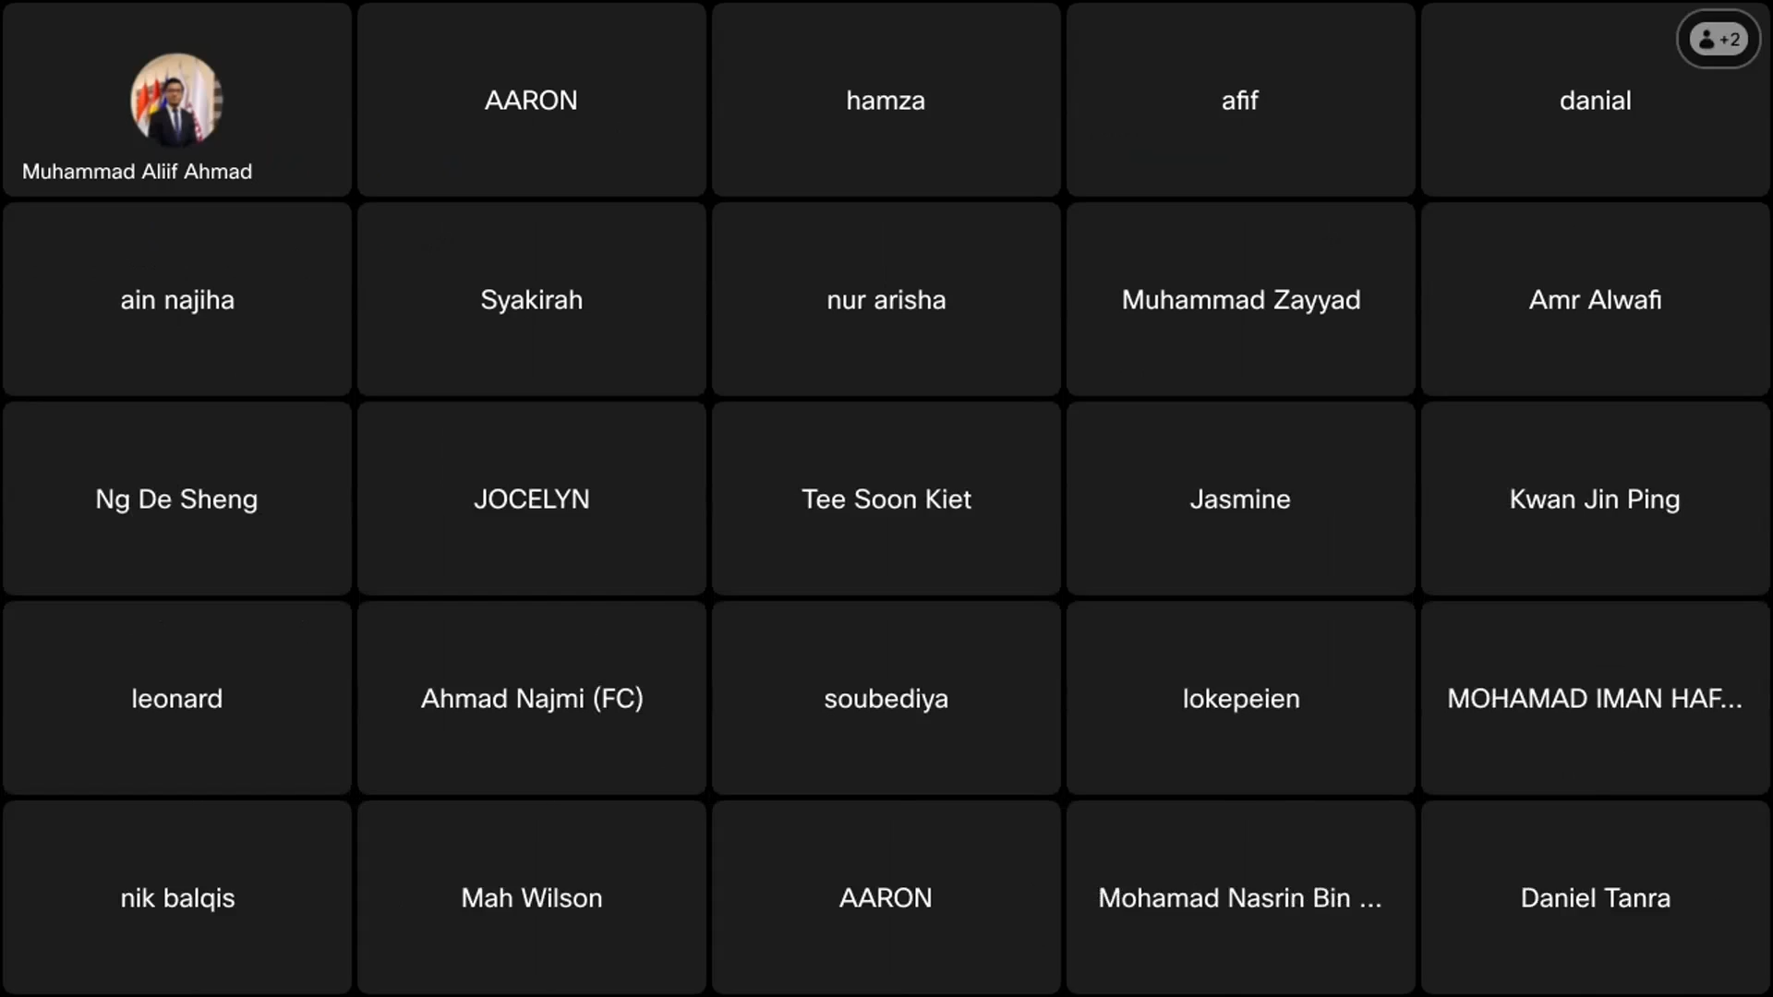

(Figure 4.0)

(Figure 4.1)

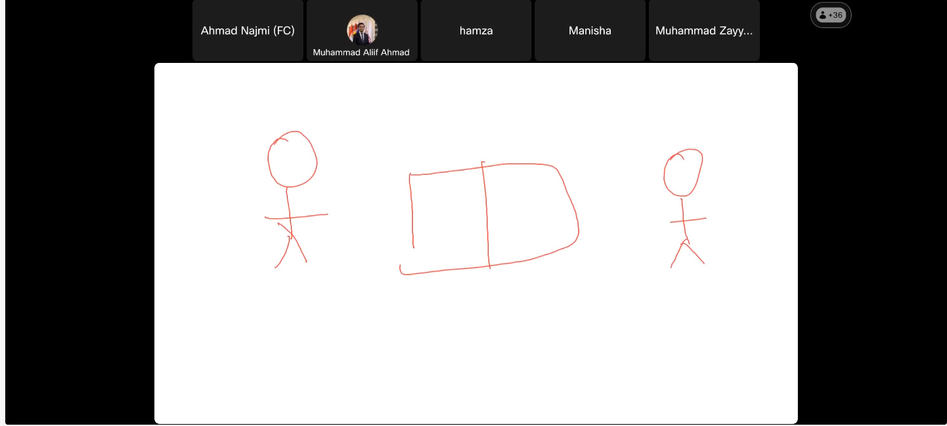

## List of Interview Question

1. Could you please introduce yourself and briefly describe your role in relation

to the postgraduate supervision module?

2. Could you describe briefly what is the current UTM postgraduate supervision

manual process is like?

3. Why would it be the reason for postgraduate supervision module to be

Proposed?

4. Why do you think this project could benefit the previous implementation?

5. Could you describe in detail how UTM postgraduate supervision process is

done manually?

6. Could you tell me the person who would usually be involved in this process?

7. Could you tell me how long does it takes for the manual process to complete?

8. Based on your experience, is there any problem or any difficulty that always

tend to happen when doing the manual process

9. How do the needs and expectations of different stakeholders align or conflict

with each other?

10. Do you have any other specific needs or demand for what this module should

do and should solve?

11. What are the essential features that the postgraduate supervision module

should have?

12. Are there any specific functionalities that stakeholders have requested, or you

think it would be beneficial to include in the module?

13. May i ask how much the budget set aside for the development of this

module?

14. May I also ask how long you think that this module should have been

completed?

15. How do you wish the module can be used, is there any specific platform that

you would like this module to be, such as mobile apps, web or desktop

Applications?

16. Is there anything else you would like to share or any other information you

believe would be beneficial for the development of the postgraduate

supervision module?

# Requirements Analysis

## Current Business Process (AI-IS analysis)

Regularly, for postgraduate students looking for their suitable supervisors when furthering their studies, they will search for their suitable supervisors through a handful of process, for example the candidate needs to gather a decent amount of potential supervisors' information whether it is from social media, referral, email and many more. After having a decent number of potential supervisors, students will need to create a proposal and approach supervisor suitably one at a time for each of the potential supervisors, this include telling the supervisor their background, what their study for, why they want the individual to be their supervisors and many more reason. Once done, the candidate would also need to wait for the potential supervisor to response. If the potential supervisor agrees, that is when the students are allowed to go through the next steps of furthering their studies.

Besides that, as the students are furthering their studies with their supervisors, there will be a time where the students will want to discuss with their supervisors regarding their research and work. For example, the students usually will want to discuss with their supervisors about their thesis and progress. Therefore, the process usually consists of students contacting their supervisors and appointing the time of meetings, this process requires students to be aware of their supervisor schedule and work. Not to mention, these activities will only work if the supervisors can allocate their time and agree on the location as well as the discussion. Once everything has settled out, that is when the meeting will happen.

Hence, that is the brief explanation about the activities and process that the students and supervisors will go through when interacting together. Based on figure 5.1.0 it depicts the current manual process as a flowchart diagram.

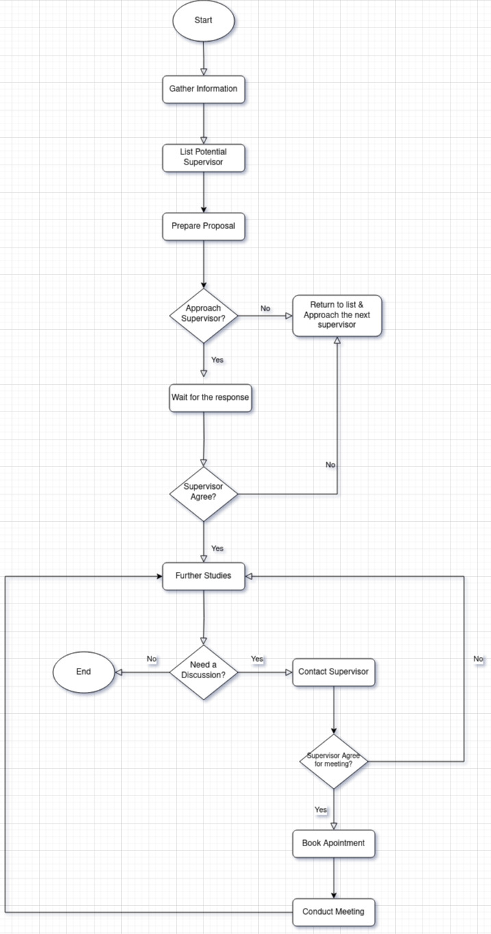

(Figure 5.1.0)

## Functional Requirements (scenarios, workflow)

* + 1. Features Available

|  |  |  |
| --- | --- | --- |
| No | Feature | Explanation |
| 1 | Supervisor Catalogue | Dr Najmi points out that the website should list all the potential supervisors that are available to supervise students, this can serve as a starting point for students to check and analyze a suitable supervisor's candidate. |
| 2 | Supervisor Engagement | Compliment to the supervisor's catalogue, Dr Najmi mentioned that students should be able to request to each of the supervisors listed on the platform. After requesting, potential supervisors are given notification and background information of the students, so that they can evaluate whether the students are suitable to be supervised or proceed for the next steps such as interviewing the candidate for further evaluation. |
| 3 | Information Display | Rule of thumb, the platform should provide a background information display for both students and supervisors. This feature can serve as a reference for both students and supervisors when students are trying to look for a potential suitable supervisor candidate as well as when supervisors want to evaluate the students in overall aspect. |
| 4 | FAQ | Dr Najmi mentioned that FAQ should be provided to facilitate any common question or concern that students might have when using the platform. For example, if they get rejected by supervisors, or a set of guidelines for applying for supervision. |
| 5 | Supervisor Research Display | Aside from background information, the platform should also dedicate a place where supervisors can display their research achievement and publishment, where students can see and judge. |
| 6 | Thesis Progression Checker | Dr Najmi also mentioned that the platform should have a feature where students can upload their document to be checked and verified by the supervisors. |
| 7 | Appointment Meetings | For facilitating the interaction between students and supervisors. Dr Najmi mentioned that the platform should provide a feature where students can book and set appointment meetings on supervisor's calendar. Meanwhile the supervisors can decide whether to proceed or refuse the meeting appointment. Supervisors could also set up a meeting date. |
| 8 | Supervisor Calendar | Dr Najmi, mention that supervisor's calendar should be provided to act as a reference for students when booking an appointment, students can simply click and set an appointment on specific date and supervisors are given an option to accept or reject as they see fit. Supervisors could also set a date for students when they should be presenting their proposal or setting up a deadline for their thesis. Besides that, a calendar has also been provided to serve as a reference for supervisor's daily schedule. |
| 9 | Students and Supervisors Registration | To use the platform, students and supervisors will be asked to register their information on the platform such as their personal info and background education. Meanwhile, the supervisors are required to give their personal field of expertise, supervision status and the availability of grant money. |

(Figure 5.2.0)

* + 1. Automated Process

|  |  |  |
| --- | --- | --- |
| No | Manual Process | Automated Solution |
| 1 | Searching for Supervisors | The automated solution would be the supervisor catalogue where it displays all the available supervisor that ready to supervise students based on their expertise and field |
| 2 | Setting up an Appointment | Provide a supervisors' calendar where students can request an appointment and automatically notified the supervisor for further action |
| 3 | Checking Progress | Provide a way to check and evaluate student research progress aside from physical or unorganized method |
| 4 | Background Advertisement | Provide a way to advertise and create an appeal for both students and supervisors based on information given, for example students information would be their background studies, while supervisors would be their achievement and research publishment. |
| 5 | Managing Students for supervisor | Eliminate the need to list all the students supervised by supervisors by providing a feature where supervisors can track all the students supervised under them inside the platform. |

(Figure 5.2.1)

## Non-Functional Requirement

|  |  |  |
| --- | --- | --- |
| No | Non-Functional Requirements | Reason |
| 1 | Security | Dr Najmi talked about how the platform should provide some aspects of security such as password hashing when storing the students and supervisor's password in the database. |
| 2 | Cost Efficiency | Due to the limited budget and financial investment, the system should be cost efficient and low expenses. |
| 3 | Usability | The platform should provide a set of crucial features to facilitate the interaction between students and supervisors as well as solving the main issues which is automating the process of searching and communicating with supervisors. |
| 4 | Sustainability | Due to the unpredictability of the future, the system should be operated over a long period of time with minimal maintenance, because of their lack of workforce dedicated to developing and maintaining the platform. |
| 5 | Extensibility | To facilitate communication between students and supervisors, the platform should be open to changes and modified, to give room for any new features or idea that could further increase the usability and user-experience. |
| 6 | Reliability | The platform should be reliable and helpful for students to search for potential supervisors' candidate when furthering their studies and convenient for supervisors when managing and accommodating their supervised students. |

(Figure 5.3.0)

## Logical DFD AS-IS system (Context Diagram, Diagram 0, Child)

For ensuring that the overall manual supervision process can be understand more clearly, Data-Flow diagram is created to capture the essence of the students and supervision activities in the process as well as differentiate some of the tasks executed by students as well as supervisors. Below 5.4.0 to 5.4.4 is a Context Diagram, Diagram 0 and some of the Child Diagram for each process.

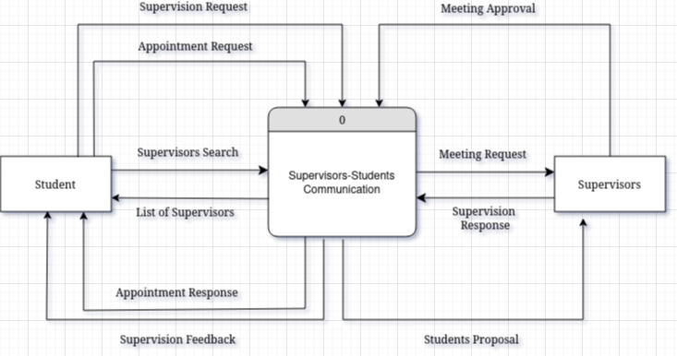

(Figure 5.4.0) Context Diagram

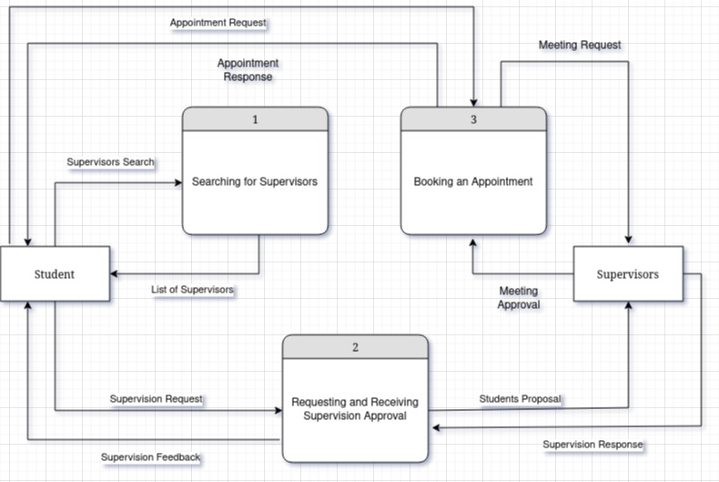

(Figure 5.4.1) Level-0 Diagram

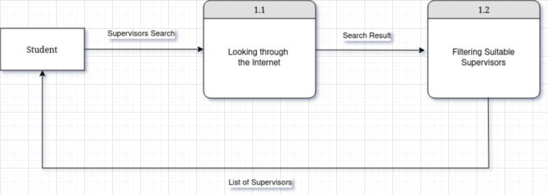

(Figure 5.4.2) Child Diagram 1

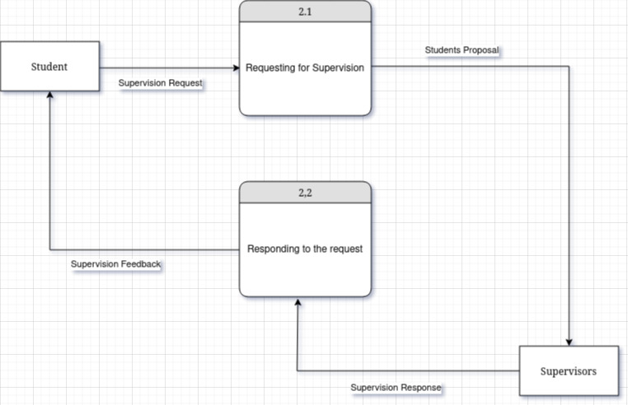

(Figure 5.4.3) Child Diagram 2

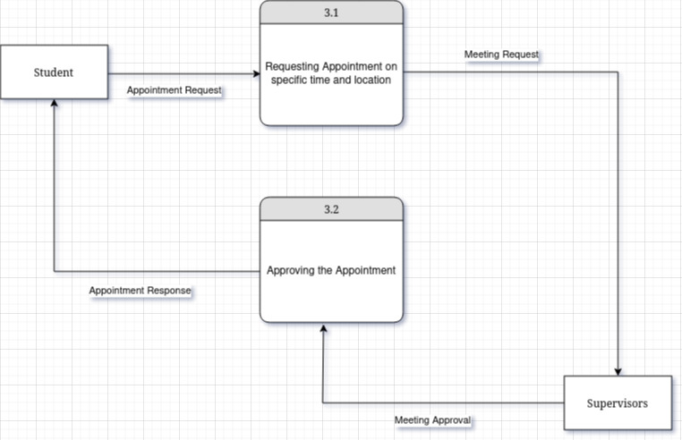

(Figure 5.4.4) Child Diagram 3

# Summary

In a nutshell, the manual process of the supervision module is carefully studied, and the project's development is planned thoroughly. The project is developed in the hope that it could solve the regular recurring problems among postgraduate candidates that want to decide on furthering their studies. In addition to that, the project is developed consist of features that could help potential students find their suitable supervisor as well as help the current students to discuss with their supervisor about their progress and research by providing features such as appointments booking and thesis checker.

Before developing the project, quality information gathering activities were executed where stakeholders were interviewed to gather more information about the module requirements and in-depth information about the problem as well as the knowledge about the background studies. After that, the requirement is analyzed critically where the process of students and supervisors is evaluated in detail. The process consists of creating a flow chart, listing functional and non-functional requirements and drawing a Data-Flow Diagram for manual process. Everything is done in the hope that the development of the is done successfully and the requirements can be satisfied.