**Submission of Camera Ready Paper**

**Camera Ready Formatting Instructions:**

* Authors are limited to 6 pages for the final version of your papers including figures, tables, and references. Papers should be formatted in the IEEE two-column format for "letter" size paper. LaTex and MS Word Doc templates for use in camera ready submissions can be found at <https://www.ieee.org/conferences/publishing/templates.html>.
* All conference papers will be marked with the following information in the left hand margin of the first page:
* Conference Name
* Conference Year
* DOI (Digital Object Identifier)
* IEEE Copyright Clearance Code
* Add the copyright notice to the bottom left of the first page of your paper. The copyright notice must appear as follows:
* For papers in which all authors are employed by the US government, the copyright notice is: **U.S. Government work not protected by U.S. copyright**
* For papers in which all authors are employed by a Crown government (UK, Canada, and Australia), the copyright notice is: **979-8-3503-2266-8/23/$31.00 ©2023 Crown**
* For papers in which all authors are employed by the European Union, the copyright notice is: **979-8-3503-2266-8/23/$31.00 ©2023 European Union**
* For all other papers the copyright notice is: **979-8-3503-2266-8/23/$31.00 ©2023 IEEE**
* You can find a pdf template of how the copyright notice must be inserted at the bottom left of your first page at: <https://github.com/123456hlj/paper_template-with_copyright_notice/upload>. Detailed instructions can be found at: https://www.ieee.org/publications/rights/index.html. An example LaTex code snippet is as follows:
* To be inserted after \maketitle:  
  \thispagestyle{fancy}  
  \lfoot{978-1-6654-5238-0/22/\$31.00~\copyright2022 IEEE}  
  \cfoot{}  
  \rfoot{}
* Proofread your source document thoroughly to confirm that it will require no revision. Authors must use the IEEE PDF eXpress site to validate your source document. Any manuscripts deviating from the IEEE conferences template will be rejected by the software. The basic steps for submission are as follows:
* Access the PDF eXpress website: <https://ieee-pdf-express.org/account/login?ReturnUrl=%2F>.
* First-time users should create a new IEEE PDF eXpress account (conference ID is 57827X). An Online confirmation will be displayed and an email confirmation will be sent verifying your account setup. Previous users of PDF eXpress need to follow the above steps, but should enter the same password that was used for previous conferences. Verify that your contact information is valid.
* Upload your source file(s) for conversion and/or PDF(s) for checking.
* Once checking is complete and passed click "Refresh File Status" from the PDF eXpress home page. Two new options will appear in the status block for your paper, "Try Again" and "Approve for Collection".
* If subsequent changes are required for your paper you may upload new versions of your paper via the "Try Again" option.
* If you are ready to complete the submission process click "Approve for Collection" and the paper will be submitted for publication.
* Use IEEE PDF eXpress to generate IEEE Xplore-compatible PDF(s). The site contains extensive instructions, resources, helpful hints, and access to technical support.
* Once your paper is approved in PDF eXpress, download the file and create a zip file version containing the following:
* your final paper checked by PDF eXpress.
* all source files for your paper.

**Steps for Camera Ready Submission:**

Once your full paper has been prepared according to the above process, you will need to return to the ICaMaL2023 CMT submission system for uploading your file. Below are steps to making your submission.

* **Author Console**
* From the Author Console in CMT, click on the link ‘Create Camera Ready Submission.’

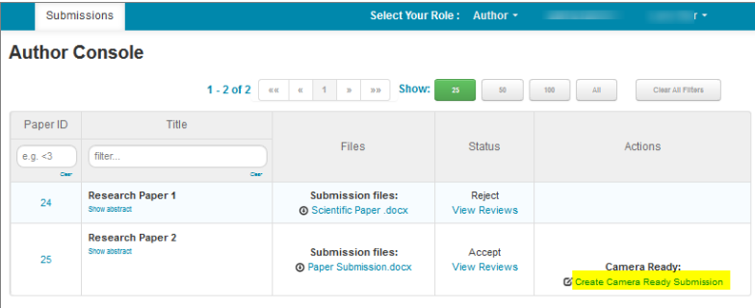

* **Create New Camera Ready Submission Page**
* The Create New Camera Ready Submission page opens. On this page, you may have the ability to edit the title, abstract, and author information. Some Conferences have this disabled.

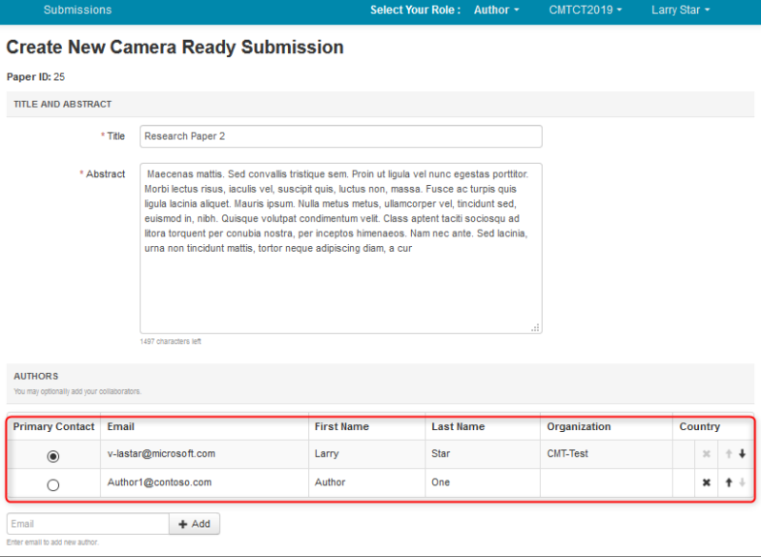

* The ‘Files’ section is where you upload the camera-ready file. You may either drag and drop the file into the dotted region or click ‘Upload from Computer’ to upload the file that way.

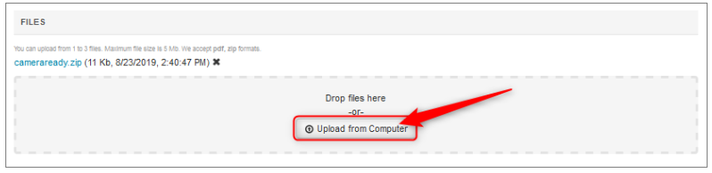

* Answer the ‘Additional Questions’ and click ‘Submit.’

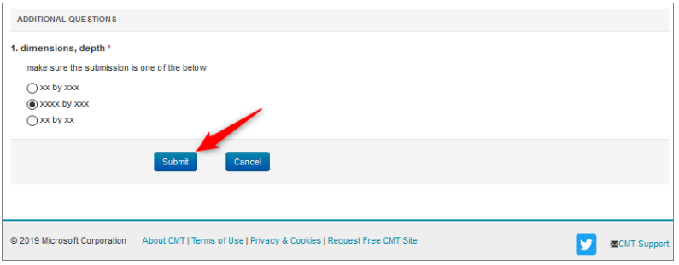

* **Edit Camera-Ready Submission**
* If the submission needs to be edited and it is before the deadline, click the 'Edit Camera-Ready Submission' link.

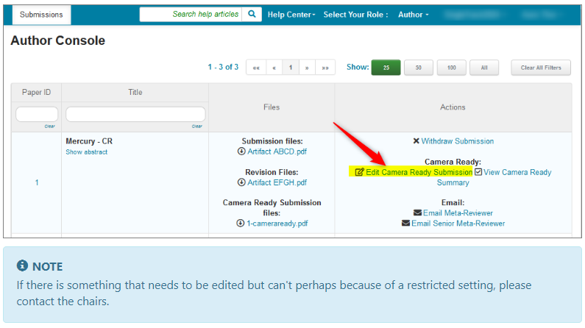

* **IEEE Copyright**

Authors will be redirected to IEEE eCF site to submit copyright form. After filling out the IEEE copyright form on eCF site, Authors need to download the form and upload it into CMT. The copyright forms can later be downloaded by the Chairs/Proceeding Editors.

* From the Author Console, click on the ‘Submit IEEE copyright form’ link.

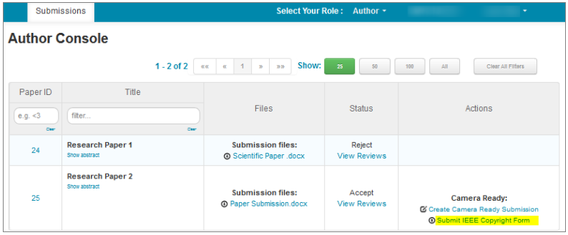

* The IEEE Copyright Form Submission page opens. You must read the instructions before proceeding:

*You need to go to the IEEE Copyright Web Site to submit IEEE Copyright Form. Upon completion, there is an option to download the completed IEEE Copyright Form in PDF. Make sure to download a copy of the completed form. When you are finished, you will be redirected back to Author Console.*

* Once you have the file, you may either drag and drop the file into the dotted region or click ‘Upload from Computer’ to upload the file that way. Then click ‘Save.’

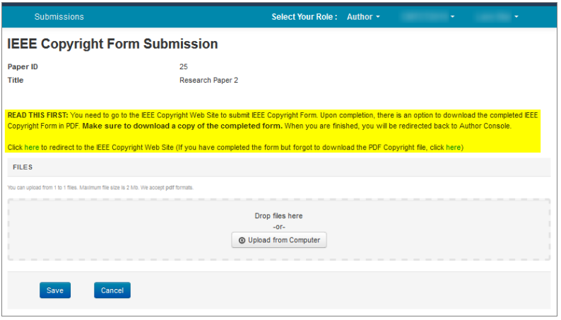

Do not forget to register for the conference by the identified deadline. Otherwise, we will not be able to publish your paper in the proceedings. For conference registrations, please visit this site: https://stle.whut.edu.cn/iCaMaL2023/pap/.

Should you have any concerns on your final paper submission, please contact the publication chair for the conference: [helj@whut.edu.cn](mailto:aguerrieri@deis.unical.it); antonio.guerrieri@icar.cnr.it.