1)

a)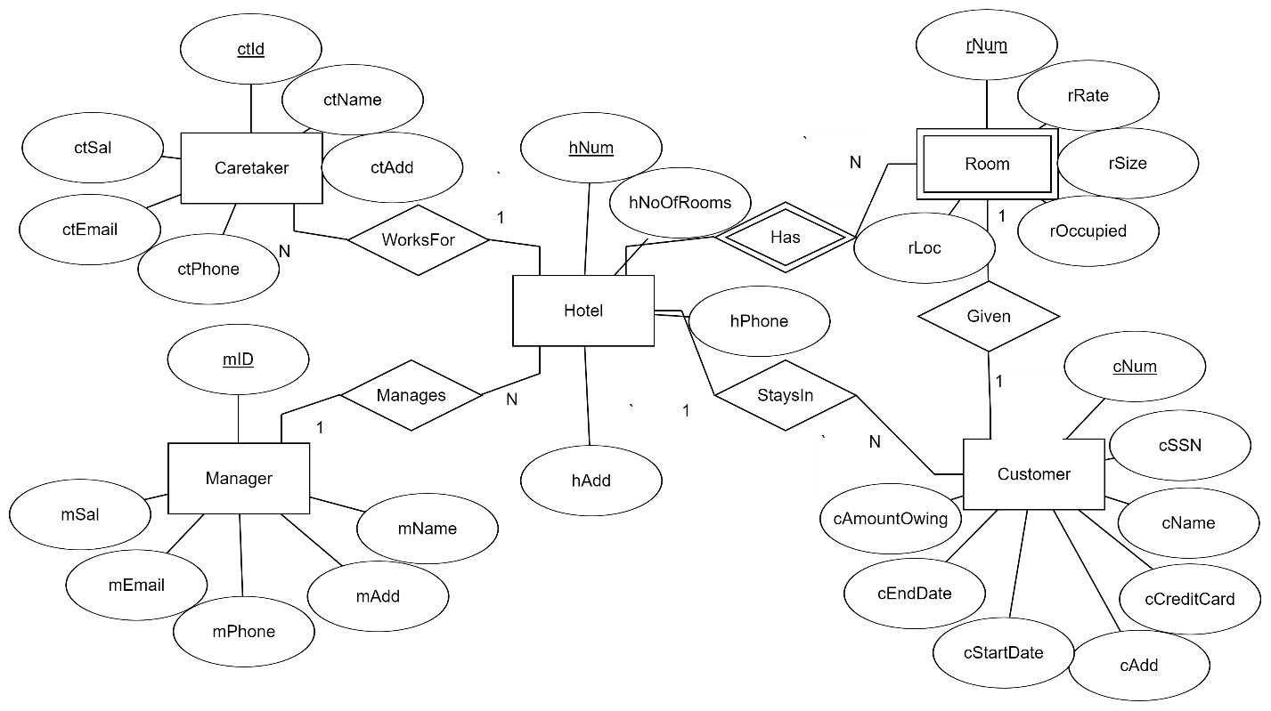

b) Manager(mID, mName, mAddm mPhone, mEmail, mSal)

Hotel(hNum, hNoOfRooms, hPhone, hAdd, hMID*)

Room(hNum, rNum, rRate, rSize, rOccupied, rLoc)

Customer(cNum, cSSN, cName, cCreditCard, cAdd, cStartDate, cEndDate, cAmountOwing, hNum*,rNum*)

Caretaker(ctID, ctName, ctAdd, ctPhone, ctEmail, ctSal, hNum*)

3rd normal form: cAmountOwing was removed since it can be calculated by

Finding out how many days the customer stayed from cStartDate and cEndDate and multiplying that by rRate.

Manager(mID, mName, mAddm mPhone, mEmail, mSal)

Hotel(hNum, hNoOfRooms, hPhone, hAdd, hMID*)

Room(hNum, rNum, rRate, rSize, rOccupied, rLoc)

Customer(cNum, cSSN , cCreditCard, cAdd cStartDate, cEndDate, hNum*,rNum*)

Caretaker(ctID, ctName, ctAdd, ctPhone, ctEmail, ctSal, hNum*)

C)

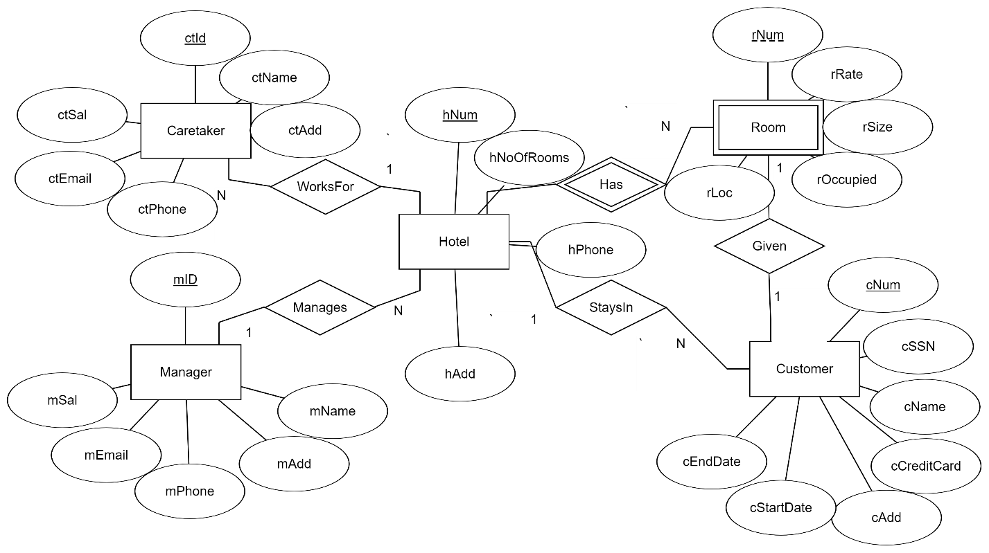

D)

DROP TABLE Hotel;

DROP TABLE Manager;

DROP TABLE Room;

DROP TABLE Caretaker;

DROP TABLE Customer;

CREATE TABLE Hotel(

hNum INT CONSTRAINT PK_hNum PRIMARY KEY,

hNoOfRooms INT CONSTRAINT CH_NoRooms CHECK(hNoOfRooms > 0 AND hNoOfRooms <= 200),

hPhone CHAR(7) CONSTRAINT UN_hPhone UNIQUE,

hAdd VARCHAR(50),

hMID INT,

CONSTRAINT CH_hPhone CHECK(hPhone LIKE '[2-9][2-9][0-9][2-9][2-9][2-9][2-9]')

);

CREATE TABLE Manager(

mID INT CONSTRAINT PK_mID PRIMARY KEY,

mName VARCHAR(50),

mAdd VARCHAR(50),

mPhone CHAR(7) CONSTRAINT CH_mPhone CHECK(mPhone LIKE '[2-9][2-9][2-9][2-9][2-9][2-9][2-9]'),

mEmail VARCHAR(100),

mSal DECIMAL(7,2),

CONSTRAINT CH_mID CHECK(mID >= 111111 AND mID <= 999999)

);

CREATE TABLE Room(

rNum INT CONSTRAINT CH_rNum CHECK(rNum > 0 AND rNum <= 200),

hNum INT,

rRate DECIMAL(5,2) CONSTRAINT CH_rRate CHECK(rRate>=50),

rSize INT CONSTRAINT CH_rSize CHECK(rSize>=2 AND rSize<=4),

rOccupied CHAR(5) CONSTRAINT CH_rOccupied CHECK(rOccupied In ('true', 'false')),

rLoc INT CONSTRAINT CH_rLoc CHECK (rLoc > 0 AND rLoc <= 100),

CONSTRAINT PK_hrNum PRIMARY KEY (hNum, rNum)

);

CREATE TABLE Caretaker(

ctID INT CONSTRAINT PK_ctID PRIMARY KEY,

ctName VARCHAR(50),

ctAdd VARCHAR(50),

ctPhone CHAR(7) CONSTRAINT CH_ctPhone CHECK(ctPhone LIKE '[2-9][2-9][2-9][2-9][2-9][2-9][2-9]'),

ctEmail VARCHAR(200),

ctSal INT CONSTRAINT CH_ctSal CHECK(ctSal > 20000 and ctSal < 40000),

hNum INT

);

CREATE TABLE Customer(

cNum int CONSTRAINT PK_cNum PRIMARY KEY,

cSSN CHAR(9) CONSTRAINT CH_cSSN CHECK(cSSN LIKE'[6][06][0-9][0-9][0-9][0-9][0-9][0-9][0-9]'),

cName VARCHAR(50),

cCreditCard VARCHAR(50),

cAdd VARCHAR(50),

cStartDate DATE,

cEndDate DATE,

hNum INT,

rNum INT,

CONSTRAINT UN_cSSN UNIQUE(cSSN)

);

ALTER TABLE Hotel

ADD CONSTRAINT FK_mID

FOREIGN KEY (hMID) REFERENCES Manager(mID);

ALTER TABLE Room

ADD CONSTRAINT FK_roomHNum

FOREIGN KEY(hNum) REFERENCES Hotel(hNum);

ALTER TABLE Customer

ADD CONSTRAINT FK_hrNUM

FOREIGN KEY(hNum,rNum) REFERENCES Room(hNum, rNum);

ALTER TABLE Caretaker

ADD CONSTRAINT FK_hNum

FOREIGN KEY(hNum) REFERENCES Hotel(hNum);

2)

1)

Write a select statement to list all the columns from the Offices table. 'Select *' is not allowed. Return the list in Office order:

SELECT office, city, region, mgr, target, sales FROM offices ORDER BY office ASC;

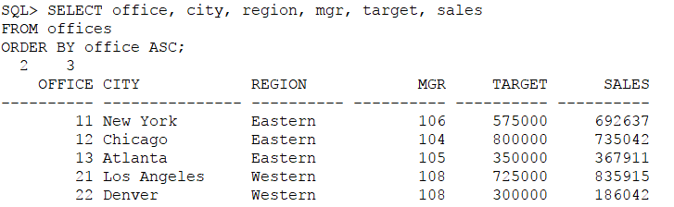

2) List the Product Name (its description), and dollar value of quantity on hand (price * quantity) . Return the list in descending order by value.

SELECT DESCRIPTION, PRICE * QTY_ON_HAND FROM PRODUCTS ORDER BY (PRICE * QTY_ON_HAND) DESC;

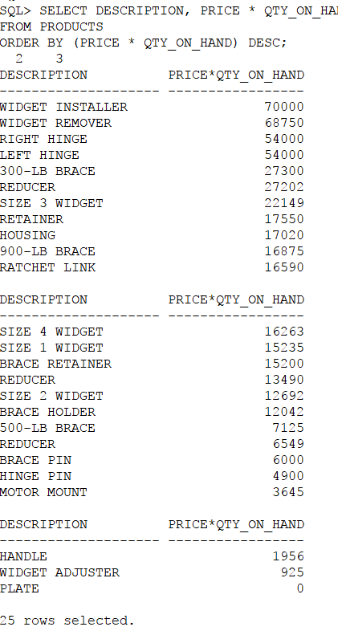

3) New: List the Order Number, Order Date, Customer Number and Sales Rep Number for orders for part 'XK47' or '775C'. (Use a compound search condition - OR.)

SELECT ORDER_NUM, ORDER_DATE, CUST, REP FROM ORDERS WHERE PRODUCT = 'XK47' OR PRODUCT = '775C';

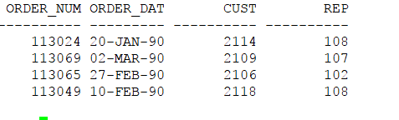

4) List the Name and Age for all Sales Reps in the following offices: 12; 21; 13. (Use the set membership test - IN.)

SELECT name, age FROM salesreps WHERE rep_office IN('12', '13', '21');

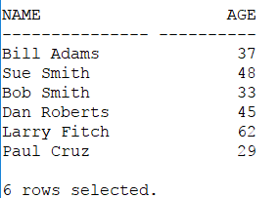

1. List the names of all Sales Reps who have the letter 'o' (this is lower case o) as the second character of their name.

SELECT name FROM salesreps WHERE name LIKE '_o%';

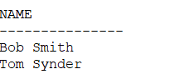

1. Return the Sales Rep ID and Name of any Sales Rep not assigned to an office yet.

SELECT empl_num, name FROM salesreps WHERE rep_office IS NULL;

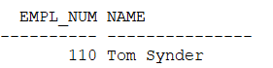

1. Show all the sales rep names with last name “Smith”.

SELECT name FROM Salesreps WHERE name LIKE '_%Smith';

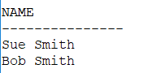

1. List different titles in the sales reps table. Only list each title once and unknown titles should be ignored. SELECT DISTINCT title FROM salesreps;

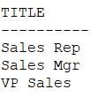

9)List the description of the products which are at least 6 character and less than 10 character long. No duplicate row is allowed. You can use the build in function length() to do this. For example, length(name) return the number of characters for attribute called “name”.

SELECT DISTINCT DESCRIPTION FROM PRODUCTS WHERE length(DESCRIPTION) > 6 AND length(DESCRIPTION) < 10;

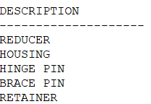

1. List the the order nums with the name of the rep who placed the order and the name of the customer who made the order and the name of the rep for that customer

SELECT ORDER_NUM, name FROM ORDERS, salesreps WHERE REP = empl_num;

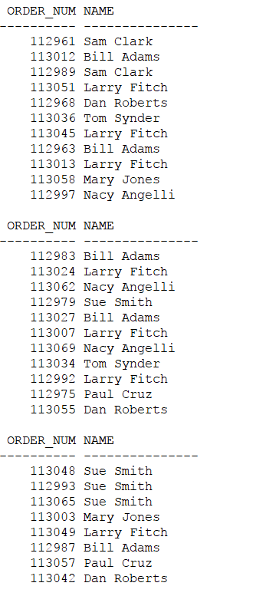

3)

1. List the Mfr Id, the Product Id, Company and PRICE of all products brought by customers where customer number is one of (2112,2105,2119) and where the amount of the order < $5000.00. Order the results by ascending Company.

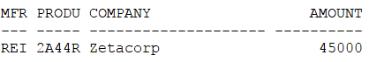

SELECT MFR, PRODUCT, COMPANY, AMOUNT FROM ORDERS, CUSTOMERS WHERE CUST = CUST_NUM AND CUST IN('2112', '2105', '2119') AND AMOUNT > 5000 ORDER BY COMPANY ASC;

2) List all salesreps (id and names) and all orders (orderNumber) in which the salesrep is the company’s (i.e. the customer) rep (Cust Rep), but didn’t take the order. Order the result based on name in ascending order.

SELECT empl_num, name, ORDER_NUM FROM ORDERS, salesreps, Customers WHERE empl_num = CUST_REP AND REP!= empl_num AND CUST = CUST_NUM ORDER BY name ASC;

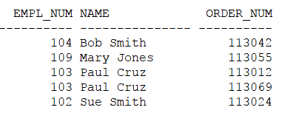

3) List all customers (Customer number, Company, and Credit Limit) and orders (Order Number, Amount) where the order is within $10000.00 of the Credit Limit (less than or equal to $10000). Sort the result by Customer number in descending order. SELECT CUST_NUM, COMPANY, CREDIT_LIMIT, ORDER_NUM, AMOUNT 2 FROM ORDERS, CUSTOMERS 3 WHERE CUST = CUST_NUM AND (CREDIT_LIMIT - AMOUNT <= 10000) 4 ORDER BY CUST_NUM DESC;

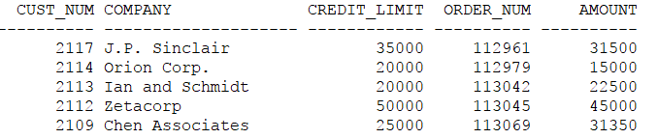

4) List all salesreps names and their managers’ names where the salesrep is at least as old as the manager.

SELECT Employees.name, Managers.name FROM salesreps Employees, salesreps Managers WHERE Employees.manager = Managers.empl_num AND Employees.age >= Managers.age;

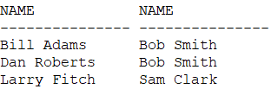

1. List all salesreps (Name) and the City they work in where the sales of the salesrep < Quota and the sales for the office is < Target. SELECT name, city FROM salesreps, offices WHERE salesreps.sales < quota AND offices.sales < target;

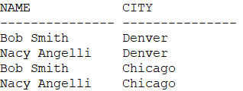

6) List the name, id, and hire date of the salesreps where at least one of the two conditions hold:

* The salesrep sales should be greater than the quota
* The salesrep has taken an order from Customer number 2117, 2111, or 2101.

Sort the result by the salesrep’s id.

SELECT DISTINCT name, empl_num, hire_date FROM salesreps, ORDERS WHERE sales > quota OR REP = empl_num AND CUST IN('2117', '2111', '2101') ORDER BY empl_num ASC;  
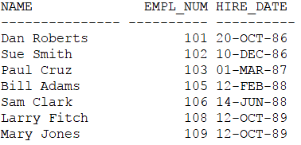

7) List all orders (Order Number) over $25000 showing the company placing the order, the Customer Rep assign to the company, the Office id and the city where the Customer Rep works in, such that the Customer Rep’s manager is not the person who actually took the order.

SELECT DISTINCT ORDER_NUM, COMPANY, CUST_REP, office, city FROM ORDERS, CUSTOMERS, salesreps, offices WHERE AMOUNT > 25000 AND office = rep_office AND CUST_REP = empl_num and manager != REP AND CUST = CUST_NUM;

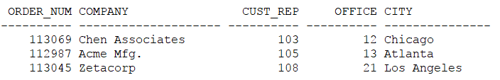

8) List all customer reps (their name and their id) and their managers name in which the manager has taken an order for the customer Rep’s company or the manager is based in New York or Denver. Use appropriate column header

SELECT DISTINCT Employees.name, Employees.empl_num, Managers.name FROM salesreps Employees, salesreps Managers, ORDERS, offices, CUSTOMERS WHERE Employees.empl_num = CUST_REP AND REP = Employees.manager AND CUST_NUM = CUST AND Employees.manager = Employees.empl_num OR (mgr = Employees.empl_num AND ( city = 'New York' OR city ='Denver'));

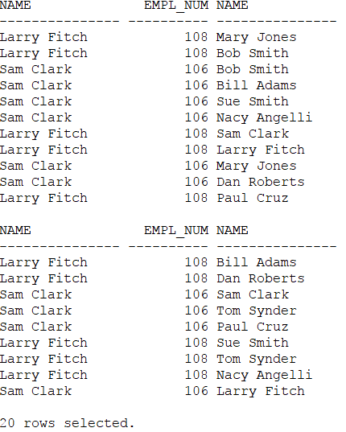

9)

List all products (ProductId, and Description), customers (CustNum, Company) who have bought that product, and orders (Order Number, and Order Date) where the order < $1000. Sort the rows by the **OrderDate.** SELECT DISTINCT PRODUCT_ID, DESCRIPTION, CUST_NUM, COMPANY, ORDER_NUM, ORDER_DATE FROM PRODUCTS, ORDERS, CUSTOMERS WHERE CUST = CUST_NUM AND PRODUCT = PRODUCT_ID AND MFR = MFR_ID AND AMOUNT < 1000 ORDER BY ORDER_DATE ASC;

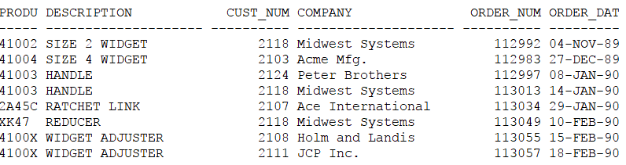

10) List the name of the salesreps and the name of their managers only if the manager has taken care of some orders.

SELECT DISTINCT PRODUCT_ID, DESCRIPTION, CUST_NUM, COMPANY, ORDER_NUM, ORDER_DATE FROM PRODUCTS, ORDERS, CUSTOMERS WHERE CUST = CUST_NUM AND PRODUCT = PRODUCT_ID AND MFR = MFR_ID AND AMOUNT < 1000 ORDER BY ORDER_DATE ASC;

