1a)

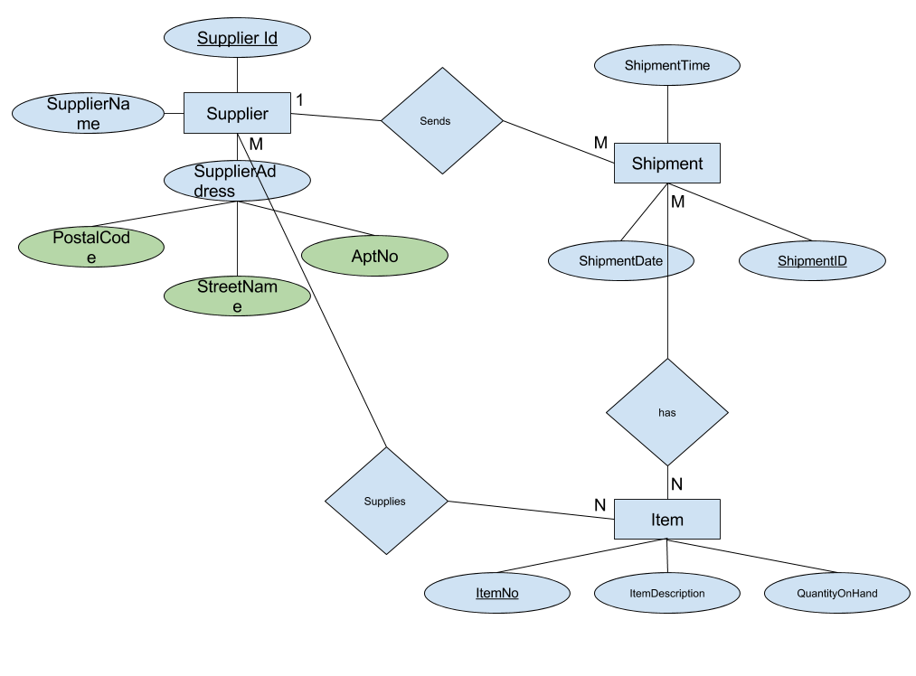

1b)Supplier:

SupplierID, SupplierName, StreetName, AptNo, PostalCode, ShipmentId\*

Shipment:

ShipmentId, ShipmentDate, ShipmentTime, SupplierID\*

Item:

ItemNo, ItemDescription, QuantityOnHand

Has:

ShipmentId, ItemNo

Supplies:

SupplierId, ItemNo

2) Student:

St-Id ,S-name, S-age, S-email

Department:

D-Id, D-Name, D-loc, M-name\*, F-id\*

Course:

C-CRN, C-name, C-des, F-id\*

Major:

M-name, D-id\*

Faculty:

F-Id, F-name, F-major, F-office, D-id\*, C-Crn\*

Takes:

St-ID, C-CRN

Dependent:

Fac-id, name, gender, age