1. **Use query tree to optimize the following query**

SELECT reps.name, off.city

FROM salesreps reps, offices off

WHERE reps.rep_office=off.office

AND reps.sales<=reps.quota

AND off.sales<=off.target;

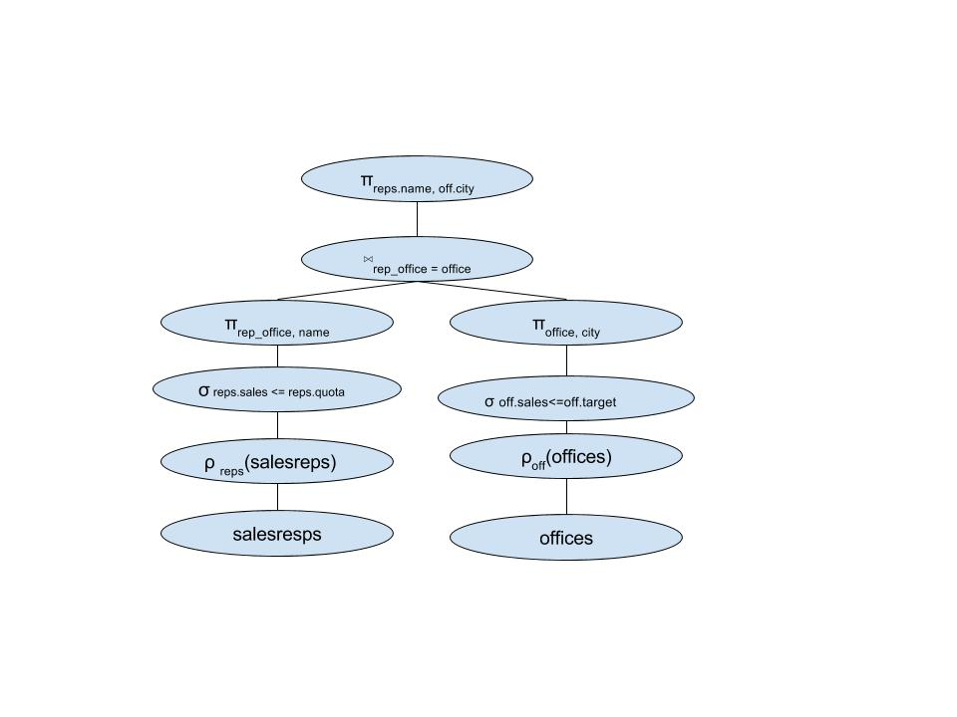

2)SELECT Order_Num, Amount, Company, Name, City

FROM Orders, Customers, Salesreps, Offices

WHERE Cust = Cust_Num

AND Cust_Rep = Empl_Num

AND Rep_Office = Office

AND Amount >= 10000

AND Region = “Eastern”

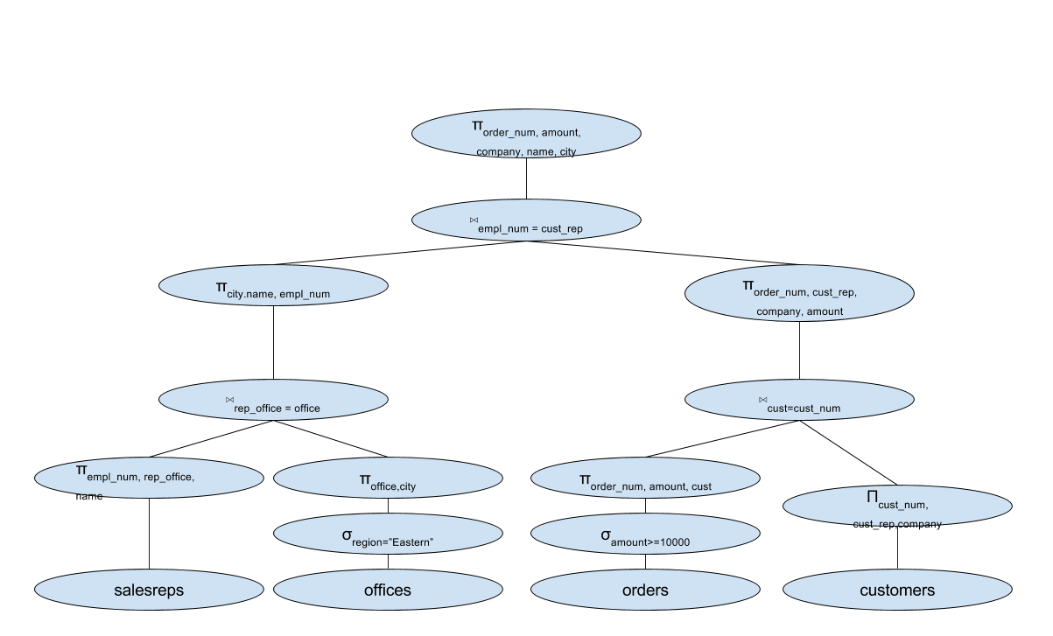

**3)Use query tree to optimize the following query**

SELECT product_id, description, cust_num, company

FROM ORDERS, CUSTOMERS, PRODUCTS

WHERE cust=cust_num

AND MFR=MFR_ID

AND Product=Product_Id

AND Amount <= 1500

